**Experiment 8**

1. Make the collaboration diagram for the Library Management System. The basic characteristics of the system are:

a) Users of the library are either normal or staff

b) A user can borrow a book

c) A staff person can borrow a book

d) The library contains one million books

e) If a user asks a book that has been borrowed, her request is inserted in a waiting list

f) Staff has no priority in borrowing books.

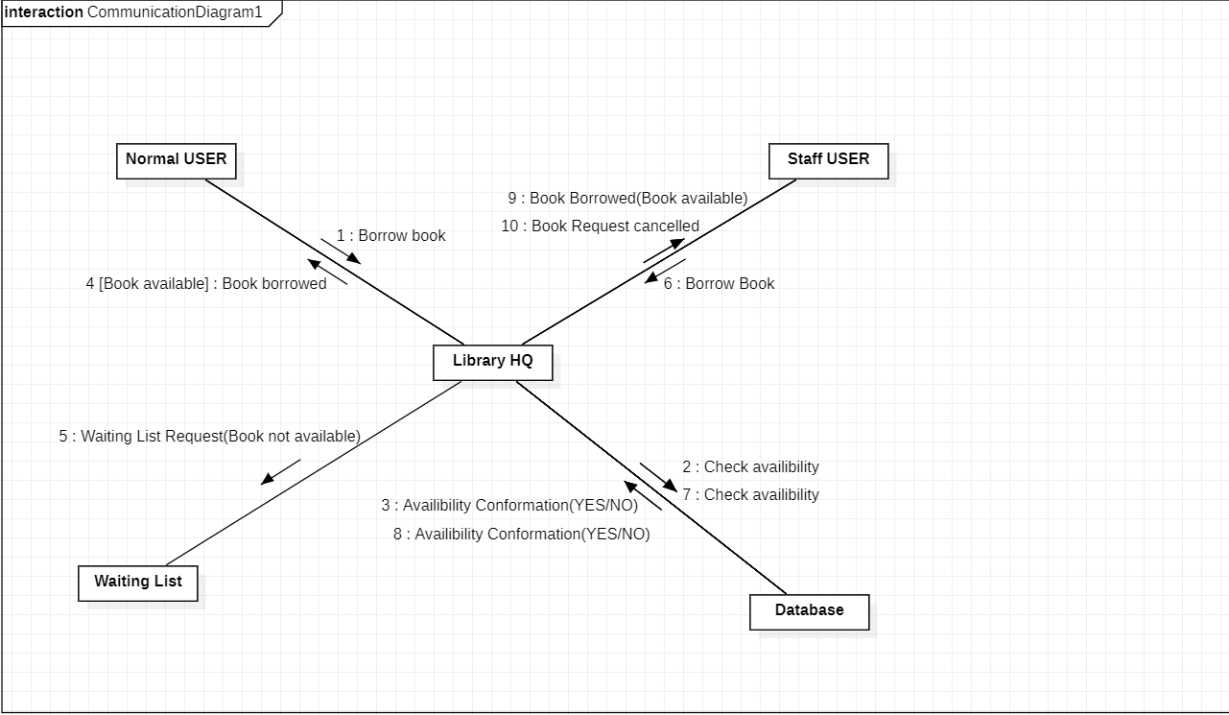

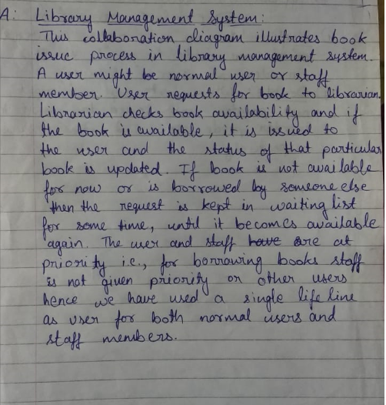

1. Create a Communication diagram that involved the interactions in booking a seat. It should consists of an actor User, and several objects for interface, controller, routes and route. It's a typical MVC sequence diagram - routes and route are model (M), interface is view (V) and mainController is controller (C)

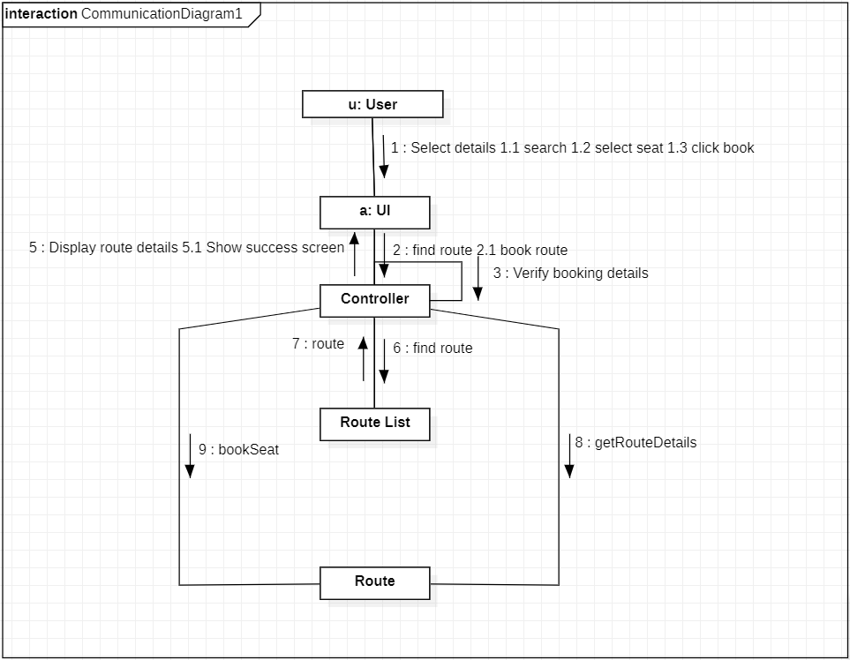

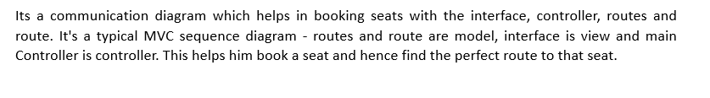

1. Create a Collaboration diagram for placing a order by customer object that create an anonymous order which checks and maintains the item availability in the stocks.

