**CLASS TEST 1**

**OOAD**

**CSE+Devops Vth Semester**

Q.1 Define a class Diagram for following:

Design a system for a movie shop, in order to handle ordering of movies and browsing of the catalogue of the store, and user subscriptions with rechargeable cards.

* Only subscribers are allowed hiring movies with their own card.
* Credit is updated on the card during rent operations.
* Both users and subscribers can buy a movie and their data are saved in there lated order.
* When a movie is not available it is ordered.

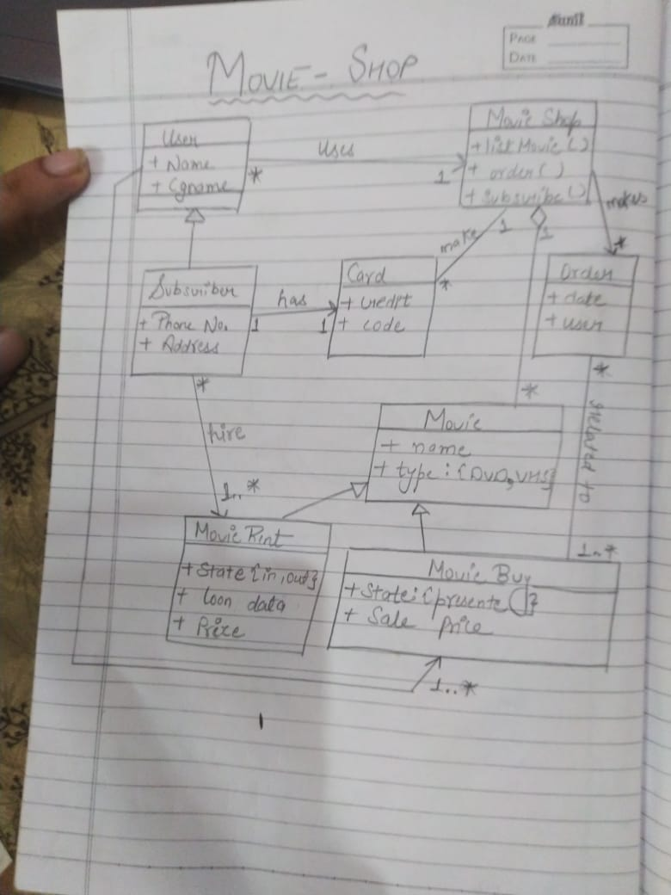

Q.2 Create an activity diagram for following:

When customer requests a room, the hotel employee looks for room availability, then he insert customer’s data and verifies if the provided credit card number has enough credit to pay the room: in this case the booking is confirmed and we wait customer arrival.

The Hotel information system allows customer to modify or cancel his/her reservation. If customer arrives he uses the room and then he pays, in case of no-show a penalty is accounted on his credit card and the booking is canceled.

