1. Arts
2. Architecture
3. The Penguin Dictionary of Architecture and Landscape Architecture

John Fleming

|  |
| --- |
| Penguin Books Ltd |
| YEAR PUBLISHED | 1999 |
| NUMBER OF PAGES | 656 |
|  |  |
| ISBN 13 | 9780140513233 |

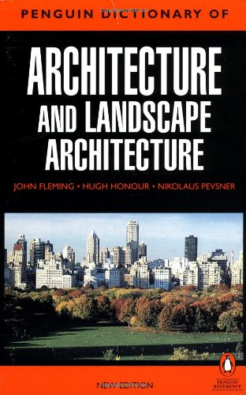

Need a handbook to your architect's business or studies? Struggling with your latest DIY project? Interested in the art of architecture? This classic work, now in its fifth edition, covers every aspect of architecture and landscape architecture. Ranging from ancient times to contemporary trends, it adopts a truly international perspective, focussing on countries and cultures such as Coptic, Tibet and De Stijl. Without doubt, this is the standard work in the field. As reflected by its new title, "The Penguin Dictionary of Architecture and Landscape Architecture" has now been expanded to include recent developments in the field of landscape architecture. Full account has been taken, too, of the huge range of building traditions around the world. The text has been completely reset and all the illustrations redrawn. 'Immensely useful, succinct and judicious...this is a book rich in fact and accumulated wisdom.' - "The Times Literary Supplement".

|  |
| --- |
| Castle: A History of the Buildings That Shaped Medieval Britain |
| AUTHOR | By (author) Marc Morris |
| CONDITION | VERYGOOD |
| BINDING TYPE | Paperback |
| PUBLISHER | Cornerstone |
| YEAR PUBLISHED | 2012 |
| NUMBER OF PAGES | 288 |
| ISBN 10 | 0099558491 |
| ISBN 13 | 9780099558491 |

1. 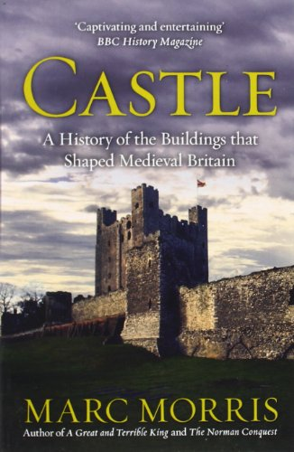

Beginning with their introduction in the eleventh century, and ending with their widespread abandonment in the seventeenth, Marc Morris explores many of the country's most famous castles, as well as some spectacular lesser-known examples. At times this is an epic tale, driven by characters like William the Conqueror, King John and Edward I, full of sieges and conquest on an awesome scale. But it is also by turns an intimate story of less eminent individuals, whose adventures, struggles and ambitions were reflected in the fortified residences they constructed. Be it ever so grand or ever so humble, a castle was first and foremost a home. To understand castles - who built them, who lived in them, and why - is to understand the forces that shaped medieval Britain.

1. Dance

|  |
| --- |
| Anton's Dance Class |
| AUTHOR | By (author) Anton Du Beke |
| CONDITION | VERYGOOD |
| BINDING TYPE | Other book format |
| PUBLISHER | Kyle Books |
| YEAR PUBLISHED | 2007 |
| NUMBER OF PAGES | 224 |
| ISBN 10 | 1856267318 |
| ISBN 13 | 9781856267311 |

1. 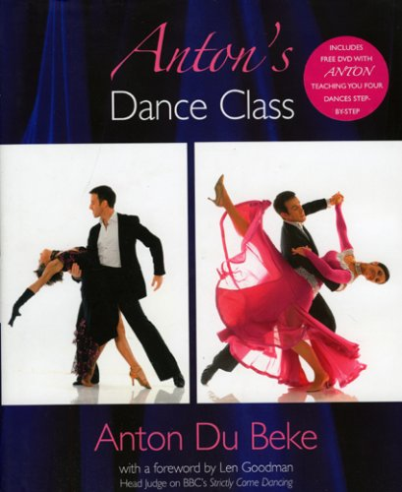

In his first book, Anton Du Beke shares his passion for ballroom dancing. Far more than just the basic steps, it is about the feeling of getting movements perfect, of building a relationship with your partner, of creating an emotional connection with the dances and of beautiful costumes too. For each of the 5 ballroom dances - from the waltz to the foxtrot - and of the 5 latin dances - from the jive to the cha cha - Anton Du Beke describes its origins and story, how to approach it and some tips and techniques, as well as showing the movements in intricate detail. A fantastic free DVD accompanies the book's step-by-step instructions; Anton will take you step-by-step through the dances so that you truly can learn from the master. 'Every woman in the world should have half an hour with Anton Du Beke' (Lesley Garrett). Now you can too. This title comes with a foreword by Len Goodman.

|  |
| --- |
| Official Strictly Come Dancing Annual 2015: The Official Companion to the Hit BBC Series |
| AUTHOR | By (author) Alison Maloney |
| CONDITION | VERYGOOD |
| BINDING TYPE | Hardback |
| PUBLISHER | Ebury Publishing |
| YEAR PUBLISHED | 2014 |
| NUMBER OF PAGES | 128 |
| ISBN 10 | 1849908737 |
| ISBN 13 | 9781849908733 |

1. 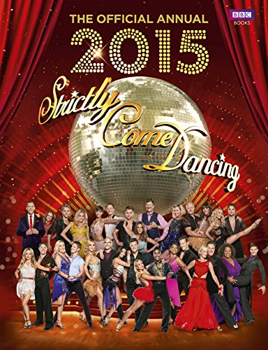

The glamour, the glitz and the glitterball are back on our screens for series twelve of Strictly Come Dancing and the 2015 annual is your perfect partner to every step, spin and shimmy. Throw your own Strictly scary halloween party, swot up an all the dances from the saucy samba to the cheeky charleston, find out just how many sequins it takes to make a Strictly costume sensation and follow a day-in-the-life of a professional dancer. The 2015 official Strictly Come Dancing Annual will have you prepped, stretched and prepared from the very first foray onto the floor to the spectacular final step. Packed full of behind-the-scenes gossip, exclusive interviews, the essential lowdown on everything from make-up to costume as well as fun games and mind-boggling quizzes to test even the best ballroom brainiac, this is your essential guide to all the drama on the dancefloor.

1. Music

|  |
| --- |
| Rockschool Guitar Grade 1 (2012-2018) |
| AUTHOR | N/A |
| CONDITION | VERYGOOD |
| BINDING TYPE | Mixed media product |
| PUBLISHER | Rockschool |
| YEAR PUBLISHED | 2012 |
| NUMBER OF PAGES | N/A |
| ISBN 10 | 1908920017 |
| ISBN 13 | 9781908920010 |

1. 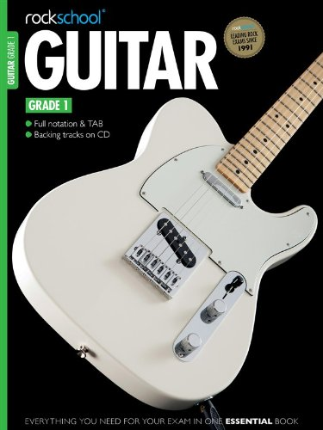
2. Biography and True stories

**a. Biography: general**

|  |
| --- |
| Mud, Sweat and Tears |
| AUTHOR | By (author) Bear Grylls |
| CONDITION | WELLREAD |
| BINDING TYPE | Paperback |
| PUBLISHER | Transworld Publishers Ltd |
| YEAR PUBLISHED | 2012 |
| NUMBER OF PAGES | 480 |
| ISBN 10 | 1905026498 |
| ISBN 13 | 9781905026494 |

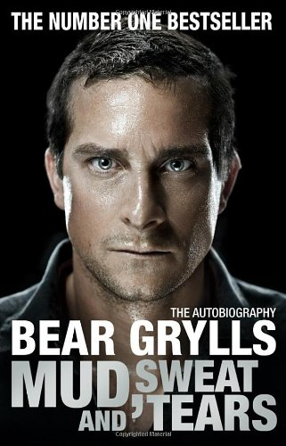

Bear Grylls is a man who has always sought the ultimate in adventure. Growing up on the Isle of Wight, he was taught by his father to sail and climb at an early age. As a teenager he found identity and purpose through both mountaineering and martial arts, which led the young adventurer to the foothills of the mighty Himalaya and a grandmaster's karate training camp in Japan. On returning home, he embarked upon the notoriously gruelling selection course for the British Special Forces to join 21 SAS - a journey that was to push him to the very limits of physical and mental endurance. Then, in a horrific free-fall parachuting accident, Bear broke his back in three places. It was touch and go whether he would ever walk again. However, only eighteen months later Bear became one of the youngest ever climbers to scale Everest, aged only twenty-three. But this was just the beginning of his many extraordinary adventures...Known and admired by millions, Bear Grylls has survived where few would dare to go. Now, for the first time, Bear tells the story of his action-packed life. Gripping, moving and wildly exhilarating, "Mud, Sweat and Tears" is a must-read for adrenalin junkies and armchair adventurers alike.

|  |
| --- |
| Chronicles: v. 1 |
| AUTHOR | By (author) Bob Dylan |
| CONDITION | VERYGOOD |
| BINDING TYPE | Paperback |
| PUBLISHER | Simon & Schuster |
| YEAR PUBLISHED | 2005 |
| NUMBER OF PAGES | 196 |
| ISBN 10 | 0743478649 |
| ISBN 13 | 9780743478649 |

1. 

This is the first spellbinding volume of the three-volume memoir of one of the greatest musical legends of all time. In CHRONICLES Volume I, Bob Dylan takes us back to the early 1960s when he arrived in New York to launch his phenomenal career. This is Dylan's story in his own words - a personal view of his motivations, frustrations and remarkable creativity. Publication of CHRONICLES Volume I is a publishing and cultural event of the highest magnitude.

* b.  **True Stories**

|  |
| --- |
| You Can't Run: The Terrifying True Story of a Young Woman Trapped in a Violent Relationship |
| AUTHOR | By (author) Mandy Thomas |
| CONDITION | VERYGOOD |
| BINDING TYPE | Paperback |
| PUBLISHER | Ebury Publishing |
| YEAR PUBLISHED | 2015 |
| NUMBER OF PAGES | 400 |
| ISBN 10 | 1785030183 |
| ISBN 13 | 9781785030185 |

* 1. 

"He would say to me, 'You can't stop me - no one can!' There was no let-up from his evil. I knew he would never stop, so I just had to do what I could to survive." Mandy Thomas was just 18 when she met the man who would change her life forever. She was soon under his spell - and then her real nightmare began. Mandy found herself part of a cruel and violent relationship that she couldn't escape. Until one day he went too far...You Can't Run is Mandy's searingly honest and moving true story.

|  |
| --- |
| Into Thin Air: A Personal Account of the Everest Disaster |
| AUTHOR | By (author) Jon Krakauer |
| CONDITION | VERYGOOD |
| BINDING TYPE | Paperback |
| PUBLISHER | Pan Macmillan |
| YEAR PUBLISHED | 2011 |
| NUMBER OF PAGES | 352 |
| ISBN 10 | 1447200187 |
| ISBN 13 | 9781447200185 |

* 1. 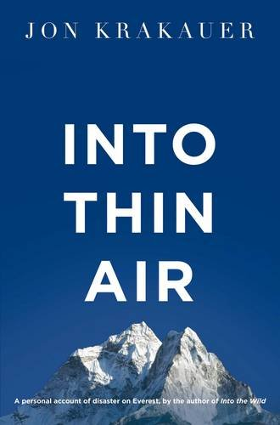

This is the true story of a 24-hour period on Everest, when members of three separate expeditions were caught in a storm and faced a battle against hurricane-force winds, exposure, and the effects of altitude, which ended the worst single-season death toll in the peak's history. In March 1996, Outside magazine sent veteran journalist and seasoned climber Jon Krakauer on an expedition led by celebrated Everest guide Rob Hall. Despite the expertise of Hall and the other leaders, by the end of summit day eight people were dead. Krakauer's book is at once the story of the ill-fated adventure and an analysis of the factors leading up to its tragic end. Written within months of the events it chronicles, Into Thin Air clearly evokes the majestic Everest landscape. As the journey up the mountain progresses, Krakauer puts it in context by recalling the triumphs and perils of other Everest trips throughout history. The author's own anguish over what happened on the mountain is palpable as he leads readers to ponder timeless questions.

1. Mathematics and science
   * 1. Mathematics

|  |
| --- |
| Statistics without Tears: An Introduction for Non-Mathematicians |
| AUTHOR | By (author) Derek Rowntree |
| CONDITION | WELLREAD |
| BINDING TYPE | Paperback |
| PUBLISHER | Penguin Books Ltd |
| YEAR PUBLISHED | 1991 |
| NUMBER OF PAGES | 208 |
| ISBN 10 | 0140136320 |
| ISBN 13 | 9780140136326 |

* + - 1. 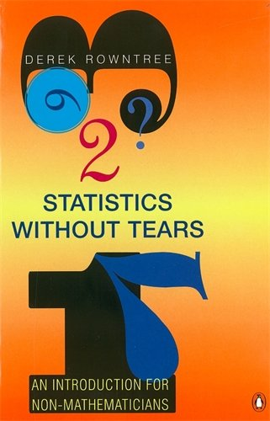

This book is written for anyone who needs or wants to know how statistics work. It assumes no expert knowledge, and teaches through words and diagrams rather than through figures, formulae and equations - providing the perfect approach for the non-mathematical reader. Written as a "tutorial in print", Derek Rowntree includes questions in his argument; readers can answer them as they go, enabling them to measure their performance and judge how far they have mastered the subject.

|  |
| --- |
| Advanced Maths for AQA: Core Maths C1+C2: C1, C2 |
| AUTHOR | By (author) Robert Smedley |
| CONDITION | VERYGOOD |
| BINDING TYPE | Paperback |
| PUBLISHER | Oxford University Press |
| YEAR PUBLISHED | 2004 |
| NUMBER OF PAGES | 320 |
| ISBN 10 | 0199149364 |
| ISBN 13 | 9780199149360 |

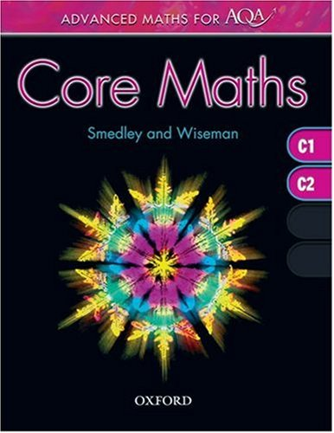

Core Maths C1+C2 is part of a series of books that match the 2005 AQA specifications for Maths A-level. The book has been produced in collaboration with a Senior Examiner to ensure complete and authoritative coverage of the Pure Core 1 and Pure Core 2 modules. It contains all the pure maths that students need to know for AS-level Mathematics, or for the first year of an A-level.

* + 1. Physics

|  |
| --- |
| Introducing Relativity: A Graphic Guide |
| AUTHOR | By (author) Bruce Bassett |
| CONDITION | VERYGOOD |
| BINDING TYPE | Paperback |
| PUBLISHER | Icon Books Ltd |
| YEAR PUBLISHED | 2009 |
| NUMBER OF PAGES | 176 |
| ISBN 10 | 1848310579 |
| ISBN 13 | 9781848310575 |

* + - 1. 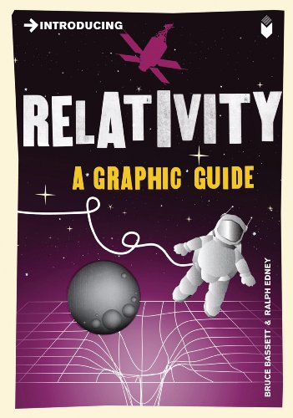

It is now more than a century since Einstein's theories of Special and General Relativity began to revolutionise our view of the universe. Beginning near the speed of light and proceeding to explorations of space-time and curved spaces, "Introducing Relativity" plots a visually accessible course through the thought experiments that have given shape to contemporary physics. Scientists from Newton to Hawking add their unique contributions to this story, as we encounter Einstein's astounding vision of gravity as the curvature of space-time and arrive at the breathtakingly beautiful field equations. Einstein's legacy is reviewed in the most advanced frontiers of physics today - black holes, gravitational waves, the accelerating universe and string theory. This is a superlative, fascinating graphic account of Einstein's strange world and how his legacy has been built upon since.

|  |
| --- |
| The Principle of Relativity |
| AUTHOR | By (author) Albert Einstein |
| CONDITION | VERYGOOD |
| BINDING TYPE | Paperback |
| PUBLISHER | Dover Publications Inc. |
| YEAR PUBLISHED | 1952 |
| NUMBER OF PAGES | 240 |
| ISBN 10 | 0486600815 |
| ISBN 13 | 9780486600819 |

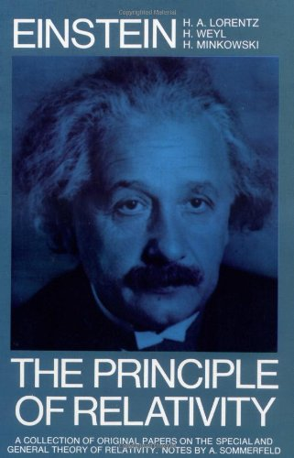

* + 1. Chemistry

|  |
| --- |
| AQA Chemistry A2 Student Book |
| AUTHOR | By (author) Ted Lister |
| CONDITION | VERYGOOD |
| BINDING TYPE | Paperback |
| PUBLISHER | Oxford University Press |
| YEAR PUBLISHED | 2009 |
| NUMBER OF PAGES | 272 |
| ISBN 10 | 0748782796 |
| ISBN 13 | 9780748782796 |

* + - 1. 

The blend of Student Books and supporting online resources allow you to personalise the delivery of the course to meet students' needs and develop the skills required to tackle How Science Works and practical assessment, so you can feel confident that you are covering exactly what is required of the AQA Chemistry A2 specification. Learning Objectives, clearly referenced to the related statements in the AQA specification, let students know exactly what they'll need to learn and understand in that topic. Maths Skills worksheets and activities with worked examples provide practice for calculations and maths in a chemistry context, while extension materials provide extra challenges, helping students to develop key skills.

|  |
| --- |
| AS Level Chemistry for AQA Student Book |
| AUTHOR | By (author) John Atkinson |
| CONDITION | WELLREAD |
| BINDING TYPE | Paperback |
| PUBLISHER | Pearson Education Limited |
| YEAR PUBLISHED | 2000 |
| NUMBER OF PAGES | 304 |
| ISBN 10 | 0435581341 |
| ISBN 13 | 9780435581343 |

* + - 1. 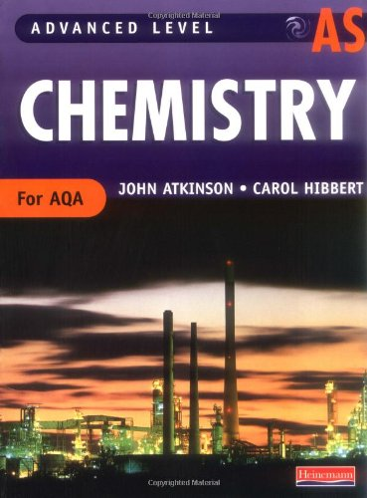

This text is written to match exactly the specification for teaching Advanced Chemistry from September 2000. There are two strands, AS and A2. The AS book is designed to meet the level required of the Advanced Secondary qualification, the A2 book helps students tackle the greater challenges of the A2 year. The accompanying resource packs have photocopiable question sheets linked to the books. These provide extra support, practice and extension questions for homework assignments, revision, and key skill development. The resource pack content is also available on customizable CD-ROM, with artwork from the books that can be projected on OHTs.