Wireframe Documentation

Job Recommender System

Revision Number: 1.0

Last date of revision: 21/12/2023

# 

# 

# Document Version Control

**Change Record**

| Date Issued | Version | Description | Author |
| --- | --- | --- | --- |
| 21/12/2023 | v1.0 | First Draft | Abraham Audu |
|  |  |  |  |
|  |  |  |  |
|  |  |  |  |
|  |  |  |  |

**Table of Contents**

**Document Version Control 2**

**1. Home Page 3**

**2. Search Jobs Page 6**

**3. Profile Page 8**

# 1. Home Page

The Job Recommender System web app has a home page with three views:

1. The user is greeted with a prompt to login or create a new account

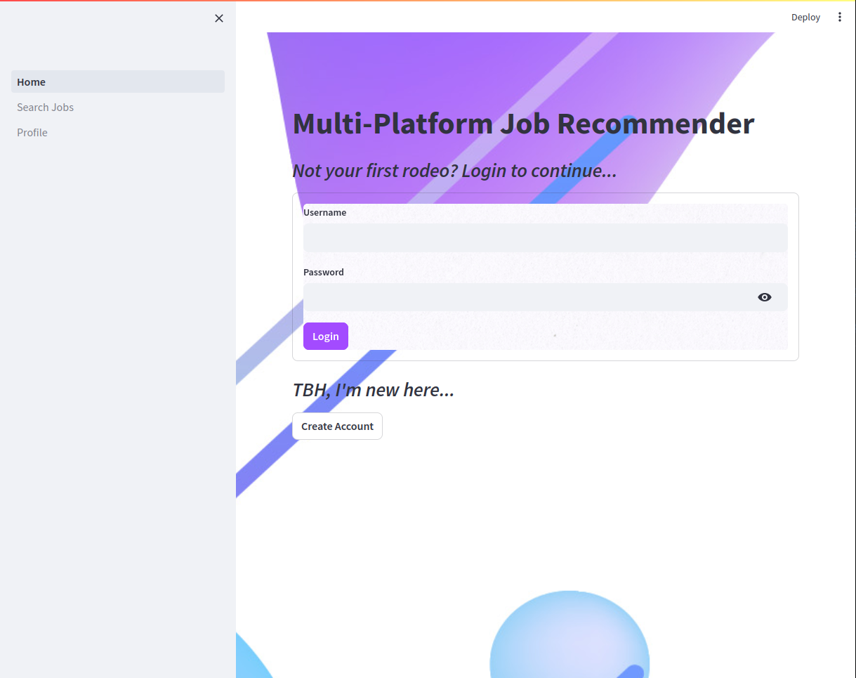

1. If the user is an admin, the admin view is loaded which allows the user trigger database setup, manually trigger job scraping and view basic database stats

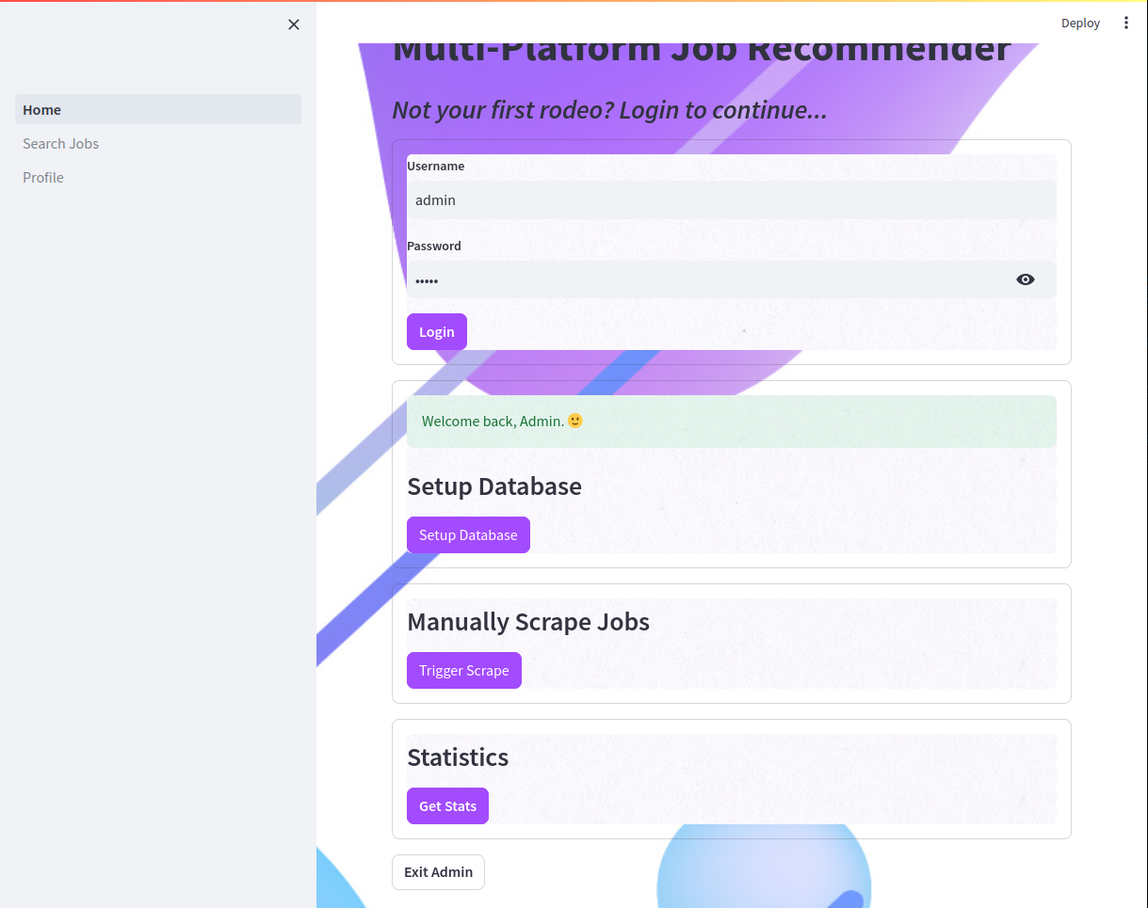

1. If the user is a regular user, the right side of the page has the navigation side bar, the middle has a quick search bar and the left has a shortcut to the profile section.

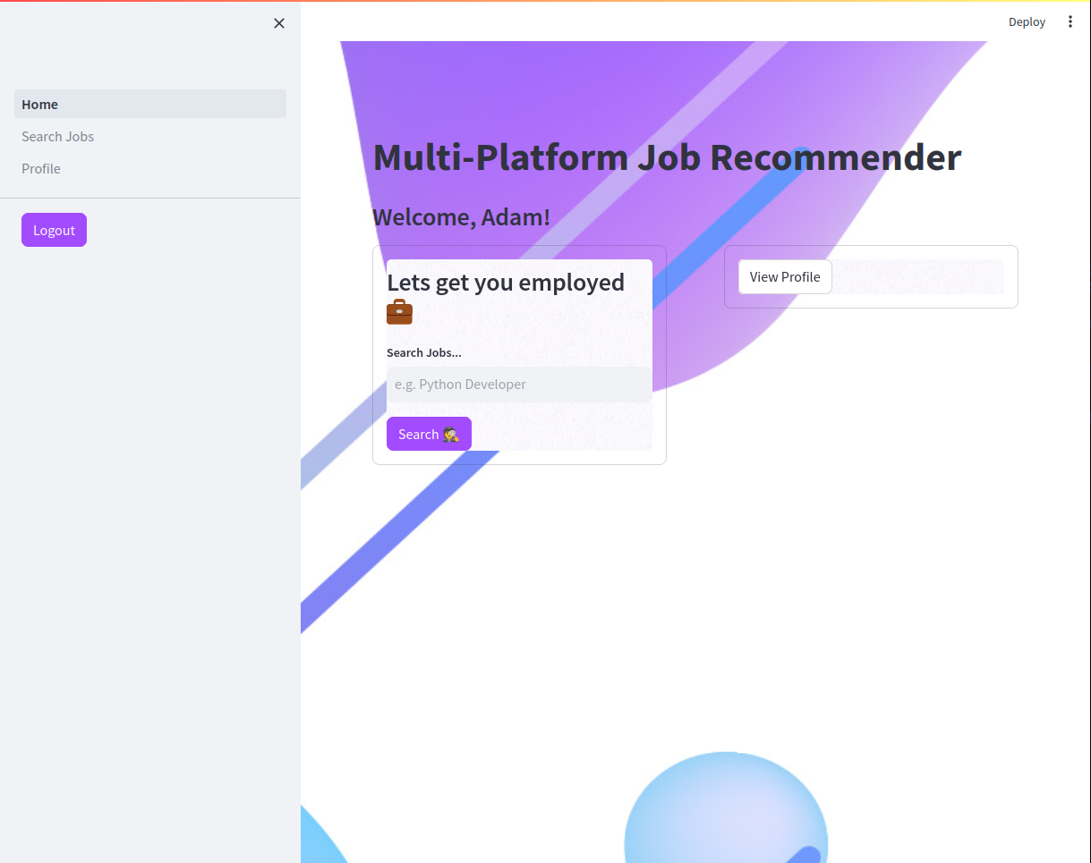

# 2. Search Jobs Page

The Search Jobs page has two views:

1. Auto-generated job recommendations when the user hasn’t made any searches

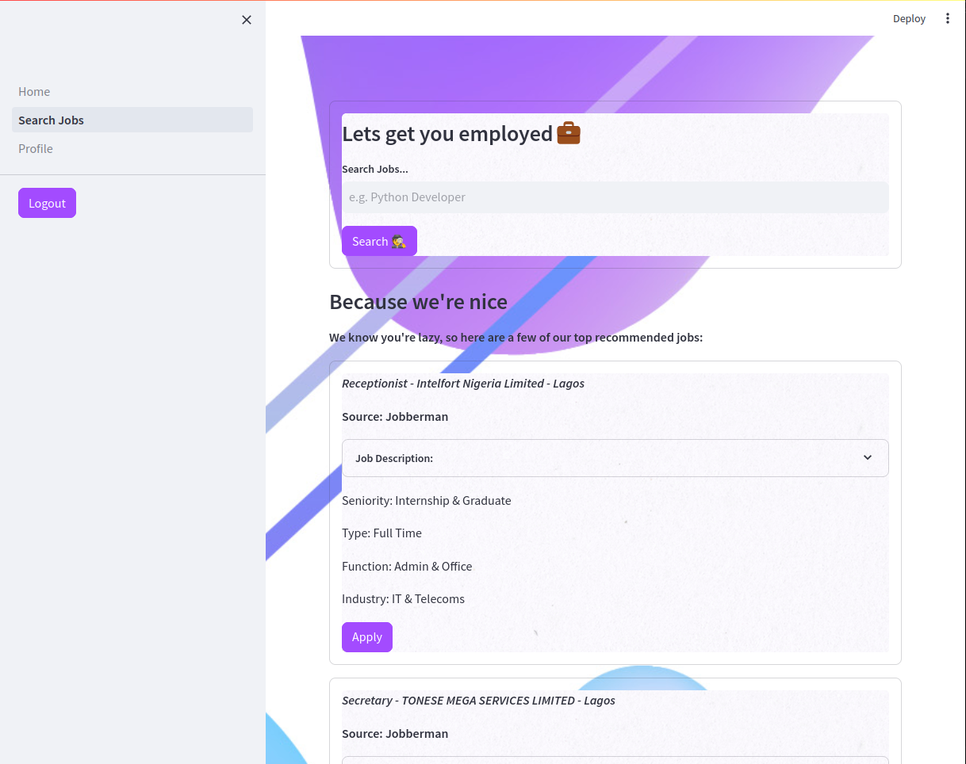

1. Top ten results after making search

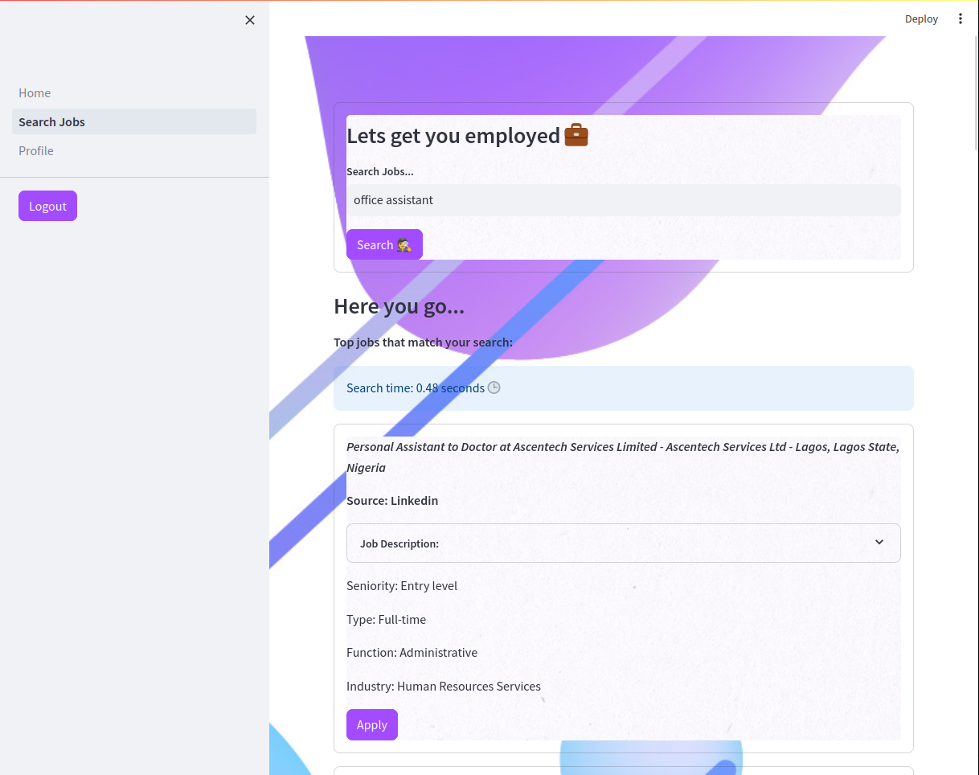

# 3. Profile Page

1. The profile page allows the user to edit their General Profile, Skills, Work History and Preferences

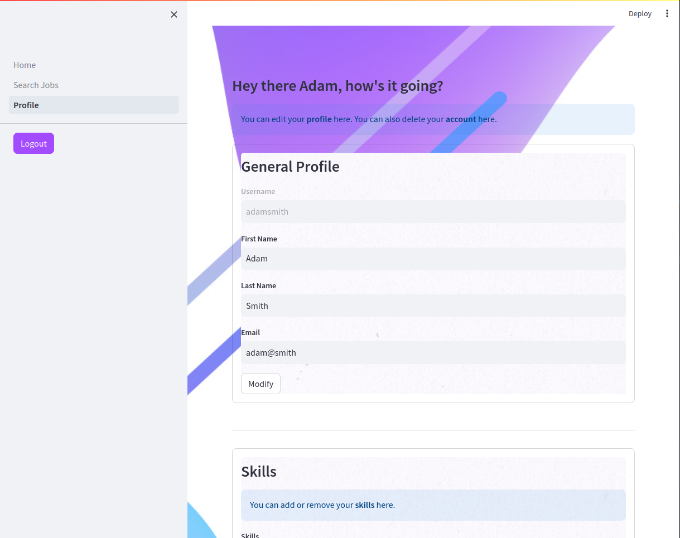

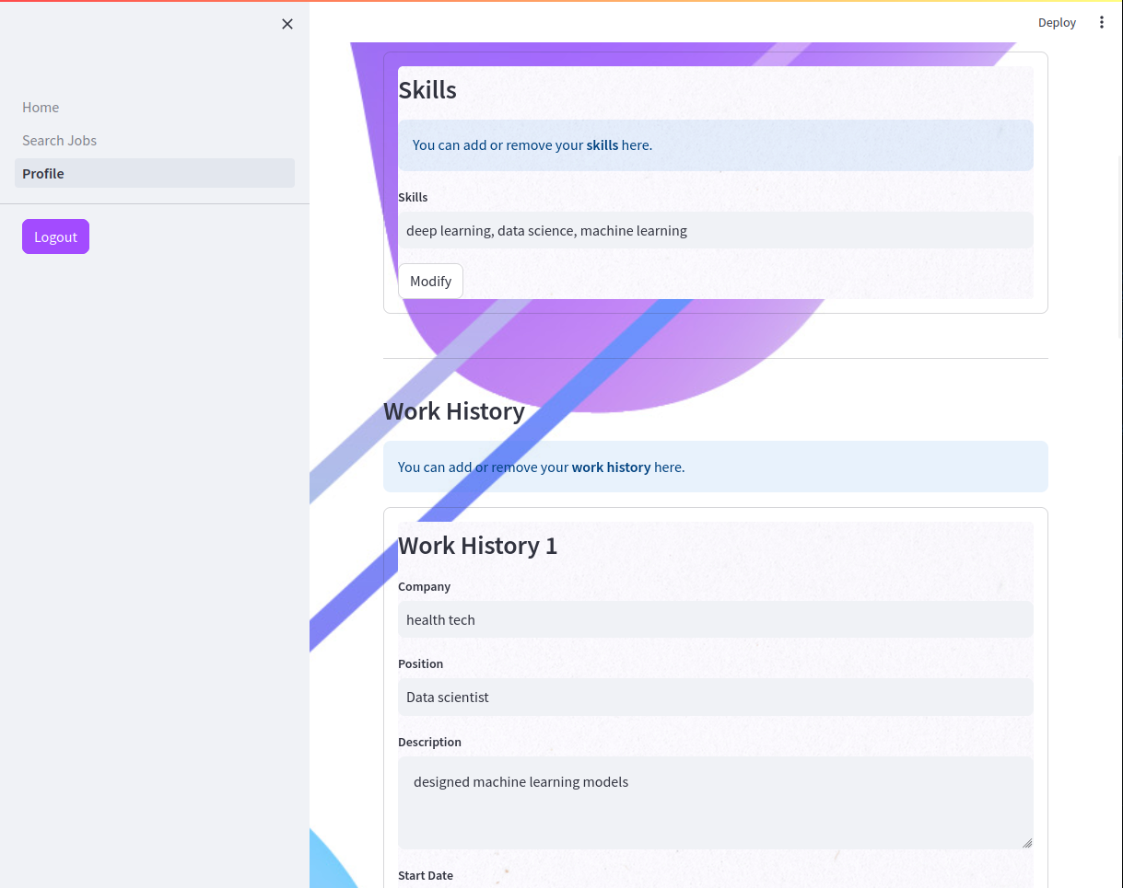

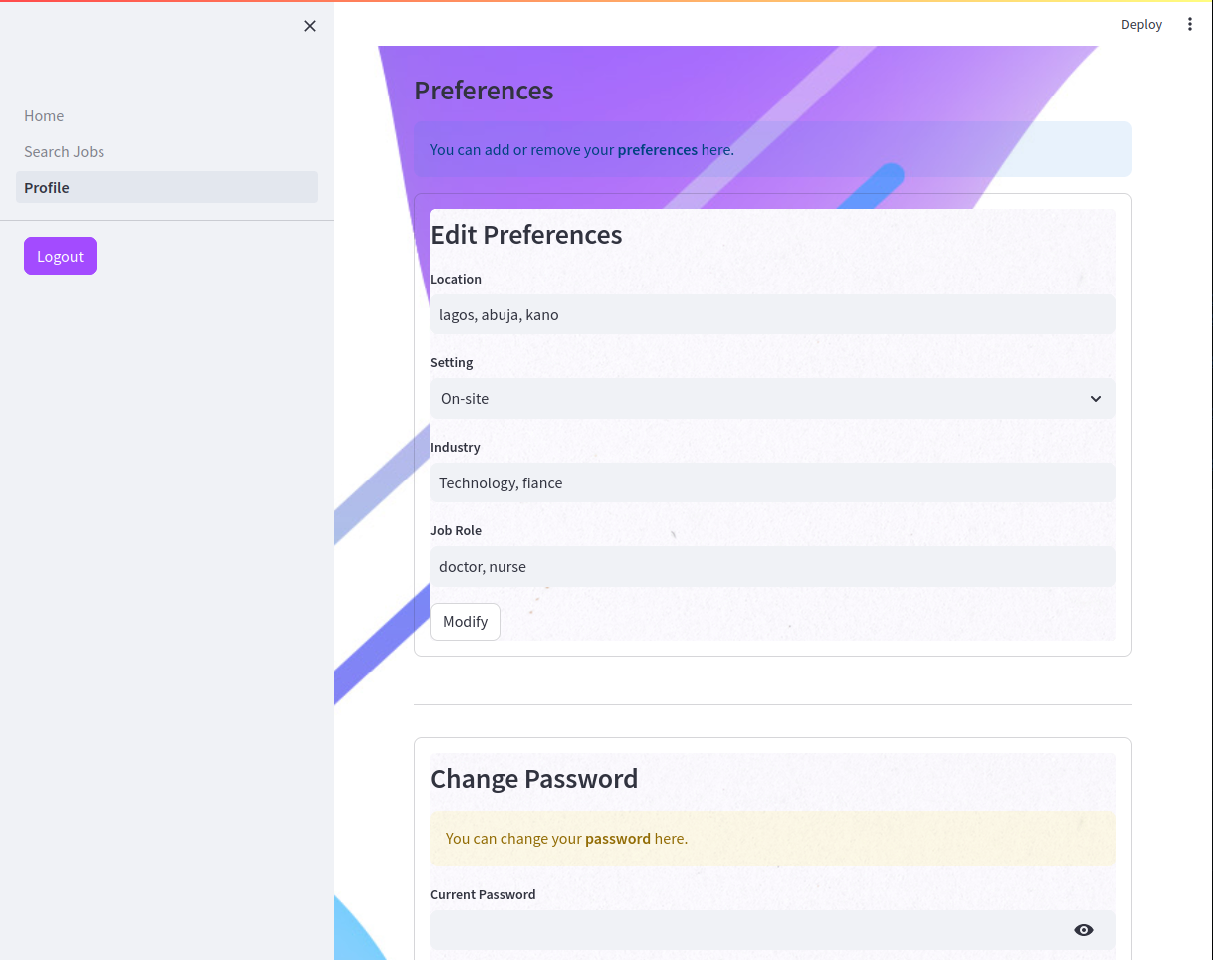

1. In addition the profile section allows the user to change their password and permanently delete their account

