Wireframe Documentation

Credit Card Default Prediction

Revision Number: 1.0

Last date of revision: 27/09/2023

# 

# 

# Document Version Control

**Change Record**

| Date Issued | Version | Description | Author |
| --- | --- | --- | --- |
| 25/09/2023 | v1.0 | First Draft | Abraham Audu |
|  |  |  |  |
|  |  |  |  |
|  |  |  |  |
|  |  |  |  |

**Table of Contents**

Document Version Control 2

**Abstract 4**

**1. Introduction 5**

1.1 Why this High-Level Design Document? 5

1.2 Scope 5

**2. General Description 5**

2.1 Product Perspective 5

2.2 Problem Statement 5

2.3 Proposed Solution 5

2.4 Further Improvements 6

2.5 Technical Requirement 6

2.6 Data Requirements 6

2.7 Tools Used 6

2.8 Constraints 6

2.9 Assumptions 6

**3. Design Details 7**

3.1a Development Process Flow 7

3.1b Deployment Process Flow 7

3.2 Event Log 7

3.3 Error Handling 8

**4. Performance 8**

4.1 Reusability 8

4.2 Application Compatibility 8

4.3 Resource Utilisation 8

4.4 Deployment 8

**5. Conclusion 8**

# 1. Landing Page

The Credit Card Default Predictor web app has a landing page with two sections:

* A user guide tab on the left, which is open by default but can be closed and reopened by the user
* The main app tab

# 2. Views

The main tab has three views as the user progresses through the use case.

## 1.1 Default

The app prompts the user to upload credit card customer data as CSV file

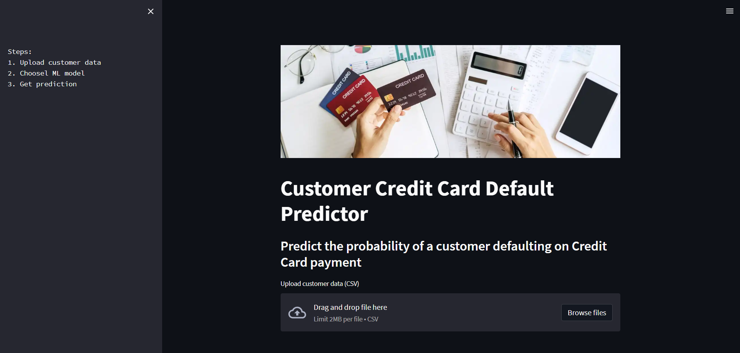

## 1.2 Data Uploaded and Validated

After uploading valid data, the option to choose a prediction model from a dropdown list and the “Predict default probability” button appears.

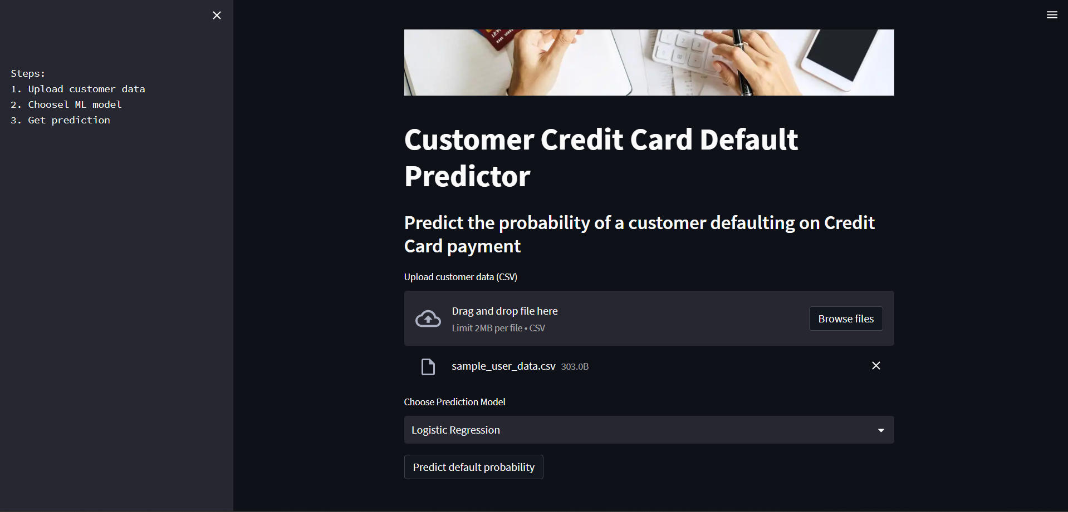

## 1.3 Prediction Made

After clicking the “Predict default probability” button, the page displays the probaility of default as well as the model prediction time and the overall runtime in separate highlighted pop-ups.

