Technical Details of Recommendation to Enter the Short-Term Rental Market

**$1,230,000 are required to convert all 41 properties but as $500,000 are committed, it is possible to convert 16 properties as short term rental. Since it is only possible to convert such low number of properties it would be beneficial if properties are of same type and cluster of properties are located in same region for efficient contracting, utilities, keep up and service. Therefore top 16 houses from Miami and Austin are to be chosen.**

**The analysis that serves as the basis of my recommendation indicates that Watershed and its client would benefit from $799663 of increased profits during the first year, and yearly profits $703663 every year thereafter if my recommendation is enacted. The initial capital investment needed to implement my recommendation would be $48,000.**

This analysis is based on financial assumptions that were confirmed by company and industry experts, but sensitivity analyses indicate that Watershed should enter the short-term rental market with their client, even if these initial assumptions need to be revised. Below, I describe the analyses I used to arrive at my conclusion, and report the results of my sensitivity analysis that assesses how expected profits and needed capital expenditure would change if my assumptions are modified.

Analysis Summary

I modeled the relationship between nightly rental price and occupancy rate for short-term rental properties using data from current short-term rentals managed by other companies and owners. I used this model to predict the short-term rental price that would maximize profits from each of Watershed’s client’s properties if it were managed as a short-term rental property. The metrics I report are based on the sum of the forecasted profits that would be gained and the forecasted capital investment that would be needed if my recommendation is followed, after the following are taken into account: (1) initial furnishing costs, (2) upkeep costs, (3) internet service fees, (4) regulatory fees, (5) hospitality charges (including key service and cleaning), (6) typical duration of stay, and (7) utilities. The details of the assumptions I used are provided below (Table 1), followed by a description of the results of my sensitivity analysis.

Analysis Assumptions and Sensitivity Analysis Ranges

Table 1

|  |  |  |  |  |  |
| --- | --- | --- | --- | --- | --- |
| **Consideration** | **Assumed Value** | **Source of Original Assumed Value** | **Minimum Value Tested** | **Maximum Value Tested** | **Rationale for Range of Values Tested** |
| Additional profit needed for a property to be considered “more profitable as a short-term rental” | $6,000 | Watershed Financial Department | $10000 | $40000 | Limit for $500,000  cash needed for  conversion |
| Cost to convert property to short-term rental (includes furnishing and decorating) | $30,000 | Watershed Marketing Department | $5000 | $50000 | 16% initial estimate,  75% initial estimate |
| Years to depreciate capital expenditures | 5 | Watershed Financial Department | 2 | 15 | realistic versus  extreme |
| Yearly upkeep | $6,000 | Watershed Marketing Department | $3000 | $12000 | +/- 50-80% initial  estimate |
| Service fees to short-term stay website (e.g. Airbnb) | 20% | Watershed Marketing Department | 10% | 40% | +/- 50-80% initial  estimate |
| Regulatory fees (taxes and potential legal fees) | 10% | Watershed Financial Department | 5% | 20% | +/- 50-80% initial estimate |
| Hospitality charges (key service, cleaning, re-stocking) | $100 | Watershed Financial Department | $20 | $250 | +/- 50-80% initial  estimate |
| Typical stay duration (days) | 3 | Watershed Marketing Department | 1 | 5 | +/- 50% initial estimate |
| Monthly utilities per property | $300 | Watershed Financial Department | $200 | $500 | +/- 50% initial estimate |

As agreed upon at the beginning of the project, some issues were NOT incorporated into the analysis, but could be incorporated in the future to help optimize short-term rental rates or to further refine projected profits (Table 2):

Table 2

|  |  |
| --- | --- |
| **Factor not included in analysis** | **Reason for exclusion from analysis** |
| Weekly or seasonal changes in rental prices/occupancy rates | Instructions from Project Manager |
| Promotions, coupons, or special events | Instructions from Project Manager |
| Loss in rental income while property is converted | Instructions from Project Manager |
| Differences in utility rates across properties | Instructions from Watershed Financial Department |

I have created a dashboard that illustrates the effects of changing these assumptions on predicted profits and required capital investment that is available to anybody on the team by request. **The minimum additional profits Watershed could earn when the assumptions were modified within the ranges described above was $ $401,000**, if all the properties that are “more profitable” as a short-term rental are converted. **The maximum additional profits Watershed could earn when the assumptions were modified within the ranges described above was $2,232,000**, if all the properties that are “more profitable” as a short-term rental are converted. The modified set of parameters associated with this minimum and maximum value are provided below (Table 3). Overall, the parameter that affected profits most was **Regulatory fees**.

Table 3

|  |  |  |
| --- | --- | --- |
| **Consideration** | **Value in Assumption Set that led to Minimum Profits** | **Value in Assumption Set that led to Maximum Profits** |
| Additional profit needed for a property to be considered “more profitable as a short-term rental” | $10000 | $40000 |
| Cost to convert property to short-term rental (includes furnishing and decorating) | $50000 | $5000 |
| Years to depreciate capital expenditures | 2 | 15 |
| Yearly upkeep | $12000 | $3000 |
| Service fees to short-term stay website (e.g. Airbnb) | 40% | 10% |
| Regulatory fees (taxes and potential legal fees) | 20% | 5% |
| Hospitality charges (key service, cleaning, re-stocking) | $250 | $20 |
| Typical stay duration (days) | 1 | 5 |
| Monthly utilities | $500 | $200 |

Predictive Modeling Details

I was provided with four types of information about short-term rentals of the same type (number of bedrooms, apartment or house, kitchen availability, unshared property) and in the same location as Watershed’s client’s 244 properties: a typical short-term nightly rental rate, the corresponding occupancy rate for the property with that rental rate, the 10th percentile nightly rental rate, and the 90th percentile nightly rental rate. When the typical rental prices were expressed in terms of percentiles relative to properties of the same type and in the same location—but not when they were analyzed as raw dollar values—they correlated linearly with occupancy rates:

**Linear Regression Line:**

y = -0.79x + 0.85  
R² = 0.52

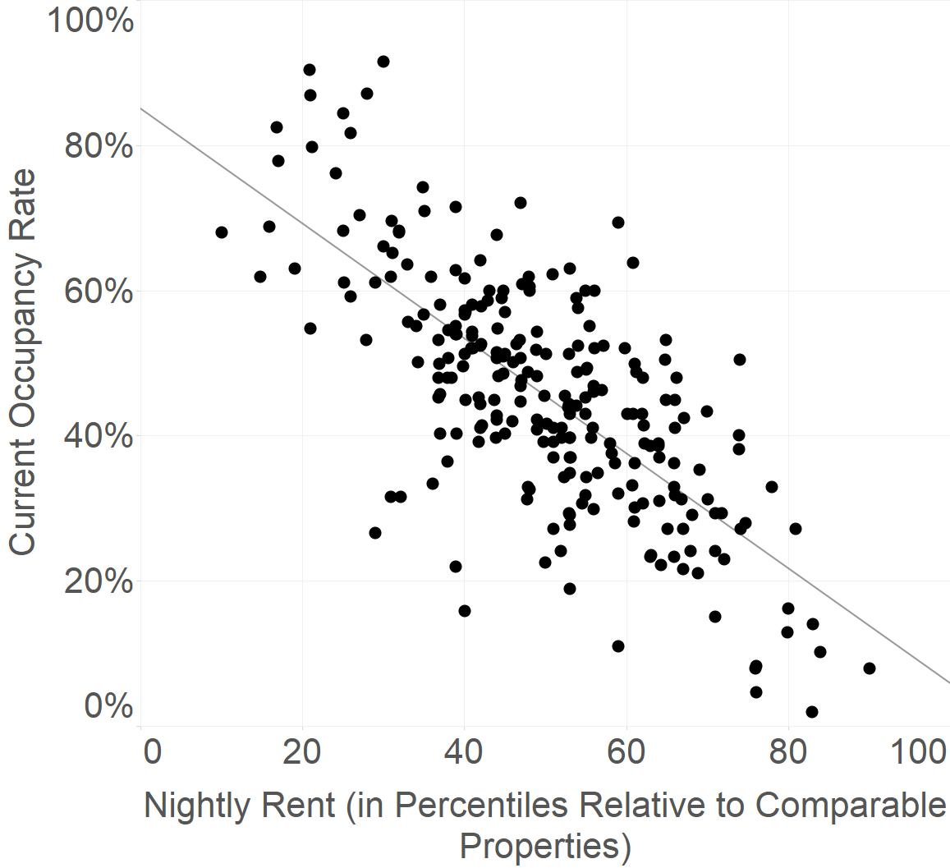

I used the parameters of the regression line and Excel’s Solver optimization function to find the rental price and occupancy rate that would maximize the profits expected from each of Watershed’s client’s 244 properties. Any optimized price below the 10th percentile rate was replaced with the 10th percentile rate, and any optimized price above the 90th percentile rate was replaced with the 90th percentile rate, in order to account for lack of data outside of these ranges in the linear model. These optimized rental rates were entered into a financial cash flow and profit model that computed the expected revenue from each property based on its projected occupancy rate, and the expected costs according to the financial assumptions described above.