Integration Runtime software installation steps
- In ADF, click on the download link for Integration Runtime software to download as shown in below screenshot
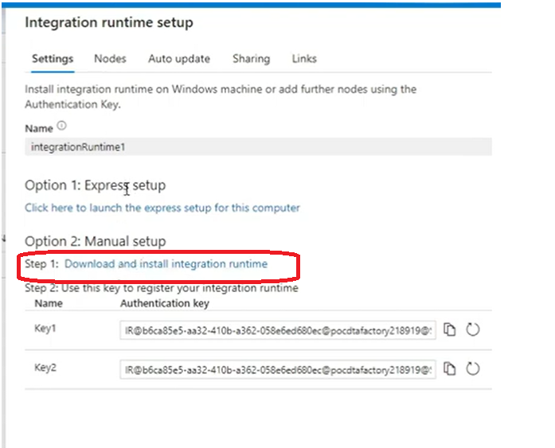
- Click on download button and select the first option to download the s/w.
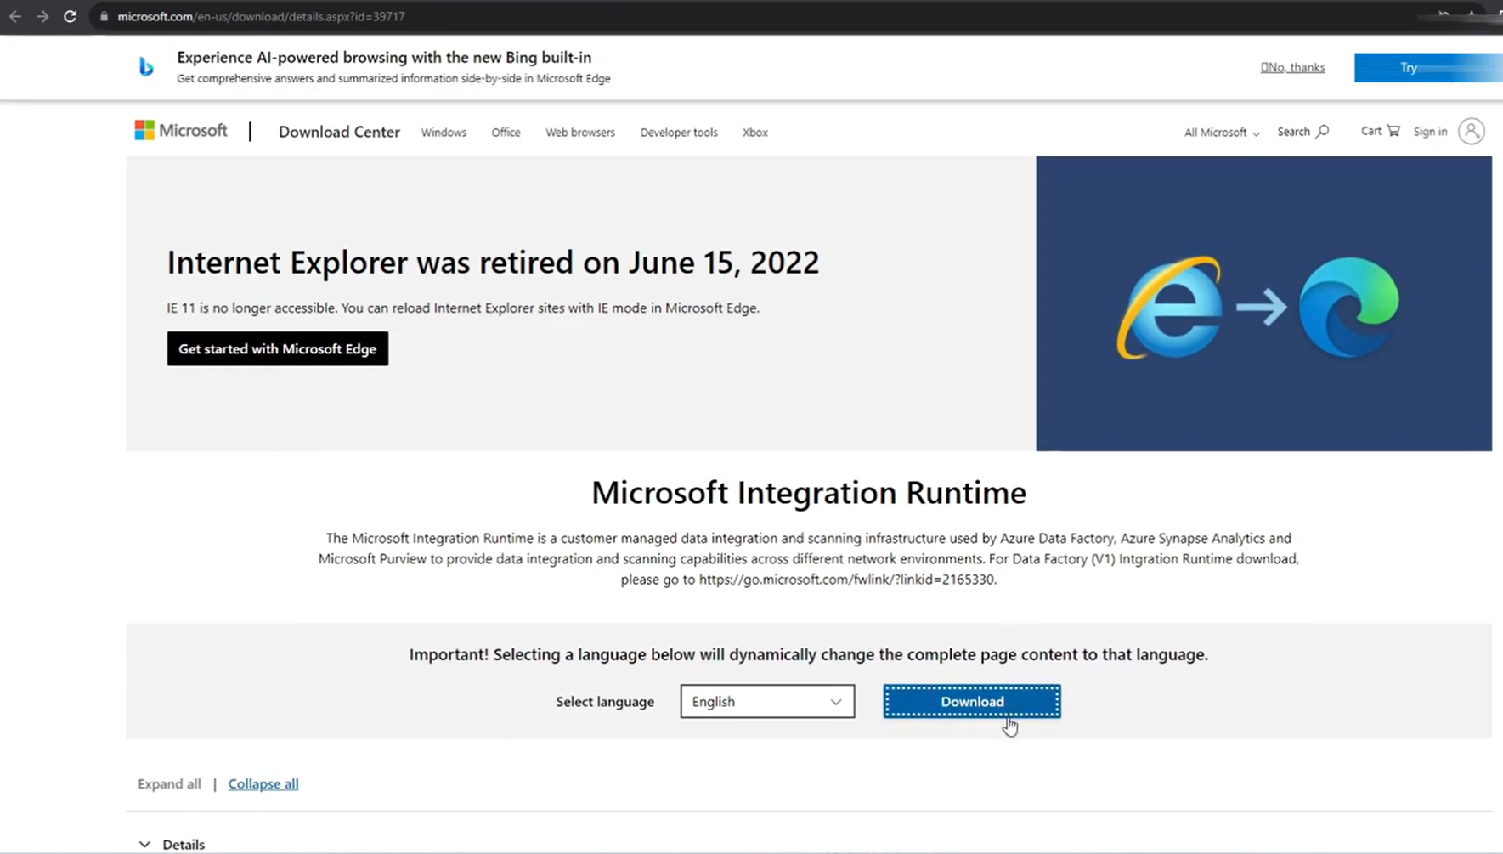
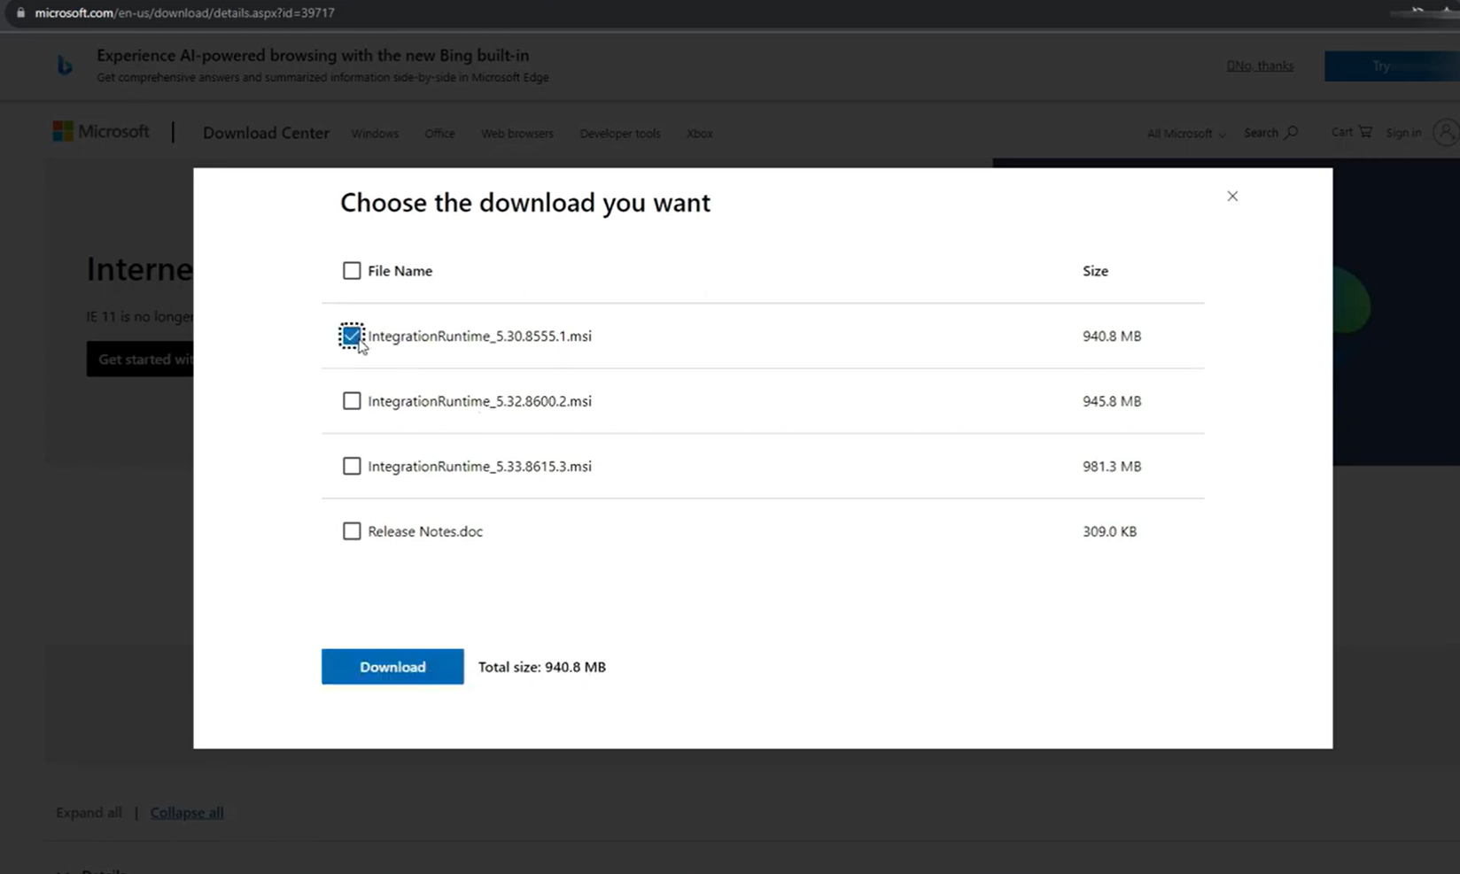
- Once the s/w is downloaded on your laptop/local machine, double click on the file to start the installation.
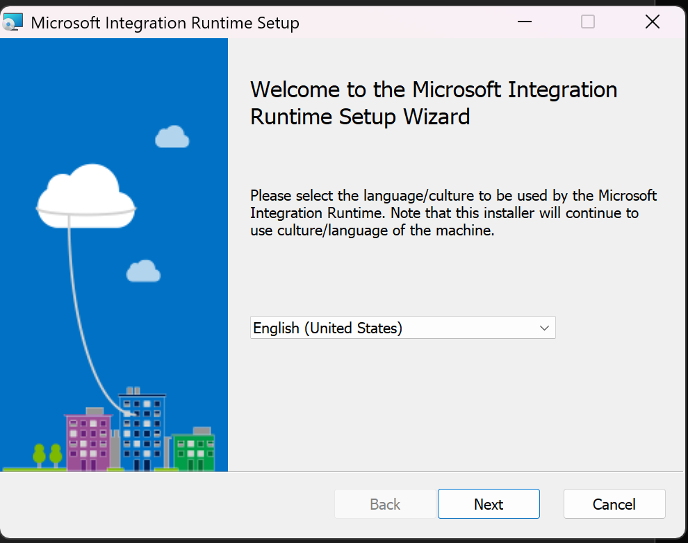
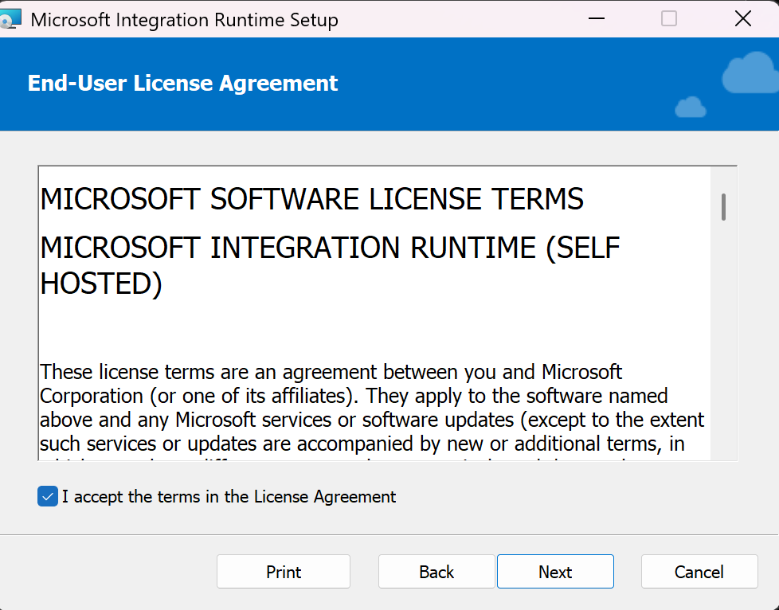
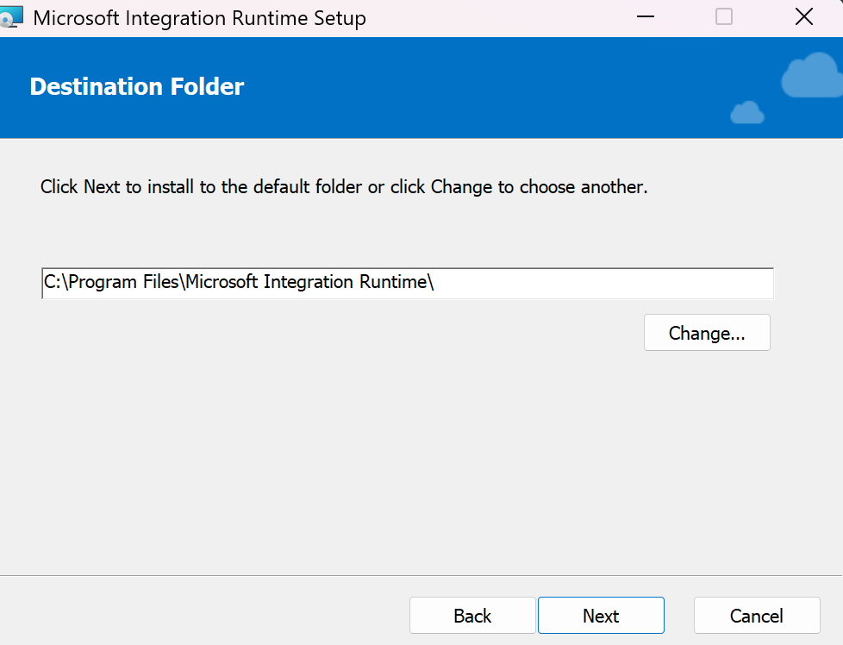
Click Install button
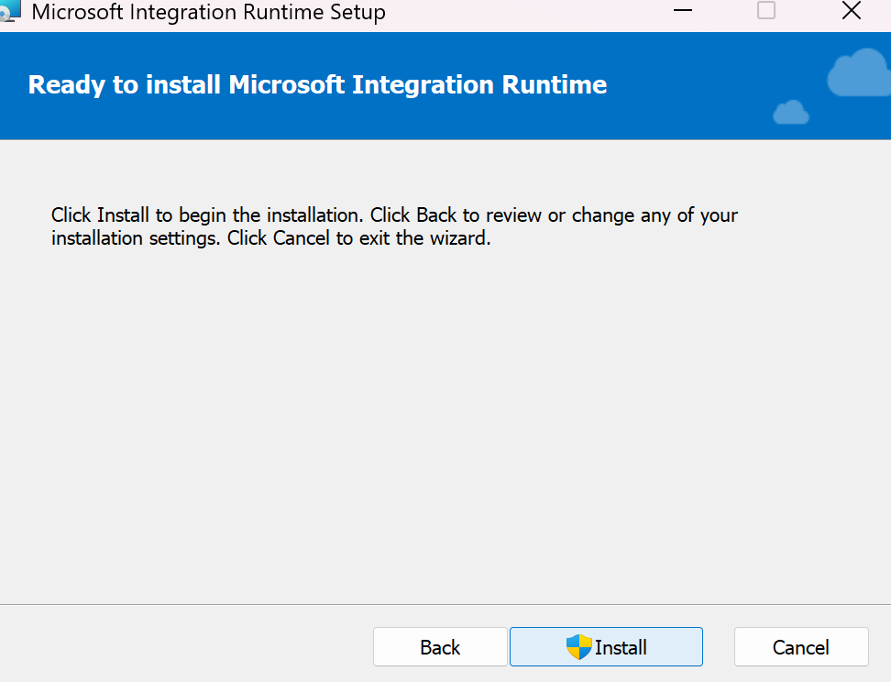
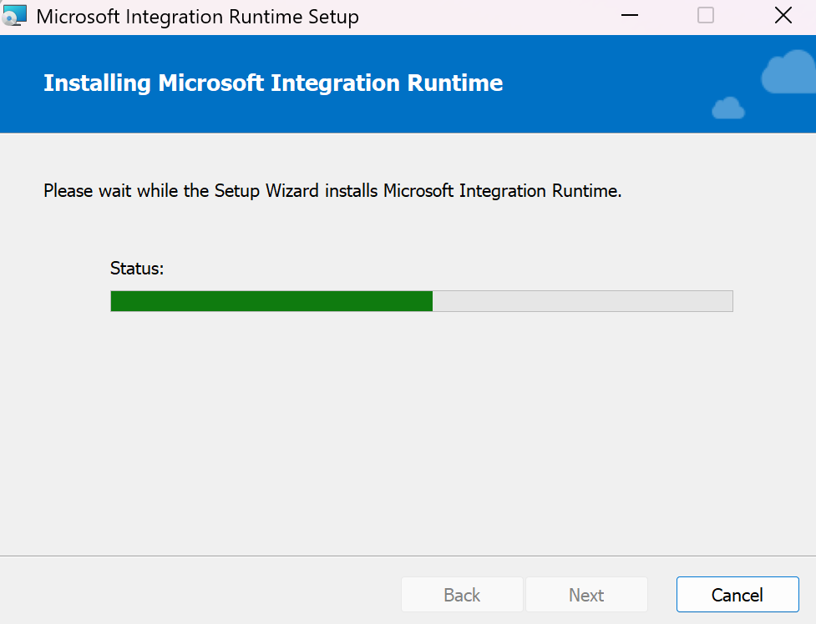
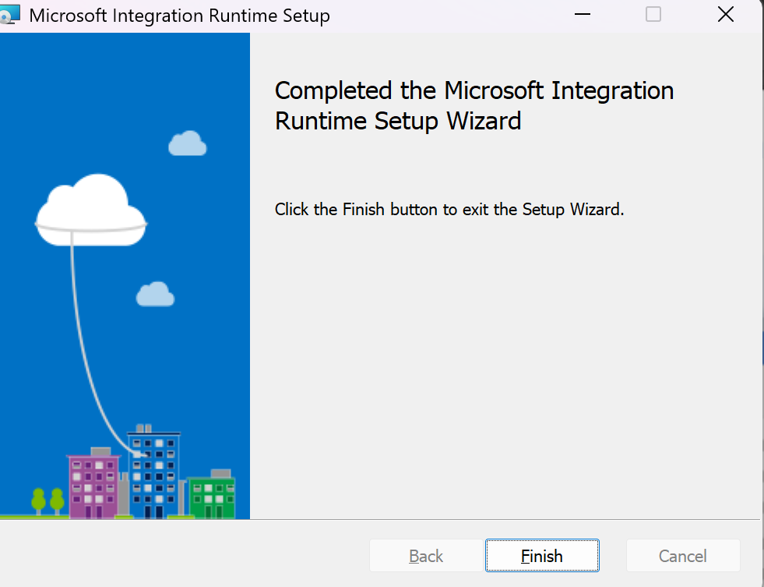
Launch the service
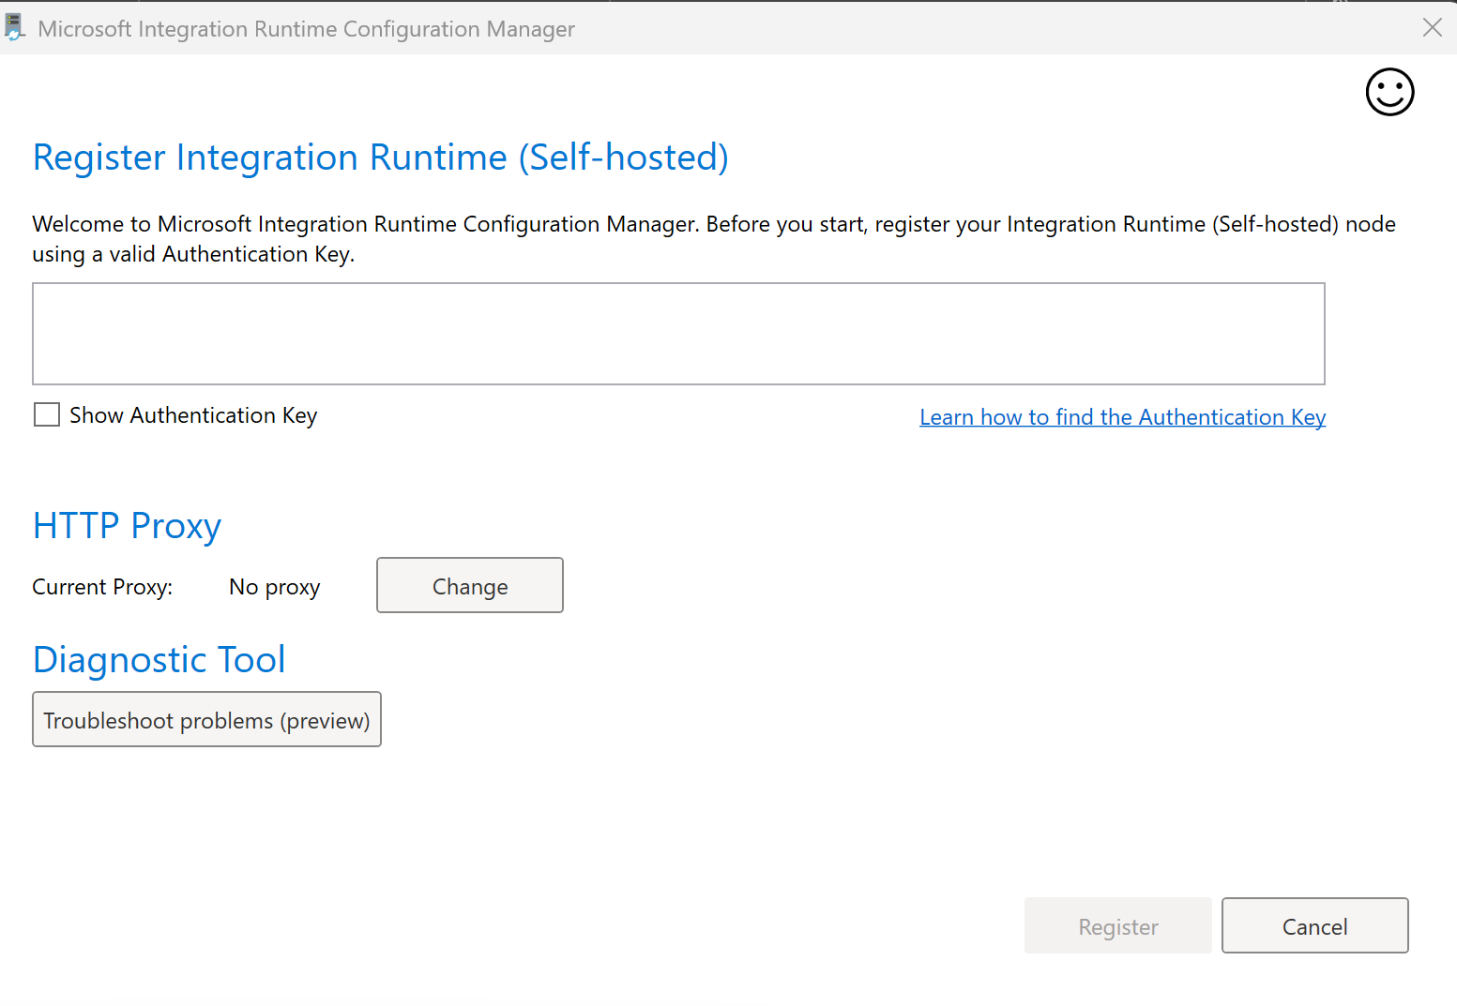
Enter the below key1 from ADF to above screen to register:
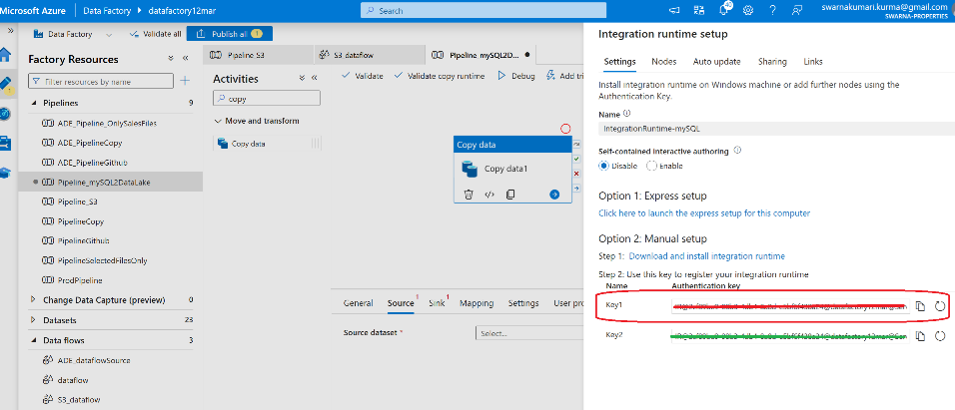
After entering the above key1 and Click Register
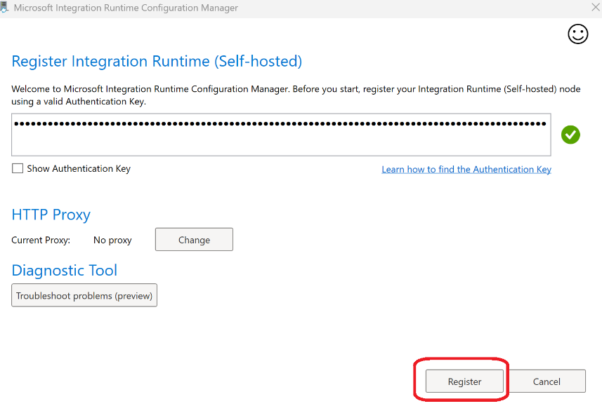
Click Finish
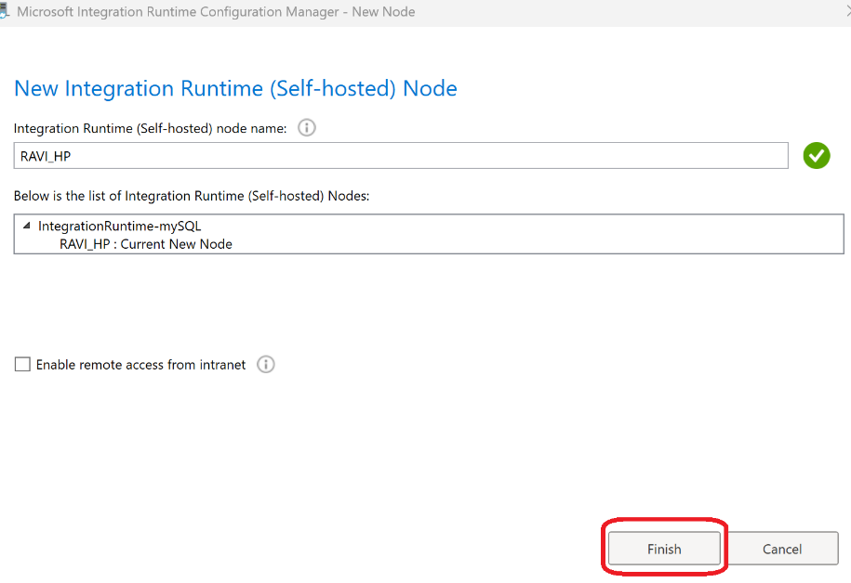
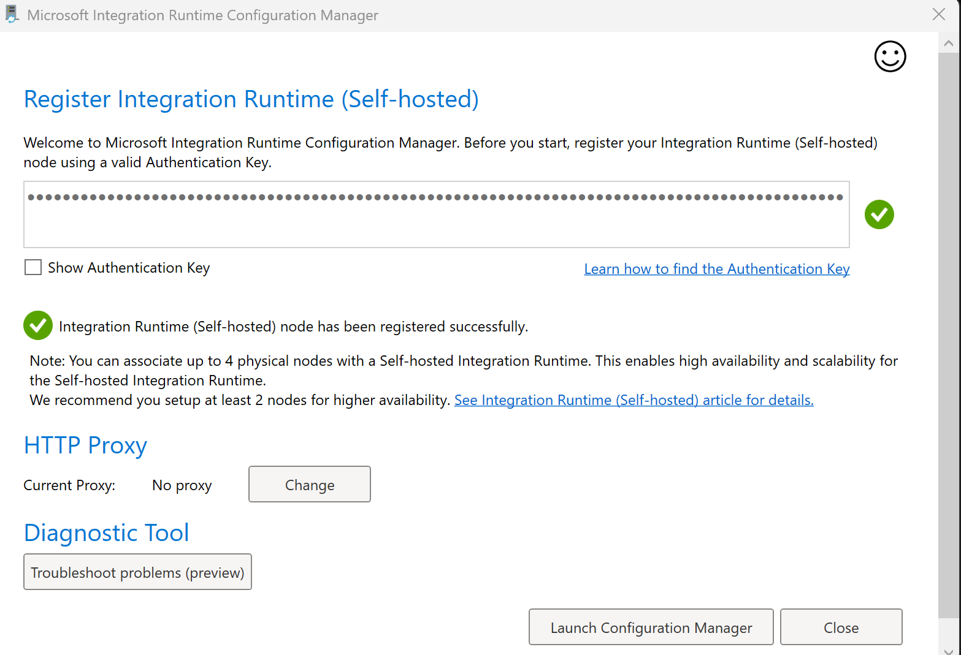
Click on “Launch Configuration Manager”
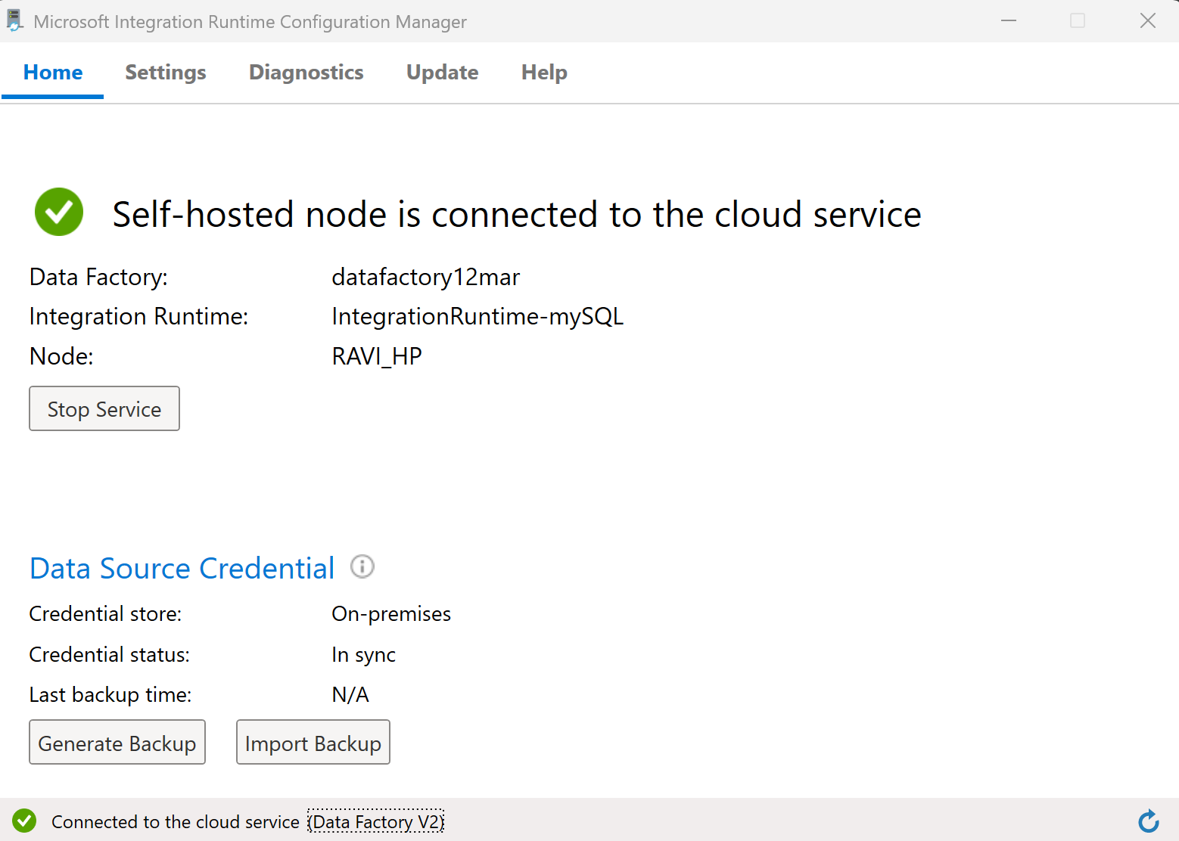
Hence “Self-Hosted node is connected”. Now go back to ADF Linked Service screen and click “close” button
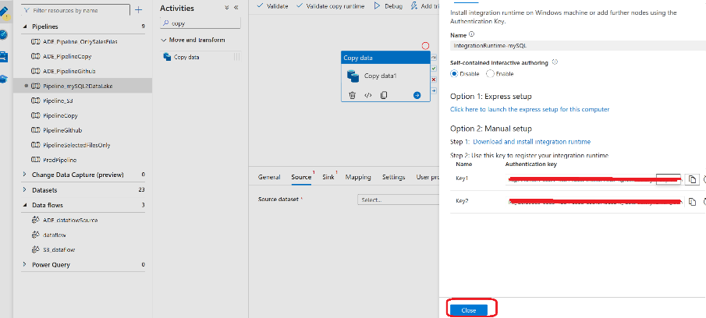
Click “refresh” option and the LS should show in Green colour as below highlighted.
x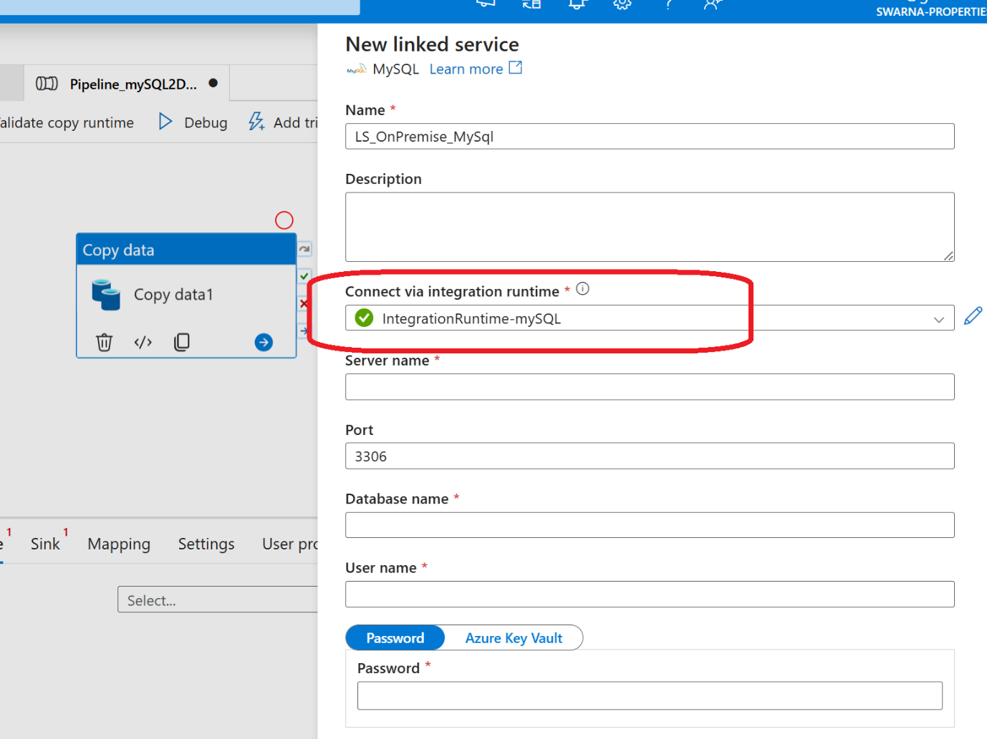
Check in Mysql workbench for below “Database -> managed connections” to fill in Linked Services of ADF
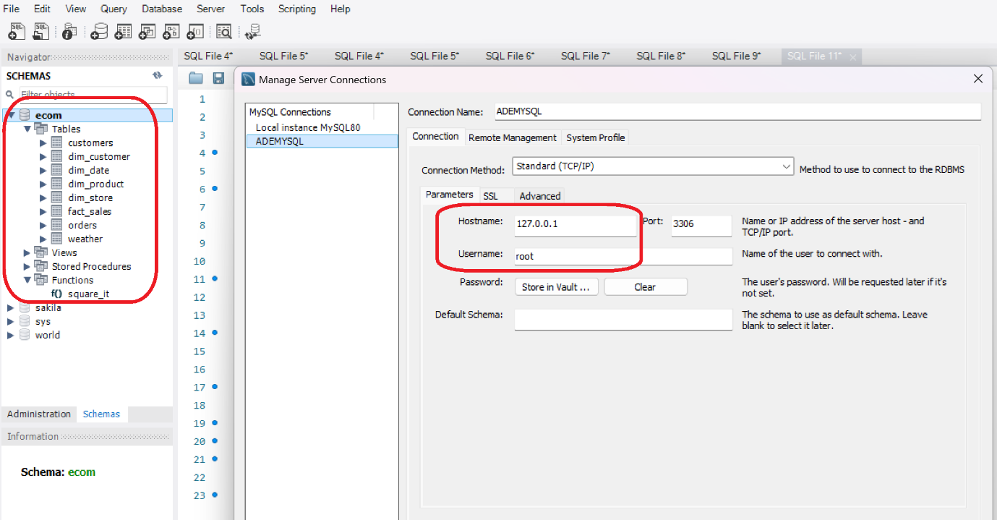

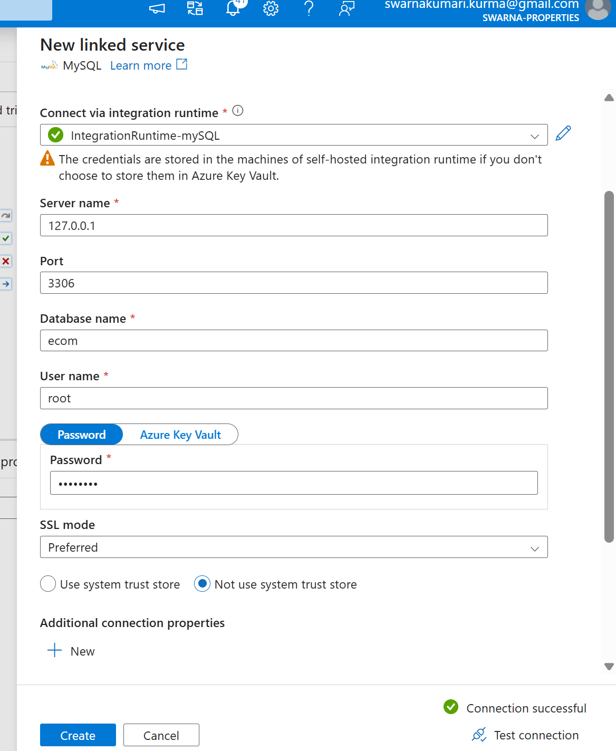
Click “Create” after “Test Connection” is successful. Finally, you will be able to see all the list of tables from database in your dropdown below:
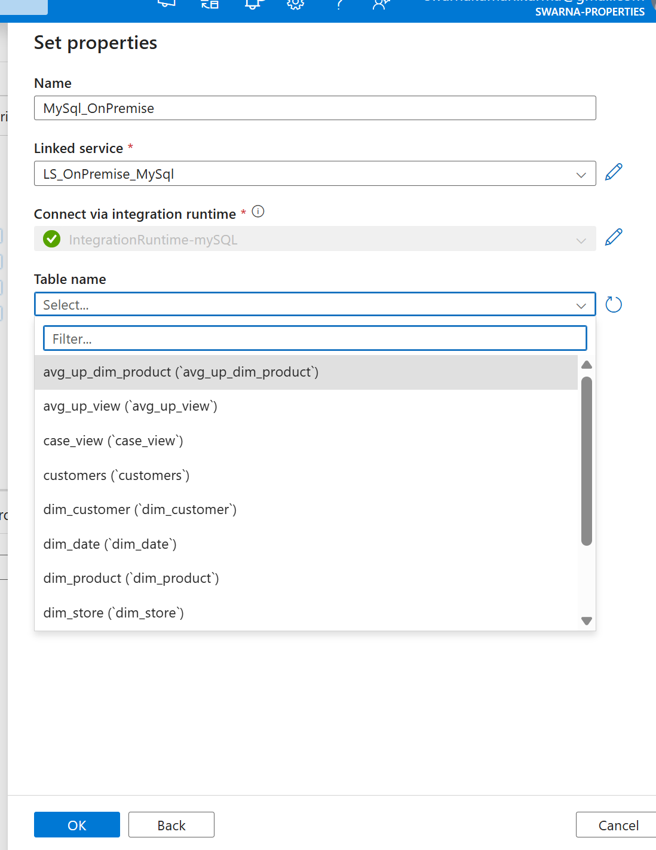
Select any one table and click OK
