Logistics Data Analyst Internship
Week 2 Report
Data Collection, Cleaning, and Preprocessing for Logistics Analysis
Dataset: Amazon Delivery Dataset (Kaggle), 43,739 real delivery records
Scenario: Last-Mile Delivery for an E-commerce Courier
Submitted by: [Your Name]
Internship Period: 09 September 2026 – 07 October 2026
Code and data: github.com/theaditisingh/logistics-last-mile-analysis (week2 folder)

1. Introduction
In Week 1 I planned a last-mile delivery analysis. In this week I started the practical work by preparing the data. Instead of creating an example dataset, I worked with a real, publicly available one: the Amazon Delivery Dataset from Kaggle, which contains 43,739 delivery records from India. I chose a real dataset because real data has real problems, and finding and fixing them is exactly the skill this task is about.
The report follows the order of the work. First I describe the dataset (Section 2). Then I explain how I audited it and what problems I found, with the number of rows affected by each (Section 3). Section 4 explains every cleaning technique, why I chose it and what it changes for the analysis. Section 5 checks the time coverage of the data, which matters for the forecasting work in later weeks. Section 6 documents the Python code, Section 7 compares the data before and after cleaning, and Section 8 reflects on how data quality affects logistics decisions.
A short summary of the outcome: out of 43,739 raw records, 40,153 (91.8%) were kept in the cleaned dataset. Eleven different kinds of problems were found; several of them could not be seen with a simple missing-value check, which I explain below.

2. Data Collection

2.1 Source
The data is the Amazon Delivery Dataset published on Kaggle (kaggle.com), a public dataset of e-commerce deliveries. I downloaded the CSV file amazon_delivery.csv and stored it unchanged in my GitHub repository (week2/data/raw). All cleaning is done by a Python script, so the raw file is never edited by hand and every change can be repeated and checked.

2.2 Dataset characteristics
Characteristic | Value
Records and columns | 43,739 rows, 16 columns (one row per delivery, 43,739 unique Order_IDs)
Time period | 2022-02-11 to 2022-04-06 (55 calendar days, of which 44 have orders)
Geography | Cities across India (store and drop-off GPS coordinates)
Target variable | Delivery_Time in minutes (mean 124.91, range 10 to 270)
Categorical variables | Weather (6 types), Traffic (4 levels), Vehicle (3 to 4 types), Area (4 types), Category (16 product types)
Numeric variables | Agent_Age, Agent_Rating, store and drop-off coordinates, Delivery_Time
Time variables | Order_Date, Order_Time, Pickup_Time (all stored as text)

Column | Raw type | Meaning | Example
Order_ID | text | Unique order code | ialx566343618
Agent_Age | integer | Age of the delivery agent | 37
Agent_Rating | decimal | Customer rating of the agent | 4.9
Store_Latitude / Longitude | decimal | GPS position of the store | 22.745, 75.892
Drop_Latitude / Longitude | decimal | GPS position of the customer | 22.765, 75.912
Order_Date | text | Date of the order | 2022-03-19
Order_Time, Pickup_Time | text | Time ordered and time picked up | 11:30:00, 11:45:00
Weather | text | Weather at delivery | Sunny
Traffic | text | Traffic level | High
Vehicle | text | Vehicle used | motorcycle
Area | text | Type of area | Urban
Delivery_Time | integer | Minutes taken to deliver | 120
Category | text | Product category | Clothing

2.3 Fit with the project scenario
The dataset fits the Week 1 scenario because it contains the information needed for the KPIs I selected: delivery time (average delivery time and on-time rate), vehicle and area (fleet and cost comparisons) and order and pickup times (demand pattern). It does not contain cost data, so the cost per delivery KPI will need an assumption in later weeks, which I will state clearly when it is used.

3. Initial Data Audit

3.1 How the audit was done
Before changing anything I examined the raw file in several ways: info() and describe() for types and ranges, isnull().sum() for missing values, value_counts() on every categorical column, duplicated() on full rows and on Order_ID, pattern checks on the time columns, range checks on coordinates, age and rating, and cross-column checks (for example, pickup time compared with order time, and the distance between store and customer). Using only isnull() would have found just two problems, so the extra checks were necessary.
Basic statistics of the raw numeric columns already pointed to problems:
Column | Min | Max | Mean | What looks wrong
Agent_Age | 15 | 50 | 29.57 | Minimum of 15 is below working age
Agent_Rating | 1 | 6 | 4.63 | Maximum of 6.0 on a 5-point scale
Store_Latitude | -30.9 | 30.9 | 17.2 | Negative and zero values (India is at about 8 to 37 N)
Store_Longitude | -88.4 | 88.4 | 70.7 | Negative and zero values (India is at about 68 to 98 E)
Delivery_Time | 10 | 270 | 124.91 | Plausible range

3.2 Problems found
The table lists every problem found, with how it was detected and how many rows it affects. The counts for later steps are measured after earlier steps (for example, the coordinate problems are counted after the corrupted records were removed), so rows are not counted twice.
Problem | How it was detected | Rows | Treatment
Extra spaces in text labels | Traffic == 'Low' returned 0 rows | 43,739 (Traffic), 42,601 (Area), 40,181 (Vehicle) | Strip spaces
Missing values stored as text "NaN" | value_counts() showed 'NaN ' as a category | 91 | Convert to real missing values
Misspelt label 'Metropolitian' | value_counts() on Area | 32,698 | Correct spelling
Corrupted records (weather, traffic and order time missing) | Missing-value pattern analysis | 91 | Remove
Impossible agent age (15) | Range check; all fall inside the corrupted records | 38 | Removed with corrupted records
Impossible rating (6.0) and suspicious rating 1.0 | Range check; all fall inside the corrupted records | 53 and 38 | Removed with corrupted records
Missing agent rating | isnull().sum() | 54 | Fill with median
Pickup earlier than order time | Pickup minus order was −1,425 to −1,435 minutes | 828 | Repair (pickup was after midnight)
Negative store latitude | Range check; distance to customer was thousands of km | 156 | Repair (remove sign)
Store coordinates equal to 0 | Range check | 3,495 | Remove (cannot be repaired)
Delivery times above the IQR limit | IQR rule | 74 | Keep and flag
Duplicates | duplicated() and Order_ID check | 0 | None needed
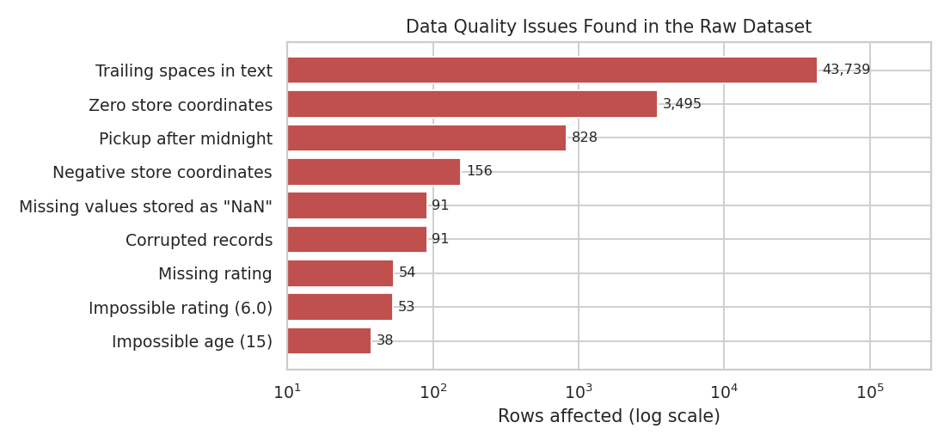
Figure 1: Data quality issues found in the raw dataset (log scale)
Two points about this audit stand out. First, the isnull() check only reported 54 missing ratings and 91 missing weather values. The 91 missing traffic values and 91 missing order times were hidden, because they were stored as the text "NaN " and not as real missing values. Second, the most serious problems (sign errors and zero values in the coordinates, and pickup times after midnight) are not missing values at all; they are wrong values that look like normal numbers.

4. Cleaning Methodology
The steps were done in a fixed order, because each step depends on the one before. For example, text must be cleaned before categories can be counted, and the corrupted records must be removed before computing the median used to fill missing ratings.

4.1 Text cleaning and label standardisation
Almost every value in Traffic, Vehicle and Area carried an invisible space at the end (for example, 'Low ' instead of 'Low'). The effect is serious: before cleaning, the filter Traffic == 'Low' returned 0 rows; after cleaning it returns 14,999. Any report, dashboard or model that filters by traffic level would have silently returned nothing. I removed the spaces from all text columns, converted the text "NaN" to real missing values, made the capitalisation consistent (for example 'motorcycle' became 'Motorcycle'), and corrected the spelling 'Metropolitian' to 'Metropolitan'. After this step each categorical column has clean labels: Traffic has 4 (Low, Medium, High, Jam), Weather 6, Area 4 and Vehicle 3 to 4.

4.2 Duplicate check
I checked for exact duplicate rows (0), repeated Order_IDs (0 of 43,739), and rows identical in everything except the ID (0). No duplicates were found, so nothing was removed. I think it is still worth reporting, because a duplicate check is a standard step and a clean result is a useful finding: it means that no delivery is counted twice in the KPIs.

4.3 Corrupted records and impossible values
While checking age and rating I noticed that the impossible values were not spread randomly. There are 91 records where weather, traffic and order time are all missing together, and these same 91 records contain every impossible agent age and rating in the file: 38 records with age 15 and rating 1.0, and 53 records with age 50 and rating 6.0 (a rating that does not exist on a 5-point scale). The pattern suggests an error in the data export, not real agents.
I removed these 91 records (0.21% of the data). Imputing them was not sensible, since three important fields are missing, including traffic and weather, which are the main drivers of delivery time that I want to analyse. Removing the records also solved the age and rating problems at once: afterwards ages are between 20 and 39, and ratings are between 2.5 and 5. A side effect is that all 15 bicycle deliveries were in these records, so bicycle no longer appears as a vehicle type.

4.4 Missing values
After the corrupted records were removed, the only column with missing values was Agent_Rating (54 rows, 0.13%). I filled them with the median rating (4.7) and not with the mean (4.635). The reason is that ratings are strongly skewed to the left (skewness -1.79), because most agents have high ratings and a few have low ones, so the median is the more typical value. With only 0.13% missing, the choice has almost no effect on the results, but a simple, documented method is easier to explain than a complex one. After this step the dataset has no missing values (0 remaining).

4.5 Dates and times
Order_Date, Order_Time and Pickup_Time were text. I converted them to proper date-time values by combining the date with each time, which allows calculating the preparation time (pickup minus order) and extracting the hour and day of week. I used an explicit format (YYYY-MM-DD) and not automatic guessing, so day and month cannot be confused.
This revealed a hidden problem: 828 orders had a pickup time earlier than the order time, and the average preparation time came out as -17.3 minutes. Looking closer, all of them were orders placed at 23:xx and picked up at 00:xx, so the pickup happened after midnight on the next day, and the data only stores the time without a date. These are not errors in the business sense, so deleting them would have been wrong; it would also have removed late-night orders only and biased the data. I added one day to the pickup time for these rows. Afterwards the preparation time takes only three values (5, 10, 15 minutes) with an average of 9.99 minutes.
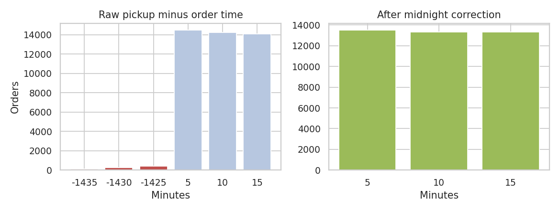
Figure 2: Pickup minus order time, before and after the midnight correction

4.6 GPS coordinates
Coordinates are essential for distance and route analysis, so I checked them against the geography of India and against each other (store and customer should be close together).
- Negative latitude (sign error): 156 stores had a negative latitude, which places them in the southern hemisphere. The customer positions for the same orders were normal. The median distance between store and customer for these rows was 5,021 km, which is impossible for a delivery. After taking the absolute value the median became 9 km and the maximum 20.9 km, matching the rest of the data. This confirmed that it was a sign error that could be repaired.
- Zero coordinates (placeholder): 3,495 stores (8.0% of the dataset) had latitude and longitude of exactly 0, a point in the Atlantic Ocean. There is no way to know the true location, so these rows cannot be repaired. What makes them dangerous is that their store-to-customer distance still looks normal (median 9.4 km, maximum 20.4 km), so a check on distance would not catch them; only checking the coordinates does. I removed these rows because location-based work (zones, clustering, route planning in Week 4) would be wrong for them.
To make sure that removing these rows did not bias the results, I compared the average delivery time of the removed rows (123 minutes) with that of the other rows (125.1 minutes). The difference of about two minutes is small, so the removal did not noticeably change the data. After the repairs, all store and customer coordinates lie inside India (latitude 9.96 to 31.05, longitude 72.77 to 88.56).
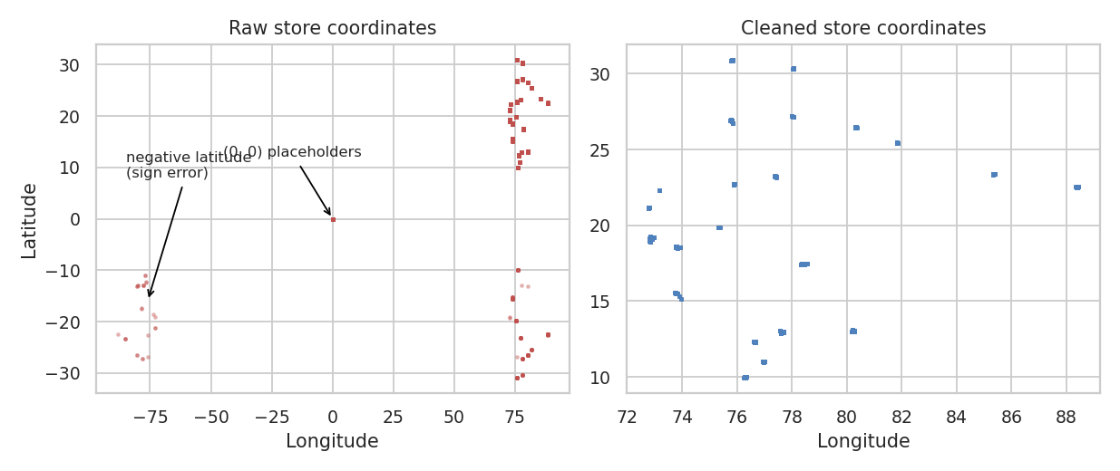
Figure 3: Store coordinates before and after cleaning

4.7 Distance and outlier detection
I calculated the distance between store and customer with the haversine formula, which accounts for the curve of the earth. On the raw coordinates the average distance was 38.6 km and the maximum 19,692.7 km, with 188 deliveries over 50 km, all caused by the coordinate errors described above. The median (9.2 km) was unaffected, which is a good example of why the median is more robust than the mean. After cleaning, the distances are between 1.47 and 20.97 km with an average of 9.71 km. The IQR rule gives an upper limit of 27.09 km, and no delivery exceeds it, so no distance outliers remain: the extreme distances were all errors, not real long deliveries.
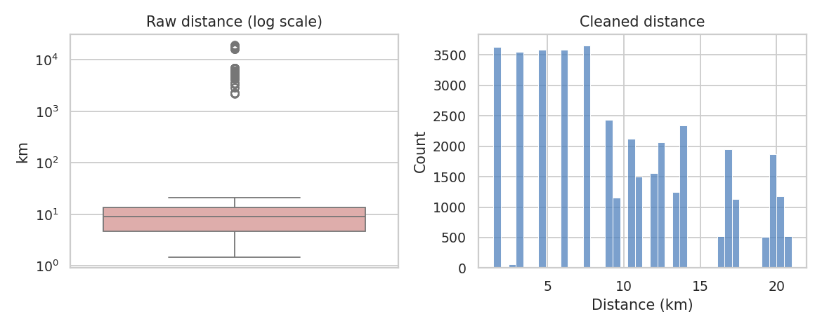
Figure 4: Distance before cleaning (log scale) and after cleaning
For the delivery time I used two outlier rules. The IQR rule (limits -15 and 265 minutes) flagged 74 deliveries, and the z-score rule (more than 3 standard deviations from the mean) flagged 0. All flagged values are exactly 270 minutes, the maximum in the data, and 69 of the 74 happened in a traffic jam. These are long but believable deliveries (4.5 hours in a jam), not recording errors, and delivery time is the variable I want to predict, so changing it would distort the results. I kept them, and added a flag column (long_delivery_flag) so they can be examined or excluded later. Capping them at the IQR limit would have changed each value by only 5 minutes.
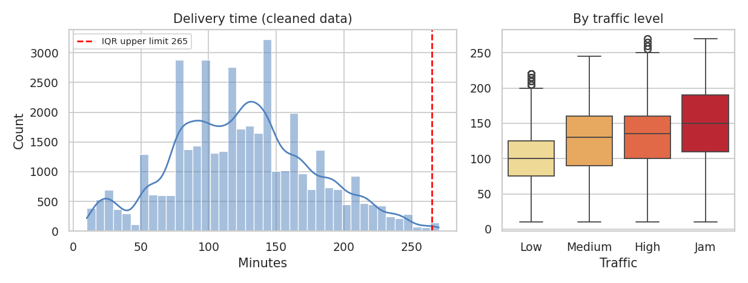
Figure 5: Delivery time distribution with the IQR limit, and delivery time by traffic level

4.8 Feature engineering
I created new columns that will be useful in the analysis: distance_km, prep_minutes, hour, day_of_week, is_weekend (27.5% of orders), part_of_day, and is_peak_hour. The peak hours were chosen from the data and not guessed: they are the hours with more orders than the hourly average, which are 17:00 to 23:00. I did not create a speed feature (distance divided by delivery time), because it is calculated from the target variable and would leak the answer into a prediction model.

4.9 Encoding and normalisation
- Encoding: Traffic has a natural order, so I used ordinal encoding (Low 0, Medium 1, High 2, Jam 3). Weather, Vehicle, Area, Category and part of day have no order, so I used one-hot encoding with the first category dropped to avoid duplicated information.
- Min-Max scaling: applied to Agent_Age, Agent_Rating, distance_km and prep_minutes to bring them to a 0 to 1 range. This matters for distance-based methods (K-Means, KNN), where a large-scale column like distance would otherwise dominate.
- Z-score standardisation: also created for distance (mean 0, standard deviation 1), useful for linear models and when comparing variables.
Tree-based models do not need scaling, so I save two files: the cleaned data with readable labels (40,153 rows, 22 columns) and the model-ready file (40,153 rows, 44 columns).
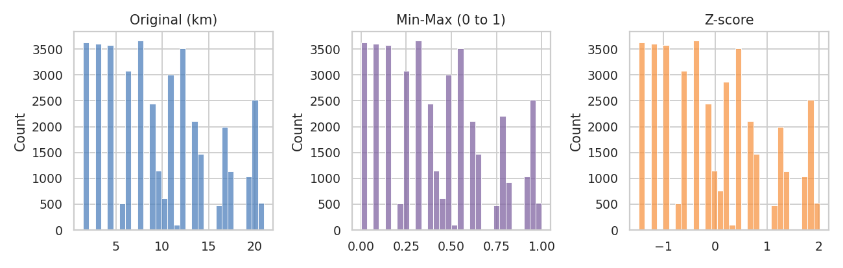
Figure 6: Distance before and after scaling (the shape stays the same, only the scale changes)

5. Time Coverage Check for Forecasting
Because later weeks include forecasting, I also checked the time structure of the cleaned data. Time series methods need regular, complete data, so gaps matter.
- Missing days: The data spans 55 calendar days (2022-02-11 to 2022-04-06) but only 44 days contain orders. 11 days are missing: 19 to 28 February (a block of 10 days) and 22 March. These days have no orders at all, which is more likely a data collection gap than a real stop in business. For forecasting I will have to decide whether to model the periods separately or fill the gap, and I will state which approach I use.
- Daily volume: On days with data there are on average 912.6 orders per day (minimum 682, maximum 1067). The first week averages 723 orders per day against 955 after the gap, so there is a level change as well. Averages for each weekday are similar (877 to 935 orders), so there is no strong weekday pattern.
- Hourly pattern: Orders follow a clear daily rhythm: no orders between 01:00 and 07:00, a morning period (08:00 to 11:00) of about 1,700 to 1,800 orders per hour, a lull from 12:00 to 16:00 of about 650 to 820 per hour, and an evening peak from 17:00 to 23:00 of about 3,900 to 4,300 orders per hour. The evening hours alone hold most of the demand, which will be the main seasonal pattern for the forecasting model.
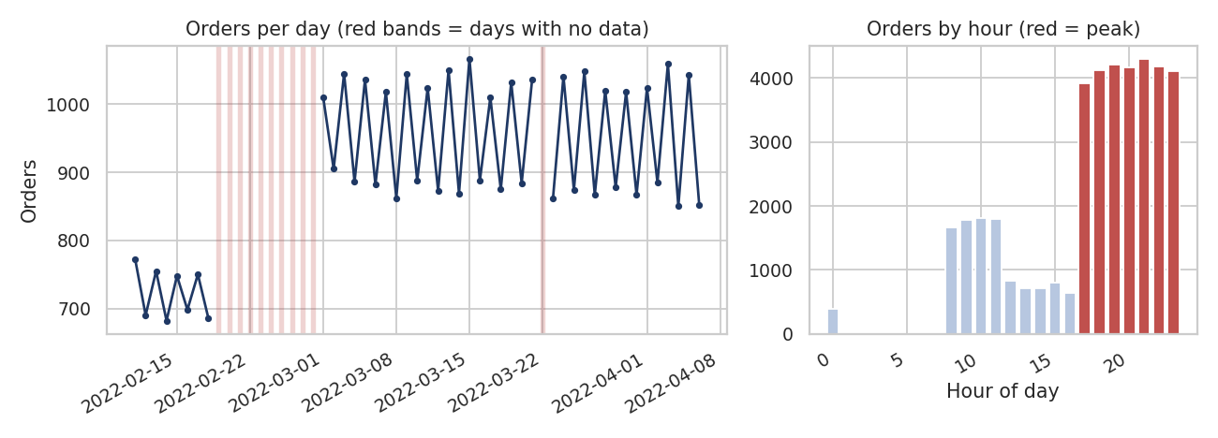
Figure 7: Orders per day (red bands show days without data) and orders per hour

6. Python Code Documentation
The complete script is in the repository (week2/data_cleaning_pipeline.py). The main steps are shown here.

6.1 Loading and auditing
raw = pd.read_csv('week2/data/raw/amazon_delivery.csv')
df = raw.copy()

print(raw.info())
print(raw.describe())
print(raw.isnull().sum()) # only finds 54 + 91, not the hidden 'NaN ' text
print(raw['Traffic'].value_counts()) # reveals labels such as 'Low ' and 'NaN '
print((raw['Traffic'] == 'Low').sum()) # 0, because the value is 'Low '
print(raw.duplicated().sum(), raw['Order_ID'].duplicated().sum())

6.2 Text cleaning
text_cols = ['Weather', 'Traffic', 'Vehicle', 'Area', 'Category']
for c in text_cols + ['Order_Time']:
df[c] = df[c].str.strip() # remove invisible spaces
df = df.replace('NaN', np.nan) # text 'NaN' -> real missing value

for c in text_cols:
df[c] = df[c].str.title() # consistent capitalisation
df['Area'] = df['Area'].replace({'Metropolitian': 'Metropolitan'})

print((df['Traffic'] == 'Low').sum()) # now 14,999

6.3 Corrupted records
corrupt = df['Weather'].isna() & df['Traffic'].isna() & df['Order_Time'].isna()
print(corrupt.sum()) # 91
print(df.loc[corrupt, ['Agent_Age', 'Agent_Rating']].value_counts()) # ages 15 / 50, ratings 1.0 / 6.0
df = df[~corrupt].copy()

6.4 Missing values
median_rating = df['Agent_Rating'].median() # 4.7
df['Agent_Rating'] = df['Agent_Rating'].fillna(median_rating)
print(df.isnull().sum().sum()) # 0

6.5 Date and time, midnight correction
df['Order_Date'] = pd.to_datetime(df['Order_Date'], format='%Y-%m-%d')
day = df['Order_Date'].dt.strftime('%Y-%m-%d')
df['order_dt'] = pd.to_datetime(day + ' ' + df['Order_Time'])
df['pickup_dt'] = pd.to_datetime(day + ' ' + df['Pickup_Time'])

prep = (df['pickup_dt'] - df['order_dt']).dt.total_seconds() / 60
midnight = prep < 0 # 828 orders placed at 23:xx, picked up at 00:xx
df.loc[midnight, 'pickup_dt'] += pd.Timedelta(days=1)
df['prep_minutes'] = (df['pickup_dt'] - df['order_dt']).dt.total_seconds() / 60

6.6 Coordinates and distance
neg = (df['Store_Latitude'] < 0) | (df['Store_Longitude'] < 0)
zero = (df['Store_Latitude'] == 0) | (df['Store_Longitude'] == 0)

# repair sign errors, then remove placeholders that cannot be repaired
df.loc[neg, ['Store_Latitude', 'Store_Longitude']] = df.loc[neg, ['Store_Latitude', 'Store_Longitude']].abs()
df = df[~(df['Store_Latitude'] == 0) & ~(df['Store_Longitude'] == 0)].copy()

def haversine(lat1, lon1, lat2, lon2):
lat1, lon1, lat2, lon2 = map(np.radians, (lat1, lon1, lat2, lon2))
a = np.sin((lat2-lat1)/2)**2 + np.cos(lat1)*np.cos(lat2)*np.sin((lon2-lon1)/2)**2
return 2 * 6371 * np.arcsin(np.sqrt(a))

df['distance_km'] = haversine(df['Store_Latitude'], df['Store_Longitude'],
df['Drop_Latitude'], df['Drop_Longitude']).round(2)

6.7 Outliers
dt = df['Delivery_Time']
q1, q3 = dt.quantile([0.25, 0.75])
lo, hi = q1 - 1.5 * (q3 - q1), q3 + 1.5 * (q3 - q1) # -15 and 265
iqr_out = dt > hi # 74 rows, all exactly 270
z = (dt - dt.mean()) / dt.std()
print(iqr_out.sum(), (z.abs() > 3).sum()) # 74 and 0
df['long_delivery_flag'] = iqr_out.astype(int) # flag, do not change the target

6.8 Features, encoding and scaling
df['hour'] = df['order_dt'].dt.hour
df['is_weekend'] = df['order_dt'].dt.dayofweek.isin([5, 6]).astype(int)
hourly = df['hour'].value_counts()
peak_hours = hourly[hourly > hourly.mean()].index # 17 to 23, chosen from the data
df['is_peak_hour'] = df['hour'].isin(peak_hours).astype(int)

m = df.copy()
m['Traffic_code'] = m['Traffic'].map({'Low': 0, 'Medium': 1, 'High': 2, 'Jam': 3})
m = pd.get_dummies(m, columns=['Weather', 'Vehicle', 'Area', 'Category', 'part_of_day'], drop_first=True)
num_cols = ['Agent_Age', 'Agent_Rating', 'distance_km', 'prep_minutes']
m[[c + '_scaled' for c in num_cols]] = MinMaxScaler().fit_transform(m[num_cols])
m['distance_z'] = StandardScaler().fit_transform(m[['distance_km']])

7. Results: Before and After Cleaning
Measure | Before | After | Change
Rows | 43,739 | 40,153 | −3,586 (8.2%)
Rows with a hidden missing value (text 'NaN') | 91 | 0 | Fixed
Missing values (real) | 145 | 0 | Fixed
Traffic == 'Low' returns (rows, after text cleaning) | 0 | 14,999 | Labels now match
Pickup before order (rows) | 828 | 0 | Fixed (midnight)
Average preparation time (min) | -17.3 | 9.99 | Realistic
Average distance (km) | 38.6 | 9.71 | Realistic
Maximum distance (km) | 19,692.7 | 20.97 | Errors removed
Agent age range | 15 to 50 | 20 to 39 | Valid
Agent rating range | 1 to 6 | 2.5 to 5 | Valid
Average delivery time (min) | 124.91 | 125.1 | Unchanged

The last row is important for the quality of the cleaning: the average delivery time is 124.91 minutes before and 125.1 minutes after, so the cleaning corrected the errors without changing the variable I want to analyse. About 91.8% of the data was kept.
A first look at the cleaned data shows the relationships that the next weeks will examine. Delivery time has a positive correlation with traffic level (0.35), distance (0.28), agent age (0.26) and hour (0.16), and a negative correlation with agent rating (-0.31); preparation time has almost none (-0.01). Average delivery time rises from 101.4 minutes in low traffic to 147.9 minutes in a jam. One finding that I want to investigate in Week 3 is that Semi-Urban deliveries take 238.7 minutes on average, compared with 104.5 to 129.8 minutes in other areas, although there are only 138 such deliveries.
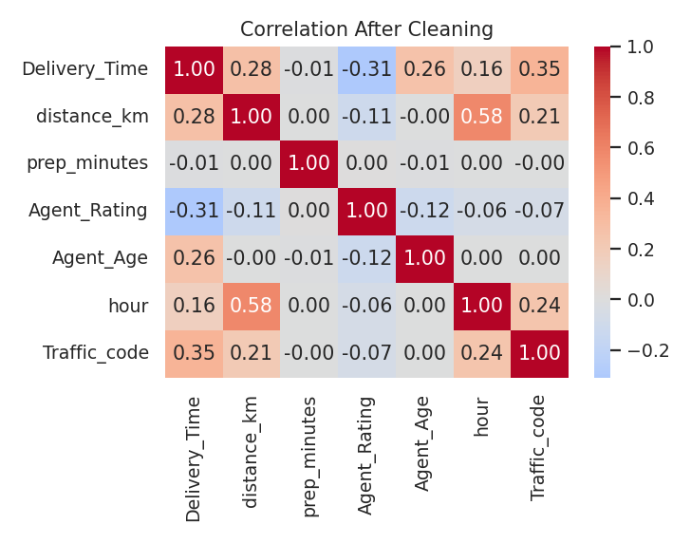
Figure 8: Correlation between numeric variables after cleaning

8. Reflection: Impact of Data Quality on Logistics Decisions
The audit showed me that data problems can be invisible and still very costly. Using actual numbers from this dataset:
- Wrong averages lead to wrong plans. The raw average distance was 38.6 km, nearly four times the true 9.71 km, because of 188 records with sign errors in the store coordinates. Fuel, cost per km and rider capacity planned from this number would be badly wrong.
- Silent filter failures. Because of trailing spaces, a report of "low traffic deliveries" would show zero rows instead of 14,999. Nobody would see an error message, only an empty result.
- Errors that look normal. The 3,495 stores at coordinates (0, 0) had normal-looking distances, so only a coordinate check found them. In a routing or zone analysis they would have been placed in the middle of the ocean.
- False performance results. The 38 records with rating 1.0 were the lowest ratings in the data (the lowest valid rating is 2.5) and would have been at the top of any "worst agents" list, though the records were corrupted.
- Mistaken process conclusions. 828 pickups looked as if they happened before the order. Anyone treating that as an error would delete late-night orders, which are part of the busiest period of the day.
My main learning is that cleaning is not only about removing bad rows. For each problem I had to decide whether to repair, remove, fill or keep, based on evidence from the data, and record the reason. Of the eleven problems, five were repaired (spaces, hidden NaN text, spelling, midnight pickups and sign errors), two groups of records were removed (corrupted records and zero coordinates), one was filled (missing ratings) and one was kept and flagged (long deliveries).

9. Limitations
- I cannot check the data against the original source system, so the causes of some problems (for example the 91 corrupted records) are assumptions based on patterns in the data.
- Removing the 3,495 rows with zero coordinates reduced the data by 8.0%. I checked that it did not change the average delivery time, but some other pattern could still be affected.
- The distance variable takes only 80 different values and the stores group into about 67 locations, which suggests that the coordinates were rounded or generated. Distances are straight-line (haversine), not road distances, so real travel distance is longer.
- The Area value 'Other' (1,051 rows) is not explained in the dataset, and Semi-Urban has only 138 rows, so results for these groups need care.
- The eleven missing days (a block of ten from 19 to 28 February, plus 22 March) limit time series methods and will need an explicit decision in the forecasting stage.

10. Conclusion and Next Steps
I audited a real dataset of 43,739 deliveries, found and documented eleven data quality issues with the number of rows affected by each, and applied cleaning methods chosen from evidence: repairing sign errors and midnight pickups, removing corrupted and unrepairable records, filling a small number of missing ratings, and keeping and flagging real extreme values. The cleaned dataset has 40,153 rows and no missing values, the average delivery time was not altered by the cleaning, and every step is repeatable with one Python script.
In Week 3 I will use the cleaned data for exploratory analysis and visualisation, including how delivery time depends on traffic, weather, area and time of day, and a time-based analysis of order volume. In Week 4 I will build a prediction model for delivery time, forecast daily order volume with a time series method, and test optimisation ideas.

References
- Amazon Delivery Dataset, Kaggle (kaggle.com). Public dataset of e-commerce deliveries (amazon_delivery.csv).
- pandas documentation: missing data, to_datetime, str accessor, drop_duplicates (pandas.pydata.org).
- scikit-learn documentation: preprocessing, MinMaxScaler and StandardScaler (scikit-learn.org).
- Tukey, J. W. (1977). Exploratory Data Analysis. Addison-Wesley (IQR outlier rule).
- Sinnott, R. W. (1984). Virtues of the Haversine. Sky and Telescope, 68(2), 159 (distance formula).

