Logistics Data Analyst Internship
Week 3 Report
Advanced Data Analysis and Visualization in Logistics
Dataset: Amazon Delivery Dataset (Kaggle), 40,153 cleaned delivery records
Scenario: Last-Mile Delivery for an E-commerce Courier
Submitted by: [Your Name]
Internship Period: 09 September 2026 – 07 October 2026
Code and data: github.com/theaditisingh/logistics-last-mile-analysis (week3 folder)

1. Introduction
This report analyses the cleaned delivery data from Week 2: 40,153 real deliveries over 44 days. The goal of this week is to move from clean data to understanding. I wanted to find out what drives delivery time and cost, when and where the process is under pressure, and how the daily pattern of orders behaves over time, because the next week includes forecasting. I used Python (pandas, scipy, statsmodels, matplotlib and seaborn) to calculate descriptive statistics, run statistical tests, fit a regression, analyse the time series and create 15 visualisations. For each chart I explain why I chose it, show the code and give the numbers behind the interpretation.
The main findings are summarised here and explained in the rest of the report:
- Grocery is a different service. Grocery orders (6.1% of orders) are delivered in 26.5 minutes on average against 131.5 minutes for all other categories. Category is the largest single factor in the data, and it comes only from this one category.
- Traffic and time of day move together. Traffic level is almost completely determined by the hour (97.8% of orders in each hour share one traffic level). Delivery time rises from 101.4 minutes in low traffic to 147.9 minutes in a jam, and the on-time rate falls from 92.4% to 52.7%.
- Two kinds of days alternate. Days alternate strictly between All-day days (about 984 orders, 110.7 min average delivery time) and Evening-only days (about 841 orders, 142 min). The 2-day cycle explains 98.8% of the variation in daily orders, while a weekly pattern is absent.
- Evening load is a bottleneck. On Evening-only days there are 119 orders per evening hour against 70 on All-day days, and deliveries in the same hours and traffic level are 22 to 33 minutes slower.
- Rider and fleet factors. Motorcycle deliveries take 14.5 minutes longer than scooter deliveries, and orders of agents rated 4.0 or lower take 180.5 minutes against about 120 for agents rated 4.6 or higher.
- Delays are not tied to specific stores. Across 67 store areas the average delivery time only ranges from 116.8 to 136.1 minutes.

2. Dataset, Key Variables and Assumptions

2.1 Data used
The analysis uses the cleaned file from Week 2 (week2/data/cleaned_delivery_data.csv): 40,153 rows, 44 days with orders (11 February to 6 April 2022, with 11 missing days), and 22 columns. The task asks for a dataset with variables such as delivery times, shipment volumes and transportation costs. The table shows how these are covered.
Variable | Source | Description
Delivery_Time | Real (column) | Minutes from order to delivery. The main performance measure.
Shipment volume | Real (derived) | Number of orders per day and per hour, counted from the order date and time.
Transportation cost | Estimated (assumption) | The dataset has no cost data, so cost is estimated from delivery time and distance (Section 2.2).
distance_km | Real (derived) | Straight-line distance from store to customer (haversine).
Traffic, Weather, Vehicle, Area, Category | Real (columns) | Conditions and order characteristics.
Agent_Age, Agent_Rating | Real (columns) | Delivery agent attributes.
hour, part_of_day, is_peak_hour, day_type | Real (derived) | Time features. day_type is described in Section 6.

2.2 Assumptions I had to make
Two items are not in the dataset, so I made assumptions and show how they affect the results.
- Delivery target (SLA). The data has no promised delivery time, so I defined a target of 150 minutes to calculate the on-time rate. To show how much this choice matters, the on-time rate is 48.6% at 120 minutes, 72% at 150 minutes and 85.3% at 180 minutes. The rankings of groups (for example Jam being worst) do not depend on this choice, but the percentages do.
- Estimated cost per delivery. Cost = Rs 1.5 per minute of delivery time for the rider (about Rs 90 per hour) + vehicle running cost per km × distance (motorcycle Rs 3.0, scooter Rs 2.5, van Rs 8.0). These rates are my own assumptions for illustration, not company data. Because cost is mostly rider time, it is closely linked to delivery time by construction, so the cost section (Section 7) mainly shows what delivery time and vehicle choice mean in money terms.
SLA = 150 # assumed target (minutes)
df['on_time'] = (df['Delivery_Time'] <= SLA).astype(int)

RIDER_RS_PER_MIN = 1.5
RUN_RS_PER_KM = {'Motorcycle': 3.0, 'Scooter': 2.5, 'Van': 8.0}
df['cost_rider'] = RIDER_RS_PER_MIN * df['Delivery_Time']
df['cost_vehicle'] = df['Vehicle'].map(RUN_RS_PER_KM) * df['distance_km']
df['est_cost'] = df['cost_rider'] + df['cost_vehicle']

3. Methodology
- Descriptive statistics: mean, median, mode, standard deviation, coefficient of variation and skewness, to understand the centre, spread and shape of each variable.
- Group comparison: average delivery time, on-time rate and estimated cost for each traffic level, weather type, vehicle, area, category and time of day.
- Statistical tests: one-way ANOVA and the Kruskal-Wallis test for differences between groups, and eta-squared (η²) as the share of variation in delivery time that a factor explains. With 40,000 rows almost any difference is statistically significant, so I use η² to judge how large an effect is.
- Correlation: Pearson and Spearman coefficients between numeric variables.
- Multivariable regression (OLS): to see the effect of each factor while holding the others fixed.
- Time series analysis: daily and hourly volume, autocorrelation (ACF) and additive decomposition.
- Visualisation: chart types chosen for the question being asked (distributions, comparisons, relationships, trends and heatmaps).
import pandas as pd, numpy as np
from scipy import stats
import statsmodels.formula.api as smf
from statsmodels.tsa.seasonal import seasonal_decompose
from statsmodels.tsa.stattools import acf
import matplotlib.pyplot as plt, seaborn as sns

df = pd.read_csv('week2/data/cleaned_delivery_data.csv', parse_dates=['Order_Date'])

4. Exploratory Data Analysis

4.1 Descriptive statistics
Variable | Mean | Median | Mode | Std. dev. | CV % | Skew | Range
Delivery time (min) | 125.08 | 125 | 130 | 51.92 | 41.51 | 0.18 | 10 – 270
Distance (km) | 9.71 | 9.19 | 12 | 5.6 | 57.62 | 0.32 | 1.47 – 20.97
Preparation (min) | 9.98 | 10 | 5 | 4.09 | 40.94 | 0.01 | 5 – 15
Agent age | 29.55 | 30 | 35 | 5.76 | 19.49 | -0.01 | 20 – 39
Agent rating | 4.63 | 4.7 | 5 | 0.31 | 6.79 | -1.79 | 2.5 – 5
Est. cost (Rs) | 219 | 214.4 | 214 | 85.8 | 39.18 | 0.28 | 20.23 – 517.52

cols = ['Delivery_Time', 'distance_km', 'prep_minutes',
'Agent_Age', 'Agent_Rating', 'est_cost']
desc = df[cols].agg(['mean', 'median', 'std', 'min', 'max', 'skew']).T
desc['mode'] = [df[c].round(0).mode()[0] for c in cols]
desc['cv_pct'] = desc['std'] / desc['mean'] * 100

- Delivery time has almost equal mean and median (125.08 and 125) and a skew of only 0.18, so it is nearly symmetric. Its coefficient of variation is 41.51%, which is high: orders are far from uniform, and the standard deviation of 51.92 minutes means that a typical order differs from the average by about 50 minutes.
- Agent rating is strongly skewed to the left (-1.79): the median is 4.7 and the mode 5, with a small group of low-rated agents.
- Distance is between 1.47 and 20.97 km with a median of 9.19 km, which is short, as expected for last-mile delivery.
- Preparation time takes only three values (5, 10 and 15 minutes), as found in Week 2.

4.2 Which factors explain delivery time?
The table ranks the factors by η², the share of the variation in delivery time that the factor explains on its own. I also repeated the calculation without grocery orders, because they are such a different group.
Factor | η² (all orders) | η² (without grocery) | p-value (Kruskal-Wallis)
Product category | 0.235 | 0 | < 0.001
Hour of day | 0.136 | – | < 0.001
Traffic level | 0.133 | 0.183 | < 0.001
Weather | 0.047 | 0.064 | < 0.001
Area type | 0.046 | 0.063 | < 0.001
Part of day | 0.05 | – | < 0.001
Vehicle | 0.019 | 0.026 | < 0.001
Weekend vs weekday | 0 | – | 0.60

Category has the largest η² (0.235) but this comes entirely from grocery: when grocery is removed, category explains nothing (η² 0, the other 15 categories only range from 129.4 to 133 minutes). Among the other factors, traffic and hour matter most (η² about 0.133, rising to 0.183 for non-grocery orders), followed by weather, area and vehicle. Day of the week has no effect: weekend deliveries take 124.9 minutes and weekday deliveries 125.1 minutes (p = 0.68). Even the most important single factors explain less than a quarter of the variation, so delivery time is shaped by several factors together, which is why Section 5.7 uses a multivariable model.
def effect(col, data=df):
groups = [g['Delivery_Time'].values for _, g in data.groupby(col)]
f, p_anova = stats.f_oneway(*groups)
h, p_kw = stats.kruskal(*groups)
gm = data['Delivery_Time'].mean()
ss_between = sum(len(g) * (g.mean() - gm) ** 2 for g in groups)
ss_total = ((data['Delivery_Time'] - gm) ** 2).sum()
return ss_between / ss_total, p_kw # eta-squared, p-value

4.3 Correlation analysis
The heatmap shows the correlations between the numeric variables. The calculation is shown below and the main values are listed after the figure.
corr_cols = ['Delivery_Time', 'distance_km', 'Agent_Age', 'Agent_Rating',
'prep_minutes', 'hour', 'Traffic_code', 'est_cost']
cm = df[corr_cols].corr() # Pearson
cm_s = df[corr_cols].corr(method='spearman') # Spearman
sns.heatmap(cm, annot=True, fmt='.2f', cmap='coolwarm', center=0)
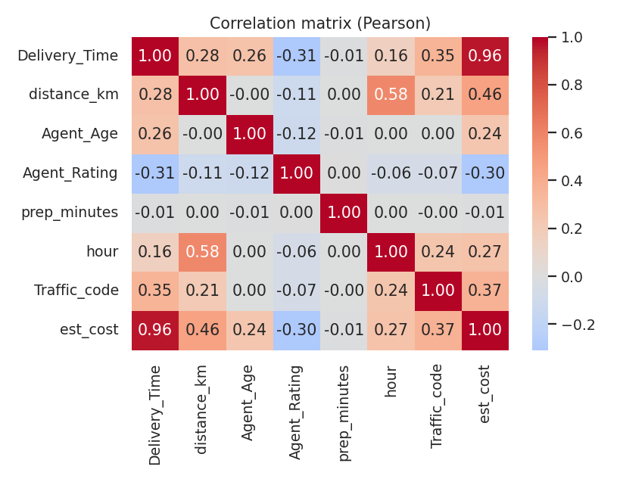
Figure 1: Correlation matrix (Pearson)
Variable vs delivery time | Pearson | Spearman | Non-grocery orders only
Traffic level (0–3) | 0.35 | 0.37 | –
Agent rating | -0.31 | -0.26 | -0.36
Distance (km) | 0.28 | 0.29 | 0.32
Agent age | 0.26 | 0.28 | 0.3
Hour of day | 0.16 | 0.09 | –
Preparation time | -0.01 | -0.01 | -0.01

Traffic level has the strongest positive link with delivery time (0.35), followed by agent rating in the negative direction (-0.31), distance (0.28) and agent age (0.26). Preparation time has no link at all (-0.01), so the time needed at the store is not a source of delay. The correlation of 0.96 with estimated cost is expected, since cost is calculated mainly from delivery time. Pearson and Spearman values are close, which means the relationships are not caused by a few extreme values. A simple regression of delivery time on distance (non-grocery orders) gives +2.68 minutes per km, but with R² of only 0.103: distance is a weak predictor on its own. I explain why in Section 5.7.

5. Visualizations and Interpretation
For every figure I explain why that type of chart was chosen, show the main code and interpret the result in logistics terms.

5.1 Delivery time distribution and product category
Why this chart: a histogram shows the shape of one numeric variable, and overlaying grocery on the other categories makes a hidden group visible. A sorted bar chart then compares the categories.
bins = np.arange(0, 281, 5)
other = df[df.Category != 'Grocery']; gro = df[df.Category == 'Grocery']
plt.hist(other['Delivery_Time'], bins=bins, label='Other categories')
plt.hist(gro['Delivery_Time'], bins=bins, label='Grocery')
cat = df.groupby('Category')['Delivery_Time'].mean().sort_values()
cat.plot(kind='barh')
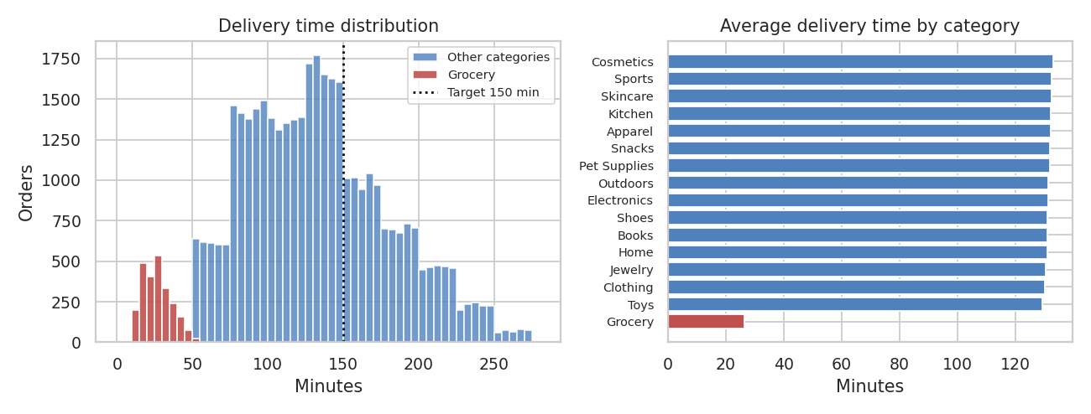
Figure 2: Delivery time distribution and average delivery time by category
The histogram shows a separate group at the left: grocery orders, with an average of 26.5 minutes, a maximum of 54 minutes, and all 2,454 of them under the 150-minute target. All other categories are almost identical (129.4 to 133 minutes). In practice grocery looks like a quick-delivery service with its own standard. Mixing it with other orders lowers the overall average (125.1 against 131.5 for the rest) and makes the on-time rate look better (72% against 70.1%). I therefore treat grocery separately in several comparisons.

5.2 Traffic level
Why this chart: a box plot compares the full distribution (median, spread and extremes) across categories, and a bar chart of the on-time rate shows the effect on service quality.
order = ['Low', 'Medium', 'High', 'Jam']
sns.boxplot(x='Traffic', y='Delivery_Time', data=df, order=order)
plt.axhline(150, color='black', ls=':')
ot = df.groupby('Traffic')['on_time'].mean().mul(100)
ot.reindex(['Low','Medium','High','Jam']).plot(kind='bar')
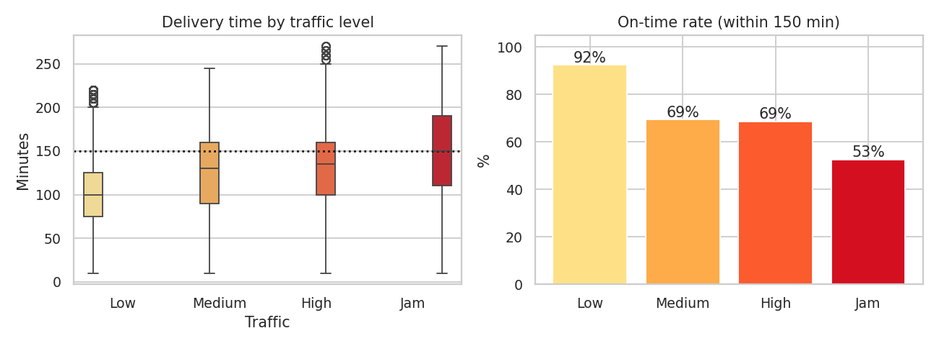
Figure 3: Delivery time and on-time rate by traffic level
Traffic | Orders | Avg time (min) | On-time % | Avg est. cost (Rs) | Avg km
Low | 13,758 | 101.4 | 92.4 | 178.5 | 8.1
Medium | 9,788 | 127 | 69.5 | 226.3 | 11.1
High | 3,950 | 129.5 | 68.6 | 208.3 | 4.4
Jam | 12,657 | 147.9 | 52.7 | 260.8 | 12

Average delivery time rises from 101.4 minutes in low traffic to 147.9 minutes in a jam, an increase of 46.5 minutes (46%), and the on-time rate falls from 92.4% to 52.7%. Jam orders are 31.5% of all orders but 53.2% of the late ones. Two details need care. Medium and High traffic give almost the same average (127 and 129.5). And the average distance differs by traffic level (4.4 km in High against 12 km in Jam), because traffic and time of day are linked, which I explain in Section 6.3.

5.3 Weather, vehicle and area
Why this chart: three small bar charts side by side let the reader compare the main categorical factors on the same scale. For weather I added 95% confidence intervals to show whether differences are real.
w = df.groupby('Weather')['Delivery_Time'].agg(['mean', 'count', 'std'])
w['ci95'] = 1.96 * w['std'] / np.sqrt(w['count'])
plt.barh(w.index, w['mean'], xerr=w['ci95'])
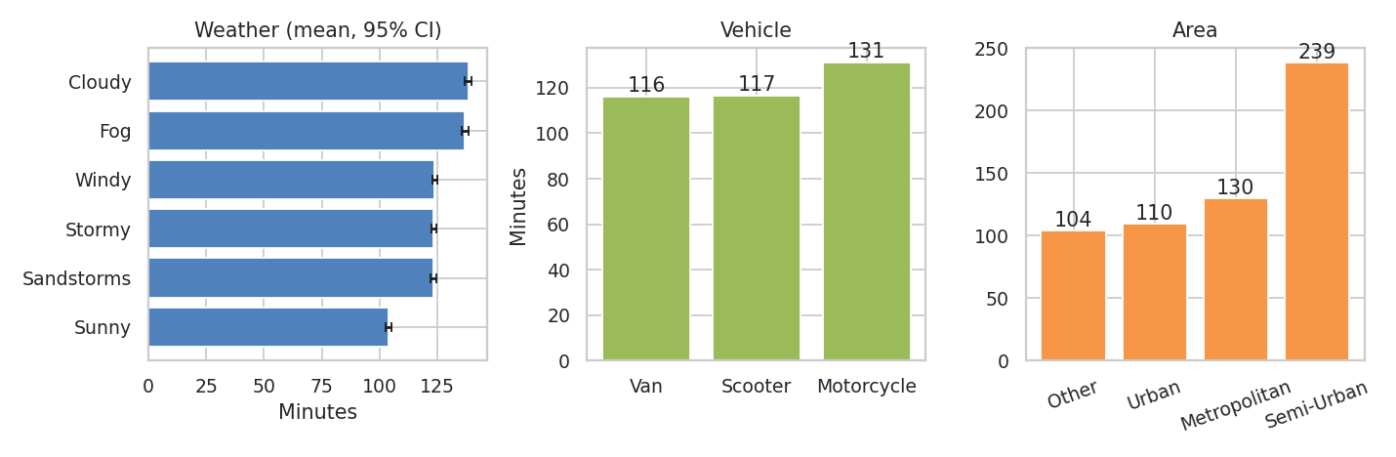
Figure 4: Average delivery time by weather, vehicle and area
- Weather: Sunny is fastest (103.9 min, on-time 88.3%). Cloudy (138.3) and Fog (136.9) are slowest, and Stormy, Sandstorms and Windy are in the middle (about 123.4). The confidence intervals are only about ±1.1 to ±1.4 minutes, so the differences are real. However, the ranking is not what I would expect physically (Cloudy slower than Stormy). I report it as it appears in the data and discuss it in Section 10.
- Vehicle: Motorcycle deliveries average 131.1 minutes, against 116.6 for scooters and 116.1 for vans. Vans and scooters are practically equal.
- Area: Semi-Urban is an extreme case: 238.7 minutes on average with only 5.1% on time, but it contains just 138 orders. Urban (109.7) and Other (104.5) are faster than Metropolitan (129.8).

5.4 Interactions: traffic by area and by vehicle
Why this chart: a heatmap with numbers in each cell shows how two factors combine, and whether an effect holds in every condition.
t_area = df.groupby(['Traffic', 'Area'])['Delivery_Time'].mean().unstack()
t_veh = df.groupby(['Traffic', 'Vehicle'])['Delivery_Time'].mean().unstack()
sns.heatmap(t_area, annot=True, fmt='.0f', cmap='YlOrRd')
sns.heatmap(t_veh, annot=True, fmt='.0f', cmap='YlOrRd')
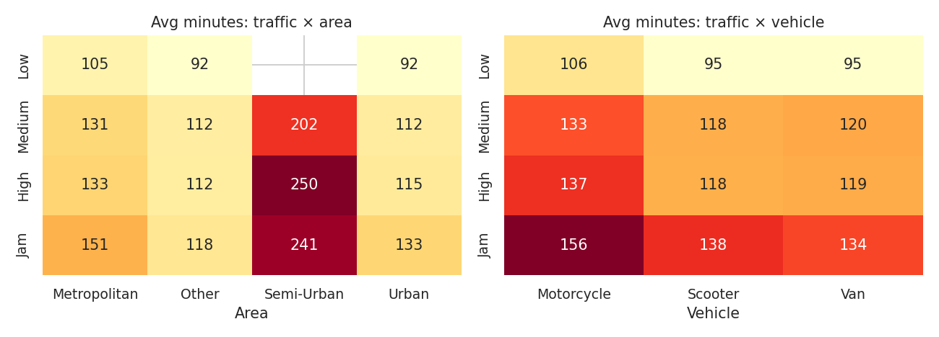
Figure 5: Average delivery time (minutes) by traffic and area, and by traffic and vehicle
Semi-Urban deliveries are slow in every traffic condition (202 to 250 minutes) and 82.6% of them take place in jam conditions. The motorcycle gap is also consistent: motorcycles are slower than scooters by 10.6, 14.6, 19.3 and 18 minutes in Low, Medium, High and Jam traffic. Because it holds at every traffic level, traffic alone does not explain it. Agent age and rating are practically the same for the three vehicle types (age about 29.5, rating about 4.63), so the gap is also not explained by the agents.

5.5 Distance and agent rating
Why this chart: with thousands of points a scatter plot becomes a solid block, so I used a hexagonal density plot with a trend line. A bar chart of average time by rating band shows a relationship that is not linear.
non = df[df.Category != 'Grocery']
x, y = non['distance_km'], non['Delivery_Time']
slope, intercept, r, p, se = stats.linregress(x, y)
plt.hexbin(x, y, gridsize=30, cmap='Blues', mincnt=1)
bands = pd.cut(non['Agent_Rating'], [0, 4.0, 4.5, 4.7, 4.9, 5.0])
non.groupby(bands)['Delivery_Time'].mean().plot(kind='bar')
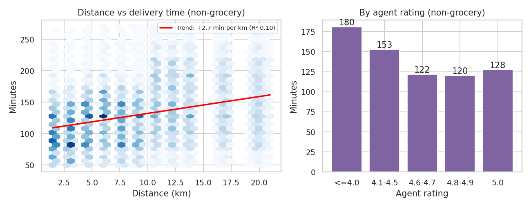
Figure 6: Distance versus delivery time, and delivery time by agent rating (non-grocery orders)
The trend line rises by 2.68 minutes per km, but the points are widely spread (R² 0.103), so distance alone tells little about an individual delivery. The rating relationship is much stronger: orders delivered by agents rated up to 4.0 take 180.5 minutes (2,073 orders), those rated 4.1 to 4.5 take 152.8, and those rated 4.6 and above take about 120.3 to 121.9. That is about 60 minutes (50%) slower for the lowest-rated group. The rating may be the result of slow deliveries (customers rate late deliveries lower) as much as the cause, so I treat it as an association.

5.6 Agent age
Why this chart: a line chart over a single numeric variable (age) shows whether the change is gradual or sudden.
non.groupby('Agent_Age')['Delivery_Time'].mean().plot(marker='o')
plt.axvline(29.5, color='red', ls='--')
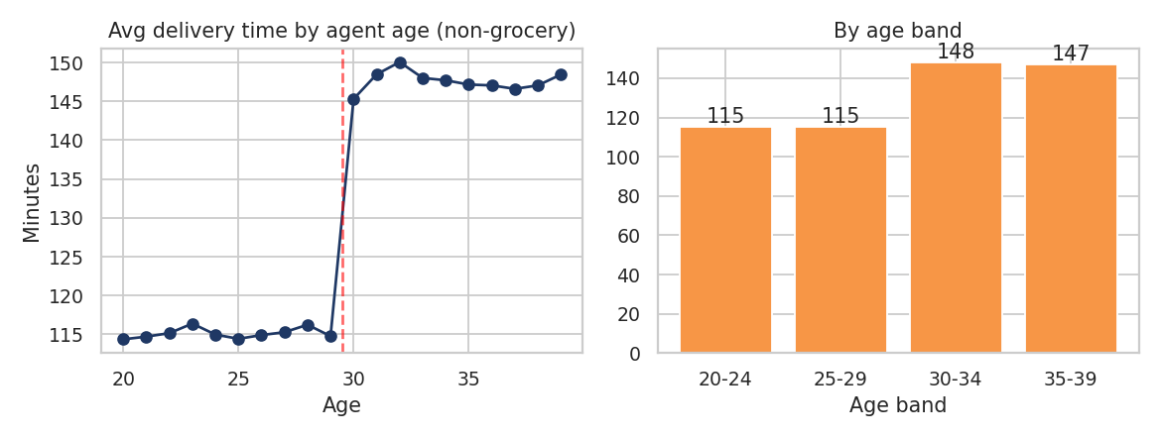
Figure 7: Average delivery time by agent age (non-grocery orders)
Delivery time stays at about 115 minutes for agents aged 20 to 29 and jumps to about 147 minutes from age 30 (114.8 minutes at age 29 and 145.3 at age 30). A real effect of age would normally build up gradually, so a sudden step at exactly 30 is suspicious. It may reflect how the data was recorded or grouped. I report it as a data pattern to verify and not as a finding about older riders, and I do not recommend using age for any decision about riders.

5.7 Multivariable regression
Why this chart: each factor above was looked at on its own, but factors overlap (for example, traffic and time of day). A regression estimates the effect of each factor while holding the others constant, and a coefficient plot with confidence intervals shows size and certainty at once.
formula = ('Delivery_Time ~ C(Traffic, Treatment("Low"))'
' + C(Weather, Treatment("Sunny"))'
' + C(Vehicle, Treatment("Motorcycle"))'
' + C(Area, Treatment("Metropolitan"))'
' + distance_km + Agent_Age + Agent_Rating + is_grocery'
' + C(day_type, Treatment("All-day"))')
ols = smf.ols(formula, data=df).fit()
print(ols.rsquared, ols.params, ols.conf_int())
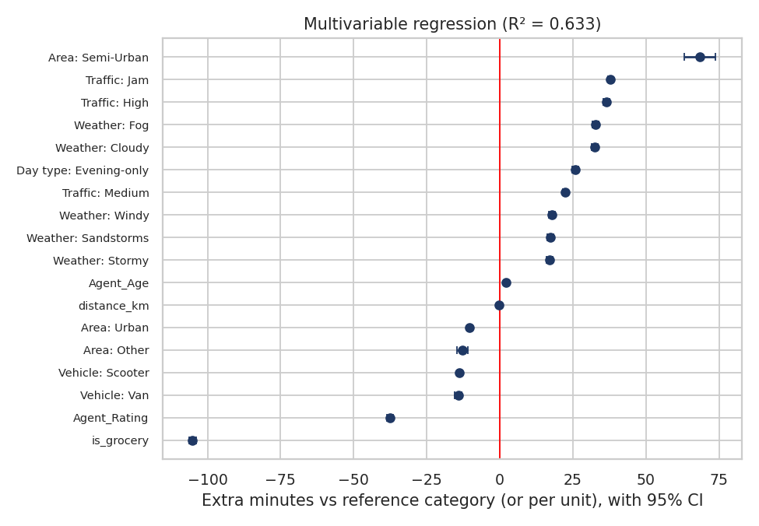
Figure 8: Regression coefficients with 95% confidence intervals
Factor (reference category) | Extra minutes | 95% confidence interval | Direction
Grocery (vs other categories) | -105.07 | -106.35 to -103.78 | Much faster
Semi-Urban (vs Metropolitan) | 68.47 | 63.19 to 73.75 | Much slower
Jam (vs Low traffic) | 37.74 | 36.94 to 38.54 | Slower
High (vs Low traffic) | 36.48 | 35.33 to 37.62 | Slower
Medium (vs Low traffic) | 22.38 | 21.54 to 23.22 | Slower
Evening-only day (vs All-day day) | 25.85 | 24.69 to 27.01 | Slower
Fog (vs Sunny) | 32.75 | 31.68 to 33.82 | Slower
Cloudy (vs Sunny) | 32.38 | 31.3 to 33.45 | Slower
Stormy (vs Sunny) | 17.08 | 16.01 to 18.15 | Slower
Scooter (vs Motorcycle) | -13.75 | -14.41 to -13.08 | Faster
Van (vs Motorcycle) | -14.23 | -15.39 to -13.07 | Faster
Agent rating (per 1 point) | -37.55 | -38.55 to -36.55 | Faster with higher rating
Agent age (per year) | 2.04 | 1.99 to 2.1 | Slower
Distance (per km) | -0.2 | -0.31 to -0.1 | No practical effect

The model explains 63.3% of the variation in delivery time (R² 0.633) with a typical error of 31.5 minutes. This is a useful baseline for the prediction model in Week 4. Several results change the picture from the one-factor views:
- Distance has no independent effect (-0.2 minutes per km) once the other factors are controlled. The apparent effect of distance in Figure 6 comes from the fact that long-distance orders are concentrated on Evening-only days and evening hours (Section 6.4), not from distance itself.
- Jam and High traffic are almost the same (37.74 against 36.48 extra minutes), while Medium is lower (22.38) and Low is the baseline.
- Weather: Cloudy and Fog add about 32.38 minutes against Sunny, and Stormy, Sandstorms and Windy about 17.08.
- Vehicle: scooters and vans are about 13.75 minutes faster than motorcycles even after controlling for the other factors.

6. Time Series Analysis

6.1 Daily shipment volume
Why this chart: a line with markers is the standard way to show a quantity over time. I coloured each day by its type (explained below) and shaded the missing period.
daily = df.groupby('Order_Date').agg(orders=('Order_ID', 'count'),
avg_time=('Delivery_Time', 'mean'),
peak_share=('is_peak_hour', 'mean'))
full = pd.date_range(daily.index.min(), daily.index.max())
daily = daily.reindex(full) # shows the 11 missing days
daily['day_type'] = np.where(daily['peak_share'] > 0.75, 'Evening-only', 'All-day')
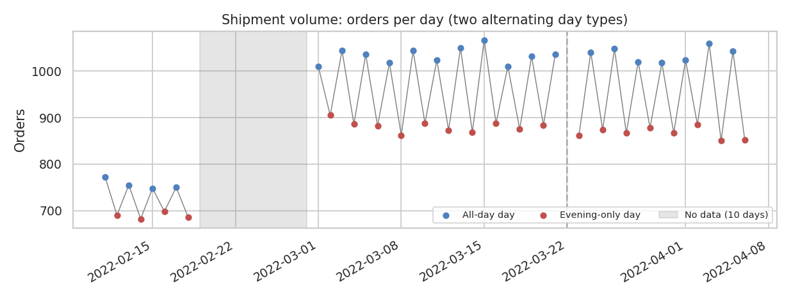
Figure 9: Orders per day, coloured by day type
On the 44 days with data there are 912.6 orders per day on average (minimum 682, maximum 1067). The chart shows a sharp zig-zag: the volume jumps up and down every day. I checked what drives it and found that there are two kinds of days. On All-day days about 49.6% of orders are placed in the evening peak (17:00 to 23:00), and orders are also placed in the morning (32.6% between 08:00 and 11:00). On Evening-only days 98.8% of orders are placed in the peak hours and there are no morning orders at all.
Measure | All-day days | Evening-only days | Comment
Number of days | 22 | 22 | Same number of each
Average orders per day | 984 | 841 | All-day days are busier
Share of orders in peak hours (17–23) | 49.6% | 98.8% | Evening-only days are compressed
Share of orders in jam traffic | 21.5% | 43.3%
Average delivery time (min) | 110.7 | 142 | 31.3 min slower
On-time rate (150 min) | 84.3% | 57.5%
Evening orders per hour | 70 | 119 | +70% load

The two types alternate strictly: in 41 of 41 pairs of consecutive days with data, the type changes. This is why the average for each weekday is nearly flat (877 to 935 orders): there is no weekly cycle, only a 2-day cycle. The daily average delivery time also swings between 107.6 and 144.6 minutes depending on the day type, and busier days are faster, with a correlation of -0.63 between daily orders and daily average delivery time. That is not because volume makes delivery faster, but because the busier All-day days spread orders across quieter hours. Two other details matter for forecasting: the alternation shifts across the missing day of 22 March (All-day on 21 March, Evening-only on 23 March), and the volume level is higher after the gap (756→1,035 orders for All-day days and 689→875 for Evening-only days).

6.2 Autocorrelation and decomposition
Why these charts: the autocorrelation plot shows how strongly the series is related to its own past values, which reveals the length of any repeating cycle. A decomposition separates the series into trend, seasonal and remaining parts. I used the longest unbroken stretch (1 to 21 March, 21 days) so that no values had to be invented.
seg = daily.loc['2022-03-01':'2022-03-21', 'orders'].astype(float)
ac = acf(seg, nlags=10, fft=False)
dec = seasonal_decompose(seg, model='additive', period=2)
dec.plot()
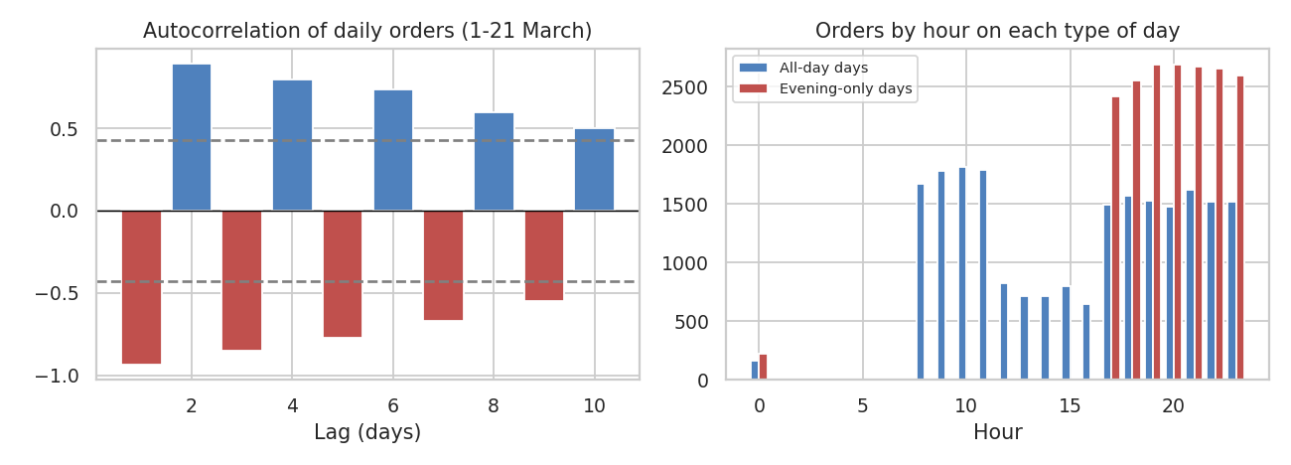
Figure 10: Autocorrelation of daily orders, and orders by hour on each type of day
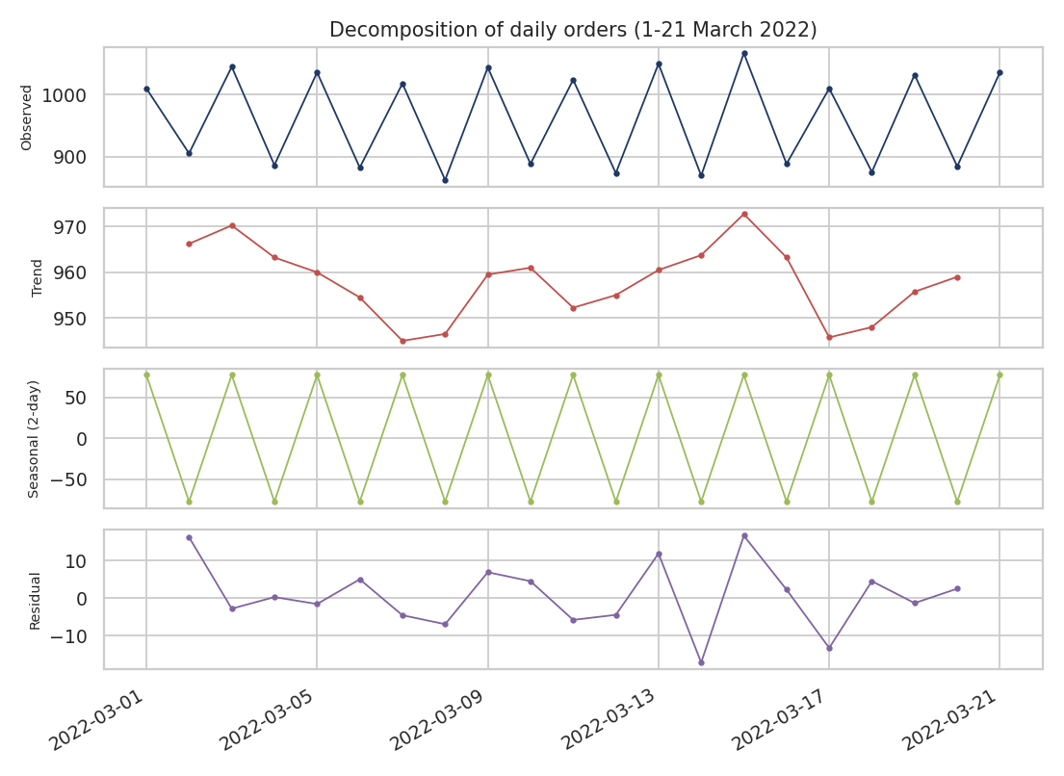
Figure 11: Decomposition of daily orders (trend, 2-day seasonal pattern and residual)
The autocorrelation alternates in sign: -0.94 at lag 1, +0.89 at lag 2, -0.85 at lag 3, which is the signature of a cycle of length 2. In the decomposition the seasonal part has an amplitude of about ±78 orders and explains 98.8% of the variation, the trend is flat (966 to 959, about -0.3 orders per day), and what is left over is small (standard deviation 8.9 against 79.5 for the whole series). For the forecasting in Week 4, the key points are therefore that the seasonal period is 2 days and not 7, that a simple model with a day-type indicator should capture almost all of the pattern, and that the phase shift around the missing day must be handled with care.

6.3 Hourly pattern
Why this chart: bars show volume for each hour, a line on a second axis shows the average delivery time, and the bar colour shows the traffic level, so three variables can be read at once.
hourly = df.groupby('hour').agg(orders=('Order_ID', 'count'),
avg_time=('Delivery_Time', 'mean'))
ax.bar(hourly.index, hourly['orders'])
ax2 = ax.twinx()
ax2.plot(hourly.index, hourly['avg_time'], color='black', marker='o')
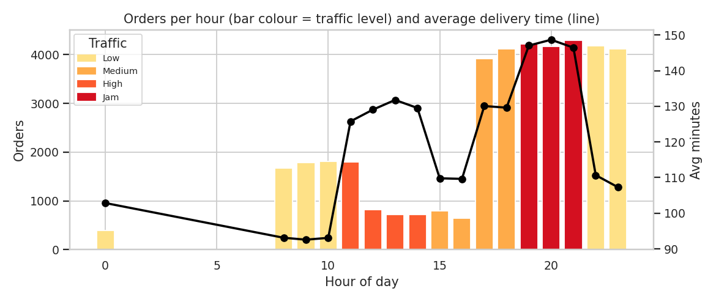
Figure 12: Orders per hour (bar colour = traffic level) and average delivery time
Orders are placed from 08:00 to 11:00 (about 1,670 to 1,813 per hour), fall to about 646 to 798 per hour from 12:00 to 16:00, and rise to 3,915 to 4,294 per hour from 17:00 to 23:00. There are no orders between 01:00 and 07:00. The traffic level is almost fixed by the hour: Low from 08:00 to 10:59, High from 11:00 to 14:59, Medium from 15:00 to 18:59, Jam from 19:00 to 21:59 and Low again at night, and 97.8% of orders in an hour share the main traffic level. The consequence is that in this dataset the effects of traffic and time of day cannot be separated, which is why their η² values are so similar (0.133 and 0.136). The peak hours (17:00 to 23:00) contain 72.2% of all orders, with an average delivery time of 131.5 minutes and on-time rate of 66.6%, against 108.2 minutes and 85.9% outside the peak.

6.4 Is the evening a bottleneck? Load versus mix
The two day types give a natural test. In the same evening hours, Evening-only days carry 119 orders per hour against 70 on All-day days, which is 70% more load. Deliveries in those hours are slower: 142.4 minutes against 113.1. The difference remains inside every traffic level:
Traffic level (peak hours) | All-day days (min) | Evening-only days (min) | Difference (min)
Low | 93 | 115.4 | 22.4
Medium | 109.1 | 142.5 | 33.4
Jam | 128.5 | 159.2 | 30.7

This points to a capacity problem on Evening-only days. However, I cannot claim that the extra load is the only cause, because the orders also differ in distance: in peak hours the average distance is 14.8 km on Evening-only days against 7.1 km on All-day days (and across the whole day, average distance is 2.3 km in the morning, 5.9 km in the afternoon and 12 km in the evening). Load and distance move together in this data, so the data cannot separate them. The regression in Section 5.7 reaches the same conclusion: the day-type effect (+25.85 minutes) is large, and distance has no separate effect.

6.5 Store areas
Why this chart: a bubble map (longitude and latitude) shows whether slow deliveries are concentrated in certain places. The stores were grouped at 0.1 degree resolution.
lat, lon = df['Store_Latitude'], df['Store_Longitude']
df['store_area'] = lat.round(1).astype(str) + ',' + lon.round(1).astype(str)
sa = df.groupby('store_area').agg(orders=('Order_ID', 'count'),
avg_time=('Delivery_Time', 'mean'),
lat=('Store_Latitude', 'mean'),
lon=('Store_Longitude', 'mean'))
plt.scatter(sa['lon'], sa['lat'], s=sa['orders']/6, c=sa['avg_time'], cmap='YlOrRd')
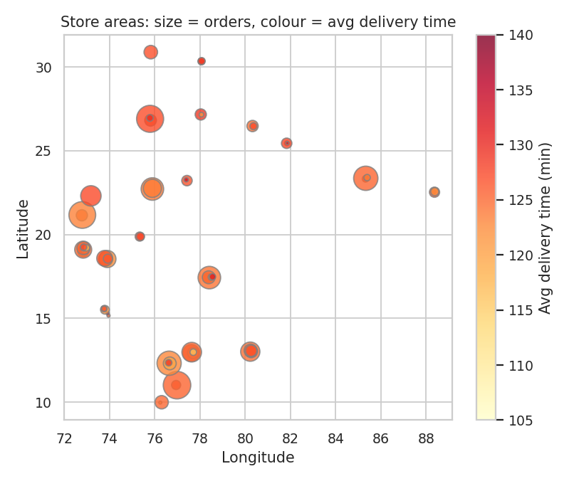
Figure 13: Store areas (bubble size = orders, colour = average delivery time)
The data has 67 store areas, with between 32 and 2,749 orders each (median 305); the five largest hold 30.5% of all orders. The average delivery time of a store area ranges only from 116.8 to 136.1 minutes (standard deviation 3.8), and the bubbles are almost the same colour. So the delays are not concentrated at particular stores or locations: they come from the conditions and the day pattern described above, which suggests process-wide measures and not store-specific ones.

7. Transportation Cost
Why this chart: a stacked bar chart shows both the total cost and how it is made up (rider time versus vehicle running cost). As explained in Section 2.2, the cost is estimated with assumed rates.
ct = df.groupby('Traffic')[['cost_rider', 'cost_vehicle']].mean()
ct.plot(kind='bar', stacked=True)
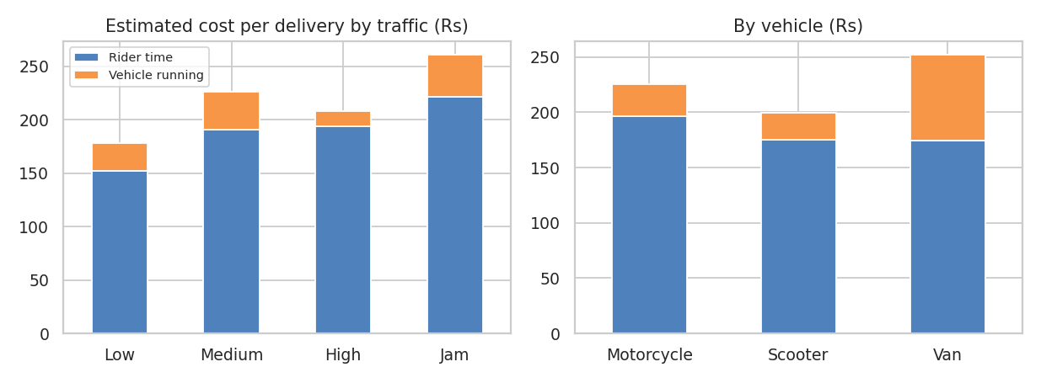
Figure 14: Estimated cost per delivery by traffic level and by vehicle (Rs)
The average estimated cost is Rs 219 per delivery, of which Rs 187.6 (85.7%) is rider time and Rs 31.4 vehicle running cost. That makes the cost per km Rs 22.5. Because rider time dominates, the delivery time is the main cost lever, and the delay factors above translate directly into cost: a jam delivery costs Rs 260.8 against Rs 178.5 in low traffic (46% more). By vehicle, motorcycles cost Rs 225.7 per delivery, scooters Rs 199.3 (they are cheaper because they are faster and cheaper to run) and vans Rs 251.9. Vans are as fast as scooters but their assumed running cost is high (Rs 8 per km), so they are the most expensive option for ordinary parcels. Grocery orders cost only Rs 70.8 against Rs 228.6 for others because of their short delivery time. The total rider time in the period was 83,703 hours.

8. Bottleneck Analysis
With the 150-minute target, 11,259 orders (28.0%) were late. The chart compares each group's share of all orders with its share of late orders: if the late share is higher, the group contributes more than its fair share to delays.
late = df[df['on_time'] == 0]
share_all = df['Traffic'].value_counts(normalize=True) * 100
share_late = late['Traffic'].value_counts(normalize=True) * 100
pd.DataFrame({'All': share_all, 'Late': share_late}).plot(kind='bar')
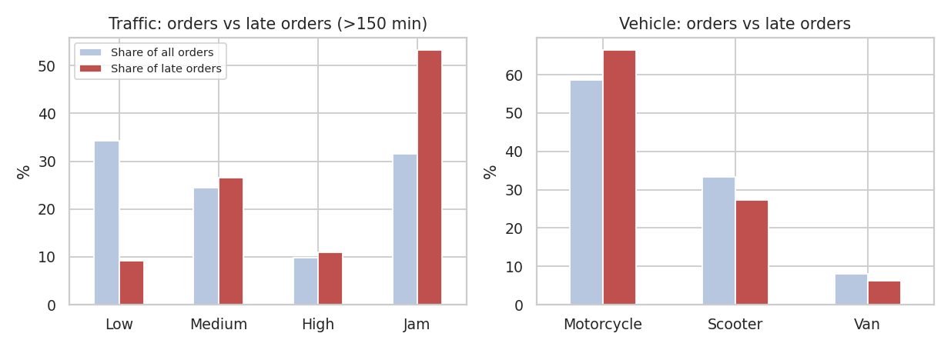
Figure 15: Share of all orders and of late orders by traffic level and by vehicle
Group | Share of orders | Share of late orders | Reading
Jam traffic | 31.5% | 53.2% | Largest source of late orders
Low traffic | 34.3% | 9.2% | Under-represented among late orders
Motorcycle | 58.7% | 66.4% | Over-represented
Scooter | 33.4% | 27.4% | Under-represented
Van | 8% | 6.2% | Under-represented

In order of importance, the bottlenecks I identified are:
- Evening peak and jam conditions: Jam alone is 31.5% of orders but 53.2% of late orders; Jam and High together account for 64.2% of late orders.
- Evening load on Evening-only days: 57.5% on time against 84.3% on All-day days.
- Motorcycle deliveries: 58.7% of orders but 66.4% of late orders, with an on-time rate of 68.3% against 77% for scooters.
- Low-rated agents: 5.6% of orders are delivered by agents rated 4.0 or lower, and these take about 60 minutes longer.
- Semi-Urban area: very poor service (5.1% on time) but only 138 orders, so a small share of the total problem.
The size of these problems can be estimated by asking how many rider minutes would be saved if a slow group performed like a comparison group. The table shows this for the 44 days of data, with the Rs value using the assumed Rs 1.5 per minute. These are not forecasts of guaranteed savings, because the gaps are associations and part of them may not be removable.
Scenario | Compared with | Gap (min) | Orders | Minutes | Rider hours | Value (assumed)
Motorcycle orders | Scooter | 14.5 | 23,555 | 341,655 | 5,694 | Rs 512,482
Jam orders | High traffic | 18.4 | 12,657 | 233,235 | 3,887 | Rs 349,853
Orders of agents rated ≤ 4.0 | Rated above 4.5 | 58.6 | 2,073 | 121,448 | 2,024 | Rs 182,173
Semi-Urban orders | Metropolitan | 108.9 | 138 | 15,025 | 250 | Rs 22,537

For context, all the deliveries together used 5,022,225 rider minutes (83,703 hours). The motorcycle and jam gaps are the largest opportunities because they affect the most orders, and the Semi-Urban gap is the largest per order but affects very few.

9. Recommendations
Recommendation | Evidence | Expected benefit
Plan evening rider capacity by day type, because the day type alternates predictably | Evening orders per hour are 119 on Evening-only days against 70 on All-day days; deliveries in the same hours are 22 to 33 minutes slower | Fewer late orders on the heavy days; better use of riders on the light days
Shift some demand out of the peak (time-slot offers, scheduled delivery) | 72.2% of orders are placed 17:00 to 23:00; on-time 66.6% against 85.9% off-peak | Smoother load and a higher on-time rate
Use traffic-aware delivery promises and dispatch times | Jam orders: 52.7% on time, 53.2% of late orders | More reliable customer promises; earlier dispatch in jam hours
Investigate the motorcycle gap (routes, fleet condition, assignment) | 10.6 to 19.3 minutes slower than scooters at every traffic level | Up to 5,694 rider hours in 44 days if the gap closes
Run coaching or monitoring for low-rated agents | 5.6% of orders; 180.5 minutes against about 120 | Up to 2,024 rider hours
Review the Semi-Urban service and set a separate promise | 138 orders, 238.7 minutes, 5.1% on time, 82.6% in jam | Realistic promises for a small but very poor segment
Keep grocery as a separate service with its own KPIs | 26.5 minutes, 100% under target; other categories 131.5 | Clearer KPIs, no distortion of the overall average
Use vans only where needed | Vans cost Rs 251.9 against Rs 199.3 for scooters with the same delivery time (assumed rates) | Lower vehicle running cost
Fix the data gaps | 11 missing days (19–28 Feb and 22 Mar); no cost data and no promised times | Better forecasting and real cost and SLA tracking

10. Limitations
- Several patterns in this dataset are unusually regular: traffic is set almost entirely by the hour, the average time jumps at exactly age 30, the days alternate strictly in type, and the weather ranking is not what one would expect physically (Cloudy slower than Stormy). This suggests that the dataset may be partly generated by rules. My conclusions therefore describe this dataset and should not be applied to a real courier without checking them on that company's own data.
- The cost figures use rates I assumed, and the 150-minute target is also my assumption. The ranking of factors does not depend on them, but the amounts and the on-time percentages do.
- Many factors overlap (traffic and hour, distance and day type), so effects cannot be fully separated, and all results are associations, not proof of cause. The scenario savings should be seen as the size of an opportunity.
- The data covers only 44 days with an 11-day gap, which limits what can be said about longer cycles such as monthly or seasonal patterns.
- Distances are straight-line and not road distances.

11. Conclusion
I analysed 40,153 real deliveries with descriptive statistics, statistical tests, a regression and a time series analysis, and presented the findings through 15 charts. The analysis shows that grocery is a separate fast service; that traffic and time of day are tied together and are the main drivers of delay; that days alternate predictably between a spread-out type and an evening-concentrated type, with the second type giving much higher evening load and slower delivery; that motorcycles and low-rated agents are slower; and that delays are not tied to particular stores. The multivariable model explains 63% of the variation in delivery time and gives a baseline for prediction. The recommendations focus on capacity planning by day type, moving demand out of the peak, traffic-aware promises and a review of the motorcycle fleet and agent performance.
In Week 4 I will build a model to predict delivery time (beating the regression baseline), forecast daily order volume using the 2-day seasonal pattern found here, and test optimisation ideas such as evening rider allocation by day type and route planning.

References
- Amazon Delivery Dataset, Kaggle (kaggle.com). Public dataset of e-commerce deliveries.
- pandas, scipy, statsmodels, matplotlib and seaborn documentation.
- Box, G. E. P., Jenkins, G. M., Reinsel, G. C. (2015). Time Series Analysis: Forecasting and Control (5th ed.). Wiley. (autocorrelation and decomposition).
- Tukey, J. W. (1977). Exploratory Data Analysis. Addison-Wesley.
- Cohen, J. (1988). Statistical Power Analysis for the Behavioral Sciences (2nd ed.). (effect size, eta-squared).

