Logistics Data Analyst Internship
Week 4 Report
Predictive Modeling, Forecasting and Optimization in Logistics Systems
Dataset: Amazon Delivery Dataset (Kaggle), 40,153 cleaned delivery records
Scenario: Last-Mile Delivery for an E-commerce Courier
Submitted by: [Your Name]
Internship Period: 09 September 2026 – 07 October 2026
Code and data: github.com/theaditisingh/logistics-last-mile-analysis (week4 folder)

1. Introduction
In Weeks 2 and 3 I cleaned and explored the real delivery data. This week I used those findings to build three things: a model that predicts how long an individual delivery will take, a forecast of how many orders will arrive each day, and optimisation methods that turn these predictions into decisions about promise times, rider schedules, vehicle use and delivery routes. The report follows that order and gives the code, the evaluation and the numbers for each part.
The main results are:
- Delivery time model. A tuned gradient boosting model predicts delivery time with an average error (MAE) of 17.26 minutes and R² of 0.821, against R² of 0.637 for the Week 3 regression. On a later period that the model never saw, R² is 0.818, so the accuracy holds up over time.
- Early warning and promise times. The model flags 82.4% of the late deliveries with 91.1% precision (AUC 0.971). Using it to set promise times lifts the on-time rate from 71.4% (fixed 150-minute promise) to 90.4% with an average promise only 3.8 minutes longer.
- Demand forecast. Daily orders alternate between two day types, and a simple same-type average forecasts them with an error of about 1.5% (MAPE), against 17.1% for a standard weekly method. The forecast for 7 to 13 April is 1,042 orders on All-day days and 862 on Evening-only days.
- Optimisation. Scheduling riders by day type with an integer program cuts planned rider-hours by 29.1% against a single schedule that covers both day types. Sweep assignment with route optimisation cuts rider distance by 19.6% on 918 real order batches. Reallocating the existing vehicle fleet saves a more modest 1.26% of delivery minutes.

2. Problem Definition and Data

2.1 The problems
Problem | Question | Target variable
A. Delivery time prediction (regression) | How long will this order take, given what is known when it is placed? | Delivery_Time (minutes)
B. Demand forecasting (time series) | How many orders will arrive on each of the next 7 days? | Orders per day
C1. Rider scheduling | How many riders are needed in each hour, and with which shifts? | Rider-hours
C2. Vehicle allocation | Which vehicle type should serve which orders? | Predicted delivery minutes
C3. Route planning | How should orders be split between riders and in which order should they be visited? | Rider distance (km)

2.2 Data and features
The data is the cleaned dataset from Weeks 2 and 3: 40,153 deliveries from 11 February to 6 April 2022. The model uses only information that is available when the order is placed or can be planned in advance:
Feature | Type | Comment
distance_km | Numeric | Store-to-customer distance
Traffic_code | Ordinal (0–3) | Low, Medium, High, Jam
is_grocery | Binary | Grocery orders are a separate fast service (Week 3)
Agent_Age, Agent_Rating | Numeric | Delivery agent attributes
hour, is_weekend, prep_minutes | Numeric / binary | Time of order and preparation time
Weather, Vehicle, Area | Categorical (one-hot) | Conditions and fleet

I deliberately left out the estimated cost, the on-time flag and the long-delivery flag. All three are calculated from the delivery time itself, so using them would leak the answer into the model (data leakage) and give accuracy that could never be reached in practice. The day type (Week 3) was tested as an extra feature but added nothing (Section 4.4), so it is not in the final model.

2.3 How the model is validated
- Random split: 32,123 training and 8,030 test orders (80/20). Model selection uses 5-fold cross-validation on the training part only, so the test set stays untouched until the end.
- Temporal holdout: orders up to 2022-03-25 (28,742 orders) are used for training, and the last 12 days (11,411 orders) for testing. A random split lets a model see the same days it is tested on. A forward-in-time test is closer to real use, where the model predicts the future.
from common import * # loads the data, defines FEATURES_A and the pipelines
train, test = split_random(df) # 32,123 / 8,030 orders
tr_t, te_t = split_time(df) # train to 25 Mar, test 26 Mar - 6 Apr
cv = KFold(5, shuffle=True, random_state=42)

3. Part A: Delivery Time Model

3.1 Model selection and rationale
Model | Why it was included
Mean baseline | Reference: any useful model must beat always predicting the average.
Linear and Ridge regression | Simple and explainable; the same type of model as the Week 3 regression, so it shows what interactions add.
Decision tree | Captures non-linear effects and interactions between factors (for example traffic and weather) without manual work.
Random forest | Averages many trees, which reduces over-fitting of a single tree; robust on mixed data.
Gradient boosting | Builds trees one after another, each correcting the previous errors; usually the most accurate on tabular data and fast to train (HistGradientBoosting).

Week 3 showed that factors overlap and interact: for example, the motorcycle gap changes with traffic level, and the Semi-Urban delay depends on the traffic level. A linear model assumes that every factor adds a fixed number of minutes, so I expected the tree-based models to do better, and tested that.
def pipe(model, features):
return Pipeline([('prep', preprocessor(features)), ('model', model)])

preprocessor = ColumnTransformer([
('num', StandardScaler(), num_features),
('cat', OneHotEncoder(drop='first', handle_unknown='ignore'), cat_features)])

tree = DecisionTreeRegressor(max_depth=10, min_samples_leaf=20)
forest = RandomForestRegressor(n_estimators=80, max_depth=14, min_samples_leaf=10)
models = {'Linear Regression': pipe(LinearRegression(), FEATURES_A),
'Decision Tree': pipe(tree, FEATURES_A),
'Random Forest': pipe(forest, FEATURES_A),
'Gradient Boosting': pipe(HistGradientBoostingRegressor(), FEATURES_A)}

for name, m in models.items():
scoring = ('r2', 'neg_root_mean_squared_error', 'neg_mean_absolute_error')
cvr = cross_validate(m, train[FEATURES_A], y_tr, cv=cv, scoring=scoring)
m.fit(train[FEATURES_A], y_tr)
pred = m.predict(test[FEATURES_A])

3.2 Evaluation metrics
- MAE (mean absolute error): the average size of the error in minutes; easy to explain to operations staff.
- RMSE (root mean squared error): like MAE but penalises large errors more, which matters when a very late delivery is costly.
- R²: the share of the variation in delivery time that the model explains (0 = no better than the average, 1 = perfect).

3.3 Results
Model | CV RMSE | CV R² (±std) | Test RMSE | Test MAE | Test R² | Later-period RMSE | Later R²
Mean baseline | – | – | 52.13 | 41.77 | 0.000 | – | –
Linear Regression | 32.4 | 0.610 ± 0.007 | 32.3 | 25.6 | 0.616 | 32.2 | 0.615
Ridge Regression | 32.4 | 0.610 ± 0.007 | 32.3 | 25.6 | 0.616 | 32.2 | 0.615
Decision Tree | 24.7 | 0.773 ± 0.004 | 24.6 | 18.9 | 0.777 | 24.6 | 0.777
Random Forest | 22.4 | 0.813 ± 0.003 | 22.2 | 17.3 | 0.819 | 22.4 | 0.815
Gradient Boosting | 22.3 | 0.815 ± 0.004 | 22.2 | 17.4 | 0.818 | 22.4 | 0.815
Tuned Random Forest | 22.5 | 0.811 ± 0.004 | 22.3 | 17.3 | 0.817 | 22.4 | 0.814
Tuned Gradient Boosting | 22.2 | 0.817 ± 0.003 | 22.0 | 17.3 | 0.821 | 22.2 | 0.818

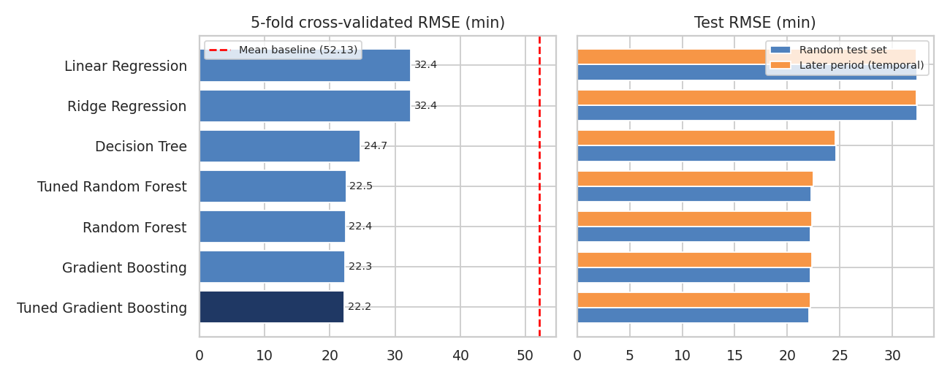
Figure 1: Cross-validated RMSE and test RMSE for each model
All models beat the baseline (RMSE 52.13 minutes). Linear regression reaches R² of 0.616 (RMSE 32.3), a single decision tree 0.777, and the ensembles about 0.819. The jump from the linear model to the tree models (RMSE 32.3 to about 22.2) confirms that interactions matter. Ridge gives the same result as plain regression, as expected with this many observations and few features. The cross-validation standard deviation is only about 0.004 in R², so the ranking of the top models is reliable, but the top four (Random Forest, Gradient Boosting and their tuned versions) are within 0.3 minutes of each other.

3.4 Hyperparameter tuning
I tuned the two best families with a grid search using 3-fold cross-validation on the training data: 24 combinations for gradient boosting (learning rate, number of leaves, minimum leaf size and regularisation) and 4 for the random forest (tree depth and minimum leaf size). The grid for the random forest is small because the computer I used has a single processor. The best gradient boosting settings were learning rate 0.1, 63 leaves and minimum leaf size 20. Tuning improved the cross-validated RMSE from 22.33 to 22.20, a small gain, which tells me that the default settings were already close to optimal and that the remaining error is mostly not explained by the available features. The model with the lowest cross-validated RMSE, chosen using training data only, was the Tuned Gradient Boosting.
gb_grid = GridSearchCV(pipe(HistGradientBoostingRegressor(), FEATURES_A),
{'model__learning_rate': [0.05, 0.1], 'model__max_leaf_nodes': [15, 31, 63],
'model__min_samples_leaf': [20, 50], 'model__l2_regularization': [0.0, 1.0]},
cv=3, scoring='neg_root_mean_squared_error').fit(train[FEATURES_A], y_tr)
print(gb_grid.best_params_) # lr 0.1, 63 leaves, min leaf 20, no L2

4. Validation of the Final Model

4.1 Accuracy and overfitting check
Evaluation | RMSE (min) | MAE (min) | R²
5-fold cross-validation (training data) | 22.2 | 17.3 | 0.817
Random test set (8,030 orders) | 22.04 | 17.26 | 0.821
Later period, never seen (11,411 orders) | 22.16 | 17.31 | 0.818
Week 3 linear regression (same test set) | 31.39 | 24.9 | 0.637
Mean baseline | 52.13 | 41.77 | 0.000

The three evaluations agree (R² 0.817, 0.821 and 0.818), so the model is not over-fitted and does not lose accuracy on later days. Compared with the Week 3 regression, the error falls from 24.9 to 17.26 minutes (a 31% reduction) and R² rises from 0.637 to 0.821. About 51.7% of predictions are within 15 minutes of the actual time and 83.6% within 30 minutes.

4.2 Residual analysis
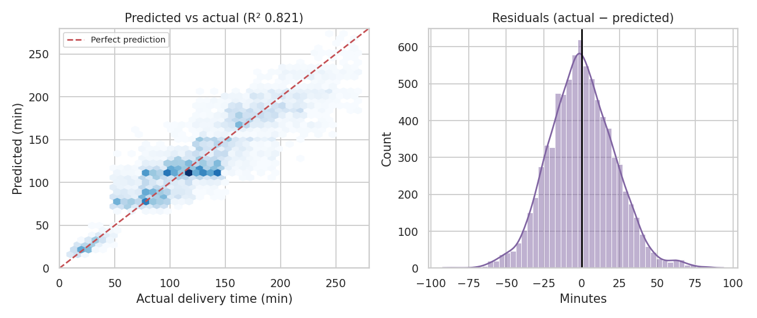
Figure 2: Predicted versus actual delivery time, and the distribution of errors
The predictions follow the diagonal, with the grocery orders (under 55 minutes) forming a tight cluster at the bottom left. The residuals are centred on zero (mean -0.11 minutes) and roughly symmetric with a standard deviation of 22.04 minutes, so the model is not biased in either direction. The small bump on the right (errors around +60 minutes) shows that some very slow deliveries are not predicted, which is expected since the available features cannot explain every delay.

4.3 Where is the model weaker?
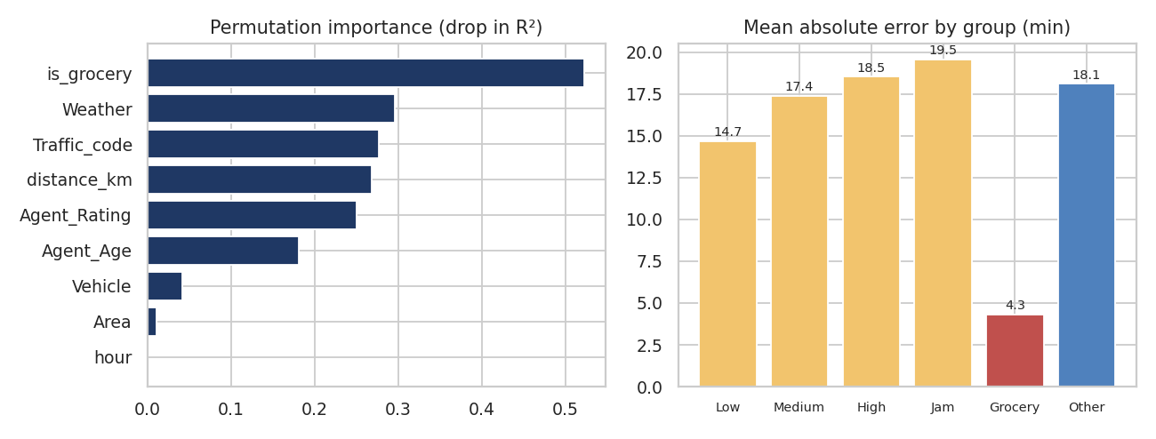
Figure 3: Permutation importance, and mean absolute error by group
Errors are smallest for grocery orders (4.3 minutes) because their delivery times are short and uniform, and largest for the others (18.1 minutes). Within traffic levels the error grows from 14.7 minutes in low traffic to 19.5 minutes in a jam: slower conditions are also more variable and harder to predict. The bias is close to zero in every traffic level (between -0.8 and 0.5 minutes), and errors are similar in all four area types (15.7 to 17.5 minutes), including the small Semi-Urban group.

4.4 What drives the predictions?
Permutation importance measures how much R² drops when one feature's values are shuffled. The grocery flag is the most important (0.5224), followed by weather (0.2961), traffic (0.2766), distance (0.2684), agent rating (0.25) and agent age (0.1808). Vehicle (0.0412) and area (0.0111) matter little, and hour, preparation time and weekend have essentially none (0.0005, 0 and 0). Three observations connect to earlier weeks:
- Distance matters here, although it had no effect in the Week 3 regression. The tree-based model can use it in combination with other factors, which the linear model could not. This is consistent with the Week 3 conclusion that the effect of distance was entangled with other variables.
- Weather ranks second, much higher than its one-factor effect size in Week 3 suggested. This suggests that its effect appears mainly in combination with other factors.
- Hour has almost no importance because traffic level is determined by the hour in this data, so traffic already carries the time-of-day information.
I also tested adding the day type from Week 3 as a feature. It did not help: test RMSE was 22.04 with it and 22.04 without it. This means that the day-type effect seen in Week 3 is already explained by the other features, so the final model does not use it.

5. Using the Model: Early Warning and Promise Times

5.1 Late-delivery early warning
A delivery is late if it takes more than 150 minutes (the target I assumed in Week 3). To warn operations before a delivery goes late, I flag an order when its predicted time is at or above a threshold. I chose the threshold by maximising the F1 score on cross-validated predictions of the training data, which gave 156 minutes, and then evaluated it on the test set.
Measure | Value | Meaning
Late orders in the test set | 2,299 (28.6%) | What we want to catch
Orders flagged | 2,080 | Predicted time ≥ 156 min
Late orders caught (recall) | 1,895 (82.4%) | Share of late orders that were flagged
False alarms | 185 | Precision 91.1%: share of flags that were truly late
Late orders missed | 404 | Not flagged but late
AUC | 0.971 | Ability to rank late above on-time (1 = perfect)

For a flagged order, 91.1% turn out to be late, so staff can trust the flags and act on them (for example by reassigning a rider or messaging the customer). Only 185 of 2,080 flags were false alarms. The threshold can be moved to suit the cost of each type of error: a lower threshold catches more late orders but raises false alarms (left chart of Figure 4).
cv_pred = cross_val_predict(final, train[FEATS], y_tr, cv=cv) # out-of-fold
late_tr = y_tr.values > 150
for thr in range(100, 181, 2):
flag = cv_pred >= thr
tp = (flag & late_tr).sum(); fp = (flag & ~late_tr).sum()
fn = (~flag & late_tr).sum()
f1 = 2 * tp / (2 * tp + fp + fn) # keep the threshold with the best F1
flag_test = pred >= best_thr
print(roc_auc_score(y_te.values > 150, pred))

5.2 Prediction-based promise times
A fixed 150-minute promise is too short for slow conditions and too long for fast ones. Instead, the promise for each order can be its predicted time plus a buffer. The buffer is the 90th percentile of the cross-validated errors on the training data (28.4 minutes), so that about 9 in 10 orders should arrive within the promise. I then tested this on the held-out test orders.
cv_res = y_tr.values - cv_pred # out-of-fold residuals (training data)
buffer = np.quantile(cv_res, 0.90) # 28.4 minutes
promise = pred + buffer # promise for each test order
print((y_te.values <= promise).mean()) # on-time rate: 0.904
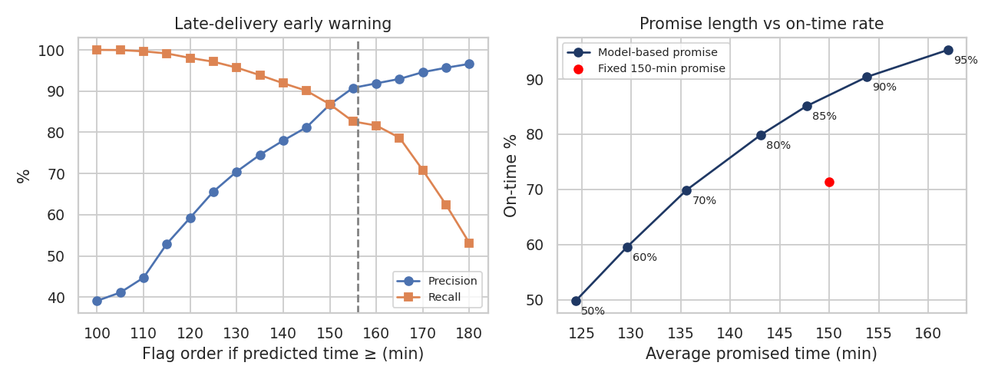
Figure 4: Early-warning precision and recall by threshold, and promise length versus on-time rate
The fixed promise gives 71.4% on-time. The model-based promise gives 90.4%, with an average promise of 153.8 minutes against 150. The right chart shows the trade-off: the red point (fixed promise) is well below the curve, which means the model-based approach gets more on-time deliveries for the same average promise length. Alternatively, at the same on-time rate as today (about 70%), the average promise could be about 14 minutes shorter (135.6 minutes at 69.9% on-time).
Traffic level | Fixed 150 min: on-time % | Model-based: on-time % | Avg model promise (min)
Low | 92.5 | 94.1 | 130.6
Medium | 68.9 | 90.2 | 155.5
High | 67.6 | 89.5 | 158.2
Jam | 51.8 | 86.9 | 175.9

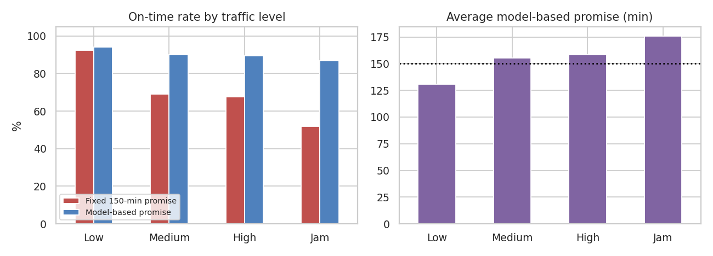
Figure 5: On-time rate and average promise by traffic level
The improvement is largest where the fixed promise fails most: in a jam, the on-time rate goes from 51.8% to 86.9%, because the promise there is 175.9 minutes instead of 150. In low traffic the promise shortens to 130.6 minutes while the on-time rate stays high (94.1%). Grocery orders get a promise of about 55.7 minutes with 100% on-time, which reflects their separate service level. The model-based promise is therefore longer when conditions are bad and shorter when they are good, which is more honest to the customer. I also tried a separate buffer for each traffic level, which gave the same result (90.3% on-time, 154.1 minutes), so the single buffer is enough. One caution: the shortest promise is 44.5 minutes and the longest 302.2, so in practice promises should be rounded and limited to a sensible range.

6. Part B: Demand Forecasting

6.1 Problem and data
Rider planning needs a forecast of daily orders. In Week 3 I found that days alternate strictly between two types, All-day days and Evening-only days, so the seasonal period is 2 days and not 7. I also noticed that the cycle follows the order of days with data and not the calendar: in 43 of 43 pairs of consecutive observed days the type changes, including across the 10-day gap in February and the missing day of 22 March. For this reason I indexed the series by observation number. The orders were also at a lower level before 1 March, so the models are trained on the 36 observed days from 2022-03-01 to 2022-04-06. In this window All-day days average 1,034.7 orders (standard deviation 16) and Evening-only days 874.8 (13.5).

6.2 Models compared
Model | Idea
Mean | Average of all training days (no pattern)
Naive (yesterday) | Tomorrow equals today
Weekly seasonal naive (lag 7) | Same weekday last week: the usual default for daily data
7-day moving average | Average of the last week
Seasonal naive (lag 2) | Same as two days ago (same day type)
Same-type average (last 3) | Average of the last 3 days of the same type
Same-type average (all) | Average of all training days of the same type
Holt-Winters (period 2) | Exponential smoothing with an additive 2-day seasonal component
Regression + AR(1) errors | Regression on a day-type indicator with first-order autoregressive errors

6.3 Backtest design
- One-step-ahead, rolling origin: for each of the last 14 days, the models are fitted on all earlier days and forecast the next day. This tests day-to-day planning.
- Multi-step: the models are fitted on the data up to the last 8 days and forecast all 8 days at once. This tests planning a week ahead, as in the staffing plan.
S = obs[obs['date'] >= '2022-03-01'] # observed days, in observation order
y, e = S['orders'].values, S['e'].values # e = 1 on Evening-only days

def f_type_mean3(tr, etr, efut, h): # mean of the last 3 same-type days
return np.array([tr[etr == t][-3:].mean() for t in efut])

for t in range(N - 14, N): # one-step-ahead rolling origin
for name, fn in MODELS.items():
pred = fn(y[:t], e[:t], e[t:t + 1], 1)[0]

hw = ExponentialSmoothing(tr, seasonal='add', seasonal_periods=2).fit()
sar = SARIMAX(tr, exog=etr.reshape(-1, 1), order=(1, 0, 0), trend='c')
sar = sar.fit(disp=False)

6.4 Results
Model | 1-step MAE | 1-step RMSE | 1-step MAPE | 8-day MAE | 8-day RMSE | 8-day MAPE
Mean | 85.7 | 86.9 | 9.1% | 86.2 | 87.8 | 9.2%
Naive (yesterday) | 167.9 | 169.2 | 17.8% | 88 | 113.2 | 8.7%
Weekly seasonal naive (lag 7) | 161.2 | 161.9 | 17.1% | 147.5 | 156.8 | 15.4%
7-day moving average | 95.8 | 96.8 | 10.1% | 86.2 | 88 | 9.1%
Seasonal naive (lag 2) | 13.9 | 17.7 | 1.5% | 17.5 | 21.5 | 1.9%
Same-type average (last 3) | 14.2 | 17.1 | 1.5% | 15.2 | 16.6 | 1.6%
Same-type average (all) | 13.2 | 15.4 | 1.4% | 16.5 | 18.4 | 1.8%
Holt-Winters (period 2) | 13.2 | 15.4 | 1.4% | 16.5 | 18.4 | 1.8%
Regression + AR(1) errors (day type) | 15 | 17.9 | 1.5% | 17.8 | 20.2 | 1.9%

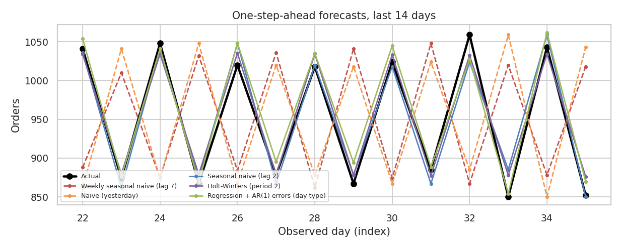
Figure 6: One-step-ahead forecasts for the last 14 days
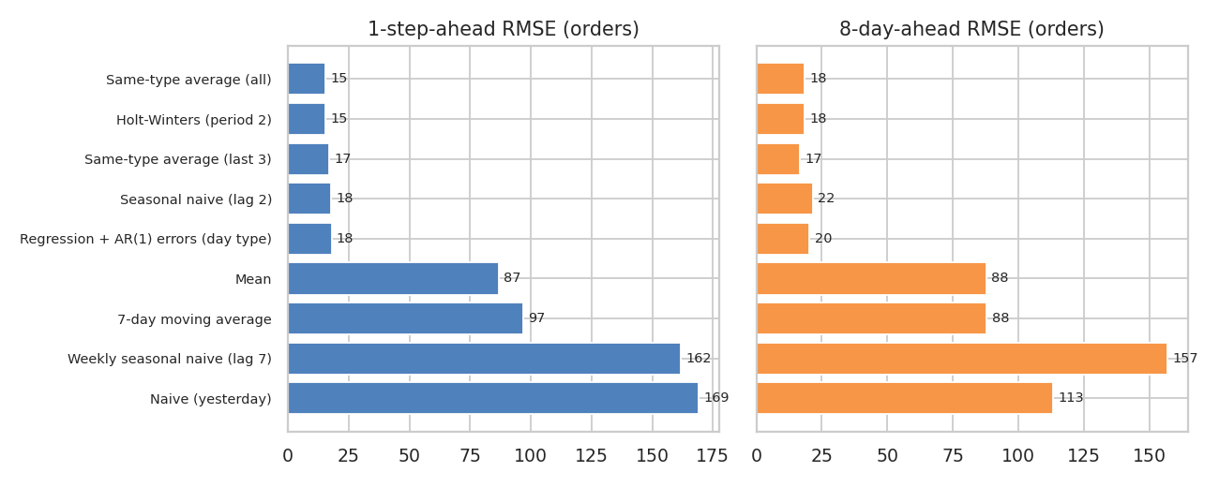
Figure 7: Forecast error of each model (RMSE, in orders)
The result is clear. The standard methods that ignore the 2-day cycle fail badly: the weekly seasonal naive method has a MAPE of 17.1%, and yesterday's value 17.8%, because they predict the wrong type of day (a lag of 7 or 1 days is an odd number, so it points at the opposite day type). Even the mean and the 7-day average are off by about 9%, since they average two very different kinds of day. Models that respect the cycle have errors of about 1.5% (about 15 orders on a base of roughly 950). The five cycle-aware models are within 2.8 orders of each other in RMSE, which is too small to separate them with only 14 and 8 test days. I chose the "same-type average of the last 3 days" because it has the lowest combined RMSE (17.1 one-step and 16.6 eight-day), it is easy to explain, and it reacts to level changes faster than the all-days average.
I also tried to keep the more complex regression with AR(1) errors, but its two components overlap: its autoregressive coefficient is -0.98, which already encodes the alternation, so the day-type coefficient becomes insignificant (p = 0.67). A simpler model is therefore the better choice here. The residuals of the chosen model show no remaining autocorrelation (Ljung-Box p = 0.387, lag-1 correlation -0.21), which means the cycle has been captured fully.

6.5 Forecast for the next 7 days
The cycle is assumed to continue: the last observed day (6 April) was an Evening-only day, so 7 April is an All-day day. The 80% prediction interval is ± 21.5 orders, taken from the 80th percentile of the absolute errors of the chosen model in both backtests.
Date | Day type | Forecast orders | Lower 80% | Upper 80%
2022-04-07 | All-day | 1,042 | 1,020 | 1,064
2022-04-08 | Evening-only | 862 | 841 | 884
2022-04-09 | All-day | 1,042 | 1,020 | 1,064
2022-04-10 | Evening-only | 862 | 841 | 884
2022-04-11 | All-day | 1,042 | 1,020 | 1,064
2022-04-12 | Evening-only | 862 | 841 | 884
2022-04-13 | All-day | 1,042 | 1,020 | 1,064

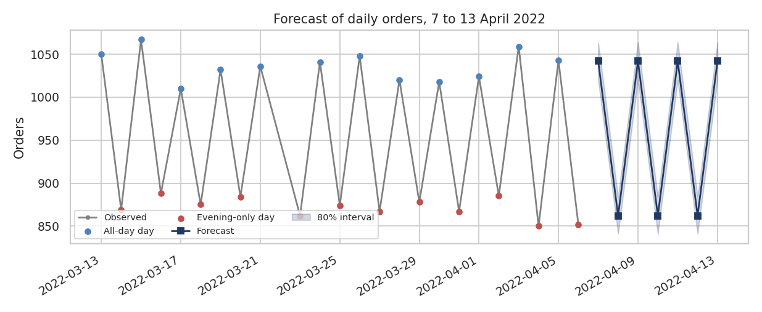
Figure 8: Observed daily orders and the forecast for 7 to 13 April 2022
The weekly total is 6,754 orders (4 All-day and 3 Evening-only days). To get an hourly forecast, I multiply each day's total by the share of orders in each hour for that day type, measured from March and April. This hourly forecast is the input of the staffing optimisation.

7. Part C: Optimisation

7.1 Rider shift scheduling (integer linear programme)
Problem: given the forecast orders per hour, how many riders are needed in each hour and which shifts should they work, to cover the demand at the lowest number of rider-hours? The two day types need very different schedules: All-day days have a morning peak and an evening level, while Evening-only days have almost all the load between 17:00 and 24:00.

7.1.1 Formulation
- Requirement: riders needed in hour h = ceil(orders in hour h × 30 / 60 / 0.8). This uses two assumptions of mine: a rider needs 30 minutes of work per delivery, and should be busy at most 80% of the time. The data records the time from order to delivery and not the rider's working time, so these values cannot be taken from it; Section 7.1.3 shows that the main conclusion does not depend on them.
- Decision variables: x(s, L) = number of riders starting at hour s with a shift of L hours (L = 4, 6 or 8; start hours from 08:00; shifts end by 00:00). They are integers.
- Objective: minimise total rider-hours (plus a small penalty of 0.25 hours per shift to avoid many tiny shifts).
- Constraints: for each hour, the number of riders on shift must be at least the requirement.
from scipy.optimize import milp, LinearConstraint, Bounds

SHIFTS = [(a, L) for L in (4, 6, 8) for a in range(8, 25) if a + L - 1 <= 24]
c = np.array([L + 0.25 for a, L in SHIFTS]) # cost of one shift (hours)
A = np.zeros((len(HOURS), len(SHIFTS))) # A[h, j] = 1 if shift j covers h
for j, (a, L) in enumerate(SHIFTS):
for h in range(a, a + L): A[HOURS.index(h), j] = 1

r = milp(c, constraints=LinearConstraint(A, lb=required_riders, ub=np.inf),
integrality=np.ones(len(SHIFTS)), bounds=Bounds(0, np.inf))
x = np.round(r.x).astype(int) # riders per shift type

7.1.2 Results
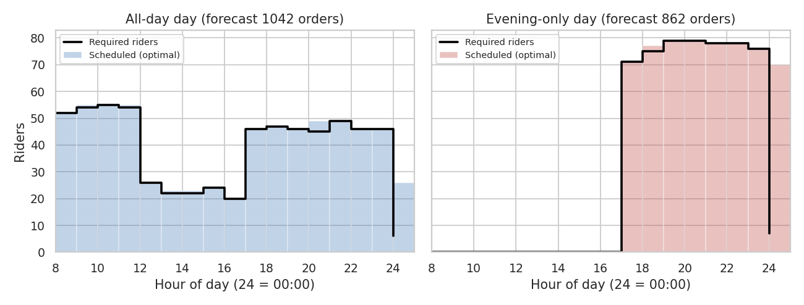
Figure 9: Required riders and the optimal schedule for each day type
On an All-day day (forecast 1,042 orders) the requirement peaks at 55 riders in the morning and stays around 46 to 49 in the evening. On an Evening-only day (862 orders) there is no demand before 17:00, but the requirement reaches 79 riders from 19:00 to 21:00, which is about 70% more than the All-day evening level. The optimal schedules need 688 rider-hours on an All-day day and 608 on an Evening-only day, with the evening-only plan relying mostly on 8-hour shifts starting at 17:00 (70 riders).
To show the value of planning by day type, I compared three policies over the forecast week (4 All-day and 3 Evening-only days):
Policy | Rider-hours (week) | Unmet rider-hours | Cost at Rs 90/h | Peak riders
One schedule for all days, sized for the highest need in every hour | 6,454 | 0 | Rs 580,860 | 79
One schedule for all days, sized for the average demand | 4,620 | 892 | Rs 415,800 | 62
Schedule by day type (optimised) | 4,576 | 0 | Rs 411,840 | 55 / 79

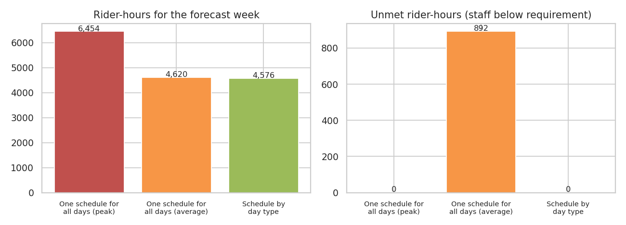
Figure 10: Rider-hours and unmet rider-hours for the three scheduling policies
The safe single schedule covers everything but wastes 1,878 rider-hours (29.1%, about Rs 169,020 at the assumed wage) compared with scheduling by day type, because it keeps morning riders on Evening-only days and evening riders at the Evening-only level on All-day days. The average-based schedule looks cheap but leaves 892 rider-hours of demand uncovered (20.9% of the need), concentrated in the evenings of Evening-only days, which are exactly the hours with the slowest deliveries (Week 3). It even costs 44 more rider-hours than the day-type plan, which covers all demand. Scheduling by day type is therefore both cheaper and safer, and it is possible because the forecast in Part B predicts the day type reliably.

7.1.3 Sensitivity to my assumptions
Rider minutes per delivery | Peak riders All-day | Peak riders Evening-only | Rider-hours saved by day-type plan | Saving %
20 | 37 | 53 | 1,254 | 29%
30 | 55 | 79 | 1,878 | 29.1%
40 | 73 | 105 | 2,488 | 29%

The number of riders needed scales with the assumed work per delivery, but the percentage saving from scheduling by day type stays at 29% to 29.1% in all three cases. The size of the result therefore depends on an assumption I could not verify, but the conclusion does not.

7.2 Vehicle allocation (transportation linear programme)
Problem: the fleet has fixed numbers of motorcycle, scooter and van deliveries. In Week 3 motorcycles were slower than the other vehicles, and the gap changed with traffic. If the same fleet is used, which orders should go to which vehicle to minimise total delivery time?
- Method: I used the trained model to predict, for every order, the delivery time it would have with each of the three vehicle types (changing only the vehicle in the inputs). Orders were grouped into 11 segments by traffic level and distance band (under 6 km, 6 to 12 km, over 12 km), and the average predicted time of each segment under each vehicle gives a cost matrix.
- Linear program: x(s, v) = number of orders of segment s given to vehicle v. Minimise the total predicted minutes, subject to every order getting one vehicle, and the number of orders per vehicle type staying equal to today's (23,555 motorcycle, 13,404 scooter, 3,194 van). This is a transportation problem, solved with the HiGHS solver.
for v in ['Motorcycle', 'Scooter', 'Van']:
d = df[FEATS].copy(); d['Vehicle'] = v # change only the vehicle
cf[v] = model.predict(d) # predicted minutes
T = [[cf.loc[df.segment == s, v].mean() for v in VEH]
for s in segments] # cost matrix

# x[s, v]: every order assigned; vehicle totals stay as today
lp = linprog(T.flatten(), A_eq=A_eq, b_eq=b_eq, bounds=(0, None),
method='highs')

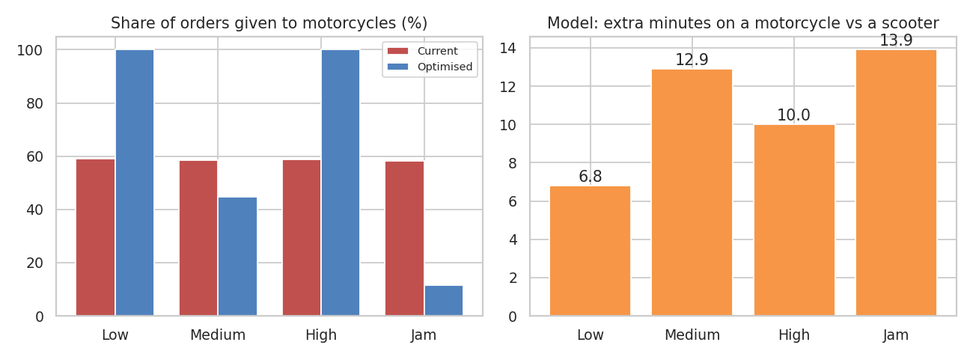
Figure 11: Share of orders given to motorcycles (current and optimised), and the model's motorcycle gap
Traffic level | Orders | Motorcycle share today | Motorcycle share optimised | Gap (min)
Low | 13,758 | 59.1% | 100% | 6.8
Medium | 9,788 | 58.6% | 44.6% | 12.9
High | 3,950 | 58.9% | 100% | 10.0
Jam | 12,657 | 58.2% | 11.7% | 13.9

Today every traffic level gets about 58% to 59% of its orders on motorcycles. The model predicts the largest motorcycle disadvantage in jam (13.9 minutes) and medium traffic (12.9), so the optimum sends scooters and vans to 88.3% of jam orders and 55.4% of medium-traffic orders, and keeps motorcycles for low and high traffic. The predicted saving is 62,992 minutes (1.26% of total predicted time, or 1.57 minutes per order), which is about 1,050 rider-hours over the 44 days (about Rs 94,487 at the assumed rate). For comparison, giving every order a scooter would save 5.07%, but that would need a different fleet. The gain from reshuffling alone is therefore real but modest.
Two cautions apply. The vehicle effect in the data is an association: the motorcycle gap may partly reflect routes or agents that I cannot see, so I would test the new allocation on a small group of orders before applying it. And the optimal allocation is sensitive to small differences between traffic levels (the gap is 10.0 minutes in High traffic but 12.9 in Medium), so the exact percentages should not be over-interpreted.

7.3 Route planning and rider assignment on real coordinates
Problem: when several orders from the same store are waiting, how should they be split between riders, and in which order should each rider visit the customers, to minimise the distance travelled? I used the real store and customer GPS coordinates. A batch (window) is all the orders of one store area placed in the same hour of the same day. I used the 918 windows with at least 8 orders, which contain 9,083 orders (22.6% of all orders), with 9.9 orders per window on average (maximum 19). Each rider can carry at most 6 stops and starts and ends at the store, so each window needs ceil(orders / 6) routes (1,944 routes in total).
Method | How it works
Random assignment (reference) | Orders are shuffled and cut into groups of 6; each rider visits them in that order.
Listed order | Orders are cut into groups of 6 in the order they appear in the data and visited in that order (a proxy for manual planning).
Sweep + listed order | Orders are sorted by angle around the store and cut into equal groups, so each rider serves one direction; visited in listed order.
Sweep + optimised route | Same groups, but each route is improved with the nearest-neighbour heuristic and then 2-opt (swapping the order of stops while the route gets shorter).

ang = np.arctan2(drop_lat - hub_lat, drop_lon - hub_lon) # angle around store
groups = np.array_split(np.argsort(ang), math.ceil(n / 6)) # sweep assignment

def nn_route(D): # nearest neighbour
left, cur, order = set(range(1, len(D))), 0, []
while left:
nxt = min(left, key=lambda j: D[cur, j])
order.append(nxt); left.remove(nxt); cur = nxt
return order

def two_opt(order, D): # reverse segments while it helps
best, bl, improved = order[:], route_len(order, D), True
while improved:
improved = False
for i in range(len(best) - 1):
for j in range(i + 1, len(best)):
cand = best[:i] + best[i:j + 1][::-1] + best[j + 1:]
if route_len(cand, D) < bl - 1e-9:
best, bl, improved = cand, route_len(cand, D), True
return best, bl

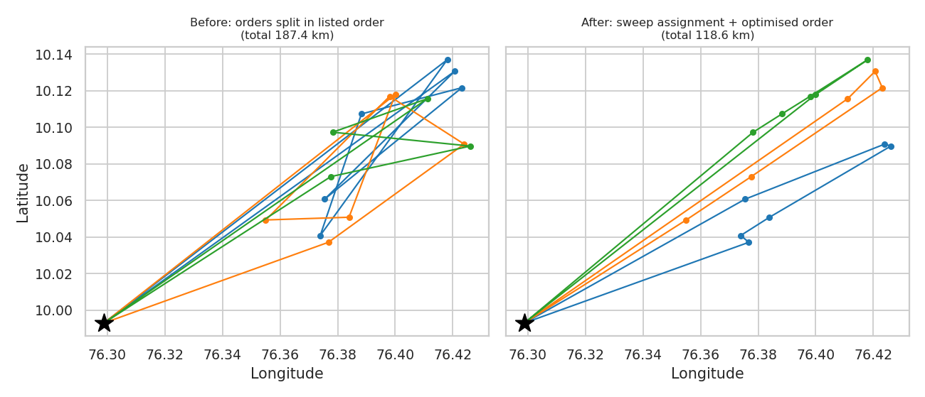
Figure 12: One real batch (store at the star) before and after optimisation
Method | Total km | Km per order | Longest route (km) | Saving vs listed
Random assignment | 81,851.7 | 9.01 | 49.3 | –
Listed order | 82,121.6 | 9.04 | 49.6 | –
Sweep + listed order | 74,786.6 | 8.23 | 42.4 | 8.9%
Sweep + optimised route | 66,028.3 | 7.27 | 36.4 | 19.6%

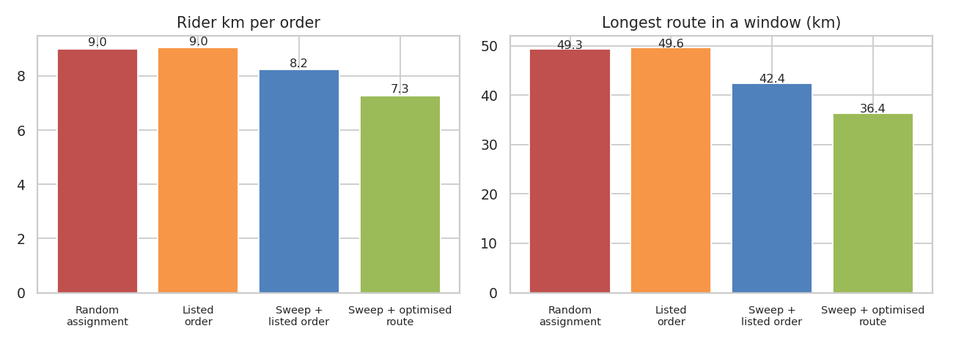
Figure 13: Rider kilometres per order and longest route by method
Splitting orders by direction (sweep) reduces the distance by 8.9%, and optimising the visiting order reduces it by a further 11.7%, giving a total saving of 19.6% compared with the listed order (9.04 to 7.27 km per order). The longest single route falls from 49.6 to 36.4 km on average, which also evens out the work between riders. Over the analysed batches this saves 16,093 km, about Rs 48,280 at an assumed Rs 3 per km, and 97.5% of the batches improve. Each route also takes less rider time, which should help the on-time rate, although I could not measure that from the data. The numbers use straight-line distances and ignore time windows and the road network, so absolute savings on real roads will differ; the relative comparison between methods is what I rely on.

8. Summary of Expected Impact
Lever | Result in this analysis | Basis and caution
Prediction-based promise times | On-time 71.4% → 90.4% at 153.8 min average promise (fixed: 150) | Held-out test orders; the 150-minute target is an assumption
Early warning for late orders | 82.4% of late orders flagged, 91.1% precision | Held-out test orders; needs traffic and weather inputs at order time
Rider scheduling by day type | −29.1% rider-hours (1,878 h per week) | Assumes 30 min rider time per delivery; percentage is stable for 20–40 min
Route planning and batching | −19.6% rider distance on 918 batches | Straight-line distances; capacity of 6 stops assumed
Vehicle reallocation | −1.26% predicted delivery minutes | Based on an association between vehicle and time; pilot first

These gains should not be added together: the levers act on overlapping parts of the process, and I have not measured their interactions.

9. Recommendations
- Plan riders by day type, using the 2-day forecast. This is the largest and most reliable saving in the analysis, and the forecast is accurate (about 1.5% error). Start with the evening of Evening-only days, where the requirement is about 79 riders against 46 to 49 on All-day days.
- Show model-based promise times to customers, and use the early warning internally. Round the promise to a sensible range, and review the 90% target and the buffer each month.
- Batch orders by direction and optimise the visiting order before dispatch. Even the simple sweep assignment saves about 9%, and the route optimisation adds a further 12%.
- Pilot the vehicle reallocation on a small share of orders (for example, scooters and vans on jam deliveries) and compare the result with a control group before changing the whole fleet.
- Close the data gaps. Record the real rider working time per delivery, actual costs, promised delivery times and traffic and weather at the time of the order, and find out why 11 days are missing. Several assumptions in this report would then be replaced by facts.
- Monitor. Track the MAE of the delivery-time model and the MAPE of the forecast every week, the on-time rate by traffic level, and the unmet rider-hours. Retrain the model monthly, and review the 2-day cycle assumption if the forecast error grows.

10. Limitations
- As noted in Week 3, the dataset has unusually regular patterns (traffic fixed by the hour, a strict 2-day cycle, a jump at age 30). The high accuracy of the model (R² 0.82) and of the forecast (about 1.5% error) may partly reflect this regularity. On a real courier's data I would expect lower accuracy, and the models should be re-tested on that data.
- The forecast is based on 36 observed days (18 of each type). It assumes that the 2-day cycle continues; if the pattern breaks, the forecast will be wrong. The prediction interval comes from only 22 backtest errors, so it is approximate. There is no information on holidays, promotions or weather.
- The staffing result depends on my assumptions for rider work per delivery (30 minutes) and utilisation (80%), and on flexible 4, 6 and 8-hour shifts. The percentage saving is stable, but the absolute number of riders is not.
- The vehicle result is based on a model of associations, not on an experiment. The routing results use straight-line distances, a capacity of 6 stops and no time windows.
- The cost and wage values (Rs 1.5 per minute, Rs 3 per km) are assumptions, as in Week 3.
- The 150-minute delivery target is my assumption because the dataset has no promised times.

11. Conclusion
In this final week I built a delivery time model that explains 82% of the variation (MAE 17.26 minutes), validated it with cross-validation, a random test set and a later time period, and used it to flag late orders and to set promise times that raise on-time delivery from 71.4% to 90.4%. I forecast daily demand with an error of about 1.5% by respecting the 2-day cycle that standard methods miss, and used that forecast in an integer program that plans rider shifts by day type and saves 29.1% of rider-hours. A transportation program for the vehicle fleet and a sweep and 2-opt method for routing complete the optimisation, with savings of 1.26% of delivery minutes and 19.6% of rider distance.
Across the four weeks, the project moved from planning (Week 1), to a real dataset with 11 documented data problems (Week 2), to an analysis that found what drives delay and how demand behaves over time (Week 3), and finally to predictions and decisions (Week 4). The same finding runs through all weeks: the evening peak and the day-type cycle are the main pressure points in this operation, and a forecast-driven plan is the most effective way to deal with them.

References
- Amazon Delivery Dataset, Kaggle (kaggle.com). Public dataset of e-commerce deliveries.
- Pedregosa, F. et al. (2011). Scikit-learn: Machine Learning in Python. Journal of Machine Learning Research, 12, 2825–2830.
- Seabold, S., Perktold, J. (2010). Statsmodels: Econometric and statistical modeling with Python. Proceedings of the 9th Python in Science Conference.
- Hyndman, R. J., Athanasopoulos, G. (2021). Forecasting: Principles and Practice (3rd ed.). OTexts. (forecast accuracy measures and backtesting).
- Virtanen, P. et al. (2020). SciPy 1.0: fundamental algorithms for scientific computing in Python. Nature Methods, 17, 261–272. (milp and linprog solvers).
- Gillett, B. E., Miller, L. R. (1974). A heuristic algorithm for the vehicle-dispatch problem. Operations Research, 22(2), 340–349. (sweep algorithm).
- Croes, G. A. (1958). A method for solving traveling-salesman problems. Operations Research, 6(6), 791–812. (2-opt).
- Dantzig, G. B., Ramser, J. H. (1959). The truck dispatching problem. Management Science, 6(1), 80–91.

