Chinook Music Store - SQL Data Analysis & Business Insights
1. Project Overview
Project Objective
In this project, I analyzed the Chinook Music Store database using SQL to understand how the business is performing and how customers are purchasing music. I worked with the relational database to analyze sales, customer behavior, product and genre performance, customer churn, regional markets, and purchasing patterns.
My main goal was to take the available data, identify useful business patterns, and convert those findings into insights that could help with sales growth, customer retention, product recommendations, and regional market opportunities.
Areas I Analyzed
- I focused on the following areas:
- Sales and product performance
- Customer purchasing behavior
- Customer value and purchasing frequency
- Customer churn and inactivity
- Genre and artist performance
- Customer genre preferences
- Product affinity and cross-selling opportunities
- Regional and international market performance
- Customer risk analysis
- Customer Lifetime Value (CLV)
My Approach
I followed a simple process throughout the analysis:
Understand the data → Validate the data → Analyze the data → Visualize the results → Identify insights → Give business recommendations
I used SQL queries to explore the database, calculate different business metrics, compare customer and product performance, and identify patterns across different countries, genres, and customer groups.
Database Overview
The Chinook database contains 11 core relational tables covering customers, invoices, invoice items, tracks, albums, artists, genres, employees, and other related information. The dataset contains 59 customers across 24 countries, with invoice activity covering the period from 2017 to 2020.
Throughout the project, I used SQL techniques such as JOINs, CTEs, aggregate functions, subqueries, window functions, ranking, and date-based calculations to perform the analysis.
2. Data Quality Assessment
2.1 Data Validation Approach
Before starting the main analysis, I first checked the quality and structure of the Chinook database. I reviewed all 11 tables to identify missing values and duplicate records.
For missing values, I checked the table structure and counted NULL values in each column. For duplicate records, I grouped the data by the primary key and checked whether any key appeared more than once.
2.2 Missing Values and Duplicate Records
I found NULL values mainly in optional fields:
- The Customer table has NULLs in company, state, postal_code, phone, and fax.
- The Employee table has 1 NULL value in reports_to, which is expected for the top-level manager.
- The Track table has 978 NULL values in composer, meaning many tracks do not have composer information.
- No duplicate records were found across the 11 tables, and the primary keys were unique.
2.3 How I Handled the Data
For NULL values, I first considered whether the missing value was actually important for the analysis. Where required, NULLs can be handled using COALESCE() or filtered using IS NULL / IS NOT NULL.
Since I did not find any duplicate records, there was no need to remove duplicates. If duplicates had been present, I could have used ROW_NUMBER() to identify the records that needed to be removed.
2.4 SQL Queries
Customer Table – NULL Check
SELECT
COUNT(*) AS total_customers,
SUM(company IS NULL) AS null_company,
SUM(state IS NULL) AS null_state,
SUM(postal_code IS NULL) AS null_postal_code,
SUM(phone IS NULL) AS null_phone,
SUM(fax IS NULL) AS null_fax
FROM customer;

Customer Table – Duplicate Check
SELECT customer_id, COUNT(*) AS cnt
FROM customer
GROUP BY customer_id
HAVING COUNT(*) > 1;

Employee Table – NULL Check
SELECT
SUM(reports_to IS NULL) AS null_reports,
SUM(title IS NULL) AS null_title,
SUM(fax IS NULL) AS null_fax
FROM employee;

Employee Table – Duplicate Check
SELECT employee_id, COUNT(*) AS empDupCnt
FROM employee
GROUP BY employee_id
HAVING COUNT(*) > 1;

2.5 Results and Key Insights
The data quality check showed that the database is largely consistent for analysis. Most NULL values are in fields that are not mandatory for every record, while the missing composer information in the Track table is more relevant when doing composer-level analysis.
The most important finding from this check was that no duplicate records were found across the 11 tables, so I could proceed with the analysis without having to remove duplicate records.
3. Sales & Product Performance
3.1 USA Track & Artist Performance
I started by analyzing sales in the USA to identify the top-selling tracks, the best-performing artist, and the main genre associated with the top artist.
Analysis Approach
To find the top-selling tracks, I joined the customer, invoice, invoice_line, track, album, and artist tables. I filtered the data for customers from the USA and calculated total sales for each track.
The track → album → artist join was necessary because the Track table does not directly contain the artist information. The Album table connects the track with its artist.
Part 1 — Top-Selling Tracks in the USA
SQL Query
SELECT
t.name AS track_name,
ar.name AS artist_name,
SUM(il.unit_price * il.quantity) AS total_sales
FROM customer c
JOIN invoice i ON c.customer_id = i.customer_id
JOIN invoice_line il ON i.invoice_id = il.invoice_id
JOIN track t ON il.track_id = t.track_id
JOIN album al ON t.album_id = al.album_id
JOIN artist ar ON al.artist_id = ar.artist_id
WHERE c.country = 'USA'
GROUP BY t.track_id, t.name, ar.name
ORDER BY total_sales DESC
LIMIT 10;
Output / Results
- War Pigs was the top-selling track in the USA with total sales of $5.94.
- You Know I'm No Good (feat. Ghostface Killah) ranked second with $4.95 in total sales.
- Seven tracks were tied at $3.96 each.
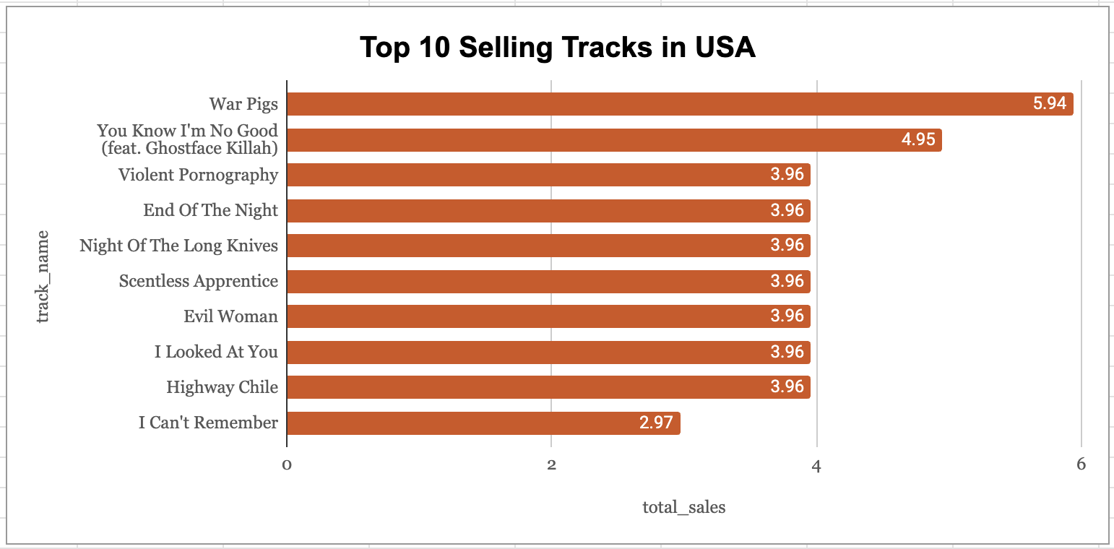
Part 2 — Top Artist in the USA
I then used the same join approach but grouped the sales by artist instead of track.
SQL Query
SELECT
ar.name AS artist_name,
SUM(il.unit_price * il.quantity) AS total_sales
FROM customer c
JOIN invoice i ON c.customer_id = i.customer_id
JOIN invoice_line il ON i.invoice_id = il.invoice_id
JOIN track t ON il.track_id = t.track_id
JOIN album al ON t.album_id = al.album_id
JOIN artist ar ON al.artist_id = ar.artist_id
WHERE c.country = 'USA'
GROUP BY ar.artist_id, ar.name
ORDER BY total_sales DESC
LIMIT 1;

Output / Results
Van Halen was the top-selling artist in the USA, with total sales of $42.57.


Part 3 — Top Genre of the Top Artist
After identifying Van Halen as the top-selling artist, I added the genre table to find which genre generated the highest sales for the artist.
SQL Query
SELECT
ar.name AS artist_name,
g.name AS genre_name,
SUM(il.unit_price * il.quantity) AS total_sales
FROM customer c
JOIN invoice i ON c.customer_id = i.customer_id
JOIN invoice_line il ON i.invoice_id = il.invoice_id
JOIN track t ON il.track_id = t.track_id
JOIN album al ON t.album_id = al.album_id
JOIN artist ar ON al.artist_id = ar.artist_id
JOIN genre g ON t.genre_id = g.genre_id
WHERE c.country = 'USA'
AND ar.name = 'Van Halen'
GROUP BY ar.name, g.genre_id, g.name
ORDER BY total_sales DESC
LIMIT 1;

Output / Results
For Van Halen, Rock was the top genre, with total sales of $42.57.
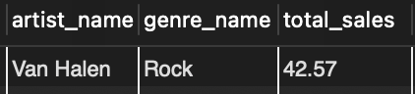
Key Insights
- Van Halen generated the highest total sales among artists in the USA, with $42.57.
- Rock was also Van Halen's highest-selling genre.
- War Pigs was the highest-selling individual track at $5.94.
- The results show that Rock had a strong presence in the USA sales data.
3.2 Revenue & Invoice Performance
Analysis Approach
After looking at track and artist performance, I analyzed the revenue generated across different countries, states, and cities.
I joined the Customer and Invoice tables and grouped the data by country, state, and city. I used the invoice.total column to calculate revenue because the analysis is being done at the invoice/location level.
SQL Query
SELECT
c.country,
c.state,
c.city,
COUNT(DISTINCT i.invoice_id) AS total_invoices,
SUM(i.total) AS total_revenue
FROM customer c
JOIN invoice i
ON c.customer_id = i.customer_id
GROUP BY
c.country,
c.state,
c.city
ORDER BY
c.country,
c.state,
c.city;

Output / Results
The analysis showed that:
- The USA generated $1,040.49 in total revenue from 131 invoices.
- Canada generated $535.59 from 76 invoices.
- Some countries, such as Argentina, Austria, and Belgium, have NULL values for state because a state/province field is not applicable or available for those records.
- Brazil appears across multiple cities, including São Paulo, Brasília, Rio de Janeiro, and São José dos Campos.
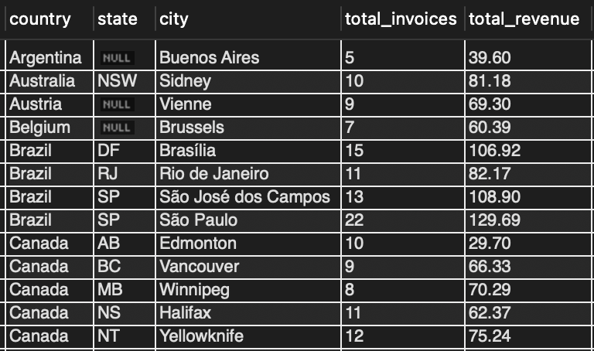
Visual Analysis
- Total Revenue by Country
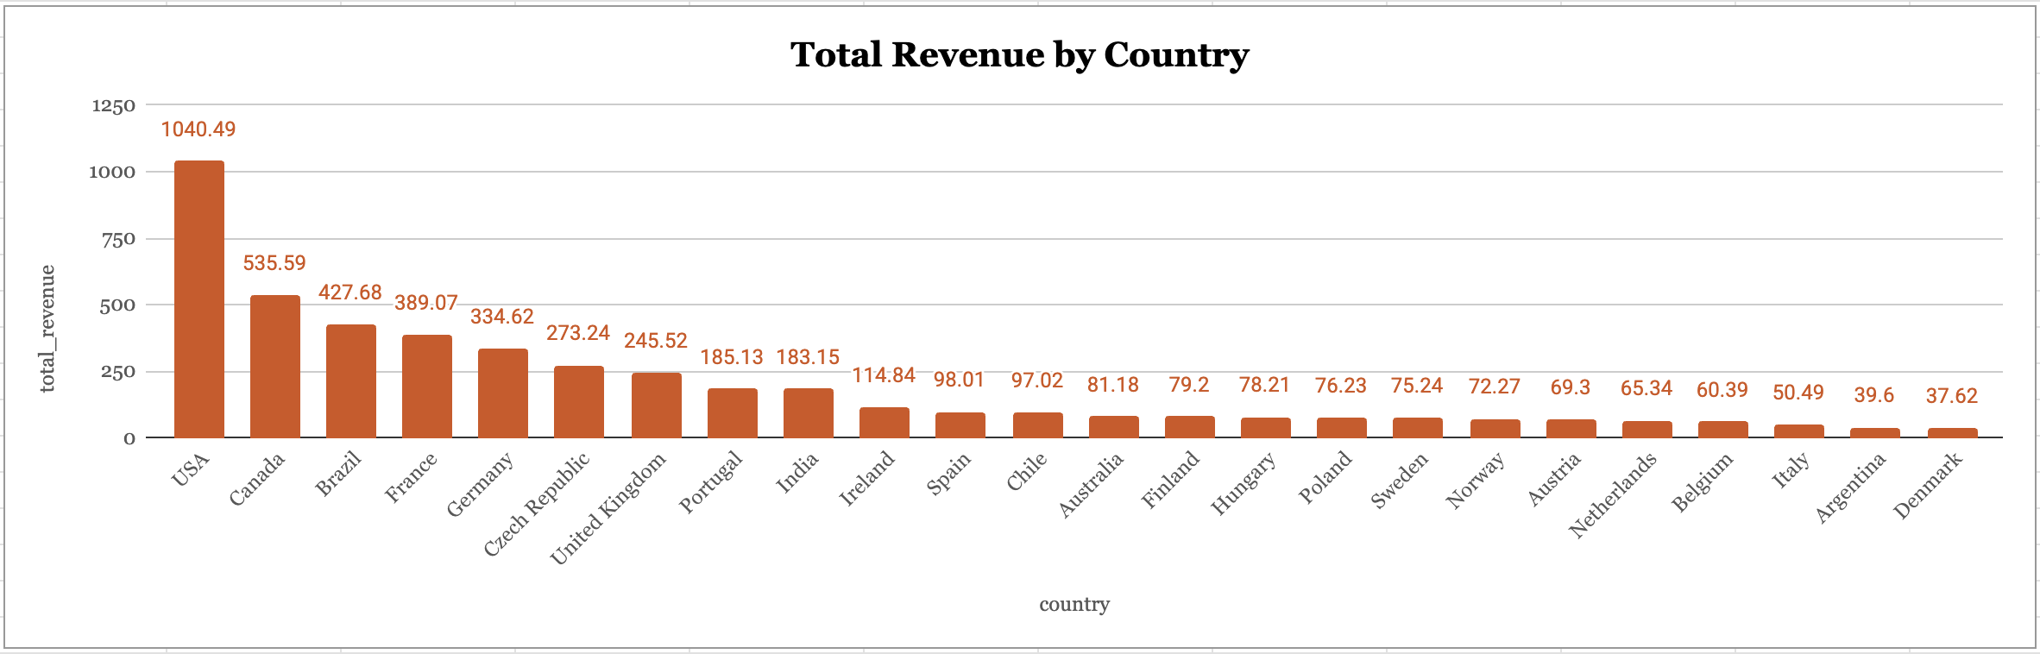
- Total Invoices by Country
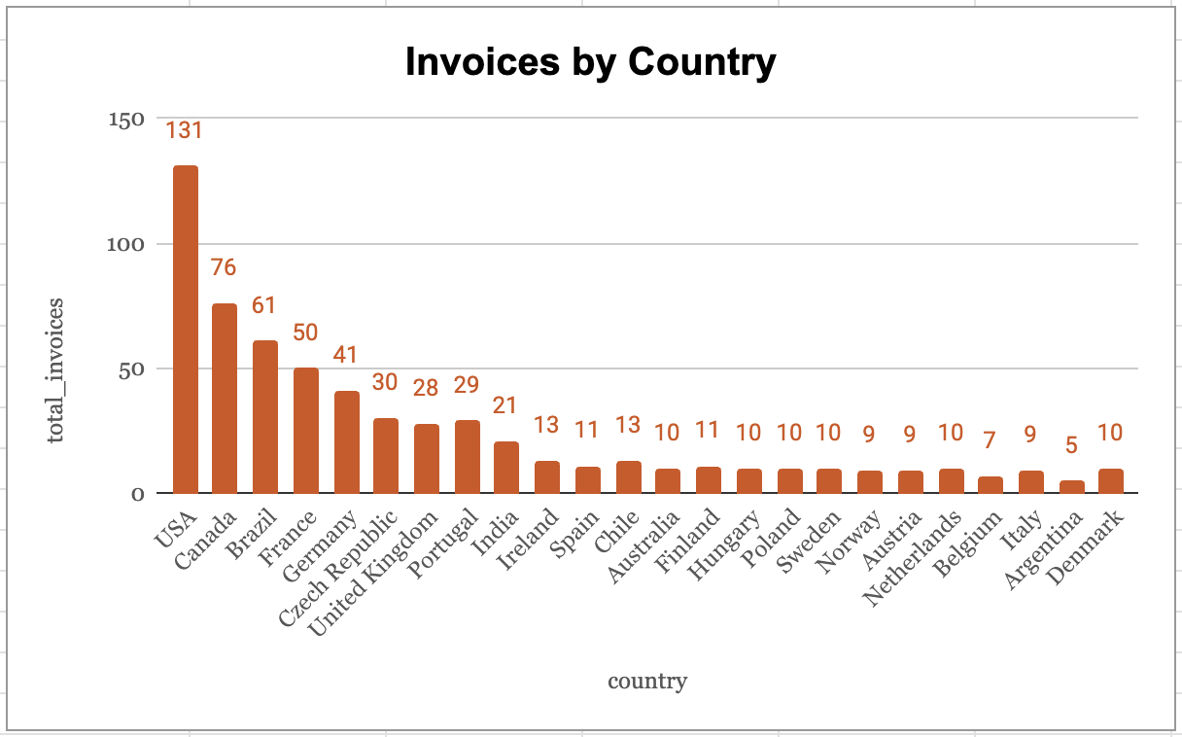
Key Insights
- The USA generated the highest revenue and number of invoices in the dataset.
- Canada was the second-highest country by both revenue and invoice count.
- The revenue and invoice charts show a similar country-level pattern, where countries with more invoices generally generate higher total revenue.
- Breaking the data down by country, state, and city helped me understand where the sales activity is concentrated.

3.3 Customer Product Preferences
Analysis Approach
I wanted to understand which track each customer purchased the most. For this, I calculated the total sales for each track purchased by each customer and then ranked the tracks within each customer.
I used a CTE with ROW_NUMBER() and partitioned the results by customer_id. I used ROW_NUMBER() because I wanted to return exactly one top-selling track for each customer, even if there was a tie.
SQL Query
WITH customer_track_sales AS (
SELECT
c.customer_id,
CONCAT(c.first_name, ' ', c.last_name) AS customer_name,
t.name AS track_name,
SUM(il.unit_price * il.quantity) AS total_sales,
ROW_NUMBER() OVER (
PARTITION BY c.customer_id
ORDER BY SUM(il.unit_price * il.quantity) DESC
) AS rn
FROM customer c
JOIN invoice i ON c.customer_id = i.customer_id
JOIN invoice_line il ON i.invoice_id = il.invoice_id
JOIN track t ON il.track_id = t.track_id
GROUP BY c.customer_id, c.first_name, c.last_name, t.track_id, t.name
)
SELECT
customer_id,
customer_name,
track_name,
total_sales
FROM customer_track_sales
WHERE rn = 1
ORDER BY customer_id;
Output / Results
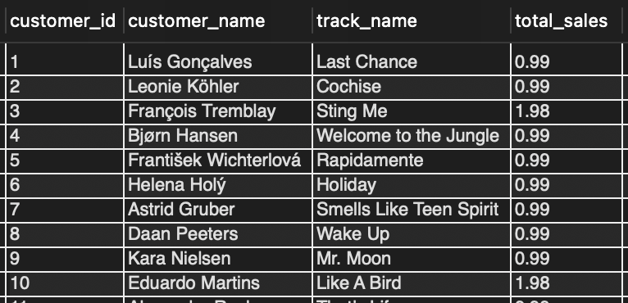
Key Insights
- Each customer has one top-selling track in the final result because ROW_NUMBER() assigns a separate ranking within each customer.
- Most of the top-selling tracks are priced at $0.99, while some are priced at $1.98.
- For example, François Tremblay's top-selling track was Sting Me, while Eduardo Martins' was Like A Bird.
- The different top-selling tracks across customers show that customers have varied music preferences.
3.4 USA Genre & Artist Performance
Analysis Approach
After analyzing individual tracks and artists, I looked at the overall genre performance in the USA. I wanted to understand which genres contribute the most to sales and which artists are performing the best within the USA market.
For the genre analysis, I calculated total sales using unit_price × quantity at the track level. I also used a window function SUM(...) OVER() to calculate each genre's percentage contribution to total USA sales.
I then used a similar approach to identify the top-selling artists and their associated genres.
Part 1 — Genre Sales Contribution in the USA
SQL Query
SELECT
g.name AS genre_name,
SUM(il.unit_price * il.quantity) AS total_sales,
ROUND(SUM(il.unit_price * il.quantity) * 100.0 /
SUM(SUM(il.unit_price * il.quantity)) OVER(), 2) AS sales_percentage
FROM customer c
JOIN invoice i ON c.customer_id = i.customer_id
JOIN invoice_line il ON i.invoice_id = il.invoice_id
JOIN track t ON il.track_id = t.track_id
JOIN genre g ON t.genre_id = g.genre_id
WHERE c.country = 'USA'
GROUP BY g.genre_id, g.name
ORDER BY total_sales DESC;

Output / Results
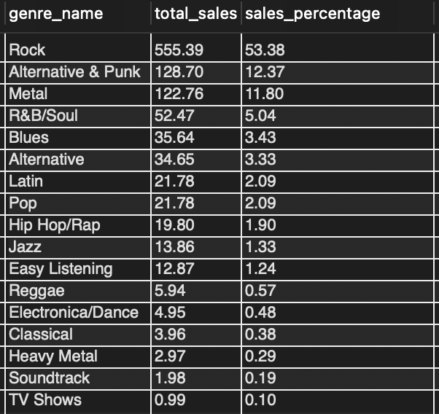
Visual
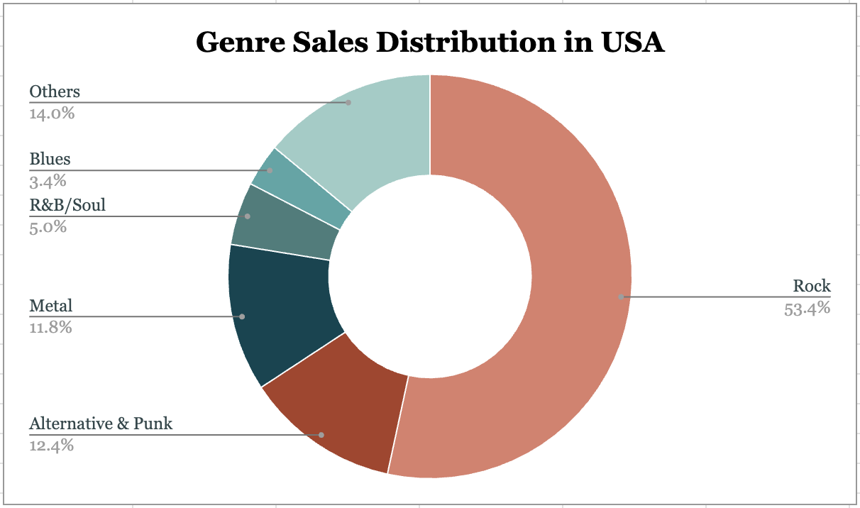
Note: Top 5 genres shown individually, remaining 12 genres grouped as "Others" (14.0%).

Part 2 — Best-Selling Artists in the USA
SQL Query
SELECT
ar.name AS artist_name,
g.name AS genre_name,
SUM(il.unit_price * il.quantity) AS total_sales
FROM customer c
JOIN invoice i ON c.customer_id = i.customer_id
JOIN invoice_line il ON i.invoice_id = il.invoice_id
JOIN track t ON il.track_id = t.track_id
JOIN album al ON t.album_id = al.album_id
JOIN artist ar ON al.artist_id = ar.artist_id
JOIN genre g ON t.genre_id = g.genre_id
WHERE c.country = 'USA'
GROUP BY ar.artist_id, ar.name, g.genre_id, g.name
ORDER BY total_sales DESC
LIMIT 10;
Output / Results
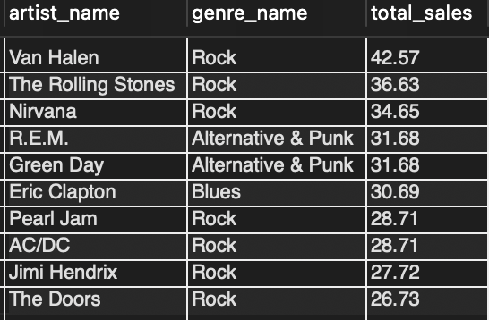
Key Insights
- Rock generated 53.38% of USA sales, with total sales of $555.39.
- Alternative & Punk contributed 12.37%, while Metal contributed 11.80%.
- The top three artists by sales were Van Halen ($42.57), The Rolling Stones ($36.63), and Nirvana ($34.65).
- 7 of the top 10 artists belonged to the Rock genre.
- R.E.M. and Green Day had the same sales of $31.68 in Alternative & Punk.
- Pearl Jam and AC/DC had the same sales of $28.71 in Rock.
Overall, this analysis helped me understand the genre mix in the USA and identify the artists contributing most to the sales within those genres.

3.5 USA Genre Sales Ranking
Analysis Approach
After analyzing the overall genre contribution in the USA, I wanted to rank all genres based on their total sales and understand how they perform against each other.
I joined the Customer, Invoice, Invoice Line, Track, and Genre tables to calculate total sales for each genre in the USA. I used the RANK() window function to assign a rank based on total sales in descending order.
I used RANK() instead of ROW_NUMBER() because genres with the same sales should receive the same rank. For example, Latin and Pop have identical sales, so both receive rank 7.
SQL Query
SELECT
RANK() OVER (ORDER BY SUM(il.unit_price * il.quantity) DESC) AS genre_rank,
g.name AS genre_name,
SUM(il.unit_price * il.quantity) AS total_sales
FROM customer c
JOIN invoice i ON c.customer_id = i.customer_id
JOIN invoice_line il ON i.invoice_id = il.invoice_id
JOIN track t ON il.track_id = t.track_id
JOIN genre g ON t.genre_id = g.genre_id
WHERE c.country = 'USA'
GROUP BY g.genre_id, g.name
ORDER BY genre_rank;

Output / Results
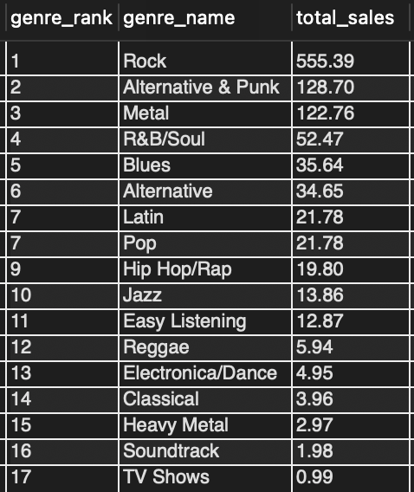
Key Insights
- Rock ranks first with total sales of $555.39, nearly four times the second-ranked genre, Alternative & Punk ($128.70).
- Latin and Pop are tied at rank 7, with identical sales of $21.78 each.
- TV Shows ranks last, at position 17, with only $0.99 in total sales.
- The top three genres — Rock, Alternative & Punk, and Metal — together account for over 77% of total USA sales.
Business Takeaway
The sales ranking shows that most USA revenue comes from a small group of genres, particularly Rock. This information can help the business focus its product promotions and marketing efforts on genres that already have strong customer demand.

4. Customer Base & Purchasing Behavior
4.1 Customer Geographic Distribution
Analysis Approach
I wanted to understand where Chinook's customers are located and how the customer base is distributed across different countries and cities.
The original question also asked for an age and gender breakdown. However, the Chinook database does not contain age or gender information, so I focused on the available location data.
I used the Customer table and grouped the records by country and city. I used COUNT(customer_id) to calculate the number of customers in each location and sorted the results in descending order to identify locations with more customers.
SQL Query
SELECT
country,
city,
COUNT(customer_id) AS total_customers
FROM customer
GROUP BY country, city
ORDER BY total_customers DESC;

Output / Results
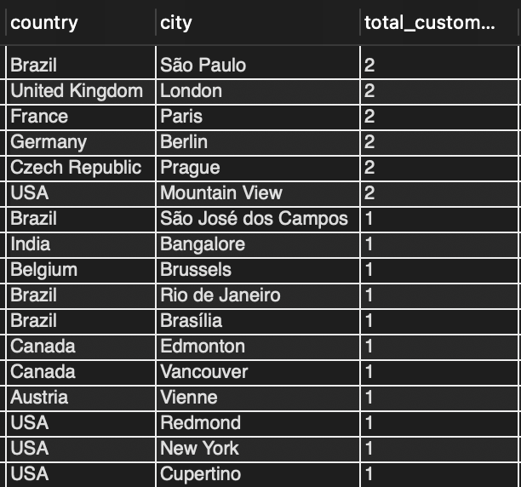
Visual
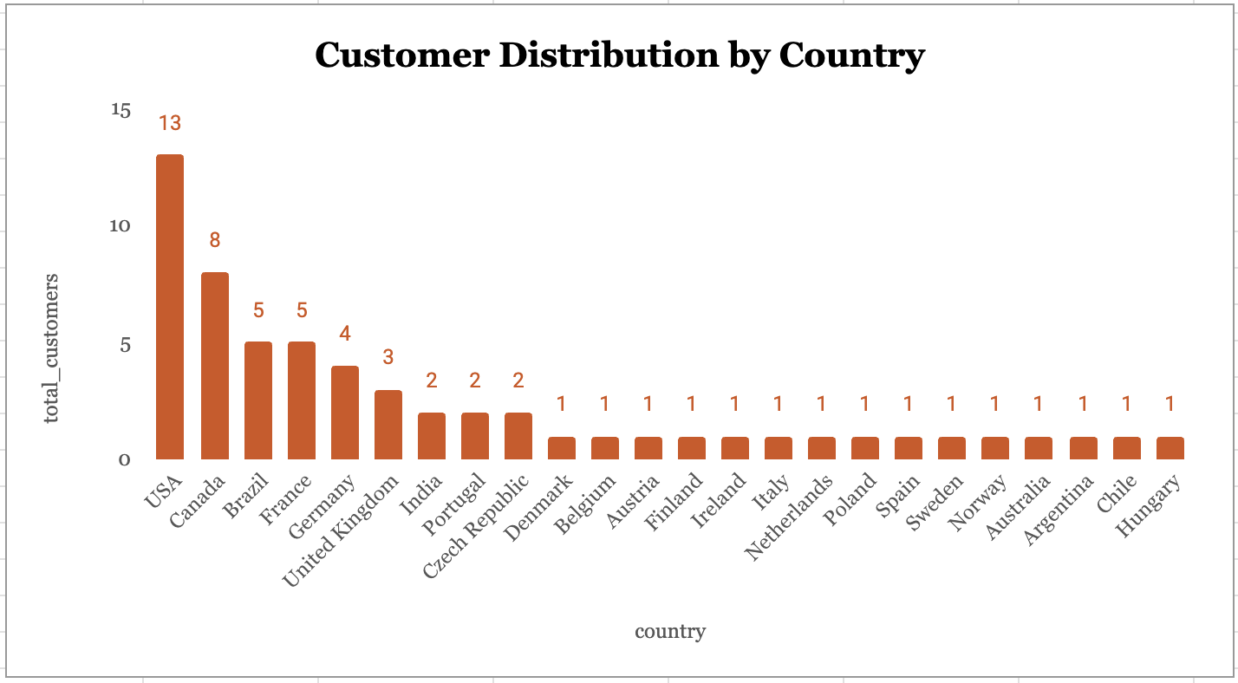
Key Insights
- The USA has the highest number of customers (13), followed by Canada (8), Brazil (5), and France (5).
- São Paulo, London, Paris, Berlin, Prague, and Mountain View each have 2 customers, the highest count among the cities.
- 15 out of 24 countries have only 1 customer, showing that Chinook has customers spread across several countries.
- Age and gender information is not available in the database, so a deeper demographic analysis cannot be performed using the current dataset.
Business Takeaway
The customer base is spread across multiple countries, but the USA and Canada have larger customer groups than other markets. This location information can help the business understand its existing customer reach and identify regions where it may explore further growth.

4.2 Top Customers by Country
Analysis Approach
I wanted to identify the highest-revenue customers in each country and understand how customer spending varies across different markets.
I joined the Customer and Invoice tables to calculate the total revenue generated by each customer using SUM(i.total). I then used a Common Table Expression (CTE) with the RANK() window function and PARTITION BY country to rank customers separately within each country.
Using RANK() allowed me to identify the top five customers in every country rather than just the top five customers across the entire database.

SQL Query
WITH customer_revenue AS (
SELECT
c.country,
c.customer_id,
CONCAT(c.first_name, ' ', c.last_name) AS customer_name,
SUM(i.total) AS total_revenue,
RANK() OVER (PARTITION BY c.country ORDER BY SUM(i.total) DESC) AS rnk
FROM customer c
JOIN invoice i ON c.customer_id = i.customer_id
GROUP BY c.country, c.customer_id, c.first_name, c.last_name
)
SELECT
country,
customer_name,
total_revenue,
rnk
FROM customer_revenue
WHERE rnk <= 5
ORDER BY country, total_revenue DESC;

Output / Results
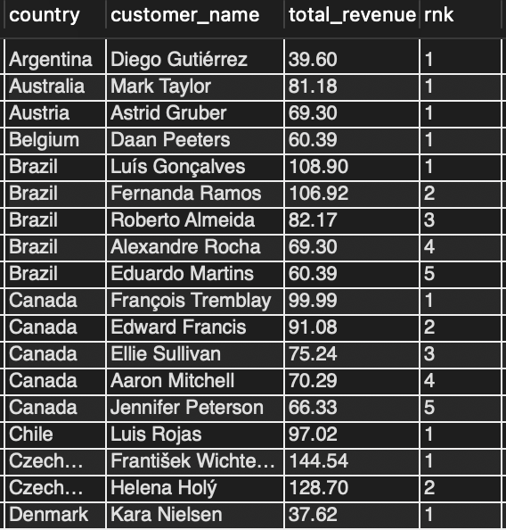
Key Insights
- Frantisek Wichterlova from the Czech Republic is the highest-revenue customer overall, generating $144.54.
- In Brazil, Luís Gonçalves is the top customer with $108.90 in revenue.
- In Canada, Francois Tremblay leads with $99.99 in revenue.
- Countries with only one customer, such as Argentina, Australia, and Austria, show only one customer at rank 1. Countries such as Brazil and Canada have up to five ranked customers.
- Using RANK() with PARTITION BY country ensures that each country's customers receive an independent ranking.
Business Takeaway
Identifying high-revenue customers in each country helps Chinook understand which customers contribute more to revenue within individual markets. This information can support customer-focused retention activities and help the business identify valuable customers across different regions.

4.3 Customer Purchasing Behaviour
Analysis Approach
I wanted to understand how frequently customers make purchases, how much they spend on each order, and how much revenue they generate overall.
I joined the Customer and Invoice tables and calculated three metrics for each customer:
- Purchase Frequency: Total number of distinct invoices.
- Average Order Value (AOV): Average amount spent per invoice.
- Total Revenue: Total amount spent across all invoices.
I grouped the results by customer and sorted them by purchase frequency to identify frequent buyers and compare their spending patterns.
Payment method information is not available in the Chinook database, so I could not analyze customer preferences for different payment methods.

SQL Query
SELECT
c.customer_id,
CONCAT(c.first_name, ' ', c.last_name) AS customer_name,
c.country,
COUNT(DISTINCT i.invoice_id) AS purchase_frequency,
ROUND(AVG(i.total), 2) AS avg_order_value,
ROUND(SUM(i.total), 2) AS total_revenue
FROM customer c
JOIN invoice i ON c.customer_id = i.customer_id
GROUP BY c.customer_id, c.first_name, c.last_name, c.country
ORDER BY purchase_frequency DESC, avg_order_value DESC;

Output / Results
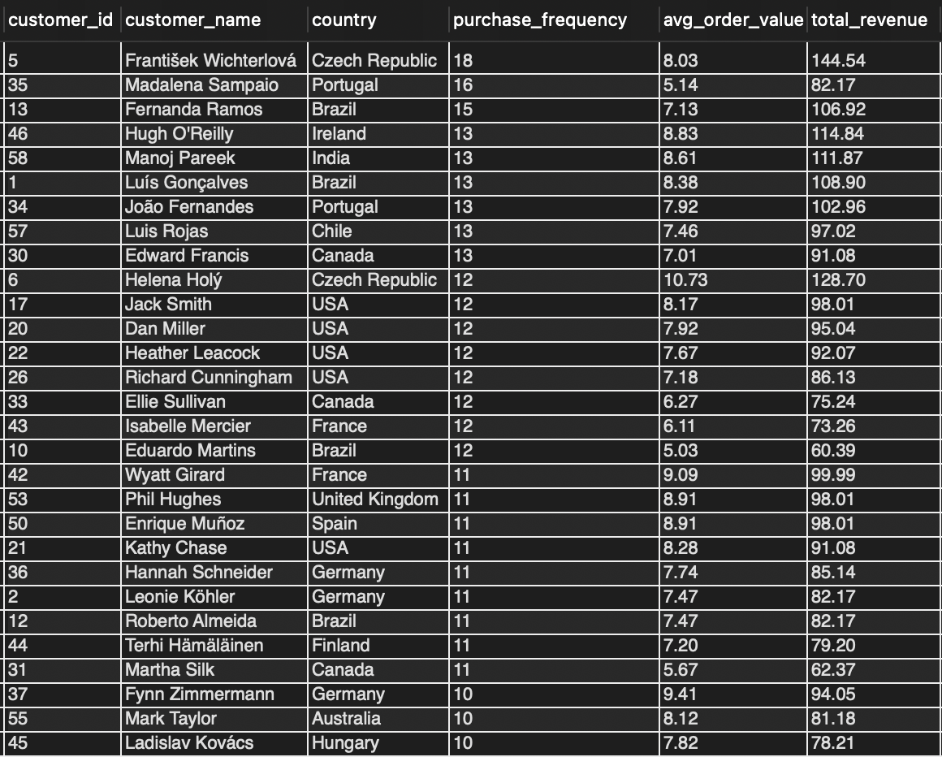

Visual – Purchase Frequency vs Average Order Value
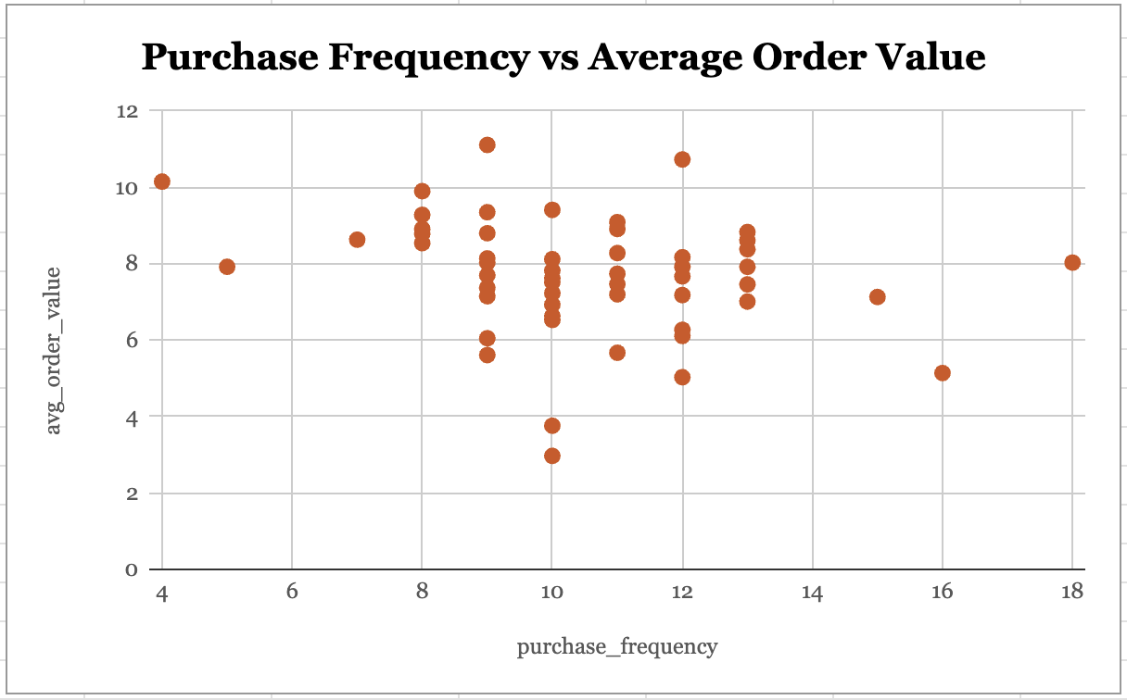
Key Insights
- Frantisek Wichterlova from the Czech Republic is the most frequent buyer, with 18 purchases and total revenue of $144.54.
- Helena Holy from the Czech Republic has the highest average order value of $10.73, indicating that she spends more per purchase than other customers.
- The scatter plot shows no strong correlation between purchase frequency and average order value. Customers who purchase more frequently do not necessarily spend more per order.
- Most customers fall within the range of 8–13 purchases, with an average order value between $7 and $9.
- Payment method preferences cannot be analyzed because the required data is not available.
Business Takeaway
Purchase frequency and average order value provide different ways to understand customer spending behavior. Chinook can use these metrics to identify frequent buyers and customers with higher spending per order, then consider suitable loyalty offers and personalized promotions for different customer groups.

4.4 Long-Term Customer Behaviour
Analysis Approach
I wanted to understand how long customers have been associated with Chinook and evaluate their purchasing behavior over time.
I used two CTEs to perform this analysis:
- customer_tenure: Calculated each customer's first purchase date, last purchase date, and total tenure in days. Customers with a tenure of at least 365 days were classified as Long-Term; the remaining customers were classified as New.
- customer_stats: Calculated purchase frequency, average order value, total spending, and the number of distinct tracks purchased by each customer.
I then joined these results to compare the customer groups and calculate their average purchasing metrics.
SQL Query
WITH customer_tenure AS (
SELECT c.customer_id,
CONCAT(c.first_name, ' ', c.last_name) AS customer_name,
c.country,
MIN(i.invoice_date) AS first_purchase_date,
MAX(i.invoice_date) AS last_purchase_date,
DATEDIFF(MAX(i.invoice_date), MIN(i.invoice_date)) AS tenure_days,
CASE
WHEN DATEDIFF(MAX(i.invoice_date), MIN(i.invoice_date)) >= 365
THEN 'Long-Term' ELSE 'New'
END AS customer_type
FROM customer c
JOIN invoice i ON c.customer_id = i.customer_id
GROUP BY c.customer_id, c.first_name, c.last_name, c.country
),
customer_stats AS (
SELECT c.customer_id,
COUNT(DISTINCT i.invoice_id) AS purchase_frequency,
ROUND(AVG(i.total), 2) AS avg_order_value,
ROUND(SUM(i.total), 2) AS total_spending,
COUNT(DISTINCT il.track_id) AS total_tracks
FROM customer c
JOIN invoice i ON c.customer_id = i.customer_id
JOIN invoice_line il ON i.invoice_id = il.invoice_id
GROUP BY c.customer_id
)
SELECT ct.customer_type,
COUNT(ct.customer_id) AS total_customers,
ROUND(AVG(cs.purchase_frequency), 2) AS avg_purchase_frequency,
ROUND(AVG(cs.avg_order_value), 2) AS avg_order_value,
ROUND(AVG(cs.total_spending), 2) AS avg_total_spending,
ROUND(AVG(cs.total_tracks), 2) AS avg_tracks_purchased
FROM customer_tenure ct
JOIN customer_stats cs ON ct.customer_id = cs.customer_id
GROUP BY ct.customer_type
ORDER BY avg_total_spending DESC;

Output / Results

Visual – Long-Term Customer Behaviour Metrics
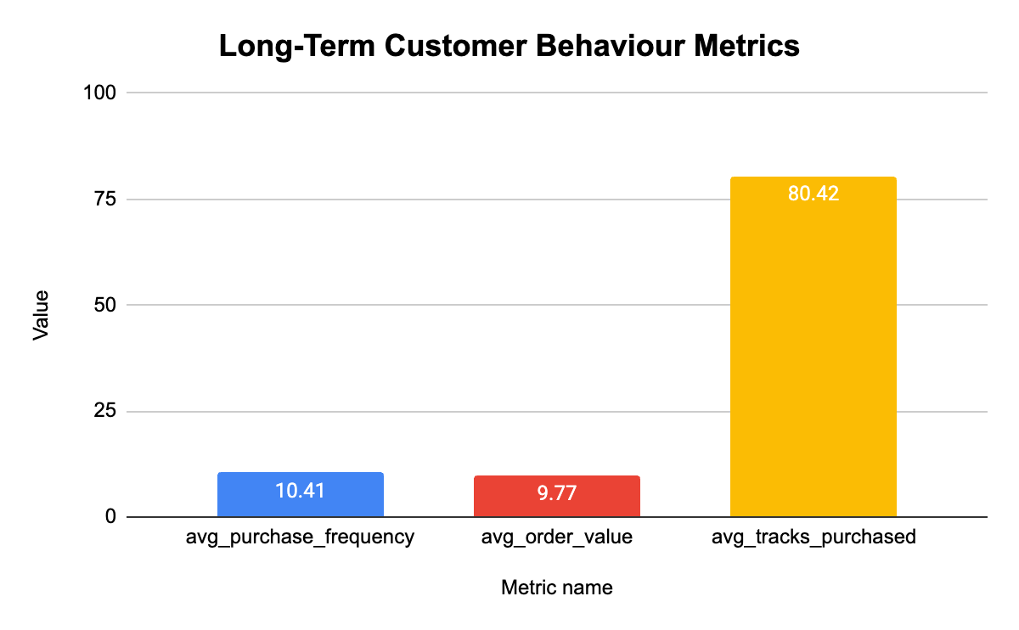

Key Insights
- All 59 customers in the Chinook database are classified as Long-Term. No customers fall into the New category based on the 365-day tenure condition.
- Long-Term customers make an average of 10.41 purchases, with an average order value of $9.77.
- Average total spending per customer is $805.14.
- Each customer purchases an average of 80.42 tracks, indicating engagement with the music catalog.

Business Takeaway
Since all 59 customers fall into the Long-Term category, the current dataset does not provide a comparison between new and long-term customers. Chinook can focus on retaining existing customers through loyalty offers and personalized recommendations while also working on customer acquisition to bring new buyers into the business.

5. Churn & Customer Risk
5.1 Churn Analysis
Analysis Approach
I wanted to understand how many customers stopped purchasing from Chinook each year and how the churn rate changed over time.
I used three Common Table Expressions (CTEs) to perform the analysis:
- Active_Customers: Identified the years in which each customer made a purchase.
- Churned_Customers: Compared customer activity between consecutive years to identify customers who purchased in one year but did not return in the following year.
- Total_Customers: Calculated the total number of active customers in each year.
I then calculated the churn rate using the following formula:
- Churn Rate = (Churned Customers / Total Customers) × 100

SQL Query
WITH Active_Customers AS (
SELECT
c.customer_id,
DATE_FORMAT(i.invoice_date, '%Y') AS purchase_year
FROM customer c
JOIN invoice i ON c.customer_id = i.customer_id
GROUP BY c.customer_id, purchase_year
),
Churned_Customers AS (
SELECT
ac1.purchase_year AS previous_year,
COUNT(DISTINCT ac1.customer_id) AS churned_customers
FROM Active_Customers ac1
LEFT JOIN Active_Customers ac2
ON ac1.customer_id = ac2.customer_id
AND ac2.purchase_year = ac1.purchase_year + 1
WHERE ac2.customer_id IS NULL
GROUP BY ac1.purchase_year
),
Total_Customers AS (
SELECT
purchase_year,
COUNT(DISTINCT customer_id) AS total_customers
FROM Active_Customers
GROUP BY purchase_year
)
SELECT
ch.previous_year,
ch.churned_customers,
t.total_customers AS total_customers_last_year,
ROUND((ch.churned_customers / t.total_customers) * 100, 2) AS churn_rate
FROM Churned_Customers ch
JOIN Total_Customers t ON ch.previous_year = t.purchase_year
ORDER BY ch.previous_year;

Output / Results
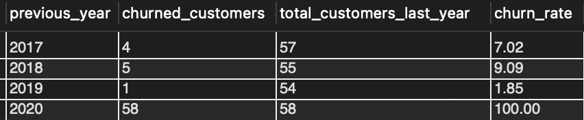

Visual – Customer Churn Rate
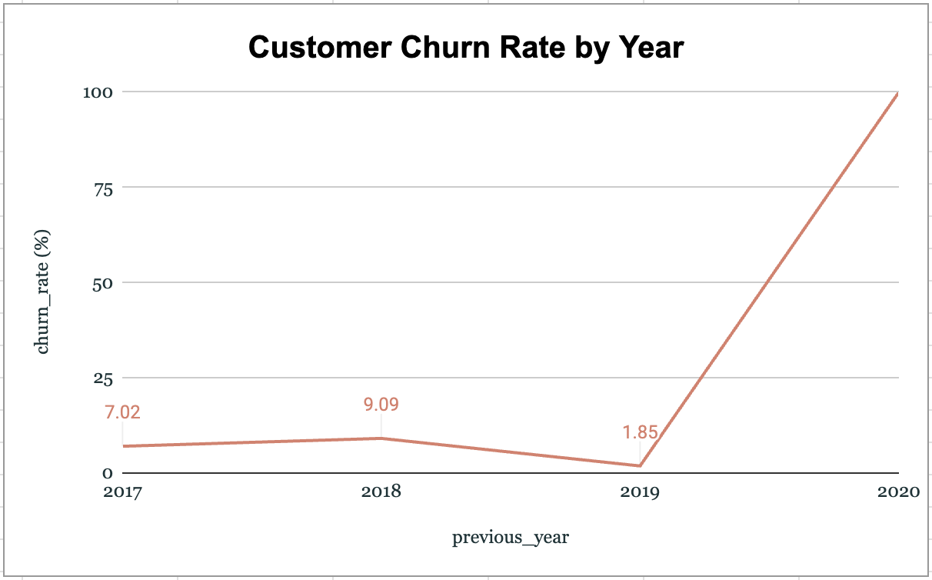

Key Insights
- 2017: 4 customers churned out of 57, resulting in a churn rate of 7.02%.
- 2018: 5 customers churned out of 55, resulting in a churn rate of 9.09%. This was the highest churn rate among the years with a subsequent year available for comparison.
- 2019: 1 customer churned out of 54, resulting in a churn rate of 1.85%.
- 2020: The analysis shows 100% churn. However, this is a data limitation because the dataset ends in 2020 and does not contain purchase records for the following year.

Business Takeaway
The 2017–2019 results show that most customers continued purchasing across consecutive years. Chinook can use customer purchase history to identify customers who stop returning and consider targeted re-engagement campaigns. The 2020 churn figure should not be treated as a normal annual churn result because there is no following-year data to confirm customer activity.

5.2 Inactive Customer Analysis
Analysis Approach
I wanted to identify customers who had not made a purchase recently and understand how long they had been inactive.
I used the latest invoice date in the database as the reference date and set a three-month inactivity cutoff. I then compared each customer's most recent purchase date with this cutoff to identify customers who had not purchased during the last three months.

SQL Query
SELECT
c.customer_id,
CONCAT(c.first_name, ' ', c.last_name) AS customer_name,
c.country,
MAX(i.invoice_date) AS last_purchase_date
FROM customer c
JOIN invoice i ON c.customer_id = i.customer_id
GROUP BY c.customer_id, c.first_name, c.last_name, c.country
HAVING
MAX(i.invoice_date) < DATE_SUB(
(SELECT MAX(invoice_date) FROM invoice),
INTERVAL 3 MONTH
)
ORDER BY last_purchase_date DESC;

Output / Results
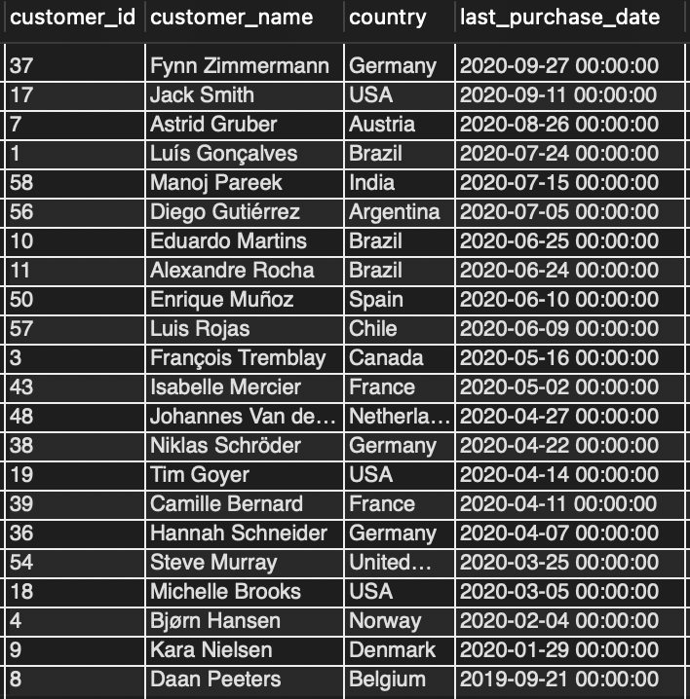

Key Insights
- 22 customers had not made a purchase in the last three months.
- Daan Peeters had the longest inactivity gap.
- Fynn Zimmermann was the most recently inactive customer.
- The latest invoice date in the dataset was 30 December 2020, and the three-month cutoff was 30 September 2020.

Business Takeaway
Customers with longer inactivity gaps may need more immediate attention. Chinook can use this analysis to identify inactive customers and plan targeted re-engagement campaigns based on how recently they made their last purchase.

5.3 Customer Risk Profiling
Analysis Approach
I wanted to classify customers based on how recently they made a purchase and identify those who may need attention.
I calculated the number of inactive days for each customer by comparing their last purchase date with the latest invoice date in the database. I then used a CASE statement to group customers into three risk categories:
- High Risk: Inactive for more than 365 days.
- Medium Risk: Inactive for 180–365 days.
- Low Risk: Inactive for less than 180 days.
This classification helped me understand the distribution of customers across different risk levels.

SQL Query
WITH customer_profile AS (
SELECT c.customer_id,
CONCAT(c.first_name, ' ', c.last_name) AS customer_name,
c.country, c.city,
COUNT(DISTINCT i.invoice_id) AS purchase_count,
ROUND(SUM(i.total), 2) AS total_spending,
ROUND(AVG(i.total), 2) AS avg_spending,
MAX(i.invoice_date) AS last_purchase_date,
DATEDIFF(
(SELECT MAX(invoice_date) FROM invoice),
MAX(i.invoice_date)) AS days_since_last_purchase
FROM customer c
JOIN invoice i ON c.customer_id = i.customer_id
GROUP BY c.customer_id, c.first_name, c.last_name, c.country, c.city
)
SELECT customer_name, country, city,
purchase_count, total_spending, avg_spending,
last_purchase_date, days_since_last_purchase,
CASE
WHEN days_since_last_purchase > 365 THEN 'High Risk'
WHEN days_since_last_purchase BETWEEN 180 AND 365 THEN 'Medium Risk'
ELSE 'Low Risk'
END AS risk_segment
FROM customer_profile
ORDER BY days_since_last_purchase DESC;

Output / Results
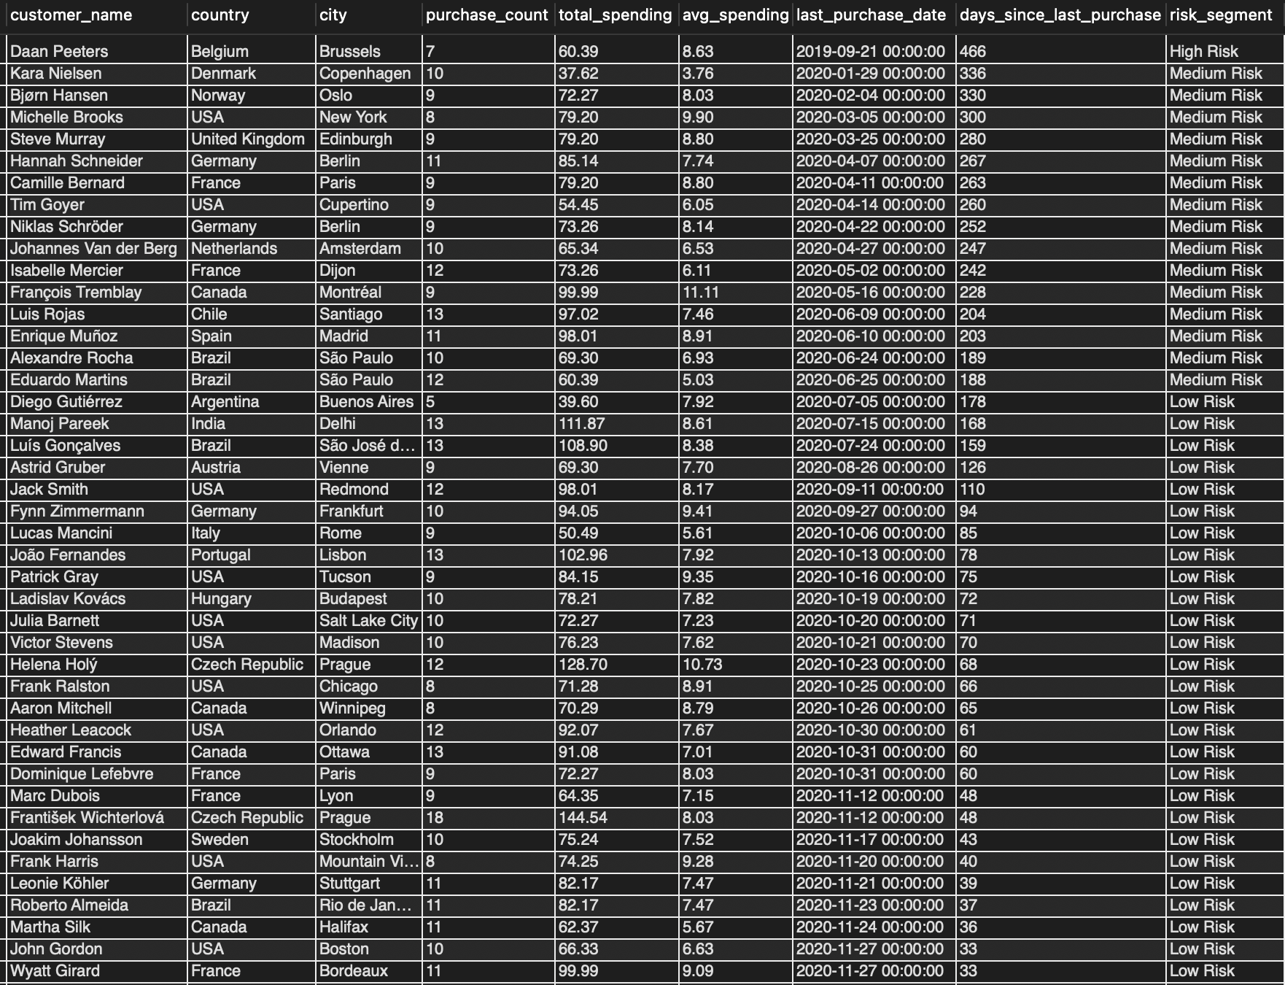

Visual – Customer Risk Profile
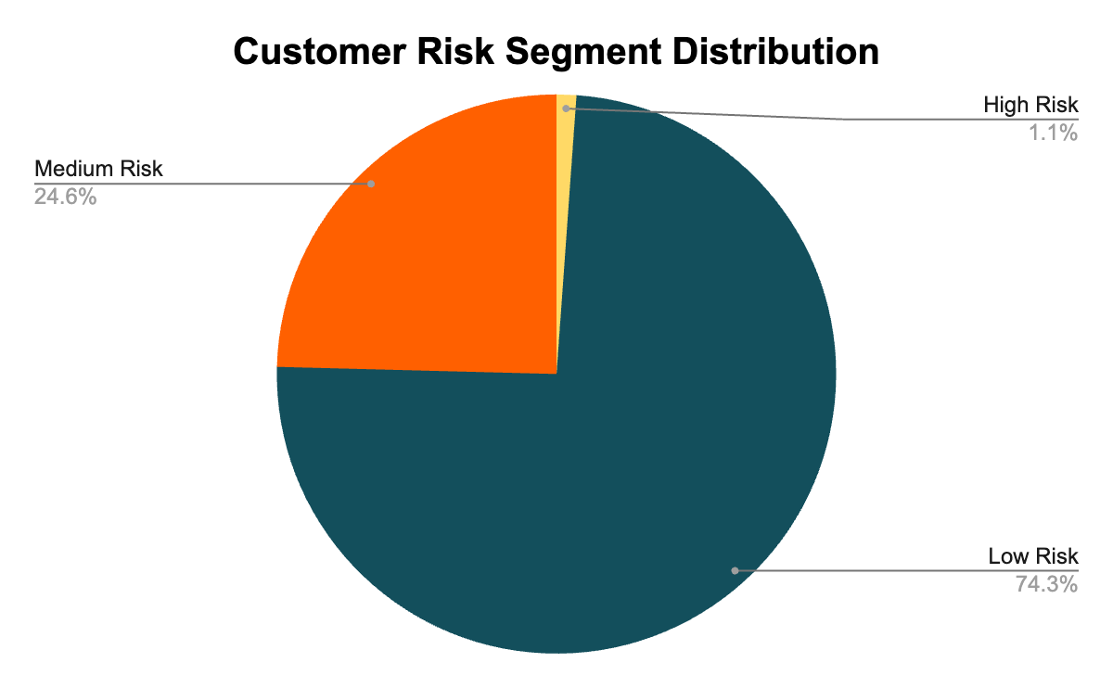

Key Insights
- High Risk: 1 customer — Daan Peeters, inactive for 466 days.
- Medium Risk: 15 customers, inactive for 180–365 days.
- Low Risk: 43 customers, active within the last 180 days.
- Longer inactivity indicates a higher risk of customer churn.

Business Takeaway
Chinook can prioritize customer retention based on inactivity. Daan Peeters may need immediate re-engagement, while the 15 Medium Risk customers can be targeted with personalized offers before their inactivity increases. The 43 Low Risk customers can be encouraged to continue purchasing through loyalty rewards and product recommendations.

6. Genre & Customer Diversity
6.1 Customer Genre Diversity
Analysis Approach
I wanted to understand how diverse customers' music preferences are and identify customers who purchase tracks across multiple genres.
I joined the Customer, Invoice, Invoice Line, Track, and Genre tables to connect each customer with the genres they had purchased. I then used COUNT(DISTINCT genre_id) to calculate the number of unique genres purchased by each customer.
I applied the HAVING clause to include customers who had purchased from at least three different genres. I used HAVING instead of WHERE because the genre count is calculated after grouping the records.

SQL Query
SELECT
c.customer_id,
CONCAT(c.first_name, ' ', c.last_name) AS customer_name,
c.country,
COUNT(DISTINCT g.genre_id) AS total_genres
FROM customer c
JOIN invoice i ON c.customer_id = i.customer_id
JOIN invoice_line il ON i.invoice_id = il.invoice_id
JOIN track t ON il.track_id = t.track_id
JOIN genre g ON t.genre_id = g.genre_id
GROUP BY c.customer_id, c.first_name, c.last_name, c.country
HAVING COUNT(DISTINCT g.genre_id) >= 3
ORDER BY total_genres DESC, c.customer_id ASC;

Output / Results
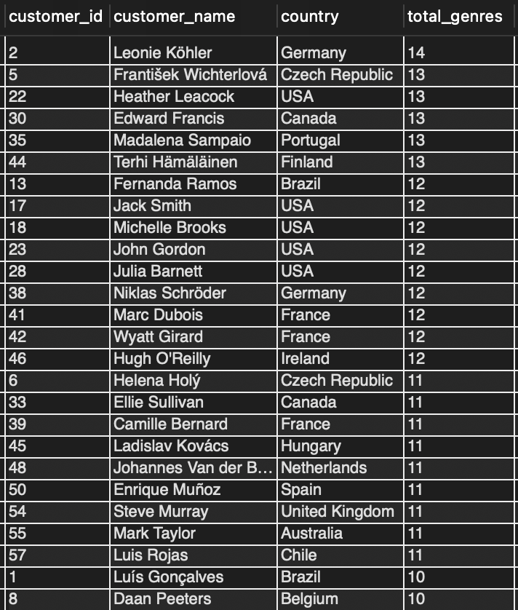

Key Insights
- Leonie Kohler from Germany is the most diverse buyer in the result, having purchased tracks from 14 different genres.
- Frantisek Wichterlova, Heather Leacock, Edward Francis, Madalena Sampaio, and Terhi Hamalainen follow with 13 genres each.
- All customers returned by the query purchased from at least 5 genres, exceeding the minimum threshold of 3.
- The results show that customers in this dataset purchase music across multiple genres rather than limiting their purchases to only one or two genres.

Business Takeaway
The genre diversity analysis shows that Chinook's customers have varied music preferences. The business can use this information to explore personalized recommendations and cross-genre promotions, helping customers discover music beyond the genres they already purchase.

7. International Genre Performance
7.1 Genre Performance Outside the USA
Analysis Approach
I wanted to understand which music genres perform well across countries outside the USA and identify common patterns and differences in customer preferences.
I joined the Customer, Invoice, Invoice Line, Track, and Genre tables to calculate total sales for each genre in every country. I excluded the USA using a WHERE condition and used the RANK() window function with PARTITION BY country to rank genres separately within each country.
I selected the top three genres for each country so I could compare their sales performance and identify common and unique genre preferences across international markets.
SQL Query
WITH genre_country_sales AS (
SELECT c.country, g.name AS genre_name,
ROUND(SUM(il.unit_price * il.quantity), 2) AS total_sales,
RANK() OVER (PARTITION BY c.country
ORDER BY SUM(il.unit_price * il.quantity) DESC) AS genre_rank
FROM customer c
JOIN invoice i ON c.customer_id = i.customer_id
JOIN invoice_line il ON i.invoice_id = il.invoice_id
JOIN track t ON il.track_id = t.track_id
JOIN genre g ON t.genre_id = g.genre_id
WHERE c.country != 'USA'
GROUP BY c.country, g.genre_id, g.name
)
SELECT country, genre_name, total_sales, genre_rank
FROM genre_country_sales
WHERE genre_rank <= 3
ORDER BY country, genre_rank;
Output / Results
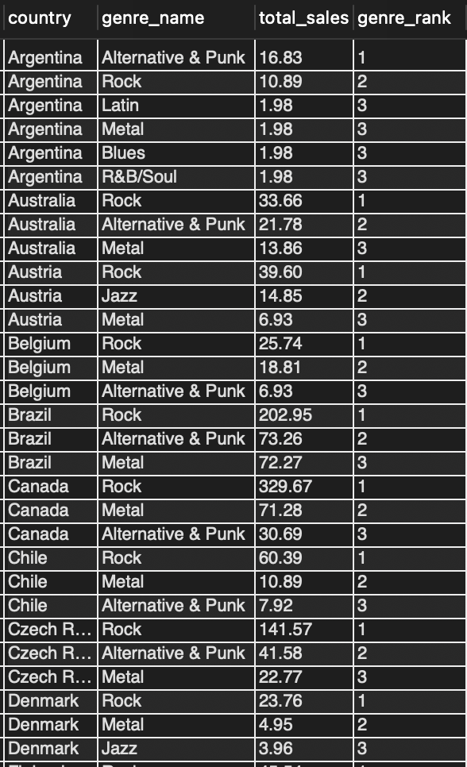
Visual – Top Selling Genre by Country (Excluding USA)
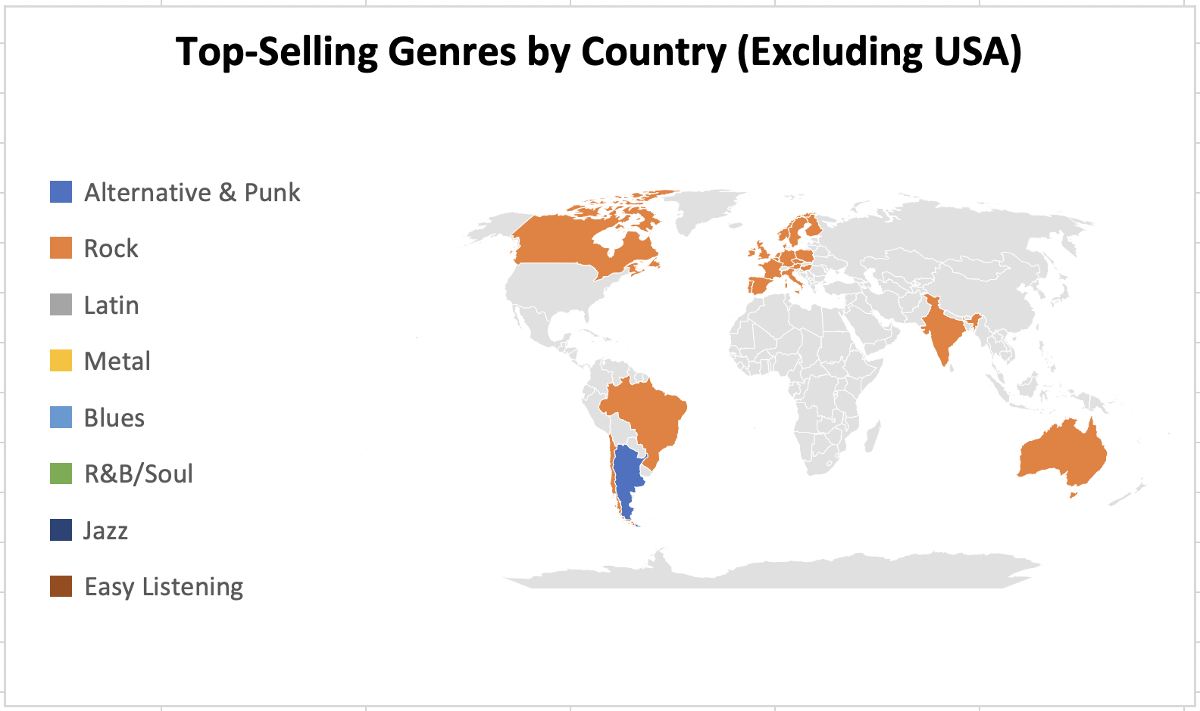

Key Insights
- Rock is the top-selling genre in 22 out of 23 countries outside the USA.
- Argentina is the only exception, where Alternative & Punk leads with $16.83 in sales, compared with Rock at $10.89.
- Canada has the highest Rock sales at $329.67, followed by France at $208.89 and Brazil at $202.95.
- Metal and Alternative & Punk frequently appear among the top three genres across international markets.
Commonalities
- Rock leads in most international markets, following a similar pattern to the USA.
- Metal and Alternative & Punk also appear among the top three genres in many countries.
- Rock, Metal, and Alternative & Punk are recurring top-performing genres across the markets analyzed.
Differences
- Argentina: Alternative & Punk ranks first instead of Rock.
- Austria, Germany, and Spain: Jazz appears among the top three genres.
- Ireland: Latin ranks second with $19.80 in sales.
- Poland: Blues ranks second with $12.87 in sales.
- France: Easy Listening ranks third with $28.71 in sales.
- Netherlands: R&B/Soul ranks second with $11.88 in sales.
Business Takeaway
Although Rock performs strongly across most international markets, customer preferences are not identical everywhere. Chinook can use these country-level differences to explore localized promotions rather than relying on the same genre strategy in every market. For example, campaigns in Argentina could give more attention to Alternative & Punk, while markets where Jazz, Latin, Blues, or other genres appear in the top rankings could be explored for more targeted promotions.
8. Product Affinity & Cross-Selling
8.1 Product Affinity Analysis
Analysis Approach
I wanted to understand which combinations of music genres, artists, and albums are commonly purchased by customers and how these patterns could support product recommendations and cross-selling.
I combined genre, artist, and album information in a single query to identify complete combinations purchased by multiple customers. I used COUNT(DISTINCT customer_id) to count the number of unique customers who purchased each combination and applied the HAVING clause to include only combinations purchased by more than one customer.
I then sorted the results by customer count in descending order and selected the top 10 combinations.

SQL Query
SELECT
g.name AS genre_name,
ar.name AS artist_name,
al.title AS album_title,
COUNT(DISTINCT i.customer_id) AS customer_count
FROM invoice i
JOIN invoice_line il ON i.invoice_id = il.invoice_id
JOIN track t ON il.track_id = t.track_id
JOIN genre g ON t.genre_id = g.genre_id
JOIN album al ON t.album_id = al.album_id
JOIN artist ar ON al.artist_id = ar.artist_id
GROUP BY g.genre_id, g.name, ar.artist_id, ar.name, al.album_id, al.title
HAVING COUNT(DISTINCT i.customer_id) > 1
ORDER BY customer_count DESC
LIMIT 10;

Output / Results
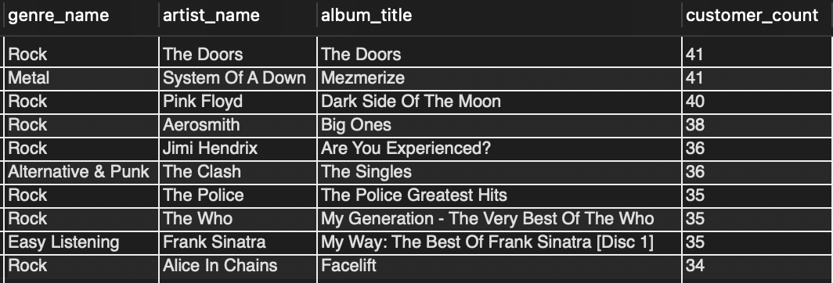

Key Insights
- Rock + The Doors + The Doors album and Metal + System Of A Down + Mezmerize are tied at the top, with 41 customers each.
- Rock + Pink Floyd + Dark Side Of The Moon ranks third, with 40 customers.
- 7 out of the top 10 combinations belong to the Rock genre, showing its strong presence in the results.
- Easy Listening also appears in the top 10 through Frank Sinatra, indicating that customers purchase music beyond the most frequently appearing Rock combinations.
Cross-Selling Recommendations
- Recommend Metal albums to customers who purchase Rock music to encourage cross-genre purchases.
- Consider promotional bundles featuring The Doors, Mezmerize, and Dark Side Of The Moon, as these combinations have high customer counts.
- Recommend The Clash's The Singles to Rock buyers as another cross-genre option.
- Include Easy Listening recommendations, such as Frank Sinatra, to reach customers with varied music preferences.

9. Regional Market Analysis
9.1 Regional Purchasing Behavior
Analysis Approach
I wanted to understand how customer purchasing behavior and churn vary across different cities and regions.
I used three CTEs: Total_Purchases, Active_Customers, and Churned_Customers. First, I calculated the total purchases and spending for each customer along with their location. I classified customers who made a purchase within the last year of the dataset as active and the remaining customers as churned.
I then joined these results and grouped the data by country, city, and state to compare customer activity, total purchases, average spending, and churn rate across locations.
SQL Query
WITH Total_Purchases AS (
SELECT c.customer_id, c.country, c.city, c.state,
COUNT(i.invoice_id) AS total_purchases,
ROUND(SUM(i.total), 2) AS total_spending
FROM customer c
LEFT JOIN invoice i ON c.customer_id = i.customer_id
GROUP BY c.customer_id, c.country, c.city, c.state
),
Active_Customers AS (
SELECT DISTINCT customer_id FROM invoice
WHERE invoice_date >= DATE_SUB(
(SELECT MAX(invoice_date) FROM invoice), INTERVAL 1 YEAR)
),
Churned_Customers AS (
SELECT DISTINCT customer_id FROM invoice
WHERE customer_id NOT IN (SELECT customer_id FROM Active_Customers)
)
SELECT t.country, t.city, t.state,
COUNT(DISTINCT a.customer_id) AS active_customers,
COUNT(DISTINCT ch.customer_id) AS churned_customers,
COUNT(DISTINCT t.customer_id) AS total_customers,
SUM(t.total_purchases) AS total_purchases,
ROUND(AVG(t.total_spending), 2) AS avg_spending,
CASE WHEN COUNT(DISTINCT t.customer_id) = 0 THEN 0
ELSE ROUND(COUNT(DISTINCT ch.customer_id) * 100.0 /
COUNT(DISTINCT t.customer_id), 2)
END AS churn_rate
FROM Total_Purchases t
LEFT JOIN Active_Customers a ON t.customer_id = a.customer_id
LEFT JOIN Churned_Customers ch ON t.customer_id = ch.customer_id
GROUP BY t.country, t.city, t.state
ORDER BY t.country, t.city, t.state;

Output / Results
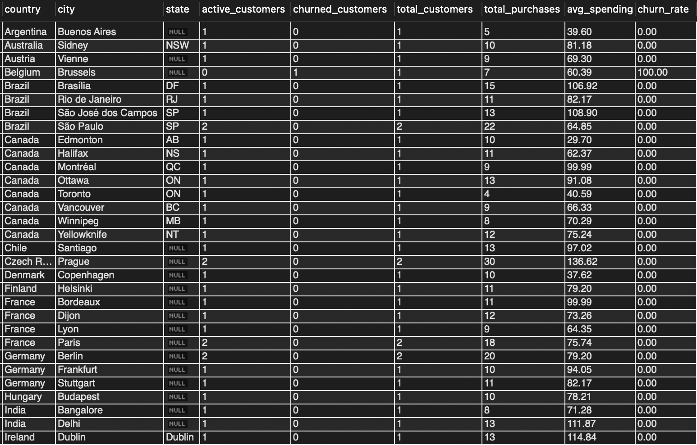

Visual – Top 10 Cities by Average Spending
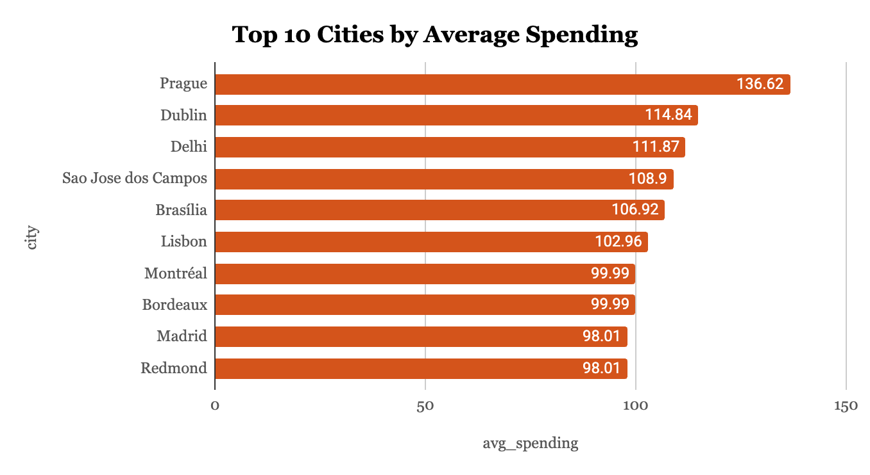
Key Insights
- Almost all cities show a 0% churn rate in this analysis.
- Brussels, Belgium, is the only city with a 100% churn rate.
- Prague, Czech Republic, has the highest average spending at $136.62, with 30 total purchases.
- Dublin, Ireland, has average spending of $114.84 despite having only one customer.
Regional Recommendations
- Focus on Prague and São Paulo, which show strong purchasing activity and spending.
- Re-engage customers in Brussels, the only location with a 100% churn rate.
- Consider cities such as Dublin ($114.84) and São José dos Campos ($108.90) for further market exploration because of their high average spending and small customer base.

10. Customer Lifetime Value Modeling
10.1 Customer Lifetime Value (CLV) Analysis
Analysis Approach
I wanted to estimate the potential long-term value of customers and understand how their purchasing behaviour differs across customer segments.
I used two CTEs to perform the analysis:
- Customer_Segments: Calculated customer tenure, purchase count, total spending, average order value, and days since the last purchase.
- CLV_Calculation: Classified customers into Active, At-Risk, and Churned segments based on their last purchase date and calculated their current value and predicted five-year CLV.
I used the following formula to estimate the predicted five-year Customer Lifetime Value:
Predicted CLV = Average Order Value × (Purchase Count / Tenure in Years) × 5
I used the latest invoice date in the dataset as the reference date for calculating customer inactivity and classifying customers into the three segments.
SQL Query
WITH Customer_Segments AS (
SELECT c.customer_id, c.city, c.country,
DATEDIFF((SELECT MAX(invoice_date) FROM invoice),
MIN(i.invoice_date)) AS customer_tenure,
COUNT(i.invoice_id) AS purchase_count,
SUM(i.total) AS total_spending,
SUM(i.total) / COUNT(i.invoice_id) AS avg_order_value,
DATEDIFF((SELECT MAX(invoice_date) FROM invoice),
MAX(i.invoice_date)) AS days_since_last_purchase
FROM customer c
JOIN invoice i ON c.customer_id = i.customer_id
GROUP BY c.customer_id, c.city, c.country
),
CLV_Calculation AS (
SELECT cs.customer_id, cs.city, cs.country,
ROUND(cs.purchase_count / (cs.customer_tenure / 365), 2) AS purchase_frequency,
ROUND(cs.avg_order_value, 2) AS avg_order_value,
CASE
WHEN cs.days_since_last_purchase > 365 THEN 'Churned'
WHEN cs.days_since_last_purchase BETWEEN 180 AND 365 THEN 'At-Risk'
ELSE 'Active'
END AS customer_status,
ROUND(cs.avg_order_value * cs.purchase_count, 2) AS current_value,
ROUND(cs.avg_order_value *
(cs.purchase_count / (cs.customer_tenure / 365)) * 5, 2) AS predicted_clv
FROM Customer_Segments cs
)
SELECT customer_status,
COUNT(customer_id) AS customer_count,
ROUND(AVG(current_value), 2) AS avg_current_value,
ROUND(AVG(predicted_clv), 2) AS avg_predicted_clv
FROM CLV_Calculation
GROUP BY customer_status
ORDER BY FIELD(customer_status, 'Churned', 'At-Risk', 'Active');

Output / Results
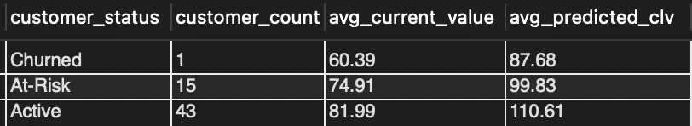
Visual – Current vs Predicted CLV by Customer Segment
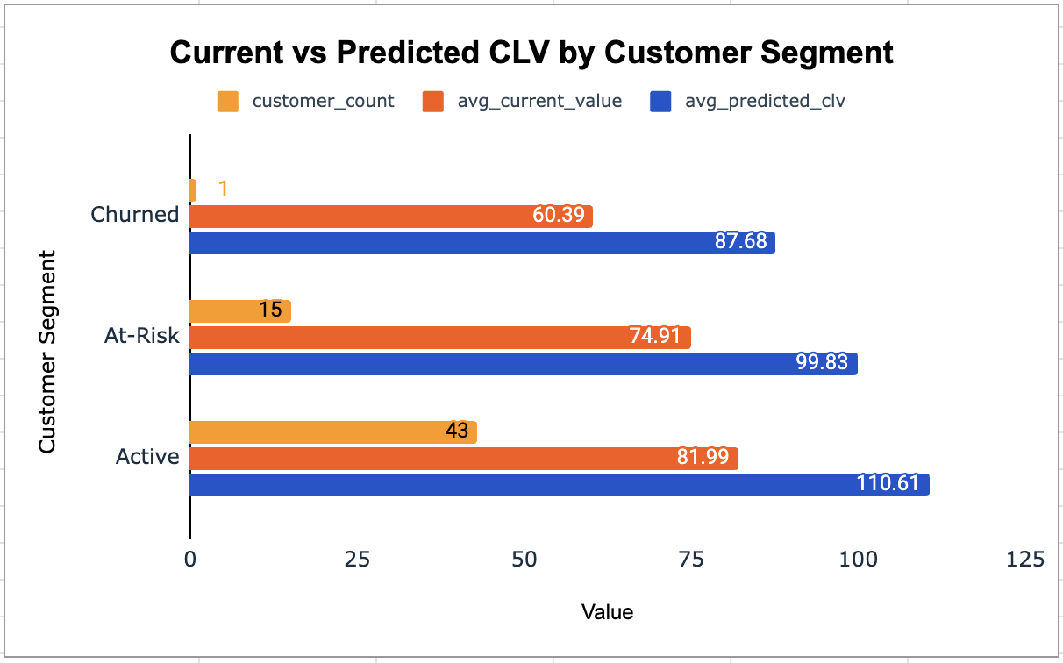
Key Insights
- Active customers: 43 customers, with an average predicted five-year CLV of $110.61.
- At-Risk customers: 15 customers, with an average predicted CLV of $99.83. These customers still have potential value and could be targeted before they stop purchasing.
- Churned customers: 1 customer, with a current value of $60.39 and a predicted CLV of $87.68.
- The predicted CLV is higher than the current value across all three segments, indicating potential for additional revenue if customers continue or resume purchasing.
Targeted Marketing Strategies
- Active customers: Introduce loyalty programmes and exclusive offers to maintain engagement.
- At-Risk customers: Send personalized offers based on previous purchases to encourage repeat purchases.
- Churned customers: Use win-back offers or discounts on previously preferred genres to encourage them to return.

11. Database Structure & SQL Techniques
11.1 Database Schema Modification
Analysis Approach
I wanted to understand how an existing database table can be modified to store additional information without creating a new table.
I used the ALTER TABLE DDL command to add a new column named ReleaseYear with the INTEGER data type to the existing Album table.
After modifying the table, I used the DESC command to verify the updated table structure and check whether the new column had been added successfully.
SQL Query
-- Step 1: Add new column
ALTER TABLE album
ADD COLUMN ReleaseYear INTEGER;

-- Step 2: Verify the change
DESC album;

Key Insights
- ALTER TABLE is a DDL (Data Definition Language) command used to modify the structure of an existing table.
- ADD COLUMN ReleaseYear INTEGER adds a new nullable integer column to store album release years.
- DESC album displays the table structure and helps verify the addition of the new column.
- The UPDATE command can be used to populate ReleaseYear values for existing albums.
- ALTER TABLE changes the table structure, whereas UPDATE modifies the data stored inside the table.
12. Business Recommendations & Geographic Purchasing Behavior
12.1 Geographic Purchasing Behavior
Analysis Approach
I wanted to understand how customer purchasing behavior varies across different countries. My focus was on comparing the average amount spent by customers, the number of customers in each country, and the average number of tracks purchased per customer.
I used a Common Table Expression (CTE) to calculate the total spending and total tracks purchased by each customer. I then grouped the results by country to calculate:
- Total Customers: Number of customers in each country.
- Average Total Spending: Average amount spent per customer.
- Average Tracks per Customer: Average number of tracks purchased by customers in each country.
I joined the Customer, Invoice, and Invoice Line tables to connect customer information with their purchasing activity.
SQL Query
WITH customer_data AS (
SELECT c.customer_id, c.country,
SUM(i.total) AS total_spending,
COUNT(il.track_id) AS total_tracks
FROM customer c
JOIN invoice i ON c.customer_id = i.customer_id
JOIN invoice_line il ON i.invoice_id = il.invoice_id
GROUP BY c.customer_id, c.country
)
SELECT country,
COUNT(customer_id) AS total_customers,
ROUND(AVG(total_spending), 2) AS avg_total_spent,
ROUND(AVG(total_tracks), 2) AS avg_tracks_per_customer
FROM customer_data
GROUP BY country
ORDER BY avg_total_spent DESC;
Output / Results
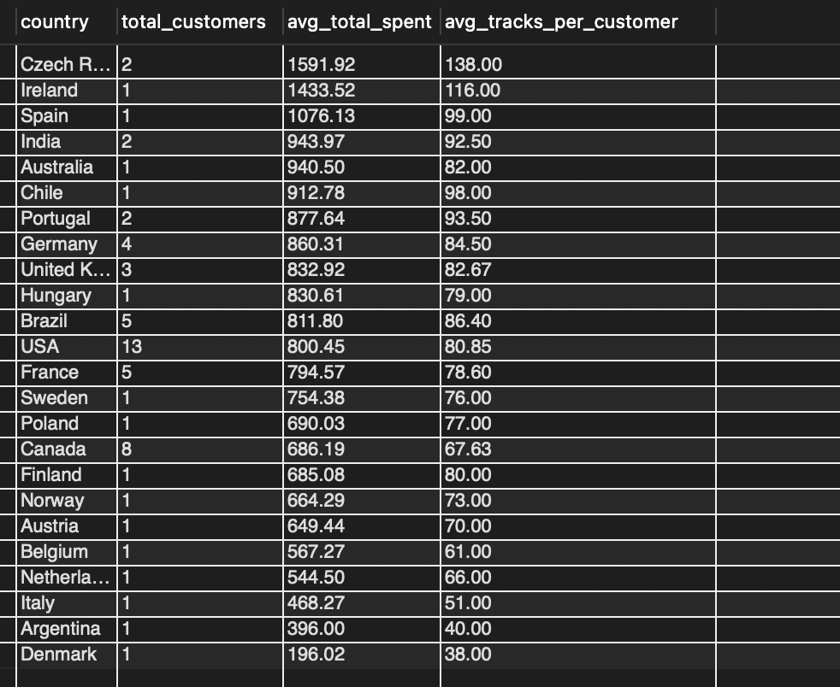

Visual – Average Total Spending per Customer by Country
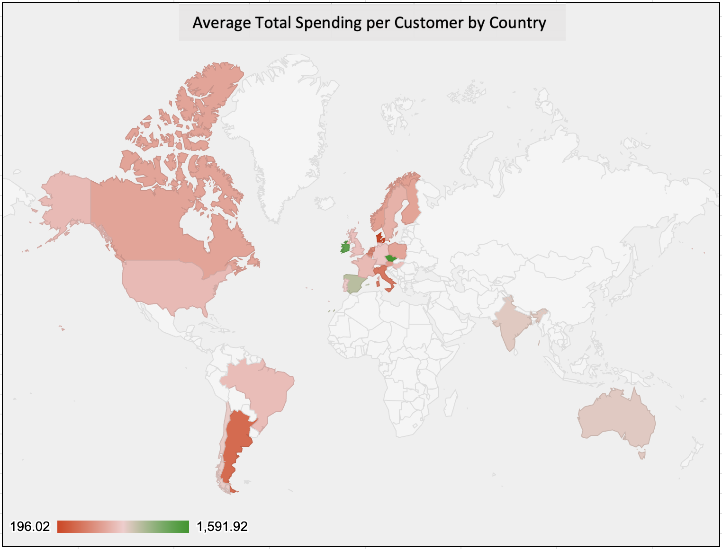
Key Insights
- The Czech Republic has the highest average spending per customer at $1,591.92, followed by Ireland at $1,433.52 and Spain at $1,076.13.
- The USA has the largest customer base, with 13 customers and average spending of $800.45 per customer.
- Denmark ($196.02) and Argentina ($396.00) have the lowest average spending per customer among the countries analyzed.
- Countries with fewer customers generally show higher average spending per customer. However, these smaller customer groups should be considered when interpreting the results.
Business Recommendations
- Focus on high-spending markets: Explore premium music content and new releases in the Czech Republic, Ireland, and Spain.
- Increase customer spending in the USA: Use personalized recommendations and relevant promotions to encourage existing customers to purchase more.
- Encourage purchases in lower-spending markets: Consider targeted offers in Denmark and Argentina to support purchasing activity.
- Expand smaller high-spending markets: Explore opportunities to attract more customers in countries where average spending is relatively high.

12.2 Sales & Product Promotion
Based on the sales and product analysis, I identified genres and albums that could be considered for promotional activities. I also used product affinity findings to identify opportunities for cross-selling.
Key Findings
- Rock contributes 53.38% of total USA genre sales, making it the largest genre in the USA market.
- Alternative & Punk and Metal are also important genres in the USA market.
- Among the albums analyzed, Nirvana's From The Muddy Banks Of The Wishkah generated $27.72 in sales, R.E.M.'s Green generated $24.75, and System Of A Down's Mezmerize generated $21.78.
- Product affinity analysis identified strong purchasing combinations, including Rock with The Doors' album and Metal with System Of A Down's Mezmerize, each purchased by 41 customers.
- Rock appeared in 7 of the top 10 product combinations.
Business Recommendations
- Promote high-performing genres: Build promotional campaigns around Rock, while also maintaining Alternative & Punk and Metal as secondary genres.
- Promote selected albums: Consider promoting From The Muddy Banks Of The Wishkah, Green, and Mezmerize to reach customers interested in different high-performing genres.
- Create cross-selling opportunities: Recommend Metal tracks to customers who purchase Rock music.
- Use product affinity for bundles: Explore bundles and recommendations featuring The Doors, Mezmerize, and The Dark Side of the Moon.
- Personalize promotions: Use customers' previous genre and artist preferences to make recommendations more relevant.
12.3 Customer Retention & Value
The customer analysis identified different levels of purchasing activity and potential churn risk. I used these findings along with the predicted Customer Lifetime Value (CLV) to identify customer groups that could benefit from different retention strategies.
Key Findings
- High Risk: 1 customer, Daan Peeters, with 466 days of inactivity.
- Medium Risk: 15 customers who had been inactive for 180–365 days.
- Active: 43 customers who had purchased within the last 180 days.
- The average predicted five-year CLV is $110.61 for Active customers and $99.83 for At-Risk customers.
- The predicted CLV is higher than the current value across all three customer segments.
Business Recommendations
- High-Risk Customer: Prioritize a personalized re-engagement offer for Daan Peeters based on his previous purchasing history.
- Medium-Risk Customers: Target the 15 customers with personalized offers before their inactivity increases further. Customers such as Francois Tremblay and Enrique Munoz can also be considered based on their customer value.
- Active Customers: Maintain engagement with loyalty rewards, personalized recommendations, and early access to selected releases.
- Use CLV for prioritization: Consider both customer value and inactivity when deciding which customers should receive retention offers.
12.4 Regional Growth Opportunities
The regional analysis helped identify cities with higher average customer spending, areas with customer inactivity, and differences in music preferences across countries.
Key Findings
- Prague recorded the highest average spending per customer among the cities analyzed, at $136.62, with 30 total purchases.
- Dublin recorded average spending of $114.84, despite having only one customer.
- Brussels was the only city with a 100% churn rate in the regional analysis.
- Rock was the leading genre in 22 of the 23 countries outside the USA.
- Argentina showed a different preference, with Alternative & Punk ranking above Rock.
- Other markets also showed genre differences, including Jazz in Austria, Germany, and Spain, Latin in Ireland, Blues in Poland, and R&B/Soul in the Netherlands.
Business Recommendations
- Explore opportunities in Prague: Use its purchasing activity and average spending as a reference when planning local promotions.
- Re-engage customers in Brussels: Investigate the purchasing history of inactive customers and consider targeted win-back offers.
- Localize genre promotions: Although Rock performs well across most international markets, promotions should also consider local preferences.
- Explore smaller markets: Cities such as Dublin and São José dos Campos show relatively high average spending with a small customer base. Further customer acquisition could be explored in these locations.

13. Data Limitations & Future Analysis
13.1 Data Limitations
During this project, I identified a few limitations in the available Chinook database that restricted certain areas of analysis.
1. Missing Customer Demographics
The database does not contain customer age or gender information. Therefore, I could not analyze purchasing behaviour based on demographic groups.
2. Missing Payment Method Information
Payment method details are not available, so I could not identify customer payment preferences or compare purchasing behaviour across payment methods.
3. No Promotional Campaign Data
The database does not contain promotional campaign records. As a result, I could not directly measure the impact of marketing campaigns on customer acquisition, retention, or sales.
4. Limited Historical Data
The invoice records cover the period from 2017 to 2020. This limits the analysis to the available historical period and does not provide a view of more recent business performance.
5. Missing Composer Information
The Track table contains 978 NULL values in the Composer column. This limits the ability to perform complete composer-level analysis.
6. Limited Customer Representation Across Countries
The database contains 59 customers across 24 countries. Some countries have only one customer, which limits the reliability of comparisons between smaller markets.
7. Predicted Customer Lifetime Value
The five-year Customer Lifetime Value (CLV) calculated in this project is an estimate based on historical purchasing behaviour. It should not be treated as actual future revenue because future customer purchases may differ from past patterns.
Overall Limitation
These limitations do not prevent analysis of the available data, but they restrict the depth of certain findings. The results should therefore be interpreted within the scope of the information available in the Chinook database.

13.2 Future Analysis
Based on the analysis performed in this project, I identified several areas that could be explored further to gain a deeper understanding of business performance.
1. Customer Demographic Analysis
Extend customer data collection to include age and gender information. This would allow purchasing behaviour to be compared across different demographic groups.
2. Payment Method Analysis
Include payment method details to understand customer payment preferences and identify differences in purchasing patterns across payment options.
3. Promotional Campaign Measurement
Maintain campaign IDs, campaign dates, discounts, and customer exposure records. This would help measure campaign performance through:
- Customer Acquisition: Number of new customers acquired.
- Customer Retention: Number of customers making repeat purchases after a campaign.
- Sales Performance: Revenue, number of orders, and Average Order Value (AOV).
4. Advanced Customer Analysis
Explore customer purchasing behaviour over longer periods to improve customer segmentation, churn analysis, and CLV estimation.
5. Product Recommendation Analysis
Analyze additional product combinations and customer preferences to identify cross-selling opportunities and develop more personalized music recommendations.
6. Regional Market Analysis
Expand the customer and transaction data available for smaller markets. This would help provide a broader basis for comparing regional performance and identifying market opportunities.
7. Regular Business Performance Monitoring
Use updated transaction data to regularly monitor revenue, customer activity, product performance, and regional trends. This would help track changes in business performance over time.
Overall Direction
Future analysis should build on the findings of this project by expanding the available data and exploring customer, product, campaign, and regional performance in greater detail.

