OBJECTIVE QUESTIONS

Question 1: What is the total no. of tables present in the data?

Solution:

Final Answer (if any):
1 Table

Approach (if any):
Checked whether multiple sheets/ tables exist.

Charts & Tables (if any):
- Table Name:
Raw Data
- Description:
Contains all call centre data of Astrosage in one table.

Question 2: What is the total no. of attributes present in the data?

Solution:

Final Answer (if any):
29

Approach (if any):
- Count of all column headers in dataset.
- Example: =COUNTA(A1: AC1)

Charts & Tables (if any):
NA

Question 3: The data consists of some inconsistent and missing values so ensure that the data used for further analysis is cleaned.

Solution:

Final Answer (if any):
Cleaned Dataset ready for analysis

Approach (if any):
- Remove Duplicates:
Select All data > Remove Duplicates
- Handling Missing Values:
=IF(ISBLANK(Region),"Unknown",Region)
- Used Nested If:
=IF(ISBLANK(callChannel), IF(H2="Call","Normal",IF(H2="Chat","Chat",
" ")),callChannel)
- Convert text type into number type:
=VALUE( LEFT(SUBSTITUTE(U2,"T"," "),19))
- Used Round function
- To clean the data, I created separate columns from the raw data instead of editing it directly. Then I applied formulas to handle missing and inconsistent values based on the required logic. Once the data was cleaned, I converted the formulas into values using paste special and removed the unnecessary columns, keeping only the final cleaned dataset.

Charts & Tables (if any):
- Table Name:
Cleaned data
- Description:
Final dataset after applying formulas and removing inconsistencies.

Question 4: What is the change in daily call volume day by day and also find the average daily call volume.

Solution:
Final Answer (if any):
The daily call volume shows noticeable day-to-day variation, with periods of both growth and decline compared to the previous day. The day-to-day change is calculated by subtracting the previous day’s call count from the current day.
The average daily call volume is calculated by dividing the total number of calls by the number of unique dates, which gives the overall daily performance.

Approach (if any):
Used a Pivot Table to get daily call counts (Date vs Count of Calls).
Calculated daily change using difference between consecutive days.
Used the formula to calculate Average daily call volume:
=ROUND(COUNTIF('Cleaned data'!F2:F28028,"Call") /
SUM(--(FREQUENCY(
MATCH('Cleaned data'!N2:N28028,'Cleaneddata'!N2:N28028,0),
MATCH('Cleaned data'!N2:N28028,'Cleaned data'!N2:N28028,0) )>0)),2)
Here, COUNTIF gives total calls and FREQUENCY + MATCH counts unique dates.

Charts & Tables (if any):
- Chart Name:
Daily Call Volume 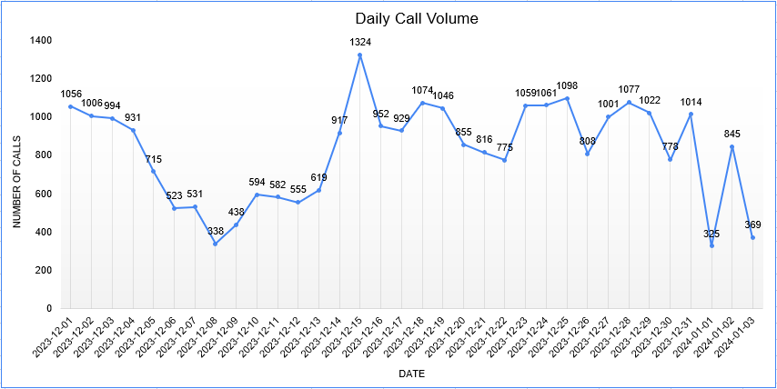
- Description:
The line chart represents daily call volume over the selected date range. It shows noticeable fluctuations, with call counts generally starting above 1000, dropping to a low around 338, and then rising to a peak of approximately 1324 mid-period. After the peak, the volume continues to vary with moderate ups and downs, before experiencing a sharp drop towards the end (around 325) and a slight recovery. Overall, the trend indicates irregular call activity with no consistent upward or downward pattern.

Question 5: Which months experienced the highest and lowest call volumes?

Solution:

Final Answer (if any):
December experienced the highest call volume, while January had the lowest call volume.

Approach (if any):
A Pivot Table was created using the Month field and Count of Call ID to calculate total calls for each month. The values were then compared to identify the highest and lowest call volumes.

Charts & Tables (if any):
- Chart Name:
Monthly Call Volume
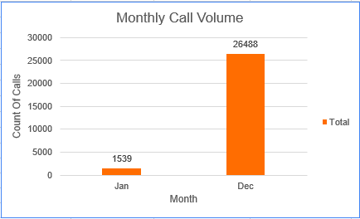

- Description:
Displays the total number of calls for each month, clearly showing that December has the highest call volume and January has the lowest, making comparison straightforward.

Question 6: What is the total operational cost for that month?

Solution:

Final Answer (if any):
The total operational cost varies depending on the selected month in the Pivot Table. For the currently selected month, the total operational cost is 93,786, calculated as the sum of astrologers’ earnings across all consultation types.

Approach (if any):
A Pivot Table was created using Consultation Type and Sum of Astrologers Earnings. The Month field was used as a filter, allowing manual selection of any month. The total operational cost is taken from the Grand Total, which updates dynamically based on the selected month.

Charts & Tables (if any):
- Chart Name:
Operational Cost Distribution
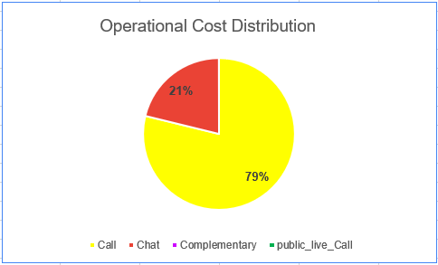

- Description:
The table shows earnings by consultation type for the selected month. The pie chart visualizes the cost distribution, where Call contributes the highest share (79%), followed by Chat (21%), while other categories contribute minimally. The values update dynamically when the month filter is changed.

Question 7: What is the average number of calls handled per agent per day?

Solution:

Final Answer (if any):
The average number of calls handled per agent per day is 2 calls.

Approach (if any):
The calculation is based on total values:
- Total Calls = 8508
- Total Days = 34
- Total Agents (Guru) = 131
The average was calculated using the formula:
Average Calls per Agent per Day = (Total Calls / Total Agents) / Total Days

Charts & Tables (if any):
- Table Name:
NA
- Description:
NA

Question 8: How many repeat callers are there, and what percentage of total calls do they represent?

Solution:

Final Answer (if any):
There are 1,478 repeat callers, and they represent 46% of the total callers. This indicates that nearly half of the users made more than one call, while the remaining 54% are unique callers.

Approach (if any):
A Pivot Table was created using User ID (uid) in rows and Count of CallSid in values to calculate the number of calls made by each user. Users with more than one call were considered repeat callers.
The total number of callers (4,598) and total calls (8,508) were also calculated. The percentage of repeat callers was then derived by comparing repeat callers with total callers.

Charts & Tables (if any):
- Chart Name:
Total Percentage of Repeat Callers
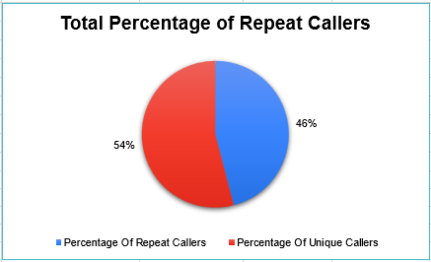

- Description:
The pie chart shows the distribution between repeat and unique callers. Repeat callers account for 46%, while unique callers make up 54%, giving a clear comparison of user behavior.

Question 9: What are the total sales generated by the call centre for each product category?

Solution:

Final Answer (if any):
The total sales for each product category are calculated by summing the amount for each consultation type, which shows how much revenue each category generated.

Approach (if any):
I created a Pivot Table using Consultation Type in rows and Sum of Amount in values to calculate total sales for each category.

Charts & Tables (if any):
- Table Name:
Sales by Product Category
- Description:
This table shows total sales for each consultation type, helping to compare revenue across different categories.

Question 10: How many calls were made for each user ID and guru ID?

Solution:

Final Answer (if any):
The total number of calls made for each user ID and guru ID is calculated to understand how calls are distributed between users and agents.

Approach (if any):
I created a Pivot Table using User ID and Guru ID in rows and Count of Call ID in values to calculate the number of calls for each combination.

Charts & Tables (if any):
- Table Name:
Calls by User and Guru
- Description:
This table shows how many calls were made by each user to each guru, helping to analyze interaction patterns.

Question 11: What is the correlation between call duration and customer satisfaction?

Solution:

Final Answer (if any):
There is a moderate positive correlation between call duration and customer satisfaction.

Approach (if any):
I used the CORREL function in Excel to calculate the correlation between call duration and customer satisfaction (rating).

Charts & Tables (if any):
- Table / Chart Name:
NA
- Description:
NA

Question 12: Which guru has the highest and lowest customer satisfaction scores?

Solution:

Final Answer (if any):
The guru with the highest and lowest customer satisfaction scores was identified based on the average ratings.

Approach (if any):
I created a Pivot Table using Guru Name in rows and Average of Rating in values to compare customer satisfaction scores.

Charts & Tables (if any):
- Table Name:
Customer Satisfaction by Guru
- Description:
This table shows the average customer satisfaction score for each guru, helping to identify the highest and lowest performers.

Question 13: What is the average customer satisfaction score by month?

Solution:

Final Answer (if any):
The average customer satisfaction score varies by month based on the calculated average ratings.

Approach (if any):
I created a Pivot Table using Month in rows and Average of Rating in values to calculate the monthly average customer satisfaction score.

Charts & Tables (if any):
- Table Name:
Monthly Customer Satisfaction
- Description:
This table displays the average customer satisfaction score for each month.

Question 14: How many categorical columns are there in the data?

Solution:

Final Answer (if any):
A total of 22 categorical columns and 7 continuous columns were identified in the dataset.

Approach (if any):
All columns were reviewed in Excel and organized into a table with Column Name, Data Type, and Category Type. Based on their values, columns were classified as either categorical or continuous. This helped in clearly identifying and counting each type.

Charts & Tables (if any):
- Table Name:
Column Classification Table
- Description:
A table was created in Excel to list all columns along with their data type and category type. This helped in clearly identifying and counting categorical and continuous columns.

SUBJECTIVE QUESTIONS

Question 1: Should the investment be used to hire more agents, improve training programs, or upgrade call center technology?

Solution:
Approach:
I compared Guru-wise average call duration and customer rating. I also checked the call and chat status distribution to understand completed, failed, incomplete, and no-answer interactions.

Charts & Tables:
- Chart Name:
1. Guru-wise Call Duration and Customer Rating
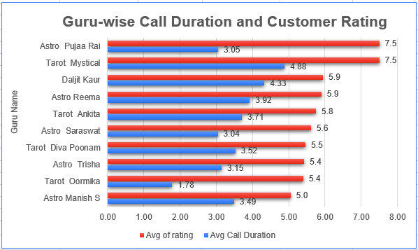

2. Call Status Distribution
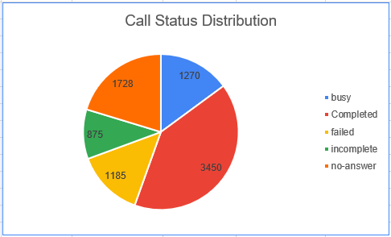
3. Chat Status Distribution
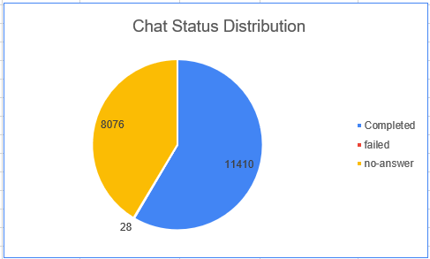

- Description:
These charts show Guru Performance along with the status of calls and chats. They help identify customer service issues and areas where training or operational improvements may be required.

Insights:
- Some Gurus have longer call durations but do not always have higher ratings.
- A significant number of calls and chats are marked as no-answer, failed, or incomplete.
- This shows that the issue is not only the number of agents but also how calls are handled and how the system manages interactions.
- Better training can help improve call handling and customer satisfaction.
- Technology improvements can help reduce missed or unsuccessful interactions.

Recommendations:
- Training should be the first priority to improve Guru Communication and call-handling skills.
- A smaller portion of the investment can be used for technology upgrades to improve call routing and reduce unsuccessful interactions.
- Hiring more agents can be considered if high call volume continues after these improvements.

Question 2: What are the potential risks of each investment option (hiring, training, technology upgrades), and how can they be mitigated?

Solution:

Approach:
I created a Pivot Table to find total calls and total earnings for each month (January and December).
Then I compared both months to understand demand, cost, and variation.

To measure risk:
- I used call volume to check hiring need.
- I calculated cost per call (Earnings ÷ Calls) to check efficiency.
- I compared both months to see variation in demand.
I also created a bar chart to visually compare the data.

Charts & Tables:
- Table / Chart Name:
- Pivot Table: Monthly Calls and Earnings.
- Bar Chart: Call Volume vs Earnings.

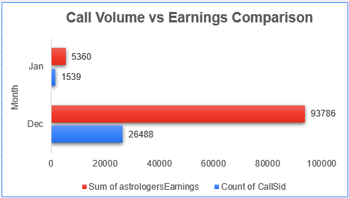

- Description:
The bar chart helps to easily compare both months and shows that December has much higher values than January.

Insights:
- Hiring Risk:
December has 26,488 calls and January has only 1,539 calls.
So demand is very high in December, which can create pressure & need more hiring.
- Inefficiency Risk:
Cost per call is almost same (Dec: 3.54, Jan: 3.48).
So there is no major inefficiency, cost is stable.
- Volume Variability Risk:
There is a big difference (24,949 calls) between both months.
This shows demand is not stable and can change a lot.

Recommendations:
- Hiring:
Increase staff during high demand months like December.
- Training:
Train existing employees so they can handle more workload during peak time.
- Technology Upgrades:
Use automation tools like Chatbots or better queue systems to manage high traffic.

Question 3: How does AstroSage's call center performance compare to AstroGuru's average call volume, customer satisfaction, and agent performance?

Solution:

Approach:
To answer this question, the focus would be on comparing call volume, customer satisfaction, and agent performance between AstroSage and AstroGuru. This can be done by calculating total number of calls handled, average customer ratings, and evaluating how each agent performs.

For this, functions like COUNT (for call volume) and AVERAGE (for customer satisfaction) would be useful. A bar chart can be used to clearly compare these factors between AstroSage and AstroGuru.

Charts & Tables:
- Table / Chart Name:
Comparison of Performance Metrics
- Description:
A bar chart can be used to compare call volume, average ratings, and agent performance, making it easier to understand differences between AstroSage and AstroGuru.
Insights:
By doing this comparison, it becomes easier to see which platform handles more calls, which one has better customer satisfaction, and how consistent the agents are in their performance.

Recommendations:
Based on the comparison, the platform with lower performance in any area should focus on improving that aspect. For example, if customer satisfaction is low, better training can be provided. If call volume handling is weak, more agents or better systems can be introduced.

And aggregation functions like COUNT and AVERAGE, along with a bar chart, would be used to solve this problem.

Question 4: How can the call center improve its handling of peak call periods to ensure high customer satisfaction?

Solution:
Approach:
I used a Pivot Table with Hour, Count of Call ID, and Average Time Duration to identify the busiest hours. A separate Top 5 Peak Hours Pivot Table was created by sorting call volume from largest to smallest, and a column chart was used to clearly show the peak hours.

Charts & Tables:
- Table / Chart Name:
1. Call Volume & Average Handling Time by Hour
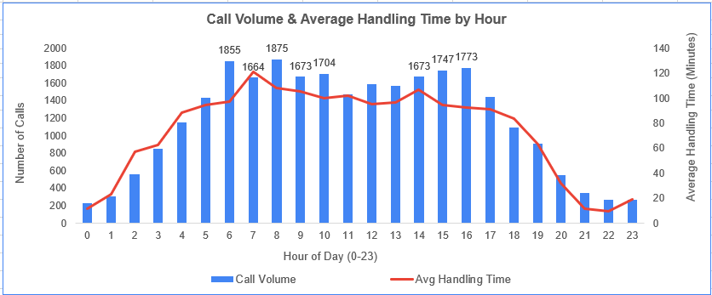

- Description:
The chart represents call distribution across different hours of the day.
The bars (columns) show the number of calls received per hour.
The line represents the average handling time for calls.
X-axis shows Hour of Day (0–23 format):
- Example:
13 = 1 PM
18 = 6 PM
Primary Y-axis shows Number of Calls
Secondary Y-axis shows Average Handling Time (minutes).

2. Peak Call Hours Requiring Additional Staffing
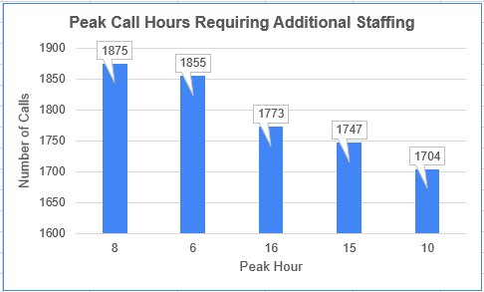

- Description:
The chart shows the five hours with the highest call volume and their exact call counts, which helps identify when additional staffing is required.

Insights:
- 8 AM has the highest call volume with 1,875 calls.
- 6 AM follows with 1,855 calls.
- Other high-volume periods are 4 PM (1,773 calls), 3 PM (1,747 calls), and 10 AM (1,704 calls).
- These peak periods can put additional pressure on agents and increase the chances of delays or missed calls.

Recommendations:
- Schedule more agents during the identified peak hours.
- Distribute workload properly during high-demand periods.
- Keep staffing lower during low-volume hours and use those periods for breaks or other activities.
- Monitor peak-hour performance regularly and adjust staffing based on call volume.

Question 5: Based on historical data, what strategic initiatives should be prioritized to improve efficiency and customer satisfaction?

Solution:
Approach:
I created a Pivot Table using Consultation Type, Platform, and Average Rating to compare customer satisfaction across different services and platforms. A clustered column chart was used to make the comparison easier.

Charts & Tables:
- Table / Chart Name:
Platform-wise Customer Rating Comparison
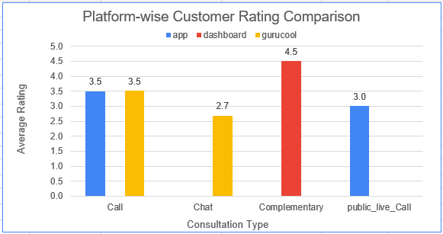
- Description:
Shows the average customer rating for each consultation type across App, Dashboard, and Gurucool.

Insights:
- Gurucool has the lowest overall average rating of 2.7.
- Chat on Gurucool also has a rating of 2.7, making it the main area that needs attention.
- Dashboard has the highest overall average rating of 4.5.
- Call ratings are 3.5 on both App and Gurucool.

Recommendations:
- Improve the Gurucool chat service based on customer feedback.
- Use the Dashboard experience as a reference for improving weaker services.
- Continue monitoring average ratings by platform and consultation type to measure improvement.

Question 6: What can be the key factors contributing to high customer satisfaction scores, and how can these be leveraged to improve overall performance?

Solution:

Approach:
I created three pivot tables to understand how customer satisfaction (rating) is related to time spent and amount paid. I also applied filters like Website and Consultation Type to analyze different segments separately. Additionally, I grouped ratings into Low
(0–2), Medium (3–5), and High (6–8) for better understanding.

Charts & Tables:
- Table Name 1: Rating Distribution

- Description:
This pivot table shows the count of ratings for different consultation types. It helps in understanding how ratings are distributed across the dataset.

- Table Name 2: Average Time Duration vs Rating

- Description:
This pivot table shows the average time duration for each rating group. It helps in analyzing whether longer or shorter interactions impact customer satisfaction.

- Table Name 3: Average Amount vs Rating

- Description:
This pivot table shows the average amount spent for each rating group. It helps in understanding the relationship between spending and satisfaction.

Insights:
- Most users fall in the medium to high rating range, which indicates overall good performance.
- Higher ratings are generally associated with longer interaction duration, showing that users who spend more time tend to be more satisfied.
- Very low ratings have very short durations, which may indicate incomplete or poor interactions.
- The amount spent is higher for medium ratings (around 4–5) and slightly lower for the highest ratings.
- This shows that higher spending does not always guarantee the highest satisfaction.
- Chat appears to have higher volume compared to calls, making it an important channel.

Recommendations:
  - Focus on maintaining an optimal interaction duration, as too short calls lead to low satisfaction.
  - Improve quality of interactions rather than just increasing duration or cost.
  - Analyze low-rating cases (0–2) to identify common issues and improve service quality.
  - Give more attention to the chat platform, as it handles a larger number of interactions.
  - Use segmented analysis (by website and consultation type) regularly to track performance more accurately.

Question 7: How should the call center balance the workload among agents to ensure optimal performance and avoid burnout?

Solution:

Approach:
A Pivot Table was created with Agent Name, Count of Call ID, and Average of astrologerOnCallDuration. The overall average call count and average call duration were calculated separately using the AVERAGE function and used as thresholds. The IF and AND/OR functions were then used to classify agents into High Load, Medium Load, and Low Load categories.

Charts & Tables:
- Table Name: Agent Workload Analysis

- Description:
The table compares call volume and average call duration for each agent.
The workload status helps identify agents who may be handling relatively higher workloads.

Insights:
- Agents with both higher call counts and longer average call durations are more likely to have a high workload.
- Some agents may have high call volume but shorter calls, while others may handle fewer calls but spend more time on each call.
- The workload classification helps identify agents who may need workload balancing.

Recommendations:
- Workload should be redistributed from high-load agents to agents with lower workloads where possible.
- Regularly monitoring call volume and average call duration can help reduce burnout while maintaining service quality and customer satisfaction.

Question 8: What new technologies or tools could be implemented to enhance call center operations and customer service?

Solution:
Approach:
For this question, I didn’t use Excel. I just thought about how a call center works and what kind of new tools or technologies can make the process faster and better for both customers and agents.

Technologies / Tools Suggested:
Some new technologies that can be implemented are:
- AI Chatbots: To handle basic customer queries quickly without human agents.
- Automatic Call Routing Systems: To connect customers to the right agent quickly.
- Customer Relationship Management (CRM) Software: To store and manage customer data efficiently
- Speech Analytics Tools: To analyze customer conversations and improve service quality.
- Cloud-based Call Center Systems: For better scalability and remote working support.

Charts & Tables:
- Table / Chart Name:
NA
- Description:
NA

Insights:
These tools can reduce the pressure on agents and make the whole process smoother. Customers will also get faster responses, which improves their experience.

Recommendations:
In my opinion, the call center should start using AI and automation tools for basic tasks. This will save time and allow agents to focus on more important problems. As a result, efficiency will increase and customer satisfaction will also improve.

Question 9: What metrics should be included in the final dashboard to comprehensively view call center performance and guide investment decisions?

Solution:
Approach:
To design the dashboard, I included important metrics related to call volume, revenue, agent performance, and customer satisfaction.
This helps in understanding overall performance and making better decisions for hiring, training, and technology.

Charts & Tables:
- Table / Chart Name:
- KPI Summary Cards (Total Consults, Total Revenue, Repeat Callers %, Avg Rating, Total Cost, Total Users, Total Callers)
- Call Volume & Avg Handling Time by Hour (Combo Chart)
- Calls/Chats handled by Agent (Bar Chart)
- Operational Cost Distribution (Pie Chart)
- Rating-wise User Distribution (Bar Chart)
- Monthly Call Volume (Column Chart)
- Daily Call Volume (Line Chart)
- Revenue by Consultation Type (Bar Chart)
- Website Distribution (Pie Chart)
- Call Status Distribution (Pie Chart)
- Chat Status Distribution (Pie Chart)

- Description:
- KPI cards give a quick overview of overall performance.
- Hourly call volume shows peak and low traffic hours along with handling time.
- Agent chart shows how work is distributed among agents.
- Cost distribution shows how operational cost is divided.
- Rating chart shows customer satisfaction levels.
- Monthly and daily charts show call trends over time.
- Revenue chart shows which consultation type generates more income.
- Website distribution shows traffic source.
- Call and chat status charts show completion and pending cases.

Insights:
- Call volume is higher during specific hours, showing clear peak time.
- Some agents are handling more calls than others, showing uneven workload.
- Majority of revenue comes from Call consultation type.
- Most users are coming from one main platform (App).
- Ratings are mostly between mid to high range, but some low ratings exist.
- Daily and monthly trends show variation in demand.
- Some calls/chats are incomplete or abandoned, indicating service gaps.
- Operational cost is mainly coming from paid calls.

Recommendations:
- Hiring:
Increase staff during peak hours to handle high call volume.
- Training:
Train low-performing agents and improve service quality to increase ratings.
- Technology Upgrades:
Improve system handling (queue, app performance) to reduce abandoned calls and chats.
- Workload Management:
Distribute calls more evenly among agents.
- Business Focus:
Invest more in high-revenue consultation types (Call).

Question 10: How would you allocate a 1 crore rupee investment to optimize operational efficiency, enhance customer satisfaction, and boost profitability, and what analysis-based recommendations would you offer to support this?

Solution:
Approach:
For this question, I reviewed the overall call center performance and considered areas where investment could improve efficiency, customer experience, and business growth. Based on the analysis, I allocated the 1 crore investment across technology, employee development, and operational improvements.

Investment Allocation (1 Crore)
- 30 Lakhs – AI Chatbots and Automation Tools
- To handle basic customer queries and reduce agent workload.
- Helps in providing faster responses to customers.
- 25 Lakhs – Agent Training and Development
  - To improve communication, product knowledge, and problem-solving skills.
  - Helps agents provide better customer support.
- 20 Lakhs – CRM System Enhancement
  - To manage customer information more effectively.
  - Enables personalized and efficient customer service.
- 15 Lakhs – Call Quality Monitoring and Analytics Tools
  - To analyze customer interactions and identify improvement areas.
  - Helps maintain service quality.
- 10 Lakhs – Infrastructure and Technology Upgrades
  - To improve system reliability and reduce technical issues.
  - Ensures smooth day to day operations.

Charts & Tables:
- Table / Chart Name:
NA

- Description:
NA

Insights:
- A significant portion of the investment is allocated to technology because automation can improve efficiency and reduce operational costs.

- Investing in employee training can improve customer interactions and increase service quality.

- Better CRM and analytics tools can help understand customer needs and support data-driven decision-making.

- Upgrading infrastructure can reduce downtime and improve overall productivity.

Recommendations:
- Implement AI-based solutions to automate repetitive tasks and reduce waiting time.

- Conduct regular training programs to enhance agent performance and customer handling skills.

- Use CRM and analytics tools to track customer behavior and improve service quality.

- Continuously monitor key performance metrics through dashboards to measure the impact of investments.

- Review workload distribution regularly to ensure agents maintain high performance without burnout.

