) is a Hindi word which means “From the core of the Heart” or “Whole Heartedly” or “Heart Felt”.

** which in English mean **Heartfelt Welcome**. This is something you may get to read in most of the Indian places, hoardings, city/country entrances etc.

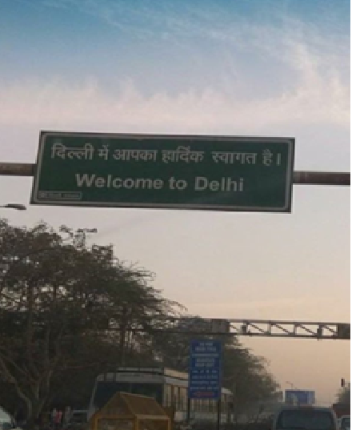

The way this name is pronounces as is  ***Haar- thee – ik (Har ðiː ik)*** *and* ***definitely not as****: Hardick*Here the alphabet d is pronounced as Thee (from shakespearean english) and not alphabet D as in Don or denmark.

Below is the Youtube link to hear and practice how it should be:

<https://youtu.be/rYSWDUloxQY>

**Note**: The reason why Indian English Accent is Hard because all the Indian languages are sound based hence it is very important to use the correct sounds when pronouncing Indian names else it may sound rude or offensive to them. Specially in this case the name may sound **abusive** even if the non-native speaker doesn’t Intend too.

P.S: Happy to get your reviews on how I can improve on this document.

Take Care 😊