Meaning
The word Hardik (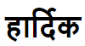) is a Hindi word which means “From the core of the Heart” or “Whole Heartedly” or “Heart Felt”.
Example: “Hardik Svaagat” 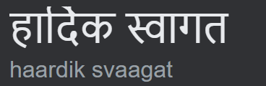 which in English mean Heartfelt Welcome. OR Hardik shubhkamna (Heartfelt Congratulations)
This is something you may get to read this name in most of the places in India like on: hoardings, city/country entrances etc.
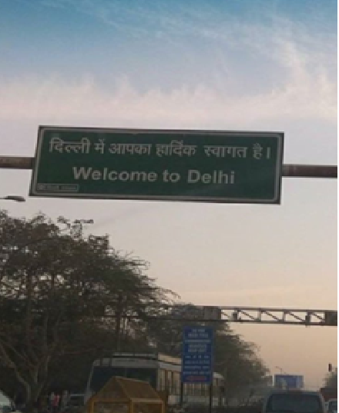

Pronunciation:
It is very common for non-Hindi speakers to mispronounce this name and turn it into insulting/abusive without even intending to do it. It is very important to pay heed to the sounds of the words in Indian languages (this is one of the reasons why Indian accents there are twice the number of alphabets in Hind (52) as compared to English (26)). Hence more sounds as compared 12.

The way this name is pronounces as is Haar- thee – ik (Har ðiː ik) and definitely not as: Hardick
Here the alphabet d is pronounced as many other engligh words like Thee, Thou (from shakespearean english) or The, Then and Though.
NOT alphabet D as in Don, Dear or Denmark.

Below is the YouTube link to hear and practice how it should be:
https://youtu.be/rYSWDUloxQY

Hope next time you meet a person named Hardik; you call him with his correct name 12

