Big Data and Cloud Computing in Networking
A Research Report
Submitted in partial fulfillment of the
Requirements for the award of the Degree of
MASTER OF SCIENCE (INFORMATION TECHNOLOGY)
By
Ahmed Dilshad Shaikh
Roll Number: 812
Under the esteemed guidance of
Mr. Mayur Tawde
Designation

DEPARTMENT OF INFORMATION TECHNOLOGY
SHRI RAJASTHANI SEVA SANGH’S
SMT.PARMESHWARIDEVI DURGADUTT TIBERWALA LIONS JUHU COLLEGE OF ARTS, COMMERCE & SCIENCE
(Affiliated to University of Mumbai)
(Autonomous)
JB NAGAR, ANDHERI EAST, MUMBAI MAHARASHTRA - 400059
2025 - 26

 | Sr. No. | Contents | Page No.
Chapter | 1 | INTRODUCTION | 3
Chapter | 2 | IMPORTANCE OF BIG DATA AND CLOUD | 5
Chapter | 3 | TECHNIQUES AND CONCEPTS | 5
Chapter | 4 | TOOLS AND PLATFORMS | 6
Chapter | 5 | CONCLUSION | 7
TABLE OF CONTENTS

CHAPTER - 1

INTRODUCTION
Big Data refers to extremely large and complex datasets that cannot be processed, stored, or analyzed using traditional data processing tools. These datasets are generated from multiple sources such as mobile devices, social media platforms, sensors, and enterprise applications. The characteristics of Big Data are commonly defined by the three V’s: volume (large amount of data), velocity (high speed of data generation), and variety (different types of data such as structured and unstructured).
Cloud computing, on the other hand, is a technology that provides on-demand access to computing resources such as storage, processing power, and software over the internet. Instead of relying on local servers or personal computers, cloud computing allows users to store and process data in remote data centers. This makes data handling more efficient, scalable, and cost-effective.
In modern networking environments, the integration of Big Data and cloud computing has become essential. Networks today handle massive amounts of data traffic generated by applications such as video streaming, online gaming, e-commerce, and Internet of Things (IoT) devices. Traditional networking systems are not capable of managing such large-scale data efficiently, which has led to the adoption of cloud-based solutions
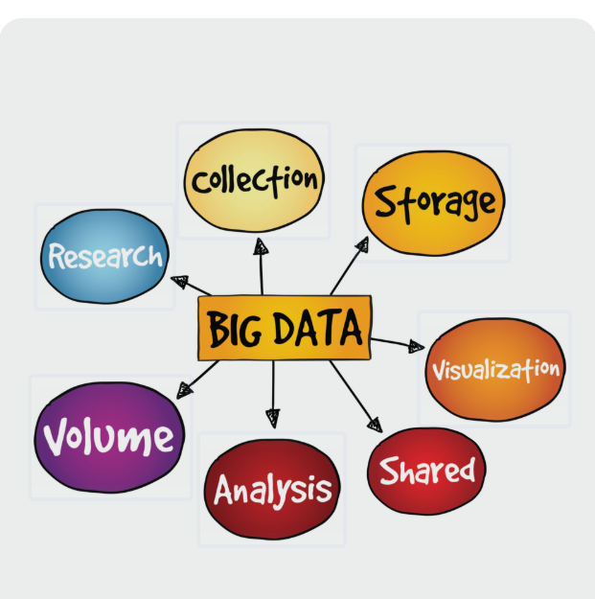.

CHAPTER - 2

IMPORTANCE OF BIG DATA AND CLOUD
Big Data and Cloud Computing are important because:
- Handle large-scale data
- Provide scalable storage
- Support real-time processing
- Reduce infrastructure cost

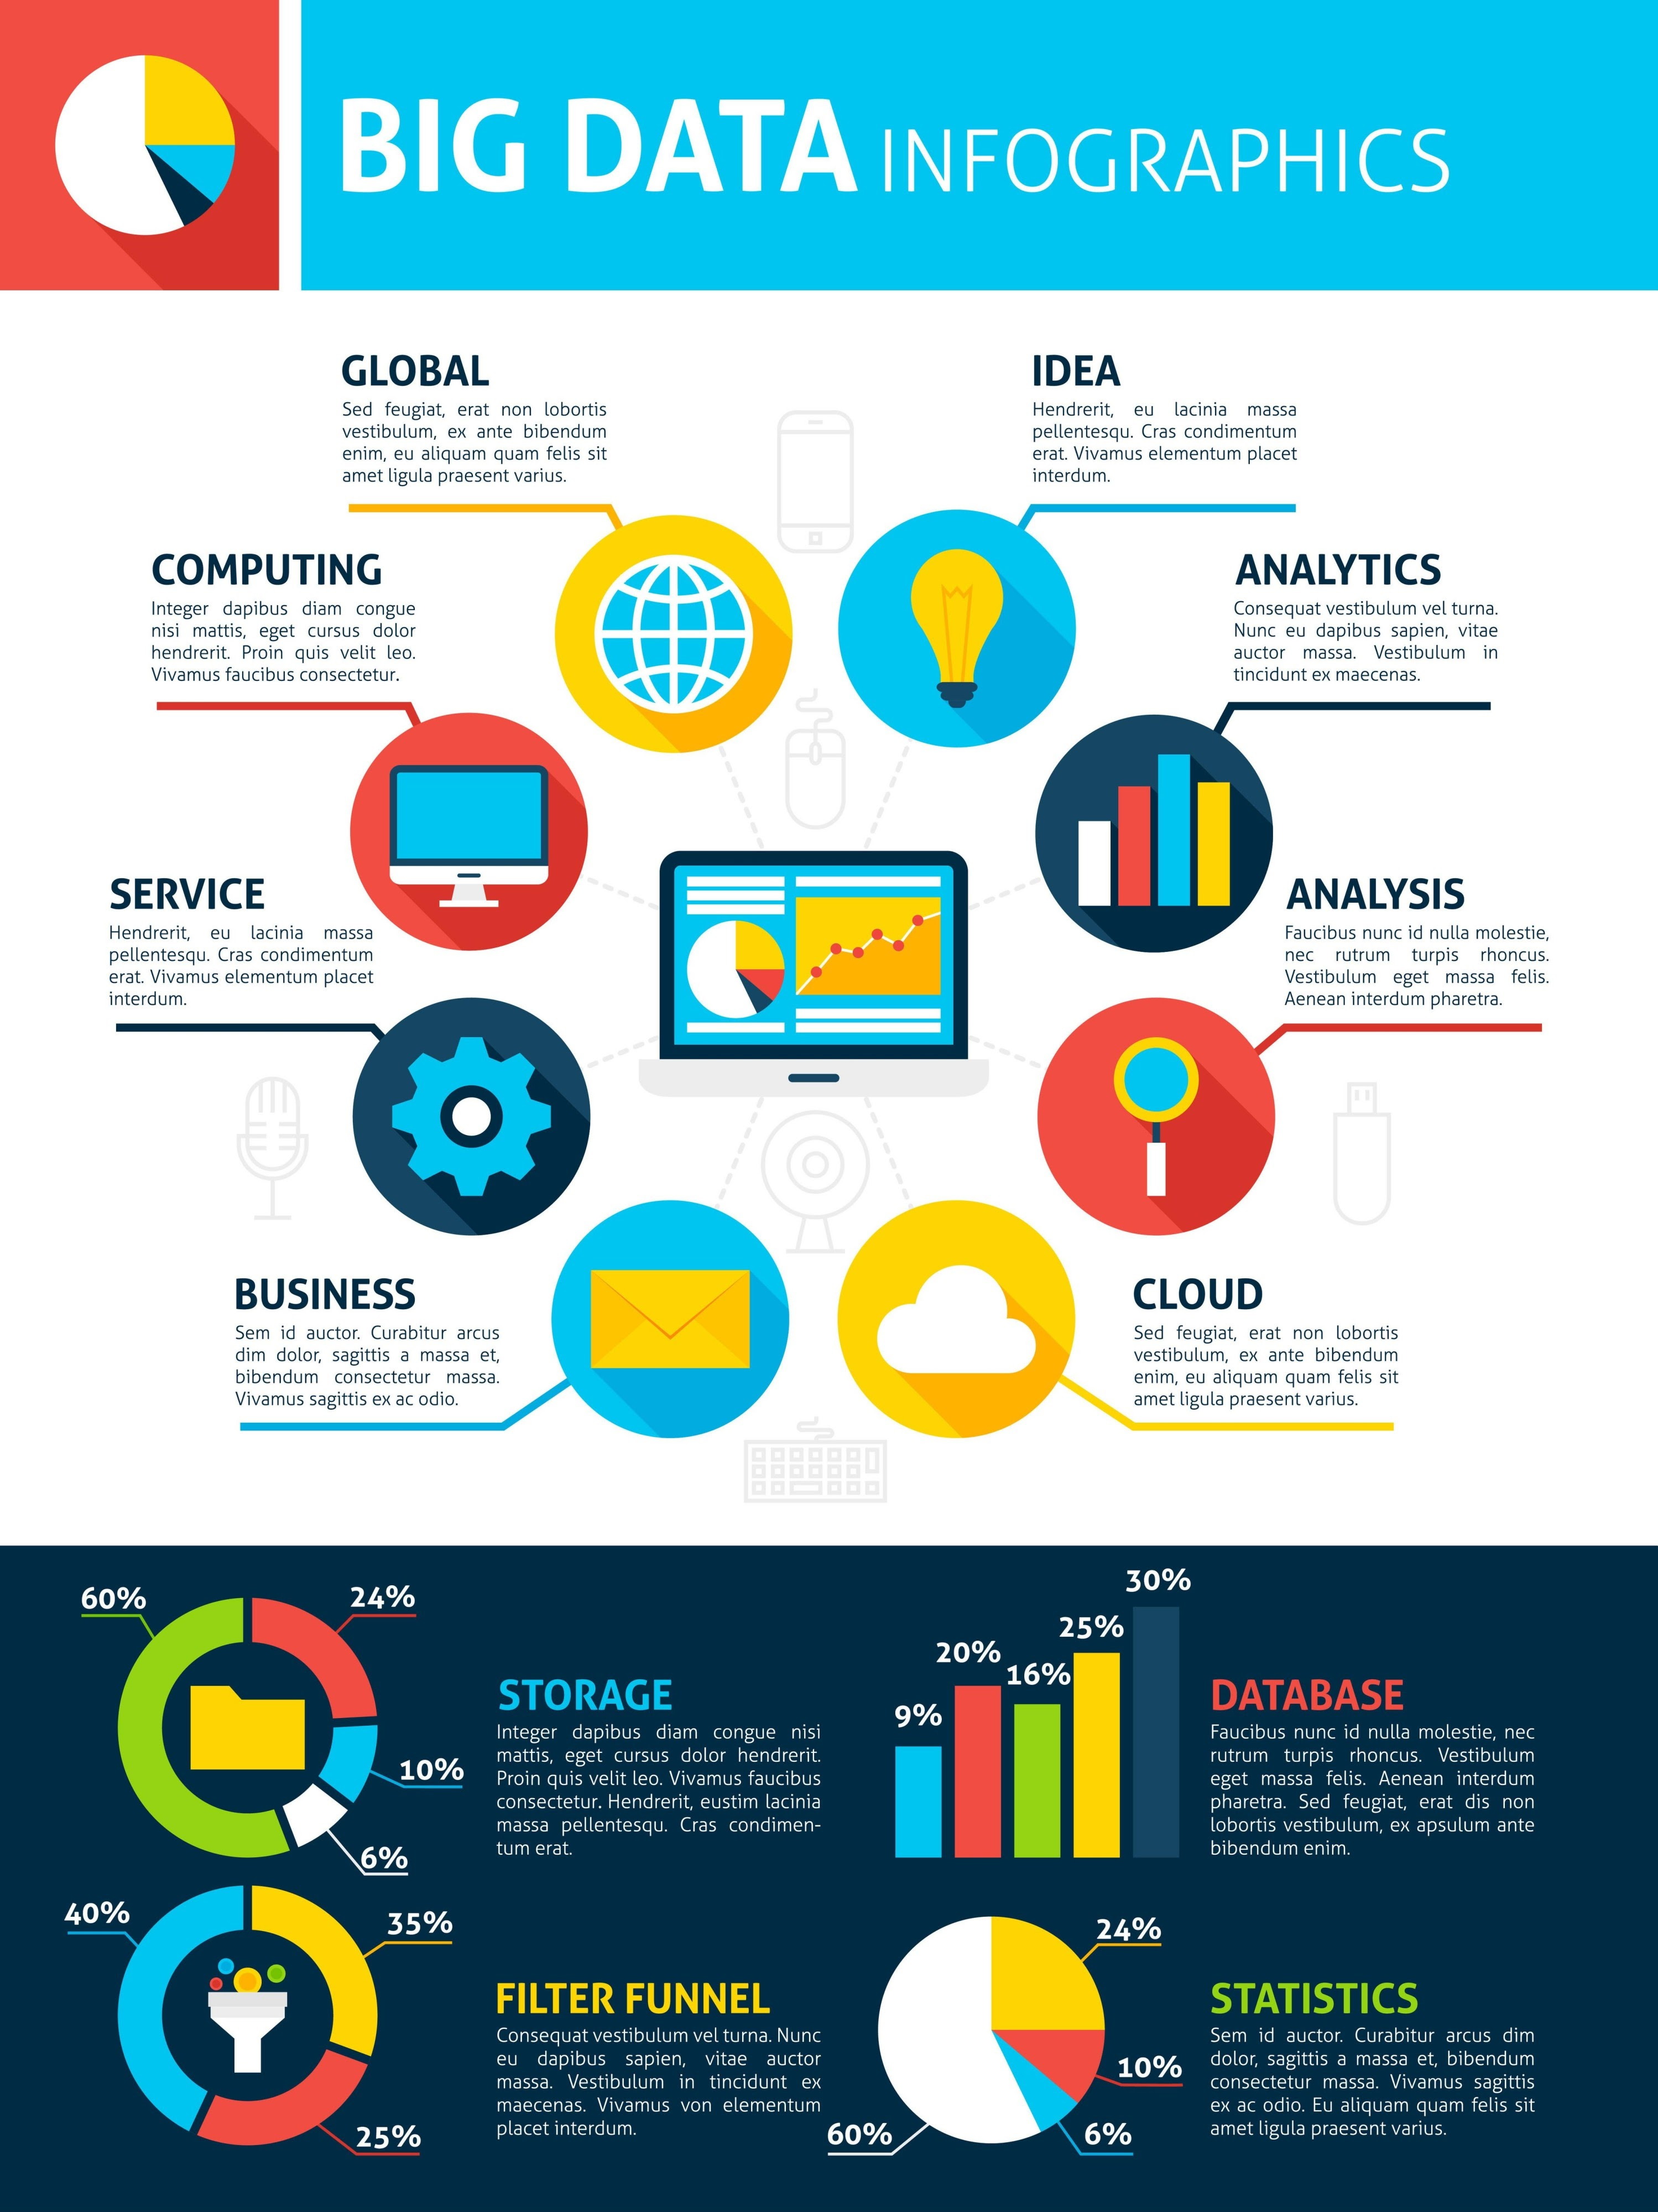

CHAPTER - 3
TECHNIQUES AND CONCEPTS

1. Big Data Characteristics
- Volume: The vast amounts of data generated every second.
- Variety: The different types of data (structured, unstructured, semi-structured).
- Velocity: The speed at which new data is generated and moves around.

2. Cloud Computing Models
- IaaS (Infrastructure as a Service)
- PaaS (Platform as a Service)
- SaaS (Software as a Service)

3. Data Processing
- Distributed computing
- Data centers

4. Network Demand
Big data and cloud operations significantly increase network traffic, requiring high bandwidth and robust network architecture to function efficiently.

CHAPTER - 4
DTOOLS AND PLATFORMS

Several key tools and platforms are utilized to manage and process big data efficiently:
- Hadoop
- AWS (Amazon Web Services)
- Microsoft Azure
- Google Cloud

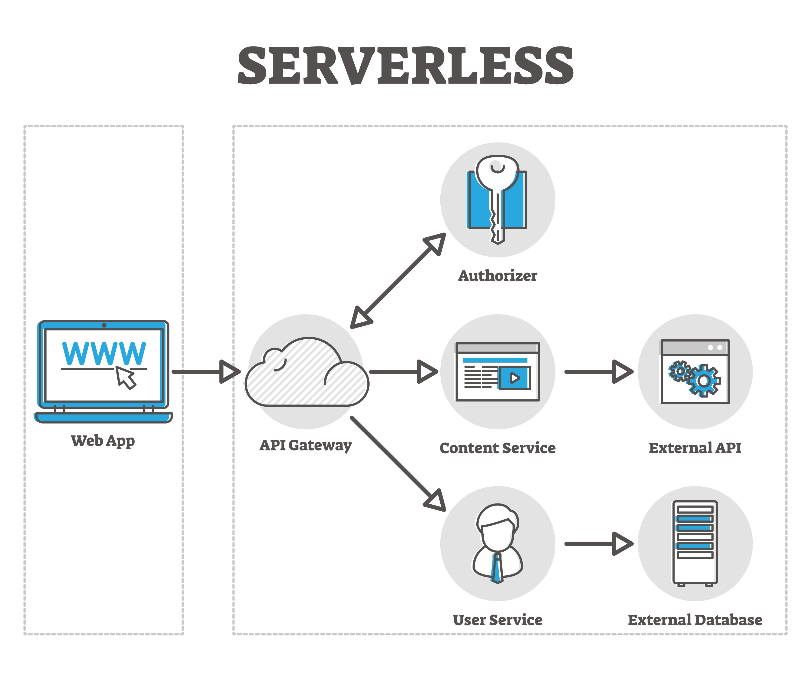

CHAPTER - 5
CONCLUSION
Big Data and Cloud Computing have become essential in modern networking systems. They help in managing large volumes of data efficiently and provide scalable solutions for storage and processing. These technologies support the growing demand for faster and more reliable communication.
Cloud computing enables flexible access to resources, while Big Data allows organizations to analyze and use information effectively. Together, they improve network performance and support real-time applications such as online services, streaming, and smart systems.
In conclusion, the integration of Big Data and Cloud Computing plays a vital role in the development of modern networks. As data continues to grow, these technologies will become even more important in ensuring efficient, secure, and high-speed communication systems.
.

