Name: Ahmed Ahmed

ID: 500836052

Lab 3 My Submission

Server:

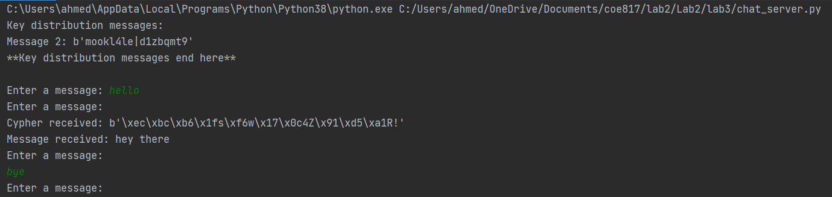

Client:

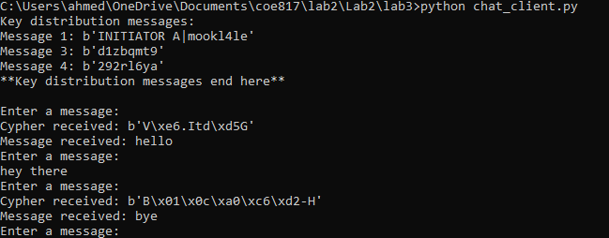

How to prevent replay attacks:

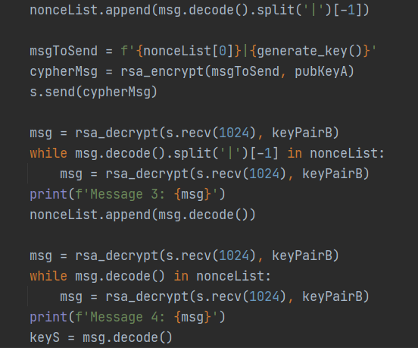

In this portion of the code, the client checks to see if the nonce of the sent message matches one of the nonces of the already sent messages. If it does, then the client ignores the message and waits to receive another one using the while loop.