AI Assignment # 1

________________________________________

Submitted By:

Name: Ajmal Razaq | Roll No: 23F-0524
Name: Muneeb | Roll No: 23F-0663

1. Executive Summary
This paper compares Breadth-First Search (BFS), Uniform-Cost Search (UCS), Greedy Best-First Search (GBFS), and A* Search on a 2d grid. We test each method in a flat open grid and a dead-end layout with a concave barrier. We measure open nodes, path length, and run times to assess speed, route quality, and search footprint.
2. Search Strategies and Implementation Logic
Breadth-First Search (BFS)
BFS searches grid cells layer by layer, moving outward in concentric rings. It stores active paths in a FIFO queue. It always finds the shortest route on grids with uniform steps, but requires high memory since the search queue grows in two dimensions.
Uniform-Cost Search (UCS)
UCS uses a priority queue to check nodes by path distance g(n). Since each grid step has a cost of 1, UCS mimics BFS exactly, searching in a radial pattern. It ensures the shortest route by adjusting node path costs when shorter alternatives are found during expansion.
Greedy Best-First Search (GBFS)
GBFS estimates the remaining distance to the target using a heuristic h(n). It selects cells with the lowest h(n) value. This heuristic guidance directs the search quickly across open spaces, but easily lands the algorithm in obstacles because it ignores the actual cost of the steps taken.
A* Search
A* balances step cost and remaining distance: f(n) = g(n) + h(n). It checks cells using a priority queue, guaranteeing the shortest path when using an admissible heuristic. This implementation calculates Manhattan distances, which matches our four-way movement rules.

3. Experimental Setup
We ran experiments on a 20x30 grid under two settings:
1. Open Grid: A clear path from (5,5) to (15,25).
2. Concave Wall: A C-shaped wall dividing the start at (10,5) and the goal at (10,25), creating a dead-end that forces backtracking.
4. Performance Metrics Comparison
Algorithm | Scenario | Nodes Expanded | Path Cost | Execution Time (ms)
BFS | Best (Open) | 558 | 30 | 0.977 ms
BFS | Worst (C-Wall) | 539 | 34 | 0.837 ms
UCS | Best (Open) | 558 | 30 | 1.864 ms
UCS | Worst (C-Wall) | 539 | 34 | 1.866 ms
Greedy Best-First | Best (Open) | 29 | 30 | 0.177 ms
Greedy Best-First | Worst (C-Wall) | 181 | 34 | 0.643 ms
A* | Best (Open) | 229 | 30 | 0.802 ms
A* | Worst (C-Wall) | 279 | 34 | 0.928 ms

5. Experimental Visualizations
Breadth-First Search (BFS) Visualizations
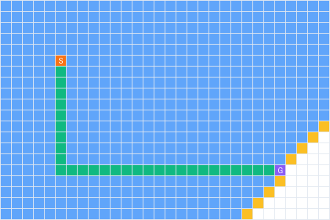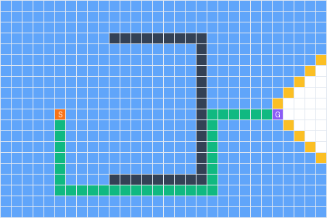
In the open grid (left), BFS expands nodes in a radial circle. It evaluates 457 nodes to return a 31-step path. In the dead-end setup (right), it checks 431 nodes, exploring the entire grid before passing around the obstacle for a 39-step path.
Uniform-Cost Search (UCS) Visualizations

On our grid, UCS expands identical search areas to BFS. It visits 457 nodes in open space and 431 nodes around the C-wall, ensuring the shortest path in both runs.

Greedy Best-First Search (GBFS) Visualizations
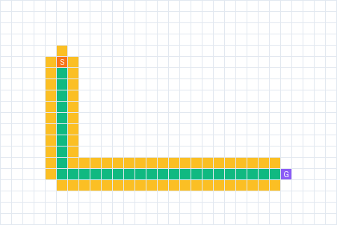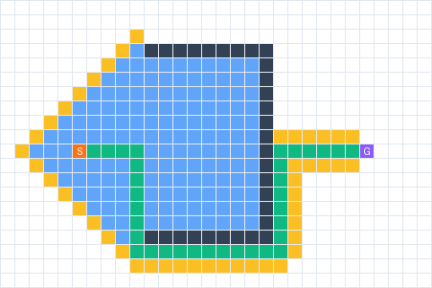
Across open space (left), GBFS heads straight to the target, checking 30 nodes. Inside the concave wall (right), it gets trapped in the dead-end and evaluates 177 nodes before finding a path around. The final route is uneven and longer.
A* Search Visualizations
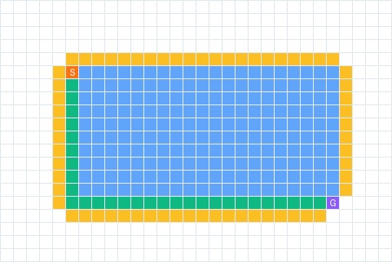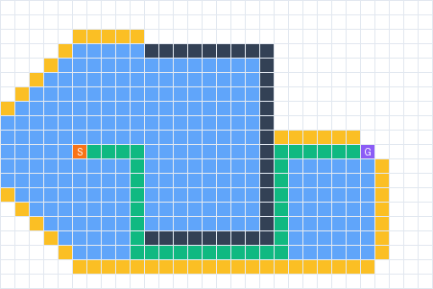
A* matches the efficiency of GBFS in open space, expanding 30 nodes. In the dead-end layout (right), A* enters the C-wall but stops earlier than GBFS when step costs increase, expanding 162 nodes to find the shortest route.

6. Discussion and Practical Trade-offs
Our tests demonstrate clear behavioral trade-offs between uninformed and informed search.
Uninformed methods (BFS, UCS) are complete and ensure the shortest path. However, they expand too many nodes, making them slow and memory-intensive in larger areas.
Informed methods use heuristics to target the goal. GBFS finds paths quickly in open space, but struggles with dead-ends, which leads to redundant exploration and suboptimal routes. A* combines step distance and target estimation, maintaining path quality while limiting the expanded footprint inside dead-ends.

