BSCS FINAL PROJECT
Phase 1

Lie Detector using facial analysis and physiological signals



Project Advisor

<Muhammad Basit Ali Gilani>

Presented by:
Group ID: F23CS094

Student Reg# Student Name

L1F20BSCS0114 ABDUL QADEER
L1F20BSCS0660 AREEB HASSAN L1F20BSCS0988 MOHAMMAD ALI

Faculty of Information Technology

University of Central Punjab
Software Requirements Specification
Version 1

Lie Detector using facial analysis and physiological signals
Advisor: Muhammad Basit Ali Gilani

Group F23CS094
Member Name | Primary Responsibility
Abdul Qadeer | Project Overview
Muhammad Ali | Diagram Creation, Technical Visualization
Areeb Hassan | Requirement Gathering and Analysis

Table of Contents
Table of Contents i
Revision History ii
Abstract iii
1. Introduction 1
1.1 Review of Related Literature 1
1.2 Problem Statement 1
1.3 Proposed Solution 2
1.4 Problem Scope 2
1.5 Challenges 3
1.6 Knowledge Areas Required 4
1.7 Completeness Criteria 4
1.8 Research Outcomes/Nature of End Product 4
1.9 Learning Outcomes 4
1.10 Document Conventions 5
2. Background Study and Literature Survey 6
3. Overall Description 7
3.1 Proposed Solution 7
3.3 Operating Environment 8
3.4 Design and Implementation Constraints 8
3.5 Assumptions and Dependencies 8
4. Functional Requirements 10
4.1 Requirement 1 OR Use-Case 1 (if requirements are modeled as use cases) 11
4.2 Analysis and Modeling of Requirements 12
5. Nonfunctional Requirements 14
5.1 Target Performance 14
5.2 Safety Requirements 14
5.4 Additional Software Quality Attributes 14
6. Other Requirements 15
7. Initial Results 15
8. Revised Project Plan 16
9. References 17

Revision History
Name | Date | Reason For Changes | Version

Abstract
Our project addresses the critical need for an easy and reliable truth verification tool in scenarios such as interviews and interrogations. The project takes advantage of facial analysis and physiological signal processing, to distinguish between truthful and deceptive responses. Building upon existing research in lie detection and emotion recognition, we utilize OpenCV, Media Pipe’s Face Mesh, and FER for facial analysis. Along with this, we analyze physiological signals such as blink rate and more. These signals are then compared to an individual's baseline behavior, the aim is to create a practical solution for deception detection. The expected outcome is a user-friendly computer application that enhances the accuracy of lie detection, ultimately supporting professionals across various domains in making more informed decisions.

Introduction

Review of Related Literature
Deception detection has been a subject of extensive study across various disciplines, leveraging technological advancements to create robust systems for identifying deceitful behavior. [1] introduces the Bag-of-Lies dataset, a multimodal resource for detecting deception in casual settings, incorporating gaze data. The dataset addresses limitations of prior ones, aiming to enable more robust detection methods.

Additionally, [2] presents a computer vision and machine learning-based approach for automated deception detection. The study explores diverse methodologies, including thermal imaging and linguistic analysis, to identify deceitful behavior. Meanwhile, [3] delves into deception detection using robust facial features extracted from videos, emphasizing the challenges in using existing video classification architectures due to overfitting concerns.

Moreover, [4] contributes the Deception Detection and Remote Physiological Monitoring dataset, aiming to overcome the drawbacks of prior research relying on private datasets. It provides an extensive array of sensing modalities, including RGB, NIR imaging, and physiological recordings. The dataset's comprehensive nature facilitates a more rigorous exploration of deception detection techniques.

These works collectively underline the multifaceted nature of the deception detection domain. They emphasize the significance of multimodal datasets and diverse sensing techniques, such as facial features, gaze data, and physiological signals, to enhance the accuracy and reliability of detection systems. The limitations of existing methodologies, such as overfitting and dataset constraints, have prompted the development of these new datasets, aiming for more robust and applicable deception detection frameworks.

The exploration of various modalities ranging from facial expressions and gaze patterns to physiological signals signifies a move toward a more comprehensive understanding of deception cues. These studies underscore the need for interpretability in detection models while addressing concerns related to dataset authenticity and size, ensuring the reliability of the detection methods.

In conclusion, these literature pieces contribute significantly to the field by providing innovative datasets and methodologies, fostering advancements in automated deception detection techniques. They lay the groundwork for more nuanced and effective systems while acknowledging the complexities inherent in identifying deceptive behavior across diverse contexts and modalities.

Problem Statement
The problem at the heart of this project is the need for a reliable and accurate tool to assist in truth verification during various scenarios such as interviews, interrogations, and investigations. In these contexts, the challenge lies in effectively analyzing facial movements and physiological signals to distinguish between truthful and deceptive responses. Specifically, the project aims to address the following questions.

- How can facial analysis and physiological signal processing be integrated to create a robust tool for deception detection?
- What are the key facial expressions and physiological signals that can provide valuable cues in determining the veracity of responses during questioning?
- How can these facial landmarks, emotional cues, and physiological changes be effectively analyzed and compared to an individual's baseline behavior to identify significant deviations indicative of deception?

By tackling these questions, the project seeks to develop a practical solution that enhances the accuracy of lie detection, ultimately providing valuable support to professionals across various domains in their decision-making processes.

Proposed Solution
- Integration of Facial Analysis and Physiological Signals:
  - Utilize state-of-the-art technologies such as OpenCV, MediaPipe's Face Mesh, and Facial Expression Recognition (FER) to analyze facial movements and emotional cues in real-time.
  - Implement signal processing techniques to extract and analyze physiological signals like blink rate, gaze, hand movements, and lip compression concurrently with facial analysis.
- Development of Robust Deception Detection Algorithm:
  - Design and implement a sophisticated algorithm capable of integrating facial analysis and physiological signal processing data.
- Identification of Deception Indicators:
  - Determine key facial expressions and physiological signals that serve as reliable indicators of potential deception during questioning.
  - Develop a comprehensive catalog of deceptive cues based on empirical research and analysis.
- Baseline Behavior Comparison and Analysis:
  - Establish methodologies to compare an individual's current facial and physiological responses to their baseline behavior.
  - Devise statistical and signal processing techniques to identify significant deviations from the norm that might indicate deceptive behavior.
- User-Friendly Application Development:
  - Create an intuitive and user-friendly computer application interface that integrates all analysis modules.
  - Provide real-time feedback and graphical representations of deception indicators, ensuring accessibility and ease of use across various professional domains.
- Validation and Accuracy Assessment:
  - Conduct thorough validation and accuracy assessments using controlled experiments and real-world scenarios.
  - Test the tool's performance across diverse scenarios to ensure its effectiveness in truth verification.
- Ethical Considerations and Privacy:
  - Adhere strictly to ethical guidelines concerning data handling, especially in dealing with sensitive information like video recordings and physiological data.
  - Ensure the tool's usage aligns with ethical standards in professional and privacy contexts, prioritizing user confidentiality and data protection.

Problem Scope
The project scope entails integrating facial and physiological analyses to construct a comprehensive deception detection system. It primarily targets interviews, interrogations, and investigations across diverse professional domains such as law enforcement and employment interviews. It’s essential to note a limitation in video length processing. The system will prioritize shorter-duration video processing, and as such, long video processing might not fall within the immediate scope. It does not encompass accommodations or specialized adaptations for individuals with specific disabilities such as blindness or conditions like lazy eye. The tool's functionalities are designed for general use and may not cater to specialized accessibility requirements for individuals with visual impairments or similar disabilities. Leveraging established technologies like OpenCV, Media Pipe’s Face Mesh, and FER, the project will craft the deception detection tool, exploring their synergy for analysis and feedback. An emphasis lies on developing a user-friendly computer application that amalgamates all analysis modules. However, the project's focus remains on facial expressions and physiological signals, omitting considerations of external factors like ambient lighting or environmental influences that might impact data collection.

While aspiring to aid professionals across various domains, the project doesn't aim for detailed integration tailored to each specific context. Rather, it prioritizes broad applicability over specialized adaptations for individual domains. It relies on existing technologies like OpenCV and MediaPipe instead of pioneering new facial analysis or signal processing algorithms. Moreover, while focusing on facial and physiological cues for deception detection, the project refrains from delving extensively into psychological profiling or intricate behavioral analyses beyond visible expressions and cues.

Challenges
- Complex Algorithm Implementation: Implementing a sophisticated deception detection algorithm capable of analyzing both facial movements and physiological signals is a significant technical challenge.
- Integration of Technologies: Integrating multiple technologies, such as OpenCV, MediaPipe's Face Mesh, and physiological signal processing, to work seamlessly in the system is an integration challenges.
- Data Acquisition and Quality: Collecting and processing high-quality video data and physiological signals for testing poses a challenge.
- Understanding Research Papers: Reviewing and understanding relevant research papers on facial analysis, emotion recognition, and deception detection is crucial but may be challenging, especially for students new to these areas.
- Baseline Behavior Modeling: Developing an effective methodology for modeling and comparing baseline behavior with the data collected from the analysis to detect deviations requires advanced statistical and signal processing knowledge.
- Usability and User Experience: Creating a user-friendly application that is easy to understand and navigate for users from various professional backgrounds is a design and usability challenge.
- Ethical Considerations: Ensuring the project adheres to ethical guidelines, especially when dealing with sensitive data like video recordings, is essential and may present ethical challenges.
- Validation and Testing: Conducting rigorous testing and validation to ensure the tool's accuracy and reliability in real-world scenarios may be resource-intensive and technically challenging.
- Performance Optimization: Optimizing the system's performance, especially when analyzing large volumes of data, may require advanced software engineering skills.
- Interdisciplinary Knowledge: Bridging the gap between computer science, psychology (for emotion recognition), and signal processing (for physiological signals) demands interdisciplinary knowledge and collaboration.

Knowledge Areas Required
Our project requires expertise in computer vision, machine learning, signal processing, and software engineering. It will make extensive use of libraries such as OpenCV and Media Pipe’s Face Mesh for facial analysis, and FER for emotion recognition. Additionally, proficiency in usability and user experience design is essential to create an intuitive and efficient user interface also interdisciplinary understanding, particularly in psychology and is beneficial for comprehensive data analysis and algorithm development.

Completeness Criteria
- Facial Analysis Module: This module should be able to accurately detect facial landmarks using OpenCV and MediaPipe's Face Mesh. It must pass a series of testing scenarios to validate accuracy.
- Emotional Analysis Module: The FER component should reliably identify emotional states from facial expressions. Testing should confirm its accuracy.
- Physiological Signal Processing Module: This module must effectively analyze heart rate, blink rate, gaze, hand covering face, and lip compression. Testing should ensure accurate signal processing.
- Deception Detection Algorithm: Implement a complex algorithm that detects significant changes in facial movements and physiological signals indicating potential deception. Rigorous testing should validate the algorithm's performance.
- Baseline Comparison: Develop a mechanism for comparing signals to an individual's baseline data to enhance the accuracy of deception detection. Testing should confirm the effectiveness of this comparison.
- User-Friendly Application: Develop a user-friendly computer application that integrates all modules and is easy to use. Usability testing should ensure that the application is intuitive and accessible.
- Overall System Testing: Conduct an end-to-end test of the complete system, including integration of all modules. Ensure that the system functions correctly in typical scenarios.

S.No. | Criteria | Weightage %
1 | Integration of Facial Analysis and Physiological Signals | 20
2 | Emotional Analysis Module | 10
3 | Physiological Signal Processing Module | 15
4 | Deception Detection Algorithm | 20
5 | Baseline Comparison | 15
6 | User-Friendly Application | 10
7 | Overall System Testing | 10

Nature of End Product
The product will be a software/computer application that applies computer vision and signal processing algorithms to detect potential deception during interviews and interrogations. This software tool will provide real-time feedback and graphical representations of deception indicators, aiding professionals in truth verification. It will serve as a practical and user-friendly tool for enhancing accuracy in deception detection processes.

Learning Outcomes
Computer Vision and Facial Analysis: Throughout this project, we will develop a strong foundation in computer vision, particularly in the context of facial analysis. As we become proficient in utilizing OpenCV and Media Pipe to process and analyze video data, extract facial landmarks, and recognize emotional cues.
Software Engineering and Application Development: We will gain practical experience in software engineering by developing a user-friendly computer application. This application will integrate various components, including OpenCV and Media Pipe, to provide feedback on deception indicators. While learning about application design, user interface development, system integration, and applying industry-standard software engineering practices.
Interdisciplinary Knowledge Integration: By working on a project that combines computer science with psychology and data analysis, we will foster interdisciplinary knowledge and will gain insights into the challenges and opportunities presented by integrating technology and behavioral analysis. This experience will enhance our awareness of the broader applications of their skills.
Ethical Considerations and Responsible Technology: Throughout the project, we will be exposed to ethical considerations surrounding the handling usage of this software for nefarious purpose causing us to develop a strong sense of responsibility and ethical awareness in the context of technology development and usage, especially in scenarios involving personal data and behavioral analysis.
Teamwork and Collaboration: We will work collaboratively as a team, developing crucial teamwork and communication skills and learn to effectively collaborate on project tasks, share responsibilities, and leverage each other's strengths to achieve project goals.
Awareness of Computer Vision Applications: Through this project, we will gain awareness of the diverse applications of computer vision technology in various industries, particularly its potential to assist fields like psychology and behavioral analysis. Also recognizing how computer vision can be a valuable tool for enhancing decision-making processes, not only in the field of technology but also in interdisciplinary contexts. This broader awareness will enable us to appreciate the relevance and impact of computer vision beyond their immediate project scope.

Document Conventions
The Software Requirements Specification (SRS) adheres to the MLA format guidelines. Bold-faced text has been strategically applied to emphasize section and sub-section headings, aiding in the clear demarcation of different parts of the document. Serves to draw attention to and define key terms within the context of the project. Moreover, italicized text has been specifically designated to label and distinguish diagrams incorporated within the SRS.

Background Study and Literature Survey
Understanding the Problem Domain
Deception, an age-old practice, has fascinated scholars and researchers across civilizations, sparking a perpetual interest in its detection. Trovillo's exploration ([1]) delves into historical evidence and the insights from Greek philosopher Diogenes. The inception of lie detection methods such as the Polygraph ([1], [2]) by Larson in 1921 underscored a significant step in identifying deceit. These methods typically rely on measuring physiological changes, including pulse rate, blood pressure, and respiration, often interpreted by experts to discern truth from deception.

Limitations of Existing Work
The established methods, notably the Polygraph, face limitations ([1], [2]). The process is time-consuming, taking up to four hours, making real-time applications impractical. Moreover, studies ([1], [2]) underscore the susceptibility of these methods to produce a high number of false positives, false negatives, and inconclusive outcomes. Additionally, substantial information about an individual’s background is often necessary to create effective control questions, further limiting the applicability of these methods in various scenarios.

The realm of deception detection expanded into vocal cues, linguistic analysis ([1]), and behavioral cues such as facial expressions and eye interactions ([2], [3]). However, these methods also pose challenges. Voice stress analysis, although explored, has been criticized ([1]), and linguistic analyses, while revealing certain patterns, demand a sophisticated understanding to be effective ([1]). Behavioral cues like micro-expressions ([2], [3]) are elusive and require specialized training for interpretation.

Current Trends in Deception Detection Methodologies
Recent studies ([2], [3]) have emphasized the need for automated systems leveraging various modalities like video, audio, text, and physiological cues for comprehensive deception detection. The advent of sophisticated architectures, such as Temporal Convolutional Networks (TCNs) ([3]), has showcased their potential in modeling long-term dependencies in video sequences, providing an avenue for improved feature extraction.

Overcoming Model Overfitting and Interpretability
Addressing overfitting issues in existing video classification architectures ([3]) remains pivotal. Prior approaches' reliance on specific individual identities in videos has led to challenges in extracting relevant features for deception detection. Furthermore, while deep learning models have shown promise, their lack of interpretability remains a concern ([2], [3]).
Challenges and Advancements in Deception Detection Methods
Deception detection methodologies have diversified, exploring various nonverbal cues and behavioral patterns. Facial Action Coding System (FACS) and facial expressions have been scrutinized for detecting micro-expressions indicative of deception ([4]). Additionally, eye movements and saccades have emerged as potential indicators, with studies showing increased saccadic frequency during long-term memory engagement, often associated with deceit ([4]).

Eye Movements and Gaze Analysis
Research has extensively explored eye movements, gaze, and blink rate as potential indicators of deception [2]. Studies suggested a correlation between cognitive effort variations and changes in eye-related attributes during deceitful acts [2]. However, the reliability of eye-related cues in isolation for deception detection has faced challenges in achieving consistent high accuracy across various studies and contexts.
In summary, while diverse methodologies, encompassing physiological, linguistic, and facial cues, have been explored for deception detection, each approach exhibits limitations in achieving high accuracy and reliability independently. The literature review underlines the complexity of identifying deceit and the necessity for integrated and refined approaches for effective deception detection.

Interdisciplinary Approaches
Several studies have attempted to integrate multiple modalities, combining linguistic, facial, and physiological cues to improve deception detection. A proposed a multi-modal methodology, combining linguistic and gesture modalities with facial features for classification. While showcasing promising results, achieving classification accuracies between 65% and 75%, challenges in achieving consistent high accuracy across different scenarios persisted [2].

Controversy Surrounding Nonverbal Clues to Deceit
Nonverbal cues to deceit, including gestures and body postures, have been both a subject of exploration and controversy ([4]). Studies such as Caso et al. ([4]) found differences in the use of deictic and metaphoric gestures between truthful and deceptive individuals, while others, like Michael et al. ([4]), considered full-body posture in deceit detection. However, meta-analyses like Luke ([4]) suggest caution due to potential biases arising from small sample sizes and selective reporting in prior studies.

Conclusion
The review highlights the multidimensional nature of deception detection and the intricate challenges associated with achieving high accuracy and reliability across various methodologies. While significant progress has been made in exploring different cues and modalities, there is a growing emphasis on integrating technological advancements, such as machine learning, to develop more robust and reliable deception detection systems.

Overall Description

Proposed Solution
- Facial Analysis Module:
  - Accurate detection of facial landmarks using OpenCV and MediaPipe's Face Mesh.
  - Interpretation of emotional states through Facial Expression Recognition (FER).
- Physiological Signal Processing:
  - Analysis of blink rate, gaze, hand movements, and lip compression for deception cues.
- Deception Detection Algorithm:
  - Integration of machine learning models to identify patterns indicative of deception by combining facial and physiological data.
- Baseline Comparison Mechanism:
  - Comparison of data collected against an individual's baseline behavior to identify significant deviations.
- User-Friendly Application:
  - Development of an intuitive computer application for real-time feedback and graphical representation of deception indicators.

Operating Environment
The software will operate in an environment optimized for facial and physiological analysis, requiring specific hardware and software components to function effectively:
- Hardware Platform:
  - Computing Devices: Compatible with standard computers or workstations with sufficient processing power (CPU/GPU) for video analysis.
- Operating System (OS) and Versions:
  - Windows: Compatible with Windows 10 and later versions for desktop environments.

Design and Implementation Constraints
- Regulatory Compliance: Adherence to legal and ethical standards regarding data privacy, particularly when dealing with sensitive information during video processing and analysis. Compliance with data protection laws (e.g., GDPR, HIPAA) will constrain data handling and storage options.
- Hardware Limitations: The software's operation may be constrained by limitations in processing power, memory availability, and camera quality, impacting analysis and the software's performance.
- Software Dependencies: Reliance on specific versions or libraries of OpenCV, Media Pipe’s Face Mesh, and FER for facial analysis, constraining the flexibility to switch to alternative technologies due to existing integration or compatibility requirements.
- Security Considerations: Implementation of robust security protocols to safeguard sensitive data from unauthorized access, imposing restrictions on data storage, encryption standards, and access control measures.
- Design Conventions and Standards: Adherence to industry-standard programming practices and design conventions, potentially dictated by the client's organization or regulatory bodies, limiting creative freedom in software architecture and coding methodologies.
- Regulated Language and Communication Protocols: Compliance with predefined communication protocols (e.g., HTTP, HTTPS) and language requirements for seamless interaction with other systems, limiting choices regarding communication and interoperability.
- Maintenance and Support Responsibility: If the customer's organization assumes responsibility for maintaining the software, adherence to specific maintenance procedures, updating protocols, and post-delivery support might be necessary, restricting development choices that deviate from the customer's capacity to maintain the software.
- Parallel Operations and Scalability: Ensuring the software's scalability and ability to handle parallel operations efficiently, requiring adherence to specific scalability protocols and performance benchmarks.

Assumptions and Dependencies
- Third-Party Component Stability: Assuming that certain libraries or tools required for the project will remain available, functional, and supported throughout the project duration.
- Future Operating System Compatibility: Assuming that the software will continue to operate effectively on upcoming versions or updates of operating systems without encountering significant compatibility issues.
- Data Availability and Quality: Assuming that the necessary datasets for training machine learning models will be accessible, complete, and of sufficient quality for accurate model development.
- Regulatory Stability: Assuming that existing regulatory policies and compliance standards related to data privacy will remain consistent and won't undergo significant changes affecting the project's implementation.
- Resource Availability: Assuming that adequate human resources, funding, and technical infrastructure will be available as needed throughout the project lifecycle.

Functional Requirements

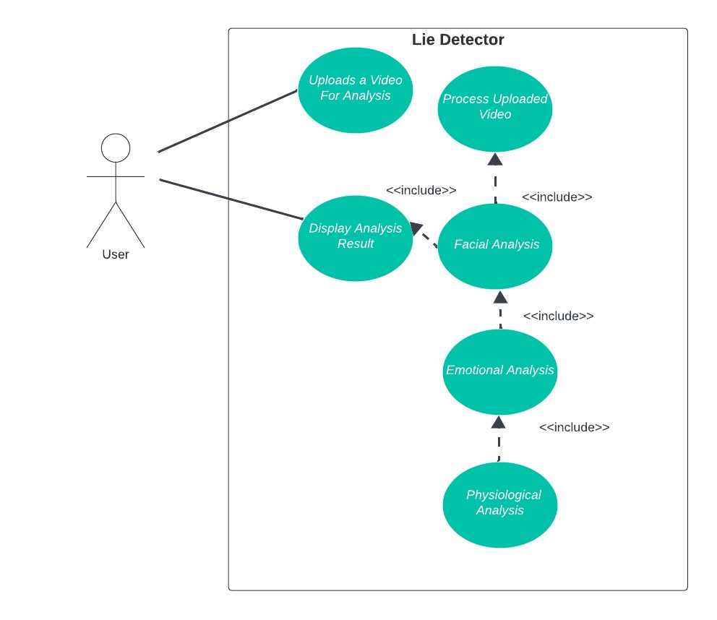

4.1 Requirement 1 OR Use-Case 1 (if requirements are modeled as use cases)

Identifier |  | UC-1
Purpose |  | This use case allows upload video to analyze it
Priority |  | High
Pre-conditions |  | User has a video file to upload it.
Post-conditions |  | This video is uploaded and processed by the system
Typical Course of Action
S# | Actor Action |  | System Response
1 | The user navigates to the application |  | The user-friendly interface is displayed.
2 | The user selects a video file to upload it |  | The system receives the uploaded video.
3 | The user can remove the provided video and select another video |  | The system will analyze the video and results will be displayed.
4 | The user can see the uploaded analysis result. |  | The system will prompt the user to upload a video.
Alternate Course of Action
S# | Actor Action |  | System Response
1 | The user cancels the upload |  | The system did not receive the video for analysis.
2 | The upload fails. |  | The system will notify that the upload has failed.
3
Table 1: UC-1

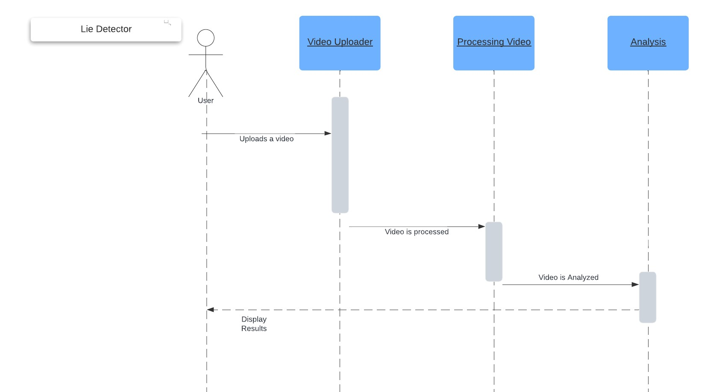
Analysis and Modeling of Requirements

(sequence diagram)

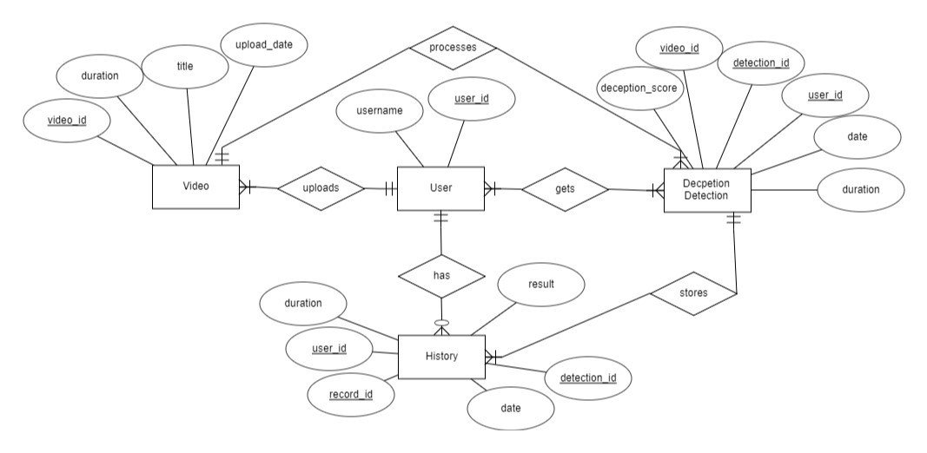

(Entity Relationship Diagram)

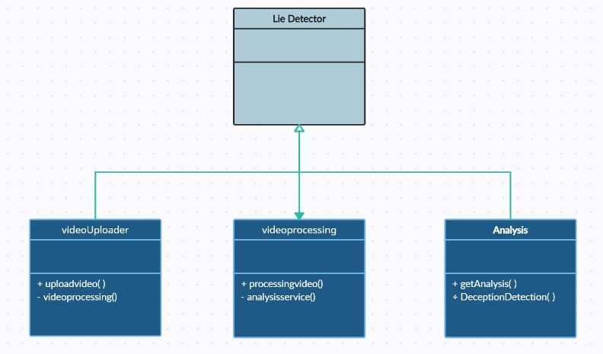

(Class Diagram)

Nonfunctional Requirements

Target Performance
The target performance for the system includes achieving an accuracy rate of at least 85% in deception detection. Additionally, the system should process video data with an efficiency of at least 10 frames per second (FPS) during video analysis.

Safety Requirements
Safety considerations primarily revolve around data privacy and ethical usage. The system must adhere to data protection regulations, ensuring that all processed video data remains confidential and is not stored beyond the analysis period. Compliance with ethical guidelines regarding data collection, especially in sensitive scenarios such as interrogations, is essential.

Additional Software Quality Attributes
- Adaptability: The system should accommodate updates and new feature integrations without substantial architectural modifications.
- Maintainability: Code should follow clear structures and documentation to facilitate easy maintenance and updates.
- Usability: While accuracy is crucial, emphasis on a user-friendly interface to ensure ease of use for professionals from various domains.

Other Requirements
Hardware and Software Specifications:
Minimum hardware and software requirements will be defined for optimal system performance, including CPU, RAM, and GPU specifications. The system will be designed to smoothly operate on Windows 10+ operating system.

Initial Results
During the initial phase of our research into lie deception detection, our team conducted an extensive literature review, analyzing seminal works ([1], [2], [3], [4]) in computer vision, machine learning, and behavioral psychology. This phase focused on comprehensively understanding the diverse modalities and methodologies utilized in automated deception detection. Simultaneously, we outlined the foundational requirements for our project, identifying key sensors, data types, and potential algorithmic approaches. These findings guided the formulation of our project.

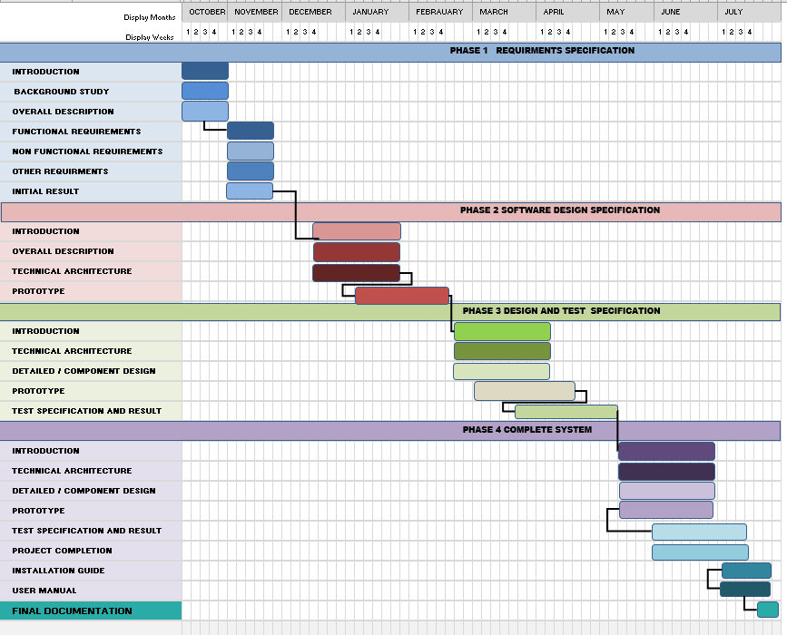
Revised Project Plan

References

- Gupta, Viresh, et al. "Bag-of-lies: A multimodal dataset for deception detection." Proceedings of the IEEE/CVF Conference on Computer Vision and Pattern Recognition Workshops, 2019, https://ieeexplore.ieee.org/document/9025340.
- Khan, Wasiq, et al. "Deception in the eyes of deceiver: A computer vision and machine learning based automated deception detection." Expert Systems with Applications, vol. 169, 2021, p. 114341, https://doi.org/10.1016/j.eswa.2020.114341.
- Stathopoulos, Anastasis, et al. "Deception detection in videos using robust facial features." Proceedings of the Future Technologies Conference (FTC) 2020, Volume 3. Springer International Publishing, 2021, https://doi.org/10.1007/978-3-030-63092-8_45.
- Speth, Jeremy, et al. "Deception detection and remote physiological monitoring: A dataset and baseline experimental results." 2021 IEEE International Joint Conference on Biometrics (IJCB). IEEE, 2021, https://ieeexplore.ieee.org/document/9484409.

