Design Rationale Document

HCI Project – FALL 2020

2020

|  |  |  |  |
| --- | --- | --- | --- |
| S. No. | Name | Roll Number | Section |
| 1 | Ali Faisal | K17-3791 | B |
| 2 | Shayan Shahid | K17-3851 | B |
| 3 | Avinash | K17-3918 | B |

# Introduction

The project in discussion is ‘MyWallet’. This is a cross-platform mobile application to keep track of user’s transactions and visualize the data through charts. This application helps the user control their expenses by showing a dialogue box that appears when a user inputs some expense. This dialogue box shows the comparison from any of the previous months, so that the user can know how much they are going to spend on an item and how they have spent in the previous months. This main feature is executed from the Add Transaction page.

The following is a screenshot of the ‘Add Transaction’ page on which the analysis is going to be performed for the Design Rationale document.

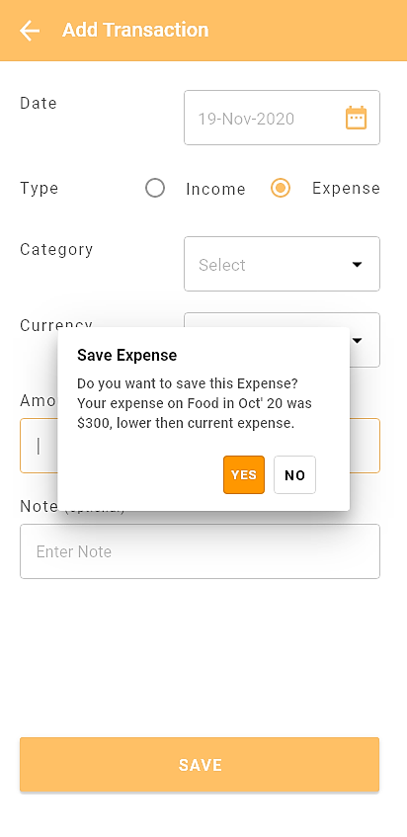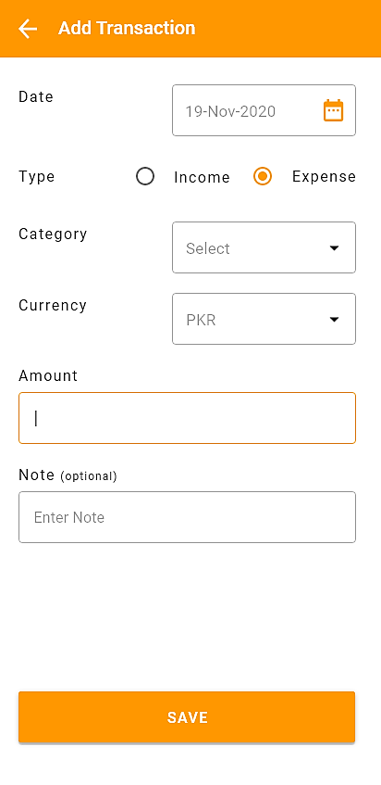

# Design Rationale

The Design Rationale type we are following is ‘Structure-Oriented’. Following are the features of our above screen.

**Features:**

# Date Input Method

The purpose of this input is to record the Date of the transaction. We have several options to implement this feature. We selected the Calendar Prompt to implement this feature. Initially, the default value is Today’s date, hence placed it on top so that Transaction Type can be placed below for better Accessibility.

**Options:**

# Text Input

# Positive Criterion

1. Unlimited Dates.
2. Constant Time for Inputting any Date. There is no scrolling to find a future or past date.

# Negative Criterion

1. Date Formatting issues. The user will input the date in wrong format and will get an error. This decreases efficiency.

# Calendar Prompt GUI

# Positive Criterion

1. The user can tap on the Calendar Icon to open the Calendar. This occupies less screen space.
2. Ensures Formatting, under constraints.
3. The dates and corresponding days are visible for a whole month. Increases visibility while selecting a date.

# Negative Criterion

1. The user can pick date from a set of years. For dates out of this range, the user can type in the textbox of provided in Calendar Prompt.

# Dropdowns: Day, Month and Year

# Positive Criterion

1. Ensures Formatting.

# Negative Criterion

1. Less Visibility than Calendar while selecting the Date.
2. Decreases efficiency as the user has to select the date by going through each dropdown.

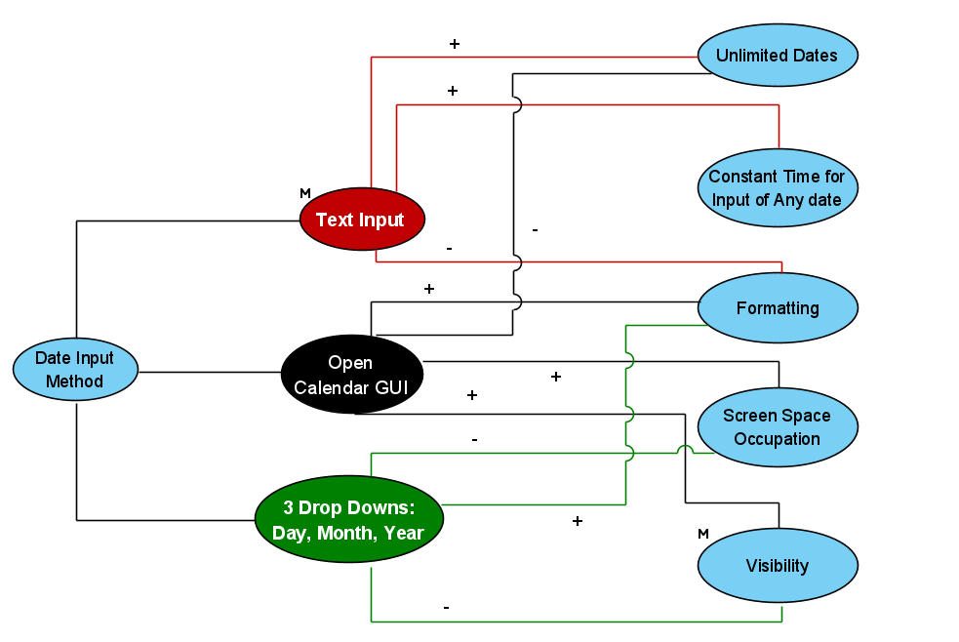

# Transaction Type Input Method

The purpose of this input is to record the type of the transaction. We have several options to implement this feature. We selected the Radio Button to implement this feature.

**Options:**

# Radio Button

# Positive Criterion

1. Since we have only two options, Expense and Income, it enhances visibility.
2. Ensures the Text Format.
3. Intact Effectiveness.
4. More Efficiency than other options.

# Drop Down

# Positive Criterion

1. Gets the Job Done, hence effective.
2. Ensures Text Formatting.

# Negative Criterion

1. The user has to open the Drop Down to see the options available, reduces efficiency.
2. The user can not see the available options from the screen. This reduces Visibility.

# Text Input

# Positive Criterion

1. Gets the Job Done, hence effective.

# Negative Criterion

1. Text Formatting is not ensured.
2. The user has to type in the type of transaction. Hence, reduces efficiency.

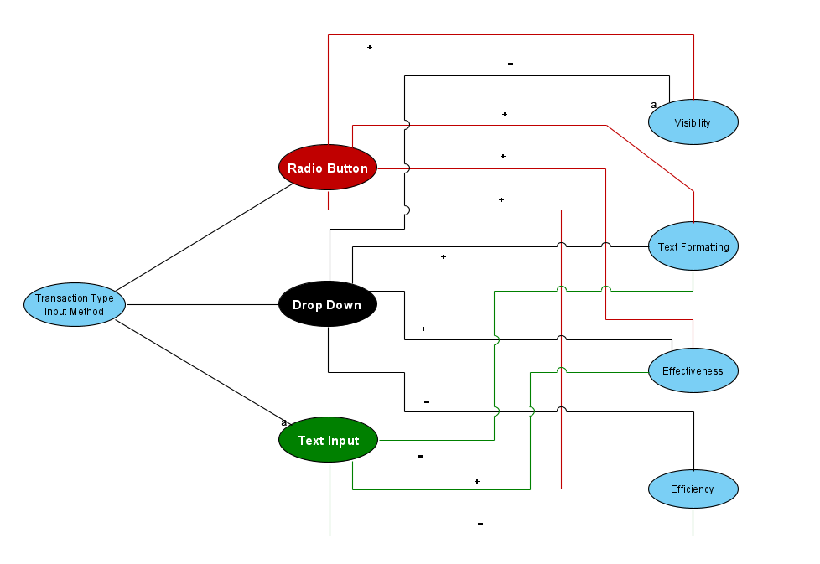

# Category and Currency Input Method

In this scenario, the user has to input category & currency of the transaction type. The following are the options & their criterions related to the input method. We selected the Drop Down to implement this feature.

**Options:**

# Text Input

# Positive Criterion

1. Enter any data without any restriction.
2. Less screen space occupancy.

# Negative Criterion

1. There is no text formatting which means there are more chances of error.
2. Not efficient & effective when the data required needs to be precise.

# Drop Down

# Positive Criterion

1. Easy to set default values under the assumption that it is common choice among the users.
2. User can easily choose between predefined data.
3. Less screen space occupancy.
4. Effective & efficient

# Negative Criterion

1. Limited choices

# Radio Button

# Positive Criterion

1. Easy to set default values under the assumption that it is common choice among the users.
2. User can easily choose between predefined data.
3. Effective & efficient

# Negative Criterion

1. Limited choices
2. High chances of screen clustering when there are more than 4-5 options.

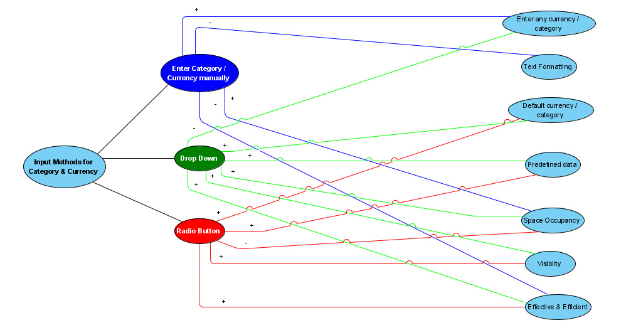

1. Amount Input Method

In this, user has to input Amount for Income or Expense. There are 3 options to input Amount. We selected the Text Input to implement this feature.

**Options:**

* 1. Text Input
     1. Positive Criterion

1. Efficient, but less as compared to Radio Buttons.
2. Gets the job done, hence highly Effective.
3. Can input any number.
   * 1. Negative Criterion
4. None, as numeric keyboard will be prompted for entering amount.
   1. Radio Buttons: Pre-Defined Numbers (200, 500, 1000, etc.)
      1. Positive Criterion
5. Efficient, as user can see his desired amount and select instantly.
6. More visibility then Drop Downs.
   * 1. Negative Criterion
7. Cannot input desired number if not available in the buttons.
8. No Effectiveness, as user’s desired value is not available to enter.
   1. Dropdown: Number Within Pre-Defined Range
      1. Positive Criterion
9. Efficient, in some scenarios when user’s desired amount is found in less time.
   * 1. Negative Criterion
10. Less efficient than Text Input as user might have to scroll deep down to get his desired number.
11. Reduces Visibility because of values hidden inside dropdown.
12. No Effectiveness, as user’s desired value is not available to enter.
13. Less Usable

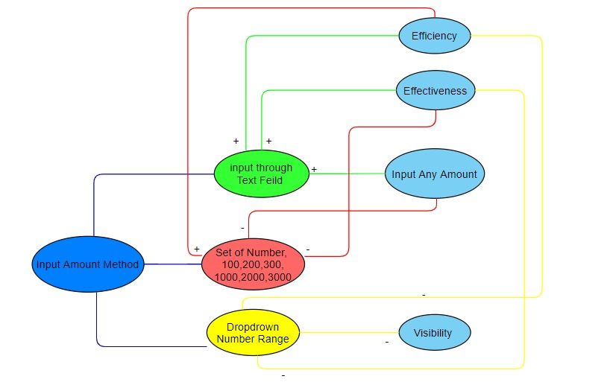

# Note Input Method (optional)

The purpose of this input is to record a note with the transaction. This enables the user to recall a certain transaction from past. We have several options to implement this feature. We selected the Text Input to implement this feature.

**Options:**

# Text Input

# Positive Criterion

1. Efficient, but less as compared to Radio Buttons.
2. Gets the job done, hence highly Effective.
3. Can input any note.

# Negative Criterion

1. None, since it is optional and personal note, user can enter anything that helps them to recall the transaction.

# Radio Buttons: Pre-Defined Common Notes

# Positive Criterion

1. Efficient, as user can see his desired note and select instantly.
2. More visibility then Drop Downs.

# Negative Criterion

1. Cannot input desired note if not available in the buttons.
2. No Effectiveness, as user’s desired note is not available to enter.

# Dropdown: Common Notes

# Positive Criterion

1. Efficient, in some scenarios when user’s desired note is found in less time.

# Negative Criterion

1. Less efficient than Text Input as user might have to scroll deep down to get his desired note.
2. Reduces Visibility because of notes hidden inside dropdown.
3. Less Effectiveness, as user’s desired note is not available to enter.

