results

Thea Knowles

2018-02-18

## This is the results section

This section reads in the contents of helper.R. You can embed figures and tables directly in this section, or you can save them to another location. Every journal has slightly different requirements, so you may have to tweak your workflow depending on where you're submitting.

### Embedding a figure

We can embed figures just like we did in the summary document, by using R code chunks. We can also include extra information to include captions and to be able to cross reference.

**Caution**: cross-referencing tables and figures is fairly straightfoward in RMarkdown when you're knitting to PDF and HTML outputs, but it's a lot more obnoxious in Word. To do that, we'll have to use a specialized output and another knitr package ([bookdown](https://bookdown.org/yihui/bookdown/a-single-document.html)). We'll visit that in a moment.

First, we'll just embed a plot and refer to it ourselves (no automatic cross referencing). Below is Figure 1, which we've called from helper.R and added a little more to.

calsugs_plot+  
 theme_bw()+  
 xlab("Sugars (g)")

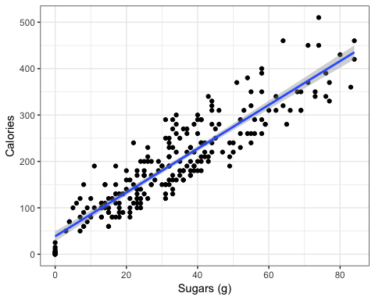

## Cross referencing figures and tables

You can cross-reference figures and tables. This is a bit more complicated, but the benefit is that you don't have to remember which figure/table was in which position (especially helpful if you are adding/removing figs/tables during editing phase). You simply refer to the figure by its chunk label.

Figure @ref(fig:figlabel) is shown here.

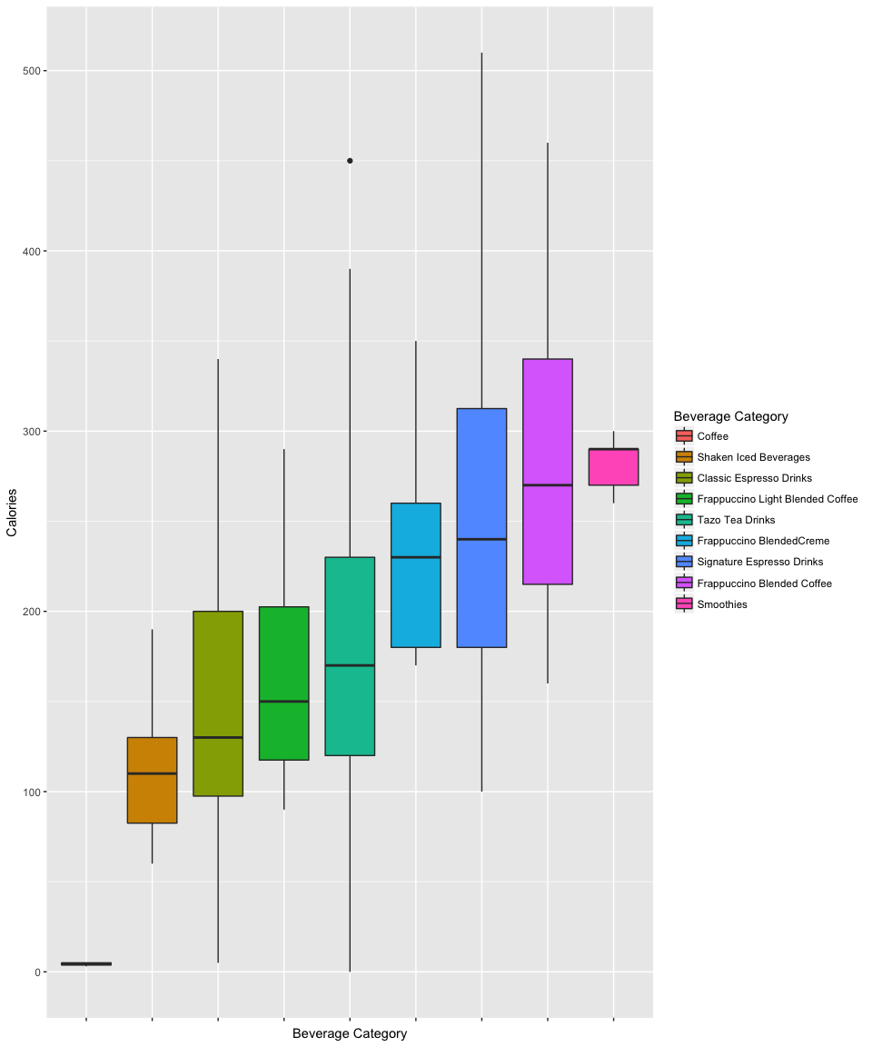

A nice figure caption

See Table @ref(calsugs_tab).

Calories and sugars for each beverage.

|  |  |  |
| --- | --- | --- |
| Beverage_category | cals | sug |
| Classic Espresso Drinks | 144.9107 | 17.57143 |
| Coffee | 4.2500 | 0.00000 |
| Frappuccino Blended Coffee | 276.9444 | 57.08333 |
| Frappuccino BlendedCreme | 233.0769 | 48.46154 |
| Frappuccino Light Blended Coffee | 162.5000 | 32.41667 |
| Shaken Iced Beverages | 114.4444 | 26.00000 |
| Signature Espresso Drinks | 250.0000 | 38.60000 |
| Smoothies | 282.2222 | 36.77778 |
| Tazo Tea Drinks | 177.3077 | 30.30769 |

We can also just redo the plot 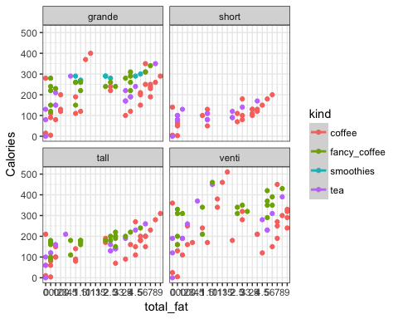

### Using inline R code to refer to values in tables

Here I will include a little extra embedded R code to clean up our model results, but I won't include this code to be shown. In the next paragraph, I'll refer directly to the contents of my model output using in-line R code. For this, we don't use embedded chunks, but rather the syntax ` r someCodeHere `. See the next paragraph in the results.Rmd file for an example.

Sugars demonstrated a significant main effect on the calorie content of starbucks beverages (estimate = 4.721, $t$ = 33.311, $p$ = 0).

Notice that our small $p−value$ shows up as 0, when it really should show up as <0.001. I'm going to include another chunk that cleans up the p-value column. Caution: This code is pretty wordy.

Now I'll refer to the same p-value as before, using almost the same inline R code as I did previously. One main difference now, though, is that we've converted the contents of the table to character variables (i.e., they're no longer numeric). We did our rounding in the code above, so I no longer have to round in the inline code.

As previously stated, sugars demonstrated a significant main effect on the calorie content of starbucks beverages (estimate = 4.721, $t$ = 33.311, $p$ = <0.001).

### Printing a table

Here I will reference a table.

This is the caption for my model coefficients table.

|  |  |  |  |  |
| --- | --- | --- | --- | --- |
|  | Estimate | Std. Error | t value | Pr(>|t|) |
| (Intercept) | 38.518 | 5.464 | 7.049 | <0.001 |
| sugars | 4.721 | 0.142 | 33.311 | <0.001 |

Other stuff - How do we change the row names? - if p < 0.001, can we write it out that way?

## You can save plots

Some journals require that you upload figures and tables separately. In this case, it may not make sense to have them print to the document output. The following code will allow you to save an image (default is the working directory) but it won't be included in the document.

jpeg("images/pressure.jpg")  
plot(pressure)  
dev.off()

## quartz_off_screen   
## 2

You could, for example, make a subdirectory called "figures", and include that in the path.