# Draft of methods & results

# Methods

*Placeholder for experiment 1*

## Another results section

This is some text! I am going to call a value from helper.R. The mean of *cholesterol* level in Starbucks drinks is 36.279

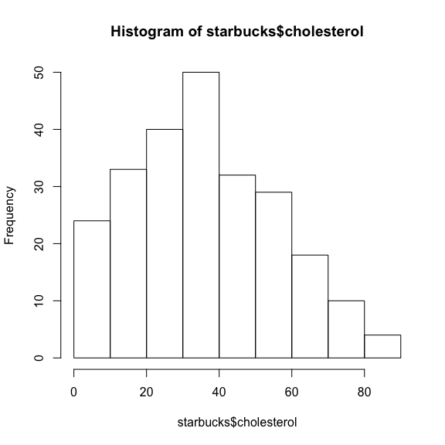

Figure 1 Histogram of cholesterol

*Placeholder for experiment 3*

# Selected references