# ASSIGNMENT-5

To perform: Create and execute C programs for following CPU Scheduling Algorithms:

1. First Come First Serve (FCFS)

2. Shortest Job First (SJF)

3. Round Robin Scheduling

1. First Come First Serve (FCFS)

#include <iostream>

using namespace std;

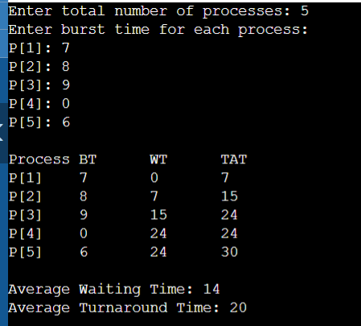

int main() {

int n, bt[20], wt[20], tat[20];

float avg_wt = 0, avg_tat = 0;

cout << "Enter total number of processes: ";

cin >> n;

cout << "Enter burst time for each process:\n";

for (int i = 0; i < n; i++) {

cout << "P[" << i + 1 << "]: ";

cin >> bt[i];

}

wt[0] = 0;

for (int i = 1; i < n; i++) {

wt[i] = 0;

for (int j = 0; j < i; j++)

wt[i] += bt[j];

}

cout << "\nProcess\tBT\tWT\tTAT";

for (int i = 0; i < n; i++) {

tat[i] = bt[i] + wt[i];

avg_wt += wt[i];

avg_tat += tat[i];

cout << "\nP[" << i + 1 << "]\t" << bt[i] << "\t" << wt[i] << "\t" << tat[i];

}

cout << "\n\nAverage Waiting Time: " << avg_wt / n;

cout << "\nAverage Turnaround Time: " << avg_tat / n;

return 0;

}

2. **Shortest Job First (SJF) – Non-preemptive**

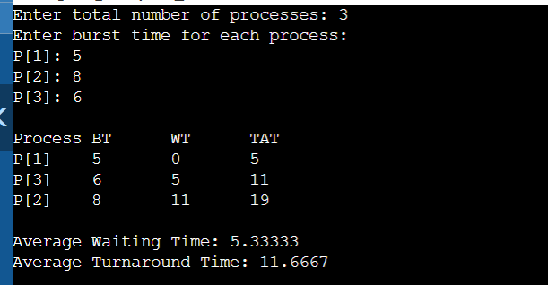**#include <iostream>**

**using namespace std;**

**int main() {**

**int n, bt[20], p[20], wt[20], tat[20], i, j, temp;**

**float avg_wt = 0, avg_tat = 0;**

**cout << "Enter total number of processes: ";**

**cin >> n;**

**cout << "Enter burst time for each process:\n";**

**for (i = 0; i < n; i++) {**

**cout << "P[" << i + 1 << "]: ";**

**cin >> bt[i];**

**p[i] = i + 1;**

**}**

**// Sorting burst times**

**for (i = 0; i < n - 1; i++) {**

**for (j = i + 1; j < n; j++) {**

**if (bt[i] > bt[j]) {**

**temp = bt[i]; bt[i] = bt[j]; bt[j] = temp;**

**temp = p[i]; p[i] = p[j]; p[j] = temp;**

**}**

**}**

**}**

**wt[0] = 0;**

**for (i = 1; i < n; i++) {**

**wt[i] = 0;**

**for (j = 0; j < i; j++)**

**wt[i] += bt[j];**

**}**

**cout << "\nProcess\tBT\tWT\tTAT";**

**for (i = 0; i < n; i++) {**

**tat[i] = bt[i] + wt[i];**

**avg_wt += wt[i];**

**avg_tat += tat[i];**

**cout << "\nP[" << p[i] << "]\t" << bt[i] << "\t" << wt[i] << "\t" << tat[i];**

**}**

**cout << "\n\nAverage Waiting Time: " << avg_wt / n;**

**cout << "\nAverage Turnaround Time: " << avg_tat / n;**

**return 0;**

**}**

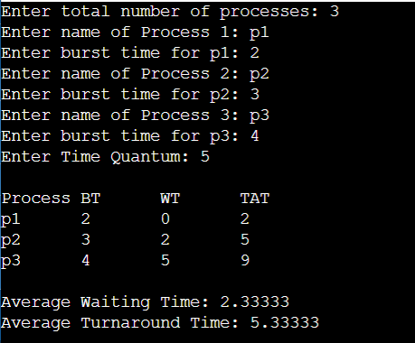**3. Round Robin Scheduling**

**#include <iostream>**

**using namespace std;**

**int main() {**

**int n, time_quantum, remaining[10], bt[10], wt[10], tat[10], t = 0;**

**bool done;**

**float avg_wt = 0, avg_tat = 0;**

**cout << "Enter total number of processes: ";**

**cin >> n;**

**cout << "Enter burst time for each process:\n";**

**for (int i = 0; i < n; i++) {**

**cout << "P[" << i + 1 << "]: ";**

**cin >> bt[i];**

**remaining[i] = bt[i];**

**}**

**cout << "Enter time quantum: ";**

**cin >> time_quantum;**

**do {**

**done = true;**

**for (int i = 0; i < n; i++) {**

**if (remaining[i] > 0) {**

**done = false;**

**if (remaining[i] > time_quantum) {**

**t += time_quantum;**

**remaining[i] -= time_quantum;**

**} else {**

**t += remaining[i];**

**wt[i] = t - bt[i];**

**remaining[i] = 0;**

**}**

**}**

**}**

**} while (!done);**

**cout << "\nProcess\tBT\tWT\tTAT";**

**for (int i = 0; i < n; i++) {**

**tat[i] = bt[i] + wt[i];**

**avg_wt += wt[i];**

**avg_tat += tat[i];**

**cout << "\nP[" << i + 1 << "]\t" << bt[i] << "\t" << wt[i] << "\t" << tat[i];**

**}**

**cout << "\n\nAverage Waiting Time: " << avg_wt / n;**

**cout << "\nAverage Turnaround Time: " << avg_tat / n;**

**return 0;**

**}**