# ASSIGNMENT-2

## Execute different Commands

# **Part1**

### Outputs of the following commands:

**1. pwd 2. cd 3. ls 4. Mkdir**

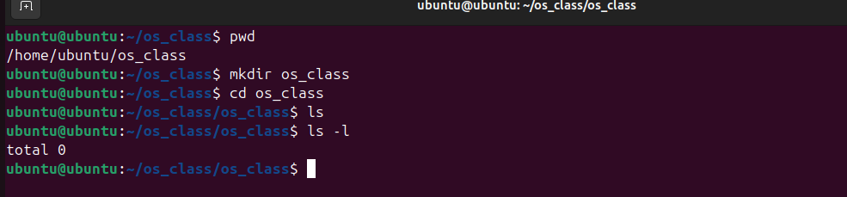

**5.rm**

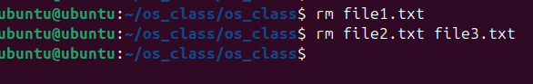

**6. touch 7. hostname 8. Cat**

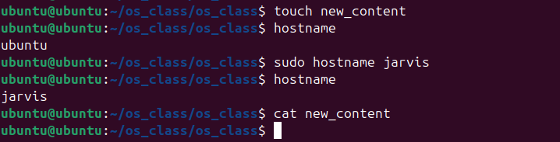

**10. Echo 11. grep 12. Fgrep 14. cp 15. more 16. Less**

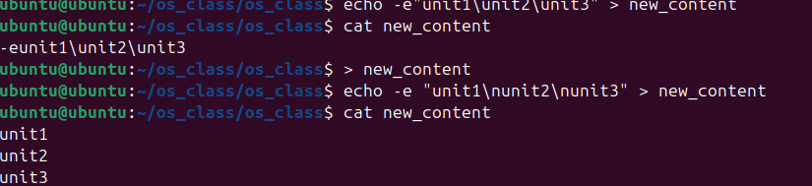

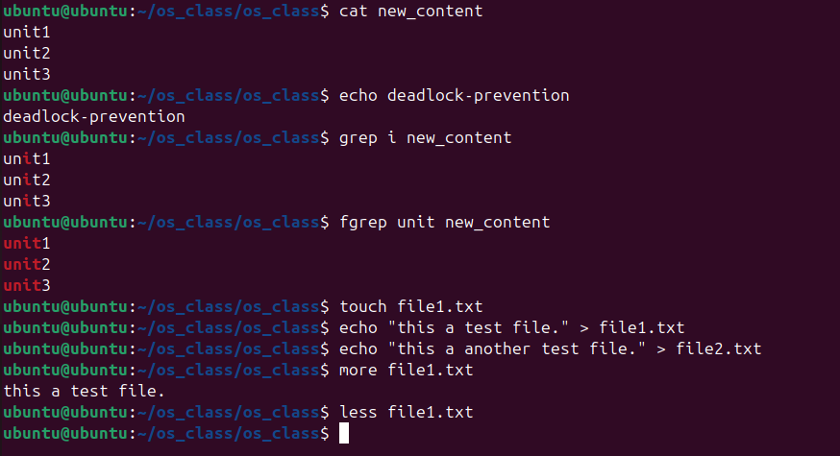

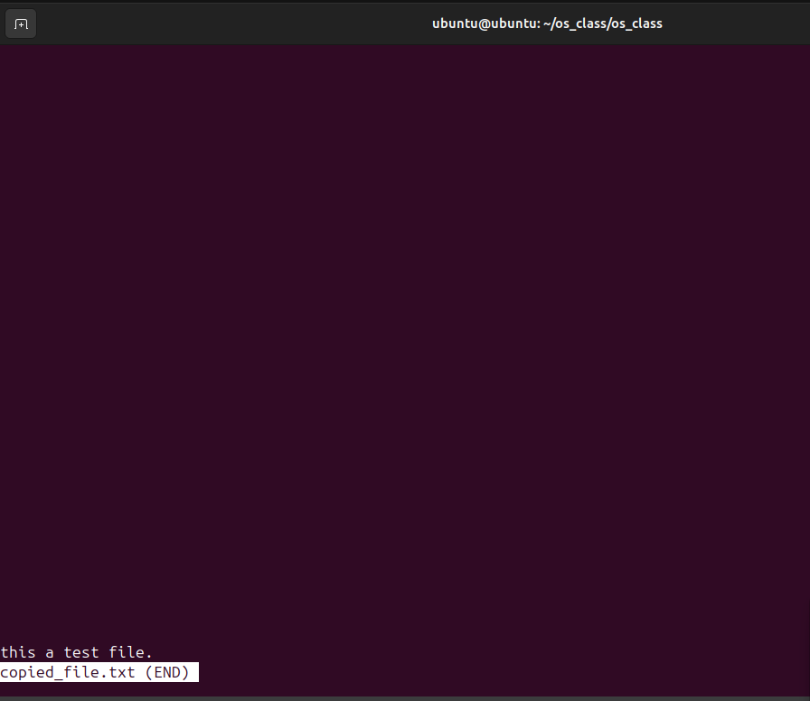

**17. wc 18. awk 19. head 20. Tail**

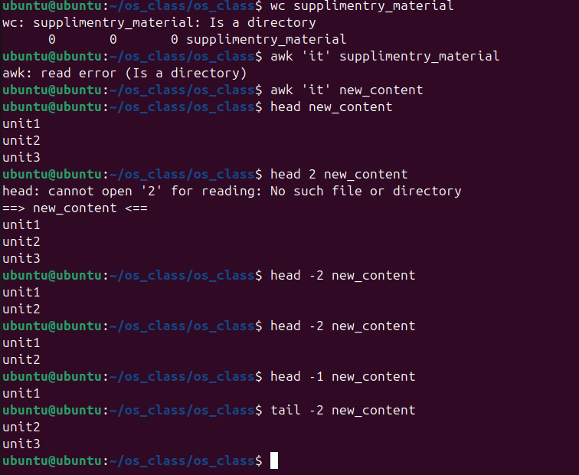

**9. chmod 13. Mv**

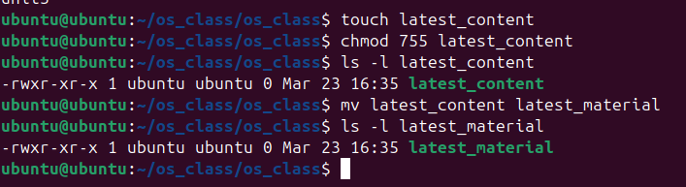

# **Part2**

**1.How to navigate to a specific directory?**

* cd /path/to/directory

**2.How to see detailed information about files and directories using ls**?

* ls -l

**3.How to create multiple directories using mkdir?**

* mkdir dir1 dir2 dir3

OR create nested directories:

* mkdir -p parent/child/grandchild

**4. How to remove multiple files at once with rm?**

* rm file1 file2 file3

**5. Can rm be used to delete directories?**

* rm -r directory_name

**6. How do you copy files and directories in Linux?**

Copy a file:

* cp file1 destination/

Copy a directory:

* cp -r dir1 destination/

**7. How to rename a file in Linux using mv command?**

* mv old_filename new_filename

**8. How to move multiple files in Linux using mv command?**

* mv file1 file2 file3 destination_directory/

**9. How to create multiple empty files using touch command in Linux?**

* touch file1 file2 file3

**10. How to view the content of multiple files in Linux?**

* cat file1 file2

**11. How to create a file and add content using cat command in Linux?**

* cat > filename
* Then type the content and press Ctrl + D to save.

**12. How to append contents of one file to the end of another file using cat command?**

* cat file1 >> file2
* This appends file1 content to file2.

**13. How to use cat command if the file has a lot of content and can’t fit in terminal?**

* cat large_file | more

OR

* cat large_file | less

**14. How to merge multiple files using cat command?**

* cat file1 file2 > merged_file

**15. How to use cat command to append to an existing file?**

* cat new_content.txt >> existing_file.txt

**16. What is “chmod 777” or “chmod 755” and “chmod +x” or “chmod a+x”?**

* chmod 777 file → Full permissions for everyone.
* chmod 755 file → Owner has all permissions, others can read/execute.
* chmod +x script.sh → Makes a script executable.
* chmod a+x script.sh→ Makes a script executable for all users.

**17. How to find the number of lines that match a string/pattern?**

* grep -c "pattern" file.txt

**18. How to display files that contain a given string/pattern?**

* grep -l "pattern" *.txt

**19. How to show the line number of file with the line matched?**

* grep -n "pattern" file.txt

**20. How to match lines that start with a string using grep?**

* grep "^pattern" file.txt

**21. Can sort command be used to sort files in descending order by default?**

* sort -r file.txt

**22. How to sort a file based on a specific column using sort command?**

* sort -k 2 file.txt

Sorts based on the second column.