# ASSIGNMENT-1

## STUDY OF UBUNTU OS

## Introduction to Linux and Ubuntu :

Linux: Linux is a free and open-source operating system kernel developed by Linus Torvalds, a Finnish computer science student, in 1991. It began as a personal endeavor to create a Unix-like operating system capable of running on personal computers that utilized Intel's 80386 processors. The kernel acts as the fundamental component of the operating system, overseeing hardware resources and facilitating communication between software and hardware. Linux is released under the GNU General Public License (GPL), which permits anyone to access, modify, and share its source code.

Over time, Linux has transformed into a versatile operating system that powers a diverse array of devices, including desktops, servers, smartphones (such as Android), supercomputers, and embedded systems. Its kernel design, which is both modular and monolithic, allows for the dynamic loading of components, enhancing its adaptability.

Ubuntu: Ubuntu is a widely-used Linux distribution created by Canonical Ltd., with its first release in October 2004. It is based on Debian but aims to be more user-friendly and accessible for both novice and experienced users. The term "Ubuntu" is derived from an African philosophy that translates to "humanity to others," embodying its open-source principles.

Ubuntu is offered in several editions tailored to specific applications:

- Desktop: Designed for personal computers with a graphical user interface.

- Server: Optimized for server environments.

- Core: Intended for IoT devices and robotics.

Canonical releases long-term support (LTS) versions every two years, providing five years of free updates for users prioritizing stability. Additionally, regular interim releases are made every six months, featuring newer functionalities but with shorter support durations.

### Linux Versions:

Linux serves as an open-source operating system kernel. Various organizations and communities develop Linux distributions (distros) by tailoring the Linux kernel with different software packages and desktop environments.

1. Debian: Renowned for its stability and commitment to free software principles, it serves as the foundation for numerous other distributions, including Ubuntu.

2. Ubuntu: Known for its user-friendliness, it is extensively utilized on both desktops and servers and is based on Debian.

3. Fedora: Backed by Red Hat, it emphasizes cutting-edge technology and innovation.

4. Arch Linux: A minimalist distribution that employs a rolling release model, requiring manual configuration.

5. CentOS Stream: Acts as the upstream version of Red Hat Enterprise Linux (RHEL) and is commonly used in enterprise settings.

6. openSUSE: Provides two distinct versions—Leap, which is stable, and Tumbleweed, which follows a rolling release approach.

7. Kali Linux: Tailored for cybersecurity professionals and penetration testing.

8. Linux Mint: Built on Ubuntu, it is designed to be beginner-friendly and user-friendly.

### Ubuntu Versions:

Ubuntu presents various versions (flavors) tailored to meet specific user requirements:

1. Ubuntu Desktop: The standard edition featuring the GNOME desktop environment.

2. Ubuntu Server: Optimized for server use, lacking a graphical interface.

3. Kubuntu: Incorporates the KDE Plasma desktop environment.

4. Xubuntu: A lightweight variant utilizing the Xfce desktop.

5. Lubuntu: An ultra-lightweight version that employs the LXQt desktop.

6. Ubuntu MATE: Features a classic desktop environment based on MATE.

7. Ubuntu Studio: Specifically designed for multimedia production, including audio and video editing.

### History:

### Linux:

1. Origins (1991)

- Linux was developed by Linus Torvalds, a computer science student hailing from Finland.

- He aimed to create a free, open-source alternative to MINIX, a UNIX-like operating system primarily used for educational purposes.

- The initial version of the Linux kernel (version 0.01) was released by Torvalds on September 17, 1991.

2. Open-Source Movement

- Linux was made available under the GNU General Public License (GPL), which permitted anyone to modify and share it.

- The synergy between the Linux kernel and GNU software facilitated the creation of a comprehensive open-source operating system.

3. Development of Linux Distributions (Mid-1990s)

- The first Linux distributions, often referred to as "distros," integrated the Linux kernel with various software packages.

- Slackware, introduced in 1993, was the first widely adopted Linux distribution.

- Following this, Debian (1993) and Red Hat (1994) emerged, offering more user-friendly interfaces.

4. Modern Growth (2000s - Present)

- Linux has served as the foundation for numerous specialized distributions, including Ubuntu, Fedora, Arch, and CentOS.

- It now powers a diverse array of devices, ranging from servers and supercomputers to Android smartphones and Internet of Things (IoT) devices.

### Ubuntu:

1. Origins (2004)

- Mark Shuttleworth, a South African entrepreneur and former Debian developer, established Ubuntu.

- The operating system was developed by Canonical Ltd., a company founded by Shuttleworth to oversee Ubuntu's support and maintenance.

- The inaugural official release, Ubuntu 4.10 (Warty Warthog), was made available on October 20, 2004.

2. Philosophy

- Built on Debian, Ubuntu embodies the principle of "Linux for human beings," prioritizing user-friendliness and accessibility.

- It champions free, open-source software and encourages community participation.

3. LTS and Regular Releases

- Ubuntu adopted a six-month release cycle to introduce new features and enhancements.

- Long-Term Support (LTS) releases commenced in 2006, providing five years of support tailored for enterprise and server applications.

4. Major Milestones

- Ubuntu 6.06 LTS (Dapper Drake) marked the introduction of the first LTS version in 2006.

- Ubuntu 12.04 LTS (Precise Pangolin) gained significant traction in enterprise settings in 2012.

- Ubuntu 20.04 LTS (Focal Fossa) showcased enhanced performance and security features in 2020.

5. Ubuntu Today

- Ubuntu is offered in various editions, including Desktop, Server, Cloud, and Core (designed for IoT).

- It supports extensive systems, such as supercomputers, cloud infrastructures, and artificial intelligence platforms.

### Feature of Ubuntu:

User-Friendly Interface: By default, Ubuntu employs the GNOME desktop environment, which offers a streamlined and user-friendly interface that caters to both novice and experienced users.

Free and Open Source: Ubuntu is available for free download, use, and modification, making it an appealing choice for both users and developers.

Software Center: The built-in Software Center in Ubuntu simplifies the process of discovering and installing applications, requiring only a few clicks.

Security: Renowned for its robust security features, Ubuntu includes regular security updates, a firewall, and access controls (AppArmor). The sudo command further enhances security for administrative tasks.

Software Updates: Ubuntu consistently provides software and security updates, ensuring that the system is equipped with the latest features and patches.

Support for Multiple Architectures: Ubuntu is compatible with a diverse array of hardware architectures, such as x86, ARM, and PowerPC.

Community Support: A large and active community surrounds Ubuntu, offering an abundance of tutorials, forums, and online resources to aid users.

Customization: Ubuntu allows for extensive customization, enabling users to modify nearly every element of the operating system, from themes to system configurations.

Package Management: Utilizing the APT (Advanced Package Tool) system, Ubuntu facilitates the installation, updating, and removal of software, with packages sourced from a central repository to ensure consistency and security.

### Installing ubuntu:

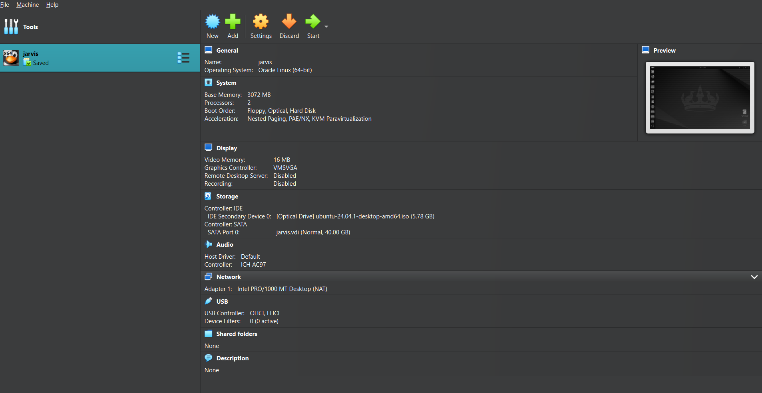

### Difference Between Ubuntu and Windows OS

To better understand the differences between Ubuntu and Windows, let’s compare them in a structured tabular format:

|  |  |  |
| --- | --- | --- |
| **Feature** | **Ubuntu (Linux-based)** | **Windows OS (Microsoft)** |
| **Source Model** | Open-source | Proprietary |
| **Cost** | Free | Paid (licensed versions) |
| **Security** | More secure, fewer malware threats | More vulnerable to viruses & malware |
| **Customization** | Highly customizable | Limited customization |
| **Software Availability** | Requires compatibility with Linux apps | Wider range of software support |
| **Performance** | Efficient & lightweight | Resource-heavy, especially for older devices |
| **System Requirements** | Runs on low-end hardware | Requires higher specs for smooth performance |
| **File System** | Ext4, XFS, Btrfs | NTFS, FAT32, exFAT |
| **User Interface** | Various desktop environments (GNOME, KDE, XFCE) | Consistent UI with taskbar & Start menu |
| **Package Management** | APT, Snap, Flatpak | Microsoft Store, .exe, .msi |
| **User Control & Permissions** | Granular control with root access | Limited user privileges in comparison |
| **Gaming Support** | Limited (but improving via Proton & Steam) | Excellent gaming support with DirectX |
| **Command-Line Interface** | Powerful CLI with Bash, Zsh | PowerShell, CMD available but less powerful |
| **Updates & Support** | Community & LTS-based support | Regular updates, Microsoft support services |

Both Ubuntu and Windows offer distinct benefits that serve various user requirements. Ubuntu stands out for its security, flexibility, and efficient performance, making it particularly suitable for developers and IT specialists. Conversely, Windows is recognized for its user-friendly interface, broad software compatibility, and robust support for gaming and enterprise applications. Ultimately, the decision between the two is influenced by personal needs and usage preferences.