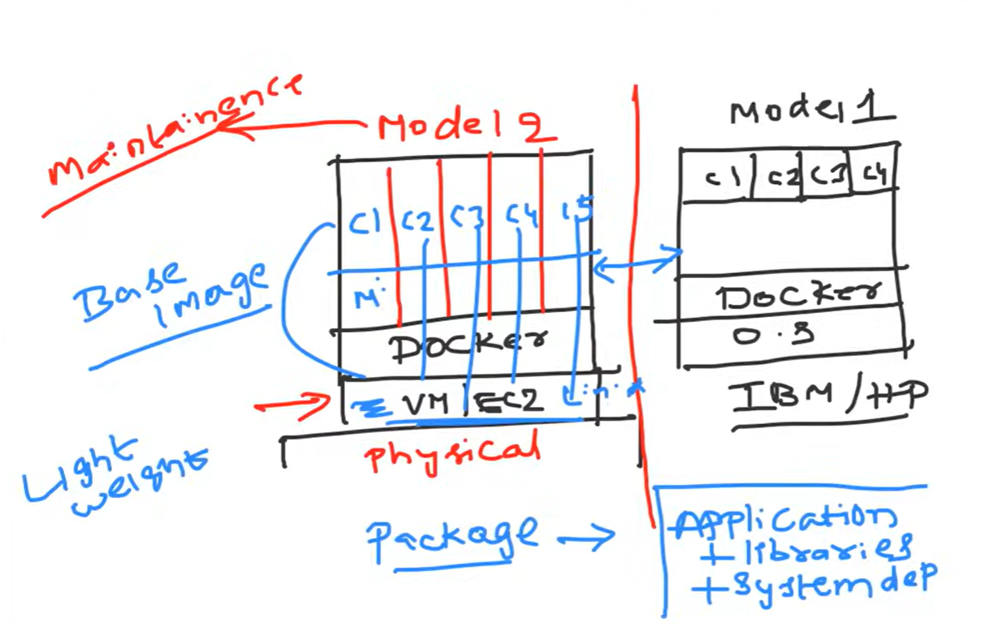

Docker container basic looks on top of the vms or the local host

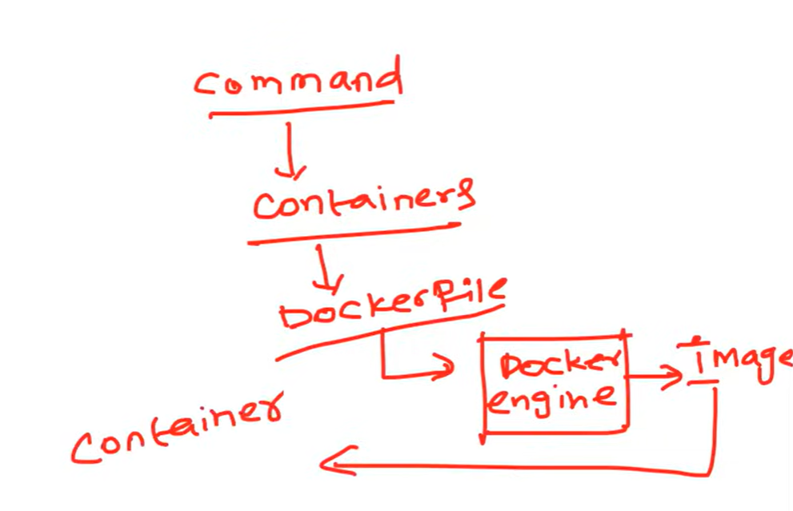
This is the basic architecture of the docker container
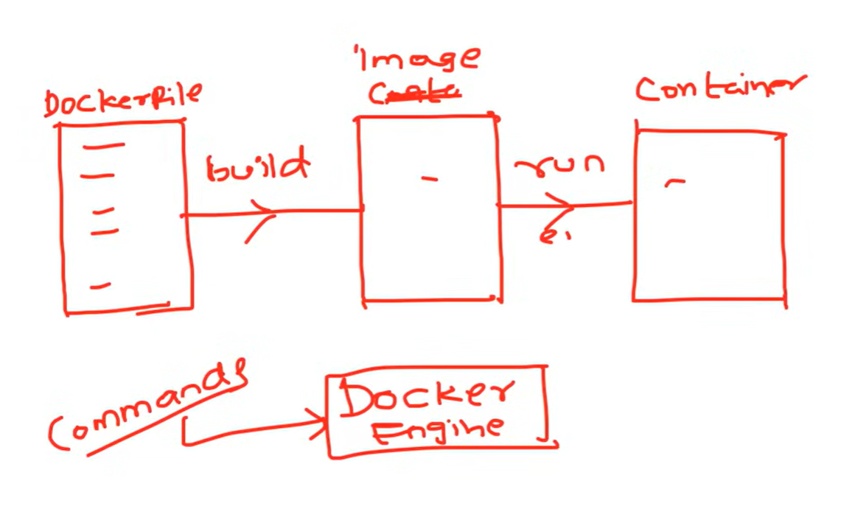
this is the basic lifecycle of the docker container. Here for creating the container we need to give docker daemon (dockerd) that will convert the docker file into the docker image using docker build command and after that the docker image will be converted into the docker container

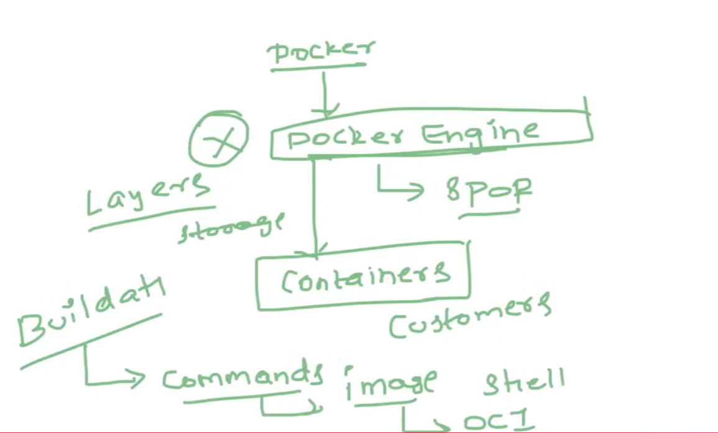

Here is the cron of the docker that if the docker engines fail , whole container will stop working or goes down and this problem is still not solved as well as docker images are built in layer Each instruction in a Dockerfile (like FROM, RUN, COPY) creates a new layer. If multiple images share the same base layer (e.g., ubuntu:20.04), Docker only stores that layer once. When you rebuild an image, unchanged layers are reused from cache. This makes builds faster.
The Main Issue with Layers :-
Image Size Bloat
- Each layer stores changes permanently. If you install a package and then remove it in a later layer, the space is still consumed.
Build Inefficiency
- If you change a layer in the middle of the Dockerfile, all subsequent layers must be rebuilt.
- Example: modifying a RUN apt-get update line invalidates cache for everything after it.
Security Risks
- Old files or secrets can remain hidden in layers even if deleted later.
- Example: Adding a secret key in one layer and deleting it in another doesn’t erase it from the image history.
Complexity in Debugging
- Understanding which layer introduced a bug or bloated the image can be tricky

So to solve this issue of the SPOF(single point of failure) and the large space of the image layers buildat comes into the picture

