Northwind Sales Analytics Dashboard
End-to-End MECE Business Analysis with Data Modeling & Dashboard Implementation

1. Project Overview
This project analyzes the Northwind transactional database using structured business intelligence techniques. The objective was to design a multi-page Power BI solution that transforms raw operational data into strategic insights using a MECE analytical framework.
The solution includes:
- Data modeling (Star Schema design)
- ER Diagram documentation
- Domain-based business analysis
- Executive dashboards
- Strategic recommendations

2. Business Problem Statement
Northwind operates across products, customers, employees, and logistics channels. However, management lacks consolidated visibility into:
- Revenue drivers
- Customer profitability
- Inventory efficiency
- Employee productivity
- Shipping performance
This project addresses these challenges through structured analytical modeling.

3. Data Modeling & Architecture
3.1 Data Model Approach
A Star Schema architecture was implemented to optimize analytical performance and ensure scalability.
Fact Table: Orders, Products
Dimension Tables: Customers, Employees, Order_details, Categories, Suppliers, Shippers
Relationships:
- One-to-many from dimension tables to Orders
- Single-direction filtering for performance optimization
- Primary keys mapped to foreign keys in fact table

3.2 ER Diagram Snapshot
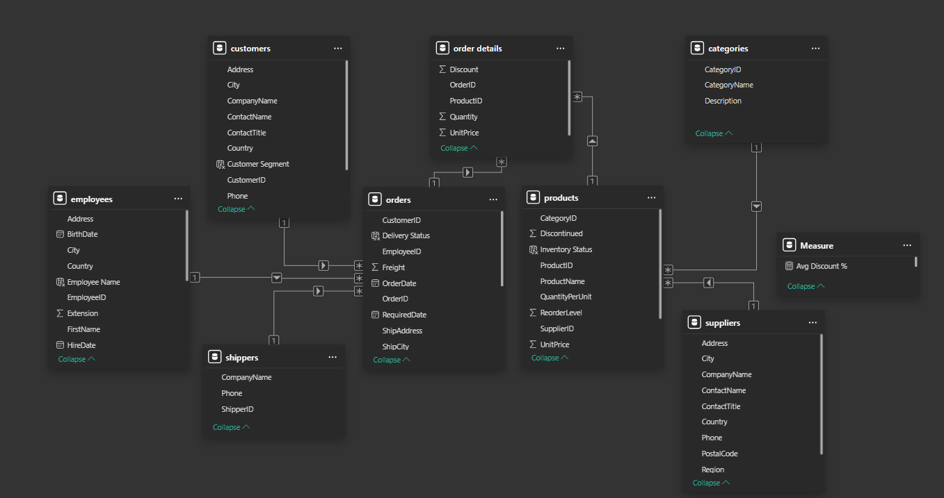

3.3 ER Diagram Explanation
The data model follows a star schema structure where the Orders table acts as the central fact table capturing transactional metrics such as quantity, unit price, discount, and freight.
Each dimension table connects to the Orders table through primary–foreign key relationships:
- CustomerID → Customers
- EmployeeID → Employees
- ProductID → Products
- ShipVia → Shippers
This design ensures:
- Efficient aggregation
- Reduced redundancy
- Optimized query performance
- Clean separation between transactional and descriptive data
The schema supports scalable analytical computations using DAX measures such as Total Revenue, Average Order Value, and Customer Lifetime Value.

4. MECE Analytical Framework
To ensure complete and non-overlapping business coverage, the analysis was divided into 5 independent domains:
- Sales Performance
- Customer Segmentation
- Inventory & Product Analysis
- Employee Performance
- Shipping & Logistics
Each domain focuses on a distinct operational dimension without analytical overlap.

5. Final Dashboard Implementation
5.1 Sales Performance Analysis
Objective: Analyze overall revenue performance and sales trends.
KPIs:
- Total Revenue Total Orders
- Total Freight Total Customers
- Average Order Value (AOV) Average Shipping Time
- Sales Growth %
Dashboard Image –
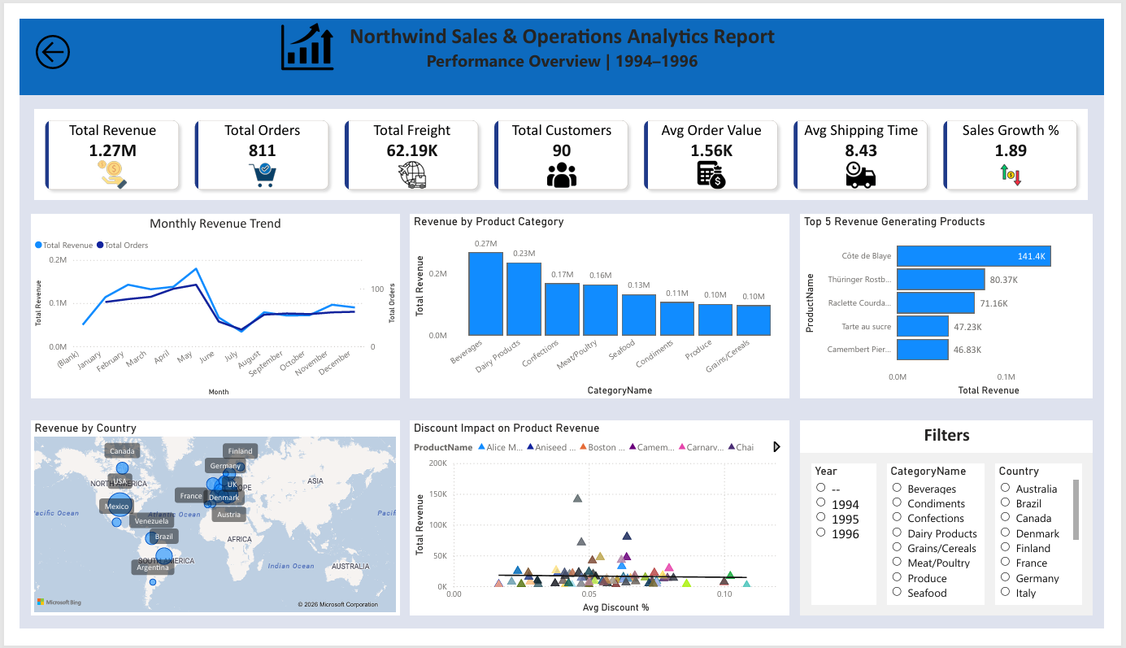

5.2 Customer Segmentation Analysis
Objective:
Understand customer behavior and profitability.
KPIs:
- Total Revenue
- Total Customer
- Average Revenue per Customer
- Repeated Customer
Dashboard Image –
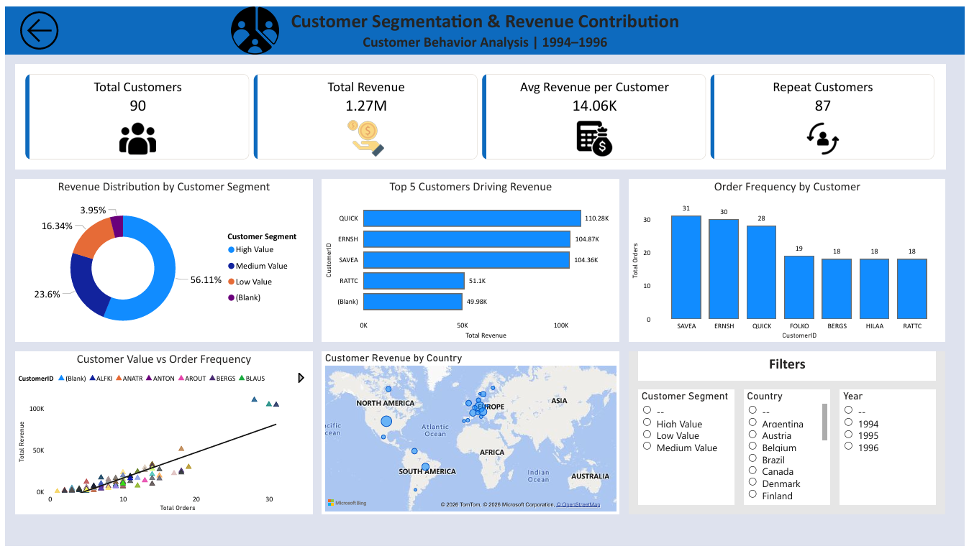

5.3 Inventory & Product Performance
Objective:
Evaluate product demand and stock efficiency.
KPIs:
- Revenue by Product Category
- Units in Stock
- Reorder Level
- Top/Bottom Products
Dashboard Image –
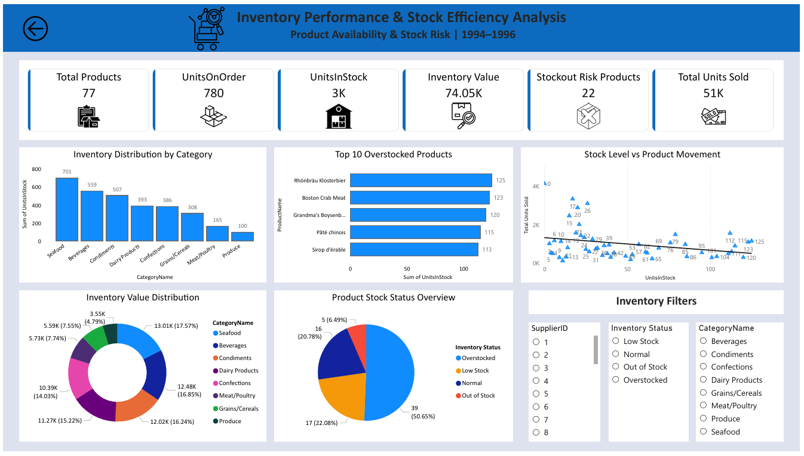

5.4 Employee Performance Analysis
Objective:
Measure sales contribution by employees.
KPIs:
- Revenue by Employee
- Orders Processed
- Revenue per Order
- Territory Sales
Dashboard Image –
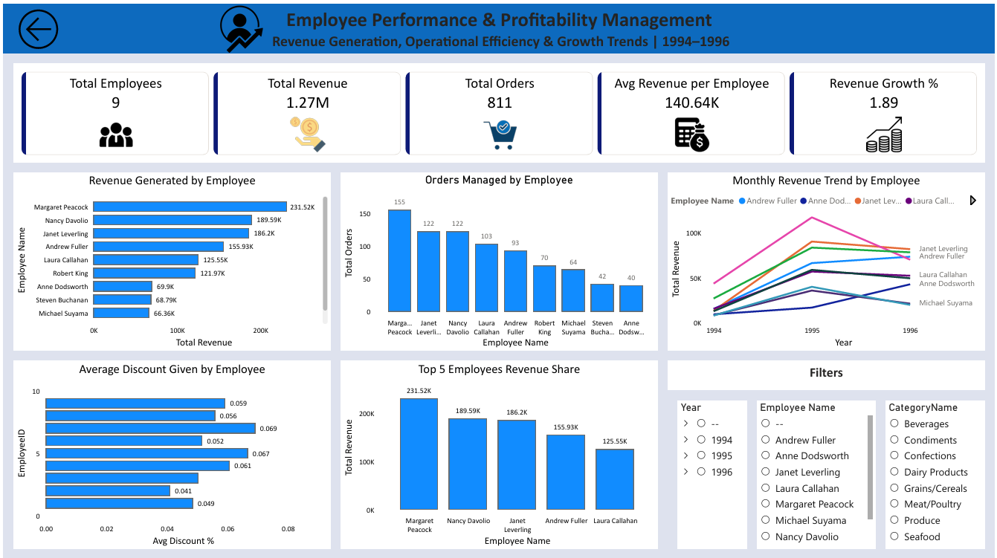

5.5 Shipping & Logistics Analysis
Objective:
Assess delivery efficiency and cost impact.
KPIs:
- Average Shipping Time
- Freight Cost
- Orders by Shipping Company
- Delivery Delay Analysis
Dashboard Image –
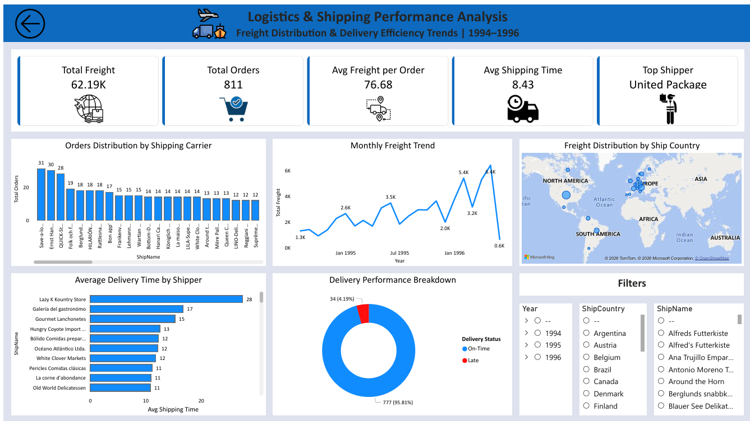

6. Strategic Recommendations
- Optimize discount strategy to protect margins
- Expand in high-performing geographic regions
- Improve inventory forecasting for high-demand SKUs
- Standardize employee performance benchmarks
- Evaluate shipping carrier efficiency

7. Conclusion
This project demonstrates:
- Structured business thinking using MECE
- Technical proficiency in data modeling
- Ability to convert raw data into executive-level dashboards
- Strategic insight generation from operational data
The integration of ER modeling with domain-specific dashboards ensures both technical robustness and business relevance.

