SYNOPSIS ON

“AI Course Generator”
Submitted in
Partial Fulfillment of requirements for the Award of Degree
of
Bachelor of Technology
In
Computer Science and Engineering
By
(Project Id: 26_CS_3B_03) Anannya Singh (2301640100075)
Anshika Shukla (2301640100093)
Ankit Yadav (2301640100085)
Amit Yadav (2301640100071)
Anurag Sharma(2301640100102) Aman Kumar Tiwari(2301640100061)

Under the supervision of
Mr. Adison Pal (Assistant professor)
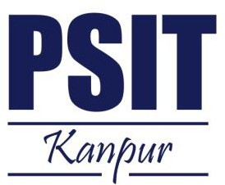

Pranveer Singh Institute of Technology.
Kanpur - Agra - Delhi National Highway - 19 Bhauti -Kanpur - 209305.
(Affiliated to Dr. A.P.J. Abdul Kalam Technical University)

Introduction
In today’s digital era, learners have access to an overwhelming amount of educational resources across various platforms such as YouTube, MOOCs, blogs, and e-books. However, finding a personalized and structured learning path remains a major challenge for students. A large number of learners waste time browsing through random tutorials without a clear roadmap.

The proposed project “Full Stack AI Course Generator” aims to solve this problem by leveraging Artificial Intelligence (AI) to generate personalized course structures, learning roadmaps, and resource recommendations. By analyzing a learner’s background, preferences, available time, and career goals, the system dynamically generates a customized course plan that includes study modules, curated resources, and project-based tasks.

This project lies in the intersection of Artificial Intelligence, Web Development, and Educational Technology (EdTech). Technical terms such as AI-powered recommendation system, personalized roadmap generation, and full-stack architecture will be central to the implementation.

Project Objective

The main objectives of this project are:

- To design and develop a web-based AI system that generates personalized learning courses for students based on their skill level, target goals, and available time.
- To create a recommendation engine that suggests the most relevant online resources (videos, documentation, GitHub projects, coding practice websites, etc.).
- To provide a visual roadmap that breaks down the course into modules, weeks, and milestones.
- To allow dynamic updates of the roadmap based on learner feedback and progress.
- To integrate progress tracking and optional gamification elements to increase learner motivation.
The project will ultimately help students and professionals save time, focus on the right resources, and achieve their learning goals more effectively.

Feasibility Study:

  - Technical Feasibility
The project is technically feasible as it will be built using proven technologies such as React (Frontend), Node.js/Next.js (Backend), MongoDB (Database), and AI APIs (OpenAI/HuggingFace). All required technologies are accessible and well-documented.

Operational Feasibility
The system is designed to be user-friendly and accessible from any modern browser. Students can input their preferences and instantly receive a roadmap, making it highly practical for adoption.

Economic Feasibility
The project is cost-effective since most of the tools are open-source (React, Node.js, MongoDB) and cloud platforms provide free tiers for development (Vercel, Render, MongoDB Atlas). Only minimal expenses may be required for API usage.

Schedule Feasibility
The project timeline is realistic and achievable within the academic semester duration.

Legal Feasibility
No legal risks are involved since only publicly available or free educational resources will be recommended.

Project Timeline (Gantt Chart)
Task | Duration (Weeks) | Start Date | End Date

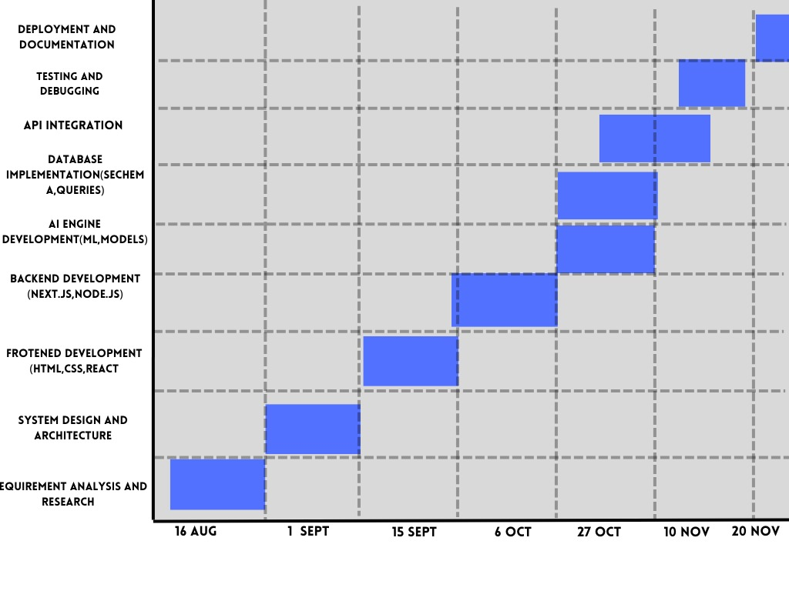

5.Methodology/ Planning of work
The development will follow the Agile methodology with iterative development and continuous integration. The key steps include:
- Requirement gathering and analysis.
- Designing system architecture (Frontend, Backend, Database, AI engine).
- Implementing user profile module (skill level, goals, preferences).
- Developing AI-based course generation and recommendation module.
- Creating visualization of roadmap and progress tracking.
- Testing, feedback collection, and improvements.
- Deployment on cloud platforms.

- Architecture Diagram (High-Level)

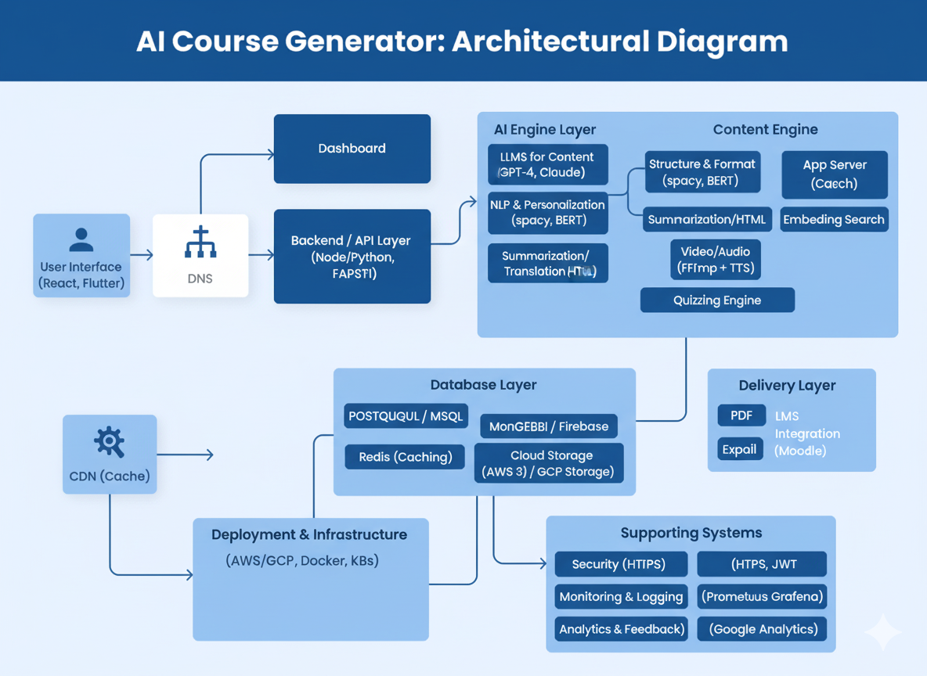

Tools/Technology Used:
  - Minimum Hardware Requirements
- CPU: Intel i5 or above
- RAM: 8 GB minimum
- GPU: Not mandatory (optional for ML fine-tuning)
- HDD/SSD: 256 GB or higher
- Others: Stable internet connection

    - ​

7.2 Minimum Software Requirements
    - Operating System: Windows 10 / Linux / macOS
    - Frontend: React.js + TailwindCSS
    - Backend: Node.js (v18+) with Express
    - Database: MongoDB (Cloud: MongoDB Atlas)
    - AI: OpenAI API / Hugging Face Transformers
    - IDE/Tools: VS Code, GitHub, Postman
    - Deployment: Vercel (Frontend), Render/Heroku (Backend)

8.References: [IEEE format]:

- M. P. Kumar and A. Sharma, “AI-powered personalized learning systems: A review,”
International Journal of Artificial Intelligence in Education, vol. 30, no. 2, pp. 120–135, 2023.

- FreeCodeCamp, “Learn Full Stack Development,” Available: https://www.freecodecamp.org/
- OpenAI, “GPT Models for AI-Powered Applications,” Available: https://platform.openai.com/
- Mozilla Developer Network (MDN), “Web Development Documentation,” Available: https://developer.mozilla.org
[5] R.S. Pressman, Software Engineering: A Practitioner’s Approach, 8th ed., McGraw Hill.

