Software Design Document


Project Aurora

Smart Road Weather Dashboard

Table of Contents

1. Introduction

1.1 System Overview

1.2 Purpose of the Document

1.3 Intended Audience

2. High-Level System Description

3. Main Components and Responsibilities

3.1 Frontend Components (React + TypeScript)

3.1.1 Dashboard View

3.1.2 Map View (Leaflet)

3.1.3 Alerts Panel

3.1.4 Live Camera Panel

3.1.5 Analytics Graphs (Recharts)

3.1.6 Settings Panel

3.1.7 Responsibilities of the Frontend

3.2 Backend Components (Spring Boot)

3.2.1 Controllers

3.2.2 Service Layer

3.2.3 External API Clients

3.2.4 Caching Layer

4. Boundaries and Interfaces

5. Class Diagram (Placeholder)

5.1 Explanation of Class Diagram

6. ER Diagram (Entity-Relationship Diagram)

6.1 Entity Descriptions

6.2 Cardinality Summary

6.3 Summary

7. User Interface Components

7.1 System Overview

7.1.1 Home Dashboard Overview & Location-Based Insights

7.1.2 Location-Based Insights

7.1.3 Live Traffic & Road Conditions

7.1.4 Settings and Personalization

8. Decision-Making Rationale

8.1 Frontend Technologies

8.2 Backend Technologies

8.3 Real-Time Updates

8.4 External APIs

8.5 No Database

9. Self-Evaluation

9.1 Adherence to the Original Design

9.2 Implementation Progress vs. Original Plan

9.3 Assessment of Design Quality

9.4 Changes Introduced After Prototype Phase

9.5 Summary

10. Conclusion

1. INTRODUCTION

The Smart Road Weather Dashboard is a web-based application designed to provide real-time weather, road condition, and traffic information for users across Finland. By integrating data from the Finnish Meteorological Institute (FMI) and Digitraffic, the system helps users make safer travel decisions by presenting accurate, timely, and location-specific insights through an interactive dashboard.

The purpose of this design document is to describe how the system is structured, how its components interact, and why specific architectural and technological choices were made. It includes high-level architecture, detailed component responsibilities, internal interfaces, diagrams (class and ER), and the reasoning behind the selected solutions. This document also discusses the development progress so far and includes a self-evaluation based on the mid-term requirements.

The intended readers of this document are the course instructors and teaching assistants responsible for evaluating the group assignment, as well as team members who need a shared understanding of the system design. The document acts as a blueprint for the implementation and supports consistent development throughout the remaining phases of the project.

2. HIGH‑LEVEL SYSTEM DIAGRAM
The architecture diagram illustrates a three-tier containerized system where users access the application through web browsers via HTTPS (localhost during development). The Frontend Container (shown in green) runs a React application with Material-UI components, Recharts for data visualization, Leaflet for interactive maps, and a WebSocket client for real-time updates. This frontend communicates with the Backend Container (shown in blue) using both REST API calls and WebSocket connections. The backend, built with Java Spring and deployed in Docker, contains API Controllers, Service Layer, Data Processing logic, Caching mechanisms, and External API Clients that fetch data from two external sources: the Digitraffic API (red box, providing traffic and road data) and the FMI API (red box, providing weather data).
The data flow follows six steps:
(1) users request data via browser,
(2) frontend sends API requests to backend,
(3) backend fetches data from Digitraffic and FMI,
(4) backend processes and caches the data,
(5) backend returns formatted data to frontend, and
(6) frontend displays the information on the dashboard.

The system's key features include real-time updates via WebSocket, interactive maps, weather and traffic alerts, historical analytics, and a stateless architecture with no database dependency, making it lightweight and easily scalable.
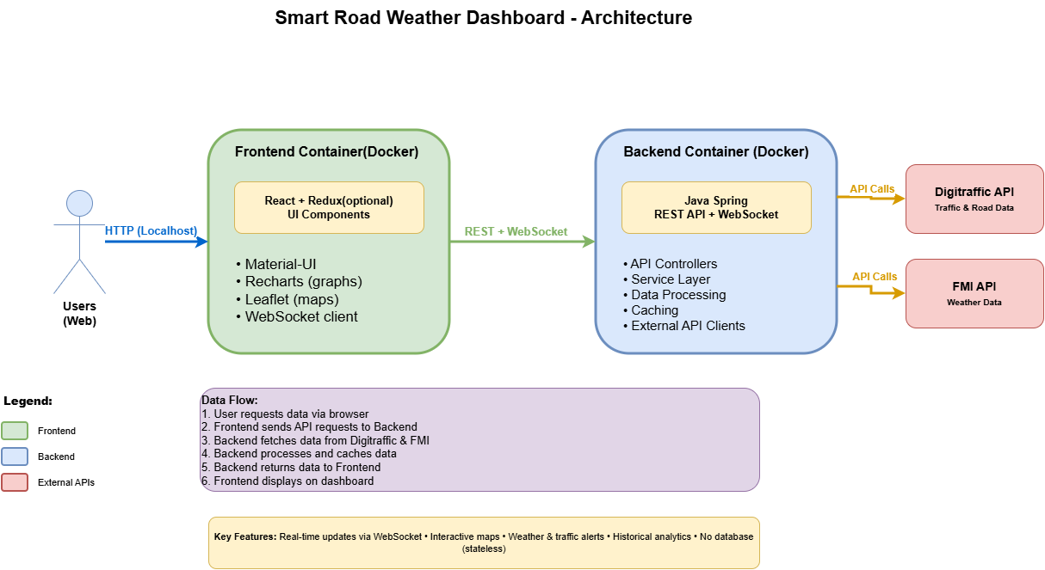
Key layers:
- Frontend (React + Leaflet + Recharts)
- Backend (Spring Boot, REST APIs, WebSocket)
- External APIs (Digitraffic & FMI)
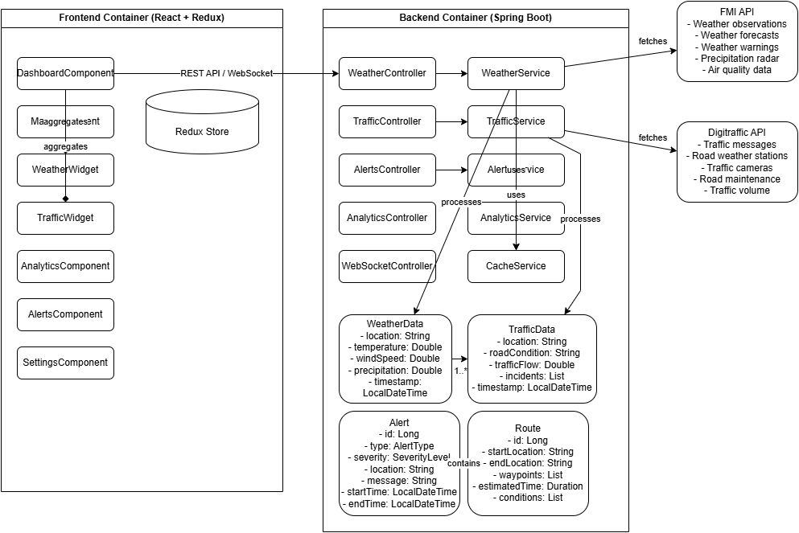
- Data processing, caching, and alert generation

3. Main Components and Responsibilities

This section describes the main system components, their roles, and their internal responsibilities. The system is divided into a frontend, backend, and external data sources, each with clearly defined boundaries and interactions.

3.1 Frontend Components (React + TypeScript)

DashboardView

Displays key weather and road summaries.

Shows quick cards for temperature, wind, precipitation, and alerts.

Acts as the entry point for most user interactions.

MapView (Leaflet)

Renders the interactive Finland map.

Displays regions, hazard levels, traffic cameras, and road weather stations.

Handles zooming, clicking regions, and updating selected areas.

AlertsPanel

Shows active FMI weather warnings and Digitraffic hazards.

Color-codes alerts by severity.

Fetches and updates alerts when the selected region changes.

LiveCameraPanel

Displays Digitraffic traffic camera feeds.

Supports filtering by region or keyword search.

Allows users to view multiple camera presets from the same station.

AnalyticsGraphs (Recharts)

Visualizes patterns between weather and road conditions.

Shows temperature trends, road friction correlation, and traffic volume.

SettingsPanel

Allows users to configure theme (light/dark), temperature units, and notification preferences.

Controls automatic location detection.

Responsibilities of the Frontend

Present real-time data in an interactive and user-friendly format.

Handle all user input and UI logic.

Communicate with backend via REST and (later) WebSocket.

Manage UI state (region selection, filters, options).

3.2 Backend Components (Spring Boot)

Controllers

WeatherController: Provides weather observations, forecasts, and warnings.

TrafficController: Provides incidents, road conditions, and traffic data.

CameraController: Provides traffic camera stations and presets.

AlertController: Provides combined weather + traffic alerts per region.

General Responsibilities

Expose REST endpoints for frontend requests.

Validate input parameters.

Map requests to service-layer logic.

Service Layer

WeatherService
Fetches and processes FMI weather data (temperature, wind, precipitation).

AlertService
Interprets FMI warnings, normalizes severity, and formats human-readable alerts.

TrafficService
Processes Digitraffic road condition sensors and incidents.

CameraService
Handles Digitraffic traffic camera feeds and station filtering.

DataMergeService (optional extension)
Combines FMI + Digitraffic data into unified region-level results.

General Responsibilities

Core business logic (processing, filtering, mapping).

Normalizing and transforming raw API responses.

Coordinating data across multiple external sources.

External API Clients

FmiApiClient
Fetches weather observations, forecasts, and warnings.

DigitrafficApiClient
Fetches cameras, road stations, and traffic incidents.

Responsibilities

Handle all external HTTP calls.

Parse XML/JSON into internal DTOs.

Manage errors from external services.

4. Boundaries and Interfaces

The system exposes interfaces through:
- REST Endpoints (JSON)
- Internal service‑to‑service interfaces through Spring components

Clear boundaries:
Frontend → Backend (HTTP)
Backend → External APIs (HTTP)
Services → Controllers (Java interfaces)
Controllers → Serialization layer

5. Class Diagram
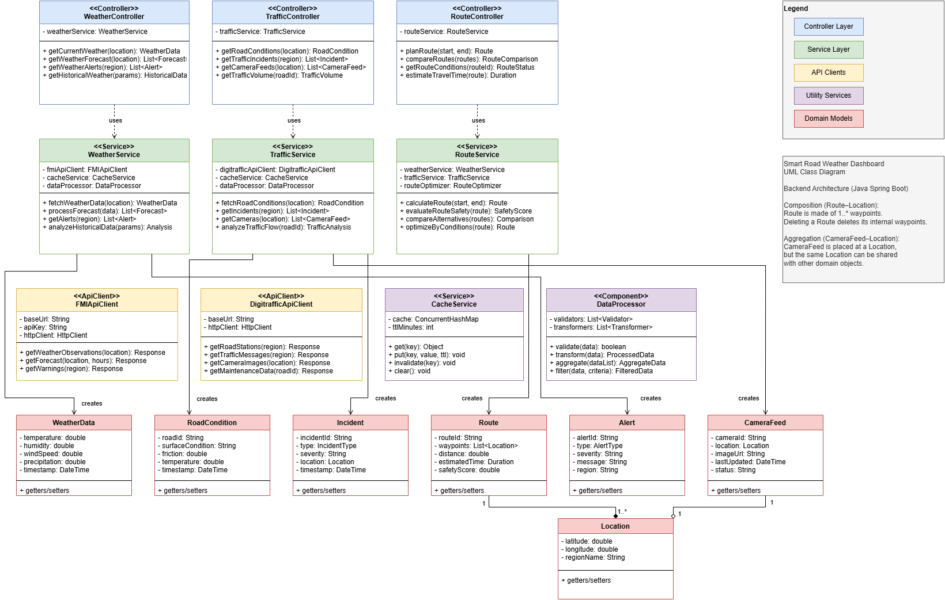

5.1 Explanation of Class Diagram

The class diagram describes domain entities such as WeatherData, TrafficIncident, CameraStation, Alert, and service layers like WeatherService and TrafficService. Controllers depend on services; services depend on ExternalApiClients and CacheManager. All domain models are immutable (value objects).
At the top, the controllers (WeatherController, TrafficController, RouteController) provide REST endpoints and delegate all processing to the service layer. The service layer (WeatherService, TrafficService, RouteService) performs the main system logic by combining data from external APIs, applying caching, validation, and data transformation, and generating domain-specific outputs such as weather summaries, road conditions, incidents, alerts, and route evaluations. These services rely on dedicated API client classes (FmiApiClient and DigitrafficApiClient) that communicate with external providers like FMI and Digitraffic to fetch raw weather, traffic, and camera data. Utility components such as CacheService and DataProcessor support the system by handling in-memory caching, data cleaning, validation, filtering, and aggregation.
At the bottom, the domain model layer defines core entities including WeatherData, RoadCondition, Incident, Route, Alert, CameraFeed, and Location, which represent the structured information used across the system. Composition and aggregation relationships indicate that routes consist of multiple locations and camera feeds are linked to locations. Overall, the diagram demonstrates a clean separation of concerns, modular design, and an efficient data flow from external APIs to processed outputs delivered through controller endpoints.

6. ER Diagram (Entity–Relationship Diagram)

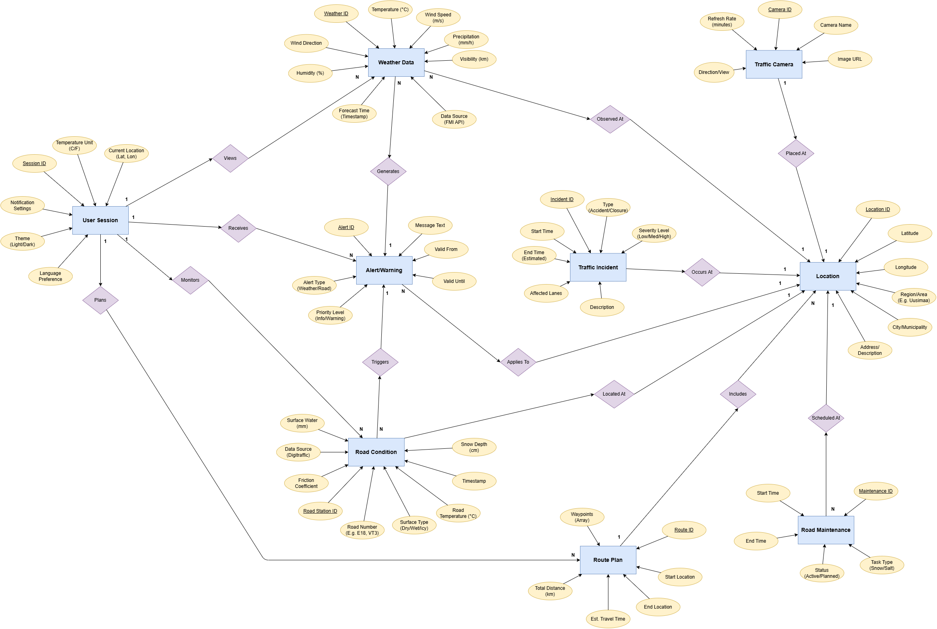

The ER diagram represents the key data entities and relationships in the Smart Road Weather & Traffic Monitoring System. The model is built around the Location entity, which acts as the central anchor linking weather data, road conditions, alerts, cameras, incidents, maintenance tasks, and route planning. Each user interacts with the system through a User Session, which manages their preferences and accessed information. The ERD ensures efficient geospatial data handling, real-time updates, and optimal integration with external APIs (FMI and Digitraffic).

6.1 Entity Descriptions
User Session
Represents the active user and their preferences (theme, units, language, location).
Relations:
- One session → many Weather Data, Road Conditions, Alerts, and Route Plans (1:N)

Location (Central Entity)
Stores geographic details (coordinates, region, municipality).
Relations:
- Connected to Weather Data, Road Conditions, Incidents, Alerts, Cameras, Maintenance, and Route Plan waypoints.

Weather Data
Contains temperature, wind, humidity, visibility, and precipitation readings.
Relations:
- Many observations per location (N:1)
- Can trigger multiple alerts (N:N)

Road Condition
Represents friction, snow depth, road temperature, and surface status.
Relations:
- Many conditions per location (N:1)
- Can generate multiple alerts (N:N)

Alert / Warning
Represents weather or road safety notifications with severity and validity times.
Relations:
- Many alerts per session (1:N)
- Many alerts assigned to one location (N:1)

Traffic Camera
Represents a single camera feed.
Relation:
- One camera → one location (1:1)

Traffic Incident
Accidents or road disruptions with severity and timing.
Relation:
- Many incidents can occur at a location (N:1)

Route Plan
User-generated travel routes with start/end, distance, and time.
Relations:
- One session → many routes (1:N)
- One route → many waypoints (1:N)

6.2 Cardinality Summary
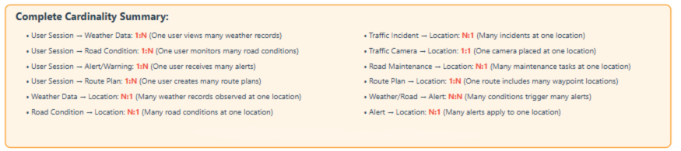

6.3 Summary
The ERD uses Location as the central reference point connecting all real-time weather, road, and traffic-related data. User Sessions link the user to the data they view and the routes they generate. This structure supports accurate, location-based monitoring and seamless integration with external data sources.

7. User Interface Components
7.1 System Overview
This has the system Overview, purpose of each component and what responsibilities do they have. The application consists of six main sections. There are differences in the ways components are presented currently, but those differences will be gone in final version when UI style is unified. Current designs are to get general idea how different components should look.
7.1.1 Home Dashboard Overview & Location-Based Insights
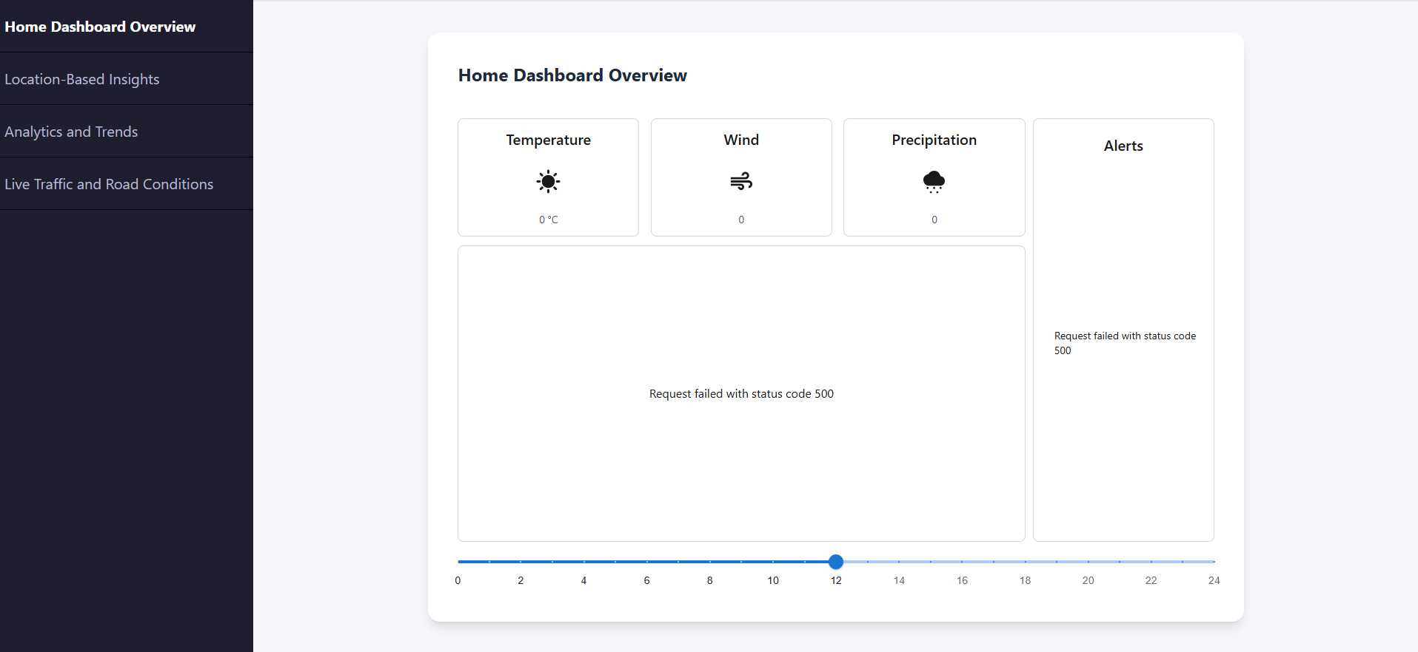

- Home Dashboard Overview
The Home Dashboard features four Weather Quick Cards displaying Temperature, Wind, Precipitation, and Alerts with clear icons and condition labels (Wet, Icy, Accidents, Road Closures) for general overview. The central Interactive Map shows with indicators that give location specific road condition info. A Time Slider at the bottom enables users to scrub through historical data or view forecasted conditions for trip planning (this part may be removed in final version).
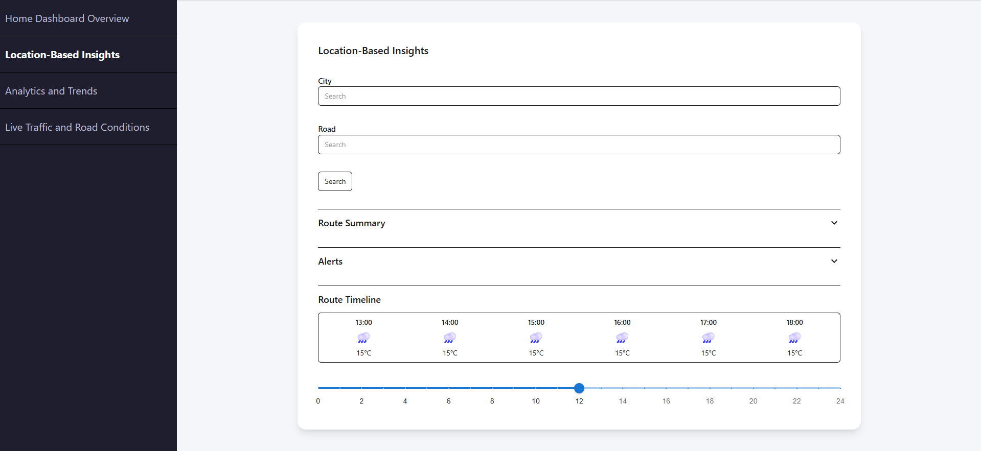
- Location-Based Insights
The Search Bar allows city, or road number entry. The Route Summary displays three key metrics: Road Conditions (Wet), Weather Forecast (15°C), and Traffic Flow via a progress bar. The collapsible Alerts Section shows hazard warnings. The Route Timeline displays hourly conditions from 13:00-18:00 with weather icons and temperatures, helping users identify optimal departure times. The time bar in final version will be movable timespan that then visualizes like in this example the weather within that span divided in hours.
Key Features:
- General overview of today’s weather
- Map indicators for road conditions
- Quick access to critical information
- Location detection

7.1.2 Analytics and Trends
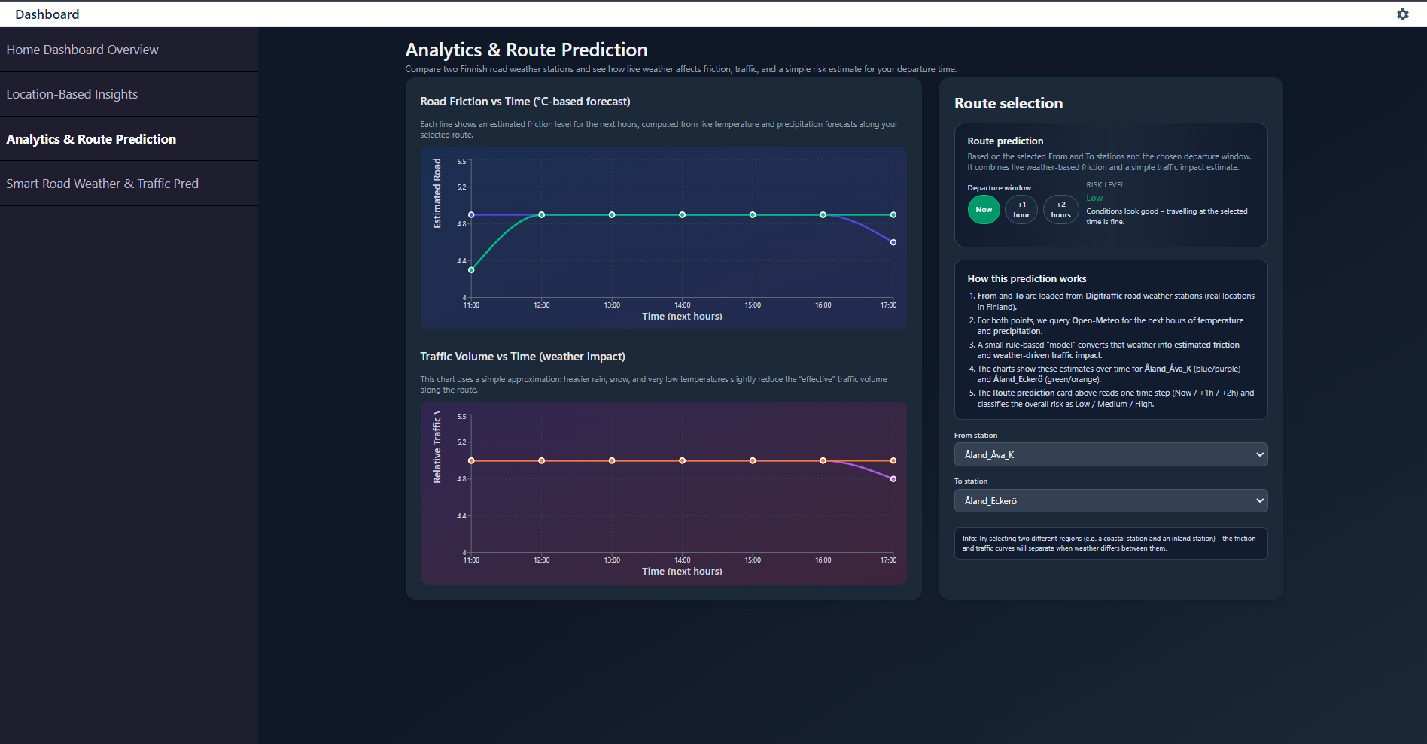

- Left Panel: Analytics & Route Insights
The left panel visualizes real-time, weather-driven analytics based on the user’s selected route. It presents two interactive trend charts: Road Friction vs Time, estimated from temperature and precipitation forecasts, and Traffic Volume vs Time, showing how weather intensity affects effective traffic flow. These graphs update dynamically using live Open-Meteo data and allow users to compare conditions between the two chosen Digitraffic stations. Together, the visuals give a clear, data-driven understanding of upcoming risks—such as potential ice, reduced traction, or weather-related slowdowns—helping users anticipate safer travel windows.
- Right Panel: Route Prediction & Station Selection
The right panel controls how the route-based analytics are generated. It includes the Route Prediction (beta) module, which evaluates conditions for “Now / +1 hour / +2 hours” and classifies the overall risk as Low, Medium, or High based on estimated friction and weather-driven traffic impact. Below this, the How This Prediction Works section offers a concise explanation of the logic behind the calculations. Users can then choose their From and To Digitraffic road weather stations. These selections instantly update the charts and prediction, enabling quick comparisons across regions. A helpful tip box encourages exploring different station combinations to observe how inland, coastal, or northern locations differ in weather-related risk.

Key Features:
- Route planning with multiple waypoints
- Alternative route comparison
- Travel time estimation
- Construction zone warnings
- Export route details

7.1.3. Live Traffic & Road Conditions

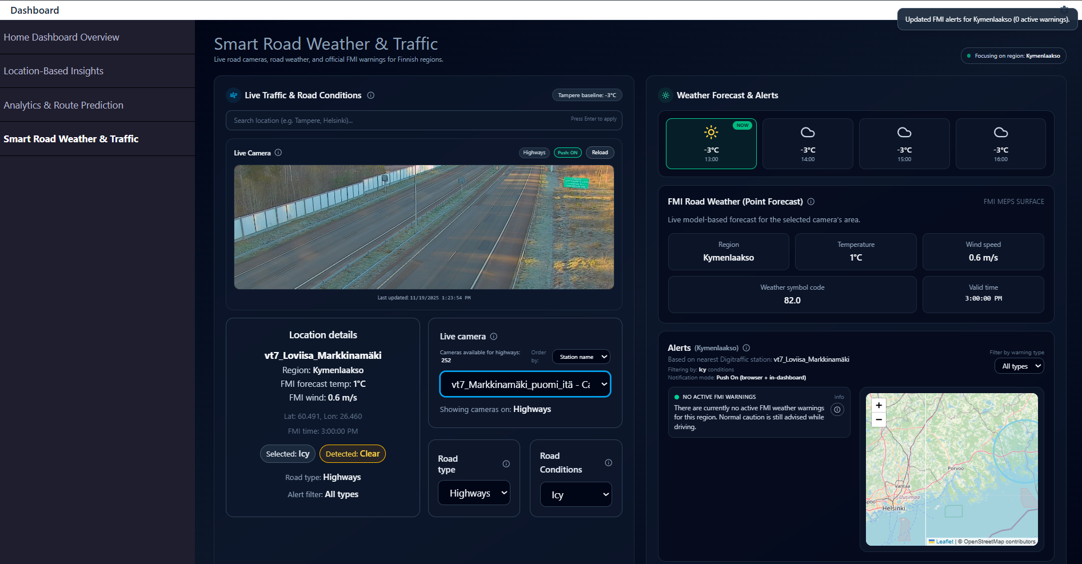

- Left Panel: Live Traffic & Road Conditions
The left panel provides real-time situational awareness for the selected location. Users can search for a city or area, view live traffic footage from Digitraffic cameras, and examine detailed road weather information such as temperature, wind speed, and timestamps from the nearest FMI station. The interface highlights both the user-selected road condition and the system-detected condition, enabling quick comparison. Additional filters—such as road type and surface condition—allow users to tailor the view to specific contexts, while the camera selector enables switching between available live camera feeds within the region.
- Right Panel: Weather Forecast & Alerts
The right panel focuses on short-term weather insights and safety-related notifications. It presents an hourly weather forecast with temperature values and weather symbols relevant to the selected area. The FMI Road Weather section summarizes key parameters including region, temperature, wind speed, and weather symbol code, offering a clear snapshot of local conditions. The Alerts section indicates whether any active FMI warnings exist for the region, and the integrated map provides a geographic reference point, helping users understand the spatial context of road weather conditions and potential hazards.
Key Features:
- Multiple camera views
- Traffic flow visualization (color-coded roads)
- Incident markers (accidents, hazards)
- Road sensor data (friction, ice detection)
- Parking availability at rest areas

7.1.4. Settings and Personalization

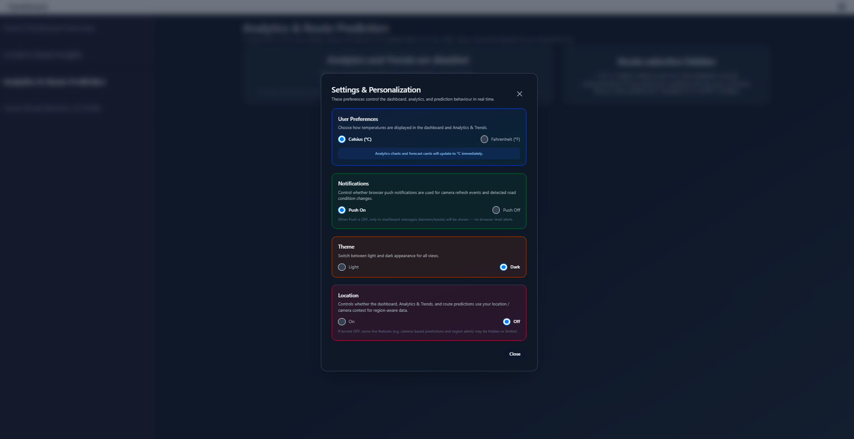

The settings and personalization modal enables users to customize their dashboard experience. User Preferences allows switching between Celsius and Fahrenheit units for temperature-based charts. Notifications lets users choose between Push or Email alerts. The Theme Toggle supports Light or Dark mode for improved usability across environments. The Location section provides on/off control for automatic location detection and displays the user’s current map position, ensuring that analytics and notifications stay relevant to the user's area.

8. Decision‑Making Rationale
The project uses a multi-layered frontend–backend architecture with external data sources. This structure was chosen because it cleanly separates UI rendering, business logic, and data retrieval, making the system easier to maintain, test, and scale. It also allows independent development of frontend and backend modules and fits the course requirement of demonstrating good software design practices.
8.1 Frontend Technologies
- React + TypeScript
Used for building the entire UI. Chosen because React’s component model supports modular views (dashboard, alerts, map, cameras), and TypeScript improves reliability by enforcing typed data models from APIs.
- Tailwind CSS
Used as the main styling framework for the frontend. Tailwind’s utility-first classes make it easy to build clean, responsive interfaces quickly without managing large CSS files. It works smoothly with React and helps keep the dashboard modern, consistent, and easy to customize.
- Leaflet
Used in the MapView to display Finland’s regions, camera markers, and weather overlays. Selected for being lightweight, flexible, and easy to integrate with React.
- Recharts
Used in the analytics page for plotting weather–traffic relationships. Selected due to simple React-based chart components and low configuration overhead.

8.2 Backend Technologies
- Spring Boot
Used for controllers, services, caching, and external API clients. Chosen for its strong support for REST architecture, clean layering (controller → service → client), and the team’s familiarity with Java.
- REST + JSON
Used as the primary communication method between frontend and backend because it is simple, stateless, and easy to test.
8.3 Real-Time Updates
- WebSocket (planned)
Chosen for future live updates (alerts, road conditions) without constant polling.
8.4 External APIs
- FMI Open Data API
Provides weather observations, forecasts, and warnings. Selected because it is the official Finnish authority for weather information and matches the project's safety-related goals.
- Digitraffic API
Provides traffic cameras, road conditions, incidents, and maintenance data. Chosen because it is the official, real-time source for Finnish road data.
8.5 No Database
No database is used because all required data is already maintained by FMI and Digitraffic. The dashboard only visualizes live information, so persistent storage is unnecessary and would complicate the design without benefits.

9. Self‑Evaluation

This section evaluates how well the implementation has followed the original design, how the design has supported development so far, and what changes are needed for completing the remaining features.

9.1 Adherence to the Original Design

The core architecture has remained strongly aligned with the initial design:

Frontend built with React + TypeScript and modular components (Dashboard, MapView, Alerts, Settings) as planned.

9. Self-Evaluation
This section evaluates how well the implementation has followed the original design, how the design has supported development so far, and what changes are needed for completing the remaining features.

9.1 Adherence to the Original Design
The core architecture has remained strongly aligned with the initial design:
- Frontend built with React + TypeScript and modular components (Dashboard, MapView, Alerts, Settings, Analytics & Route Prediction) as planned.
- Backend implemented with Spring Boot, following the intended structure: Controllers → Services → External API Clients → Caching.
- System remains stateless, using only in-memory caching.
- Digitraffic and FMI integrations follow the original plan, and an additional Open-Meteo forecast source has been introduced for analytics and route prediction.
Minor adjustments:
- The TrafficService was split into CameraService and IncidentService for clarity.
- The analytics view was restructured into a two-column layout, with charts on the left and route selection + route prediction (beta) on the right for better use of screen space.
- The AnalyticsandTrends component now reacts to the global Settings (theme, temperature unit, location on/off) and uses live forecast data instead of static mock values.
- Inline info tooltips (Info icons) were added to explain key UI areas such as Live Traffic & Road Conditions, live camera behaviour, road type/condition filters, FMI point forecast, and the Alerts panel.
These changes improved usability and maintainability without altering the overall architecture.

9.2 Implementation Progress vs. Original Plan
Implemented as planned (and extended):
- FMI weather and warning fetching.
- Digitraffic cameras and road weather data.
- Interactive map (Leaflet) with region-based views.
- Alerts panel using live API data.
- Basic settings (theme, units, location toggle).
- Initial caching layer.
- Analytics graphs now driven by live Open-Meteo data:
  - Road friction vs. time (estimated from temperature and precipitation).
  - Traffic impact vs. time (simple rule-based reduction based on weather).
- Prototype route prediction (beta):
  - Uses selected “From” and “To” Digitraffic stations.
  - Reads forecast for “Now / +1h / +2h” and classifies risk as Low / Medium / High.
- In-app toast notifications for real-time feedback:
  - When the live camera is reloaded.
  - When no cameras match the current filters.
  - When detected road conditions change.
  - When FMI alerts are refreshed for the selected region.

9.3 Assessment of Design Quality
- Modularity: Clear separation between UI components (dashboard, map, alerts, analytics, settings), backend services, and API clients. The new analytics and notification logic are encapsulated in dedicated components and hooks.
- Maintainability: Codebase is structured cleanly, making it straightforward to extend analytics, adjust the risk model, or refine notification behaviour.
- Scalability: Stateless backend and a simple caching layer support horizontal scaling; the analytics and notification logic remain lightweight and driven by external APIs.
- Flexibility: API models and UI state are structured to allow new data sources (e.g. additional weather providers or traffic sensors) and more advanced route models without changing the overall architecture.
- Reliability: Basic error handling and fallback messages are implemented in the analytics and alerts views. The toast notifications highlight important state changes without relying on slower external channels.
Overall, the design continues to align well with the quality criteria expected in software design.

9.4 Changes Introduced After Prototype Phase
Documented improvements after the initial prototype:
- Split TrafficService into separate CameraService and IncidentService for clearer responsibilities.
- Added a dedicated WeatherAlertService for FMI warning parsing.
- Refined frontend state handling for region selection, filters, and Settings (theme, units, location).
- Introduced a DTO layer to separate raw API payloads from processed domain models.
- Improved the UI layout into a multi-panel view, including:
  - A dedicated Analytics & Route Prediction screen.
  - Charts (friction and traffic impact) sized and styled to fit typical screens better.
  - Route prediction (beta) moved to the right column next to route selection for more intuitive interaction.
- Connected analytics to live forecast data (Open-Meteo) and added a simple rule-based route risk model (Low / Medium / High) based on weather-derived friction and traffic impact.
- Added inline info tooltips to explain complex UI elements (traffic panel, cameras, road filters, FMI point forecast, alerts).
- Introduced React in-app toast notifications for key live updates (camera reloads, empty filter results, condition changes, refreshed alerts), and removed email alerts because they are too slow and not suitable for real-time dashboard feedback.
These updates enhance clarity, performance, user experience, and maintainability.

9.5 Summary
The design has supported development effectively, and the team has followed the planned structure with only small, justified refinements. The introduction of live, weather-aware analytics, inline explanations, and real-time toast notifications demonstrates that the original architecture can accommodate new features without major changes. The remaining work focuses on deepening functionality (full route planning, historical analytics) rather than reworking the design, confirming that the solution is scalable, modular, and appropriate for the system’s requirements.

10. Conclusion

The Smart Road Weather Dashboard provides an innovative and practical solution to improve road safety and travel planning across Finland. By integrating real-time traffic data from Digitraffic and weather information from the Finnish Meteorological Institute (FMI), the system empowers users to make informed decisions about their routes and driving conditions.
Through its intuitive, web-based interface, users can access live updates, weather forecasts, and traffic alerts in one place, helping reduce accidents and improve overall travel efficiency. The system’s lightweight, containerized architecture ensures scalability, reliability, and ease of maintenance, while its adherence to performance, usability, and accessibility standards guarantees a seamless experience for all users.
In summary, the Smart Road Weather Dashboard combines technology, safety, and convenience to create a smarter, safer, and more connected road network for everyone.
The system design fully aligns with the submission guidelines. It includes all necessary components, clear division of responsibility, diagrams, interfaces, and reasoning. The next steps include completing all backend endpoints and finalizing the UI for real‑time analytics.

