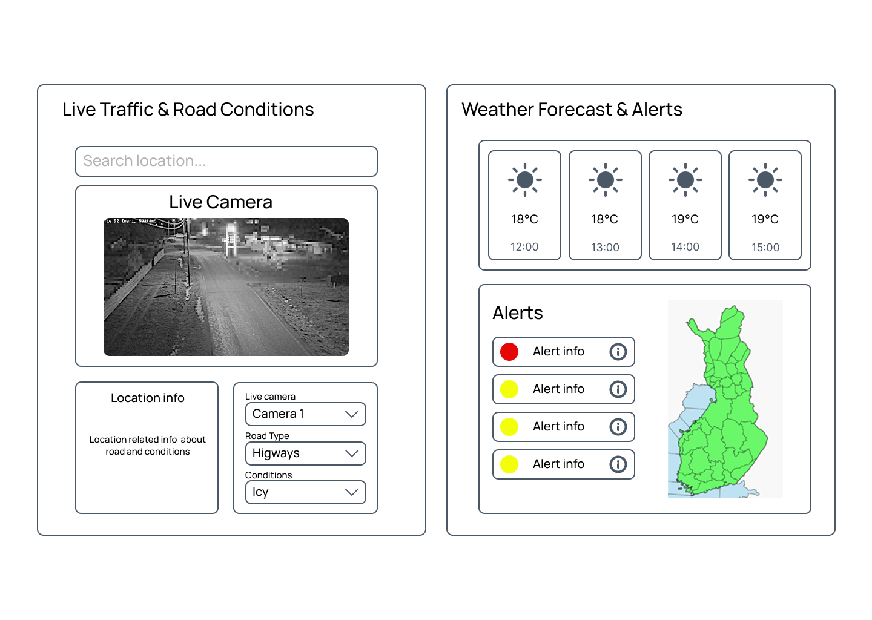Smart Road Weather Dashboard

Table of Contents
- Overall Use Case
1.1 Objectives
1.2 Target Users
- Software Requirements Specification (SRS)
- System Architecture
5.1 High-Level Architecture Diagram
5.2 Architecture Explanation
5.3 Data Flow Process
- User Interface Components
6.1 Wireframe Overview
- Key Features Summary
- Development Roadmap
- Conclusion

1. Overall use-case
1.1 Objectives
The primary objective of this project is to create an integrated platform that combines real-time road conditions and weather data to enhance road safety across Finland. The dashboard aims to provide users with immediate access to critical information that affects their travel decisions. By leveraging official data sources from Digitraffic and FMI, the system ensures accuracy and reliability in delivering weather forecasts, road condition updates, and safety alerts.
The secondary objectives include enabling proactive route planning through historical data analysis, reducing accident rates by providing timely warnings about hazardous conditions, and creating a user-friendly interface that makes complex data accessible to all user groups. The dashboard should serve as a comprehensive tool for both casual users planning daily commutes and professional drivers managing logistics operations.

This application takes data from following APIs:
- Digitraffic API: https://www.digitraffic.fi/en/
Provides:
- Traffic messages and incidents
- Road weather stations
- Traffic cameras (live images)
- Road maintenance data
- Traffic volume and speed

- FMI API : https://en.ilmatieteenlaitos.fi/open-data
Provides:
- Weather observations
- Weather forecasts
- Weather warnings
- Precipitation radar
- Air quality data

In normal use-case users can see from web dashboard traffic and weather condition related data in visual format like maps and notifications, making road planning easier. There are also options for more analytical outlook with visualized graphs showing historical data. No login is required, and the application should just be tool for users to visualize/analyze data and make decisions based on that.

1.2 Target Users
The dashboard is designed to serve multiple user segments with varying needs and technical expertise. Daily commuters represent the largest user base, requiring quick access to route conditions before their morning and evening travels. These users benefit from simple, at-a-glance information about their regular routes and real-time alerts about changing conditions.
Professional drivers and logistics companies form another critical user group. They require detailed information about road conditions across multiple routes, extended weather forecasts for trip planning, and historical data to optimize delivery schedules. Their needs include integration capabilities with fleet management systems and the ability to monitor multiple routes simultaneously.
Road maintenance authorities use the dashboard for operational planning and resource allocation. They need comprehensive regional overviews, trend analysis for maintenance scheduling, and integration with their existing infrastructure management systems. Tourism and travel agencies benefit from the extended forecast features and scenic route information, while the general public uses the dashboard for occasional travel planning and safety awareness.

2. Software Requirements Specification (SRS)
1. Functional Requirements
- Display Real-Time Data
Show live road and weather information using Digitraffic and FMI APIs.
- Interactive Map
Users can zoom, pan, and select areas to view traffic and weather conditions.
- Weather Forecast & Alerts
Display current and future weather forecasts with warning messages.
- Traffic Cameras & Incidents
Show live traffic camera images and any ongoing incidents or maintenance.
- Historical Data Analysis
Allow users to view and analyze past traffic and weather trends.
- Route & Location Search
Let users search by location or route to see specific conditions.
- Real-Time Updates
Use WebSocket or auto-refresh to update the dashboard continuously.
- User Settings
Support light/dark mode, temperature unit selection, and notification preferences.

2. Non-Functional Requirements
- Performance
Dashboard should load within 3–5 seconds and update smoothly.
- Reliability
System should have at least 99% uptime and handle API failures gracefully.
- Scalability
Should support multiple users without slowing down.
- Security
All data communication must be over HTTPS; no sensitive data stored.
- Usability
Interface should be simple, responsive, and easy to use on desktop and mobile.
- Maintainability
Code should be modular and easy to update or debug.
- Compatibility
Should work on major browsers (Chrome, Firefox, Edge, Safari).
- Accessibility
Follow basic accessibility standards (clear labels, color contrast, keyboard navigation).

3. System Architecture
The Smart Road Weather Dashboard is a web-based application that provides real-time road safety and weather analysis for Finnish roads. By integrating data from Digitraffic (Finnish Transport Infrastructure Agency) and FMI (Finnish Meteorological Institute), this dashboard helps users make informed decisions about route planning and travel safety.
Key Benefits:
- Real-time traffic and weather monitoring
- Interactive maps and data visualizations
- Safety alerts and warnings
- Historical data analysis
- No login required

5.1 High-Level Architecture Diagram
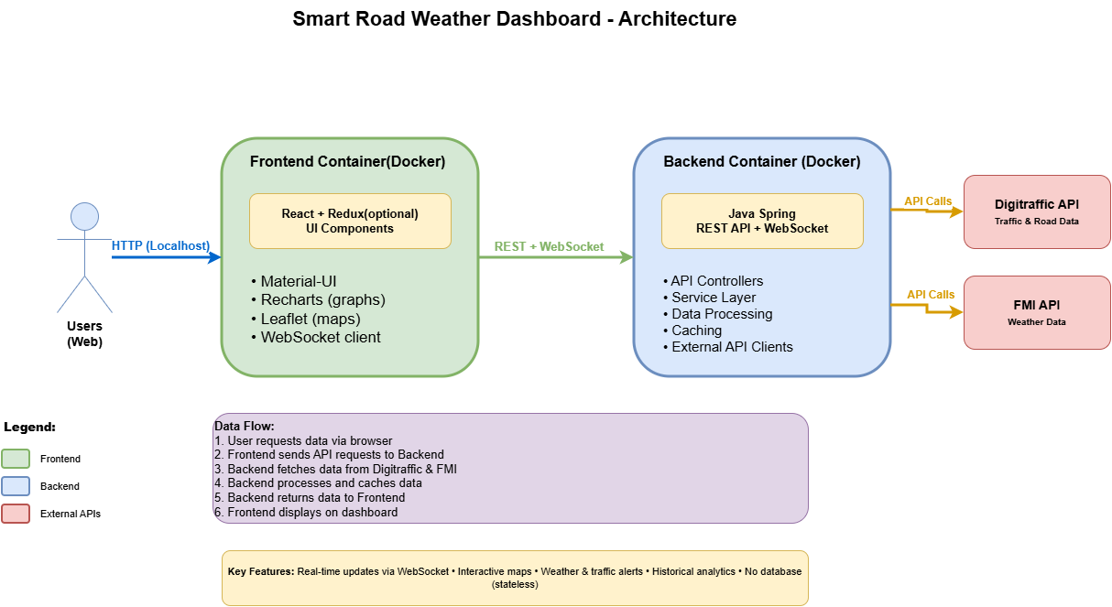

The architecture diagram illustrates a three-tier containerized system where users access the application through web browsers via HTTPS (localhost during development). The Frontend Container (shown in green) runs a React + Redux application with Material-UI components, Recharts for data visualization, Leaflet for interactive maps, and a WebSocket client for real-time updates. This frontend communicates with the Backend Container (shown in blue) using both REST API calls and WebSocket connections. The backend, built with Java Spring and deployed in Docker, contains API Controllers, Service Layer, Data Processing logic, Caching mechanisms, and External API Clients that fetch data from two external sources: the Digitraffic API (red box, providing traffic and road data) and the FMI API (red box, providing weather data).
The data flow follows six steps:
(1) users request data via browser,
(2) frontend sends API requests to backend,
(3) backend fetches data from Digitraffic and FMI,
(4) backend processes and caches the data,
(5) backend returns formatted data to frontend, and
(6) frontend displays the information on the dashboard.

The system's key features include real-time updates via WebSocket, interactive maps, weather and traffic alerts, historical analytics, and a stateless architecture with no database dependency, making it lightweight and easily scalable.

5.2 Architecture Explanation
The system consists of four main layers:
Layer 1: Users
Users access the dashboard through web browsers on desktop or mobile devices via secure HTTPS connections.
Layer 2: Frontend Container (Docker)
Hosts the React-based user interface:
- React + Redux: Manages UI and application state
- Material-UI: Provides professional UI components
- Recharts: Creates charts and graphs
- Leaflet/Mapbox: Powers interactive maps
- WebSocket Client: Enables real-time updates
Layer 3: Backend Container (Docker)
Runs the Java Spring Boot application:
- REST API + WebSocket: Handles requests and pushes live updates
- Service Layer: Contains business logic for data processing
- Caching: Stores frequently access data to reduce API calls
- API Clients: Connects to Digitraffic and FMI APIs
Layer 4: External APIs
- Digitraffic API: Traffic cameras, road conditions, incidents
- FMI API: Weather forecasts, observations, warnings
5.3 Data Flow Process
- User opens the dashboard or selects a location
- Frontend sends a request to the backend
- Backend checks the cache for existing data
- If not cached, backend fetches from Digitraffic/FMI APIs
- Backend processes and formats the data
- Data is cached for future requests
- Backend returns formatted data to frontend
- React components update to display the information
- WebSocket pushes real-time updates automatically

4. User Interface Components
6.1 Wireframe Overview
The application consists of six main sections (refer to uploaded wireframe image):
1. Home Dashboard Overview & Location-Based Insights

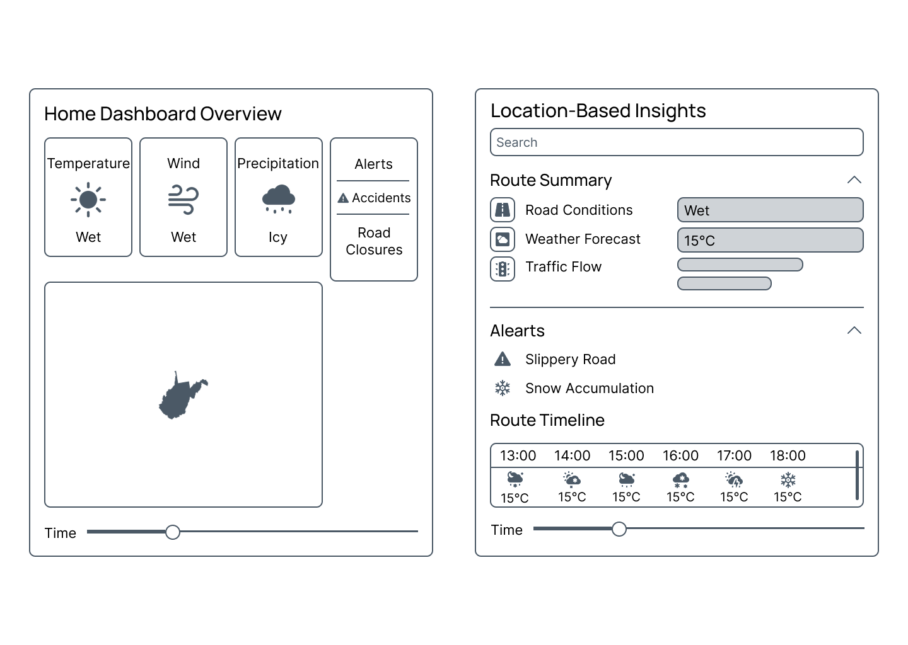

- Left Panel: Home Dashboard Overview
The Home Dashboard features four Weather Quick Cards displaying Temperature, Wind, Precipitation, and Alerts with clear icons and condition labels (Wet, Icy, Accidents, Road Closures) for rapid scanning. The central Interactive Map shows Finland with color-coded regions indicating hazard levels, allowing users to click areas for detailed information. A Time Slider at the bottom enables users to scrub through historical data or view forecasted conditions for trip planning.
- Center Panel: Location-Based Insights
The Search Bar allows route, city, or road number entry. The Route Summary displays three key metrics: Road Conditions (Wet), Weather Forecast (15°C), and Traffic Flow via a progress bar. The collapsible Alerts Section shows Slippery Road and Snow Accumulation warnings. The Route Timeline displays hourly conditions from 13:00-18:00 with weather icons and temperatures, helping users identify optimal departure times.

Key Features:
- Real-time weather widgets
- Color-coded map by safety conditions
- Quick access to critical information
- Location detection

2. Location-Based Insights
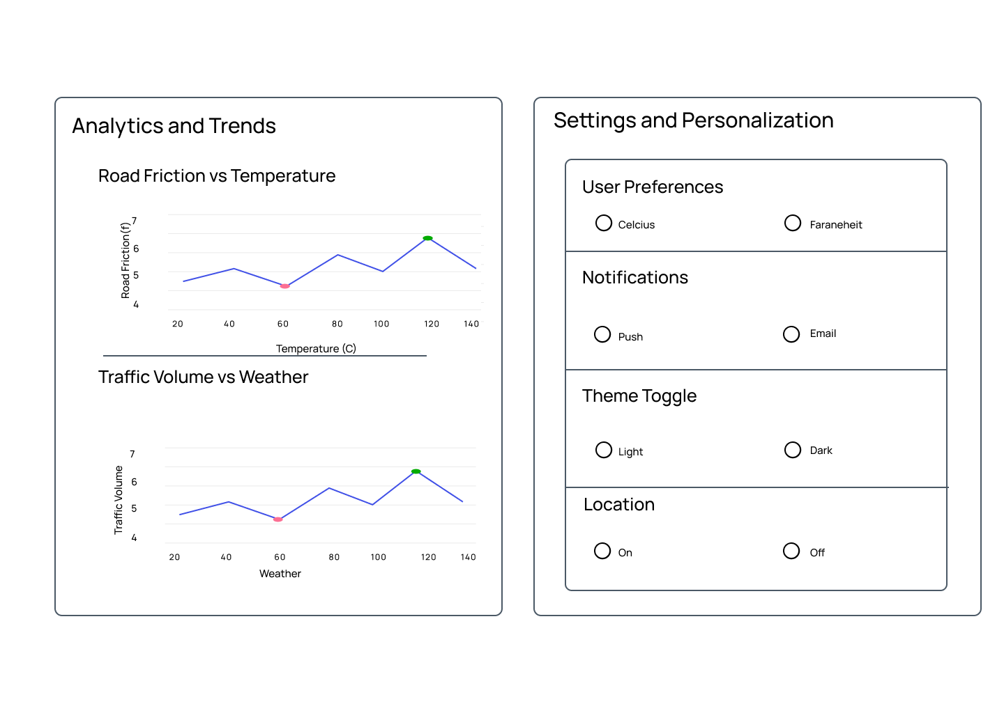

- Left Panel: Analytics and Trends
The Road Friction vs Temperature Graph displays correlation between friction coefficient and temperature (currently 20-140°C, should be -20 to 40°C for Finland), revealing dangerous zones where ice reduces traction. The Traffic Volume vs Weather Graph shows how weather patterns affect traffic flow, helping users anticipate congestion and safety concerns during various conditions.
- Right Panel: Settings and Personalization
User Preferences offers Celsius/Fahrenheit temperature selection. Notifications provides Push/Email delivery options. Theme Toggle switches between Light/Dark modes for visual comfort. Location controls automatic position detection for local conditions (On/Off).

Key Features:
- Route planning with multiple waypoints
- Alternative route comparison
- Travel time estimation
- Construction zone warnings
- Export route details

3. Live Traffic & Road Conditions

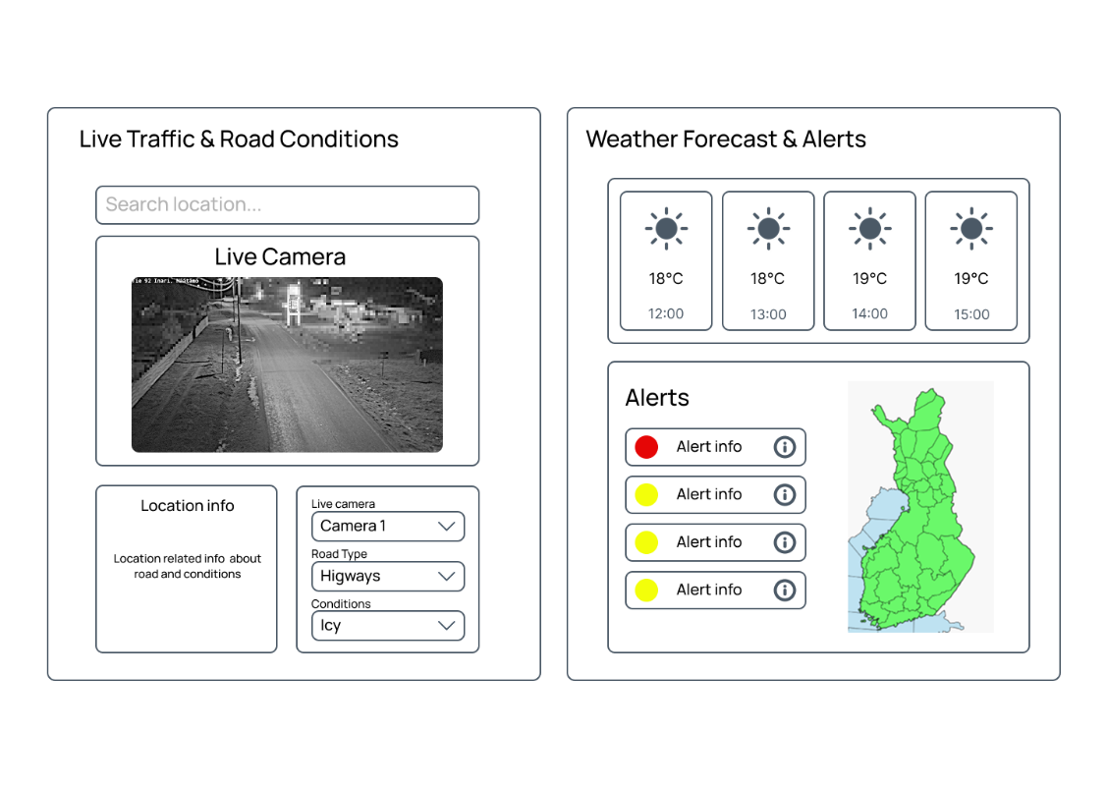

- Left Panel: Live Traffic & Road Conditions
The Search Location Bar supports finding specific locations. The Region Selector filters by administrative areas. The Live Camera Feed shows real-time traffic footage (prototype displays nighttime urban street) providing visual confirmation of conditions. Road Type and Condition filters enable focusing on relevant road categories and surface conditions.
- Right Panel: Weather Forecast & Alerts
The Hourly Forecast displays four time slots (12:00-15:00) with sun icons and temperatures (18-19°C). The Alerts Section uses color-coded severity (red for critical, yellow for moderate) with info buttons for details. The Regional Map shows Finland with color-coded regions (green for safe, yellow and red for concerns) providing nationwide overview.
Key Features:
- Multiple camera views
- Traffic flow visualization (color-coded roads)
- Incident markers (accidents, hazards)
- Road sensor data (friction, ice detection)
- Parking availability at rest areas

5. Key Features Summary
Real-Time Monitoring
- Live weather and road conditions
- WebSocket-powered instant updates
- Traffic camera feeds refreshed every 2-5 minutes
Route Planning
- Compare multiple routes
- View conditions along entire route
- Estimate travel time based on current conditions
- Receive alerts for hazardous sections

Safety Alerts
- Weather warnings (ice, snow, wind)
- Traffic incidents (accidents, road closures)
- Construction zone notifications
- Color-coded severity indicators

Historical Analysis
- View past weather and traffic patterns
- Identify peak traffic times
- Analyze accident frequency by conditions
- Export data for further analysis

Customization
- Personalized alert preferences
- Saved favorite locations and routes
- Theme selection (light/dark mode)
- Multi-language support

6. Development Roadmap
Phase 1: Foundation (Weeks 1-2)
- Set up Docker containers
- Configure Spring Boot backend
- Initialize React frontend
- Connect to APIs

Phase 2: Core Features (Weeks 3-5)
- Build Home Dashboard
- Implement map integration
- Create real-time data updates
- Add weather and traffic widgets
Phase 3: Advanced Features (Weeks 6-7)
- Route planning functionality
- Camera feeds integration
- Analytics visualizations
- Settings page

Phase 4: Testing & Polish (Weeks 8-9)
- Performance optimization
- Accessibility compliance
- Comprehensive testing

7. Conclusion
The Smart Road Weather Dashboard provides an innovative and practical solution to improve road safety and travel planning across Finland. By integrating real-time traffic data from Digitraffic and weather information from the Finnish Meteorological Institute (FMI), the system empowers users to make informed decisions about their routes and driving conditions.
Through its intuitive, web-based interface, users can access live updates, weather forecasts, and traffic alerts in one place, helping reduce accidents and improve overall travel efficiency. The system’s lightweight, containerized architecture ensures scalability, reliability, and ease of maintenance, while its adherence to performance, usability, and accessibility standards guarantees a seamless experience for all users.
In summary, the Smart Road Weather Dashboard combines technology, safety, and convenience to create a smarter, safer, and more connected road network for everyone.

