FARM MANAGEMENT SYSTEM

User Story:
In the Farm Management System (FMS), as a farmer, farm manager, or system administrator, I want to use a centralized Salesforce-based platform to record and manage farm, crop, farmer, and buyer information so that all agricultural data is stored securely and systematically. I want to enter and update farm details, crop production records, and buyer transactions easily through a user-friendly interface with proper validation rules to prevent incorrect entries. I also want the system to generate real-time reports and interactive dashboards so that I can analyze farm productivity, monitor sales, and make informed decisions. Additionally, I want role-based access and secure data storage to ensure that sensitive information is protected while enabling smooth collaboration among users. This system will help reduce manual paperwork, minimize errors, improve efficiency, and support data-driven farm management.

INTRODUCTION

Project Overview:

The Farm Management System (FMS) is a Salesforce-based application designed to digitize and streamline agricultural operations. It manages data related to farms, crops, farmers, and buyers while providing real-time insights through reports and dashboards. The system helps farmers and managers monitor agricultural activities efficiently and make informed decisions.

The main purpose of this project is to:

    - Digitize agricultural data management
    - Improve data accuracy and accessibility
    - Automate record handling
    - Enable real-time monitoring
    - Support data-driven farming decisions
    - Enhance productivity and transparency

IDEATION PHASE

Problem Statement (Customer Problem Statement Template)

PS | I am (Customer) | I’m trying to | But | Because | Which makes me feel
PS-1 | Farmer | Maintain farm and crop records | Data is often incomplete or incorrect | Records are kept manually in registers | Frustrated and confused
PS-2 | Farm Manager | Monitor farm productivity and sales | Reports are delayed and inaccurate | Data is scattered across files and sheets | Stressed and inefficient
PS-3 | Buyer | Access crop availability and pricing | Information is not updated regularly | There is no centralized digital system | Uncertain and dissatisfied
PS-4 | System Admin | Manage user access and system security | Unauthorize d access may occur | Access control is handled manually | Concerned and insecure

  - Empathy Map Canvas
Target Users:
    - Farmers
    - Farm Managers
    - Buyers
    - System Administrators
Empathy Analysis
    - Think & Feel: Need accurate and timely farm data
    - Hear: Feedback from agricultural officers
    - See: Registers, paper files, spreadsheets
    - Say & Do: Enter records manually
    - Pain: Data loss, errors, delays
    - Gain: Automation, fast reporting

Brainstorming
Brainstormed Ideas
    - Manual farm records
    - Excel-based management
    - Web-based system
    - Mobile farm app
    - Salesforce-based FMS
Selected Idea
Salesforce-based Farm Management System.

REQUIREMENT ANALYSIS PHASE

Customer Journey Map
Stages:
- Login
- Access Farm Management App
- Enter Farm and Crop Data
- Register Farmers and Buyers
- Generate Reports
- Analyze Results
- Decision Making

Solution Requirements
Functional Requirements

FR No | Requirement
FR-1 | User Authentication
FR-2 | Farm, Crop, Farmer, Buyer Management
FR-3 | Data Entry and Validation
FR-4 | Relationship Mapping
FR-5 | Report Generation

Non-Functional Requirements

NFR | Description | Example
Usability | Easy interface | Simple Lightning UI
Security | Data protection | Profiles & roles
Reliability | No data loss | Cloud backup
Performance | Fast access | Reports in <3 sec
Availability | 24/7 access | Cloud hosting
Scalability | Handles growth | More farms/users

Data Flow Diagram
Data Flow:
User → Salesforce UI → Custom Objects (Farm, Crop, Farmer, Buyer) → Validation Rules → Relationships → Reports → Dashboards

  - Technology Stack

Layer | Technology
Frontend | Salesforce Lightning UI
Backend | Salesforce Platform
Database | Salesforce Cloud
Automation | Validation Rules
Analytics | Reports & Dashboards

- Data Layer – Custom Objects
- Analytics Layer – Reports and Dashboards

PROJECT DESIGN PHASE

Problem–Solution Fit
The FMS replaces manual farming records with automated data management. Cloud storage prevents data loss, dashboards improve analysis, and real-time reports eliminate delays. This ensures accurate and timely agricultural insights.

Proposed Solution
Functional Requirements

Parameter | Description
Problem | Manual maintenance of farm, crop, farmer, and buyer records leading to errors, data loss, and delays.

Solution | Salesforce-based Farm Management System with centralized data storage and automation.
Innovation | Automated data entry validation, cloud storage, and real-time reporting dashboards.
Impact | Improved data accuracy, faster reporting, and better decision-making for farmers and managers.es
Business Model | Digital farm management and agricultural data services platform.
Scalability | Supports multiple farms, users, and regions with cloud-based infrastructure.

Solution Architecture
Architecture Layers
- Presentation Layer – Salesforce Lightning UI
- Application Layer – Validation Rules, Relationships

PROJECT PLANNING & SCHEDULING

Project Planning
    - Created Salesforce Developer Org
    - Developed custom objects
    - Configured tabs and Lightning App
    - Created fields and relationships
    - Designed profiles and roles
    - Created users and sharing rules
    - Developed reports and dashboards
    - Conducted testing and reviews

Product Backlog, Sprint Schedule, and Estimation (4 Marks)
Use the template below to create product backlog and sprint schedule

Sprint | Total Story Points | Duratio n | Sprint Start Date | Sprint End Date (Planned) | Story Points Completed (as on Planned End  Date) | Sprint Release Date (Actual)
Sprint-1 | 20 | 6 Days | 24 Oct 2022 | 29 Oct 2022 | 20 | 29 Oct 2022
Sprint-2 | 20 | 6 Days | 31 Oct 2022 | 05 Nov 2022
Sprint-3 | 20 | 6 Days | 07 Nov 2022 | 12 Nov 2022
Sprint-4 | 20 | 6 Days | 14 Nov 2022 | 19 Nov 2022

Project Description:

The Farm Management System (FMS) in Salesforce is a comprehensive solution designed to digitize and streamline agricultural operations. This application empowers farmers, farm managers, and stakeholders by managing data related to crops, Farm, Farmer, and buyers, while providing actionable insights through reports, and dashboards.

What Is Salesforce?

Salesforce is your customer success platform, designed to help you sell, service, market, analyze, and connect with your customers.
Salesforce has everything you need to run your business from anywhere. Using standard products and features, you can manage relationships with prospects and customers, collaborate and engage with employees and partners, and store your data securely in the cloud.

Creating a Salesforce Developer Org:

A Developer org has all the features and licenses you need to get started with Salesforce.
- Search Developer.salesforce.com/signup
- Enter the following details like First name, last name, Email, Role, Company, Country/Region, Postal code, and Username must be unique.
- Click sign me up, after a few min you will reserve a mail salesforce org and by using the verify account link you can create your new password.
- Click save.
- Search login.salesforce.com

PROJECT OBJECTIVE
To build a Salesforce application that stores and manages farm information such
as farmer name, contact number, crop type, and farm size.

MILESTONE 2
Access Object Manager
Objective
Navigate to the object management area.
Steps
- Click the Gear Icon in the top right corner.
- Select Setup.
- Locate the search bar on the left side.
- Type Object Manager.
- Click Object Manager.
Outcome
The system displays a list of Salesforce objects.

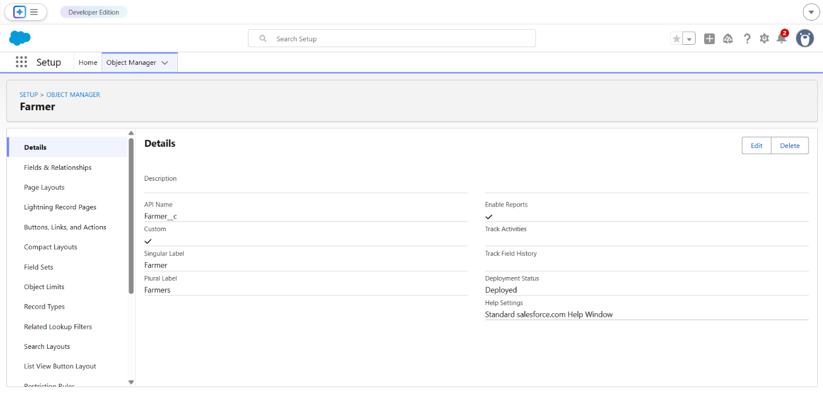

MILESTONE 3
Create Farm Record Object
Objective
Create a custom object that will store farm data.
Steps
- Inside Object Manager click Create.
- Select Custom Object.
- Fill the form with the following details.
Label: Farm Record
Plural Label: Farm Records
Record Name: Farm Name
Data Type: Text
- Enable the following options.
Allow Reports
Allow Search
- Click Save.

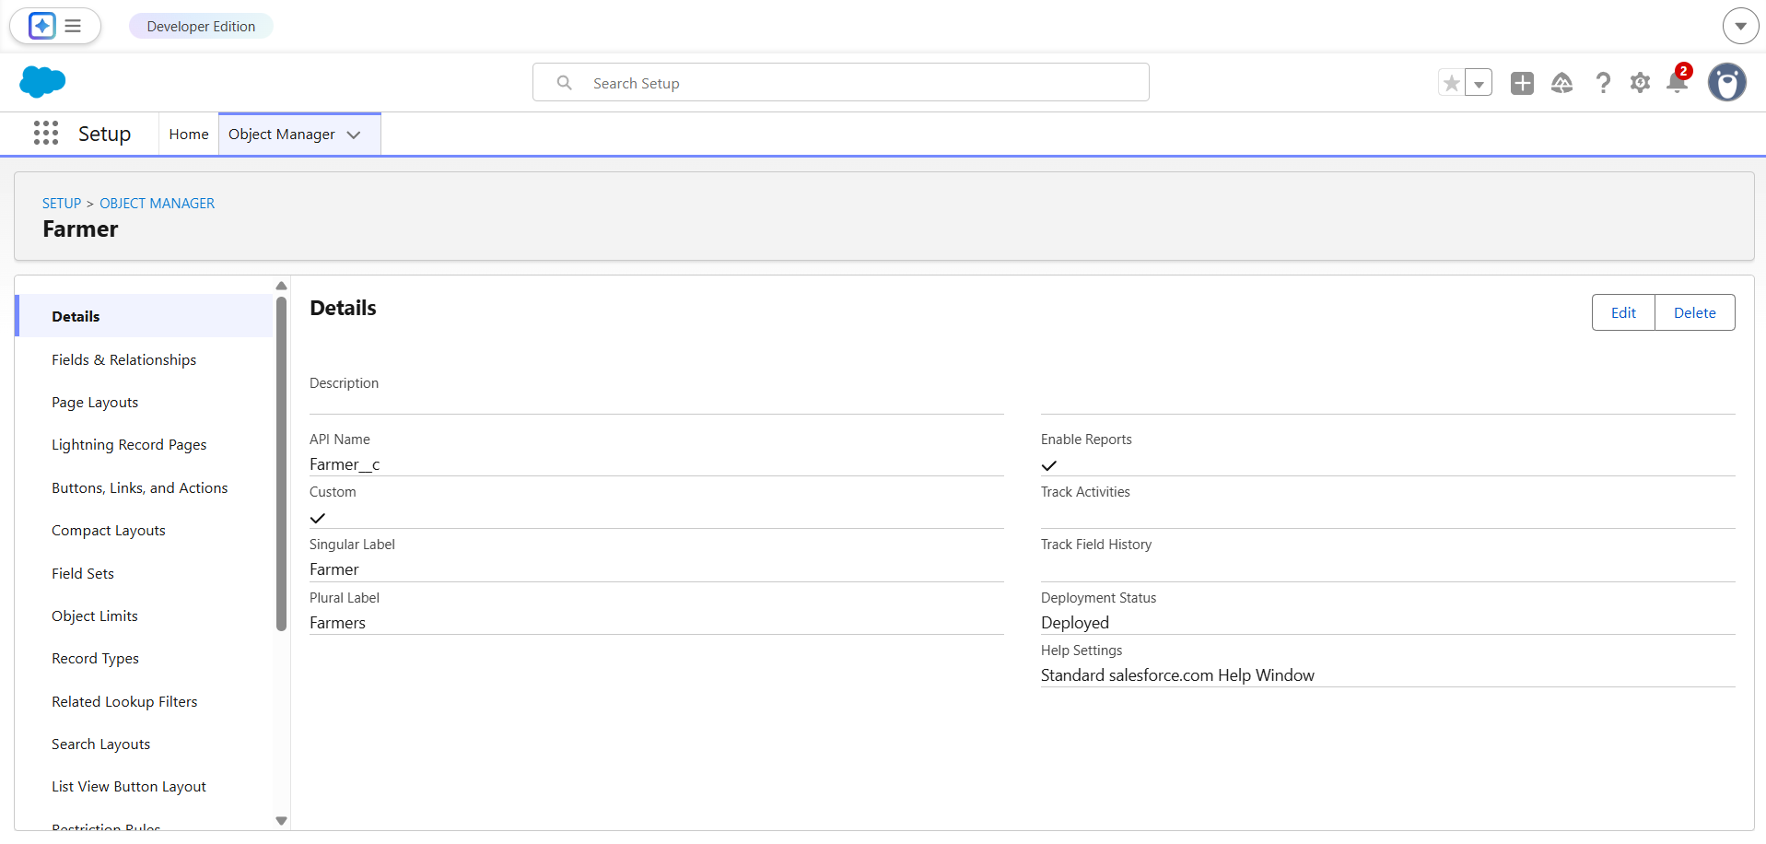

MILESTONE 4
Create Object Fields
Objective
Add fields required to store farm details.

Field 1

Field Label: Farmer Name
Data Type: Text
Steps
- Open the Farm Record object.
- Click Fields & Relationships.
- Click New.
- Select Text.
- Enter Field Label: Farmer Name.
- Click Next.
- Click Save.

Field 2

Field Label: Contact Number
Data Type: Phone
Steps
- Click New.
- Select Phone.
- Click Next.
- Enter Field Label: Contact Number.
- Click Next.
- Click Save.

Field 3

Field Label: Crop Type
Data Type: Picklist
Steps
- Click New.
- Select Picklist.
- Click Next.
- Enter Field Label: Crop Type.
Picklist Values
Rice
Wheat
Sugarcane
Vegetables
- Click Next.
- Click Save.

Field 4

Field Label: Farm Size
Data Type: Number
Configuration
Length: 5
Decimal Places: 0
Steps
- Click New.
- Select Number.
- Click Next.
- Enter Field Label: Farm Size.
- Enter the configuration values.
- Click Next.
- Click Save.

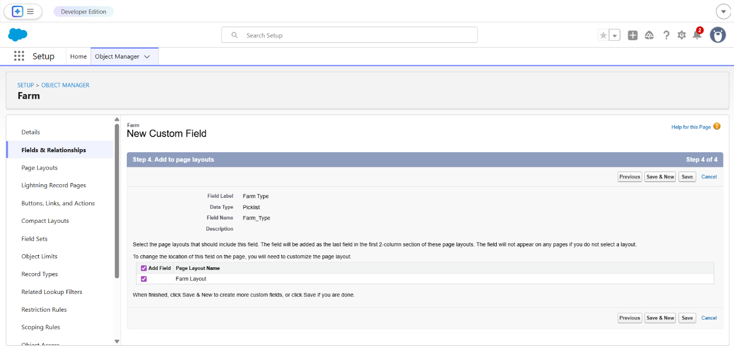

MILESTONE 5
Create Object Tab
Objective
Allow users to access the Farm Record object through the interface.
Steps
- Go to Setup.
- In the search bar type Tabs.
- Click Tabs.
- Under Custom Object Tabs click New.
- Select object Farm Record.
- Choose a tab style icon.
- Click Next.
- Click Next again.
- Click Save.
Outcome
The Farm Record tab becomes accessible in the interface.

MILESTONE 6
Create Application
Objective
Create a Salesforce application that contains the farm management components.
Steps
- Go to Setup.
- In the search bar type App Manager.
- Click App Manager.
- Click New Lightning App.
- Enter App Name
Farm Management App
- Click Next.
- Keep default settings.
- Add the following navigation items.
Farm Record
Reports
Dashboards
- Click Next.
- Click Save and Finish.
Outcome
The Farm Management App is successfully created.

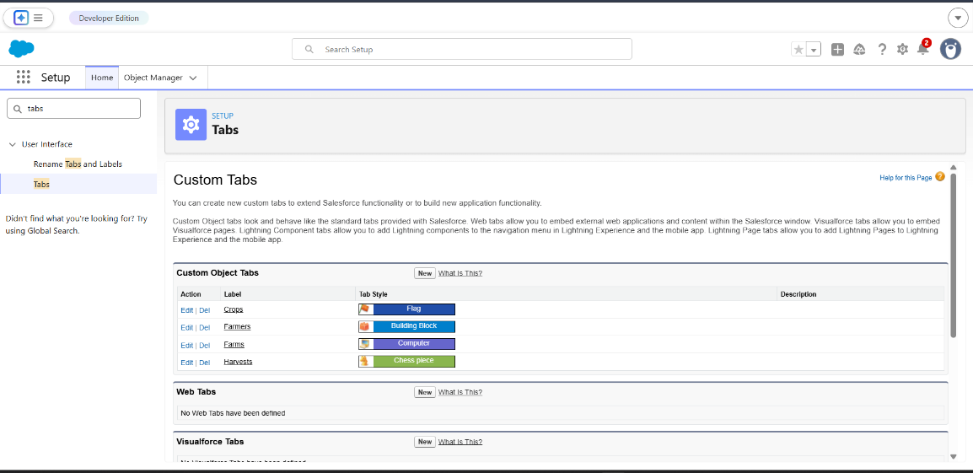

MILESTONE 7
Launch Application
Objective
Access the application interface.
Steps
- Click the App Launcher icon.
- Search for Farm Management App.
- Click the application.
Outcome
The application dashboard opens and displays the Farm Record tab.

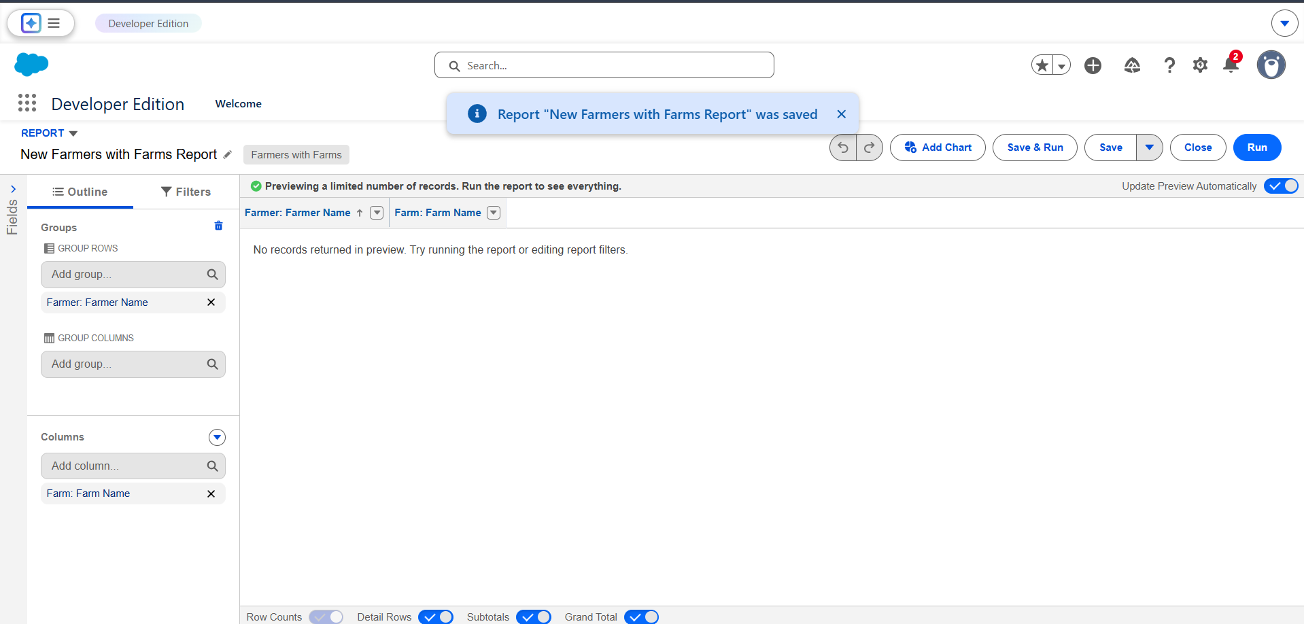

MILESTONE 8
Create Farm Record Entry
Objective
Store farm data in the system.
Steps
- Click the Farm Record tab.
- Click New.
- Enter the following example data.
Farm Name: Green Farm
Farmer Name: Ramesh
Contact Number: 9876543210
Crop Type: Rice
Farm Size: 5
- Click Save.
Outcome
The farm record is successfully stored in Salesforce.

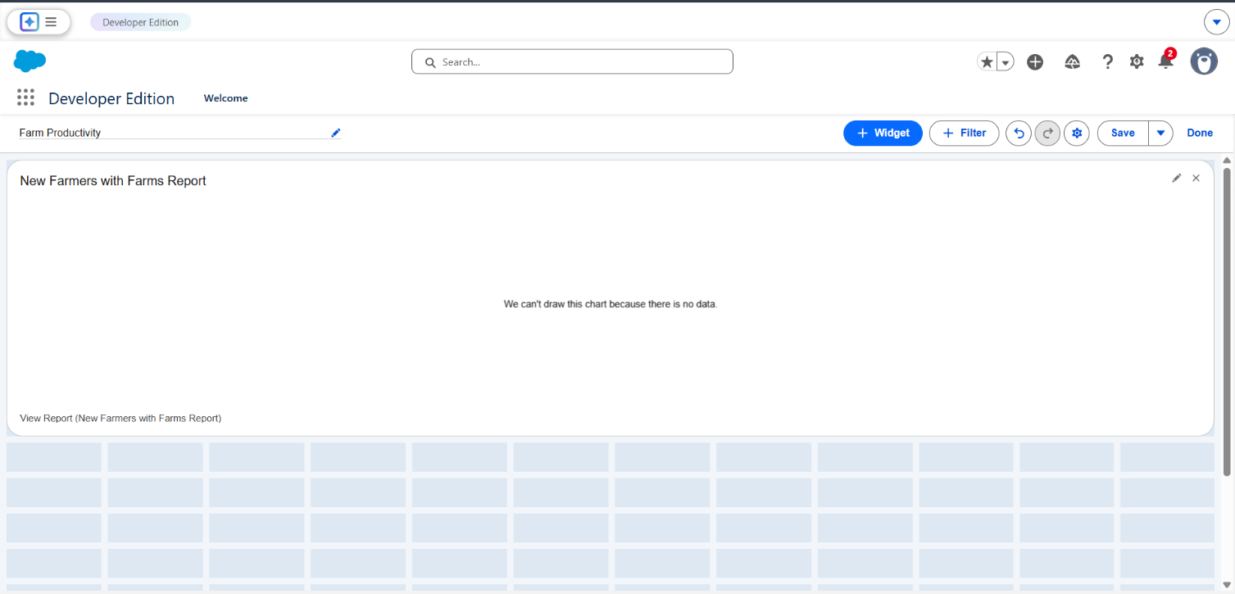

FUNCTIONAL & PERFORMANCE TESTING

During the testing phase, screenshots were captured from the Salesforce interface to verify system functionality. The following were tested:

  - Creation of Farm, Crop, Farmer, and Buyer records
  - Validation of input fields
  - Relationship and dependency checks
  - Profile and role access testing
  - Sharing rule verification
  - Report and dashboard generation

Performance testing ensured smooth system response and stability during multiple user operations.

ADVANTAGES & DISADVANTAGES

Advantages

  - Centralized data system
  - Reduced paperwork
  - Improved accuracy
  - Better monitoring
  - Real-time analytics

Disadvantages

  - Requires internet connection
  - Salesforce license dependency
  - Limited offline access

Conclusion:

The Farm Management System successfully digitizes agricultural data management using Salesforce. It improves efficiency, reduces errors, and enables farmers and managers to make informed decisions through automation and analytics.

FUTURE SCOPE
  - Mobile application integration
  - AI-based crop prediction
  - Weather data integration
  - IoT sensor connectivity
  - Government scheme integration
  - Market price forecasting

APPENDIX
  - Source Code: Salesforce Configuration and Metadata
  - Dataset: Farm, Crop, Farmer, and Buyer Records
  - Tools Used: Salesforce Developer Org

FUNCTIONAL & PERFORMANCE TESTING

During the testing phase, screenshots were captured from the Salesforce interface to verify system functionality. The following were tested:

  - Creation of Farm, Crop, Farmer, and Buyer records
  - Validation of input fields
  - Relationship and dependency checks
  - Profile and role access testing
  - Sharing rule verification
  - Report and dashboard generation

Performance testing ensured smooth system response and stability during multiple user operations.

ADVANTAGES & DISADVANTAGES

Advantages

  - Centralized data system
  - Reduced paperwork
  - Improved accuracy
  - Better monitoring
  - Real-time analytics

Disadvantages

  - Requires internet connection
  - Salesforce license dependency
  - Limited offline access

Conclusion:

The Farm Management System successfully digitizes agricultural data management using Salesforce. It improves efficiency, reduces errors, and enables farmers and managers to make informed decisions through automation and analytics.

FUTURE SCOPE
  - Mobile application integration
  - AI-based crop prediction
  - Weather data integration
  - IoT sensor connectivity
  - Government scheme integration
  - Market price forecasting

APPENDIX
  - Source Code: Salesforce Configuration and Metadata
  - Dataset: Farm, Crop, Farmer, and Buyer Records
  - Tools Used: Salesforce Developer Org

Thank You

