P10 Integrated MVP Report
Score Companion | Team 08 | November 2, 2026
This report records the completed local MVP, its verified integration path, and the GitLab evidence for the P10 work completed today.

Golden path
A musician starts in the Offline Score Library, opens the downloaded percussion score in Score Viewer, selects a difficult measure in Measure Marker, saves it for practice, then opens Practice Review to resolve the mark or return to the exact score passage. The path is complete on the local main branch.

Mock authentication
The app uses a development-only user switcher with Alex Rivera and Sam Lee. The selected user is sent to the local API through the X-Mock-User header. Practice marks are scoped by user, so each user can independently mark the same passage. This is a structural placeholder for local multi-user behavior, not production authentication.

Data contract
The shared contract is documented in API_CONTRACT.md. The golden path relies on User, Score, Passage, and PracticeMark. Library passes a score identifier to Viewer; Marker creates a user-scoped PracticeMark for a Passage; Practice Review filters the active user’s marks and links back to the score and passage context.
Entity | Fields used by path
User | id, display name
Score | id, title, movement, instrument, page_count, available_offline
Passage | id, score_id, section, measure_number, page_number
PracticeMark | id, owner, passage, note, is_resolved, timestamps

P9 screen to P10 responsibility
Member | P9 screen | P10 responsibility | GitLab evidence
Ankit Joshi | Score Viewer and navigation | Shared mock-user integration and path contract | Issue #30 · MR !8
Logan Broussard | Offline Score Library | API-backed library entry and viewer handoff | Issue #31 · MR !9
Matthew Pisani | Measure Marker | User-scoped mark creation and review handoff | Issue #32 · MR !10
Jonathan Dempsey | Practice Review | User-scoped review, resolve action, and return loop | Issue #33 · MR !11

Delivery schedule
Date | Member | Contribution
Nov. 2, 2026 | Ankit | Shared mock-user and data-contract integration
Nov. 2, 2026 | Logan | Library-to-viewer golden-path handoff
Nov. 2, 2026 | Matthew | Marker-to-review golden-path handoff
Nov. 2, 2026 | Jonathan | Practice-review completion loop
Nov. 2, 2026 | Team | Integration, clean-clone evidence, README, and report materials

Feature and integration summary

Shared mock user and contract
A single shared session module exposes Alex and Sam to the UI. The API stores the mark owner and allows one practice mark per user per passage. The backend suite verifies that both demo users can mark the same passage independently.

Library to Viewer
The static library cards were replaced with available offline scores from the API. Each Open score control sends the selected score ID to the viewer route.

Marker to Review
Measure Marker loads passages for the selected score, shows the active demo user, and saves an API-backed practice mark. After saving, the user can open Practice Review directly.

Practice Review completion loop
Practice Review reads and updates only the active user’s marks. A resolved mark remains linked to its original score and passage through Open passage.

Integration points and resolutions
Area A | Area B | How they connect | Resolution
Library | Viewer | score query parameter | Open score preserves the selected score ID.
Marker | Practice Review | PracticeMark API record | Marker POST creates a user-scoped mark; review GET returns it.
Practice Review | Viewer | score_id and passage id | Open passage returns to the original score context.
Mock user selector | API | X-Mock-User header | Shared helper prevents each screen from inventing auth behavior.

Local testing and README
The README documents clone, dependency installation, migrations, demo fixture loading, frontend startup, the mock-user selector, and the golden-path smoke test. A clean GitLab-main clone was verified on November 2, 2026: migrations completed, demo_scores loaded one score and four passages, all 9 backend tests passed, all 14 frontend tests passed, lint reported only Fast Refresh advisories, and the production build completed.

AI usage summary
AI assistance was used to organize the P10 plan, draft implementation changes, and identify data-contract integration gaps. The resulting code was validated with tests and a production build. One correction was replacing Django’s automatic uniqueness error with the intended passage_id validation response and adding the two-user isolation test.

Demo preparation
Demo script: select Alex Rivera, open the available score, save Measure 24 for practice, open Practice Review, resolve the mark, and use Open passage to return to the score. Switch to Sam Lee to show that Alex’s mark is user-scoped. Target duration: 60–90 seconds. Demo video: not included; the course template marks it optional.

MVP screenshots
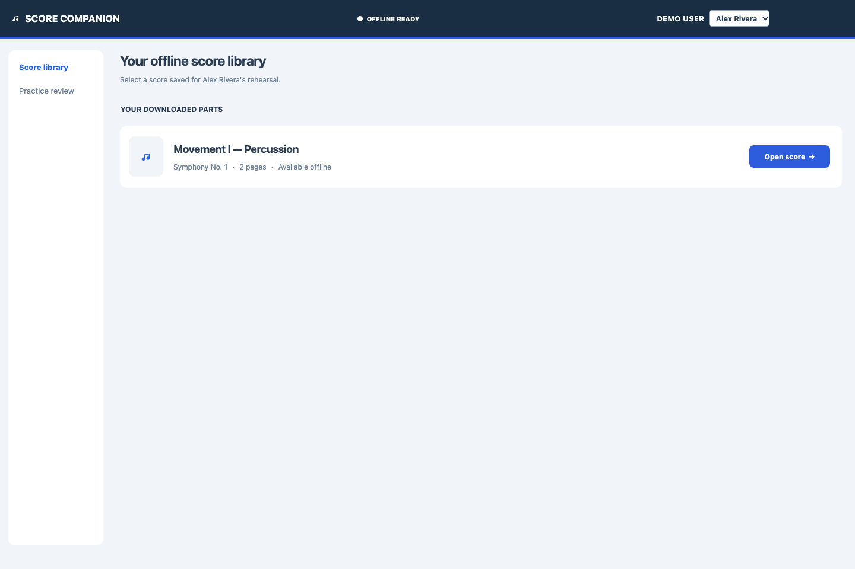
Figure 1. Offline Score Library showing Alex Rivera’s available local score and the Open score handoff.
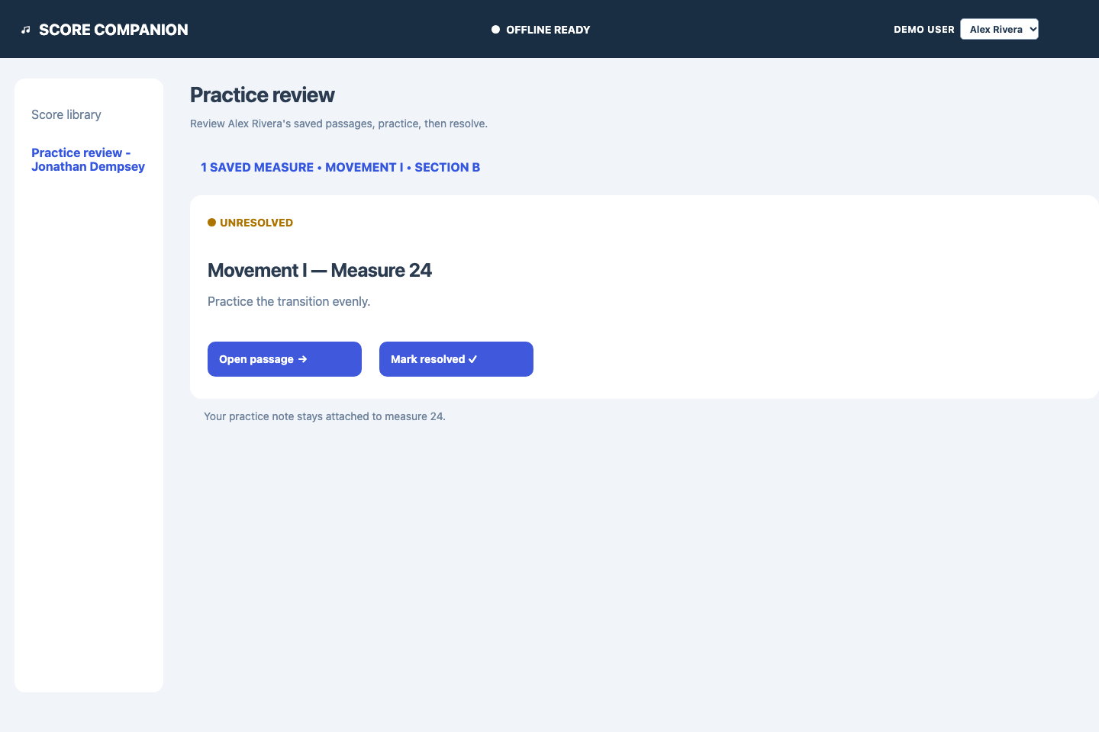
Figure 2. Practice Review showing Alex Rivera’s saved Measure 24 with open-passage and resolve actions.

Git activity evidence
Completed GitLab merge requests: !8 shared mock-user integration, !9 library-to-viewer handoff, !10 marker-to-review handoff, !11 practice-review completion, !12 README and integration evidence, and !13 clean-clone and screenshot evidence. Each product slice has its own linked issue and merge request.
Repository: https://gitlab.com/ull-gitlab/453/fa26/fa26-team-08/music-project | Default branch: main

Self assessment
What works well: the local golden path is coherent, user-scoped practice marks are shared across screens, and the project can be cloned and run with the README. What needs improvement: production authentication, richer score notation, and a formal teammate review record are outside this local MVP. Confidence: very confident that a user can complete the documented golden path locally.

