Score Companion
  - Development Setup and First Commit
CMPS 453 | P#9 | Team 08 | Draft report
Prepared October 26, 2026 | Due October 26, 2026 at 11:55 PM
Score Companion helps musicians find a score, mark measures for practice, and review saved reminders. The shared application, REST API, and four assigned screens are now in main. This report records the design revisions, development choices, ownership, and available setup and GitLab evidence. Items requiring team confirmation appear on the final page.
GitLab repository | P9 milestone | Updated Figma design

Part 1 Design revision
The P#8 study included three participants. The revised ten-page screen export addresses the following findings; these are design changes, with current implementation scope described on page 3.
Screen | Change made in the revised design | P#8 evidence
Score Viewer and Practice Review | Added notation-like score excerpts, persistent movement and part labels, and section and measure context. PDF pages 2 and 5. | Participants 1 and 2 wanted recognizable sheet music; Participant 1 lacked song context in review.
Measure Marker and saved state | Added an explicit Mark for practice action, a saved confirmation, and Add practice note and Review saved passages actions. PDF pages 3 and 7. | All three participants showed uncertainty about marking, saving, or reaching review.
Practice note | Changed the timing to Add a practice note now or later and supplied a concrete example. PDF page 4. | Participant 3 found after-rehearsal wording too restrictive; Participant 2 wanted a clearer note prompt.
Measure Marker and review | Added independent saved states for multiple measures and a marked-measure count. PDF pages 8 to 10. | The P#8 synthesis prioritizes repeated marking from Participant 3 feedback.
Library and resolved confirmation | Retained visible offline status and a clear resolved confirmation with a next action. PDF pages 1 and 6. | Participant 3 valued offline readiness and found the resolved check motivating.

Evidence: p8/P8_SYNTHESIS_AND_IMPLEMENTATION.md and p9/Score_Companion_P8_Revised_Screens.pdf. Findings are formative and should not be treated as population-wide results. Tuner, metronome, social features, and automatic correction detection remain deferred.

Part 2 Technical decisions
Platform choice: a browser-based web application. React and Vite provide the interface; Django REST Framework exposes JSON endpoints; Django models persist local development data in SQLite. During development, Vite proxies /api requests to Django.
Area | Choice | Classification | Rationale
Frontend | React + Vite  JavaScript | Mandatory | Reusable components support four separately owned screens. Vite provides a shared local development and build workflow.
Backend | Django + Django REST Framework | Mandatory | Models, migrations, validation, and REST responses provide a small shared contract for screen integration.
Database | SQLite | Mandatory | A file-based development database avoids a separate database service and works with the Django ORM.
Runtimes | Python 3.12+  Node.js LTS | Mandatory | Python runs Django; Node.js runs the frontend tooling. These match the repository setup instructions.
Version control and tracker | Git + GitLab  GitHub file mirror | Mandatory | GitLab tracks issues, milestone, reviews, and merge requests. Repository files are also mirrored to GitHub.
IDE | VS Code | Recommended | A common editor supports JavaScript, Python, terminals, Git, and the submitted environment screenshots.
AI assistance | Codex or GitHub Copilot | Recommended | Supports setup, implementation, and debugging. Each owner remains responsible for checking generated work.
API testing | Postman | Recommended | Allows manual inspection of JSON requests and responses. Automated API tests are also included.
UI design | Figma and revised PDF | Recommended | Maintains the shared screen reference. The revised PDF in p9 is the primary implementation reference.

Shared structure and boundaries
frontend/ contains the React application and shared Score Companion components. backend/config/ holds Django settings and routing; backend/scoreapi/ contains the API models, serializers, views, migrations, and tests. The component usage guide supports reuse while screen owners retain their own data and behavior.
The planned architecture is recorded in architecture.md. Authentication, cloud synchronization, production deployment, and a production database are outside P#9. Offline file caching and full PDF rendering are future work.
Team confirmation before submission: verify that all members agree with these choices and confirm their individual AI tooling. Recommended tools are not claims that every member used each tool.

Part 3 Screen ownership
Owner | Assigned screen | Complexity | GitLab issue
Ankit Joshi | Score Viewer and Navigation | Hardest | #24
Matthew Pisani  Team Lead | Measure Marker | Hard | #25
Jonathan Dempsey | Practice Review | Medium | #26
Logan Broussard | Offline Score Library | Easiest | #27

Current implementation scope
- Ankit: page controls, section selection, and measure navigation use API score and passage data. Empty-library and error states offer a labeled sample. Shared components support reuse. Notation remains illustrative rather than a rendered score PDF.
- Matthew: measures can be selected and saved independently; labels and a count reflect saved state. Demo marks persist in browser localStorage. They do not yet populate the backend or Jonathan’s Practice Review.
- Jonathan: Practice Review loads backend marks, displays score context and notes, and updates resolution status. Open passage targets the saved score, passage, and page in the viewer. An empty database displays an empty review.
- Logan: the library presents the revised downloaded-parts layout with sample entries and offline labels. Actual offline score caching and complete library-to-viewer integration remain future work.

Recorded application verification
Latest verification recorded October 26, 2026, for the code mirrored at commit dfc9438. The checks below verify the shared codebase, not every interaction on every member’s machine.
Check | Recorded result
Frontend automated tests | 14 passed
Backend API tests | 8 passed
Frontend lint and production build | Passed
Django system and migration checks | Passed; no uncreated migrations
Live HTTP checks | Health endpoint, Practice Review API through Vite, and frontend response passed

The API implements score list/detail, score passages, practice-mark list/create/update, and the preserved health endpoint. API_CONTRACT.md documents examples, validation, and relationships. Interactive browser verification was unavailable during the latest check; the following member screenshots provide development-environment evidence.

Part 4 Development environment evidence
Screenshot #1 is required from every member with the app and IDE visible. These supplied captures show environment setup; three show the initial application shell rather than the final screen implementation.
Figure 1 Ankit Joshi | App shell running with VS Code and Codex visible
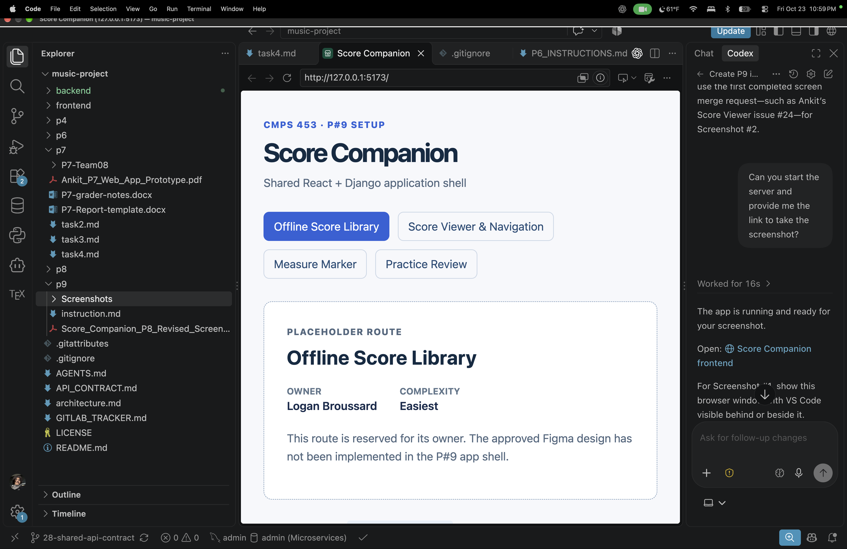
Figure 2 Logan Broussard | App shell and Vite terminal with VS Code visible
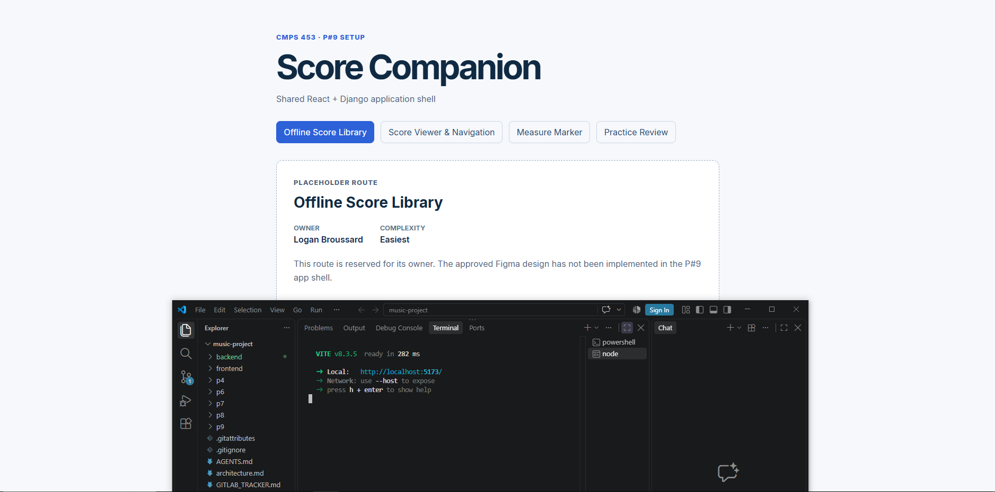

Part 4 Additional environment evidence
Figure 3 Matthew Pisani | Measure Marker running beside VS Code and terminal
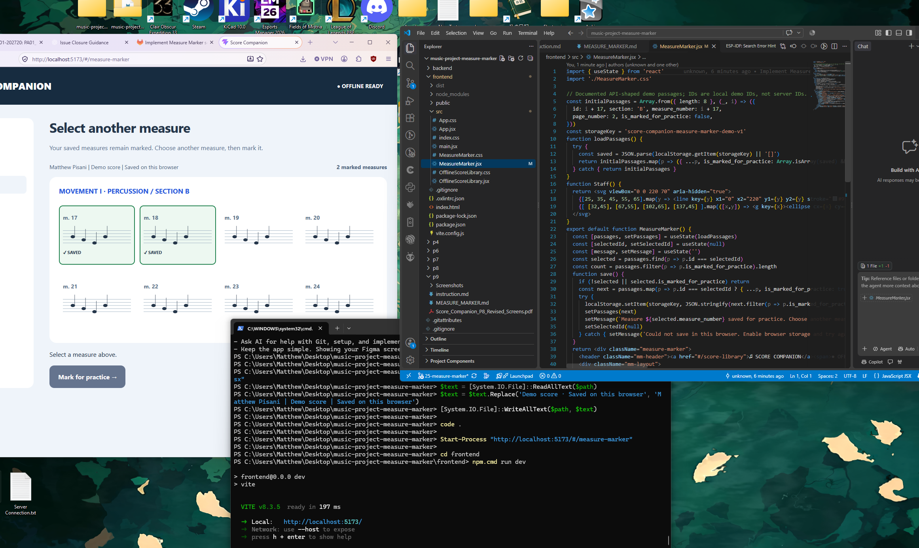
Figure 4 Jonathan Dempsey | Practice Review placeholder route in the initial shell with VS Code visible
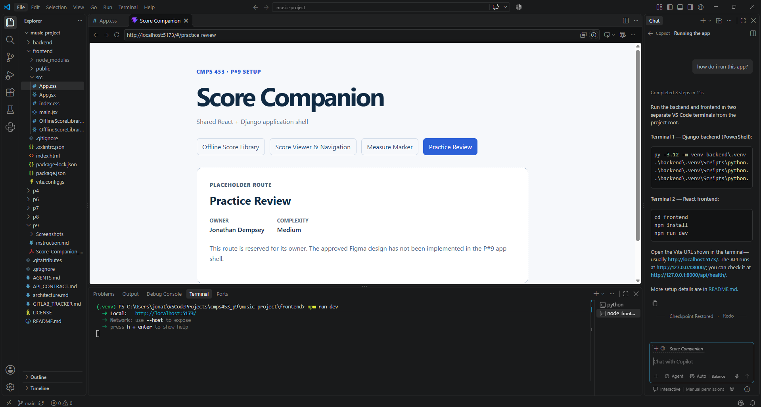
All four original files are retained under p9/Screenshots/. These captures establish the supplied setup evidence; they do not demonstrate that the current four screens or every API action were tested on all four machines.

Part 5 Reviewed and merged work
Screenshot #2 uses Matthew’s Measure Marker merge request !4. The capture shows Merged, Closes #25 (closed), and approval by Ankit Joshi, who is a teammate of the author. The merge entered main as 4b665f6 on October 26, 2026.
Approved and merged MR 4 | Linked screen issue 25
Figure 5 Screenshot 2 | Matthew’s MR 4 approved by Ankit and merged into main
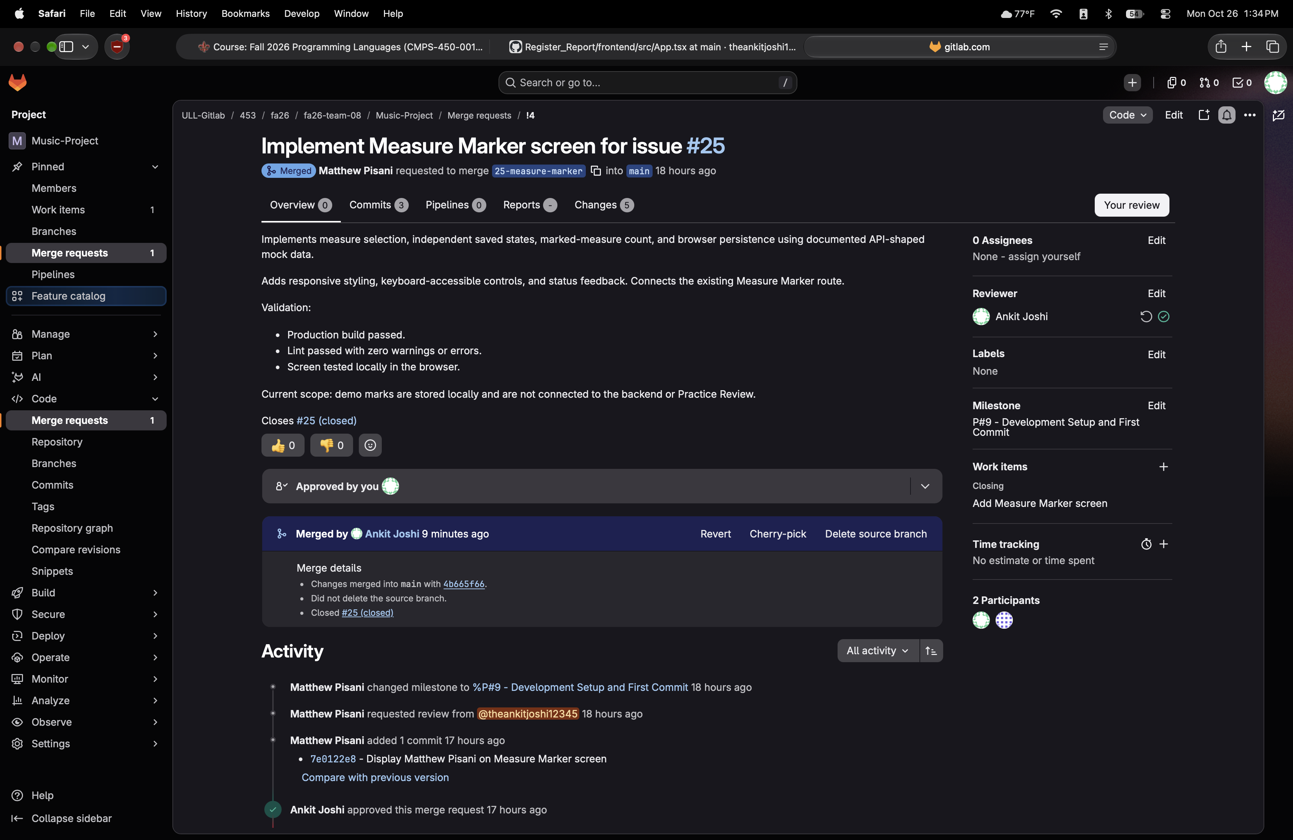
Member | Screen issue | Recorded integration history
Ankit | #24 closed | MR !6 merged. Confirm a teammate review record before claiming the complete review workflow.
Matthew | #25 closed | MR !4 approved by Ankit and merged. Figure 5 provides the required approval and merge evidence.
Jonathan | #26 closed | Screen commit 00deda8 was already in main; passage navigation was completed in 8fb442c. Empty draft MR !7 was closed, not merged.
Logan | #27 closed | MR !3 merged. Confirm a teammate review record before claiming the complete review workflow.

All four screen issues and both shared setup/API repair issues are closed in the October 26 tracker snapshot. The P#9 milestone remains active for the report and submission. Implementation in main does not by itself establish a reviewed, issue-closing MR for every member.

Setup and final team review
From the repository root, use Python 3.12 or newer, Node.js LTS, and Git. The commands below are for macOS or Linux. Run the backend and frontend in separate terminals.

Backend
python3.12 -m venv backend/.venv
backend/.venv/bin/pip install -r backend/requirements.txt
backend/.venv/bin/python backend/manage.py migrate
backend/.venv/bin/python backend/manage.py runserver

Frontend
cd frontend
npm install
npm run dev
Open http://localhost:5173/ and use the four navigation links. Check the backend at http://127.0.0.1:8000/api/health/. On Windows, create the environment with py -3.12 -m venv backend/.venv. Replace backend/.venv/bin/python and pip with backend\.venv\Scripts\python.exe and backend\.venv\Scripts\pip.exe.

Before submitting the report
- Team Lead Matthew: confirm the technical-decision rationale, ownership, and individual tool usage with the team; maintain the README and review this draft.
- Jonathan and the Team Lead: resolve or explicitly report the missing merged screen MR evidence. His implementation is in main, but the closed empty MR !7 does not satisfy a merged MR requirement. Do not recreate work or claim approval that did not occur.
- Ankit and Logan: confirm the recorded teammate reviews for their merged screen MRs. Each member should check the current app on their machine and confirm their visible name on the assigned screen.
- After team review: update any facts, remove draft confirmation notes, export the final report to PDF, and submit the PDF with the GitLab repository and revised Figma links by October 26 at 11:55 PM. Close the P#9 milestone after submission is complete.

Reference material
Course instructions | Project README | P9 tracker
P8 findings | Revised screens PDF | Figma design
API contract | Shared component guide | GitHub file mirror
Source snapshot: main at dfc9438, October 26, 2026. Figures 1 to 5 embed the existing repository screenshots without changing the originals. This draft has not been submitted to the course.

