Glen Club Documentation

1. Visit the link <http://club.glenindia.com/admin/log-in>

2. Use the following credentials to log-in

Email: [admin@admin.com](mailto:admin@admin.com)

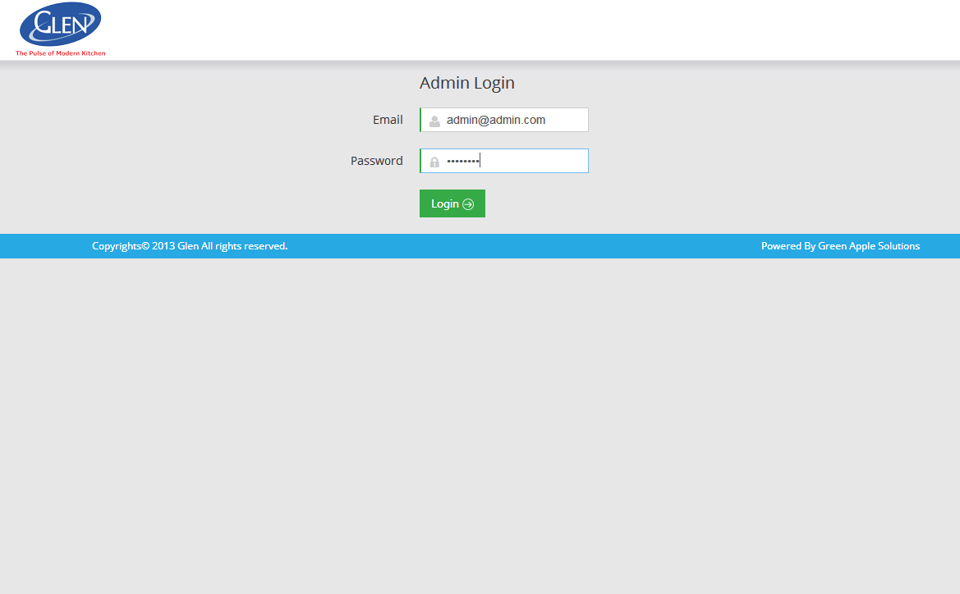 Password: password

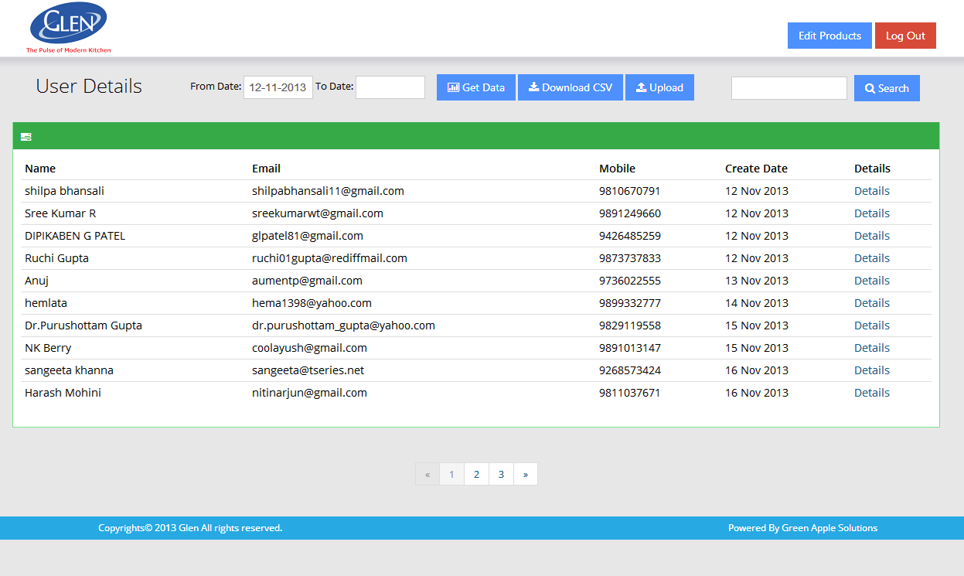3. Once you log in, you will be able to see the dashboard displaying the list of all the registered users with their respective details.

4. How to use the dashboard

1. To retrieve desired data use the **From Date** and **To Date** section and click the **Get Data** button. All the entries retrieved between the selected date range will be displayed.
2. Click the **Download CSV** button to download data in csv format.
3. The **Search** button enables you to filter the results/entries based on the keywords entered.

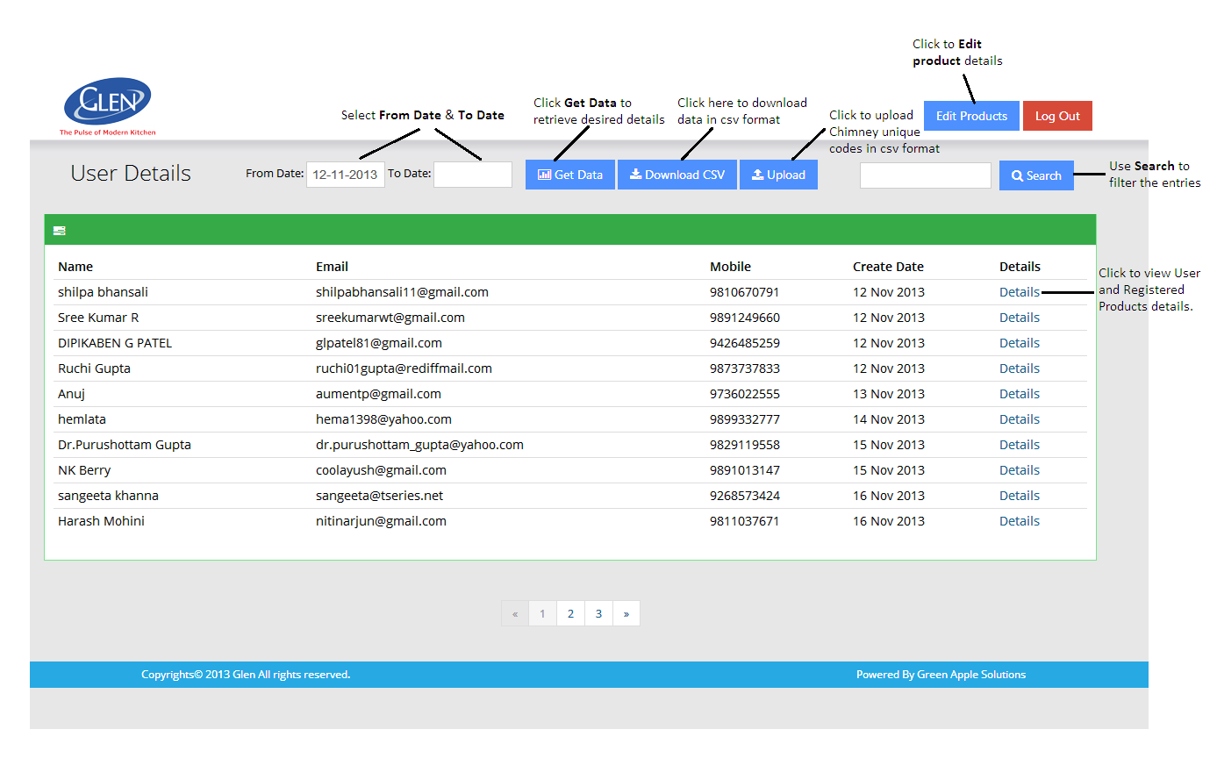

1. The **Upload** button can be used to upload chimney unique codes.
2. Choose the csv file with the following column names

* **Model Name,**
* **Serial No.**
* **Unique Code**

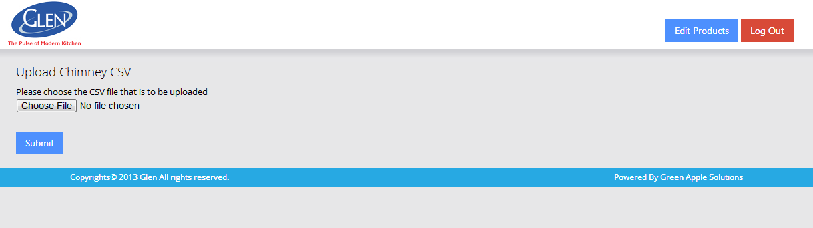

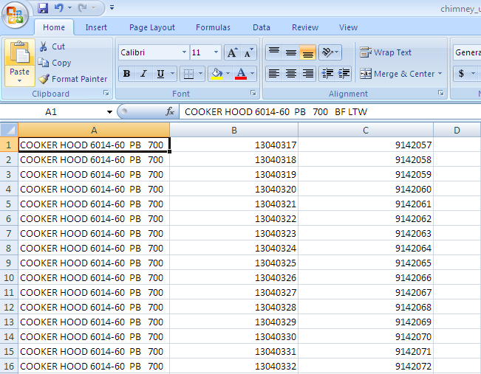CSV Format for uploading the chimney unique codes

2. To manually add the Chimney Unique Code, you can go to **Add Products** section under the Straight Line Chimney & Designer Hood Chimney category.

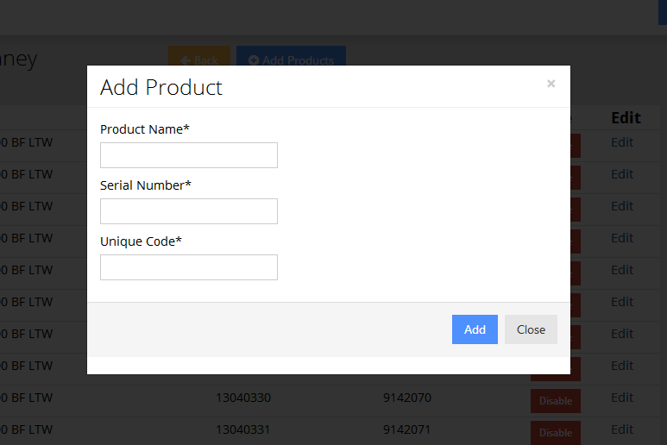

1. The **Details** section in every row can be used to view the information about the user and the product registration details.

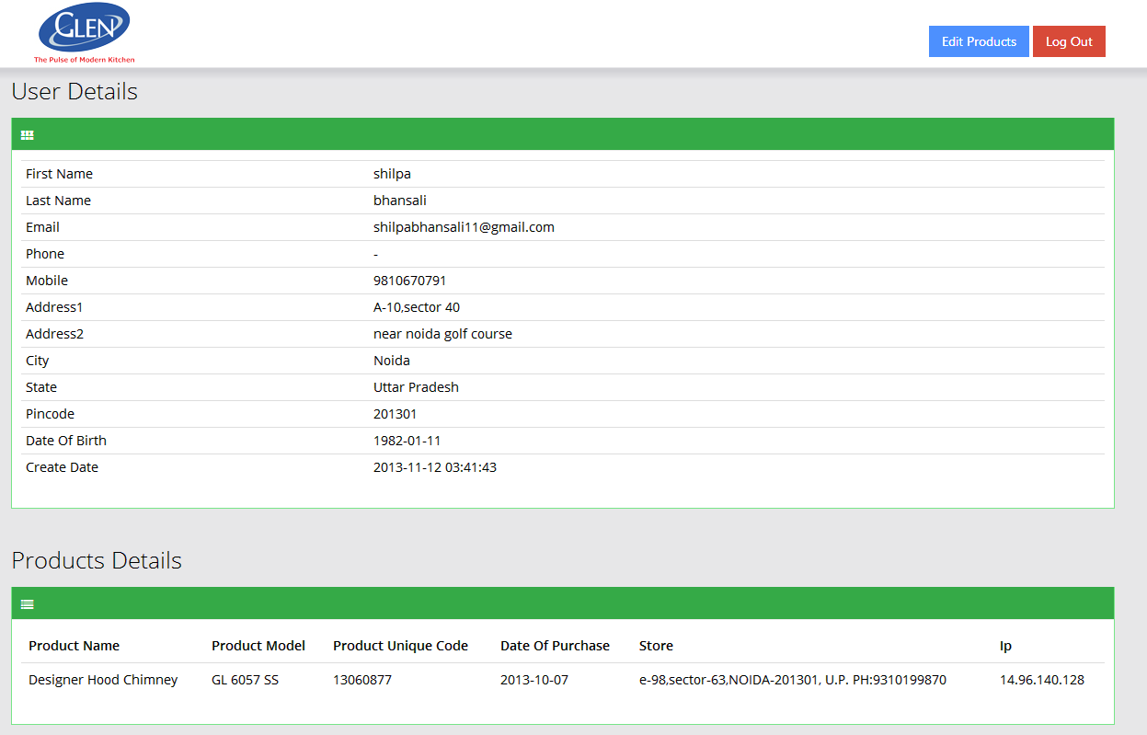

1. Click the **Edit Products** button to edit the product details.

* **Enable**/**Disable** & **Edit** buttons let you enable/disable & edit the category of products respectively.
* Under the **Add Product** section, you can add new products by entering their **Product Type** (category) and the products under that category (models).
* **Edit Products** button shows and enables you to edit the information of the products under the specific Product Type.

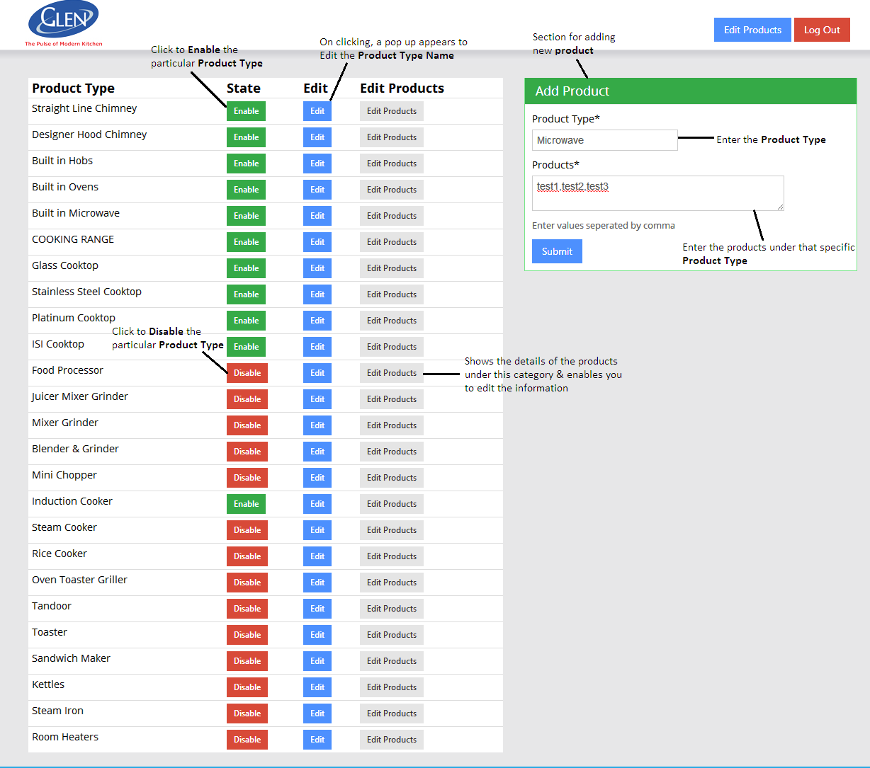

1. To jump to home page click Glen Logo on the topmost left corner