See jargos email per small changes he made-!!

Recently, economists from Chicago school of economics produced a widely cited study about preferences for redistribution (i.e., whether one thinks that the government should redistribute income from the rich to the poor. The dependent variable, preferences for redistribution is coded as:
“Some people think that the government in Washington should do everything to improve the standard of living of all poor Americans (they are at point 1 on this card). Other people
think it is not the government’s responsibility, and that each person should take
care of himself (they are at point 5). Where are you placing yourself in this scale?” Authors of the study recoded this question (reversed the scale) so that a higher number means one is more favorable to redistribution. Regression results are set in Table 1. (see footnotes below the table!)
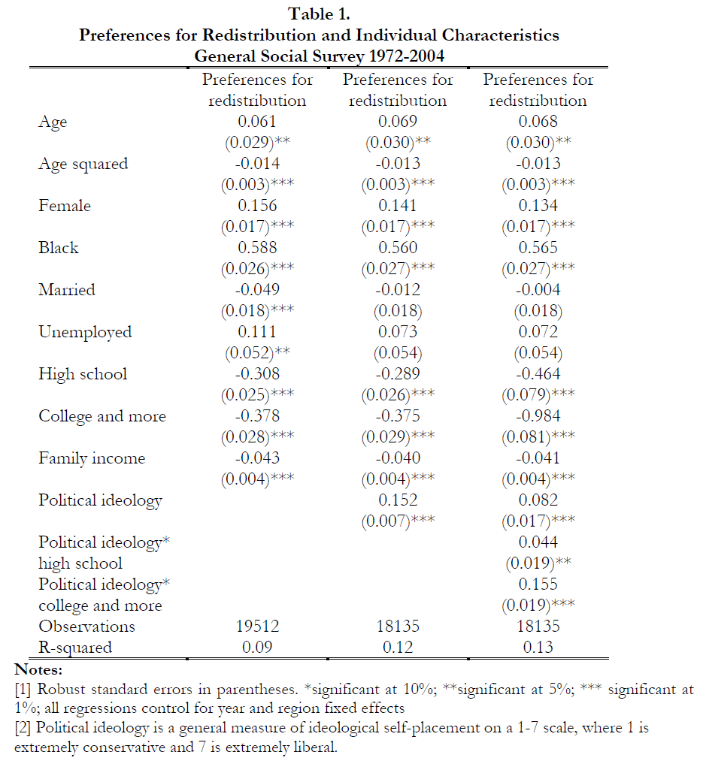
[3] Sample includes blacks, whites, Asians, and Hispanics.
[4] Column 3 includes interactions.

For each of the following sub-questions a), b), c), d), and e): do you agree or disagree and why (briefly explain in few sentences)?

a) The results show that the size effect of being a female is several-fold (sever hundred percent) of that of being married. That is, being a female, has much stronger effect on redistribution than being married.

b) Family income has stronger effect than gender.

c) There is a nonlinear effect of age. Instead of using quadratics, how else the nonlinear effect could be modeled?

d) Clearly, income and education are closely related—people who have more education, have higher income. What does it mean for the results. Specifically, how is the statistical significance affected? And how can you fix this problem?

e) Other recent research suggests that physical strength affects preferences for redistribution: strong persons tend to be against redistribution. We also know that females are less physically strong and blacks are stronger than others—how are estimates on female and black coefficents affected?

Answers:
note: same table as in spring; but all questions are different!
note: a), b) and c) are bnased on preferences for redistribution by alesina and giuiliano (nber14825)
a) yes by all means: student need to compare coeff sizes, and note that they can be compared—both are dummies!
b) they cannot be compared
c) For instance using logs
d) Collinearity: se, CI, p-values bigger or t-stat smaller; don't do anything if both belong to the model, especially that we have big sample
e) LOVB
corr(strength, black): +
corr(strength, redistribution)-
so – bias on black

corr(strength, female): -
corr(strength, redistribution)-
so + bias on female

