Materialism and Immorality: More Urban than Rural?

Abstract
Many argue positive relationships between urbanness and materialism/immorality. Materialism is higher in urban areas, and commonly considered vice or immoral. Some argue that there is also more vice and immorality in cities in general. In this study, we explore empirically the relationship between urbanness and materialism/immorality using 1972-2018 US General Social Survey. We find much support for our thesis that urbanness is associated with higher materialism and immorality. Seven out of eight measures show some evidence of materialism/immorality in large cities, and four measures remain significant even in the most oversaturated models. Yet, we caution, as it is one of the first quantitative studies in the area, the evidence is provisional. More research is needed–while there is much theory, empirical quantitative research is virtually nonexistent. The study is associative, not causal, and results may not generalize outside of the US.
urbanism, urbanness, cities, urban-rural, deviance, morality, corruption, greed, money, love of money (LOM)
1whitegray90
“With urbanization comes disharmony” The Dalai Lama
“To look at the cross-section of any plan of a big city is to look at something like the section of a fibrous tumor.” (Frank Lloyd Wright)
Capitalism alienates (Petrović 1963, Marx [1867] 2010). The hallmarks of capitalism, industrialization and commercialization, are closely linked with urbanization (e.g., O’Sullivan 2009, Glaeser 2011). It is in the city where capitalism is most full-blown and felt most (Simmel 1903). Capitalism works best at high density where agglomeration economies are possible (e.g., O’Sullivan 2009, Glaeser 2011). “Rat race” and money chase are mostly concentrated in cities and urbanites tend to work longer (Rosenthal and Strange 2002, 2003, 2008, Snowdon 2015).
Consumption is concentrated in cities (Glaeser et al. 2001, Currid-Halkett et al. 2019, Joye et al. 2020). In particular luxury, positional, or conspicuous consumption is centered in the city (Rabiei-Dastjerdi et al. 2020). There is commodity fetishism (Pierce and Hankins 2019), indeed city itself is a fetish (Okulicz-Kozaryn and Valente 2017). City intensifies conspicuous consumption: urban etiquette, sophistication, manners and finish ( White and White 1977, p. 169)
City compounds materialism–one mechanism is built environment–corporate buildings, shops, advertisements–they signal wealth and material possessions (Joye et al. 2020). Visual and social comparisons are more likely in urban areas as there are more people and more stimuli. Likewise, use of social media is higher in urban areas (Perrin 2015), and both visual and social comparisons in real life and on social media can make people seek status through money, material possessions, and conspicuous consumption (Taylor and Strutton 2016, Joye et al. 2020).
Materialism and consumerism have been widely criticized and commonly considered vices and immoral (e.g., Kasser 2016, Dittmar et al. 2014, Kasser 2003, Schmuck et al. 2000, Kasser and Ryan 1993, Leonard 2010, Hirst 1934). City itself intensifies vice, crime, indifference, strangeness, aversion, and repulsion (Bettencourt and West 2010, Simmel 1903, Wirth 1938, Thrift 2005, Amin 2006, Veblen 2005, Park 1915, Park et al. [1925] 1984, Tönnies [1887] 2002, White and White 1977).
In what follows we explore the relationship between urbanness and materialism/immorality. Almost all of the literature is theoretical and qualitative–a quantitative test is missing. We start with the classic urban sociological literature, review more recent writings, and finally proceed to our quantitative study.

1 Basic Theory
Already in 1938 Wirth ( 1938, p. 1) observed that in a city “the pecuniary nexus tends to displace personal relations”, and “the urban world puts a premium on visual recognition” (p. 14)–urbanites are more extrinsic and focused on success than rural folks (Morrison and Weckroth 2017). According to Wirth urban communities more than rural communities are likely to suffer from: “personal disorganization, mental breakdown, suicide, delinquency, crime, corruption, and disorder” ( Wirth 1938, p. 23).
City intensifies materialism, consumerism, vice, crime, indifference, strangeness, aversion, repulsion, and indeed often results in hatred and conflict (Simmel 1903, Wirth 1938, Thrift 2005, Amin 2006, Veblen 2005, Park 1915, Park et al. [1925] 1984, Tönnies [1887] 2002, White and White 1977, Okulicz-Kozaryn 2015). Urbanism negatively affects quality of nearly all social relationships and even produces fear, revulsion, and distrust ( Wilson 1985). Cities are consumerist and materialistic–e.g., urbanites try to classify others in terms of visible attributes such as dress (Wilson 1985). Marx observed that humans are alienated under capitalism (Freud et al. 1930, Struhl 2016, Byron 2016, Petrović 1963, Wheeler 2015), and so humans are most alienated in cities, where capitalism is felt most: “urbanism makes alienation tangible” ( Vaneigem 1997, p. 127). Urbanism is not only aggressive (Burgess 1926), but also oppressive (Vaneigem 1997). Some striking examples are seen where urbanism is currently most rife, in China (Yang 2013). Not only industrialization, but also postindustrialization has produced more alienation (Choi 2016). While there is much evidence of urbanism-alienation link, calls for more research (Parker 1978) have been largely unanswered.
City overstimulates human brain (Simmel 1903), to the point where it is neurologically unhealthy (Lederbogen et al. 2011). Reactions of an urbanite to stimuli are rational/economic, furthest possible from one true self. Human density forces differentiation and specialization as already observed by Darwin and Durkheim ( Wirth 1938, p. 15). City not only enables, but what is often missed, forces differentiation and specialization, because it’s the only way high density can be supported (e.g., Burgess 1926). And humans, as most other animals, have not evolved to spend about half of their wake time performing a repetitive task–it is against human nature (Marx 1844, [1867] 2010)–indeed one ideally should be able to “to do one thing today and another tomorrow, to hunt in the morning, fish in the afternoon, rear cattle in the evening, criticize after dinner” ( Marx and Engels [1845] 1965)
Greatest cities are clearly the most competitive, aggressive, and dominant places–think of New York City, Chicago, London, Shanghai, etc. It is no wonder that aggressiveness and city are closely linked as remarked in a classic observation of city life ( Burgess 1926, p. 82):
If a metropolite would "get ahead" he usually must become "aggressive," but aggressiveness on the part of one person or of a group is often an invasion of the status of other persons or groups. Hence social-distance reactions are kept in turmoil.
High density increases aggressiveness in many forms: urbanites toil longer hours (Rosenthal and Strange 2008, 2003, 2002), and there is more violence and crime in cities (Bettencourt et al. 2010, Bettencourt and West 2010, Bettencourt et al. 2007). Other animals suffer at high densities, too. Rats, for instance, become more stressed, aggressive, and kill each other (Calhoun 1962). Some species like ants and bees do thrive at high densities, and Glaeser (2011) likes to point it out, but human nature is unlike that of bees: by one estimate we’re 90% chimp and only 10% bee (Haidt 2012). Cities combine people and things in an often conflicting or even dysfunctional way:
Cities bring people and things together in manifold combinations. Indeed, that is probably the most basic definition of a city that is possible. But it is not the case that these combinations sit comfortably with one another. Indeed, they often sit very uncomfortably together. Many key urban experiences are the result of juxtapositions which are, in some sense, dysfunctional, which jar and scrape and rend. ( Thrift 2005, p. 140).
Ad there is a clear remarkably dark side to an urban experience, the dark side that is seldom talked about:
Cities are polluted, unhealthy, tiring, overwhelming, confusing, alienating. They are places of low-wage work, insecurity, poor living conditions and dejected isolation for the many at the bottom of the social ladder daily sucked into them. They hum with the fear and anxiety linked to crime, helplessness and the close juxtaposition of strangers. They symbolize the isolation of people trapped in ghettos, segregated areas and distant dormitories, and they express the frustration and ill-temper of those locked into long hours of work ( Amin 2006, p. 1011)
Steve Pile in his colorful writings about cities, for example, often invokes urban folklore characters that prey on humans in cities (e.g., vampires, werewolves, ghosts) (Pile 2005a, 2005b, Pile et al. 1999). And city is referred to as ’labyrinth’ ’nightmare, or ’jungle’ (Knox and Pinch 2014), or ’cancer’ (White and White 1977).

2 Urbanness and Materialism/Immorality
Most of the writings about urbanness, materialism and immorality are decades old, mostly theoretical and qualitative–there are no modern quantitative studies on the topic except one–Joye et al. (2020) found that materialism is higher in urban areas.
Joye et al. (2020) argues that the mechanism is exposure to nature, i.e., the more nature, the less materialism. Clearly, nature (wilderness) is the opposite of large and dense city–the more built environment, the less nature. Sure, there are urban parks, and some urban nature, but in general it holds that the more city, the less nature Okulicz-Kozaryn (2015). (Joye et al. 2020) enumerates three pathways between urbanness and materialism: 1) urban environment itself (commerce, ads, etc) amplifies materialism, 2) nature “provides an antidote to insecurities and worries about meeting one’s psychological and physical needs, known to drive materialism” ( Joye et al. 2020, p. 5), 3) nature makes one value self-transcendent values such as altruism, and self-transcendent values are opposite of self-enhancement values to which materialism belongs and “nature decreases extrinsic aspirations (including the desire for wealth) through increased nature relatedness and autonomy” ( Joye et al. 2020, p. 5).
In general, the benefits of nature for human flourishing are multiple and have been extensively documented (Frumkin 2001a, 2001b, Maller et al. 2006, Mayer et al. 2009, Fromm 1964, Pretty 2012, Wilson 1980, Jerolmack 2012, Tesson 2013, Berman et al. 2012, White and White 1977, Mitchell and Popham 2008, Wells and Evans 2003, Alter 2013, Thoreau 1995 [1854])
What about the relationship between materialism and immorality? Materialism is commonly considered immoral. For instance, the Bible states: “For the love of money is a root of all kinds of evil, for which some have strayed from the faith in their greediness, and pierced themselves through with many sorrows” (Timothy 6:10). A Confucius successor saw the root of all evil in selfishness or materialism ( Hirst 1934, p. 332): “The source of disorder in a State lies in the lack of mutual love.” Benjamin Franklin, who wrote on moral perfection, includes frugality, temperance, and moderation in his list of virtues. And again, there is an indication of a positive relationship between urbanness and immorality. As discussed earlier, classic sociological urban literature points to a moral breakdown in cities in general.

3 Data and Model
We use the 1972-2018 US General Social Survey (GSS) gss.norc.org cumulative file. The GSS is collected face-to-face and is nationally representative. Since 1994, the GSS is collected every other year (earlier, it was collected mostly annually).
Materialism is rather a straightforward concept and can be measured using several items in GSS listed in table 1. We faced a challenge, however, in choice of measures of immorality/dishonesty as there is not a standard set of measures. Likewise, there is not an agreed model and a set of predictors.
GSS lists under ’morality’ tag the following variables: PUNSIN, BLKWHITE, ROTAPPLE, PERMORAL, GODRIGHT, SOCRIGHT, PERRIGHT, LESSPAIN. But we do not use several of them because morality is confounded with religiosity: PUNSIN “r agrees that sinners must be punished,” GODRIGHT “god’s laws should decide right and wrong,” PERRIGHT “conscience should decide right and wrong.” Likewise, we do not use another two as they may confound with secularism: SOCRIGHT “society’s laws should decide right and wrong,” LESSPAIN “feel deep sense of respect for reducing pain.” Our measures of outcomes, materialism and immorality, are listed in table 1. All dependent variables were re-coded in such a way that the higher value means more materialistic or immoral. Distributions of all variables are shown in SOM (Supplementary Online Material).

Table 1: Dependent variable definitions.

name | description
materialism:
next to health, money is most important | "Now I’m going to read you several more statements. Some people agree with a statement, others disagree. As I read each one, tell me whether you more or less agree with it, or more or less disagree." "A. Next to health, money is the most important thing in life" 0=’disagree’, 1=’agree’
no right and wrong ways to make money | "Now I’m going to read you several more statements. Some people agree with a statement, others disagree. As I read each one, tell me whether you more or less agree with it, or more or less disagree." "C. To make money, there are no right and wrong ways any more, only easy and hard ways" 0=’disagree’, 1=’agree’
hrsmoney: more and more | "Think of the number of hours you work and the money you earn in your main job, including any regular overtime. If you had only one of these three choices, which of the following would you prefer?" 1=’Work longer hours and earn more money’, 0=’Work the same number of hours and earn the same money’ OR ’Work fewer hours and earn less money’
job just a way of earning money, no more | "Thinking of work in general, please circle one number for each statement below to show how much you agree or disagree with each." "A. A job is just a way of earning money - no more" 1=’disagree strongly’ to 5=’agree strongly’
immorality:
honest least desirable | "A. Which three qualities listed on this card would you say are the most desirable for a child to have? B. Which one of these three is the most desirable of all? C. All of the qualities listed on this card may be desirable, but could you tell me which three you consider least important? D. And which one of these three is least important of all?" "3. That he is honest" 1=’1 most desirable’ to 5=’1 least desirable’
r agrees that morality a personal matter | "Please consider the following statements and tell me whether you agree strongly, agree somewhat, disagree somewhat or disagree strongly with each statement." "D. Morality is a personal matter and society should not force everyone to follow one standard" 1=’disagree strongly’ to 4=’agree strongly’
r disagrees immoral person corrupts society | "Please consider the following statements and tell me whether you agree strongly, agree somewhat, disagree somewhat or disagree strongly with each statement" "C. Immoral actions by one person can corrupt society in general." 1=’agree strongly’ to 4=’disagree strongly’
r agrees right/wrong not black/white, but grey | "Please consider the following statements and tell me whether you agree strongly, agree somewhat, disagree somewhat or disagree strongly with each statement." "B. Right and wrong are not usually a simple matter of black and white; there are many shades of gray" 1=’disagree strongly’ to 4=’agree strongly’

Table 2: Inependent variable definitions.

name | description
xnorcsiz | EXPANDED N.O.R.C. SIZE CODE (see appendix for details)
srcbelt | SRC BELTCODE (see appendix for details)
family income in $1986, millions | Income variables ( INCOME72 , INCOME , INCOME77 , INCOME82 , INCOME86 , INCOME91 , INCOME98 , INCOME06 ) are recoded in six-digit numbers and converted to 1986 dollars. The collapsed numbers above are for convenience of display only. Since this variable is based on categorical data, income is not continuous, but based on categorical mid-points and imputations. For details see GSS Methodological Report No. 64.
highest year of school completed | HIGHEST YEAR OF SCHOOL COMPLETED A. "What is the highest grade in elementary school or high school that (you/your father/ your mother/your [husband/wife]) finished and got credit for? " CODE EXACT GRADE.; B. IF FINISHED 9th-12th GRADE OR DK*: "Did (you/he/she) ever get a high school diploma or a GED certificate?" [SEE D BELOW.]; C. "Did (you/he/she) complete one or more years of college for credit–not including schooling such as business college, technical or vocational school?" IF YES: "How many years did (you/he/she) complete?"
subjective class identification | "If you were asked to use one of four names for your social class, which would you say you belong in: the lower class, the working class, the middle class, or the upper class? "
age | age of respondent
male | male
married | MARITAL STATUS "Are you currently–married, widowed, divorced, separated, or have you never been married?" NOTE: variable recoded to 1 if married, 0 otherwise
number of persons in household | NUMBER OF PERSONS IN HOUSEHOLD "Household Size and Composition"
health | CONDITION OF HEALTH "Would you say your own health, in general, is excellent, good, fair, or poor?"
white | RACE "What race do you consider yourself?"
liberal | "We hear a lot of talk these days about liberals and conservatives. I’m going to show you a seven-point scale on which the political views that people might hold are arranged from extremely liberal–point 1–to extremely conservative– point 7. Where would you place yourself on this scale?" "SLGHTLY LIBERAL" or "LIBERAL" or "EXTRMLY LIBERAL"
conservative | "We hear a lot of talk these days about liberals and conservatives. I’m going to show you a seven-point scale on which the political views that people might hold are arranged from extremely liberal–point 1–to extremely conservative– point 7. Where would you place yourself on this scale?" "SLGHTLY CONSERVATIVE" or "CONSERVATIVE" or "EXTRMLY CONSERVATIVE"
how often r attends religious services | "How often do you attend religious services? (USE CATEGORIES AS PROBES, IF NECESSARY.)" 0=’never’ to 8=’more thn once wk’
r’s religious preference | "In what religion were you raised?" protestant, catholic, jewish, none, other, buddhism, hinduism, other eastern, moslem/islam, orthodox-christian, christian, native american, inter-nondenominational

The control variables are listed in table 2. There are multiple correlates of immorality/dishonesty: age, religiosity, political orientation, and social class (e.g., Clerke et al. 2018). Notably higher social class predicts unethical behavior (Piff et al. 2012). And higher social class is likely to be more urban than rural, and hence urbanicity and social class may confound. As discussed earlier, materialism is at least moderately related to immorality/dishonesty, and so its predictors should be similar. Duh (2015) presents a useful listing of materialism antecedents–we control for basic socio-demographics such as gender, age, and income.
But we do not find good GSS measures for the following predictors of materialism: birth order, childhood experience, family/consumer socialization, peer influence, self-esteem, subjective experience of economic deprivation, insecurity during one’s formative years (Duh 2015). In general, we cannot capture well the social influence of family and peers to shape materialistic orientations (Ahuvia 2002). But many of our control variables somewhat proxy the missing predictors, e.g., we control for income, social class, education, race, and religiosity. Still, future research can improve greatly by including better control variables.
The dependent variables are ordinal or binary–for simplicity OLS results are presented. As a robustness check, SOM (Supplemetary Online Material) includes multinomial logit results, which are very similar.

4 Results
Results are shown in tables below. In general larger places exhibit more materialism and immorality, most consistently the top category, gt 250k, except in table 6: job is just a way to earn money–is higher in many places as compared to the base case, country. In general, larger places are more materialistic or immoral, and the largest places, gt 250k, most consistently so.
While there is some indication that the largest places are most materialistic/immoral, urbanism in general is associated with more materialism/immorality. This agrees with Joye et al. (2020)–exposure to nature that is arguably the mechanism, and there is more nature in smallest places.

 | a1 | a2a | a2b | a3 | a4 | a5
urbanism (base: country)
lt 2.5k | -0.04 | -0.02 | -0.05 | -0.03 | -0.03 | -0.00
2.5-10k | -0.02 | -0.02 | -0.01 | -0.02 | 0.01 | 0.05
10-50k | 0.03 | 0.04 | 0.04 | 0.04 | 0.04 | -0.01
uninc med | -0.08+ | -0.09+ | -0.07 | -0.08+ | -0.06 | -0.07
uninc lrg | 0.05 | 0.05 | 0.05 | 0.04 | 0.04 | 0.01
med sub | 0.02 | -0.00 | 0.03 | -0.01 | 0.01 | 0.02
lrg sub | 0.08* | 0.09* | 0.07+ | 0.08* | 0.06 | 0.03
50-250k | 0.04 | 0.07 | 0.04 | 0.07 | 0.07 | 0.09
gt 250k | 0.16*** | 0.19*** | 0.16*** | 0.18*** | 0.16** | 0.13*
new england | 0.00 | 0.00 | 0.00 | 0.00 | 0.00 | 0.00
middle atlantic | 0.05 | -0.01 | 0.06 | 0.01 | -0.09 | -0.05
e. nor. central | -0.04 | -0.08 | -0.03 | -0.06 | -0.16* | -0.10
w. nor. central | -0.10+ | -0.16* | -0.07 | -0.13+ | -0.14 | -0.07
south atlantic | -0.12* | -0.15* | -0.10+ | -0.11+ | -0.22** | -0.13
e. sou. central | -0.09 | -0.11 | -0.08 | -0.09 | -0.19* | -0.08
w. sou. central | -0.01 | -0.03 | 0.01 | -0.01 | -0.08 | -0.04
mountain | -0.02 | -0.05 | -0.01 | -0.04 | -0.11 | -0.05
pacific | -0.01 | -0.02 | -0.01 | -0.01 | -0.12 | -0.09
subjective class identification |  | 0.00 |  | 0.00 | 0.02 | 0.03
family income in $1986, millions |  |  | 0.02 | -0.34 | 0.53 | 0.16
highest year of school completed |  |  | 0.00 | 0.01* | 0.01 | 0.01+
age |  |  |  |  | -0.01** | -0.01*
age squared |  |  |  |  | 0.00* | 0.00*
male |  |  |  |  | 0.07** | 0.07*
married |  |  |  |  | -0.01 | -0.00
number of persons in household |  |  |  |  | -0.00 | 0.00
health |  |  |  |  | -0.03+ | -0.03+
white |  |  |  |  | -0.07 | -0.11+
liberal |  |  |  |  |  | 0.01
conservative |  |  |  |  |  | -0.01
how often r attends religious services |  |  |  |  |  | -0.01
protestant |  |  |  |  |  | 0.00
catholic |  |  |  |  |  | 0.10*
jewish |  |  |  |  |  | 0.11
none |  |  |  |  |  | 0.09
other |  |  |  |  |  | 0.17
constant | 2.01*** | 1.99*** | 1.95*** | 1.86*** | 2.41*** | 2.24***
N | 8059 | 6491 | 7483 | 6050 | 3899 | 3032

Table 3: Immorality: OLS regressions of honest least desirable.

 | b1 | b2a | b2b | b3 | b4 | b5
urbanism (base: country)
lt 2.5k | 0.01 | 0.04 | 0.04 | 0.05 | 0.02 | 0.04
2.5-10k | 0.06+ | 0.09* | 0.10** | 0.11** | 0.11** | 0.09*
10-50k | 0.07* | 0.07* | 0.09** | 0.09* | 0.07* | 0.07+
uninc med | -0.00 | 0.02 | 0.05 | 0.06+ | 0.07* | 0.10*
uninc lrg | 0.00 | 0.02 | 0.08* | 0.08* | 0.08* | 0.07+
med sub | 0.01 | 0.04 | 0.07+ | 0.07+ | 0.08+ | 0.10*
lrg sub | 0.04 | 0.06* | 0.12*** | 0.12*** | 0.12*** | 0.12***
50-250k | 0.05 | 0.07* | 0.09** | 0.10** | 0.09** | 0.09**
gt 250k | 0.09*** | 0.12*** | 0.14*** | 0.15*** | 0.11*** | 0.10**
new england | 0.00 | 0.00 | 0.00 | 0.00 | 0.00 | 0.00
middle atlantic | 0.03 | 0.03 | 0.04 | 0.05 | 0.06 | 0.04
e. nor. central | -0.03 | -0.03 | -0.03 | -0.02 | -0.02 | -0.01
w. nor. central | -0.05 | -0.06 | -0.07 | -0.08 | -0.07 | -0.05
south atlantic | -0.00 | -0.00 | -0.03 | -0.03 | -0.04 | -0.01
e. sou. central | -0.08+ | -0.09+ | -0.10* | -0.11* | -0.11* | -0.07
w. sou. central | -0.08+ | -0.09* | -0.08+ | -0.09* | -0.06 | -0.03
mountain | -0.09+ | -0.08 | -0.09* | -0.08 | -0.06 | -0.06
pacific | -0.06 | -0.08+ | -0.06 | -0.07 | -0.06 | -0.05
subjective class identification |  | -0.04*** |  | 0.02+ | 0.02 | 0.03+
family income in $1986, millions |  |  | -1.48*** | -1.56*** | -1.25*** | -1.07*
highest year of school completed |  |  | -0.04*** | -0.04*** | -0.03*** | -0.03***
age |  |  |  |  | 0.00 | 0.00
age squared |  |  |  |  | 0.00 | 0.00
male |  |  |  |  | 0.02 | 0.03+
married |  |  |  |  | 0.03+ | 0.04+
number of persons in household |  |  |  |  | -0.00 | -0.00
health |  |  |  |  | -0.02+ | -0.01
white |  |  |  |  | -0.23*** | -0.25***
liberal |  |  |  |  |  | -0.02
conservative |  |  |  |  |  | -0.02
how often r attends religious services |  |  |  |  |  | -0.02***
protestant |  |  |  |  |  | 0.00
catholic |  |  |  |  |  | 0.05*
jewish |  |  |  |  |  | 0.11+
none |  |  |  |  |  | -0.01
other |  |  |  |  |  | 0.02
constant | 0.32*** | 0.41*** | 0.76*** | 0.68*** | 0.69*** | 0.65***
N | 4463 | 3694 | 4120 | 3410 | 3395 | 2573

Table 4: Materialism: OLS regressions of next to health, money is most important.

 | e1 | e2a | e2b | e3 | e4 | e5
urbanism (base: country)
lt 2.5k | 0.08 | 0.08 | 0.05 | 0.05 | 0.14 | 0.17
2.5-10k | 0.10 | 0.11+ | 0.11+ | 0.11+ | 0.08 | 0.10
10-50k | 0.13* | 0.12* | 0.09 | 0.08 | 0.10 | 0.08
uninc med | 0.13** | 0.10* | 0.09+ | 0.08 | 0.11 | 0.12+
uninc lrg | 0.15** | 0.13* | 0.11* | 0.10+ | 0.08 | 0.09
med sub | 0.13* | 0.12* | 0.13* | 0.13* | 0.09 | 0.09
lrg sub | 0.17*** | 0.14*** | 0.13** | 0.13** | 0.13* | 0.12*
50-250k | 0.06 | 0.06 | 0.05 | 0.05 | 0.02 | 0.03
gt 250k | 0.11** | 0.11* | 0.12* | 0.12* | 0.11+ | 0.10+
new england | 0.00 | 0.00 | 0.00 | 0.00 | 0.00 | 0.00
middle atlantic | -0.18** | -0.17** | -0.13+ | -0.13* | -0.07 | -0.05
e. nor. central | -0.10 | -0.09 | -0.08 | -0.08 | -0.03 | -0.00
w. nor. central | -0.13+ | -0.12+ | -0.10 | -0.10 | -0.06 | -0.02
south atlantic | -0.22*** | -0.20*** | -0.17** | -0.17** | -0.10 | -0.03
e. sou. central | -0.25*** | -0.23*** | -0.24** | -0.24** | -0.17+ | -0.04
w. sou. central | -0.29*** | -0.29*** | -0.25*** | -0.26*** | -0.22* | -0.13
mountain | -0.12+ | -0.11 | -0.10 | -0.10 | -0.07 | -0.03
pacific | -0.13* | -0.12+ | -0.11 | -0.11+ | -0.03 | -0.05
subjective class identification |  | 0.08*** |  | 0.02 | 0.02 | 0.03
family income in $1986, millions |  |  | 1.38*** | 1.27** | 1.06+ | 0.94+
highest year of school completed |  |  | 0.02*** | 0.02*** | 0.02*** | 0.02***
age |  |  |  |  | 0.01** | 0.02***
age squared |  |  |  |  | -0.00** | -0.00**
male |  |  |  |  | 0.04 | 0.01
married |  |  |  |  | -0.11** | -0.07*
number of persons in household |  |  |  |  | -0.01 | 0.00
health |  |  |  |  | 0.03 | 0.04*
white |  |  |  |  | 0.10** | 0.09*
liberal |  |  |  |  |  | 0.10**
conservative |  |  |  |  |  | -0.13***
how often r attends religious services |  |  |  |  |  | -0.04***
protestant |  |  |  |  |  | 0.00
catholic |  |  |  |  |  | 0.07*
jewish |  |  |  |  |  | -0.06
none |  |  |  |  |  | 0.11*
other |  |  |  |  |  | 0.36***
buddhism |  |  |  |  |  | 0.03
hinduism |  |  |  |  |  | -0.06
other eastern |  |  |  |  |  | -0.58*
moslem/islam |  |  |  |  |  | -0.26
orthodox-christian |  |  |  |  |  | 0.10
christian |  |  |  |  |  | 0.00
native american |  |  |  |  |  | 0.36
inter-nondenominational |  |  |  |  |  | -0.15
constant | 2.53*** | 2.34*** | 2.24*** | 2.21*** | 1.72*** | 1.60***
N | 8323 | 8278 | 7361 | 7337 | 4822 | 4702

Table 5: Immorality: OLS regressions of r disagrees immoral person corrupts society.

 | i1 | i2a | i2b | i3 | i4 | i5
urbanism (base: country)
lt 2.5k | 0.24* | 0.27* | 0.14 | 0.21+ | 0.37** | 0.29*
2.5-10k | 0.13 | 0.21* | 0.10 | 0.24* | 0.39*** | 0.39**
10-50k | -0.01 | 0.06 | 0.04 | 0.12 | 0.12 | 0.12
uninc med | -0.03 | 0.00 | 0.08 | 0.14 | 0.15 | 0.12
uninc lrg | -0.06 | 0.11 | 0.14+ | 0.25* | 0.28* | 0.28*
med sub | 0.02 | 0.13 | 0.11 | 0.22* | 0.29** | 0.25*
lrg sub | 0.04 | 0.13 | 0.21** | 0.26** | 0.25* | 0.21*
50-250k | 0.08 | 0.13 | 0.17* | 0.26** | 0.26* | 0.25*
gt 250k | 0.17* | 0.21* | 0.26*** | 0.33*** | 0.25* | 0.23*
new england | 0.00 | 0.00 | 0.00 | 0.00 | 0.00 | 0.00
middle atlantic | 0.03 | 0.03 | -0.03 | -0.04 | -0.04 | -0.03
e. nor. central | -0.08 | -0.14 | -0.12 | -0.16+ | -0.17+ | -0.15
w. nor. central | -0.19* | -0.17+ | -0.25** | -0.21* | -0.25* | -0.22+
south atlantic | 0.03 | 0.05 | 0.00 | -0.00 | -0.01 | -0.00
e. sou. central | -0.03 | -0.02 | -0.15 | -0.16 | -0.16 | -0.15
w. sou. central | 0.20* | 0.10 | 0.15+ | 0.08 | 0.04 | 0.04
mountain | -0.25** | -0.22* | -0.24** | -0.23* | -0.26* | -0.23+
pacific | -0.13 | -0.16+ | -0.10 | -0.12 | -0.16 | -0.14
subjective class identification |  | -0.33*** |  | -0.15*** | -0.12** | -0.09*
family income in $1986, millions |  |  | -4.07*** | -3.39*** | -2.90** | -3.39***
highest year of school completed |  |  | -0.10*** | -0.10*** | -0.09*** | -0.08***
age |  |  |  |  | 0.00 | -0.00
age squared |  |  |  |  | -0.00 | 0.00
male |  |  |  |  | 0.07+ | 0.07
married |  |  |  |  | -0.05 | -0.06
number of persons in household |  |  |  |  | 0.02 | 0.03
health |  |  |  |  | -0.04 | -0.03
white |  |  |  |  | -0.43*** | -0.46***
liberal |  |  |  |  |  | -0.07
conservative |  |  |  |  |  | -0.01
how often r attends religious services |  |  |  |  |  | -0.01
protestant |  |  |  |  |  | 0.00
catholic |  |  |  |  |  | 0.04
jewish |  |  |  |  |  | -0.14
none |  |  |  |  |  | -0.02
other |  |  |  |  |  | 0.00
buddhism |  |  |  |  |  | -0.58***
hinduism |  |  |  |  |  | -0.27
other eastern |  |  |  |  |  | -0.02
moslem/islam |  |  |  |  |  | -0.45
orthodox-christian |  |  |  |  |  | -0.33
christian |  |  |  |  |  | 0.00
native american |  |  |  |  |  | 0.02
inter-nondenominational |  |  |  |  |  | -0.28
constant | 2.48*** | 3.27*** | 3.83*** | 4.10*** | 4.28*** | 4.25***
N | 5567 | 4040 | 4958 | 3657 | 2781 | 2644

Table 6: Materialism: OLS regressions of job is just a way to earn money.
The above tables presented predictions of only 4 outcomes. Remaining 4 measures of materialism/immorality and urbanicity as defined in table 1 are left for SOM–urbanicity measures are mostly insignificant in more elaborate models predicting these 4 measures. But we do note that for all measures except: r agrees that morality a personal matter, the coefficient on gt 250k is positive and significant at least in less elaborated specifications, and never it is negative and significant. In sum, 7 out of 8 measures indicate at least some positive relationship between urbanicity and materialism/immorality, and in 4 cases even in the most elaborated/oversaturated models results remain significant. In addition SOM includes results using an alternative measure of urbanicity, rank of MSA–results are similar but weaker arguably due to lower precision of that measure of urbanicity.

5 Conclusion and Discussion
Curiously, it is urbanites who often feel more moral or righteous than rural folks (Haidt 2012, Hanson 2015, Fuller 2017). And yet our findings point to the contrary–we find much support for the thesis that urbanness is associated with higher materialism and immorality. Seven out of eight measures show some evidence of greater materialism/immorality in large cities, and four measures remain significant even in the final most oversaturated model. Yet, we caution, that as it is one of the first studies in the area, it is provisional evidence; more research is needed in this new research area–while there is much theory, empirical research is virtually nonexistent.
The classic sociological urban literature is remarkably critical of cities. The authors must admit that we could not fully agree with very strong statements that city intensifies materialism, consumerism, vice, crime, indifference, strangeness, aversion, and repulsion (Simmel 1903, Wirth 1938, Thrift 2005, Amin 2006, Veblen 2005, Park 1915, Park et al. [1925] 1984, Tönnies [1887] 2002, White and White 1977, Okulicz-Kozaryn 2015). But our results support the thesis that urbanism is associated with materialism and immorality.
We use only the US data–while the results results may not generalize outside of the US, the results may actually be stronger outside of the US. If materialism/consumerism is anywhere accepted, it is the US (Gershuny 2005, Musk 2018, Robinson and Murphy 2009, Mogilner 2010, 2010, Wilkinson and Pickett 2010). But at the same time, materialism and consumerism are also most rampant in the US, and hence its effects outside of the US may not be that strong.
We use secondary data and hence our results are associative and not causal. An important limitation of the present study is measurement of materialism and especially immorality, and also limited controls–future research using better data is needed. The role of the present study is rather to spark more research in this overlooked area than provide definitive evidence.
Social Indicators research should cover cities more–in 1950, a third of the world population lived in cities, and by 2050 it is estimated that this population will increase to about two thirds (https://esa.un.org/unpd/wup). It is especially important because people are rather forced into cities than urbanize voluntarily (Molotch 1976).
References
Ahuvia, A. C. (2002): “Individualism/collectivism and cultures of happiness: A theoretical conjecture on the relationship between consumption, culture and subjective well-being at the national level,” Journal of Happiness Studies, 3, 23–36.
Alter, A. (2013): “How Nature Resets Our Minds and Bodies,” The Atlantic.
Amin, A. (2006): “The good city,” Urban studies, 43, 1009–1023.
Berman, M. G., E. Kross, K. M. Krpan, M. K. Askren, A. Burson, P. J. Deldin, S. Kaplan, L. Sherdell, I. H. Gotlib, and J. Jonides (2012): “Interacting with nature improves cognition and affect for individuals with depression,” Journal of affective disorders, 140, 300–305.
Bettencourt, L. and G. West (2010): “A unified theory of urban living,” Nature, 467, 912–913.
Bettencourt, L. M., J. Lobo, D. Helbing, C. Kühnert, and G. B. West (2007): “Growth, innovation, scaling, and the pace of life in cities,” Proceedings of the National Academy of Sciences, 104, 7301–7306.
Bettencourt, L. M., J. Lobo, D. Strumsky, and G. B. West (2010): “Urban scaling and its deviations: Revealing the structure of wealth, innovation and crime across cities,” PloS one, 5, e13541.
Burgess, E. W. (1926): The urban community: selected papers from the proceedings of the American Sociological Society, 1925, vol. 4, The University of Chicago press, Chicago IL.
Byron, C. (2016): “Essence and Alienation: Marx’s Theory of Human Nature,” Science & Society, 80, 375–394.
Calhoun, J. B. (1962): “Population density and social pathology.” Scientific American.
Choi, B.-D. (2016): “Urban alienation and the just city,” Journal of the Korean association of regional geographers, 22, 576–598.
Clerke, A. S., M. Brown, C. Forchuk, and L. Campbell (2018): “Association between social class, greed, and unethical behaviour: A replication study,” Collabra: Psychology, 4.
Currid-Halkett, E., H. Lee, and G. D. Painter (2019): “Veblen goods and urban distinction: The economic geography of conspicuous consumption,” Journal of Regional Science, 59, 83–117.
Dittmar, H., R. Bond, M. Hurst, and T. Kasser (2014): “The relationship between materialism and personal well-being: A meta-analysis.” Journal of personality and social psychology, 107, 879.
Duh, H. I. (2015): “Antecedents and consequences of materialism: an integrated theoretical framework,” Journal of Economics and Behavioral Studies, 7, 20–35.
Freud, S., J. Riviere, and J. Strachey (1930): Civilization and its discontents, Hogarth Press London.
Fromm, E. (1964): The heart of man: Its genius for good and evil, vol. 12, Taylor & Francis.
Frumkin, H. (2001a): “Beyond toxicity: human health and the natural environment,” American journal of preventive medicine, 20, 234–240.
——— (2001b): “Beyond toxicity: human health and the natural environment,” American journal of preventive medicine, 20, 234–240.
Fuller, T. (2017): “California’s Far North Deplores Tyranny of the Urban Majority,” The New York Times.
Gershuny, J. (2005): “Busyness as the badge of honor for the new superordinate working class,” Social research, 287–314.
Glaeser, E. (2011): Triumph of the City: How Our Greatest Invention Makes Us Richer, Smarter, Greener, Healthier, and Happier, Penguin Press, New York NY.
Glaeser, E. L., J. Kolko, and A. Saiz (2001): “Consumer city,” Journal of economic geography, 1, 27–50.
Haidt, J. (2012): The righteous mind: Why good people are divided by politics and religion, Vintage.
Hanson, V. D. (2015): “The Oldest Divide. With roots dating back to our Founding, America’s urban-rural split is wider than ever.” City Journal, Autumn 2015.
Hirst, E. (1934): “The categorical imperative and the Golden Rule,” Philosophy, 9, 328–335.
Jerolmack, C. (2012): “Toward a Sociology of Nature,” The Sociological Quarterly, 53, 501–505.
Joye, Y., J. W. Bolderdijk, M. A. Köster, and P. K. Piff (2020): “A diminishment of desire: Exposure to nature relative to urban environments dampens materialism,” Urban Forestry & Urban Greening, 54, 126783.
Kasser, T. (2003): The high price of materialism, MIT press.
——— (2016): “Materialistic values and goals,” Annual review of psychology, 67, 489–514.
Kasser, T. and R. Ryan (1993): “A dark side of the American dream: correlates of financial success as a central life aspiration.” Journal of personality and social psychology, 65, 410.
Knox, P. and S. Pinch (2014): Urban social geography: an introduction, Routledge.
Lederbogen, F., P. Kirsch, L. Haddad, F. Streit, H. Tost, P. Schuch, S. Wust, J. C. Pruessner, M. Rietschel, M. Deuschle, and A. Meyer-Lindenberg (2011): “City living and urban upbringing affect neural social stress processing in humans,” Nature, 474.
Leonard, A. (2010): The story of stuff: How our obsession with stuff is trashing the planet, our communities, and our health-and a vision for change, Simon and Schuster.
Maller, C., M. Townsend, A. Pryor, P. Brown, and L. St Leger (2006): “Healthy nature healthy people:’contact with nature’as an upstream health promotion intervention for populations,” Health promotion international, 21, 45–54.
Marx, K. (1844): “Economic and Philosophical Manuscripts of 1844. Human Requirements and Division of Labour Under the Rule of Private Property,” www.marxists.org.
——— ([1867] 2010): Capital, vol. 1, http://www.marxists.org.
Marx, K. and F. Engels ([1845] 1965): “The German Ideology (1845),” .
Mayer, F. S., C. M. Frantz, E. Bruehlman-Senecal, and K. Dolliver (2009): “Why is nature beneficial? The role of connectedness to nature,” Environment and Behavior, 41, 607–643.
Mitchell, R. and F. Popham (2008): “Effect of exposure to natural environment on health inequalities: an observational population study,” The Lancet, 372, 1655–1660.
Mogilner, C. (2010): “The pursuit of happiness: Time, money, and social connection,” Psychological Science, 21, 1348–1354.
Molotch, H. (1976): “The city as a growth machine: Toward a political economy of place,” American journal of sociology, 82, 309–332.
Morrison, P. S. and M. Weckroth (2017): “Human values, subjective well-being and the metropolitan region,” Regional Studies, 1–13.
Musk, E. (2018): “A person needs to work 80-100 hours per week to "change the world",” LinkedIN Pulse.
Okulicz-Kozaryn, A. (2015): Happiness and Place. Why Life is Better Outside of the City., Palgrave Macmillan, New York NY.
Okulicz-Kozaryn, A. and R. R. Valente (2017): “The Unconscious Size Fetish: Glorification and Desire of the City,” in Psychoanalysis and the GlObal, ed. by I. Kapoor, University of Nebraska Press.
O’Sullivan, A. (2009): Urban economics, McGraw-Hill.
Park, R. E. (1915): “The city: Suggestions for the investigation of human behavior in the city environment,” The American Journal of Sociology, 20, 577–612.
Park, R. E., E. W. Burgess, and R. D. Mac Kenzie ([1925] 1984): The city, University of Chicago Press, Chicago IL.
Parker, J. H. (1978): “The urbanism-alienation hypothesis: a critique,” International Review of Modern Sociology, 239–244.
Perrin, A. (2015): “Social media usage,” Pew research center, 52–68.
Petrović, G. (1963): “Marx’s Theory of Alienation,” Philosophy and Phenomenological Research, 23, 419–426.
Pierce, J. and K. B. Hankins (2019): “The City as "Dissonant" Fetish: Urban (Re) production, Gentrification, and the Conceptual Limits of Commodity Fetishism,” Annals of the American Association of Geographers, 109, 1529–1540.
Piff, P. K., D. M. Stancato, S. Côté, R. Mendoza-Denton, and D. Keltner (2012): “Higher social class predicts increased unethical behavior,” Proceedings of the National Academy of Sciences, 109, 4086–4091.
Pile, S. (2005a): Real cities: modernity, space and the phantasmagorias of city life, Sage, Beverly Hills CA.
——— (2005b): “Spectral Cities: Where the Repressed Returns and Other Short Stories,” in Habitus: A sense of place, ed. by J. Hillier and E. Rooksby, Ashgate Aldershot.
Pile, S., C. Brook, and G. Mooney (1999): “Unruly cities,” Order/disorder.
Pretty, J. (2012): The earth only endures: On reconnecting with nature and our place in it, Routledge, New York NY.
Rabiei-Dastjerdi, H., G. McArdle, and A. Ballatore (2020): “Urban Consumption Patterns: OpenStreetMap Quality for Social Science Research.” in GISTAM, 278–285.
Robinson, M. and D. Murphy (2009): Greed is good: Maximization and elite deviance in America, Rowman & Littlefield.
Rosenthal, S. S. and W. C. Strange (2002): “The urban rat race,” Syracuse University Working.
——— (2003): “Agglomeration, Labor Supply, and the Urban Rat Race,” Center for Policy Research Working Paper.
——— (2008): “Agglomeration and hours worked,” The Review of Economics and Statistics, 90, 105–118.
Schmuck, P., T. Kasser, and R. M. Ryan (2000): “Intrinsic and extrinsic goals: Their structure and relationship to well-being in German and US college students,” Social Indicators Research, 50, 225–241.
Simmel, G. (1903): “The metropolis and mental life,” The Urban Sociology Reader, 23–31.
Snowdon, C. (2015): “Selfishness, greed and capitalism. Debunking myths about the free market.” IEA.
Struhl, K. J. (2016): “Marx and human nature: The historical, the trans-historical, and human flourishing,” Science & Society, 80, 78–104.
Taylor, D. G. and D. Strutton (2016): “Does Facebook usage lead to conspicuous consumption?” Journal of Research in Interactive Marketing.
Tesson, S. (2013): Consolations of the Forest: Alone in a Cabin in the Middle Taiga, Penguin, London UK.
Thoreau, H. D. (1995 [1854]): Walden, Dover Publications, Mineola NY.
Thrift, N. (2005): “But malice aforethought: cities and the natural history of hatred,” Transactions of the institute of British Geographers, 30, 133–150.
Tönnies, F. ([1887] 2002): Community and society, DoverPublications.com, Mineola NY.
Vaneigem, R. (1997): “Comments against urbanism,” October, 79, 123–128.
Veblen, T. (2005): The theory of the leisure class; an economic study of institutions, Aakar Books, New York NY.
Wells, N. M. and G. W. Evans (2003): “Nearby nature a buffer of life stress among rural children,” Environment and Behavior, 35, 311–330.
Wheeler, M. (2015): “Why Raising Employee Wages Sometimes Backfires,” LinkedIN Pulse.
White, M. G. and L. White (1977): The intellectual versus the city: from Thomas Jefferson to Frank Lloyd Wright, Oxford University Press, Oxford UK.
Wilkinson, R. G. and K. E. Pickett (2010): The spirit level: Why equality is better for everyone, Penguin, New York NY.
Wilson, E. O. (1980): Sociobiology: The Abridge Edition, Belknap Press of Harvard University Press.
Wilson, T. C. (1985): “Urbanism, misanthropy and subcultural processes.” The Social Science Journal.
Wirth, L. (1938): “Urbanism as a Way of Life,” American Journal of Sociology, 44, 1–24.
Yang, D. Y.-R. (2013): “A tale of Foxconn city: Urban village, migrant workers and alienated urbanism,” in Rural Migrants in Urban China, Routledge, 171–187.

6 SOM (Supplementary Online Material)/ Online Appendix

6.1 Variable distributions.

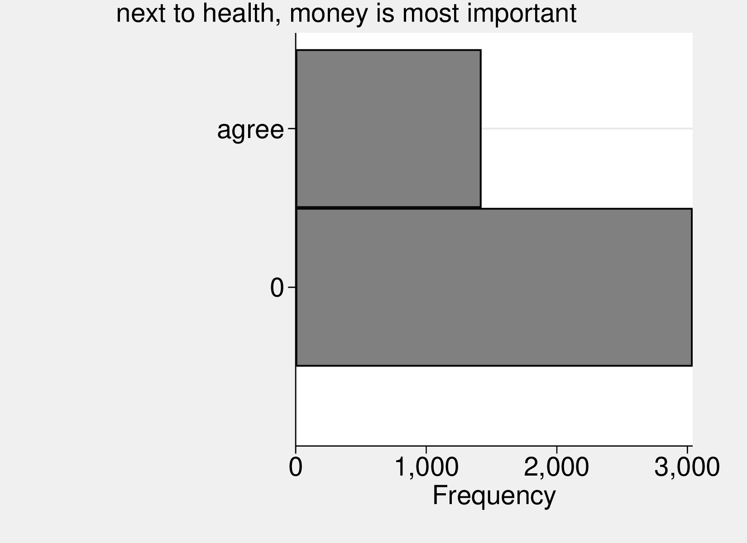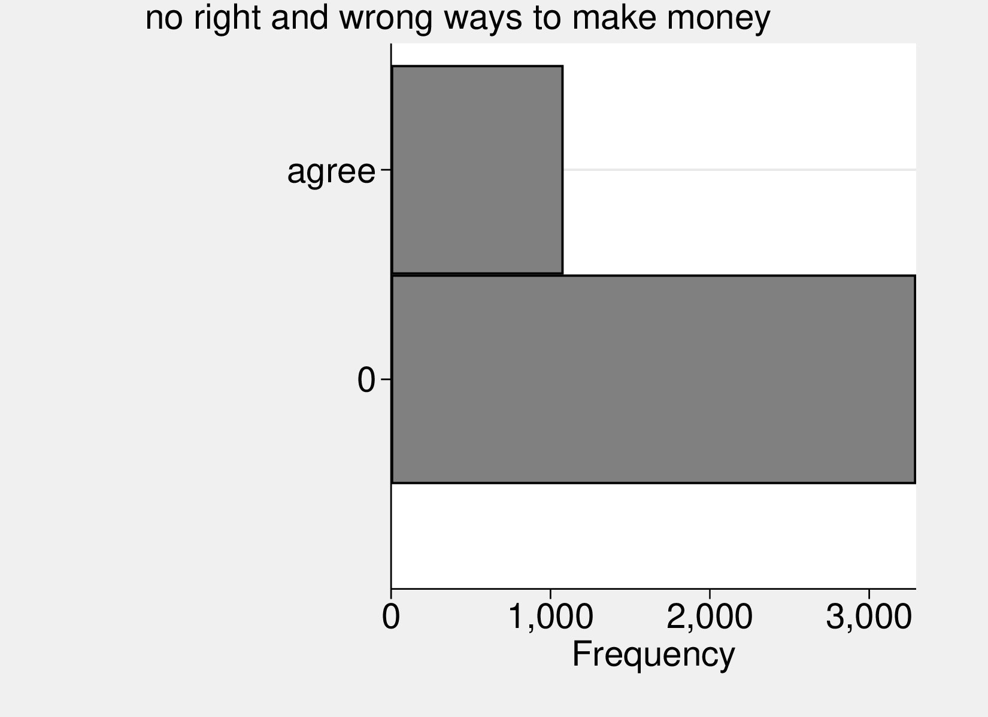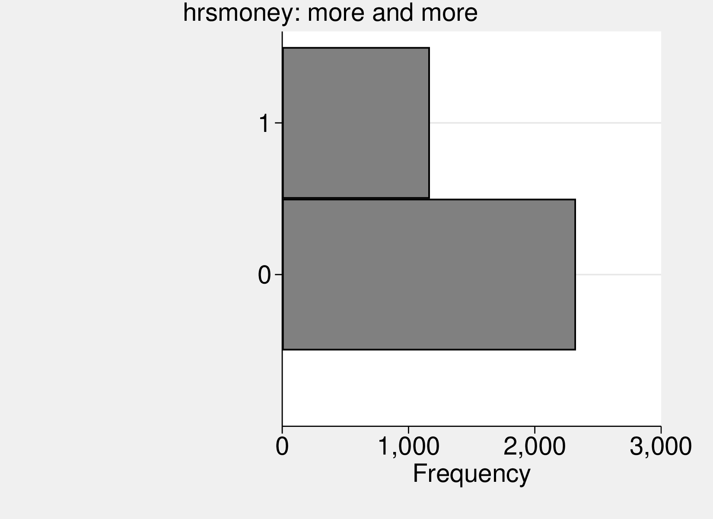
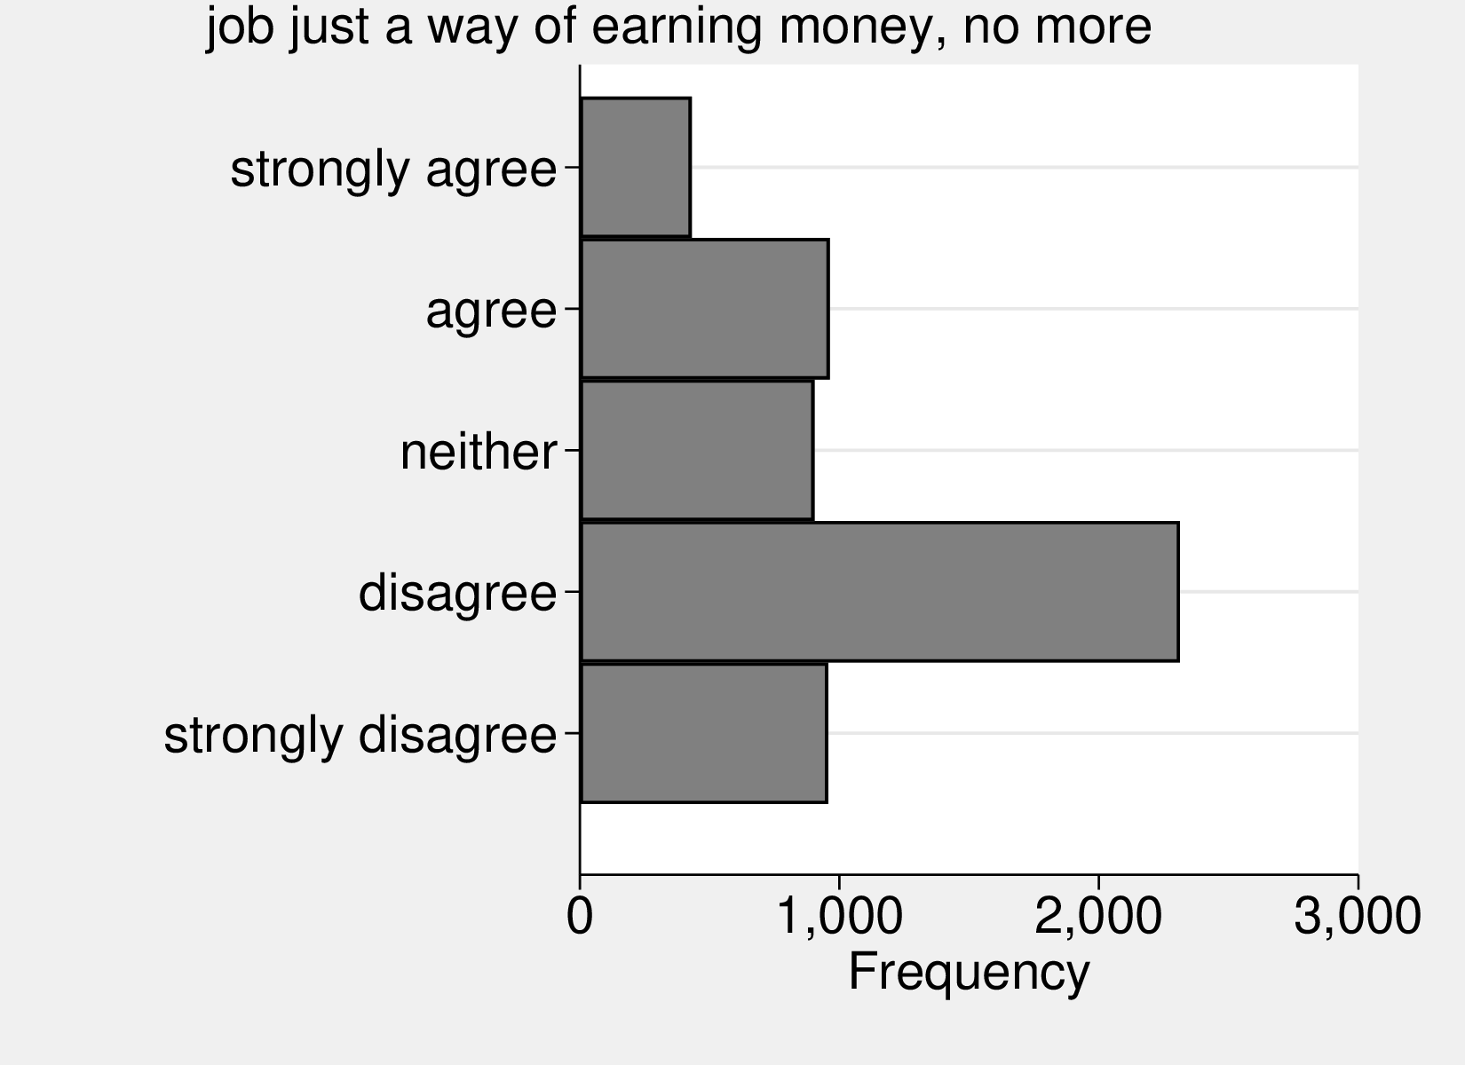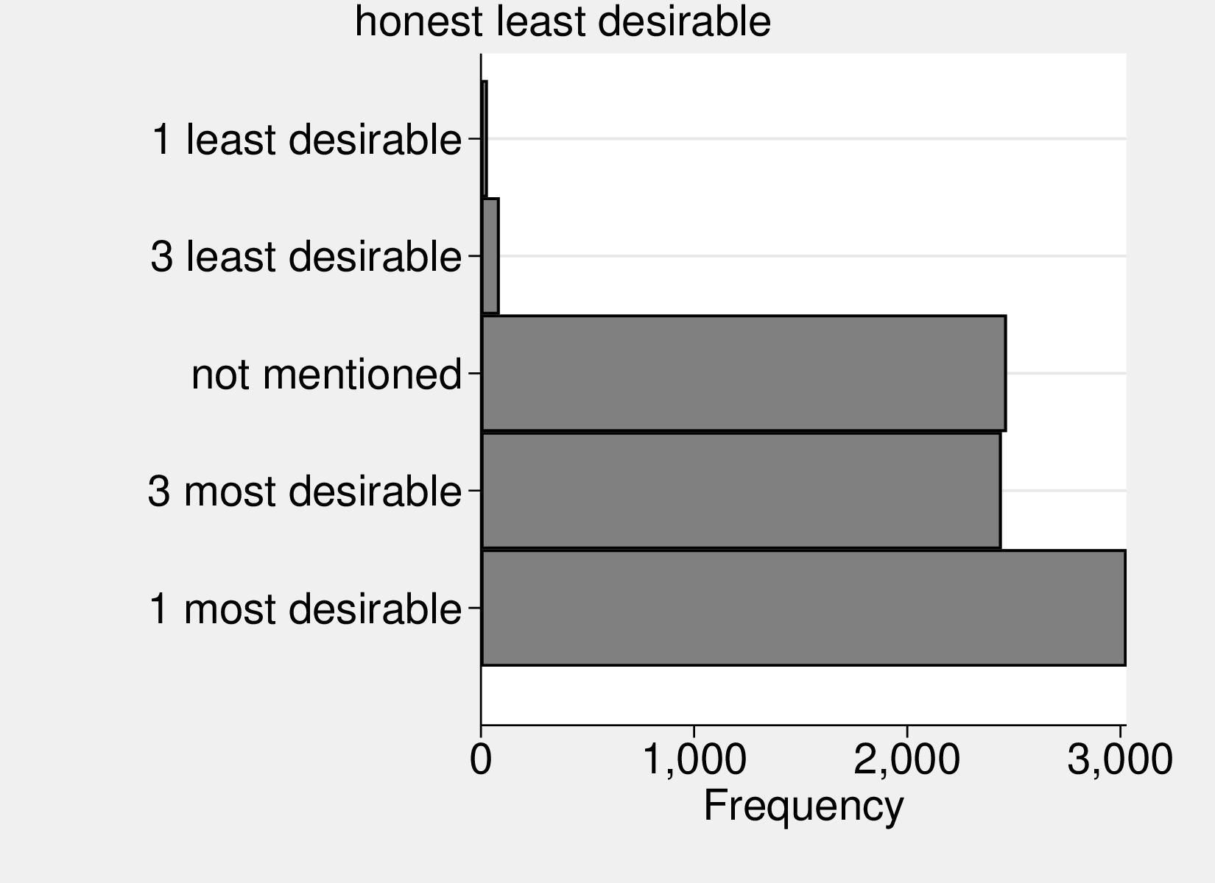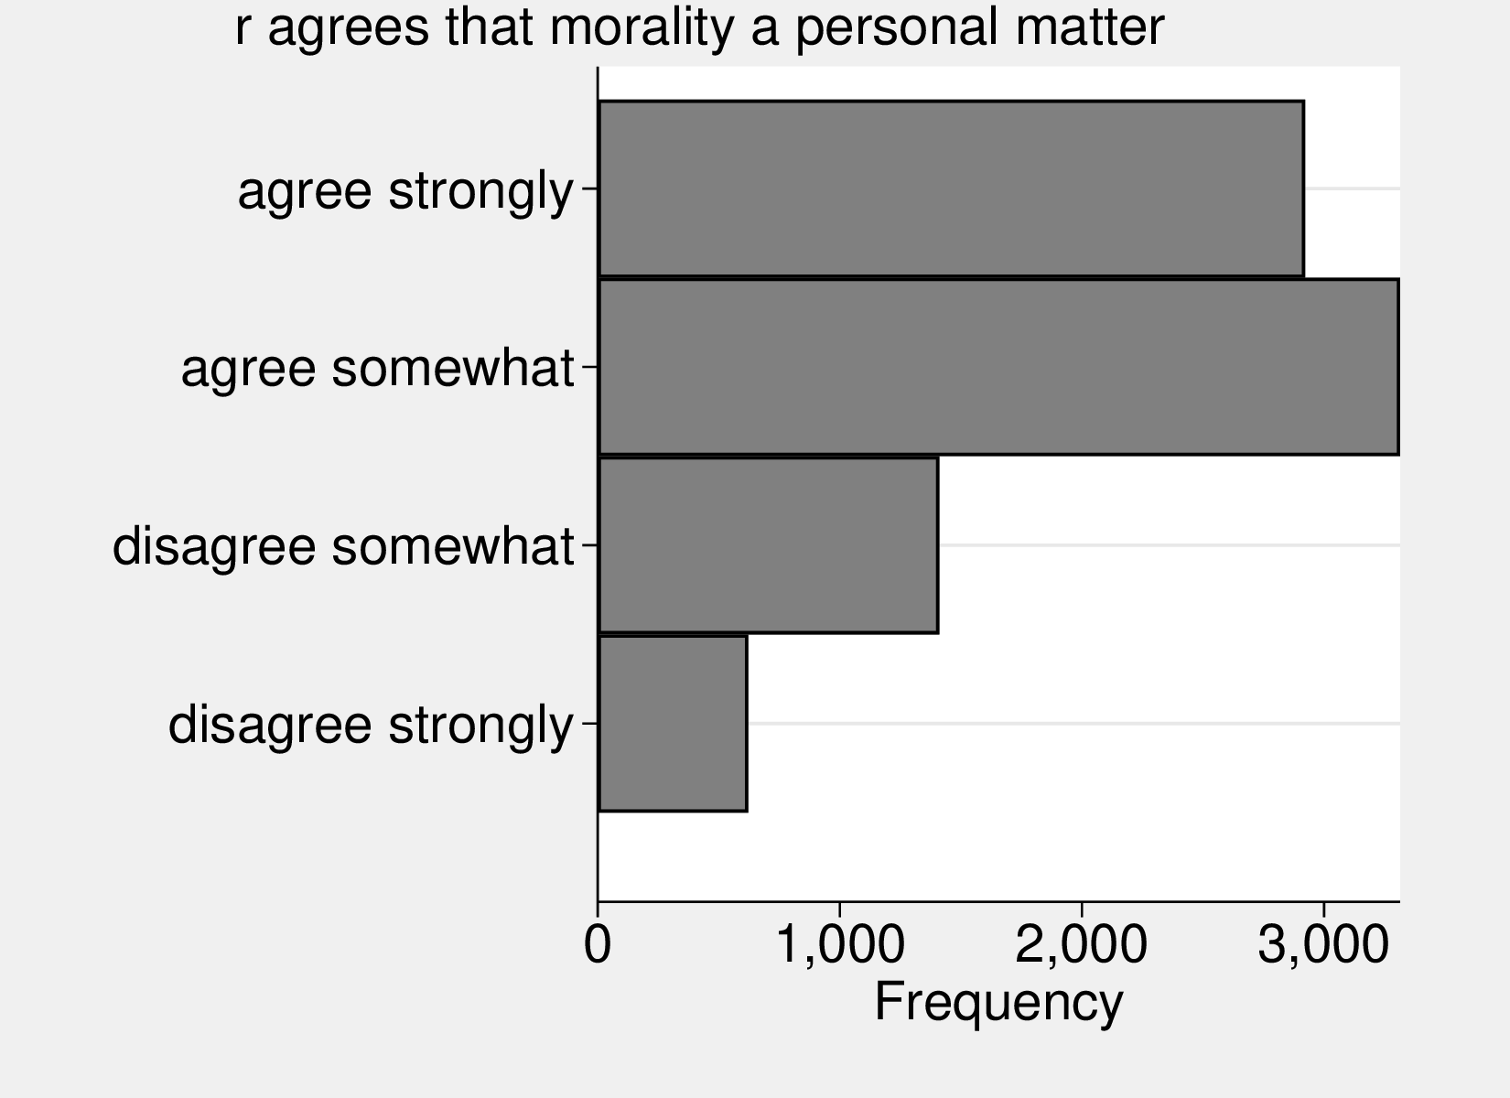
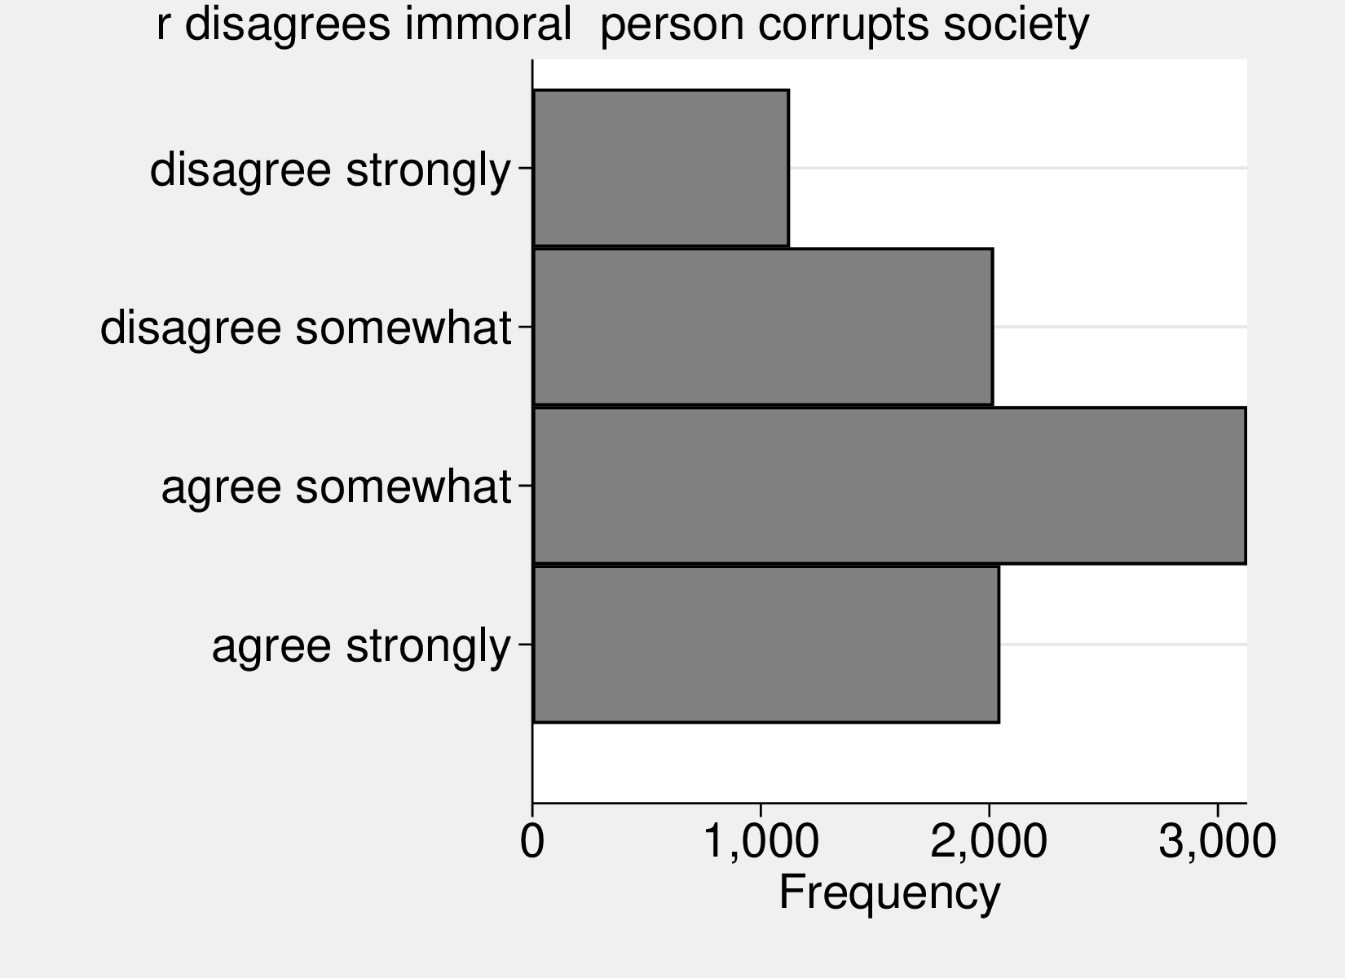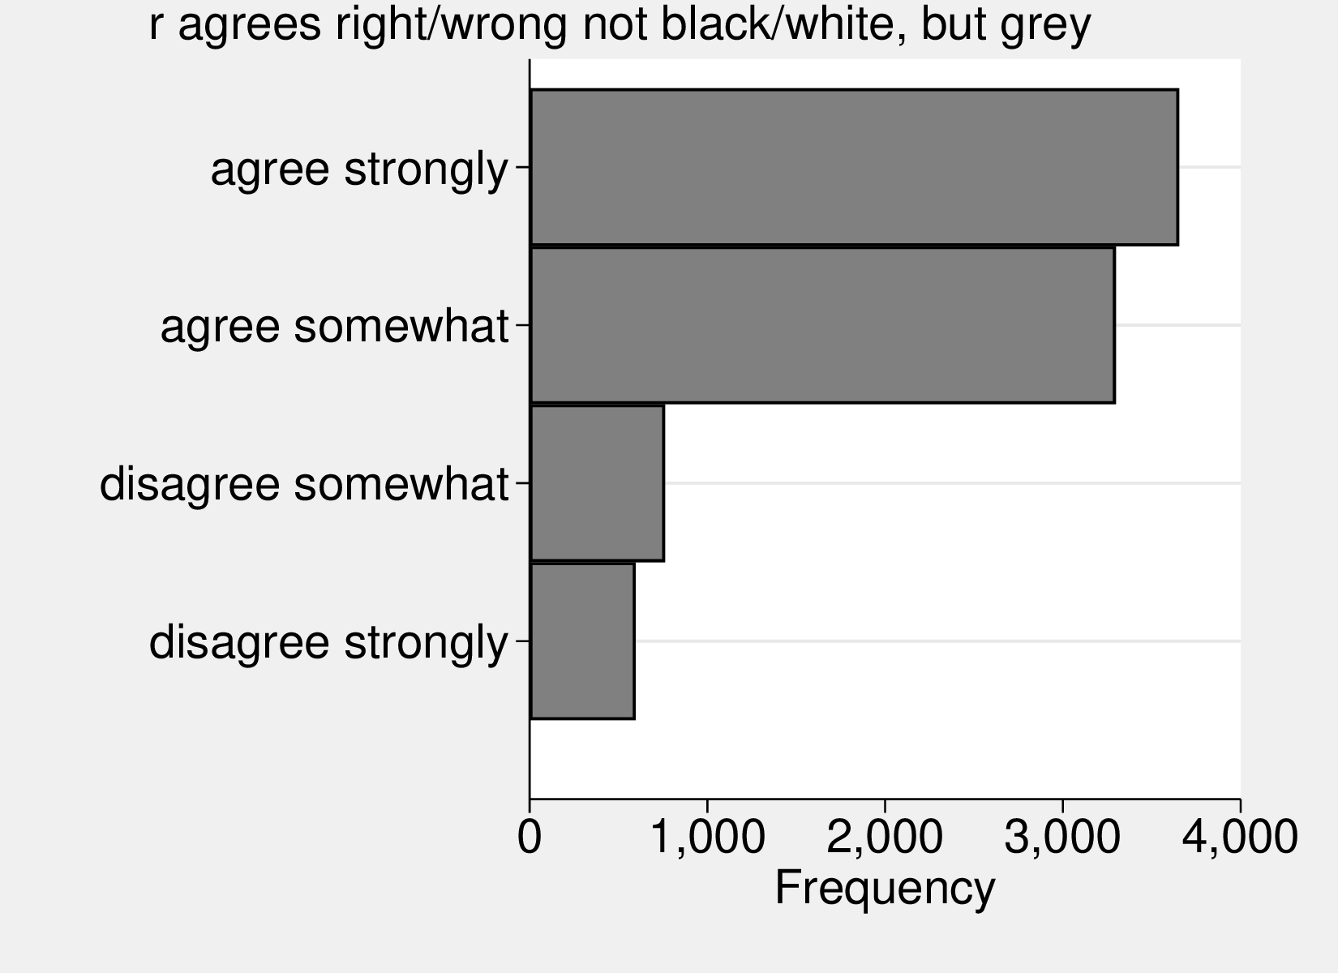
Figure 1: Variables’ distribution.

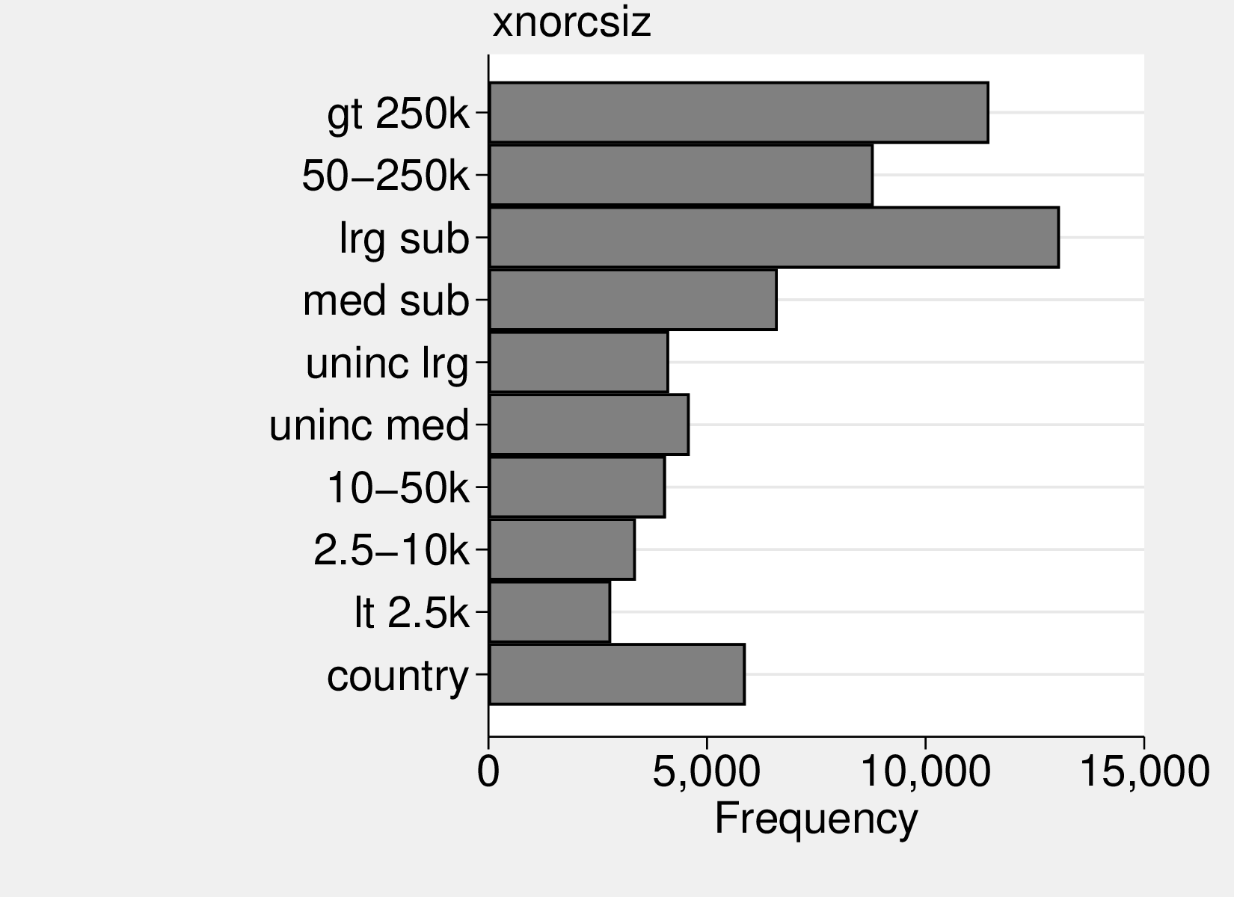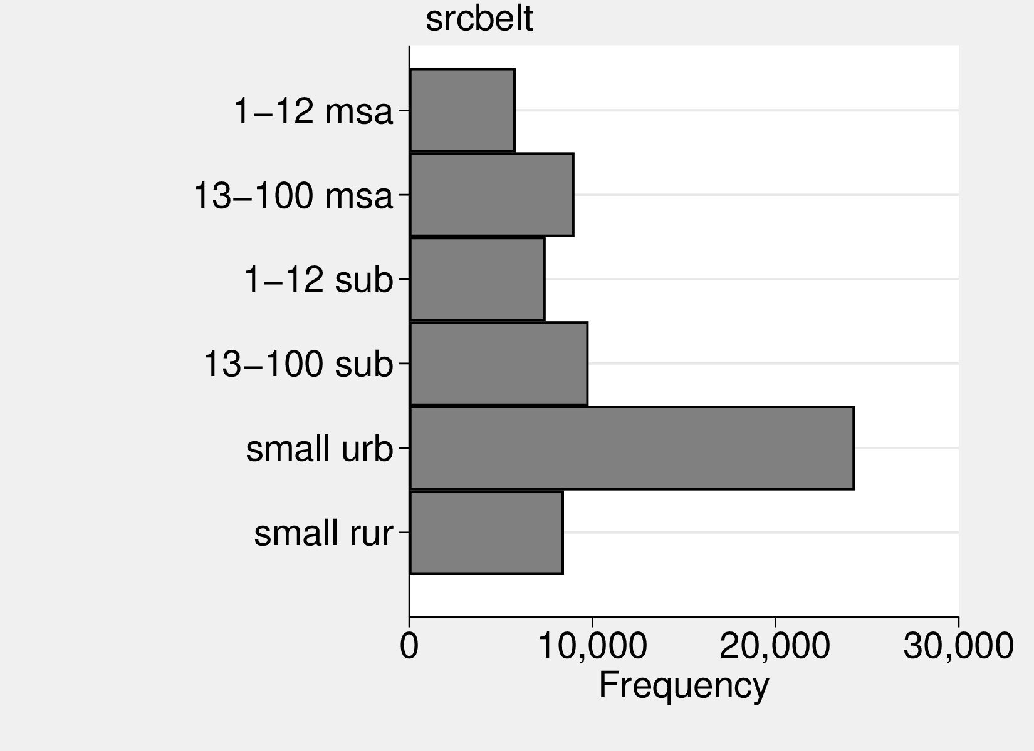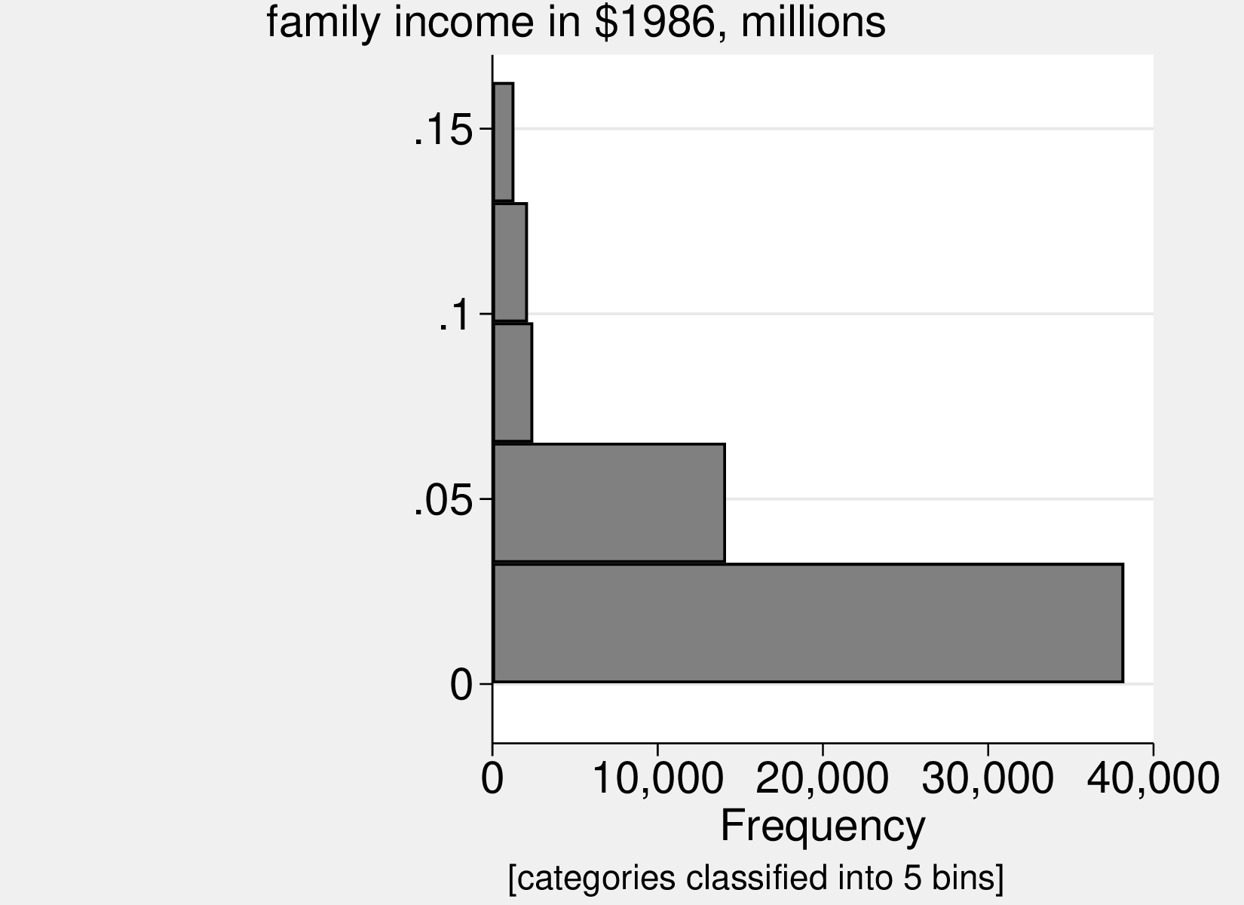
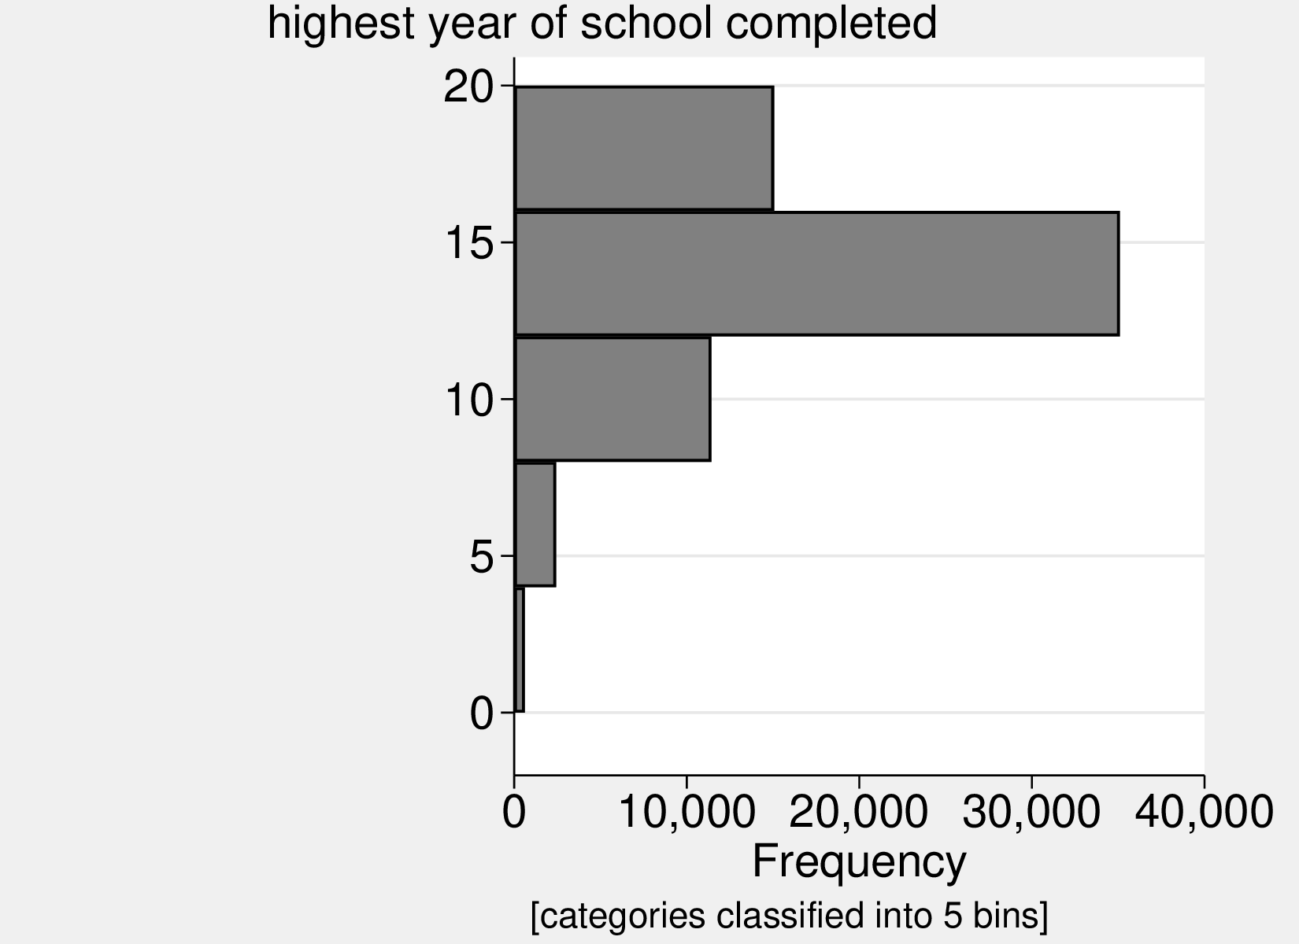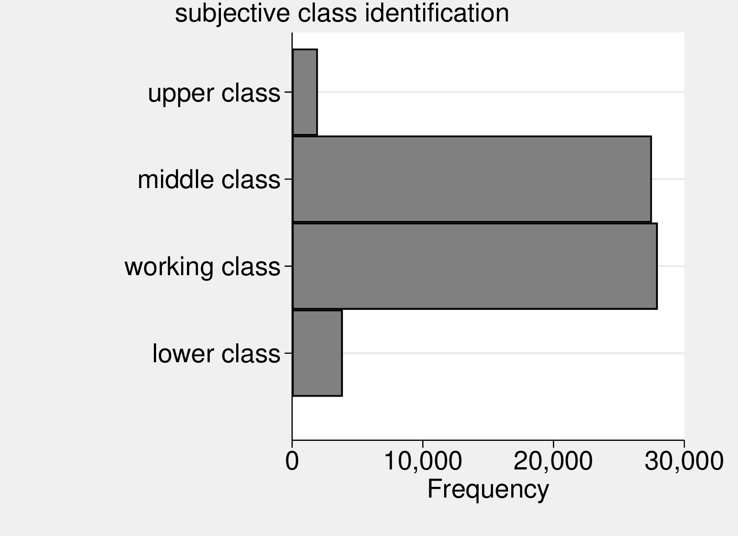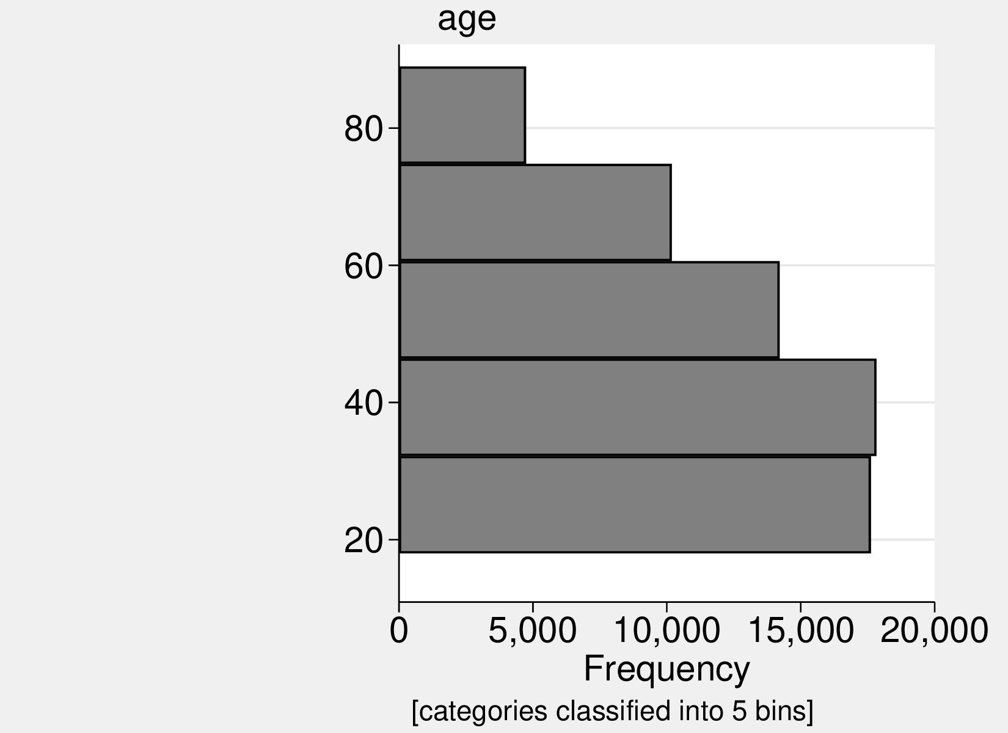
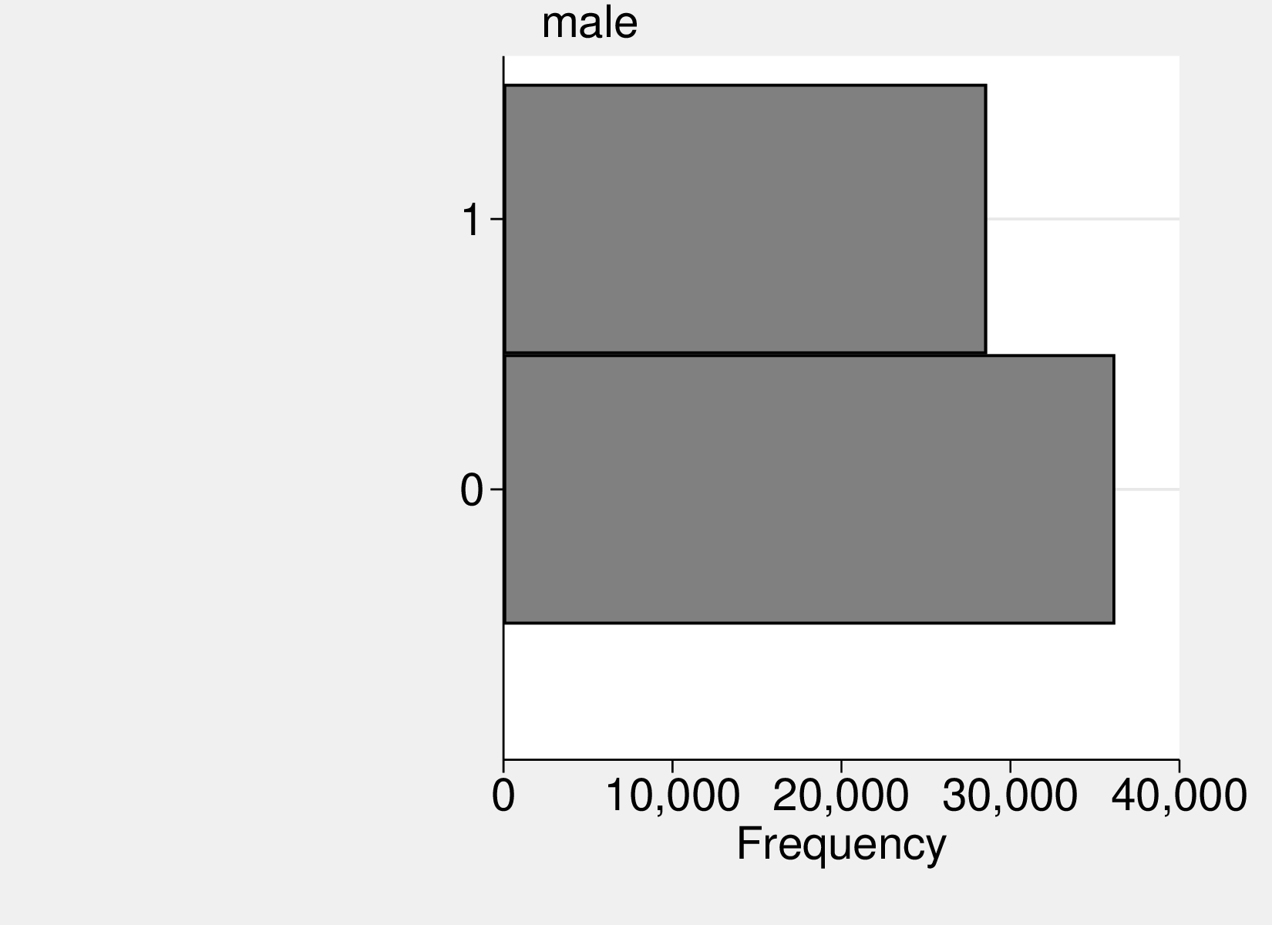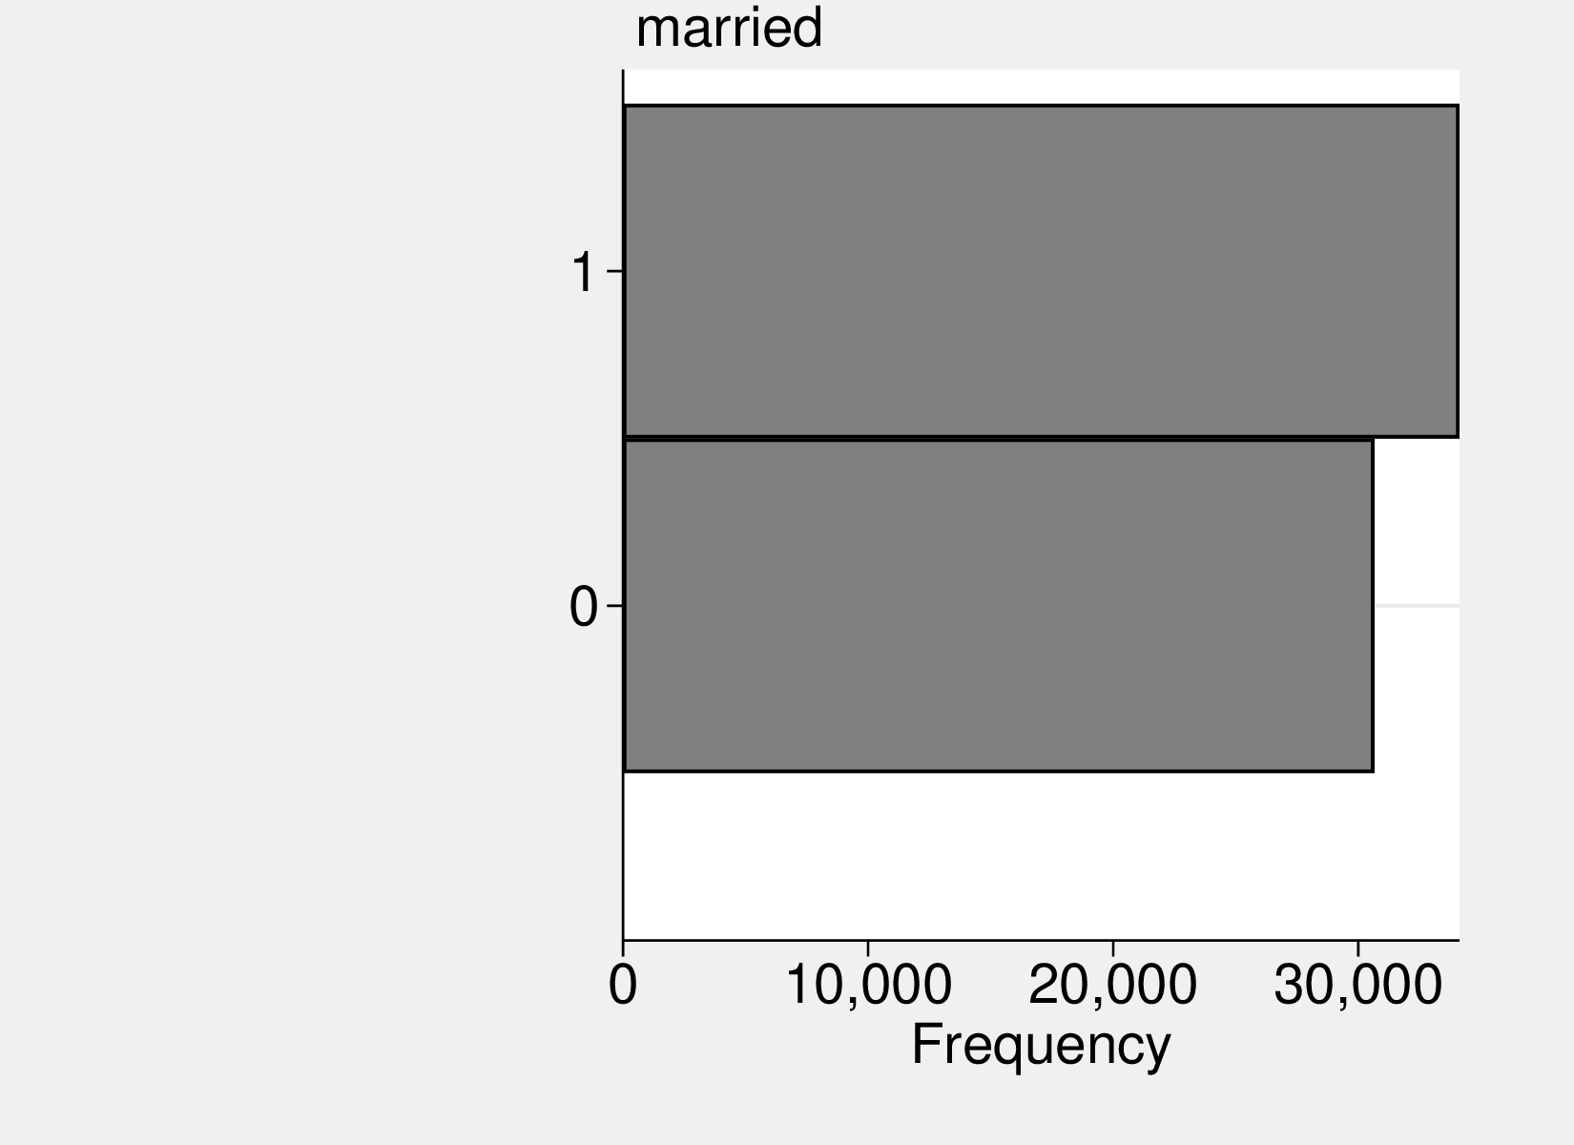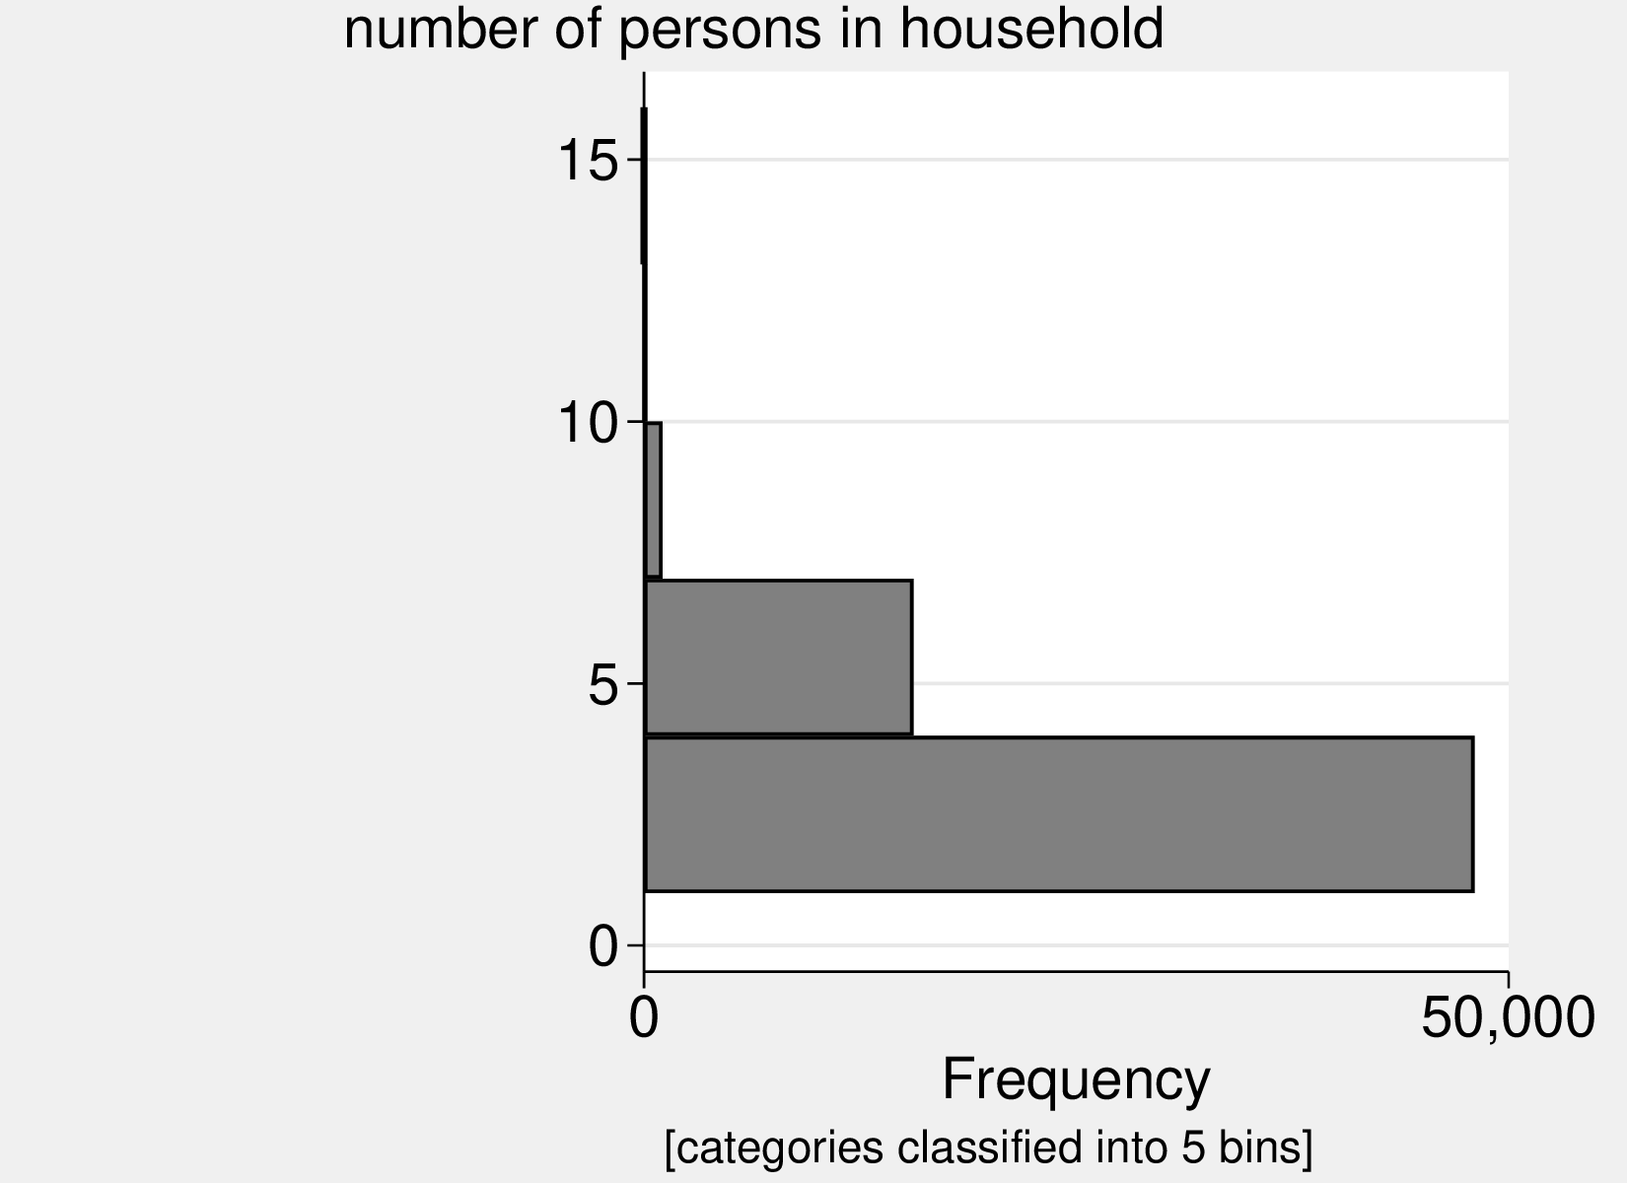
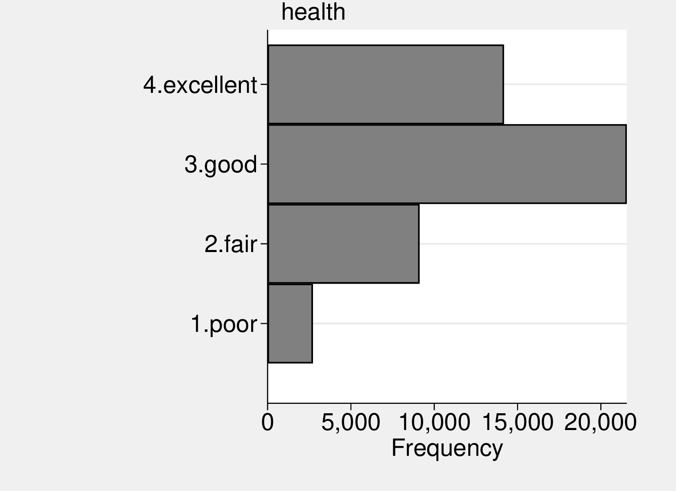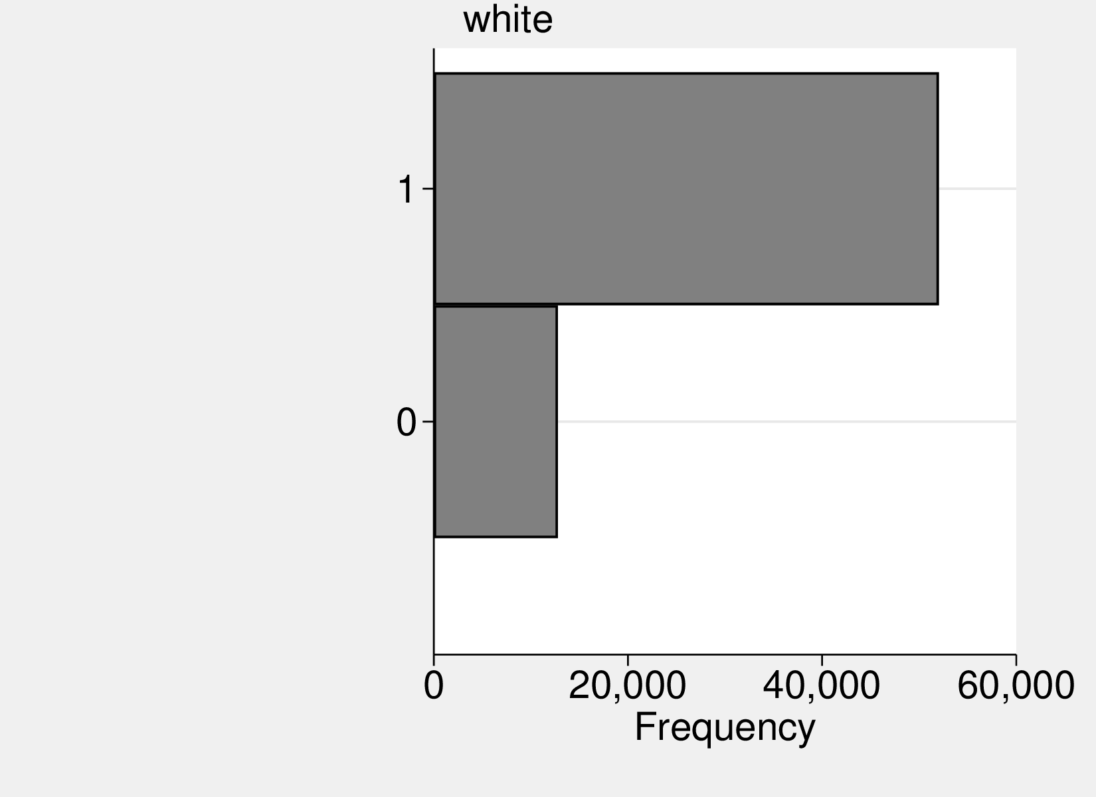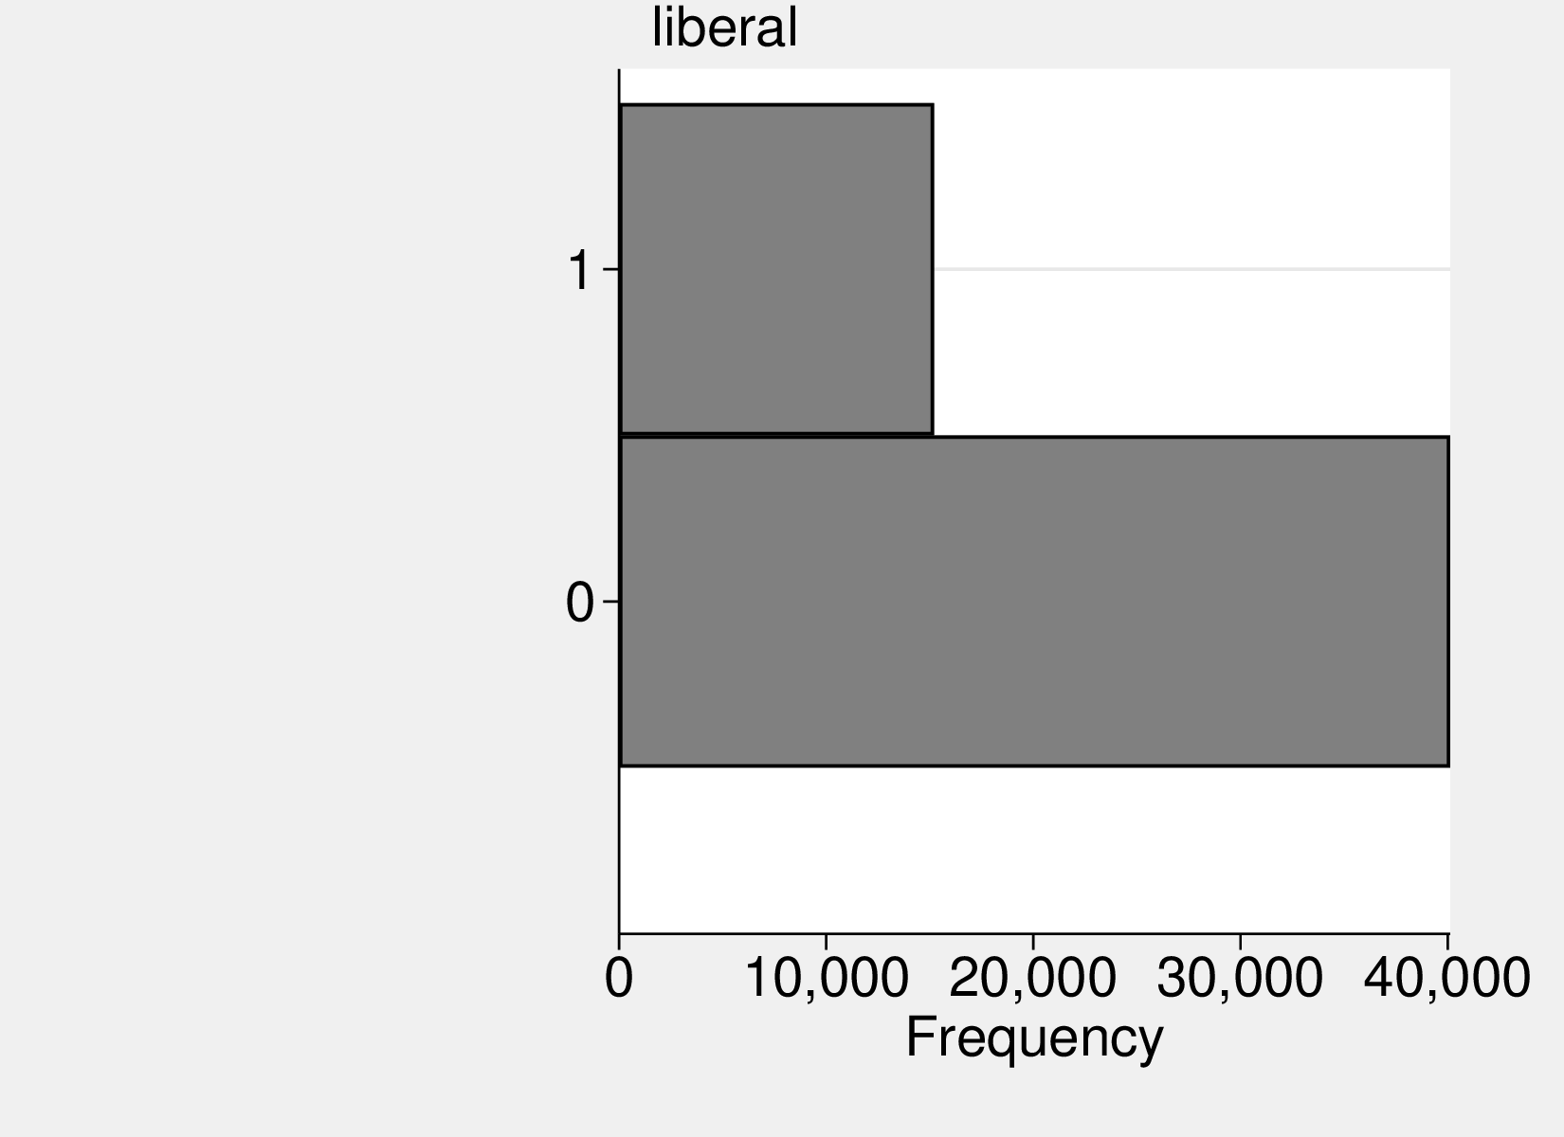
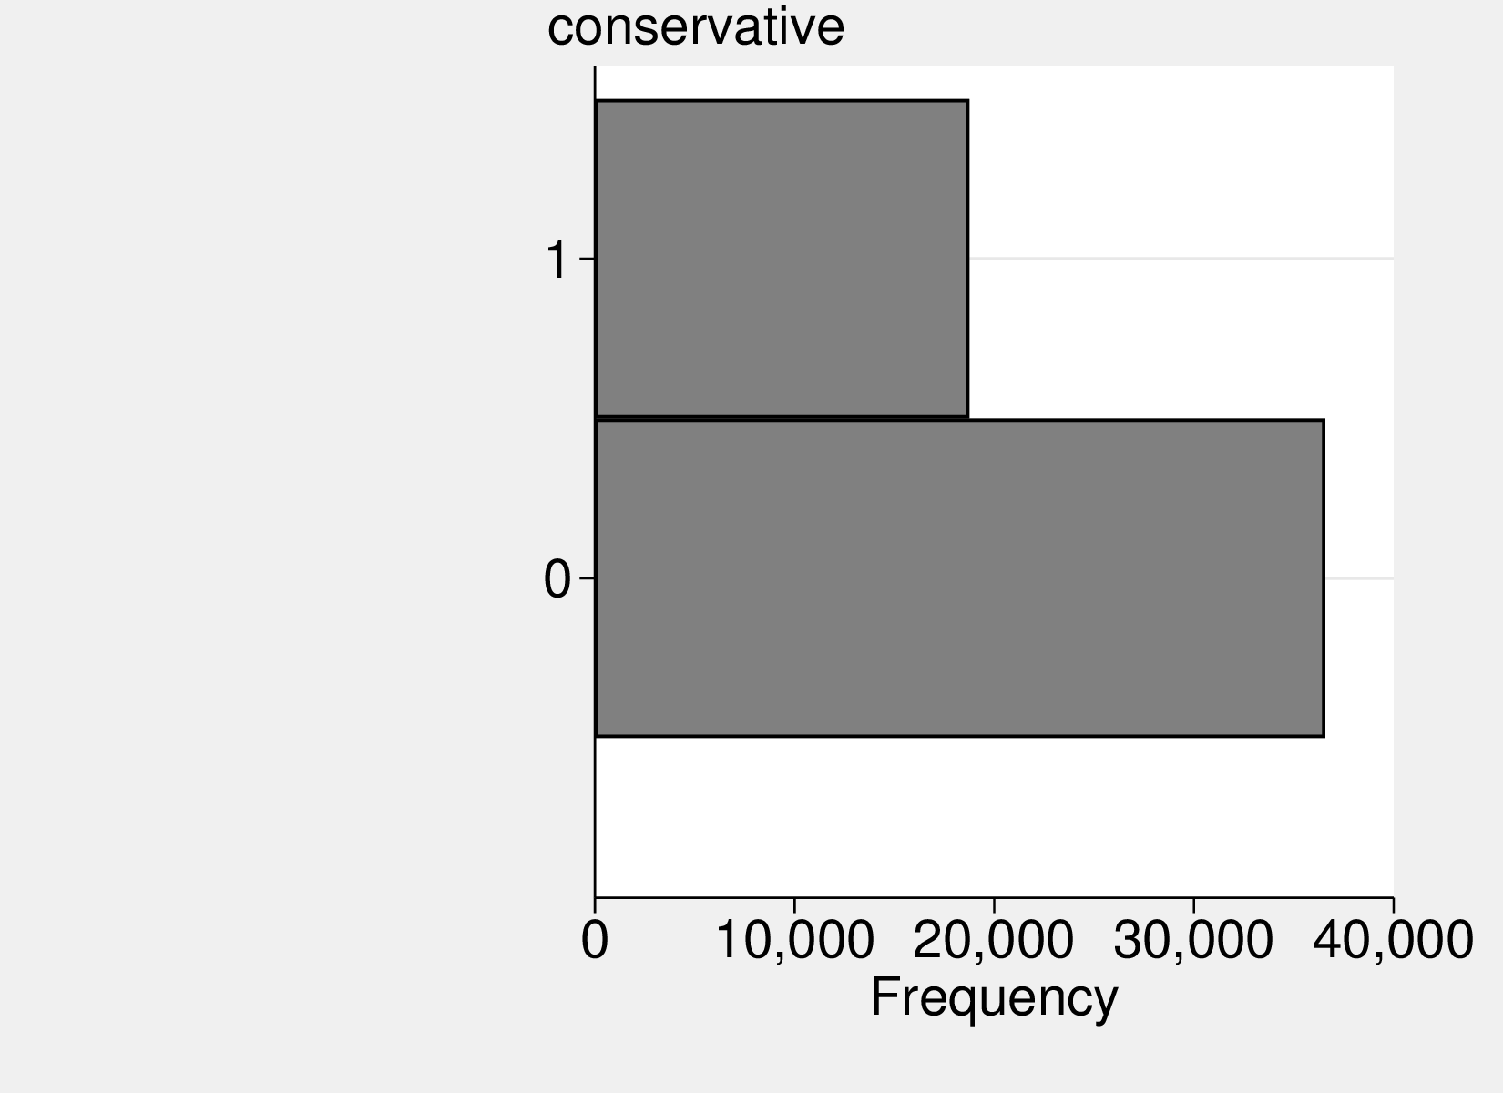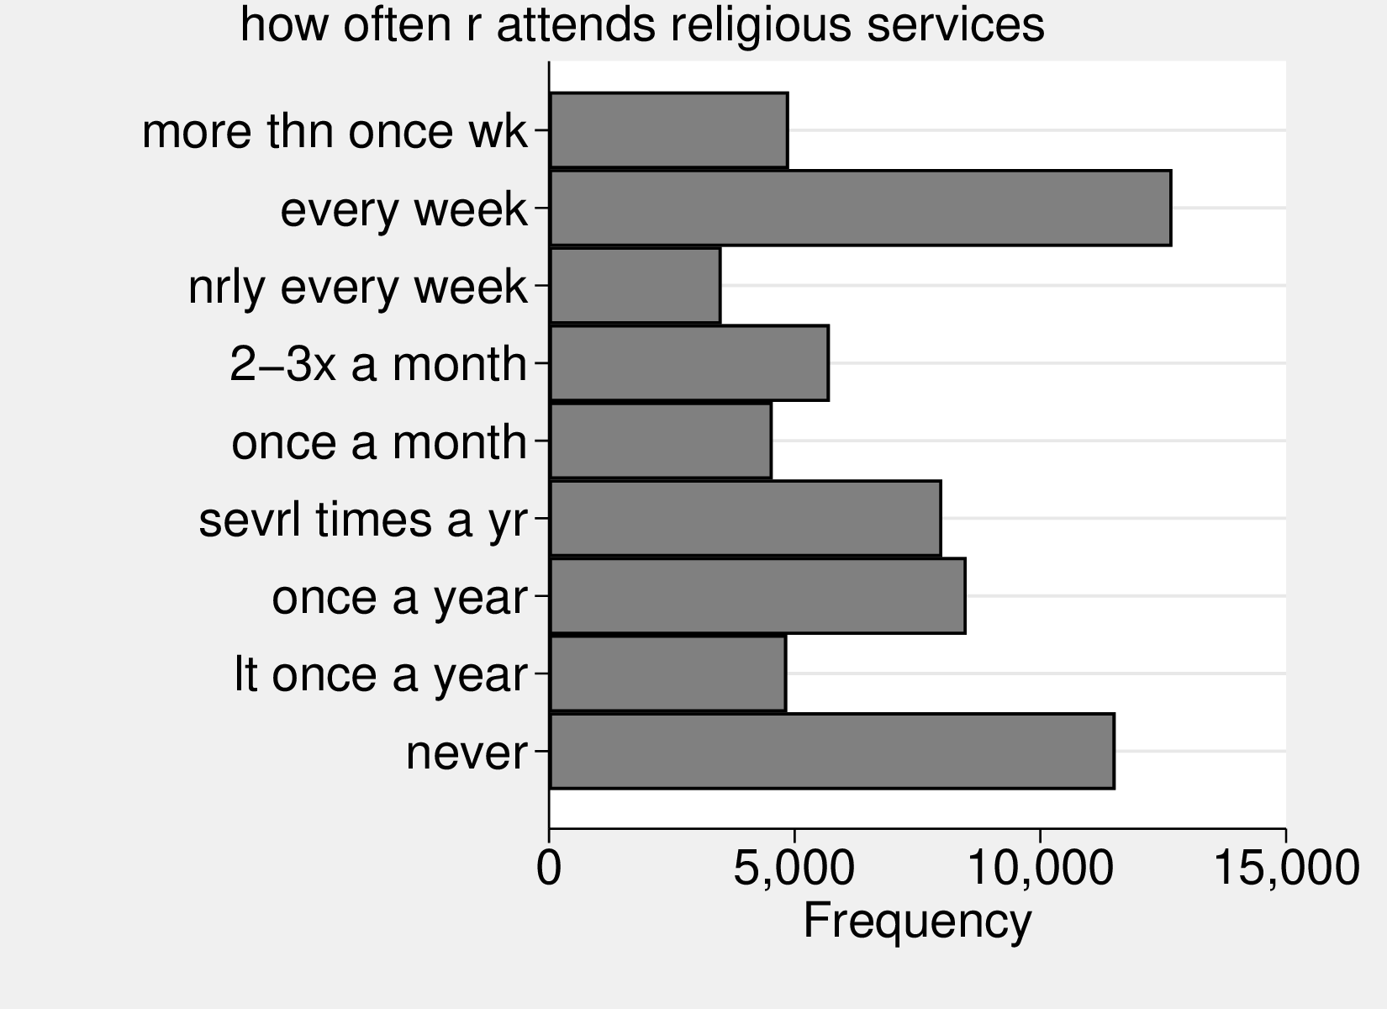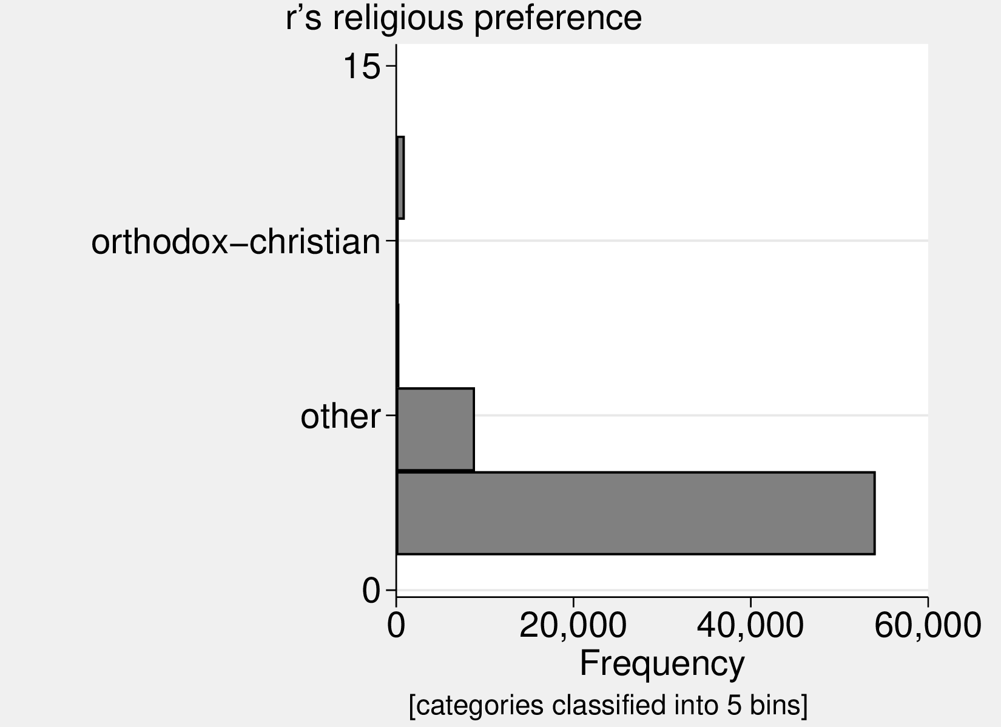

Figure : Variables’ distribution.

6.2 The less significant or insignificant results.

 | c1 | c2a | c2b | c3 | c4 | c5
urbanism (base: country)
lt 2.5k | -0.03 | 0.03 | -0.01 | 0.04 | 0.05 | 0.06
2.5-10k | -0.02 | 0.02 | -0.00 | 0.03 | 0.04 | 0.04
10-50k | 0.05 | 0.07* | 0.06+ | 0.07* | 0.07* | 0.06
uninc med | -0.03 | -0.01 | 0.01 | 0.02 | 0.02 | -0.00
uninc lrg | -0.06+ | -0.02 | 0.01 | 0.03 | 0.03 | 0.01
med sub | -0.07* | -0.02 | -0.02 | 0.01 | 0.02 | 0.00
lrg sub | -0.03 | 0.00 | 0.03 | 0.05+ | 0.04 | 0.02
50-250k | -0.00 | 0.01 | 0.03 | 0.05 | 0.04 | 0.05
gt 250k | 0.01 | 0.02 | 0.04 | 0.05+ | 0.02 | -0.02
new england | 0.00 | 0.00 | 0.00 | 0.00 | 0.00 | 0.00
middle atlantic | -0.02 | -0.05 | -0.01 | -0.04 | -0.04 | -0.01
e. nor. central | -0.06+ | -0.08* | -0.05 | -0.07 | -0.06 | -0.04
w. nor. central | -0.03 | -0.06 | -0.04 | -0.07 | -0.07 | -0.06
south atlantic | -0.03 | -0.05 | -0.05 | -0.07 | -0.08+ | -0.04
e. sou. central | -0.17*** | -0.19*** | -0.18*** | -0.20*** | -0.20*** | -0.15**
w. sou. central | -0.09* | -0.09* | -0.08* | -0.08+ | -0.08+ | -0.02
mountain | -0.07 | -0.10* | -0.07 | -0.10+ | -0.08 | -0.04
pacific | -0.12** | -0.15*** | -0.11** | -0.13** | -0.13** | -0.11*
subjective class identification |  | -0.07*** |  | -0.02 | -0.01 | -0.01
family income in $1986, millions |  |  | -1.52*** | -1.26*** | -0.96** | -0.82*
highest year of school completed |  |  | -0.03*** | -0.02*** | -0.03*** | -0.02***
age |  |  |  |  | -0.00 | -0.01+
age squared |  |  |  |  | 0.00 | 0.00
male |  |  |  |  | 0.06*** | 0.06***
married |  |  |  |  | 0.01 | 0.02
number of persons in household |  |  |  |  | -0.01 | -0.01
health |  |  |  |  | -0.03*** | -0.03**
white |  |  |  |  | -0.10*** | -0.15***
liberal |  |  |  |  |  | -0.05*
conservative |  |  |  |  |  | -0.01
how often r attends religious services |  |  |  |  |  | -0.01***
protestant |  |  |  |  |  | 0.00
catholic |  |  |  |  |  | 0.09***
jewish |  |  |  |  |  | 0.13*
none |  |  |  |  |  | 0.04
other |  |  |  |  |  | 0.04
constant | 0.33*** | 0.47*** | 0.65*** | 0.67*** | 0.96*** | 1.00***
N | 4376 | 3622 | 4049 | 3352 | 3339 | 2534

Table 7: no right and wrong ways to make money

 | d1 | d2a | d2b | d3 | d4 | d5
urbanism (base: country)
lt 2.5k | -0.11 | -0.11 | -0.15 | -0.15+ | -0.05 | -0.04
2.5-10k | -0.07 | -0.07 | -0.07 | -0.07 | -0.09 | -0.08
10-50k | -0.05 | -0.04 | -0.05 | -0.05 | -0.04 | -0.06
uninc med | -0.08+ | -0.07 | -0.07 | -0.07 | -0.10 | -0.09
uninc lrg | -0.08+ | -0.07 | -0.07 | -0.07 | -0.10+ | -0.10+
med sub | -0.05 | -0.04 | -0.05 | -0.04 | -0.11+ | -0.11+
lrg sub | -0.05 | -0.04 | -0.06 | -0.06 | -0.05 | -0.05
50-250k | -0.06 | -0.06 | -0.07+ | -0.07+ | -0.09+ | -0.08
gt 250k | 0.01 | 0.01 | 0.01 | 0.02 | -0.01 | -0.03
new england | 0.00 | 0.00 | 0.00 | 0.00 | 0.00 | 0.00
middle atlantic | -0.07 | -0.08 | -0.06 | -0.06 | -0.11 | -0.08
e. nor. central | -0.09 | -0.09 | -0.08 | -0.08 | -0.14* | -0.10
w. nor. central | -0.02 | -0.03 | -0.03 | -0.03 | -0.10 | -0.05
south atlantic | -0.08 | -0.08 | -0.08 | -0.08 | -0.14* | -0.09
e. sou. central | -0.10 | -0.11+ | -0.10 | -0.11 | -0.24** | -0.13
w. sou. central | -0.10+ | -0.11+ | -0.12* | -0.12* | -0.20** | -0.10
mountain | -0.08 | -0.08 | -0.08 | -0.08 | -0.17* | -0.14+
pacific | -0.00 | -0.01 | -0.00 | -0.00 | -0.09 | -0.09
subjective class identification |  | -0.04** |  | -0.02 | -0.00 | 0.01
family income in $1986, millions |  |  | -0.49 | -0.39 | -0.75 | -0.79
highest year of school completed |  |  | -0.01** | -0.01** | -0.01 | -0.01
age |  |  |  |  | -0.00 | -0.00
age squared |  |  |  |  | 0.00 | 0.00
male |  |  |  |  | 0.10*** | 0.06*
married |  |  |  |  | -0.11*** | -0.05
number of persons in household |  |  |  |  | -0.01 | -0.01
health |  |  |  |  | -0.00 | 0.01
white |  |  |  |  | -0.01 | -0.04
liberal |  |  |  |  |  | 0.04
conservative |  |  |  |  |  | -0.17***
how often r attends religious services |  |  |  |  |  | -0.05***
protestant |  |  |  |  |  | 0.00
catholic |  |  |  |  |  | 0.00
jewish |  |  |  |  |  | 0.15
none |  |  |  |  |  | 0.00
other |  |  |  |  |  | -0.01
buddhism |  |  |  |  |  | 0.22
hinduism |  |  |  |  |  | -0.62*
other eastern |  |  |  |  |  | 0.15
moslem/islam |  |  |  |  |  | -0.12
orthodox-christian |  |  |  |  |  | -0.49
christian |  |  |  |  |  | -0.05
native american |  |  |  |  |  | 0.43*
inter-nondenominational |  |  |  |  |  | 0.00
constant | 3.10*** | 3.21*** | 3.28*** | 3.30*** | 3.55*** | 3.60***
N | 8269 | 8226 | 7329 | 7305 | 4797 | 4676

Table 8: r agrees that morality a personal matter

 | f1 | f2a | f2b | f3 | f4 | f5
urbanism (base: country)
lt 2.5k | 0.02 | 0.06 | 0.03 | 0.08 | 0.04 | 0.01
2.5-10k | 0.11* | 0.11+ | 0.11* | 0.11+ | 0.08 | 0.06
10-50k | 0.03 | 0.05 | 0.07 | 0.07 | 0.04 | 0.03
uninc med | -0.03 | 0.01 | 0.00 | 0.02 | -0.04 | -0.07
uninc lrg | -0.06 | 0.04 | 0.01 | 0.05 | 0.01 | -0.03
med sub | 0.01 | 0.05 | 0.05 | 0.06 | 0.06 | 0.05
lrg sub | 0.01 | 0.07 | 0.07+ | 0.10* | 0.05 | 0.02
50-250k | 0.04 | 0.08 | 0.06 | 0.08 | 0.02 | 0.00
gt 250k | 0.08* | 0.10* | 0.10** | 0.10* | 0.05 | 0.02
new england | 0.00 | 0.00 | 0.00 | 0.00 | 0.00 | 0.00
middle atlantic | 0.05 | 0.10* | 0.04 | 0.08+ | 0.09+ | 0.09+
e. nor. central | 0.02 | 0.06 | 0.00 | 0.03 | 0.04 | 0.04
w. nor. central | -0.03 | 0.03 | -0.07 | -0.02 | 0.01 | 0.02
south atlantic | 0.07+ | 0.11* | 0.06 | 0.09+ | 0.07 | 0.09+
e. sou. central | 0.08 | 0.09+ | 0.04 | 0.04 | 0.09 | 0.11
w. sou. central | 0.09* | 0.12* | 0.05 | 0.09+ | 0.06 | 0.07
mountain | -0.02 | -0.01 | -0.05 | -0.04 | -0.00 | -0.00
pacific | 0.02 | 0.06 | 0.00 | 0.04 | 0.05 | 0.07
subjective class identification |  | -0.10*** |  | -0.05** | -0.05* | -0.06**
family income in $1986, millions |  |  | -2.34*** | -2.31*** | -1.55*** | -1.58***
highest year of school completed |  |  | -0.02*** | -0.01** | -0.01** | -0.01**
age |  |  |  |  | 0.00 | 0.00
age squared |  |  |  |  | -0.00 | -0.00
male |  |  |  |  | 0.11*** | 0.09***
married |  |  |  |  | -0.07** | -0.08**
number of persons in household |  |  |  |  | -0.01 | -0.00
health |  |  |  |  | -0.02 | -0.02
white |  |  |  |  | -0.11*** | -0.11***
liberal |  |  |  |  |  | 0.01
conservative |  |  |  |  |  | 0.06*
how often r attends religious services |  |  |  |  |  | -0.01
protestant |  |  |  |  |  | 0.00
catholic |  |  |  |  |  | 0.03
jewish |  |  |  |  |  | 0.19*
none |  |  |  |  |  | -0.01
other |  |  |  |  |  | -0.04
buddhism |  |  |  |  |  | 0.07
hinduism |  |  |  |  |  | -0.16
other eastern |  |  |  |  |  | -0.18*
moslem/islam |  |  |  |  |  | -0.09
orthodox-christian |  |  |  |  |  | 0.60***
christian |  |  |  |  |  | -0.03
native american |  |  |  |  |  | -0.15+
inter-nondenominational |  |  |  |  |  | -0.21
constant | 0.26*** | 0.46*** | 0.57*** | 0.58*** | 0.82*** | 0.82***
N | 3495 | 2481 | 3195 | 2309 | 1758 | 1688

Table 9: hrsmoney: more and more

 | g1 | g2a | g2b | g3 | g4 | g5
urbanism (base: country)
lt 2.5k | -0.05 | -0.06 | -0.04 | -0.05 | -0.03 | -0.05
2.5-10k | 0.02 | 0.02 | -0.00 | -0.01 | -0.01 | 0.00
10-50k | 0.04 | 0.04 | -0.02 | -0.02 | -0.04 | -0.07
uninc med | 0.03 | 0.02 | -0.02 | -0.02 | 0.03 | 0.02
uninc lrg | 0.02 | 0.01 | -0.03 | -0.03 | -0.01 | -0.02
med sub | 0.05 | 0.05 | 0.00 | 0.00 | -0.00 | -0.02
lrg sub | 0.11** | 0.10* | 0.05 | 0.05 | 0.04 | 0.02
50-250k | 0.07+ | 0.06 | 0.01 | 0.01 | -0.01 | -0.00
gt 250k | 0.10* | 0.09* | 0.03 | 0.03 | -0.00 | -0.04
new england | 0.00 | 0.00 | 0.00 | 0.00 | 0.00 | 0.00
middle atlantic | -0.08 | -0.08 | -0.07 | -0.08 | -0.06 | -0.03
e. nor. central | -0.14** | -0.14** | -0.10* | -0.11* | -0.07 | -0.01
w. nor. central | -0.12* | -0.12* | -0.12* | -0.12* | -0.09 | -0.02
south atlantic | -0.27*** | -0.26*** | -0.26*** | -0.27*** | -0.22*** | -0.12+
e. sou. central | -0.36*** | -0.36*** | -0.35*** | -0.36*** | -0.40*** | -0.25**
w. sou. central | -0.28*** | -0.28*** | -0.28*** | -0.28*** | -0.31*** | -0.17*
mountain | -0.18** | -0.18** | -0.17** | -0.18** | -0.15* | -0.08
pacific | -0.18*** | -0.18*** | -0.16** | -0.17** | -0.16* | -0.15*
subjective class identification |  | 0.04** |  | -0.00 | -0.01 | 0.00
family income in $1986, millions |  |  | -0.31 | -0.27 | 0.23 | 0.15
highest year of school completed |  |  | 0.03*** | 0.03*** | 0.04*** | 0.04***
age |  |  |  |  | -0.00 | 0.00
age squared |  |  |  |  | 0.00 | 0.00
male |  |  |  |  | -0.06* | -0.09***
married |  |  |  |  | -0.11*** | -0.05+
number of persons in household |  |  |  |  | -0.01 | -0.00
health |  |  |  |  | -0.02 | -0.00
white |  |  |  |  | 0.00 | -0.02
liberal |  |  |  |  |  | 0.03
conservative |  |  |  |  |  | -0.21***
how often r attends religious services |  |  |  |  |  | -0.05***
protestant |  |  |  |  |  | 0.00
catholic |  |  |  |  |  | 0.11***
jewish |  |  |  |  |  | 0.19**
none |  |  |  |  |  | 0.02
other |  |  |  |  |  | 0.02
buddhism |  |  |  |  |  | 0.16
hinduism |  |  |  |  |  | 0.13
other eastern |  |  |  |  |  | 0.28
moslem/islam |  |  |  |  |  | 0.11
orthodox-christian |  |  |  |  |  | -0.17
christian |  |  |  |  |  | 0.06
native american |  |  |  |  |  | 0.01
inter-nondenominational |  |  |  |  |  | -0.05
constant | 3.31*** | 3.22*** | 2.97*** | 2.98*** | 3.11*** | 3.01***
N | 8311 | 8267 | 7351 | 7327 | 4808 | 4687

Table 10: r agrees right/wrong not black/white

6.3 Results using alternative measure of urbanicity, rank of MSA.
Results are similar but weaker arguably due to lower precision of this measure of urbanicity.

 | a1 | a2a | a2b | a3 | a4 | a5
small rur | 0.00 | 0.00 | 0.00 | 0.00 | 0.00 | 0.00
small urb | 0.01 | 0.03 | 0.01 | 0.02 | 0.03 | 0.03
13-100 sub | 0.08* | 0.08* | 0.07+ | 0.07 | 0.04 | 0.03
1-12 sub | 0.09* | 0.11* | 0.08+ | 0.10* | 0.11+ | 0.03
13-100 msa | 0.06+ | 0.10* | 0.05 | 0.08+ | 0.04 | 0.03
1-12 msa | 0.28*** | 0.31*** | 0.29*** | 0.31*** | 0.25*** | 0.24***
new england | 0.00 | 0.00 | 0.00 | 0.00 | 0.00 | 0.00
middle atlantic | 0.02 | -0.02 | 0.04 | -0.01 | -0.11 | -0.09
e. nor. central | -0.05 | -0.08 | -0.04 | -0.07 | -0.17* | -0.13
w. nor. central | -0.10+ | -0.15* | -0.08 | -0.13+ | -0.14 | -0.08
south atlantic | -0.12* | -0.14* | -0.11* | -0.11+ | -0.23** | -0.15+
e. sou. central | -0.07 | -0.09 | -0.06 | -0.07 | -0.18* | -0.10
w. sou. central | 0.03 | 0.01 | 0.05 | 0.03 | -0.04 | -0.03
mountain | 0.02 | -0.00 | 0.02 | 0.01 | -0.07 | -0.04
pacific | -0.04 | -0.04 | -0.03 | -0.03 | -0.14+ | -0.12
subjective class identification |  | 0.00 |  | 0.01 | 0.02 | 0.03
family income in $1986, millions |  |  | 0.01 | -0.39 | 0.50 | 0.02
highest year of school completed |  |  | 0.00 | 0.01* | 0.01 | 0.01+
age |  |  |  |  | -0.01** | -0.01*
age squared |  |  |  |  | 0.00* | 0.00*
male |  |  |  |  | 0.07** | 0.07*
married |  |  |  |  | -0.01 | -0.00
number of persons in household |  |  |  |  | -0.00 | 0.00
health |  |  |  |  | -0.03+ | -0.03
white |  |  |  |  | -0.08 | -0.10+
liberal |  |  |  |  |  | 0.02
conservative |  |  |  |  |  | -0.01
how often r attends religious services |  |  |  |  |  | -0.01
protestant |  |  |  |  |  | 0.00
catholic |  |  |  |  |  | 0.10*
jewish |  |  |  |  |  | 0.10
none |  |  |  |  |  | 0.09
other |  |  |  |  |  | 0.14
constant | 2.00*** | 1.96*** | 1.94*** | 1.84*** | 2.41*** | 2.25***
N | 8059 | 6491 | 7483 | 6050 | 3899 | 3032

Table 11: honest least desirable

 | b1 | b2a | b2b | b3 | b4 | b5
small rur | 0.00 | 0.00 | 0.00 | 0.00 | 0.00 | 0.00
small urb | 0.00 | 0.00 | 0.04* | 0.03 | 0.04+ | 0.05+
13-100 sub | 0.05+ | 0.07* | 0.11*** | 0.11*** | 0.12*** | 0.13***
1-12 sub | 0.05 | 0.05 | 0.12*** | 0.12*** | 0.12*** | 0.11**
13-100 msa | 0.03 | 0.03 | 0.06* | 0.06* | 0.04 | 0.04
1-12 msa | 0.14*** | 0.18*** | 0.18*** | 0.20*** | 0.16*** | 0.16***
new england | 0.00 | 0.00 | 0.00 | 0.00 | 0.00 | 0.00
middle atlantic | 0.01 | 0.01 | 0.03 | 0.02 | 0.04 | 0.01
e. nor. central | -0.03 | -0.04 | -0.03 | -0.03 | -0.02 | -0.02
w. nor. central | -0.04 | -0.06 | -0.05 | -0.07 | -0.06 | -0.06
south atlantic | 0.00 | -0.00 | -0.03 | -0.03 | -0.04 | -0.03
e. sou. central | -0.06 | -0.08 | -0.08+ | -0.10* | -0.10* | -0.07
w. sou. central | -0.05 | -0.07 | -0.05 | -0.06 | -0.04 | -0.02
mountain | -0.06 | -0.06 | -0.08+ | -0.07 | -0.06 | -0.07
pacific | -0.08* | -0.10* | -0.07+ | -0.09* | -0.08+ | -0.07
subjective class identification |  | -0.04*** |  | 0.02+ | 0.02 | 0.02
family income in $1986, millions |  |  | -1.60*** | -1.71*** | -1.40*** | -1.25**
highest year of school completed |  |  | -0.04*** | -0.04*** | -0.03*** | -0.03***
age |  |  |  |  | 0.00 | 0.00
age squared |  |  |  |  | 0.00 | 0.00
male |  |  |  |  | 0.02 | 0.03+
married |  |  |  |  | 0.04* | 0.04+
number of persons in household |  |  |  |  | -0.00 | -0.00
health |  |  |  |  | -0.02+ | -0.01
white |  |  |  |  | -0.21*** | -0.23***
liberal |  |  |  |  |  | -0.02
conservative |  |  |  |  |  | -0.01
how often r attends religious services |  |  |  |  |  | -0.02***
protestant |  |  |  |  |  | 0.00
catholic |  |  |  |  |  | 0.05*
jewish |  |  |  |  |  | 0.08
none |  |  |  |  |  | -0.03
other |  |  |  |  |  | -0.01
constant | 0.33*** | 0.43*** | 0.77*** | 0.71*** | 0.69*** | 0.67***
N | 4463 | 3694 | 4120 | 3410 | 3395 | 2573

Table 12: next to health, money is most important

 | c1 | c2a | c2b | c3 | c4 | c5
small rur | 0.00 | 0.00 | 0.00 | 0.00 | 0.00 | 0.00
small urb | 0.05** | 0.06** | 0.07*** | 0.07*** | 0.07*** | 0.04+
13-100 sub | 0.02 | 0.05+ | 0.07** | 0.09** | 0.08** | 0.05
1-12 sub | 0.02 | 0.03 | 0.08** | 0.08** | 0.07* | 0.03
13-100 msa | 0.03 | 0.03 | 0.05* | 0.04+ | 0.03 | 0.02
1-12 msa | 0.07** | 0.06* | 0.09** | 0.08** | 0.05 | -0.04
new england | 0.00 | 0.00 | 0.00 | 0.00 | 0.00 | 0.00
middle atlantic | -0.02 | -0.05 | -0.01 | -0.04 | -0.04 | -0.02
e. nor. central | -0.04 | -0.06 | -0.04 | -0.06 | -0.05 | -0.04
w. nor. central | -0.01 | -0.04 | -0.02 | -0.06 | -0.06 | -0.05
south atlantic | -0.00 | -0.03 | -0.03 | -0.05 | -0.07+ | -0.04
e. sou. central | -0.14*** | -0.16*** | -0.16*** | -0.18*** | -0.19*** | -0.16**
w. sou. central | -0.06 | -0.07 | -0.05 | -0.06 | -0.06 | -0.03
mountain | -0.05 | -0.09+ | -0.05 | -0.09+ | -0.08 | -0.05
pacific | -0.11** | -0.13*** | -0.10** | -0.12** | -0.12** | -0.11*
subjective class identification |  | -0.07*** |  | -0.02+ | -0.01 | -0.01
family income in $1986, millions |  |  | -1.64*** | -1.39*** | -1.08** | -0.94*
highest year of school completed |  |  | -0.03*** | -0.02*** | -0.03*** | -0.02***
age |  |  |  |  | -0.00 | -0.01+
age squared |  |  |  |  | 0.00 | 0.00
male |  |  |  |  | 0.06*** | 0.06***
married |  |  |  |  | 0.01 | 0.02
number of persons in household |  |  |  |  | -0.01 | -0.01
health |  |  |  |  | -0.03*** | -0.03**
white |  |  |  |  | -0.11*** | -0.16***
liberal |  |  |  |  |  | -0.04*
conservative |  |  |  |  |  | -0.01
how often r attends religious services |  |  |  |  |  | -0.01***
protestant |  |  |  |  |  | 0.00
catholic |  |  |  |  |  | 0.09***
jewish |  |  |  |  |  | 0.13*
none |  |  |  |  |  | 0.05
other |  |  |  |  |  | 0.04
constant | 0.26*** | 0.43*** | 0.60*** | 0.64*** | 0.94*** | 1.00***
N | 4376 | 3622 | 4049 | 3352 | 3339 | 2534

Table 13: no right and wrong ways to make money

 | d1 | d2a | d2b | d3 | d4 | d5
small rur | 0.00 | 0.00 | 0.00 | 0.00 | 0.00 | 0.00
small urb | 0.00 | 0.01 | -0.02 | -0.02 | -0.02 | -0.02
13-100 sub | -0.02 | -0.00 | -0.03 | -0.03 | -0.02 | -0.03
1-12 sub | 0.00 | 0.02 | -0.01 | -0.01 | -0.02 | -0.03
13-100 msa | 0.02 | 0.03 | 0.01 | 0.02 | -0.03 | -0.05
1-12 msa | 0.06 | 0.07 | 0.04 | 0.04 | 0.04 | 0.02
new england | 0.00 | 0.00 | 0.00 | 0.00 | 0.00 | 0.00
middle atlantic | -0.06 | -0.07 | -0.05 | -0.05 | -0.10 | -0.08
e. nor. central | -0.08 | -0.08 | -0.07 | -0.06 | -0.13+ | -0.09
w. nor. central | -0.00 | -0.01 | -0.01 | -0.01 | -0.07 | -0.03
south atlantic | -0.07 | -0.07 | -0.07 | -0.07 | -0.13+ | -0.08
e. sou. central | -0.08 | -0.09 | -0.08 | -0.08 | -0.21* | -0.10
w. sou. central | -0.08 | -0.09 | -0.10+ | -0.11+ | -0.18* | -0.08
mountain | -0.07 | -0.07 | -0.07 | -0.07 | -0.16* | -0.13+
pacific | 0.01 | 0.00 | 0.01 | 0.01 | -0.06 | -0.06
subjective class identification |  | -0.05** |  | -0.02 | -0.00 | 0.01
family income in $1986, millions |  |  | -0.50 | -0.39 | -0.74 | -0.77
highest year of school completed |  |  | -0.01** | -0.01** | -0.01 | -0.01
age |  |  |  |  | -0.01 | -0.00
age squared |  |  |  |  | 0.00 | 0.00
male |  |  |  |  | 0.10*** | 0.06*
married |  |  |  |  | -0.11*** | -0.05
number of persons in household |  |  |  |  | -0.01 | -0.01
health |  |  |  |  | -0.00 | 0.01
white |  |  |  |  | -0.01 | -0.04
liberal |  |  |  |  |  | 0.04
conservative |  |  |  |  |  | -0.17***
how often r attends religious services |  |  |  |  |  | -0.05***
protestant |  |  |  |  |  | 0.00
catholic |  |  |  |  |  | 0.00
jewish |  |  |  |  |  | 0.16
none |  |  |  |  |  | 0.01
other |  |  |  |  |  | -0.01
buddhism |  |  |  |  |  | 0.22
hinduism |  |  |  |  |  | -0.61*
other eastern |  |  |  |  |  | 0.15
moslem/islam |  |  |  |  |  | -0.11
orthodox-christian |  |  |  |  |  | -0.49
christian |  |  |  |  |  | -0.05
native american |  |  |  |  |  | 0.41*
inter-nondenominational |  |  |  |  |  | -0.01
constant | 3.03*** | 3.15*** | 3.23*** | 3.25*** | 3.49*** | 3.55***
N | 8269 | 8226 | 7329 | 7305 | 4797 | 4676

Table 14: r agrees that morality a personal matter

 | e1 | e2a | e2b | e3 | e4 | e5
small rur | 0.00 | 0.00 | 0.00 | 0.00 | 0.00 | 0.00
small urb | 0.02 | 0.01 | -0.00 | -0.00 | -0.02 | -0.04
13-100 sub | 0.07 | 0.05 | 0.03 | 0.03 | 0.02 | -0.00
1-12 sub | 0.13** | 0.10* | 0.08 | 0.07 | 0.10 | 0.08
13-100 msa | 0.06 | 0.05 | 0.01 | 0.01 | -0.00 | -0.04
1-12 msa | -0.01 | -0.02 | 0.02 | 0.02 | -0.02 | -0.03
new england | 0.00 | 0.00 | 0.00 | 0.00 | 0.00 | 0.00
middle atlantic | -0.16** | -0.15* | -0.11+ | -0.12+ | -0.05 | -0.03
e. nor. central | -0.10 | -0.08 | -0.07 | -0.07 | -0.03 | 0.00
w. nor. central | -0.13+ | -0.12+ | -0.09 | -0.10 | -0.05 | -0.01
south atlantic | -0.21*** | -0.20*** | -0.16** | -0.16** | -0.10 | -0.02
e. sou. central | -0.26*** | -0.25*** | -0.24** | -0.24** | -0.16+ | -0.03
w. sou. central | -0.30*** | -0.29*** | -0.25*** | -0.26*** | -0.22* | -0.13
mountain | -0.10 | -0.09 | -0.08 | -0.08 | -0.04 | -0.01
pacific | -0.13* | -0.11+ | -0.10 | -0.10 | -0.01 | -0.02
subjective class identification |  | 0.08*** |  | 0.03 | 0.02 | 0.03
family income in $1986, millions |  |  | 1.44*** | 1.30** | 1.06+ | 0.96+
highest year of school completed |  |  | 0.02*** | 0.02*** | 0.02*** | 0.02***
age |  |  |  |  | 0.01** | 0.02***
age squared |  |  |  |  | -0.00** | -0.00**
male |  |  |  |  | 0.04 | 0.01
married |  |  |  |  | -0.11** | -0.06+
number of persons in household |  |  |  |  | -0.01 | -0.00
health |  |  |  |  | 0.03 | 0.05*
white |  |  |  |  | 0.10** | 0.08*
liberal |  |  |  |  |  | 0.10**
conservative |  |  |  |  |  | -0.13***
how often r attends religious services |  |  |  |  |  | -0.04***
protestant |  |  |  |  |  | 0.00
catholic |  |  |  |  |  | 0.08*
jewish |  |  |  |  |  | -0.06
none |  |  |  |  |  | 0.11*
other |  |  |  |  |  | 0.36**
buddhism |  |  |  |  |  | 0.03
hinduism |  |  |  |  |  | -0.06
other eastern |  |  |  |  |  | -0.54*
moslem/islam |  |  |  |  |  | -0.23
orthodox-christian |  |  |  |  |  | 0.09
christian |  |  |  |  |  | 0.01
native american |  |  |  |  |  | 0.37
inter-nondenominational |  |  |  |  |  | -0.16
constant | 2.59*** | 2.39*** | 2.30*** | 2.27*** | 1.79*** | 1.69***
N | 8323 | 8278 | 7361 | 7337 | 4822 | 4702

Table : r disagrees immoral person corrupts society

 | f1 | f2a | f2b | f3 | f4 | f5
small rur | 0.00 | 0.00 | 0.00 | 0.00 | 0.00 | 0.00
small urb | 0.01 | 0.01 | 0.03 | 0.03 | 0.05 | 0.05
13-100 sub | -0.01 | 0.02 | 0.05 | 0.05 | 0.05 | 0.04
1-12 sub | -0.02 | 0.03 | 0.06 | 0.08+ | 0.07 | 0.05
13-100 msa | 0.06+ | 0.07 | 0.08* | 0.07+ | 0.07 | 0.06
1-12 msa | 0.06 | 0.06 | 0.08* | 0.07 | 0.05 | 0.04
new england | 0.00 | 0.00 | 0.00 | 0.00 | 0.00 | 0.00
middle atlantic | 0.06 | 0.11* | 0.05 | 0.09+ | 0.09+ | 0.10+
e. nor. central | 0.03 | 0.07 | 0.02 | 0.05 | 0.05 | 0.05
w. nor. central | -0.01 | 0.05 | -0.05 | 0.01 | 0.03 | 0.04
south atlantic | 0.07+ | 0.12** | 0.07 | 0.10* | 0.07 | 0.09+
e. sou. central | 0.08 | 0.10+ | 0.04 | 0.06 | 0.10 | 0.11+
w. sou. central | 0.11* | 0.13** | 0.07+ | 0.11* | 0.08 | 0.08
mountain | -0.00 | 0.01 | -0.02 | -0.01 | 0.00 | 0.00
pacific | 0.03 | 0.07 | 0.02 | 0.06 | 0.06 | 0.07
subjective class identification |  | -0.11*** |  | -0.05** | -0.05* | -0.06**
family income in $1986, millions |  |  | -2.41*** | -2.37*** | -1.58*** | -1.60***
highest year of school completed |  |  | -0.02*** | -0.01** | -0.01** | -0.01**
age |  |  |  |  | 0.00 | 0.00
age squared |  |  |  |  | -0.00 | -0.00
male |  |  |  |  | 0.11*** | 0.10***
married |  |  |  |  | -0.07* | -0.08**
number of persons in household |  |  |  |  | -0.01 | -0.00
health |  |  |  |  | -0.02 | -0.02
white |  |  |  |  | -0.10*** | -0.11***
liberal |  |  |  |  |  | 0.01
conservative |  |  |  |  |  | 0.06*
how often r attends religious services |  |  |  |  |  | -0.01
protestant |  |  |  |  |  | 0.00
catholic |  |  |  |  |  | 0.03
jewish |  |  |  |  |  | 0.18*
none |  |  |  |  |  | -0.01
other |  |  |  |  |  | -0.04
buddhism |  |  |  |  |  | 0.08
hinduism |  |  |  |  |  | -0.17
other eastern |  |  |  |  |  | -0.17*
moslem/islam |  |  |  |  |  | -0.10
orthodox-christian |  |  |  |  |  | 0.57***
christian |  |  |  |  |  | -0.02
native american |  |  |  |  |  | -0.11
inter-nondenominational |  |  |  |  |  | -0.21
constant | 0.27*** | 0.48*** | 0.58*** | 0.59*** | 0.81*** | 0.80***
N | 3495 | 2481 | 3195 | 2309 | 1758 | 1688

Table 16: hrsmoney: more and more

 | g1 | g2a | g2b | g3 | g4 | g5
small rur | 0.00 | 0.00 | 0.00 | 0.00 | 0.00 | 0.00
small urb | 0.08* | 0.07* | 0.05 | 0.05 | 0.02 | 0.01
13-100 sub | 0.09* | 0.08* | 0.05 | 0.05 | 0.01 | -0.01
1-12 sub | 0.18*** | 0.17*** | 0.13** | 0.14** | 0.07 | 0.04
13-100 msa | 0.18*** | 0.18*** | 0.14** | 0.15*** | 0.08 | 0.05
1-12 msa | 0.08+ | 0.08+ | 0.03 | 0.03 | -0.06 | -0.10
new england | 0.00 | 0.00 | 0.00 | 0.00 | 0.00 | 0.00
middle atlantic | -0.06 | -0.06 | -0.06 | -0.07 | -0.05 | -0.02
e. nor. central | -0.13** | -0.13** | -0.10* | -0.11* | -0.08 | -0.01
w. nor. central | -0.10+ | -0.10+ | -0.09 | -0.10+ | -0.09 | -0.03
south atlantic | -0.26*** | -0.26*** | -0.27*** | -0.27*** | -0.24*** | -0.14*
e. sou. central | -0.36*** | -0.36*** | -0.35*** | -0.36*** | -0.41*** | -0.26**
w. sou. central | -0.28*** | -0.27*** | -0.27*** | -0.28*** | -0.32*** | -0.19*
mountain | -0.17** | -0.16** | -0.16** | -0.17** | -0.16* | -0.09
pacific | -0.18*** | -0.18*** | -0.16** | -0.17*** | -0.17* | -0.16*
subjective class identification |  | 0.04* |  | -0.00 | -0.00 | 0.00
family income in $1986, millions |  |  | -0.41 | -0.36 | 0.24 | 0.16
highest year of school completed |  |  | 0.03*** | 0.03*** | 0.04*** | 0.04***
age |  |  |  |  | -0.00 | 0.00
age squared |  |  |  |  | 0.00 | 0.00
male |  |  |  |  | -0.06* | -0.09***
married |  |  |  |  | -0.11*** | -0.05+
number of persons in household |  |  |  |  | -0.01 | -0.00
health |  |  |  |  | -0.02 | -0.00
white |  |  |  |  | 0.00 | -0.02
liberal |  |  |  |  |  | 0.03
conservative |  |  |  |  |  | -0.20***
how often r attends religious services |  |  |  |  |  | -0.05***
protestant |  |  |  |  |  | 0.00
catholic |  |  |  |  |  | 0.11***
jewish |  |  |  |  |  | 0.20**
none |  |  |  |  |  | 0.01
other |  |  |  |  |  | 0.02
buddhism |  |  |  |  |  | 0.14
hinduism |  |  |  |  |  | 0.11
other eastern |  |  |  |  |  | 0.28
moslem/islam |  |  |  |  |  | 0.10
orthodox-christian |  |  |  |  |  | -0.16
christian |  |  |  |  |  | 0.06
native american |  |  |  |  |  | 0.05
inter-nondenominational |  |  |  |  |  | -0.05
constant | 3.27*** | 3.18*** | 2.93*** | 2.93*** | 3.09*** | 3.00***
N | 8311 | 8267 | 7351 | 7327 | 4808 | 4687

Table 17: r agrees right/wrong not black/white

 | i1 | i2a | i2b | i3 | i4 | i5
small rur | 0.00 | 0.00 | 0.00 | 0.00 | 0.00 | 0.00
small urb | -0.11* | -0.16** | 0.00 | -0.04 | -0.09 | -0.09
13-100 sub | -0.15* | -0.17* | 0.06 | 0.01 | -0.09 | -0.10
1-12 sub | -0.04 | -0.06 | 0.22** | 0.15+ | 0.02 | 0.01
13-100 msa | -0.04 | -0.05 | 0.12+ | 0.13+ | -0.06 | -0.06
1-12 msa | 0.14+ | 0.05 | 0.24** | 0.19* | -0.03 | -0.02
new england | 0.00 | 0.00 | 0.00 | 0.00 | 0.00 | 0.00
middle atlantic | 0.02 | 0.04 | -0.02 | -0.01 | -0.02 | -0.02
e. nor. central | -0.06 | -0.12 | -0.09 | -0.13 | -0.16+ | -0.14
w. nor. central | -0.16+ | -0.15 | -0.20* | -0.17+ | -0.23* | -0.20+
south atlantic | 0.04 | 0.07 | 0.04 | 0.03 | 0.01 | 0.02
e. sou. central | 0.01 | -0.01 | -0.11 | -0.13 | -0.16 | -0.15
w. sou. central | 0.21* | 0.11 | 0.18* | 0.11 | 0.04 | 0.04
mountain | -0.19* | -0.18+ | -0.19* | -0.18+ | -0.24* | -0.21+
pacific | -0.09 | -0.14 | -0.06 | -0.09 | -0.13 | -0.11
subjective class identification |  | -0.33*** |  | -0.15*** | -0.12** | -0.09*
family income in $1986, millions |  |  | -4.20*** | -3.46*** | -2.99*** | -3.49***
highest year of school completed |  |  | -0.10*** | -0.10*** | -0.09*** | -0.08***
age |  |  |  |  | 0.00 | -0.00
age squared |  |  |  |  | -0.00 | 0.00
male |  |  |  |  | 0.07+ | 0.07
married |  |  |  |  | -0.05 | -0.06
number of persons in household |  |  |  |  | 0.02 | 0.03
health |  |  |  |  | -0.03 | -0.03
white |  |  |  |  | -0.43*** | -0.46***
liberal |  |  |  |  |  | -0.07
conservative |  |  |  |  |  | -0.01
how often r attends religious services |  |  |  |  |  | -0.01
protestant |  |  |  |  |  | 0.00
catholic |  |  |  |  |  | 0.04
jewish |  |  |  |  |  | -0.14
none |  |  |  |  |  | -0.02
other |  |  |  |  |  | 0.01
buddhism |  |  |  |  |  | -0.56**
hinduism |  |  |  |  |  | -0.31
other eastern |  |  |  |  |  | -0.12
moslem/islam |  |  |  |  |  | -0.44
orthodox-christian |  |  |  |  |  | -0.31
christian |  |  |  |  |  | -0.02
native american |  |  |  |  |  | -0.27+
inter-nondenominational |  |  |  |  |  | -0.27
constant | 2.59*** | 3.48*** | 3.87*** | 4.25*** | 4.56*** | 4.50***
N | 5567 | 4040 | 4958 | 3657 | 2781 | 2644

Table 18: job is just a way to earn money

6.4 results using multinomial logit
For ease of exposition, we only present the full model #5 Results are very similar. For the first variable: “honest least desirable,” we have combined top 3 categories, as the top category had only 32 observations and second top only 88 observations.

 | a5
 | most_desirable | not_mentioned_or_least_desirable
country | 0.00 | 0.00
lt 2.5k | 0.00 | -0.03
2.5-10k | 0.00 | 0.14
10-50k | 0.00 | -0.07
uninc med | 0.00 | -0.26
uninc lrg | 0.00 | -0.08
med sub | 0.00 | 0.07
lrg sub | 0.00 | -0.06
50-250k | 0.00 | 0.21
gt 250k | 0.00 | 0.30*
family income in $1986, millions | 0.00 | 0.43
highest year of school completed | 0.00 | 0.04*
subjective class identification | 0.00 | 0.06
new england | 0.00 | 0.00
middle atlantic | 0.00 | -0.16
e. nor. central | 0.00 | -0.36
w. nor. central | 0.00 | -0.28
south atlantic | 0.00 | -0.39+
e. sou. central | 0.00 | -0.35
w. sou. central | 0.00 | -0.21
mountain | 0.00 | -0.38
pacific | 0.00 | -0.31
age | 0.00 | -0.03*
age squared | 0.00 | 0.00*
male | 0.00 | 0.15+
married | 0.00 | -0.04
number of persons in household | 0.00 | 0.01
health | 0.00 | -0.06
white | 0.00 | -0.20
liberal | 0.00 | -0.02
conservative | 0.00 | -0.11
how often r attends religious services | 0.00 | -0.04**
protestant | 0.00 | 0.00
catholic | 0.00 | 0.19+
jewish | 0.00 | -0.07
none | 0.00 | 0.13
other | 0.00 | 0.41
constant | 0.00 | -0.10
N | 3032

Table 19: honest least desirable

 | b5
 | 0 | agree
country | 0.00 | 0.00
lt 2.5k | 0.00 | 0.22
2.5-10k | 0.00 | 0.51*
10-50k | 0.00 | 0.38
uninc med | 0.00 | 0.57*
uninc lrg | 0.00 | 0.39+
med sub | 0.00 | 0.61*
lrg sub | 0.00 | 0.69***
50-250k | 0.00 | 0.55**
gt 250k | 0.00 | 0.58**
family income in $1986, millions | 0.00 | -6.55*
highest year of school completed | 0.00 | -0.14***
subjective class identification | 0.00 | 0.13
new england | 0.00 | 0.00
middle atlantic | 0.00 | 0.24
e. nor. central | 0.00 | -0.00
w. nor. central | 0.00 | -0.24
south atlantic | 0.00 | -0.04
e. sou. central | 0.00 | -0.40
w. sou. central | 0.00 | -0.13
mountain | 0.00 | -0.28
pacific | 0.00 | -0.27
age | 0.00 | 0.01
age squared | 0.00 | 0.00
male | 0.00 | 0.14
married | 0.00 | 0.21+
number of persons in household | 0.00 | -0.01
health | 0.00 | -0.07
white | 0.00 | -1.20***
liberal | 0.00 | -0.15
conservative | 0.00 | -0.10
how often r attends religious services | 0.00 | -0.09***
protestant | 0.00 | 0.00
catholic | 0.00 | 0.29*
jewish | 0.00 | 0.59*
none | 0.00 | -0.08
other | 0.00 | 0.11
constant | 0.00 | 0.69
N | 2573

Table 20: next to health, money is most important

 | c5
 | 0 | agree
country | 0.00 | 0.00
lt 2.5k | 0.00 | 0.39
2.5-10k | 0.00 | 0.20
10-50k | 0.00 | 0.33
uninc med | 0.00 | -0.01
uninc lrg | 0.00 | 0.07
med sub | 0.00 | 0.03
lrg sub | 0.00 | 0.11
50-250k | 0.00 | 0.28
gt 250k | 0.00 | -0.16
family income in $1986, millions | 0.00 | -6.97*
highest year of school completed | 0.00 | -0.15***
subjective class identification | 0.00 | -0.04
new england | 0.00 | 0.00
middle atlantic | 0.00 | -0.04
e. nor. central | 0.00 | -0.18
w. nor. central | 0.00 | -0.30
south atlantic | 0.00 | -0.23
e. sou. central | 0.00 | -1.08**
w. sou. central | 0.00 | -0.11
mountain | 0.00 | -0.14
pacific | 0.00 | -0.69*
age | 0.00 | -0.03+
age squared | 0.00 | 0.00
male | 0.00 | 0.35***
married | 0.00 | 0.12
number of persons in household | 0.00 | -0.05
health | 0.00 | -0.18**
white | 0.00 | -0.81***
liberal | 0.00 | -0.29*
conservative | 0.00 | -0.07
how often r attends religious services | 0.00 | -0.09***
protestant | 0.00 | 0.00
catholic | 0.00 | 0.54***
jewish | 0.00 | 0.84**
none | 0.00 | 0.24
other | 0.00 | 0.30
constant | 0.00 | 3.39***
N | 2534

Table 21: no right and wrong ways to make money

 | d5
 | disagree_strongly | disagree_somewhat | agree_somewhat | agree_strongly
country | 0.00 | 0.00 | 0.00 | 0.00
lt 2.5k | -0.31 | 0.49 | 0.00 | 0.05
2.5-10k | 0.15 | 0.22 | 0.00 | -0.05
10-50k | 0.30 | 0.16 | 0.00 | 0.04
uninc med | 0.48+ | 0.38+ | 0.00 | 0.16
uninc lrg | 0.03 | 0.18 | 0.00 | -0.23
med sub | 0.60* | 0.35+ | 0.00 | 0.13
lrg sub | 0.28 | 0.44* | 0.00 | 0.21
50-250k | 0.03 | 0.31+ | 0.00 | -0.06
gt 250k | -0.11 | 0.10 | 0.00 | -0.05
family income in $1986, millions | 1.28 | 0.48 | 0.00 | -1.61
highest year of school completed | 0.02 | 0.02 | 0.00 | -0.01
subjective class identification | -0.32** | -0.02 | 0.00 | -0.11+
new england | 0.00 | 0.00 | 0.00 | 0.00
middle atlantic | -0.11 | -0.22 | 0.00 | -0.42*
e. nor. central | 0.20 | -0.16 | 0.00 | -0.32+
w. nor. central | 0.09 | -0.22 | 0.00 | -0.24
south atlantic | 0.16 | -0.23 | 0.00 | -0.31
e. sou. central | 0.29 | -0.27 | 0.00 | -0.39+
w. sou. central | 0.31 | 0.08 | 0.00 | -0.14
mountain | 0.56 | -0.21 | 0.00 | -0.29
pacific | 0.30 | 0.03 | 0.00 | -0.13
age | 0.09*** | 0.00 | 0.00 | 0.02
age squared | -0.00** | -0.00 | 0.00 | -0.00
male | 0.05 | -0.08 | 0.00 | 0.16*
married | -0.01 | 0.08 | 0.00 | -0.11
number of persons in household | 0.04 | 0.00 | 0.00 | -0.01
health | 0.07 | -0.01 | 0.00 | 0.05
white | -0.13 | 0.34** | 0.00 | 0.02
liberal | 0.09 | 0.07 | 0.00 | 0.21*
conservative | 0.74*** | 0.27** | 0.00 | -0.03
how often r attends religious services | 0.18*** | 0.02 | 0.00 | -0.06***
protestant | 0.00 | 0.00 | 0.00 | 0.00
catholic | -0.19 | -0.13 | 0.00 | -0.15+
jewish | 0.22 | 0.03 | 0.00 | 0.50+
none | 0.35 | 0.12 | 0.00 | 0.20+
other | -1.48 | 0.09 | 0.00 | -0.30
buddhism | -0.55 | -0.40 | 0.00 | 0.36
hinduism | 1.77+ | 0.19 | 0.00 | -1.29
other eastern | -12.39*** | -13.32*** | 0.00 | -0.89
moslem/islam | 0.45 | 0.83 | 0.00 | 0.26
orthodox-christian | 1.70* | -0.93 | 0.00 | -0.44
christian | 0.41 | 0.06 | 0.00 | 0.07
native american | -13.11*** | -12.61*** | 0.00 | -0.09
inter-nondenominational | 0.61 | 0.78 | 0.00 | 0.64
constant | -5.35*** | -1.42** | 0.00 | 0.11
N | 4676

Table 22: r agrees that morality a personal matter

 | e5
 | agree_strongly | agree_somewhat | disagree_somewhat | disagree_strongly
country | 0.00 | 0.00 | 0.00 | 0.00
lt 2.5k | -0.64+ | 0.00 | 0.22 | -0.12
2.5-10k | -0.06 | 0.00 | 0.13 | 0.29
10-50k | -0.09 | 0.00 | 0.25 | 0.09
uninc med | -0.09 | 0.00 | 0.26 | 0.23
uninc lrg | -0.36* | 0.00 | 0.04 | -0.08
med sub | -0.14 | 0.00 | 0.21 | 0.08
lrg sub | 0.10 | 0.00 | 0.49** | 0.32+
50-250k | -0.06 | 0.00 | 0.27+ | -0.16
gt 250k | 0.07 | 0.00 | 0.31+ | 0.32
family income in $1986, millions | -1.53 | 0.00 | 2.22 | 0.83
highest year of school completed | -0.05*** | 0.00 | -0.00 | 0.02
subjective class identification | -0.15* | 0.00 | -0.07 | -0.01
new england | 0.00 | 0.00 | 0.00 | 0.00
middle atlantic | -0.16 | 0.00 | 0.02 | -0.39
e. nor. central | -0.21 | 0.00 | 0.01 | -0.23
w. nor. central | -0.25 | 0.00 | -0.07 | -0.31
south atlantic | -0.06 | 0.00 | 0.08 | -0.21
e. sou. central | 0.16 | 0.00 | 0.35 | -0.15
w. sou. central | -0.09 | 0.00 | -0.15 | -0.58*
mountain | -0.21 | 0.00 | -0.06 | -0.34
pacific | -0.02 | 0.00 | -0.21 | -0.07
age | 0.04** | 0.00 | 0.04** | 0.10***
age squared | -0.00* | 0.00 | -0.00** | -0.00***
male | 0.14+ | 0.00 | -0.00 | 0.21*
married | 0.10 | 0.00 | 0.05 | -0.20+
number of persons in household | 0.01 | 0.00 | 0.01 | 0.01
health | -0.03 | 0.00 | 0.03 | 0.13*
white | -0.34*** | 0.00 | 0.11 | -0.17
liberal | -0.05 | 0.00 | 0.23* | 0.23*
conservative | 0.36*** | 0.00 | -0.08 | -0.05
how often r attends religious services | 0.05** | 0.00 | -0.04** | -0.07***
protestant | 0.00 | 0.00 | 0.00 | 0.00
catholic | -0.09 | 0.00 | 0.13 | 0.10
jewish | 0.63+ | 0.00 | 0.27 | 0.28
none | -0.16 | 0.00 | 0.18 | 0.17
other | -0.72 | 0.00 | 0.76* | 0.43
buddhism | 0.35 | 0.00 | 0.85+ | -0.09
hinduism | 1.35 | 0.00 | 0.72 | 1.12
other eastern | 0.30 | 0.00 | -0.89 | -14.25***
moslem/islam | 0.81 | 0.00 | 0.34 | -0.25
orthodox-christian | -0.03 | 0.00 | 0.74 | -0.41
christian | 0.26 | 0.00 | 0.10 | 0.32
native american | 15.27*** | 0.00 | 0.30 | 16.14***
inter-nondenominational | 1.32* | 0.00 | 0.74 | 0.84
constant | -0.33 | 0.00 | -1.51** | -3.18***
N | 4702

Table 23: r disagrees immoral person corrupts society

 | f5
 | 0 | 1
country | 0.00 | 0.00
lt 2.5k | 0.00 | 0.06
2.5-10k | 0.00 | 0.27
10-50k | 0.00 | 0.11
uninc med | 0.00 | -0.38
uninc lrg | 0.00 | -0.17
med sub | 0.00 | 0.22
lrg sub | 0.00 | 0.09
50-250k | 0.00 | -0.01
gt 250k | 0.00 | 0.10
family income in $1986, millions | 0.00 | -9.62***
highest year of school completed | 0.00 | -0.06**
subjective class identification | 0.00 | -0.28**
new england | 0.00 | 0.00
middle atlantic | 0.00 | 0.52+
e. nor. central | 0.00 | 0.27
w. nor. central | 0.00 | 0.17
south atlantic | 0.00 | 0.52+
e. sou. central | 0.00 | 0.61+
w. sou. central | 0.00 | 0.37
mountain | 0.00 | 0.04
pacific | 0.00 | 0.39
age | 0.00 | 0.02
age squared | 0.00 | -0.00
male | 0.00 | 0.47***
married | 0.00 | -0.37**
number of persons in household | 0.00 | -0.02
health | 0.00 | -0.10
white | 0.00 | -0.49***
liberal | 0.00 | 0.03
conservative | 0.00 | 0.29*
how often r attends religious services | 0.00 | -0.04
protestant | 0.00 | 0.00
catholic | 0.00 | 0.18
jewish | 0.00 | 0.91*
none | 0.00 | -0.05
other | 0.00 | -0.16
buddhism | 0.00 | 0.39
hinduism | 0.00 | -0.93
other eastern | 0.00 | -13.02***
moslem/islam | 0.00 | -0.53
orthodox-christian | 0.00 | 15.19***
christian | 0.00 | -0.10
native american | 0.00 | -12.79***
inter-nondenominational | 0.00 | -1.44
constant | 0.00 | 1.47+
N | 1688

Table 24: hrsmoney: more and more

 | g5
 | disagree_strongly | disagree_somewhat | agree_somewhat | agree_strongly
country | 0.00 | 0.00 | 0.00 | 0.00
lt 2.5k | -0.07 | 0.35 | 0.43 | 0.00
2.5-10k | -0.30 | 0.38 | -0.14 | 0.00
10-50k | 0.30 | 0.28 | -0.16 | 0.00
uninc med | 0.01 | -0.20 | -0.04 | 0.00
uninc lrg | -0.11 | 0.24 | 0.16 | 0.00
med sub | 0.11 | -0.00 | -0.06 | 0.00
lrg sub | -0.10 | -0.08 | -0.05 | 0.00
50-250k | -0.05 | -0.03 | 0.07 | 0.00
gt 250k | -0.06 | 0.30 | 0.08 | 0.00
family income in $1986, millions | -0.50 | -0.44 | -0.99 | 0.00
highest year of school completed | -0.16*** | -0.12*** | -0.08*** | 0.00
subjective class identification | -0.11 | 0.10 | 0.11+ | 0.00
new england | 0.00 | 0.00 | 0.00 | 0.00
middle atlantic | 0.10 | -0.04 | 0.18 | 0.00
e. nor. central | -0.11 | 0.01 | 0.23 | 0.00
w. nor. central | 0.09 | 0.12 | 0.10 | 0.00
south atlantic | 0.45 | 0.38 | 0.32+ | 0.00
e. sou. central | 0.86+ | 0.66+ | 0.39+ | 0.00
w. sou. central | 0.73+ | 0.39 | 0.22 | 0.00
mountain | 0.38 | 0.26 | 0.06 | 0.00
pacific | 0.78+ | 0.28 | 0.25 | 0.00
age | 0.03 | -0.03 | -0.03* | 0.00
age squared | -0.00 | 0.00 | 0.00* | 0.00
male | 0.24+ | 0.43*** | 0.25*** | 0.00
married | 0.18 | 0.14 | 0.17* | 0.00
number of persons in household | 0.02 | 0.02 | -0.04 | 0.00
health | 0.09 | -0.11 | -0.04 | 0.00
white | 0.06 | 0.03 | -0.06 | 0.00
liberal | -0.02 | -0.19 | -0.22** | 0.00
conservative | 0.79*** | 0.66*** | 0.05 | 0.00
how often r attends religious services | 0.24*** | 0.12*** | 0.04** | 0.00
protestant | 0.00 | 0.00 | 0.00 | 0.00
catholic | -0.83*** | -0.13 | 0.10 | 0.00
jewish | -14.22*** | -0.09 | -0.56* | 0.00
none | -0.02 | 0.02 | -0.27* | 0.00
other | 0.34 | -0.35 | -0.54+ | 0.00
buddhism | -0.82 | -0.08 | -0.66 | 0.00
hinduism | -13.90*** | -0.04 | -0.62 | 0.00
other eastern | -14.67*** | 0.33 | -15.67*** | 0.00
moslem/islam | -14.69*** | 0.42 | -0.38 | 0.00
orthodox-christian | 0.70 | 0.55 | 0.30 | 0.00
christian | 0.06 | -0.47 | -0.62** | 0.00
native american | -20.04*** | 1.09 | -19.26*** | 0.00
inter-nondenominational | 0.70 | -0.74 | -0.67 | 0.00
constant | -2.29** | -0.38 | 1.24** | 0.00
N | 4687

Table 25: r agrees right/wrong not black/white

 | i5
 | strongly_disagree | disagree | neither | agree | strongly_agree
country | 0.00 | 0.00 | 0.00 | 0.00 | 0.00
lt 2.5k | -0.45 | 0.00 | 0.36 | 0.36 | 0.77
2.5-10k | 0.03 | 0.00 | 0.57+ | 0.98** | 1.11+
10-50k | 0.36 | 0.00 | -0.38 | 0.49 | 1.01+
uninc med | 0.28 | 0.00 | 0.16 | 0.09 | 1.14+
uninc lrg | -0.16 | 0.00 | -0.09 | 0.72+ | 0.80
med sub | 0.04 | 0.00 | 0.18 | 0.41 | 1.20*
lrg sub | -0.20 | 0.00 | -0.00 | 0.47 | 0.60
50-250k | -0.00 | 0.00 | -0.21 | 0.63+ | 1.02+
gt 250k | 0.15 | 0.00 | -0.12 | 0.53 | 1.13*
family income in $1986, millions | 0.55 | 0.00 | -5.30+ | -7.51* | -15.56**
highest year of school completed | 0.10*** | 0.00 | -0.06* | -0.13*** | -0.17***
subjective class identification | 0.14 | 0.00 | -0.14 | -0.14 | -0.14
new england | 0.00 | 0.00 | 0.00 | 0.00 | 0.00
middle atlantic | 0.21 | 0.00 | 0.12 | -0.24 | 0.49
e. nor. central | 0.56+ | 0.00 | 0.13 | -0.24 | 0.23
w. nor. central | 0.72* | 0.00 | 0.09 | -0.18 | -0.23
south atlantic | 0.54+ | 0.00 | 0.14 | 0.11 | 0.59
e. sou. central | 0.54 | 0.00 | -0.19 | -0.38 | 0.40
w. sou. central | 0.25 | 0.00 | 0.35 | -0.08 | 0.57
mountain | 0.36 | 0.00 | -0.13 | -0.48 | -0.23
pacific | 0.70* | 0.00 | 0.46 | -0.22 | 0.26
age | 0.02 | 0.00 | -0.04+ | 0.00 | 0.03
age squared | -0.00 | 0.00 | 0.00+ | 0.00 | -0.00
male | 0.06 | 0.00 | 0.18 | 0.30* | 0.09
married | -0.07 | 0.00 | -0.02 | -0.10 | -0.31
number of persons in household | -0.03 | 0.00 | 0.04 | 0.07 | 0.05
health | 0.05 | 0.00 | -0.09 | -0.00 | -0.04
white | 0.37+ | 0.00 | -0.19 | -0.73*** | -0.97***
liberal | 0.25+ | 0.00 | -0.09 | -0.19 | 0.17
conservative | 0.07 | 0.00 | -0.17 | -0.17 | 0.30
how often r attends religious services | 0.01 | 0.00 | 0.02 | -0.04+ | -0.01
protestant | 0.00 | 0.00 | 0.00 | 0.00 | 0.00
catholic | 0.13 | 0.00 | 0.08 | 0.14 | 0.22
jewish | -0.10 | 0.00 | -0.08 | -1.13 | -0.16
none | -0.03 | 0.00 | -0.03 | -0.28 | 0.23
other | 0.46 | 0.00 | -0.19 | 0.48 | 0.22
buddhism | 0.42 | 0.00 | -0.28 | -14.43*** | -13.95***
hinduism | -0.74 | 0.00 | -14.64*** | -0.44 | -14.21***
other eastern | 0.70 | 0.00 | -14.06*** | 1.13 | -13.44***
moslem/islam | -0.50 | 0.00 | 0.17 | -15.15*** | -0.82
orthodox-christian | 0.16 | 0.00 | -14.51*** | -0.11 | -14.43***
christian | 1.45** | 0.00 | 0.49 | 0.65 | 1.19+
native american | -15.98*** | 0.00 | -15.21*** | -14.58*** | -13.50***
inter-nondenominational | 0.47 | 0.00 | 0.95 | -0.61 | -13.77***
constant | -4.26*** | 0.00 | 1.34+ | 1.22 | -0.19
N | 2644

Table 26: job is just a way to earn money

”Benjamin Franklin on Moral Perfection”–Practical advice on obtaining a perfectly moral bearing. From his autobiography. https://www.ftrain.com/franklin_improving_self. American intellectuals tended to be ambivalent or hostile towards cities White and White (1977).

