Are We Happier Among Our Own Race?

Abstract
We study the effect of residential segregation by race on wellbeing. Wellbeing is measured as self
reported happiness (subjective wellbeing). 1978-2012 General Social Surveys surveyed respondents about race at block level. There are conflicting theories about the effect of segregation on wellbeing, but we know surprisingly little about the actual net effect. Sociologists tend to assume, without testing, that segregation has a negative effect because it is associated with concentrated poverty, exclusion, lack of opportunity, and crime. The negative effect is argued for minorities, and especially blacks. Our results, however, indicate that people are happier among their own race.

Introduction

Geographic segregation of people along racial (and economic) lines is one of the defining features
of American cities (e.g., Massey & Denton 1993, Jargowsky 1997, Reardon et al. 2015). From 1970 to
2010, number of segregated metropolitan areas has declined, but the degree of segregation changed
little and still about a third of blacks live in highly segregated areas (Massey & Tannen 2015).
In sociology, segregation is commonly equated with disadvantage and assumed to reduce wellbeing
(e.g., Massey & Denton 1993). For instance, Massey et al. (1987) claim that segregation affects
social and economic wellbeing–yet they do not measure social and economic wellbeing directly by
asking people whether they are satisfied with their lives.

Stiglitz et al. (2009), Helliwell et al. (2012), and Easterlin (2013) have recently asked social
scientists and policy makers to use measures of happiness to better understand social processes and
draft informed policies. We propose to use a happiness yardstick to evaluate the effect of segregation
on the overall human wellbeing. Are we happier among our own race?

Data and Results

We use pooled 1978-2012 General Social Surveys.

Happiness. Happiness is measured with answers to ”Taken all together, how would you say
things are these days–would you say that you are very happy, pretty happy, or not too happy?”
1=”not too happy,” 2=”pretty happy,” 3=”very happy.”
Opposite race in the neighborhood. ”Are there any [’blacks’ or ’whites’ for ’whites’ or
’blacks’ ] living in this neighborhood now?” (GSS name: “raclive”) 1=”yes” (58%); 0=”no” (42%).
Distance to opposite race. ”How many blocks (or miles) away do they ([’black’ or ’white’
for ’white’ or ’black’ respondents] families who live closest to you) live?” (GSS name: “racdis”)
1=”same block” (47%), 2=”1-3 blks away” (31%), 3=”4-8 blks away” (12%), 4=”over 8 blks”
(9%).
Controls. Usual controls are included

We use OLS (Ordinary Least Squares) as opposed to maximum likelihood estimation. OLS is easier to interpret and when happiness is a dependent
variable, there is little difference between discrete models and OLS (Ferrer-i Carbonell & Ramos
2014). Results are set in tables 2 and 3. All regressions include year dummies to account for pooling of data
across waves, and South dummy to account for its distinctiveness. All significance levels are based on robust standard errors to account for heteroskedascity.

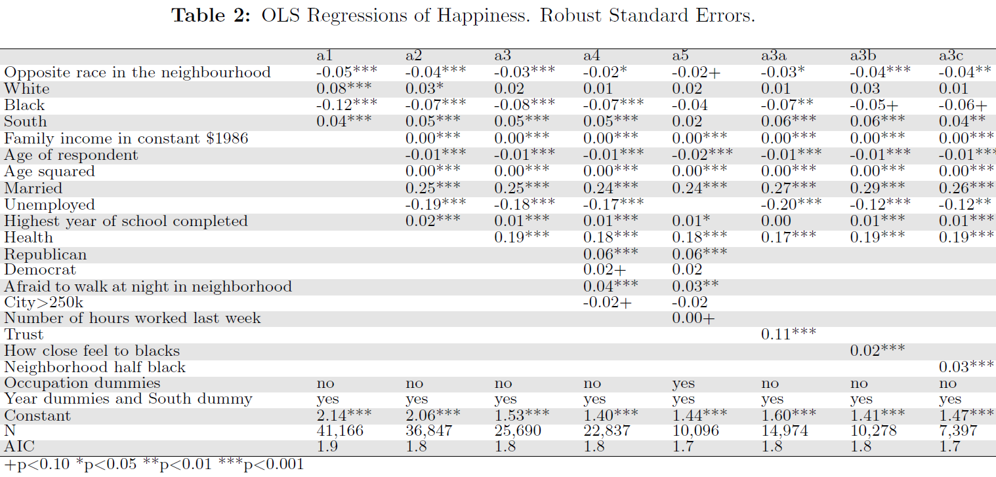
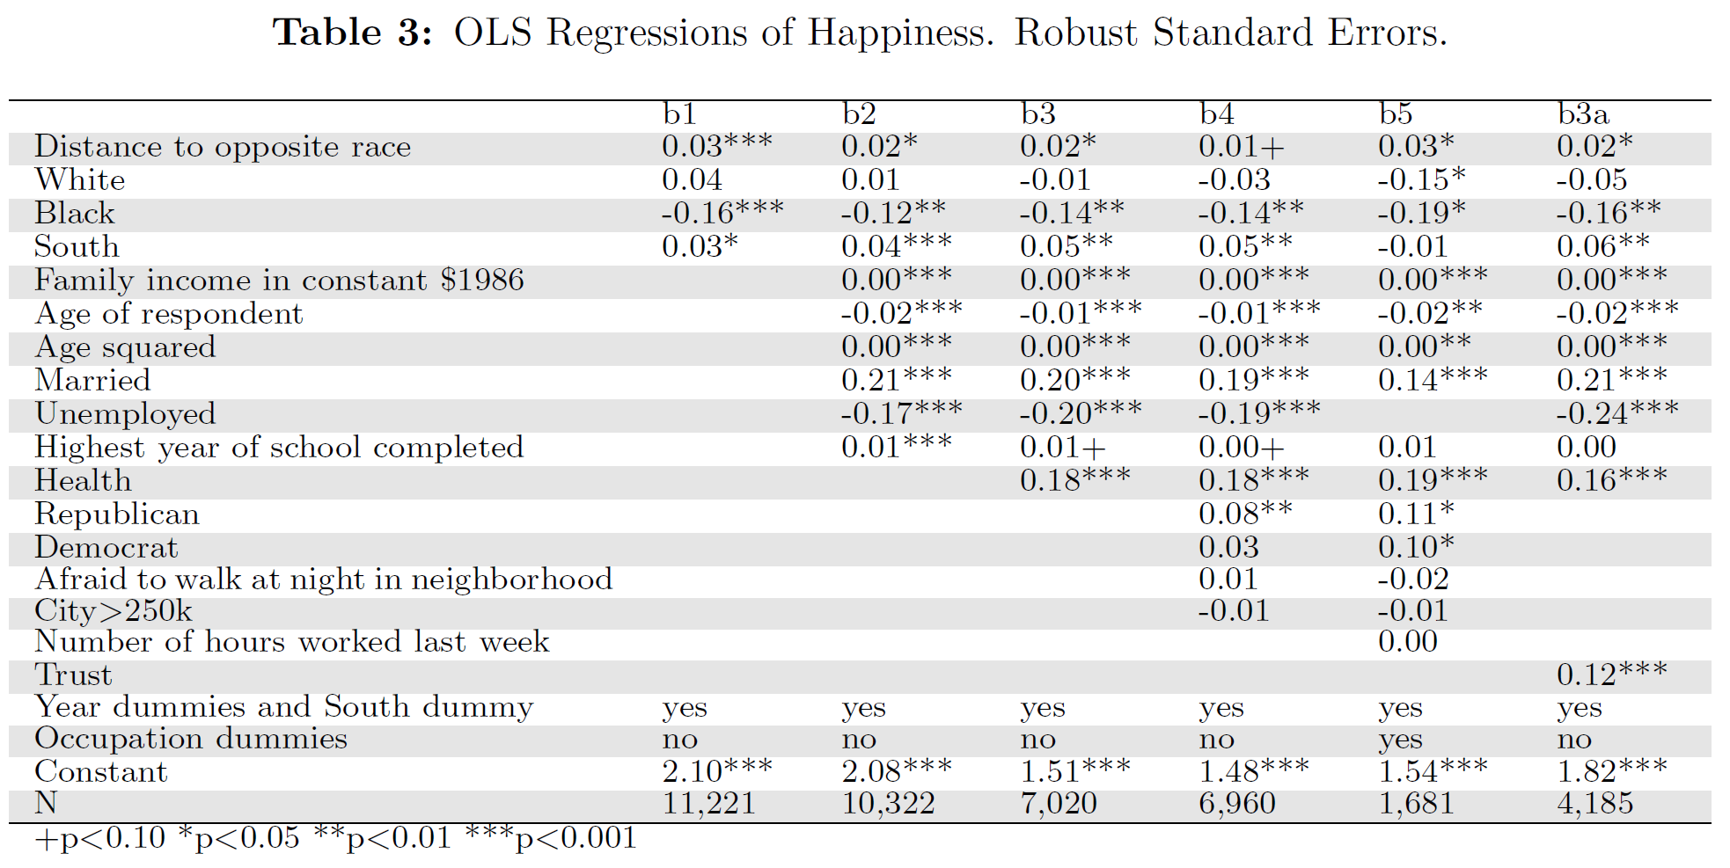

- Is researchers' hypothesis, “We are Happier Among Our Own Race”, supported? Why yes or why not? Specifically, are results consistent across tables and specifications, and please discuss statistical significance and practical significance (so called 'effect size').
- What limitation is there in race measurement and how it affects the study conclusions?
- Study uses data polled over long period of time—what could be the problem?
- There is arguably self-selection—people who live in desegregated neighborhoods are arguably more open to other races. How such self-selection would affect results?
- How would you improve this study in terms of statistics and/or research design? And how would you interpret its implications in terms of community development?

answers
- yes! Results are consistent across the board! And statistically significant, but there is a need for discussion of effect sizes—student must compare size of coeficients to other variables and discuss and student must take into account measurement of variables in discussion! Notably dummy variable can be directly compare to another dummy variable but for other variables, student need to take into account the number of levels.
- There are just whites and blacks and so cannot generalize to other races.
- Everything is socially constructed! And so is race and conceptions of race have changed over time!
- Results are weaker than they would be without selfselection—that is without self selection, people would be even more happy among their own race
- Many ways! Notably panel data, multilevel modeling, quasi experiment or even experiment, say MTO!; the interpretation is tough! Notably what makes us happy is not always the right thing to do and there are other multiple benefits in terms of community development—notably segregation has at least long run negative consequences, so short run happiness is probably not the outcome to be maximized

