MEDIAN VOTERS’ HAPPINESS CYCLES IN THE UNITED STATES ALONG THE NATION’S PRINCIPAL POLITICAL FAULTLINE

Brian J.L. Berry[1], Adam Okuliez-Kozary[2], and Rubia Valente[3]

Abstract: American politics is polarized between happy conservative Republicans and unhappy liberal Democrats. Oscillating in the “happiness gap” between these extremes are median voters whose happiness, low on average, falls the longer in power the party of the opposing ideology. It is the rise and fall of median voters’ unhappiness that drives the regime change between the two major political parties.

1. INTRODUCTION: THE GAP

The popular press has been quick to proclaim that there is a “happiness gap” in American politics: Republicans are happier than democrats; conservatives are happier than liberals (Taylor et al., 2006, Weiner, 2008, Montgomery, 2008). The gap is said to have been produced by a “Big Sort” (Bishop and Cushing 2008, Fiorina and Abrams 2008, Abrams and Pope 2008, Abramowitz and Sanders 2008, Levendusky 2009, Johnston, Manley and Jones 2016) that is the outcome of the confrontation of two political cultures, competitive individualism and egalitarian collectivism, that are committed to conflicting core values of ordered liberty and social justice (Marietta 2012) and that separate party and ideology along the nation’s principal “political fault line” (Brooks 2008). This polarization may be seen in Figure 1, a phase-space rendering (Baumol and Benhabib 1989) of the changes in happiness of conservative Republicans and liberal Democrats (LD) over the 1972-2014 timespan, as recorded by 30 successive General Social Surveys (Appendix A). The figure reveals that happiness cycles up and down along a principal axis. Consistent with the extant literature there is a clear gap between the ideological extremes of the two parties: there is clear evidence of the Big Sort.

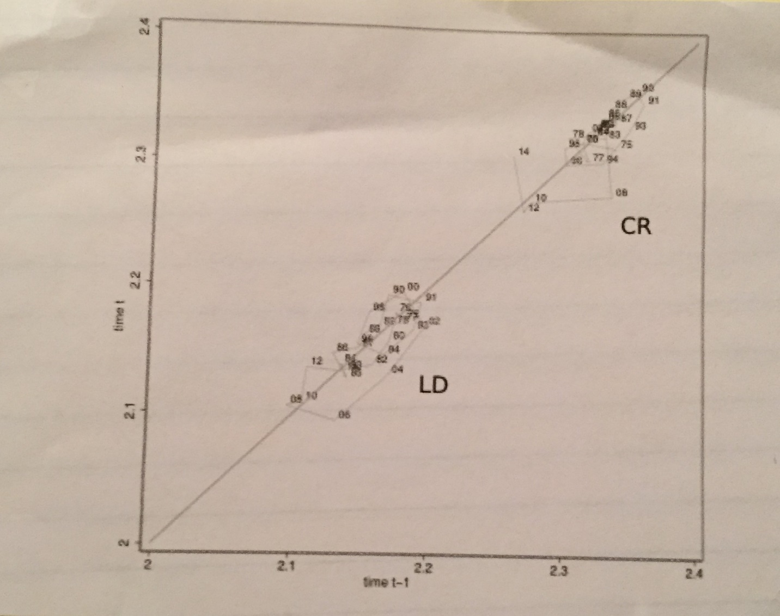  
Figure 1. Smoothed average happiness scores for conservative Republicans (CR) and liberal Democrats (LD) 1972 - 2014 plotted in t/t-1 phase space. The data come from the 30 successive General Social Surveys described in Appendix A, smoothed with a 5-survey moving average (2 lags each forward and back, plus the present term). Survey years are dated by two digits, i.e., 91 is 1991, etc. The CR are top right and are tightly clustered, with the exception of the recent lag during the Obama presidency (2010-2014). The LD show wider cycling, with the lower values during the G. W. Bush presidency (2006-2008). The phase-space plot’s axis (an “attractor”) provides an initial suggestion of an “equilibrium or limit time path of a stable dynamic system” (Baumol and Benhabib 1989, p. 91). When the data reveal a closed loop, the limit path is a cycle, which implies an endogenous causal process.

What is missing in this representation is the middle, however — “the median voter” (Holcombe 2006). The purpose of this paper is to present a preliminary examination of the relationship between happiness, party preference and ideology of those in the middle, the so-called “Independent” voters with moderate political beliefs. The data source used, the General Social Survey, yields only 30 data points from 1972 to 2014, too few for refined statistical analyses. What therefore are discussed in this paper are preliminary findings and research questions that ultimately will need to be resolved by using different kinds of data that permit more refined analyses. The facts of polarization are clear. What we offer are hypotheses about the voters in the middle. Does their happiness and their vote run counter to the party in power as Merrill, Grofman and Brunell (2008) suggest, or is there a different dynamic? Are there differences in the happiness/voting dynamics of ideologically differentiated Independents? These are the types of questions that are of interest.

1. WHY POLARIZATION?

The setting for the discussion is CR/LD polarization at the extremes (Appendix B). Explanations for polarization by party and ideology are to be found not only among political scientists, but also in the work of cultural anthropologists and political psychologists. Culture (the “collective programming of the mind” (Hofstede 1980) is what transmits values and sets priorities for sorting out and implementing one code of behavior as opposed to others. For example, the fact that conservative Republicans enjoy better health status than other Americans, even when controlling for age, sex, income, etc., and are happier, for it, probably reflects the core value of individual responsibility (Subramanian and Perkins 2009). Prioritizing involves emotional commitment, with roots in the values that are learned during socialization, when a child becomes committed to a particular paradigm, a set of beliefs about the world that guides and legitimates subsequent action — either the core values of the societal mainstream or values in opposition to them (Lane 2000). Through the process of legitimation, core values translate into ideology and ideology drives politics (Jost et al. 2009). Party ideology thus serve as a proxy for the broader influence of culture on happiness. Napier and Jost (2008 p. 265) write:

political conservatism is a system-justifying ideology that is associated with the endorsement of a fairly wide range of rationalizations of current social, economic, and political institutions and arrangements … the endorsement of system-justifying beliefs is generally associated with high personal satisfaction, as well as increased positive affect and decreased negative affect.

Within a society that is committed by its constitution to competitive individualism, the result is discontent and feelings of unfairness among those who feel left out (Wildavsky 1987, Piketty 1995, Benabou and Tirole 2006). At the core is inequality, which conservatives see as the natural outcome of a fair, legitimate meritocratic system (Napier and Jost 2008) whereas the liberal view is that inequality reflects discriminatory exploitation, is socially undesirable because it makes people, including themselves, miserable, and therefore must be corrected by governmental action (Brooks 2007). Inequality has increased in the U.S. since 1970 and liberals’ unhappiness with it (Napier and Jost 2008). The result is argued to be a bipolar crystallization: disparate political cultures have strengthened, with the parties taking ownership of social and religious issues that once straddled the political divide (Gelman et al. 2008). DiMaggio et al. (1996) and Di Tella and MacCulloch (2005) relate increased partisanship to polarization and to widening gaps in happiness. Confirming the polarization, the national exit polls taken at each election 2004-2014 show that Democrats voting for their own party varied between 90 and 93 percent while that for Republicans voting Republican ranged from 89 to 94 percent.

1. THE MIDDLE GROUND

Polarization is not the end of the story, however: there is a middle ground. The national exit polls also show an Independent vote that ranges from 37 to 57 percent for Democrats and 39 to 56 percent for Republicans, each high when the other is low. Between 1972 and 2014 this Independent vote cycled up and down along the nation’s principal political axis, reaching a high point for Democrats when Obama was elected and falling to lows in the Nixon and Reagan second terms (Figure 2). Independent votes for Republicans were at their highest during the Carter and Reagan presidencies and lowest under G. W. Bush.

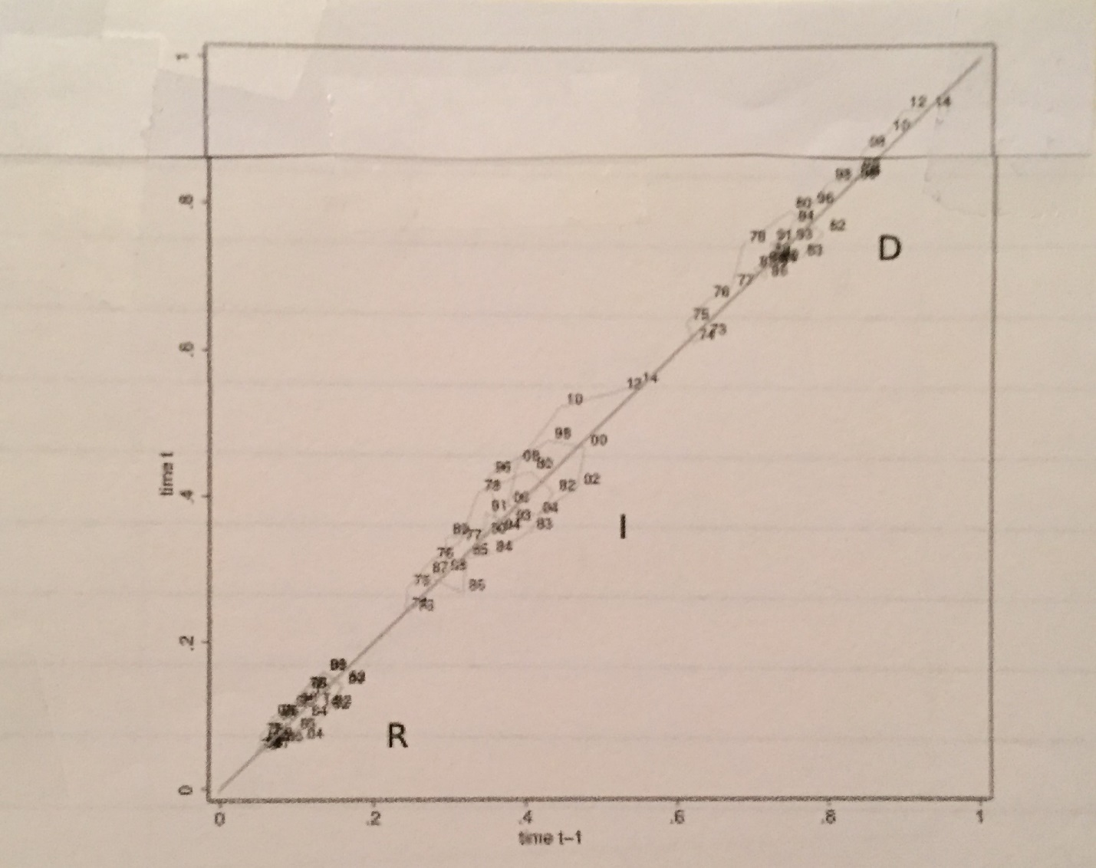

Figure 2. Shares of the votes of Democrats, Independents and Republican voters for Democrat candidates 1972-2014 plotted in t|t-1 phase space. The data are smoothest using the same process as in Fig. 1. The plot reveals a single political spectrum with three non-overlapping blocs cycling along it.

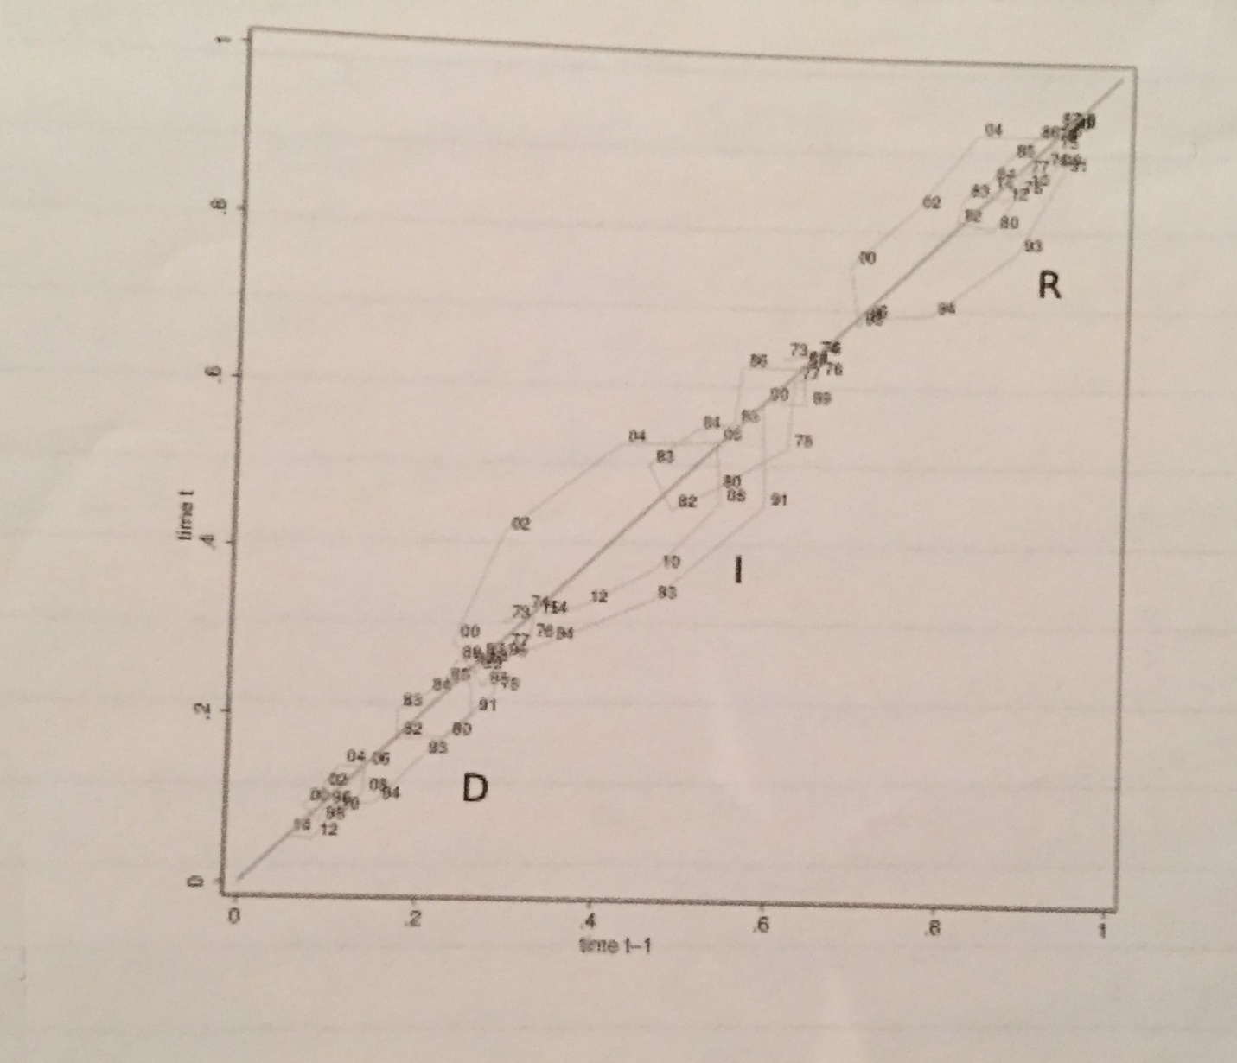

Figure 3. Shares of the votes of Republican, Independent and Democrats voters and for Republican candidates 1972-2014, plotted t|t-1 phase space. The data are smoothed using the same process as in Fig. 1. There is much greater variability in the Republican vote shares, as evidenced by the wider cycling along the nation’s political axis than in Fig. 2.

This evidence supports that part of the political scientists’ “median voter” hypothesis that rests on election alternatives being arrayed along a single political spectrum from right to left (Hotelling 1929) as well as the part that argues that election outcomes are consistent with the preferences of the median voter (Holcomb 2006). The first question we ask is therefore whether the cycling of electoral outcomes is correlated with swings in the happiness of Independent voters. Do median voters become unhappier the greater the longevity of the party in power, leading to vote swings, as implied by Merrill, Grofman and Brunell (2008), or is there some other dynamic at work, or perhaps no relationship at all? To provide insights we examine the varying levels of happiness of different ideological subgroups of Independent voters over the 1972-2014 timespan.

First, the GSS tells us that over the 1972-2014 period Independent voters of all ideological persuasions were unhappier than Republicans and slightly less happy than Democrats. Across all three party preferences, conservatives were happier than moderates who in turn were slightly happier than liberals. At the extremes, the average happiness score of Conservative Republicans was 2.33 while that of Liberal Democrats was 2.15, as shown in Table 1.

Table 1

Average Happiness Scores by Party and Ideology, 1972-2014

|  |  |  |  |
| --- | --- | --- | --- |
|  | Republicans | Independent | Democrat |
| Conservative | 2.33 | 2.15 | 2.18 |
| Moderate | 2.25 | 2.14 | 2.16 |
| Liberal | 2.22 | 2.11 | 2.15 |

1For details see Appendix A.

Information on the accompanying dynamics can be gleaned from three phase space diagrams, Figures 4, 5 and 6. What these diagrams reveal is the volatility of the happiness of the three ideological subgroups of Independent voters, for greater than that of the CR and LD extremes which is consistent with the greater overall levels of unhappiness of the Independent voters. Liberal Independents plunged to the lowest levels of happiness during the G. W. Bush presidency (Figure 4), moderate Independents cycled in a range overlapping the higher happiness levels of the LIs (Figure 5) and conservative Independents maintained higher happiness levels that peaked during Ronald Raegan’s first term in office (Figure 6). Together, the subgroups of independent voters’ happiness scores range over and above those of the liberal Democrats but do not rise to that of the conservative Republicans.

More detailed inspection of the graphs yields further insights into the links between unhappiness and regime change. The Merrill-Grofman-Brunell thesis, a component of their voter party interaction model, is “that voters near the center of the voter distribution and

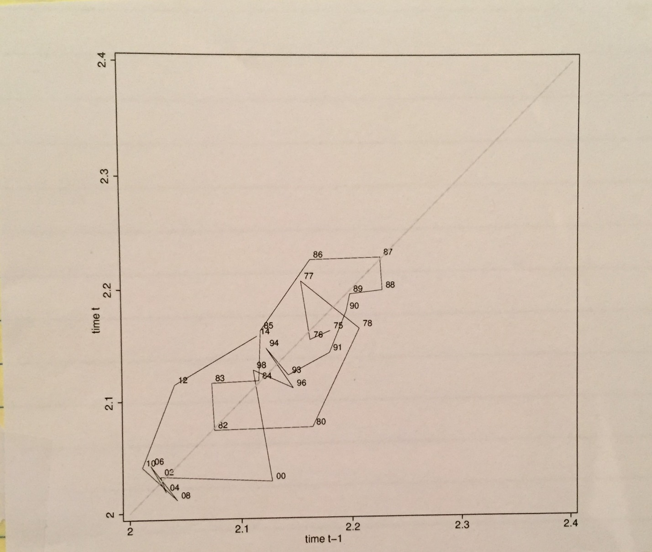Figure 4. Variations in the happiness of liberal Independents in t|t-1 phase space, with data smoothed consistent with Fig. 1.

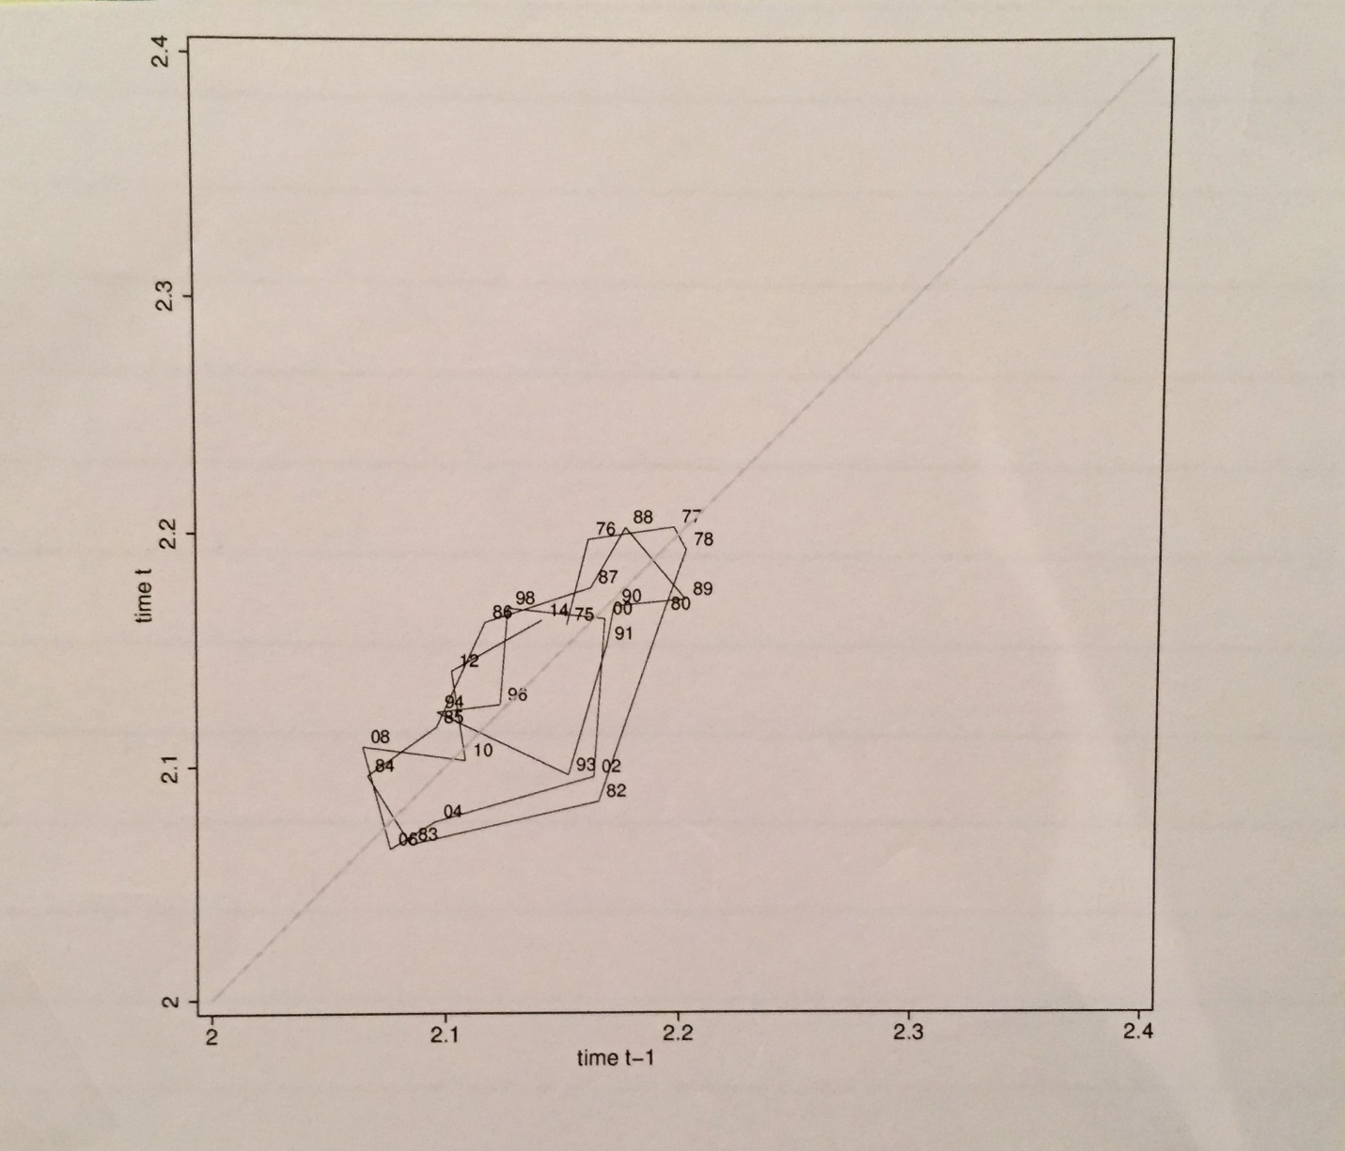Figure 5. Variations in the happiness of moderate Independents in t|t-1 phase space, with data smoothed consistent with Fig. 1.

hence the median voter - move away from the position of the party in power, by an amount proportional to the distance between the median voter and the party’s position. In other words swing voters including the median voter may react negatively to politics implemented by the party in power.” (*ibid* 2008 p.8). Evidence in support of this thesis is to be found in the three figures, *revealing that increased unhappiness goes hand in hand with the incumbency of the opposing ideology*. Liberal and moderate Independents joined with liberal Democrats in their unhappiness during the conservative Reagan and G. W. Bush presidencies.

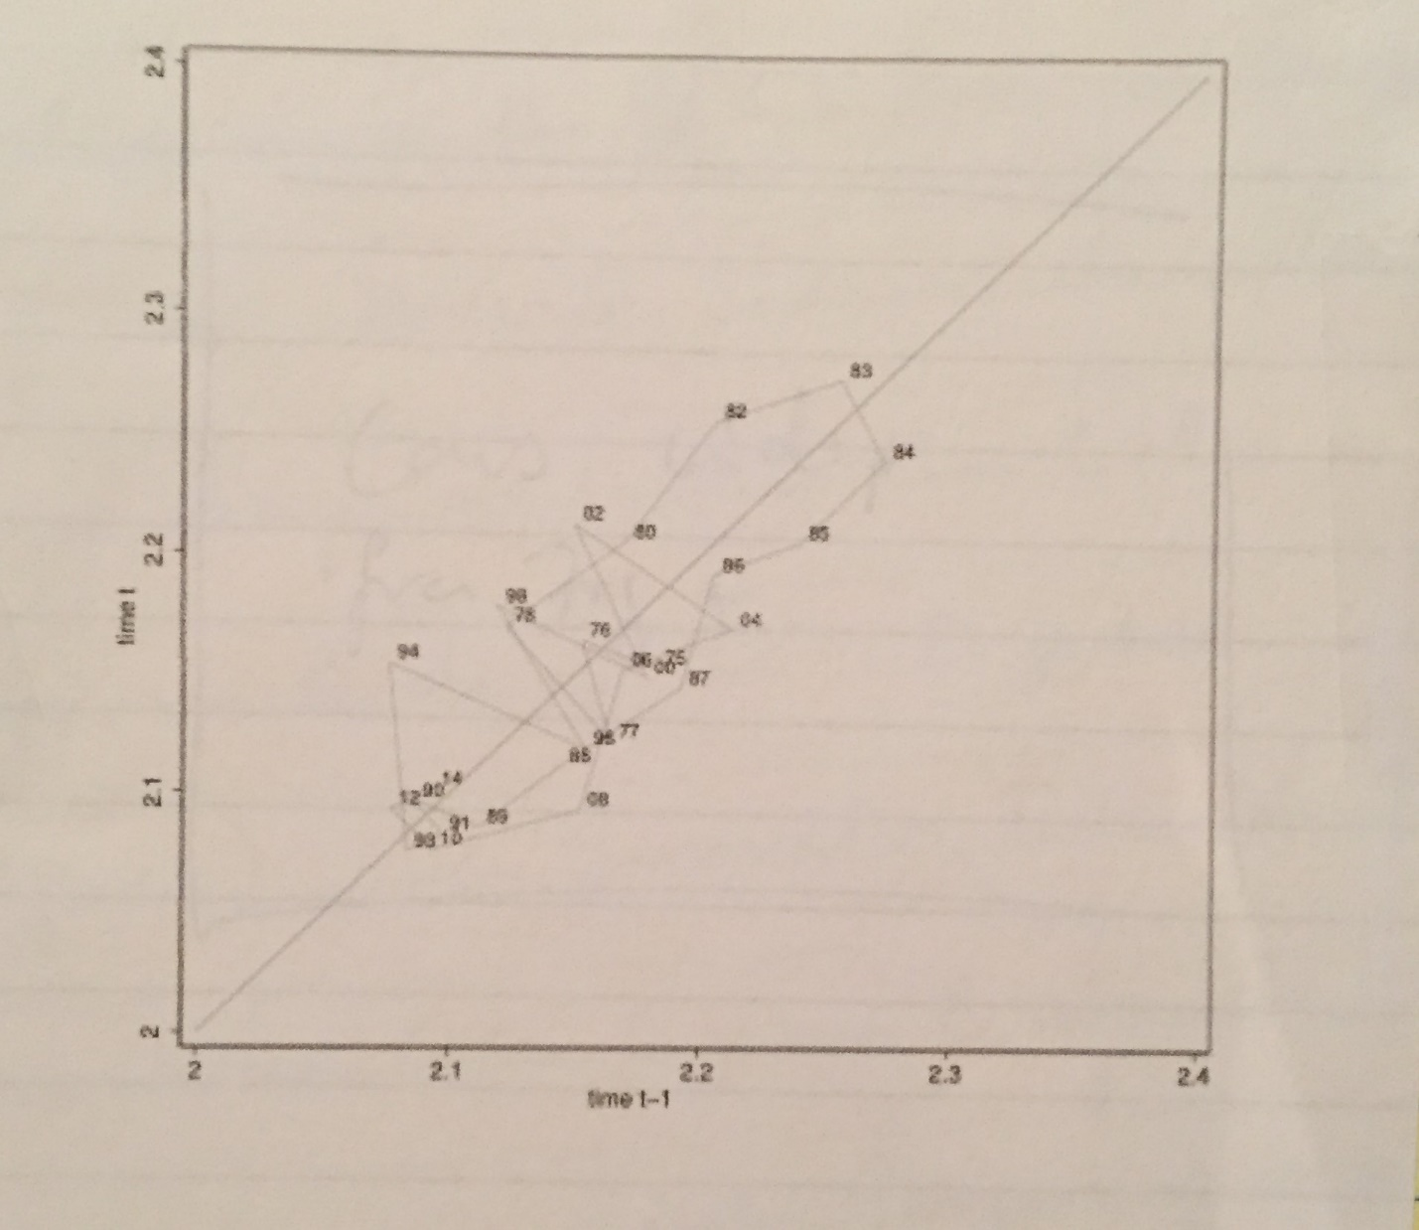Figure 6. Variations in the happiness of conservative Independents in t|t-1 phase space, with data smoothed consistent with Fig. 1.

Conservative Independents and conservative Republicans shared extreme unhappiness during the Obama administration, and to a lesser extent during the George H. W. Bush presidency as he retreated from Reagan’s conservative principles. At the other extreme, liberals and moderates were at their happiest after Carter replaced the Nixon-Ford administration and as the Reagan-Bush presidency drew to an end. Conservatives’ happiness was greatest after Reagan was elected and Democrats were ousted from office.

__________________________________________________________________________

Table 2 goes here __________________________________________________________________________

Table 2 summarizes these findings. There are two ideologically differentiated groups of responses. Liberal Independents shared surging happiness with Liberal Democrats during the post-Nixon/Ford presidency of Carter and as the Reagan/Bush presidencies drew to an end. Maximum unhappiness occurred during the Reagan and G. W. Bush presidencies. Self-named “moderate” Independents also followed this pattern, consistent with the ideological drift of this group shown in Appendix A. At the other extreme Conservative Independents

Table 2

Happiness Highs and Lows 1972-2014 by Party, Ideology and Presidency

|  |  |  |
| --- | --- | --- |
| Respondents’ Ideology | Happiness | |
|  | Highest | Lowest |
| Liberal | Carter | GHW Bush |
| Democrats | GHW Bush | Reagan |
| Liberal | Reagan 2 | G. W. Bush |
| Independent | Carter | Reagan 1 |
| Moderate | Carter | G. W. Bush |
| Independent | G. H. W. Bush | Reagan 1 |
| Conservative | Reagan 1 | Obama |
| Independent |  | G. H. W. Bush |
| Conservative | Reagan 1 | Obama |
| Republican |  |  |

and Conservative Republicans were happiest when the conservative Ronald Reagan was in office and have been at their unhappiest during the left-wing presidency of Barack Obama.

Thus, happiness for liberals is greatest when Conservative regimes approach their end but for Conservatives it is at its peak when a Conservative is president. Unhappiness soars for both groups when the White House is occupied by a president of opposite ideology. Mounting unhappiness with the party in power thus lies at the heart of periodicities in political realignment (Schlesinger 1939). Incumbents lose vote share over time (Samuels 2004): as easy issues are dealt with what is left are more intractable problems (Bartels and Zaller 2001). These accumulate to a “common national mood (that) responds thermostatically to government policy. Mood becomes more conservative under liberal governments, more liberal under conservative regimes” (Stimson 2004).

Polarization at the extremes means that the critical mood swings are those driven by rising unhappiness among those in the middle: as happiness increases liberal and moderate Independents cast less votes for Democrats: they support their own party most when they are the unhappiest - the greater the perceptions of unfairness the greater the misery and the greater the party support (Brooks 2008). On the other hand, the vote share of conservative Independents for Democrats remains constant. Conservative Independents are happiest during the early years of Republican administrations but unhappiest as they approach their end. Moderate and liberal Independents are unhappiest in the early stages of Republican administrations, but their happiness grows as the prospect of the replacement of the Republicans by a Democratic administration increases. The greatest volatility in the vote associated with happiness/liberal policy mood is seen among moderate and liberal Independents. The greater their unhappiness the less likely they are to support the Republicans and more likely to vote for Democrats. Not unexpectedly, the elasticity of this vote shift appears to be greater for their Republican vote than for their Democrat support. The Merrill-Grofman-Brunell principle thus does not apply to all “median” voters; conservative Independents’ vote shares for Republicans and Democrats appear immune to swings in their happiness. It is the vote shares of liberal and moderate Independents that fluctuate. The greater their unhappiness the more likely they are to vote for Democrats.

Notes

1. There are interesting subcultural variations. Podhoretz (2009) asks why American Jews “live rich but vote poor.” American Jews, despite their material success in America, vote predominantly for Democrats. Podhoretz says this is because the Democratic party represents the closest counterparts to the forces on the left that favored Jewish emancipation in Europe. As a result the American Jewish attitude towards Christian conservatives is most frequently one of contempt. There is a strong echo of the Menshevik Jews who fled to America, with a gradual attenuation of Marxism into social democracy and social democracy into the liberalism that has becomes the very essence of American Jewish culture.

APPENDIX A

HAPPINESS, PARTY AND IDEOLOGY IN THE GENERAL SOCIAL SURVEYS

The General Social Survey (GSS) has been conducted by the National Opinion Research Center annually since 1972, except for the years 1979, 1981 and 1992 (a supplement was added in 1992), and biennially beginning in 1994 — a total of 30 surveys in all. For each survey the Roper Center for Public Opinion Research prepares a cumulative dataset that merges previous years of the GSS into a single file, with each year of survey constituting a subfile. The content of each survey changes slightly as some items are added to or deleted from the interview schedule. Main areas covered in the GSS include socioeconomic status, social mobility, social control, the family, race relations, sex relations, civil liberties, and morality. Topical modules designed to investigate new issues aor to expand the coverage of an existing subject have been part of the GSS since 1977, when the first module on race, abortion, and feminism appeared.

In the surveys the question is

*Taken all together, how would you say things are these days - would you say that*

*you are very happy, pretty happy, or not too happy?*

*Very happy 1*

*Pretty happy 2*

*Not too happy 3*

To facilitate analysis in this paper this scale was reversed from “very happy” 3 to “not too happy” 1.

The GSS also provides information on each respondent’s party preference and ideology. The preference question is:

*Generally speaking, do you usually think of yourself as a Republican. Democrat, Independent or what?*

*Republican (ASK A) 1*

*Democrat (ASK A) 2*

*Independent (ASK B) 3*

*Other (SPECIFY AND ASK B) 4*

*No preference (ASK B) 8*

1. *Would you call yourself a strong (Republican/Democrat) or not?*

*Strong 1*

*Not very strong 2*

1. *Do you think of yourself as closer to the Republican or Democratic Party?*

*Republican 3*

*Democratic 4*

*Neither 8*

To facilitate analysis with this paper party affiliation was collapsed into three groups: Republican and leaning Republican (1 + B3). Democrat and leaning Democrat (1 + B4), and Independent (B8). Grouped in this way 35.5% of the survey respondents classified themselves as Republicans, 49.57% as Democrats and 14.88% as Independents.

The GSS respondents’ political ideology comes from the question:

*We hear a lot of talk these days about liberals and conservatives. I’m going to show you a seven-point scale on which the political views that people might hold are arranged from extremely liberal —point 1 — to extremely conservative — point 7. Where would you place yourself on this scale?*

*Extremely liberal 1*

*Liberal 2*

*Slightly liberal 3*

*Moderate, middle of the road 4*

*Slightly conservative 5*

*Conservative 6*

*Extremely conservative 7*

Ideology was collapsed into three categories: liberal (1+2+3), moderate (4), and conservative (5+6+7). So grouped, the surveys yielded 34.09% conservatives, 38.66% moderates and 27.25% liberals.

APPENDIX B

DISTRIBUTION OF GSS RESPONDENTS BY PARTY AND IDEOLOGY: SHIFTS TO THE EXTREMES

The percentage distribution of GSS respondents by party and ideology between 1972 and 2014 is as follows:

|  |  |  |  |  |
| --- | --- | --- | --- | --- |
|  | Republicans | Independent | Democrat | Row Sum |
| Conservative | 18.99 | 3.99 | 11.12 | 34.09 |
| Moderate | 11.62 | 7.26 | 19.77 | 38.66 |
| Liberal | 4.95 | 3.68 | 18.67 | 27.25 |
| Column Sum | 35.55 | 14.88 | 49.57 | 100.00 |

Clearly, party ideology are not closely related. If they were not related at all but had the same marginal percentage breakdowns, the joint probability of independent events yields a somewhat different subgroup breakdown:

|  |  |  |  |  |
| --- | --- | --- | --- | --- |
|  | Republicans | Independent | Democrat | Row Sum |
| Conservative | 12.12 | 5.07 | 16.90 | 34.09 |
| Moderate | 13.74 | 5.75 | 19.16 | 38.66 |
| Liberal | 9.69 | 4.05 | 12.51 | 27.25 |
| Column Sum | 35.55 | 14.88 | 49.57 | 100.00 |

The difference between these tables (actual minus independent) provides estimates of the extent and location of the relationship between party and ideology:

|  |  |  |  |  |
| --- | --- | --- | --- | --- |
|  | Republicans | Independent | Democrat | Row Sum |
| Conservative | +6.89 | -.108 | -5.78 | 0 |
| Moderate | -2.12 | +1.51 | +0.61 | 0 |
| Liberal | -4.74 | -0.42 | +5.16 | 0 |
| Column Sum | 0 | 0 | 0 | 0 |

There is a clear shift of 13.53 percentage points to the principal axis, with 12 percentage points of this to the pair of polar extremes, +6.86% conservative Republicans and +5.16% liberal Democrat. Polarization thus exists along a main axis, but there also are moderate Independents on that axis.

REFERENCES

Abramowitz, A. I., & Saunders, K. L. (2008). Is polarization a myth? *The Journal of Politics*, *70*(02), 542-555.

Baumol, W. J., & Benhabib, J. (1989). Chaos: significance, mechanism, and economic applications. *The Journal of Economic Perspectives*, *3*(1), 77-105.

Benabou, R., & Tirole, J. (2005). Belief in a just world and redistributive politics. *Quarterly Journal of Economic Research, 121,* 699 -749.

Bishop, B. (2009). *The big sort: Why the clustering of like-minded America is tearing us apart*. Boston: Houghton Mifflin.

Brooks, A. C. (2007). The Left's Inequality Obsession. *Wall Street Journal*.

_______ (2008). *Gross national happiness: why happiness matters for America--and how we can get more of it*. New York: Basic Books.

Di Tella, R., & MacCulloch, R. (2005). Partisan social happiness. *The Review of Economic Studies*, *72*(2), 367-393.

DiMaggio, P., Evans, J., & Bryson, B. (1996). Have American's social attitudes become more polarized? *American Journal of Sociology*, *120,* 690-755.

Fiorina, M. P., & Abrams, S. J. (2008). Political polarization in the American public. *Annual Review of Political Science*, *11*, 563-588.

Fiorina, M. P., Abrams, S. A., & Pope, J. C. (2008). Polarization in the American public: Misconceptions and mis-readings. *The Journal of Politics*, *70*(02), 556-560.

Gelman, A. B. Shor, J. Bafumi, & D. Park (2008). *Red state, blue state, rich state, poor state: Why Americans vote the way they do*. Princeton NJ: Princeton University Press.

Hofstede, G. (1980). *Culture’s consequences: National differences in thinking and organizing.* Beverly Hills, CA.: Sage.

Holcombe, R. G. (2006). *Public sector economics: The role of government in the American economy*. Prentice Hall.

Jost, J. T., Federico, C. M., & Napier, J. L. (2009). Political ideology: Its structure, functions, and elective affinities. *Annual Review of Psychology*, *60*, 307-337.

Johnston, R., Manley, D., & Jones, K. (2016). Spatial Polarization of Presidential Voting in the United States, 1992–2012: The “Big Sort” Revisited. *Annals of the Association of American Geographers*, *106*(5), 1047-1062.

Lane, R. E. (2000). *The loss of happiness in market democracies*. Yale University Press.

Marietta, M. (2012). *A Citizen’s Guide to American Ideology: Conservatism and Liberalism in Contemporary Politics*. New York, NY: Routledge.

Merrill, S., Grofman, B., & Brunell, T. L. (2008). Cycles in American national electoral politics, 1854–2006: statistical evidence and an explanatory model. *American Political Science Review*, *102*(01), 1-17.

Montgomery, D. (2008). A Happiness Gap: Doomacrats and Republigrins. *Washington Post*, *Oct.* *24.*

Napier, J. L., & Jost, J. T. (2008). Why are conservatives happier than liberals? *Psychological Science*, *19*(6), 565-572.

Piketty, T. (1995). Social mobility and redistributive politics. *The Quarterly Journal of Economics*, 551-584.

Podhoretz, N. (2010). *Why are Jews Liberals?* Vintage Books USA.

Schlesinger, A. M. (1939). Tides of American politics. *Yale Review*, *29*(2), 217-230.

Stimson, J. A. (2015*). Tides of consent: How public opinion shapes American politics.* Cambridge University Press.

Subramanian, S. V., & Perkins, J. M. (2010). Are republicans healthier than democrats?  *International Journal of Epidemiology*, *39*(3), 930-931.

Taylor, P., Funk, C., & Craighill, P. (2006). Are we happy yet? *A Pew Research Center Social Trends Report.*

Weiner, E. (2008). Why Republicans Are So Darn Happy? *Washington Post, Feb. 9.*

Wildavsky, A. (1987). Choosing preferences by constructing institutions: A cultural theory of preference formation. *American Political Science Review*, *81*(01), 3-21.

Williams, G. P. (1997). *Chaos theory tamed*. Joseph Henry Press.

1. Lloyd Viel Berkner Regental Professor, The University of Texas at Dallas, School of Economic, Political and Policy Sciences, 800 W. Campbell GR 31, Richardson, TX, 75080, United States.
2. Assistant Professor of Public Policy, Department of Public Policy and Administration, Rutgers University, 401 Cooper St., Camden, NJ 08102.
3. Research Associate, The University of Texas at Dallas, School of Economic, Political and Policy Sciences, 800 W. Campbell GR 31, Richardson, TX, 75080, United States.