**Experiment-1**

Name of Student: Abhishek Venkat Bhadre

Division: ICA-B1 Roll No: 21

**Title:** Diode as Clipper & Clamper Circuit

**Objectives:**

* To understand the theory of operation of the clipping and clamping diode circuits.
* To design wave shapes that meet different circuits needs.

**Outcomes:** After completion of the experiment students will be able

* To observe the clipping waveforms in different clipping configurations.
* To understand the IO waveforms of positive and negative clamper

circuits

**Diode as Clipper:**

Electronic devices are very sensitive to voltage. If a large amplitude voltage is applied, it may permanently destroy the device. So, it is essential to protect the electronics devices. The protection of the electronic devices can be achieved by using the clipper circuits. A clipper is a device that removes either the positive half (top half) or negative half (bottom half), or both positive and negative halves of the input AC signal. In other words, a clipper is a device that limits the positive amplitude or negative amplitude or both positive and negative amplitudes of the input AC signal. In some cases, a clipper removes a small portion of the positive half cycle or negative half cycle or both positive and negative half cycles.

The clipper circuits are generally categorized into three types: series clippers, shunt clippers and dual (combination) clippers. In series clippers, the diode is connected in series with the output load resistance. In shunt clippers, the diode is connected in parallel with the output load resistance.

The series and shunt clippers are again classified into four types: series positive clipper, series positive clipper with bias, series negative clipper and series negative clipper with bias.

**Diode Positive Clipper**

Figure 1.(a) shows a diode positive limiter (also called **clipper**) that limits or clips the positive part of the input voltage. As the input voltage goes positive, the diode becomes forward biased and conducts current. Point *A* is limited to +0.7 V when the input voltage exceeds this value. When the input voltage goes back below 0.7 V, the diode is reverse-biased and appears as an open. The output voltage looks like the negative part of the input voltage, but with a magnitude determined by the voltage divider formed by *R*1 and the load resistor, *RL*, as follows:



If *R*1 is small compared to *RL, then Vout ≈ Vin*



If the diode is turned around, as in Figure 1 (b), the negative part of the input voltage is clipped off. When the diode is forward-biased during the negative part of the input voltage, point *A* is held at by the diode drop. When the input voltage goes above the diode is no longer forward-biased; and a voltage appears across *RL* proportional to the input voltage.



**Biased Limiters**The level to which an ac voltage is limited can be adjusted by adding a bias voltage, *V*BIAS, in series with the diode, as shown in Figure 2.a. The voltage at point *A* must equal *V*BIAS + 0.7 V before the diode will become forward-biased and conduct. Once the diode begins to conduct, the voltage at point *A* is limited to *V*BIAS + 0.7 V so that all input voltage above this level is clipped off. To limit a voltage to a specified negative level, the diode and bias voltage must be connected as in Figure 2.b. In this case, the voltage at point *A* must go below -*V*BIAS - 0.7 V to forward-bias the diode and initiate limiting action as shown.



Figure 2.a Positive Biased Clipper



Figure 2.b Negative Biased Clipper

**Procedure: Positive Biased Clipper**

1. Apply sine wave input of 10, 1 KHz for the circuit shown in **2.a.**
2. Connect P-N Junction Diode, R1=10K, RL=100K
3. Connect the biasing potential of 3 V to the diode.
4. Observe and measure the output voltage on Scope.
5. Also observe and draw output waveform for square waveform & triangular wave input.
6. Plot all waveforms

**I/P & O/P Waveforms:** To be drawn by students

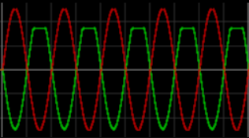

**Procedure:**

**Negative Biased Clipper**

1. Apply sine wave input of 10, 1 KHz for the circuit shown in **2.b.**
2. Connect P-N Junction Diode, R1=10K, RL=100K
3. Connect the biasing potential of 2 V to the diode.
4. Observe and measure the output voltage on Scope.
5. Also observe and draw output waveform for square waveform & triangular wave input.
6. Plot all waveforms

**I/P & O/P Waveforms:** To be drawn by students

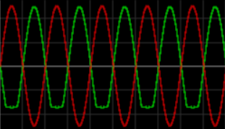

**Conclusion:** To be written by students

1. A Clipper is a circuit designed to prevent a signal from exceeding a predetermined reference voltage level.
2. It does not distort the remaining part of the applied waveform.
3. Clippers are often referred to as voltage limiters, current limiters, slicers, or amplitude selectors.
4. Positive Biased Clippers can be used to clip the positive component of the waveform.
5. Negative Biased Clippers can be used to clip the negative component of the waveform.

**Diode as Clamper:**

A clamper is an electronic circuit that changes the DC level of a signal to the desired level without changing the shape of the applied signal. In other words, the clamper circuit moves the whole signal up or down to set either the positive peak or negative peak of the signal at the desired level.

The dc component is simply added to the input signal or subtracted from the input signal. A clamper circuit adds the positive dc component to the input signal to push it to the positive side. Similarly, a clamper circuit adds the negative dc component to the input signal to push it to the negative side. Clampers are sometimes known as ***dc restorers****.*

**Positive Clamper:**

Figure 3 shows a diode clamper that inserts a positive dc level in the output waveform. The operation of this circuit can be seen by considering the first negative half-cycle of the input voltage. When the input voltage initially goes negative, the diode is forward biased, allowing the capacitor to charge to near the peak of the input as shown in Figure 3(a). Just after the negative peak, the diode is reverse-biased. This is because the cathode is held near by the charge on the capacitor. The capacitor can only discharge through the high resistance of *RL.* So, from the peak of one negative half-cycle to the next, the capacitor discharges very little. The amount that is discharged, of course, depends on the value of *RL.*



Figure 3: Positive Clamper

If the capacitor discharges during the period of the input wave, clamping action is affected. If the *RC* time constant is 100 times the period, the clamping action is excellent. An *RC* time constant of ten times the period will have a small amount of distortion at the ground level due to the charging current. The net effect of the clamping action is that the capacitor retains a charge approximately equal to the peak value of the input less the diode drop. The capacitor voltage acts essentially as a battery in series with the input voltage. The dc voltage of the capacitor adds to the input voltage by superposition, as in Figure 3(b).

**Negative Clamper:**

If the diode is turned around, a negative dc voltage is added to the input voltage to produce the output voltage as shown in Figure 4.



Figure 4 : Negative Clamper

**Procedure: Positive Clamper**

1. Apply sine wave input of 10, 1 KHz for the circuit shown in **3.a.**
2. Connect P-N Junction Diode, Electrolyte Capacitor=10 uF & RL=10K
3. Observe and measure the output voltage on Scope.
4. Also observe and draw output waveform for square waveform & triangular wave input.
5. Plot all waveforms

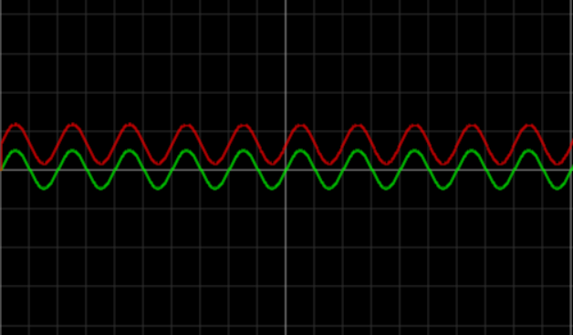

**Procedure: Negative Clamper**

1. Apply sine wave input of 10, 1 KHz for the circuit shown in Figure 4**.**
2. Connect P-N Junction Diode, Electrolyte Capacitor=10 uF & RL=10K
3. Observe and measure the output voltage on Scope.
4. Also observe and draw output waveform for square waveform & triangular wave input.
5. Plot all waveforms

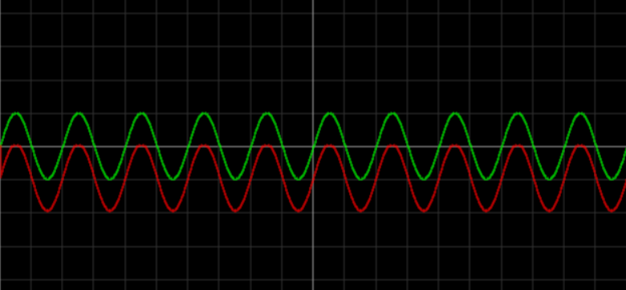

**Conclusion:** To be written by students

1. A clamper is an electronic circuit that moves the whole signal up or down to set either the positive peak or negative peak of the signal at the desired level.
2. The dc component is simply added to the input signal or subtracted from the input signal.
3. In Positive Clamper the positive DC components are added by the circuit to the input signal.
4. In Negative Clamper the negative DC components are added to the input signal to push the signal towards negative side.