**Experiment No: 3**

**Design and evaluation of second order system**

**Aim**: To obtain time response of a second order system in case of under damped, over damped and critically damped systems.

**Theory**: The time response of control system consists of two parts.

* **Transient response**: The part of the time response which goes to zero after large interval of time is known as transient response.
* **Steady state response**: The part of response that means even after the transients have died out is said to be steady state response.

The total response of a system is sum of transient response and steady state response:

**C(t)=Ctr(t)+Css(t).**

Most of the control systems use time as its independent variable. Analysis of response means to see the variation of output with respect to time. The output of the system takes some finite time to reach to its final value. Every system has a tendency to oppose the oscillatory behavior of the system which is called damping. The damping is measured by a factor called damping ratio of the system. If the damping is very high then there will not be any oscillations in the output. The output is purely exponential. Such system is called an over damped system. If the damping is less compared to over damped case then the system is called a critically damped system. If the damping is very less than the system is called under damped system. With no damping system is undammed.

The dynamic behavior of the second-order system can then be described in terms of two parameters: **the damping ratio and the natural frequency.**

If the dumping ratio is between **0 and 1**, the system poles are complex conjugates and lie in the left half s plane. The system is then called **under damped**, and the transient response is oscillatory. If the damping ratio is equal to **1** the system is called **critically** damped, and when the damping ratio is larger than 1 we have **over damped** system. The transient response of critically damped and over damped systems do not oscillate. If the damping ratio is 0, the transient response does not die out called as **un-damped** system .

* **Delay time (*td*) :** The delay time is the time required for the response to reach half the final value the very first time.
* **Rise time (*tr*):** The rise time is the time required for the response to rise from 10% to 90%, 5% to 95%, or 0% to 100% of its final value. For under damped second-order systems, the 0% to 100% rise time is normally used. For over damped systems, the 10% to 90% rise time is commonly used.
* **Peak time (*tp*):** The peak time is the time required for the response to reach the first peak of the overshoot.
* **Maximum (percent) overshoot (*Mp*)** : The maximum overshoot is the maximum peak value of the response curve measured from unity. If the final steady-state value of the response differs from unity, then it is common to use the maximum percent overshoot.
* **Settling time (*t*s)** : The settling time is the time required for the response curve to reach and stay within a range about the final value of size specified by absolute percentage of the final value (usually 2% or 5%). The settling time is related to the largest time constant of the control system.

|  |  |
| --- | --- |
| **ξ** | **Damping Type** |
| 1<ξ<∞ | Over damped system. |
| ξ =1 | Critically damped system. |
| 0<ξ<1 | Under damped system. |
| ξ=0 | Un-damped system. |

**Time domain specifications**:

1. Delay time Td = (1 + 0.7ξ)/wn
2. Rise Time Tr =(Π – θ)/ wd
3. Peak overshoot time = Tp = Π/ wd
4. % Mp = exp( - Πξ/sqrt(1-ξ2 ))
5. Settling Time Ts = 4/ ξwn (2% tolerance)

**Apparatus Required:**

PC or laptop loaded with MATLAB

**Procedure:**

Open the MATLAB command window.

1) Click on file-new-M file to open the MATLAB editor window.

2) In the given MATLAB editor window enter the program to obtain the step response.

3) Save the file in work directory.

4) Run the program and enter the respective value for natural frequency, damping ratio and time.

5) The graphs displayed are according to the above values.

6) The values of ***wd, td, tr, ts, Mp*** can be obtained by,

* Right click on the figure window and select grid to get grids on the curve.
* Right click on the figure window and select characteristics and enable peak response, settling time and rise settling.
* Repeat the steps 5,6,7 for different values of ξ.

**Graph:**

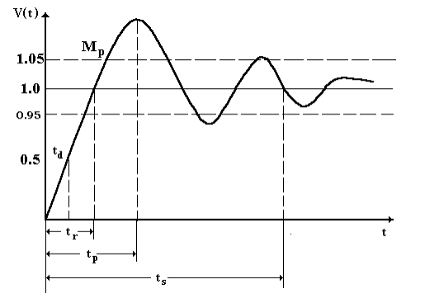

**MATLAB Output (Graph):** (To be Drawn by the students)

**1) Over damped system waveform:**

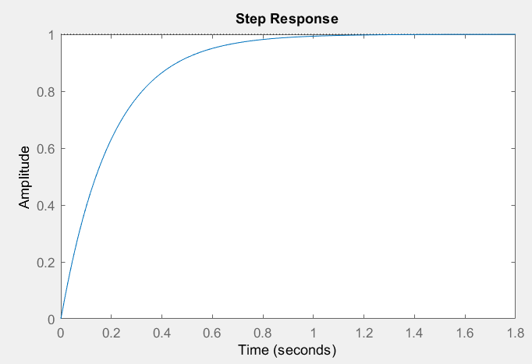

**2) Critically damped system:**

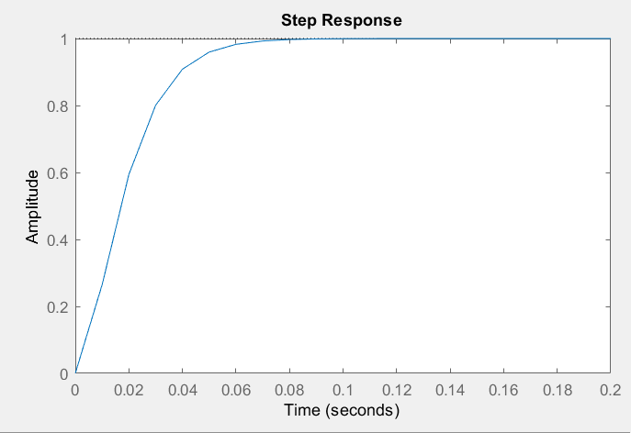

**3)Under damped system:**

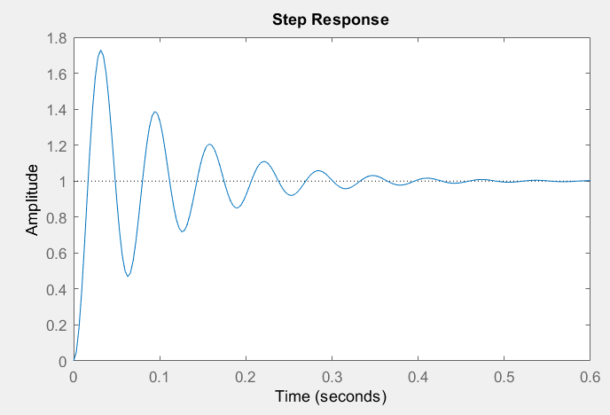

**4) Un-damped system:**

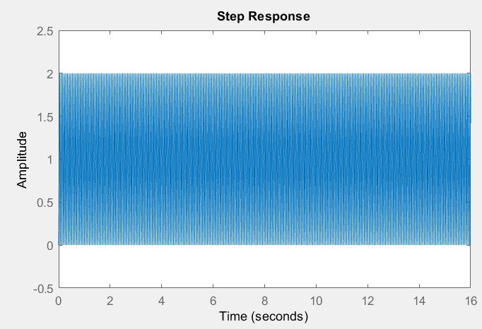

|  |  |  |  |  |  |  |  |  |  |
| --- | --- | --- | --- | --- | --- | --- | --- | --- | --- |
| **Parameter** | **ξ=0.1 and ωn=10** | **ξ=0.1 and ωn=100** | **ξ=0.1 and ωn=1000** | **ξ=1 and ωn=10** | **ξ=1 and ωn=100** | **ξ=1 and ωn=1000** | **ξ=2 and ωn=10** | **ξ=2 and ωn=100** | **ξ=2 and ωn=1000** |
| **Td** | **0.107** | **0.0107** | **0.00107** | **0.17** | **0.017** | **0.0017** | **0.24** | **0.024** | **0.0024** |
| **Tr** | **0.113** | **0.0113** | **0.00113** | **0.336** | **0.0354** | **0.00336** | **0.823** | **0.0823** | **0.00823** |
| **Mp** | **72.9** | **72.9** | **72.9** | **0** | **0** | **0** | **0** | **0** | **0** |
| **Tp** | **0.314** | **0.0314** | **0.00314** | **>0.8** | **>0.2** | **>0.012** | **>2.5** | **>0.25** | **>0.025** |
| **Ts** | **3.84** | **0.384** | **0.0384** | **0.583** | **0.0589** | **0.00583** | **1.49** | **0.149** | **0.0149** |

**Conclusion:**

The time response of the system is determined by considering the damping ratio and frequency of the signal. Transient response of the system was learned and the analysis of the system was performed.