**Experiment No: 5**

**Implementation of Load Power Control Using**

**Gate Firing Circuits of SCR**

Name: Niraj Ahire Roll No. 05

**Aim**: To implement and analyze, Fan Regulator as an application of load power control, using firing angle (α°) control.

**Theory**:

***1. Introduction***

Control and conversion of large power using electronic circuits, is referred as power electronics. Variety of industrial/ commercial loads such as motors are powered either from a dc source or ac source. Single phase and three phase ac supplies are readily available for conversion and utilization in driving these loads. Power converters are generally classified as – ac to dc converters (Rectifiers), dc to dc converters, dc to ac converters (Inverters), ac to ac converters.

***1.1 Silicon Controlled rectifier (SCR): A Power Device-***

Every power device is used as a switch in converter circuits. SCR, Triac are thyristor family devices, which are turned on by a control signal (gate signal) and turned off by power circuit supply. These are used for high power low frequency applications.

Refer the **Fig. (1)**.:- SCR and it’s characteristics

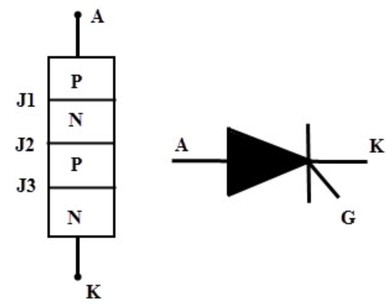 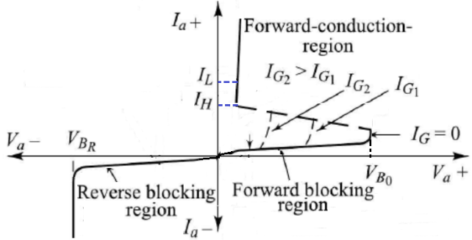

**Fig. (1)**

SCR which is a four layered PNPN switching device, has three external terminals namely **Anode(A), Cathode(K) and Gate(G)**. Anode and Cathode terminals are connected in main power circuit and gate terminal carries low level current from Gate to Cathode. Since it conducts only in one direction, i.e. from Anode to Cathode, it is referred as a controlled ‘*rectifier switch*’.

SCR shows three operational regions, 1. **Reverse Blocking Region** (OFF-state) 2. **Forward Blocking Region** (OFF-state) and 3. **Forward Conduction Region** (ON-state)

The forward breakover voltage (VBO) at which SCR switches ON depends on the magnitude of gate current. Gate current should be more than Ig-min required to turn On the SCR. When SCR is operated with *ac supply*, during the positive half cycle, the instant at which SCR switches ON is referred as ***Firing Angle(α)*** of the SCR. While switching it ON, SCR current should be greater than a minimum value, called ***Latching current***. For switching it OFF, SCR current should fall below a level, called ***Holding current***.

***1.2 Firing (Triggering) Circuit of SCR:***

Gate triggering is the most commonly used method for triggering SCR. A signal is applied between gate and cathode of the SCR. By varying gate signal, firing angle and hence the conduction period of the SCR can be controlled.

**Resistance (R) Firing Circuit**: -Refer **Fig. (2)**.

The circuit shows simple method for varying firing angle and therefore controlling load power. Here gate current is supplied by an ac source through Rmin, R1 and series diode D. The circuit operates as follows:

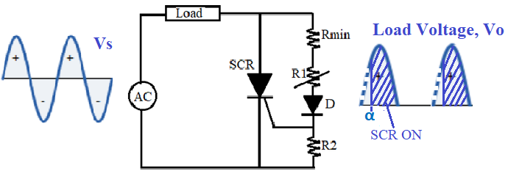

**Fig. (2)**

With the supply voltage positive, SCR is forward biased; however, it will not conduct until it’s gate current reaches Ig-min. The positive supply voltage also forward biases diode D and the SCR gate-cathode junction; causing flow of gate current Ig.

With the increase in supply voltage, gate current will increase and upon reaching required Ig value, switches ON the SCR (i.e. firing angle). Now load voltage **Vload ≈ Vsupply**. (SCR in conduction acts as a closed switch)

SCR remains ON till load current goes below holding current of SCR. Then SCR turns ‘OFF’ and remains ‘OFF’ during negative half cycle of supply since it is reverse biased. Now the SCR is an open switch, load voltage is zero during this period. **Vload ≈ 0**.

The diode D in the gate circuit prevents gate-cathode reverse bias. Same sequence is repeated when supply voltage again goes positive. Load voltage waveform can be controlled by varying resistor R1, causing Ig to delay/ advance in the half cycle which in turn varies **firing angle (α)** of SCR. If R1 increases; required Ig will be delayed. More is the firing angle, less is the load voltage and load power.

A resistor Rmin in the anode-gate path is to limit peak gate current with the condition R1 = 0. Minimum firing angle can be obtained with R1 equal to 0. This circuit controls the load voltage waveform for a range of α=0° to 90°.

**Fan Regulator using TRIAC with R-C-Diac Firing Circuit**: -Refer **Fig. (3)**.

The circuit implements ac power control for an application of fan regulator or light dimmer. The Triac is used as a main controlling switch and a circuit consisting of R-C-Diac is used as a control circuit.

Triac is a three terminal ac switch that can be triggered using gate signal. It incorporates two SCRs connected in inverse parallel with a common gate terminal, which makes it to conduct in either direction when turned ON. A Diac is a two terminal bidirectional device which can be switched ON by applied voltage exceeding it’s breakover voltage.

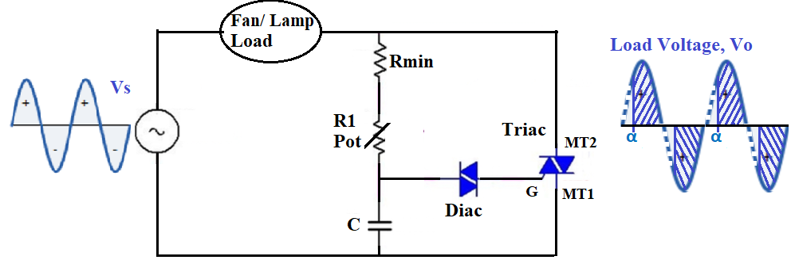

**Fig. (3)**

The circuit operates as follows: Initially Triac and Diac, both are in OFF state. During positive half cycle, capacitor C charges through Rmin-R1 to supply voltage. Now, when capacitor voltage reaches to breakover voltage of Diac, it switches ON thereby applying gate signal to trigger the Triac. Conduction of Triac produces load voltage **Vload ≈ Vsupply**. Triac switches OFF when supply polarity reverses. It turns ON and conducts for negative half cycle after receiving the gate signal thus applying controlled ac voltage across load. **firing angle (α)** is varied by adjusting potentiometer resistance R1.

**Apparatus Required:**

PC / Laptop; Suitable circuit simulation software

**Procedure:**

**Resistance (R) Firing Circuit**:

1. Apply AC input of 230V, 50Hz for the circuit shown in Fig (2).
2. Adjust the values of Rload = 100Ω; Rmin = 1KΩ; Rpot = 20KΩ; R2 = 100Ω.
3. Observe the load voltage waveform on the scope.
4. Vary the firing angle(α) of SCR by varying potentiometer and observe variation in load voltage. Plot the waveforms for two different angles.

**Waveforms:**

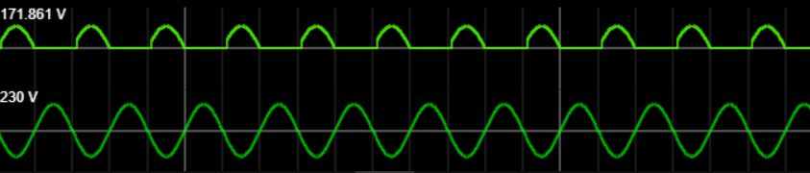

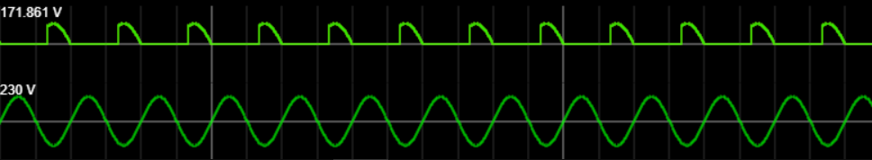

**Fan Regulator using TRIAC with R-C-DIAC Firing Circuit:**

1. Apply AC input of 230V, 50Hz for the circuit shown in Fig (3).
2. Adjust the values of Rload = 100Ω; Rmin = 10KΩ; Rpot = 500KΩ; C = 0.1μf
3. Observe the load voltage waveform on the scope (with resistive load or lamp load).
4. Vary the firing angle(α) of Triac by varying potentiometer and observe variation in load voltage. Plot the waveforms for two different angles.

**Waveforms:**

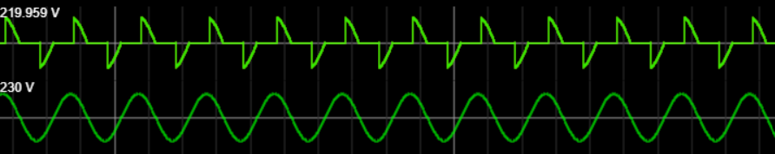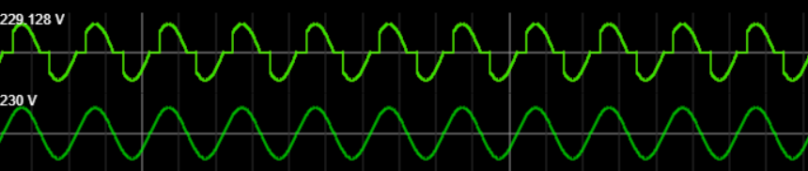

**Conclusion:**

1. In resistance firing circuit, the triggering angle is limited to 90 degrees only. Because the applied voltage is maximum at 90 degrees so the gate current has to reach minimum gate current value somewhere between zero to 90 degrees.
2. In TRIAC with R-C-DIAC Firing Circuit, the triggering is done on both sides i.e. on positive half cycle and negative half cycle also