**Experiment No: 6**

**Home Network**

**Name:** Niraj Ahire **Roll No. O5**

**Aim**: To design and implement a **Home Network** as application of Digital communication system.

**Objectives:**

**Part 1: Establishing a Home Network**

**Part 2: Create a Simple Packet Data Unit (PDU) in Simulation Mode**

**Theory**

**Introduction:**

By this time we have studied the basics of modulation, demodulation, digital communication basics and networking principles. This experiment is intended to apply the theory for practical application.

We are everyday users of internet at home for various purposes. This is both wired and wireless. Few users of broadband networks must be familiar with devices like Routers, Modems and Ethernet cables too. We need to set an IP address, password etc to set up the network.

We also know that offices and Software companies connect their computers on network. However, it is important to know that with the advent of Industry 4.O, Industry has widely adapted wired or wireless networks for both shop floors i.e. connecting machines with each other on wired networks to capture real time information of manufacturing. The data captured is connected with enterprise software such as SAP or ORACLE for taking business decisions.

As we observe irrespective of your core branch subjects , you will adapt networking. Therefore, as an engineer, it is important to all of us to have basic knowledge of how networks are set up, how they work and in case of faults what are the tools deployed to diagnose and correct the network.

**Application:**

The applications of networking are numerous and cover all industry and business. To name a few, in transport, it is used to track the fleet, Manufacturing Execution System (MES) that connects various machines with each other in plants and various plants with each other, it is used to track the migratory birds, sensor networks are used habitat monitoring etc.

**Concept:**

It is always easy to start from something that we are familiar with. Therefore, we have chosen a home network. Most of you have multiple devices like laptop, Smart phones, smart TV, or fire sticks, wireless hotspot routers, Switches.

We intend to acquaint you with the new tool "Packet Tracer" that is commonly used in industry. We will set up a home network with the help of Packet Tracer

**Apparatus Required:**

PC / Laptop; Packet Tracer

**Procedure:**

**Part 1**

1. Double click on the **Packet Tracer** icon on your desktop
2. Packet Tracer should open with a blank default **Logical** topology workspace as

shown in the figure.



1. **Create the network**

* Select **network devices**- **wireless router**- Pick **Home Router**
* Place **Home Router** in logical workspace
* Connect **PC, Laptop, Smartphone** to this Router
* Select **end device, place laptop, Desktop and smartphone** in logical workspace.
* **Smart phone** gets connected
* To connect the desktop, go to connector (left bottom side),select copper straight through cable, click on desktop select fast Ethernet0. The cable gets connected to the desktop.
* click on router, select gigabit Ethernet 1, desktop and router get connected.
* click on **laptop**, physical, zoom in and scroll down.
* We will see the power button, and some ports, switch **off** the power button
* Select the wired network port by left clicking and drag it over the left and replace it by WPC, for wi fi connectivity.
* When we click on WPC we see the description of the card.
* Drag and drop the card in the open slot
* Switch **ON** the Power
* Thus we have successfully built the Packet Tracer network.

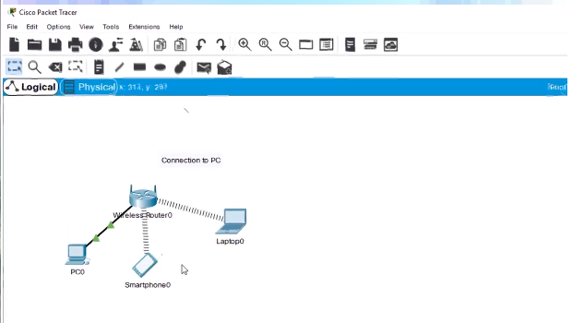

**4.** **Create a Simple PDU in Simulation Mode**

* + - * click the **Simulation** mode icon in the bottom-right corner of the Packet Tracer

window to open the **Simulation** panel.



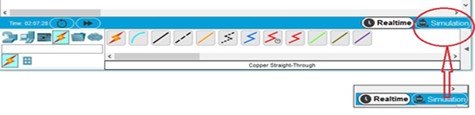

* **Create a simple PDU that sends a ping from the PC to the laptop**
* Click the Add Simple PDU icon (looks like a closed envelope) in the top pane of the Packet Tracer window.
* The cursor will change to an envelope with a plus sign. Click the PC first so that it will become the source of the ping and then click the Laptop so that it will become the destination.
* Expand the Event Simulation pane by clicking the gray arrow at the bottom right of the Packet Tracer Window

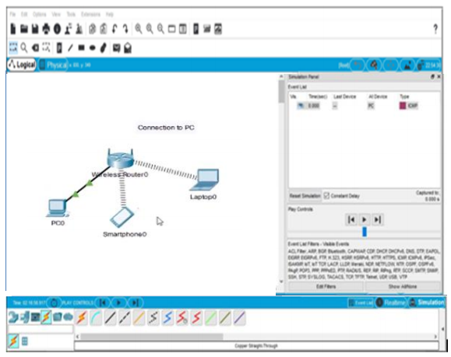

* **Observe traffic moving through the network.**
* Click the **Capture/Forward** button and observe the traffic move through the network each time the button is clicked.
* Notice also that each time the **Capture/Forward** button is clicked, sent packets are displayed in the **Event List** window.
* Continue clicking the **Capture/Forward** button until the return ICMP packet makes it back to the PC.

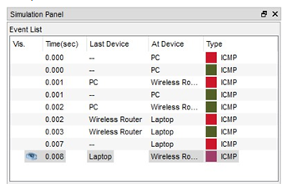

**Simulation Event Screen shot**

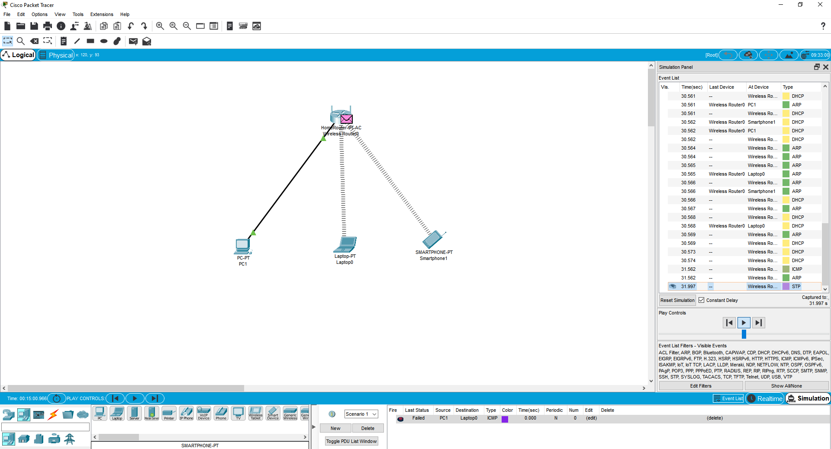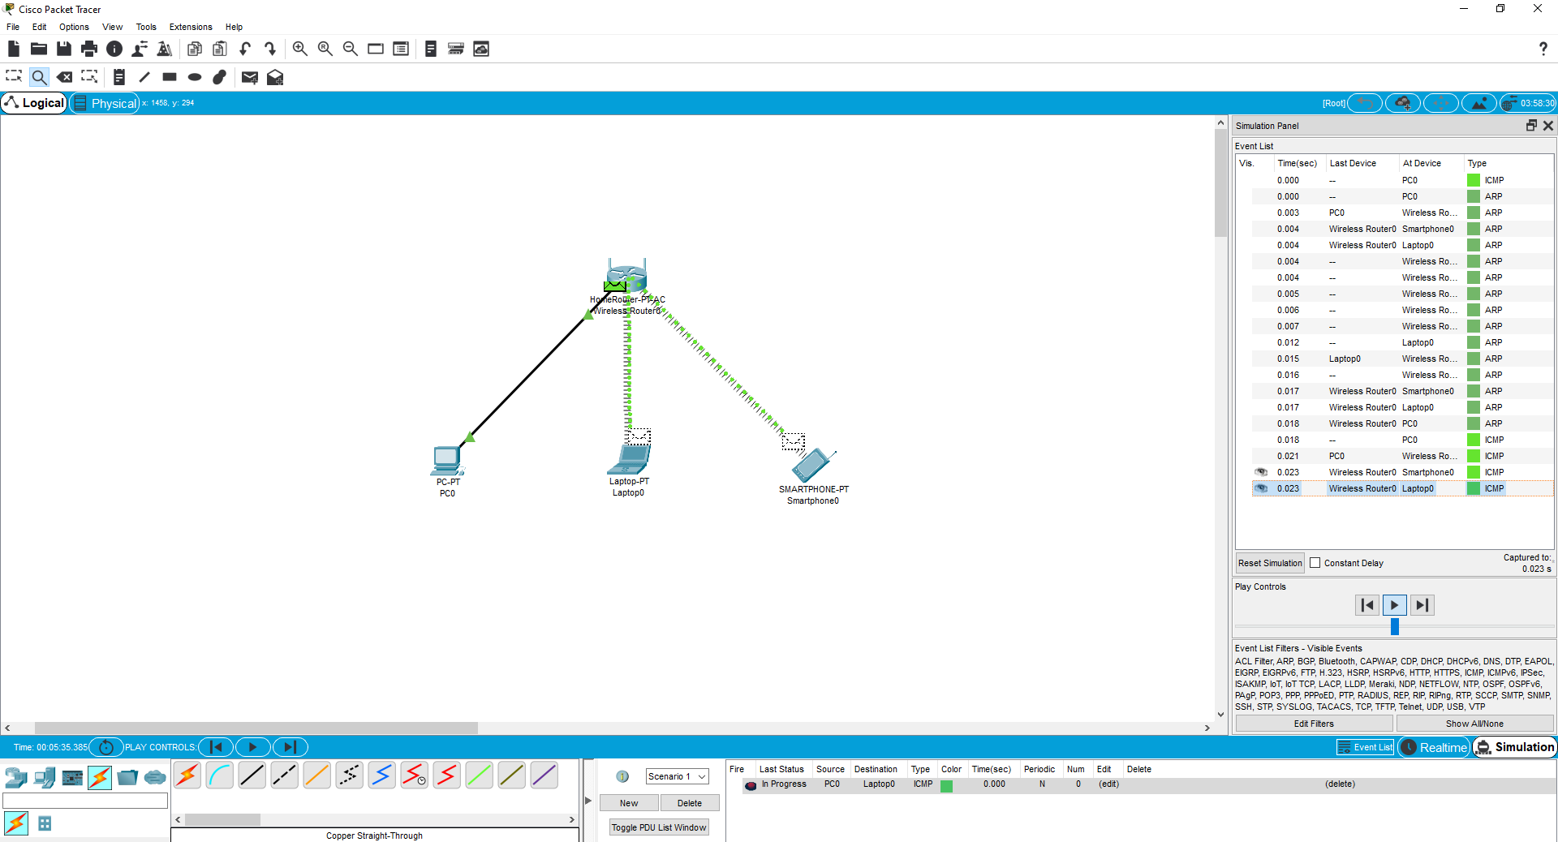

**Conclusion:**

1. Home network created.
2. Working od simple PDU has been verified.