RELAY STUDIO

Relay Studio UML Guide
  - Fourteen complementary views of the application

Audience: Developers, architects, QA, and product managers
Version 1.0 | Sprint 15 | July 2026

Deliverable: Every diagram is available as an individual editable Visio file and as one page in Relay-Studio-UML-Atlas.vsdx. The preview in this guide is for reading and review.

How to Read the Atlas
Structural diagrams explain what exists. Behavioral diagrams explain how users and components collaborate over time. No single diagram is the architecture; use the smallest view that answers the current question.
Category | Diagram types | Best question
Structural | Class, Object, Component, Deployment, Package, Profile, Composite Structure | What exists and how is it organized?
Behavioral | Use Case, Activity, State Machine, Sequence, Communication, Interaction Overview, Timing | What happens, in what order, and under which conditions?

1. Class Diagram: Relay Studio Project Domain Model
Defines the persisted project types and their cardinality so schema, import, persistence, and execution changes begin from the same model.
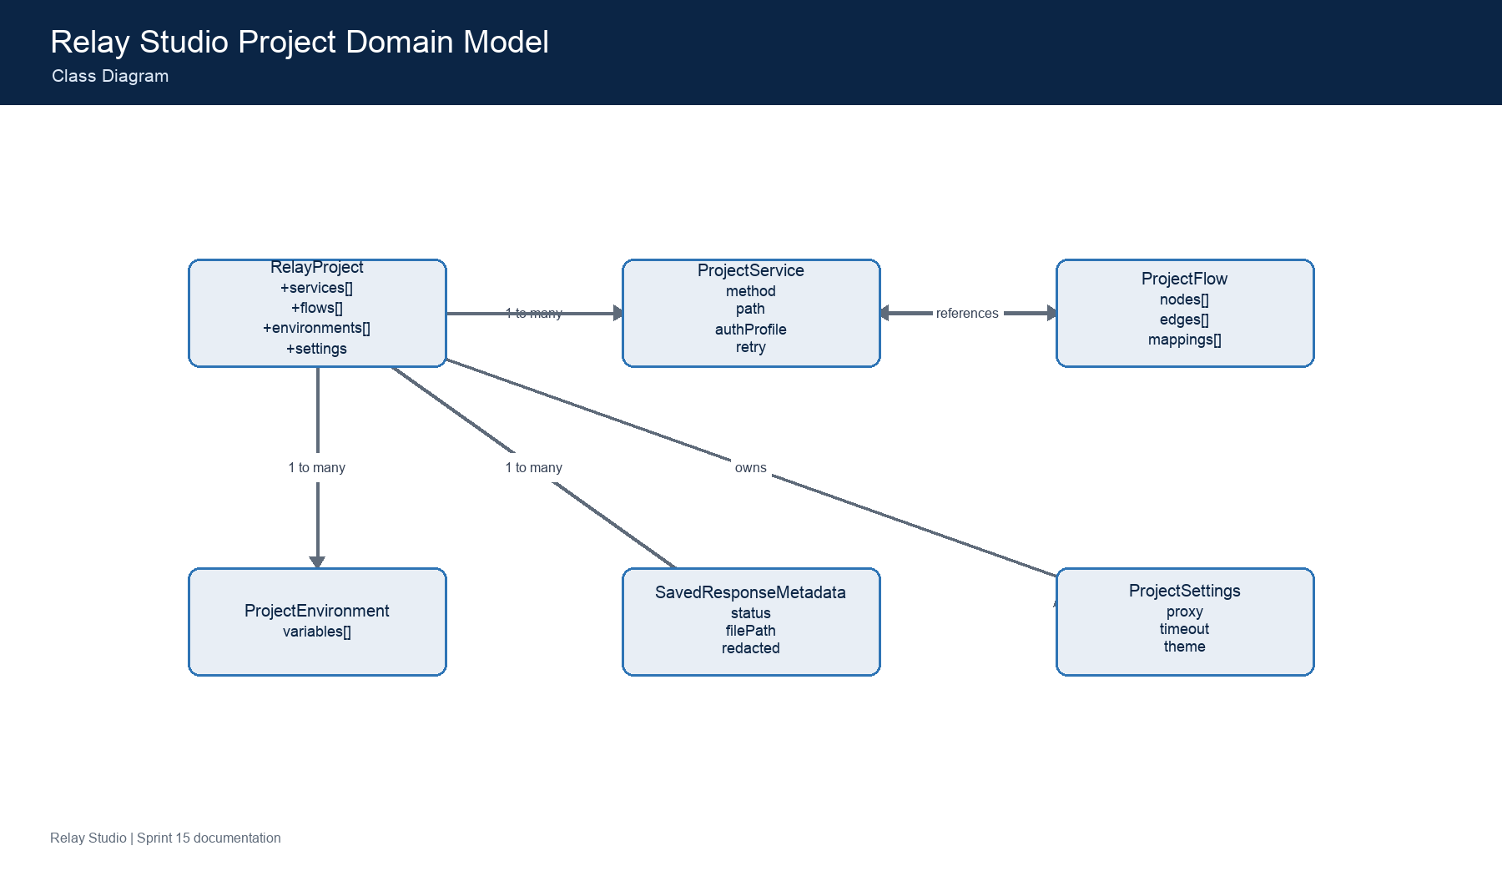
Visio source: documentation/uml/visio/class-diagram.vsdx
- Source: src/project/projectModel.ts
- Schema version is explicit and validated before use.

2. Object Diagram: Sample API Regression Project Snapshot
Shows representative runtime instances for debugging project load, selection, environment substitution, and saved response behavior.
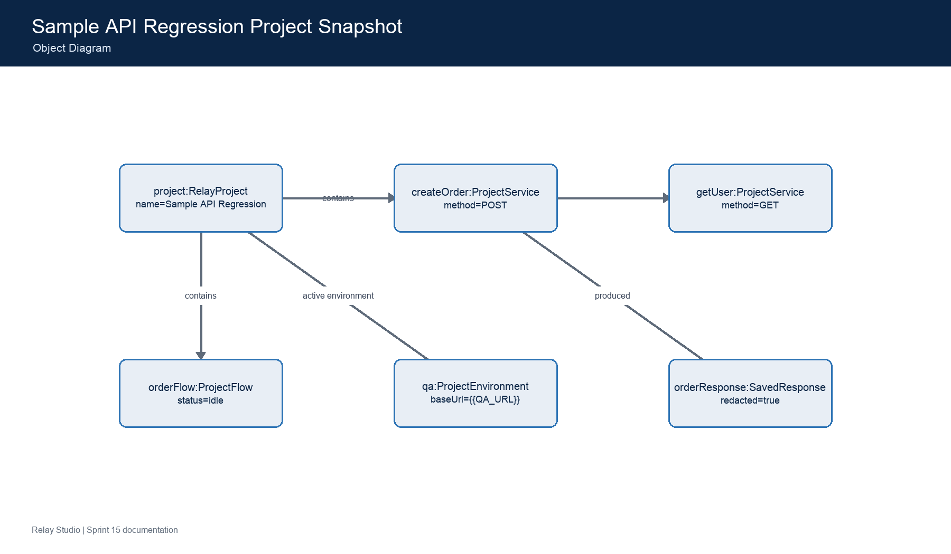
Visio source: documentation/uml/visio/object-diagram.vsdx
- Values are illustrative and contain no credentials.
- Use this snapshot when explaining object identity versus persisted type definitions.

3. Component Diagram: Relay Studio Component Architecture
Shows the major replaceable components and the interfaces across the React, TypeScript, Tauri, filesystem, and network boundaries.
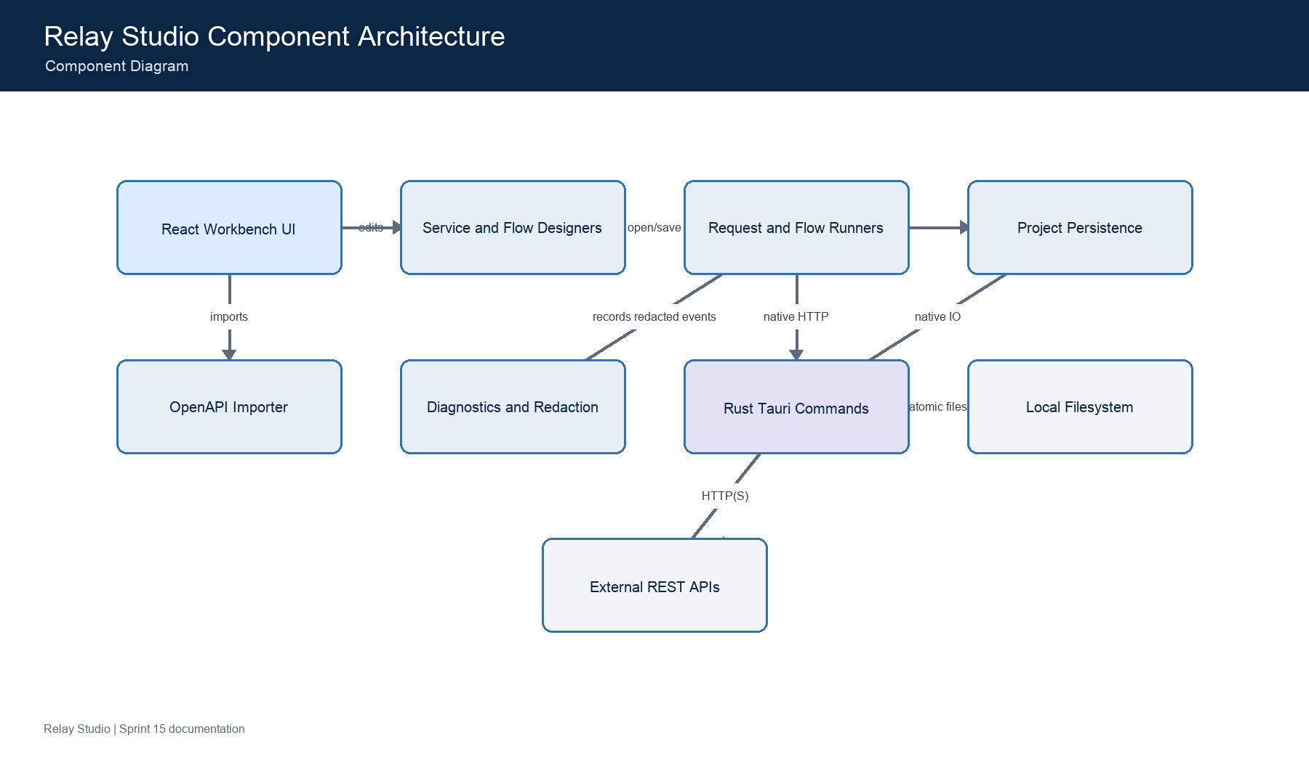
Visio source: documentation/uml/visio/component-diagram.vsdx
- Browser-mode adapters support automated UI testing.
- Native commands are explicitly allow-listed in the Tauri capability.

4. Deployment Diagram: Relay Studio Deployment Topology
Maps unsigned desktop packages and their runtime dependencies across supported operating systems and GitHub Actions.
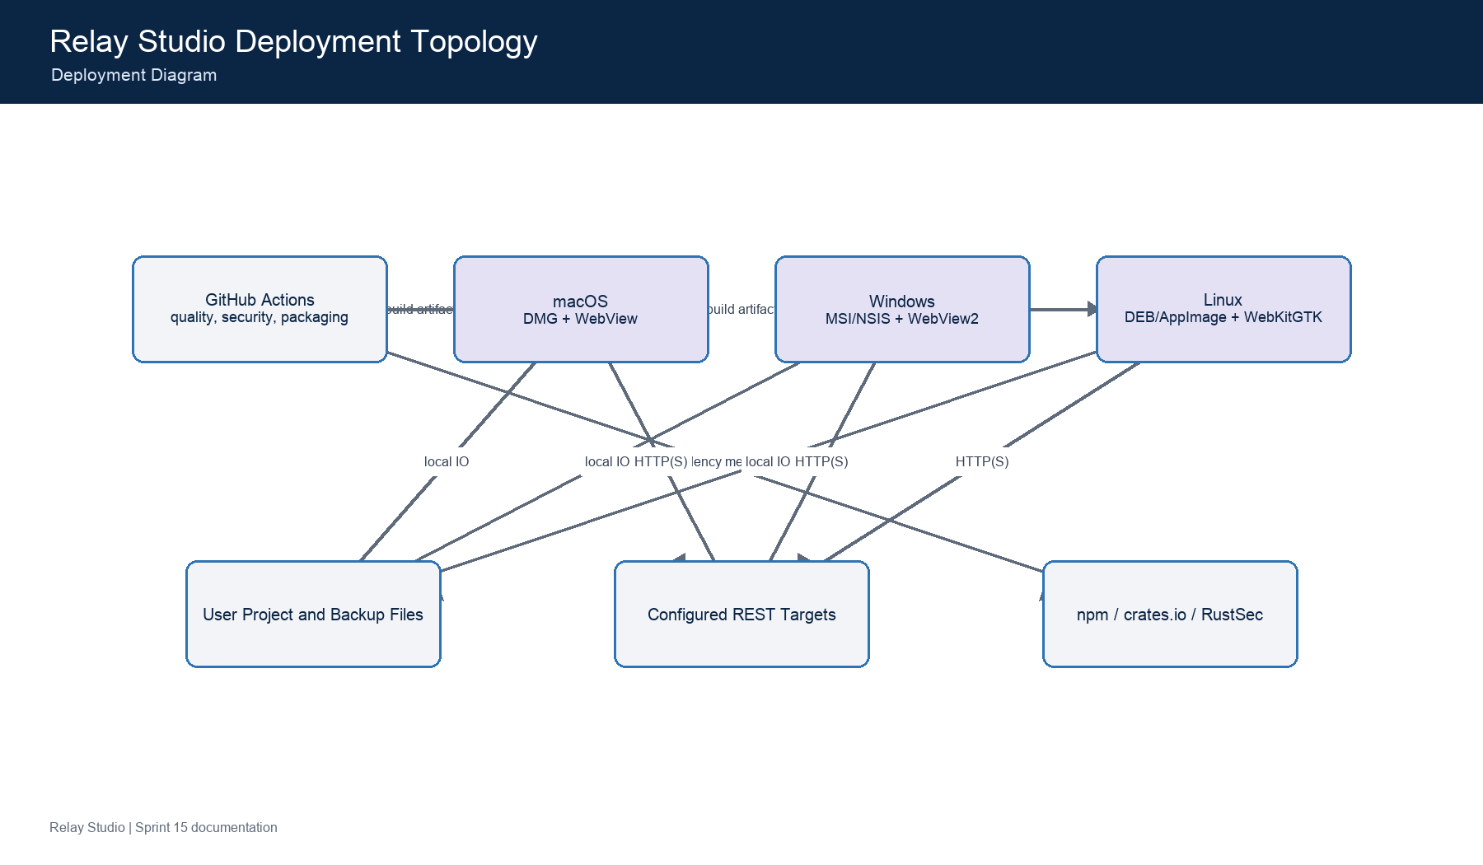
Visio source: documentation/uml/visio/deployment-diagram.vsdx
- Packages are intentionally unsigned developer betas.
- Credentials remain local or in protected GitHub secrets.

5. Package Diagram: Relay Studio Source Package Dependencies
Provides a module-level map for locating code before debugging or adding a feature.
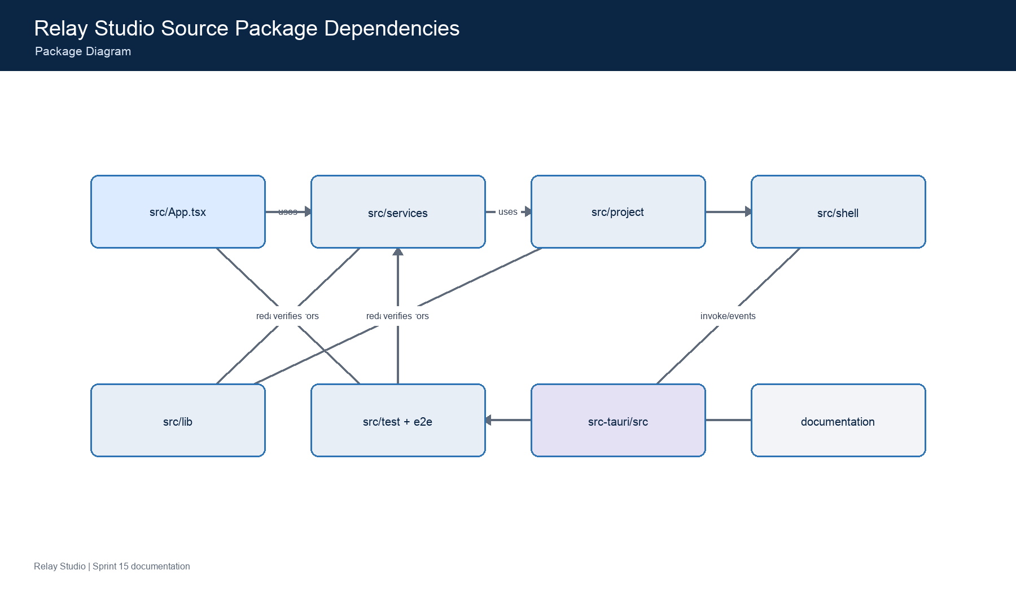
Visio source: documentation/uml/visio/package-diagram.vsdx
- Dependencies should point inward toward typed domain and utility modules.
- Avoid hidden coupling through globals or silent fallbacks.

6. Profile Diagram: Relay Studio UML Profile
Defines project-specific stereotypes used consistently across the architecture atlas.
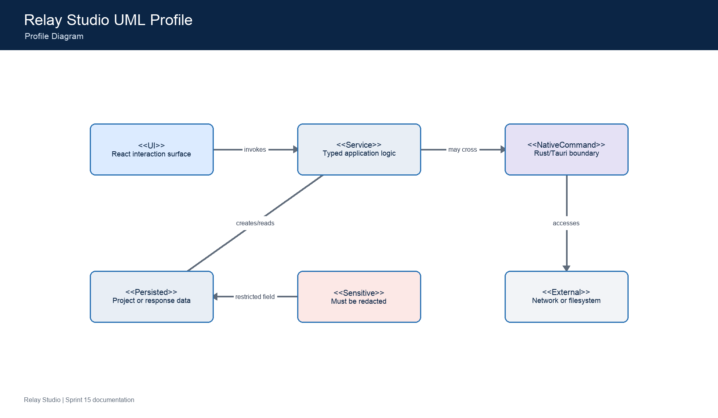
Visio source: documentation/uml/visio/profile-diagram.vsdx
- Stereotypes are documentation conventions, not runtime annotations.
- Sensitive data must pass the shared redaction policy.

7. Composite Structure Diagram: Request Execution Composite Structure
Shows the collaborating parts inside a request execution and their ports to project state, native transport, cancellation, and diagnostics.
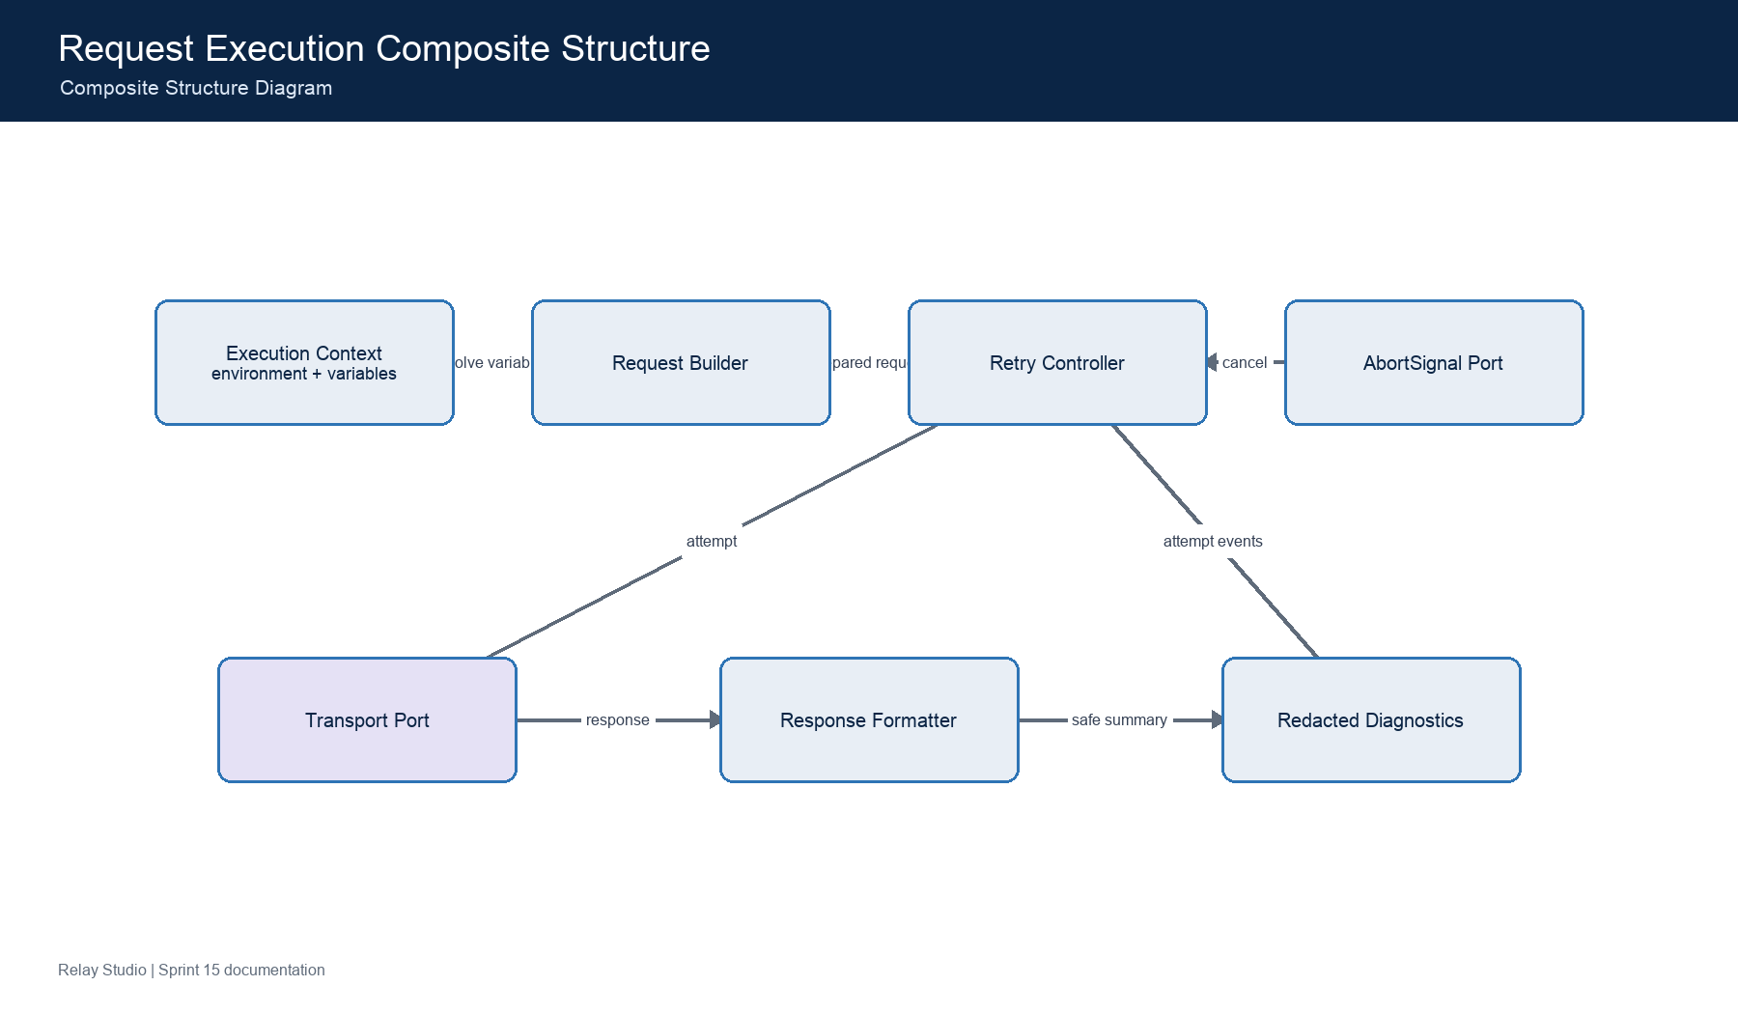
Visio source: documentation/uml/visio/composite-structure-diagram.vsdx
- Cancellation is cooperative through AbortSignal.
- Retry count and backoff are bounded by the service definition.

8. Use Case Diagram: Relay Studio User and Maintainer Use Cases
Explains the value of Relay Studio without requiring source-code knowledge.
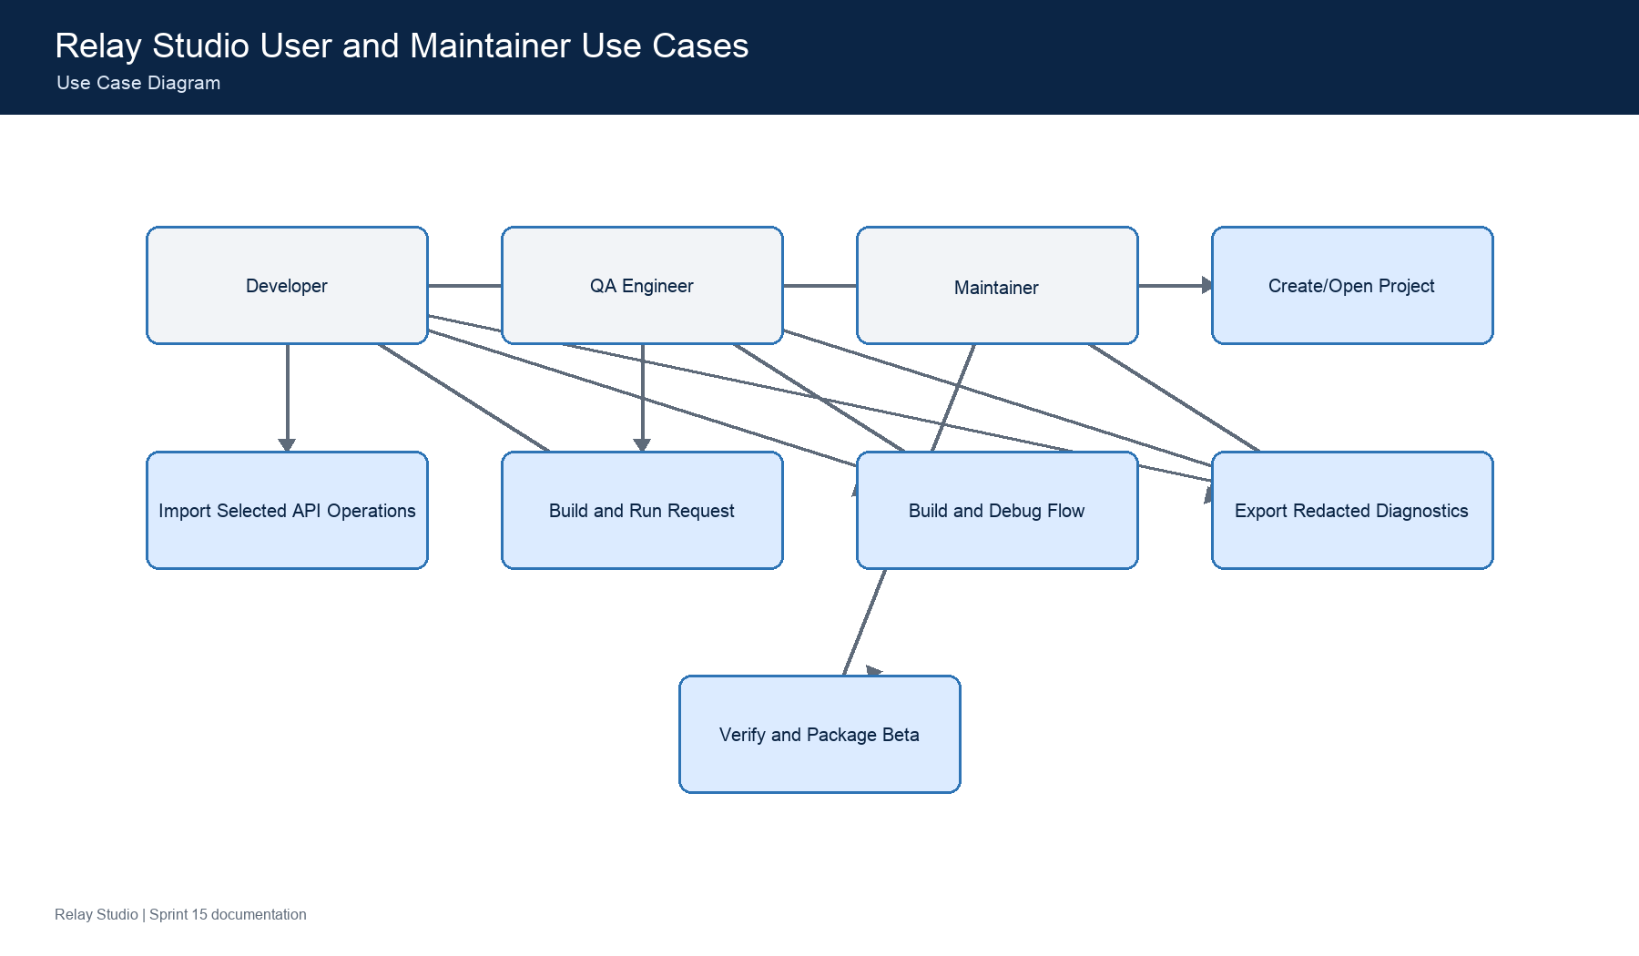
Visio source: documentation/uml/visio/use-case-diagram.vsdx
- The product is a personal developer tool, not a hosted collaboration service.
- All imports require explicit operation selection.

9. Activity Diagram: Selective OpenAPI Import Activity
Models the user-visible decisions and failure paths from a Swagger UI or direct definition URL to committed project services.
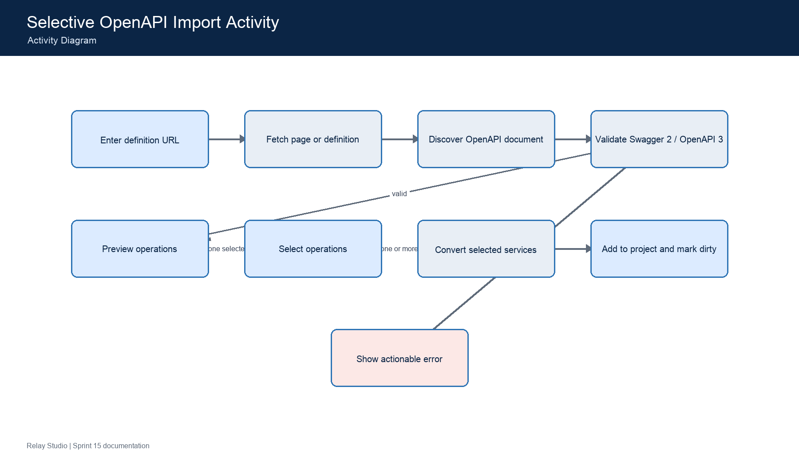
Visio source: documentation/uml/visio/activity-diagram.vsdx
- Nothing changes in the project until the user confirms a non-empty selection.
- Example credentials are never imported.

10. State Machine Diagram: Request and Flow Execution State Machine
Defines visible execution states and terminal behavior used by the workbench, flow canvas, console, and cancellation controls.
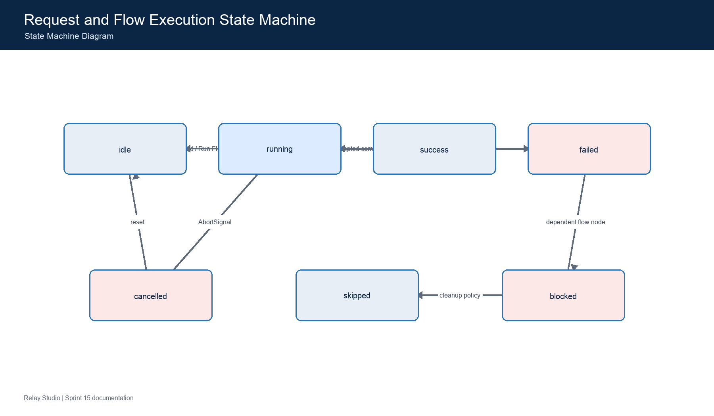
Visio source: documentation/uml/visio/state-machine-diagram.vsdx
- Every terminal state is visible; there are no silent fallbacks.
- Flow nodes use the same named state vocabulary as persisted UI state.

11. Sequence Diagram: Request Execution, Retry, Cancellation, and Diagnostics
Shows chronological responsibility during request execution and the points where secrets are resolved, transported, and redacted.
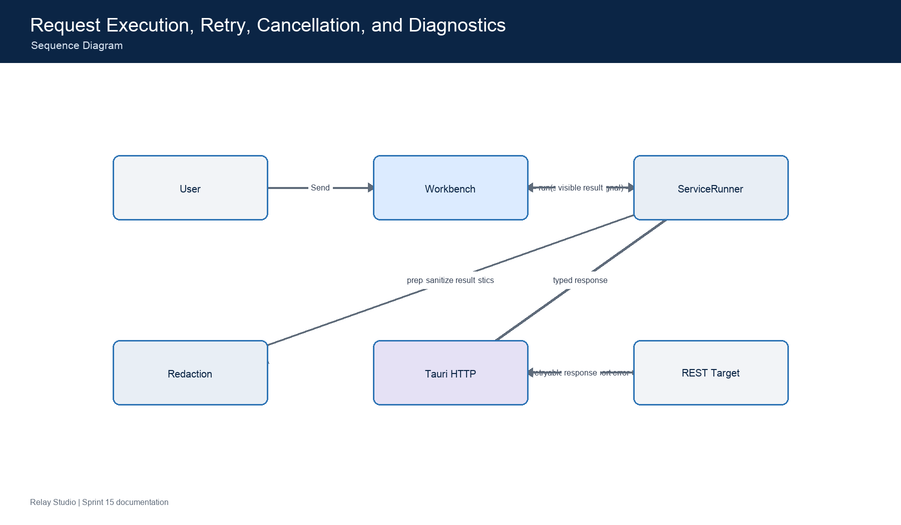
Visio source: documentation/uml/visio/sequence-diagram.vsdx
- If the user cancels, the AbortSignal terminates the active attempt and suppresses further retries.
- Passwords, bearer tokens, API keys, cookies, and secret variables never enter visible diagnostics.

12. Communication Diagram: Project Save, Backup, and Recovery Collaboration
Emphasizes numbered collaboration between project state, validation, redaction, concurrency protection, native atomic IO, and recovery backup.
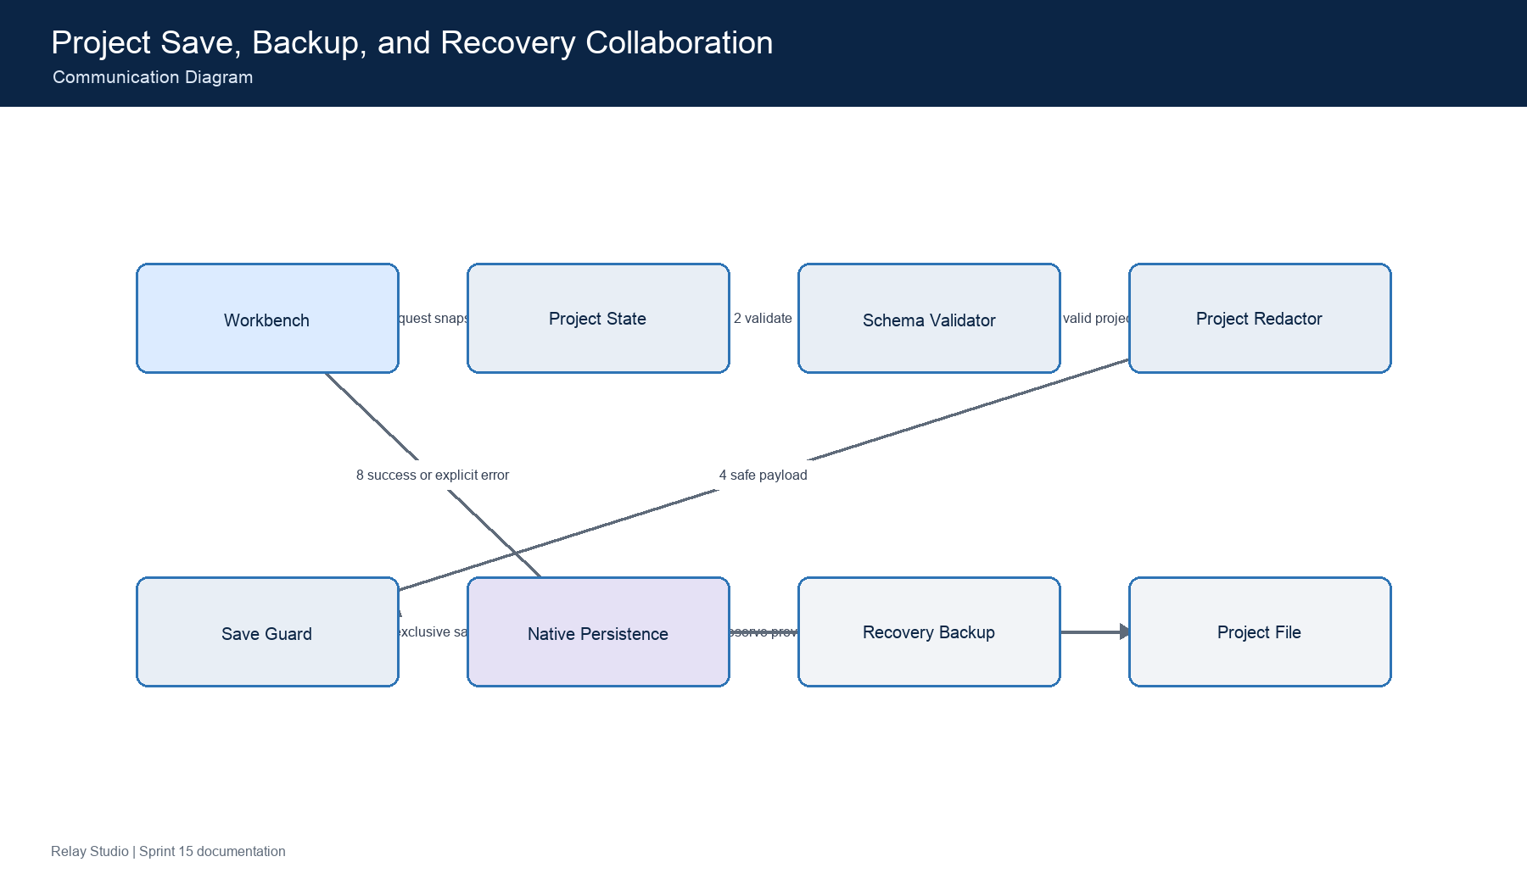
Visio source: documentation/uml/visio/communication-diagram.vsdx
- Concurrent saves fail explicitly instead of racing.
- Recovery guidance identifies the backup and original paths without exposing project secrets.

13. Interaction Overview Diagram: End-to-End API Debugging Interaction Overview
Combines the major interactions a developer uses to diagnose an unfamiliar API from import through a reproducible flow and safe evidence bundle.
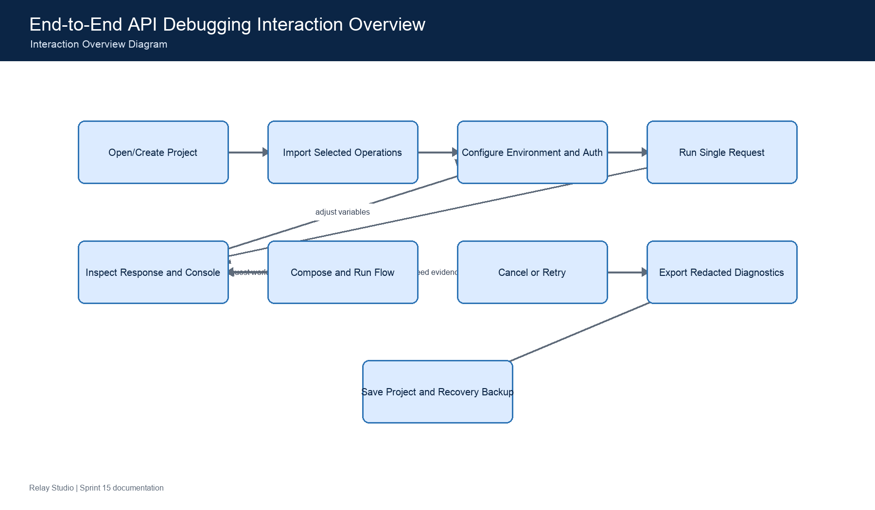
Visio source: documentation/uml/visio/interaction-overview-diagram.vsdx
- Each interaction node expands to a detailed activity or sequence view elsewhere in the atlas.
- The workflow remains useful without a hosted account or cloud workspace.

14. Timing Diagram: Request Timeout, Retry, Backoff, and Cancellation Timing
Makes bounded execution behavior visible when diagnosing slow endpoints, retry policies, and user cancellation.
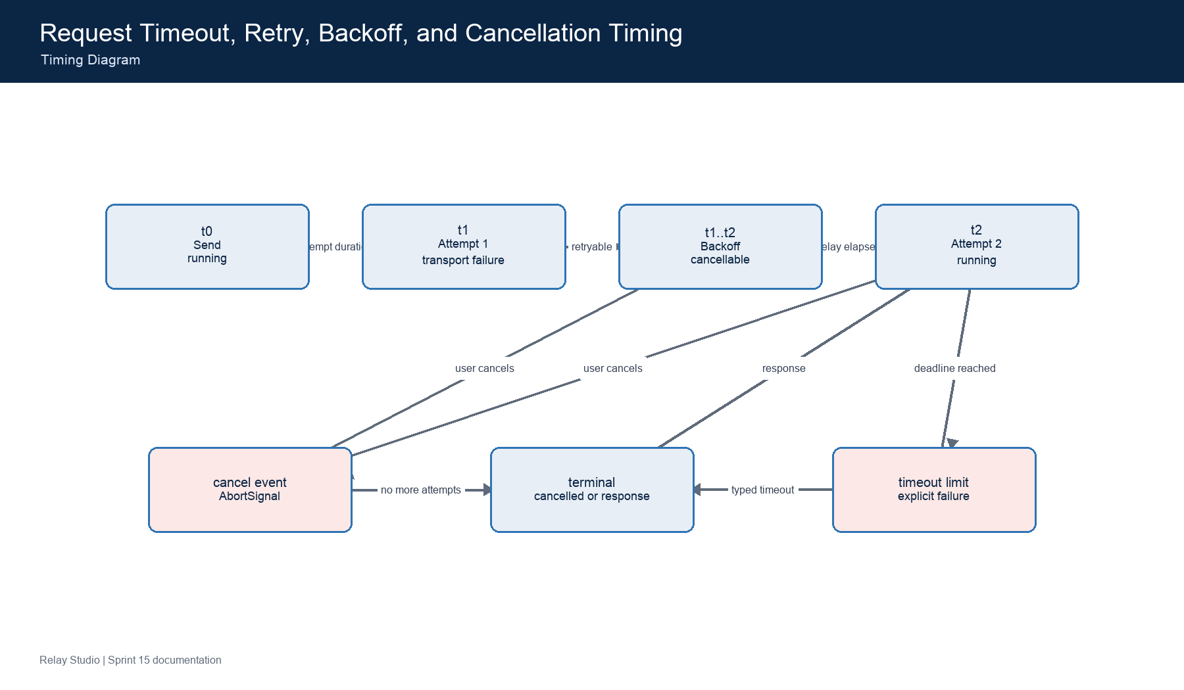
Visio source: documentation/uml/visio/timing-diagram.vsdx
- Backoff and timeout values come from the service and project settings.
- Cancellation wins over retry scheduling and produces a visible cancelled state.

Maintenance Rules
- Keep shape labels aligned with current UI and code terminology.
- Update both the individual diagram and the corresponding page in the master atlas.
- Run the VSDX structural validator after any edit.
- Do not place credentials, real tokens, or private endpoint values in diagrams.
- Revise this guide when a diagram's purpose, assumptions, or authoritative source changes.

