**CLOUDY STORAGE**



***A Project Report submitted in partial fulfillment of the requirements for the award of the degree of***

# Bachelor of Computer Applications

## By

|  |  |
| --- | --- |
| **Mr. ANUJ ARORA** | **(184200036)** |
| **Mr. YOGESH SHARMA** | **(184200185)** |
| **Mr. ADARSH PANDEY** | **(184200009)** |
| **Mr. ARYAN VARSHNEY** | **(184200040)** |
| **Mr. SHIVAM SHARMA** | **(184200156)** |
| **Mr. ABHISHEK GUPTA** | **(184200007)** |

Under the Guidance of

**Ms. Kriti Bansal (Assistant Professor)** Department of Computer Engineering & Applications **Institute of Engineering & Technology.**

**GLA University Mathura, 281406, Uttar Pradesh, India**

**Department of Computer Engineering and**

**Applications GLA University, Mathura**

**17 km. Stone NH#2, Mathura-Delhi Road,**

**P.O. – Chaumuhan, Mathura – 281406**

**U.P (India)**

**Declaration**

We hereby declare that the work which is being presented in the B.C.A. Project “cloudy storage ”, in partial fulfillment of the requirements for the award of the Bachelor of Computer Applications and submitted to the Department of Computer Engineering and Applications of GLA University, Mathura, is an authentic record of our work carried under the supervision of Mr. Narendra Mohan, Assistant Professor of Computer Engineering Department.

The contents of this project report, in full or in parts, have not been submitted to any other institute or university for the award of any degree.

|  |  |  |
| --- | --- | --- |
| Anuj Arora (184200036) |  | Yogesh Sharma (184200185) |
| Adarsh Pandey (184200009) |  | Aryan Varshney (184200040) |
| Abhishek Sharma (184200007) |  | Shivam Sharma (154200156) |
|  | **Certificate** |  |

This is to certify that the above statements made by the candidates are correct to the best of my/our knowledge and belief.

#### Project Supervisor Date:2020-05-20

(Mr. Narendra Mohan)

#### Project Incharge Program Coordinator Head of Department

**(Mr. D.P. Yadav) (Mr. Narendra Mohan) (Prof. Anand Singh Jalal)**

**Acknowledgment**

The satisfaction which accompanies the successful completion of the project is incomplete without the mention of a few names. We take this opportunity to acknowledge the efforts of the many individuals who helped us to make this project possible.

Firstly we would like to express our heartfelt appreciation and gratitude to our project guide **Ms. Kriti Bansal, Assistant Professor, Computer Engineering Department.** His vision and execution aimed at creating a structure, definition, and realism around the project and fostered the ideal environment for us to learn and do. This project is a result of his teaching, encouragement, and inputs in the numerous meetings he had with us, despite his busy schedule.

We would also like to extend our immense gratitude to respected Head of Department **Prof. Anand Singh Jalal** who allowed us to choose the topic for our dissertation.

The experience was a novel one and we would like to thank all the people, who have lent their valuable time for the completion of the report. Without their consideration, it would have been difficult to complete the report.

|  |  |
| --- | --- |
| Mr. Anuj Arora | (184200036) |
| Mr. Yogesh Sharma | (184200185) |
| Ms. Adarsh Pandey | (184200009) |
| Mr. Aryan Varshney | (184200040) |
| Ms. Abhishek Gupta | (184200007) |
| Mr. Shivam Sharma | (184200156) |

This cloud storage system will provide to add/upload/modify data on the real-time cloud In this Online Cloud Storage project, we mention the uploading and downloading the file from the server which is meant as a cloud server This is a very useful application to store the data in the cloud. The user will get more ideas about the cloud and other applications. It is also useful to create a small environment for Storing and downloading information from the cloud to get more ideas In Proposed Cloud Storage system user downloads the file on the cloud. Which is means the End user is getting the more speed about the Internet when they will click on the User. Because the cloud is also similar to the database which is means is also database but having the more space that a reasonable user getting more speed to search the information as well as getting more security about the data

|  |  |
| --- | --- |
| **Topic**  Certificate Acknowledgement | **Pg. no.**ii  iii |
| List of Tables | vii |
| List of Figures | viii |
| Chapter1 Introduction | 1 |
| 1.1 Overview &Motivation | 1 |
| 1.2 Objectives | 2 |
| 1.3 Organization of ProjectReport | 2 |
| Chapter2 Software RequirementAnalysis | 3 |
| 2.1 RequirementAnalysis | 3 |
| 2.1.1 Hardware Requirement | 4 |
| 2.1.2 Software Requirement | 4 |
| 2.1.3 Tools and Technologies | 4 |
| 2.2 FeasibilityStudy | 5 |
| 2.2.1 Technical Feasibility | 5 |
| 2.2.2 Operational Feasibility | 6 |
| 2.2.3 Economical Feasibility | 7 |
| 2.3 Analysis | 7 |
| 2.4 Summary ofModules | 8 |
| Chapter3 software design | 9 |
| 3.1 DFD | 10 |
| DFD Level 0 | 11 |
| DFD Level 1.1 | 11 |
| DFD Level 1.2 | 11 |
| DFD Level 1.3 | 12 |
| DFD Level 1.4 | 12 |
| 3.2 ER | 13 |
| ER Diagram | 14 |
| 3.3 database design | 15 |
| Chapter 4 Implementation & User Interface | 18 |

|  |  |
| --- | --- |
| Chapter 5 Software Testing | 22 |
| 5.1 Testing | 22 |
| 5.2 Objectives of SoftwareTesting | 22 |
| 5.3 Principles of SoftwareTesting | 23 |
| 5.3.1 White Box Testing | 23 |
| 5.3.2 Black Box Testing | 23 |
| 5.4 TestingFundamentals | 24 |
| 5.5 TestingInformation | 24 |
| Conclusion | 25 |
| References | 26 |

|  |  |  |  |
| --- | --- | --- | --- |
| **S.No.** | **Table Name** | **Table No.** | **Page** |
| **1** | Admin Login | Table 3.1 | 15 |
| **2** | User | Table 3.2 | 16 |
| **3** | User file | Table 3.3 | 16 |
| **4** | Contact | Table 3.4 | 16 |
| **S.No.** | **Figure Name** | **Fig. no** | **Page** |
| **1** | Data Flow Diagram Symbols | Fig 3.1 | 10 |
| **2** | 0 level DFD | Fig 3.2 | 11 |
| **3** | 1 level DFD | Fig 3.3 | 11 |
| **4** | 1.2 level DFD Admin | Fig 3.4 | 11 |
|  |  |  |  |

# INTRODUCTION

**Present Problem Statement:**

The existing system has lots of flaws because peoples have to face the problem during storing their data. And the peoples sometimes think about the time which will be more required in such processes. Now the present system will save time as well as their storage and the people don’t need to buy external storage devices.

**Proposed System:**

Through this new online storage system helps in storing our data in the cloud and we can also retrieve it at any time and from any place.

This project used by three types of module:-

* User
* Admin

Cloud storage is a model in which data is stored on remote servers accessed from the internet, or "cloud." It is maintained, operated, and managed by cloudy storage service which was provider by us.

* 1. **Overview and motivation:**

**Overview:**

The main motive of our project “cloudy storage” is to help the people who can not afford paid storage system our service is free of cost and anyone can use it by just creating their user account in our server and can upload their data

**Motivation:**

* Money-saving process.
* We have to face many difficulties to carry external storage devices.
* Huge chance of data loss in external devices.

#### Chapter1 Introduction

## Objective:

Cloudy storage aims to provide the best storage service. The main goal of over project is to provide users free of cost, infinitely, extensible, and highly reliable storage platform which can support various types of data. Our project “cloudy storage” also has abilities to satisfy the different requirements of different users.

## Organization of Project Report:

|  |  |
| --- | --- |
| **PHASES** | **TIME DURATION** |
| Software requirement specification | 2 weeks |
| System design | 3 weeks |
| Coding | 5 weeks |
| Testing | 2 weeks |
| Documentation | 2 weeks |
| Implementation | 1 weeks |

**SOFTWARE REQUIREMENT ANALYSIS**

System Analysis is a detailed study of the various operations performed by a system and their relationship within and outside the system. It is a systematic technique that defines goals and objectives the goal of the development is to deliver the system in line with the user’s requirements, and analysis is this process.

System study has been conducted with the following objectives in mind: -

* + - Identify the client’s needs.
    - Evaluate the system concept for feasibility.
    - Perform economic and technical analysis.
    - Allocate functional to hardware, software, people, database and other system elements
    - Establish cost and schedule constraints.
    - Both hardware and software expertise is required to successfully attain the objectives.

## RequirementAnalysis

Information gathering is usually the first phase of the software development project. The purpose of this phase is to identify and document the exact requirements for the system. The user’s request identifies the need for a new information system and on investigation re-defined the new problem to be based on MIS, which supports management. The objective is to determine whether the request is valid and feasible before a recommendation is made to build a new or existing manual system continue

The major steps are –

* + - Defining user requirements.
    - Studying the present system to verify the problem.
    - Defining the performance expected by the candidate to user requirement

#### HardwareRequirements

Processor : INTEL PENTIUM 4

ProcessorSpeed : 2.5 GHZ

RAM: 2 GB

HardDisk : 20 GB of freespace

#### Software Requirements

**OperatingSystem**: Window 7 and higher

**FrontEnd** : HTML, CSS, JavaScript

**Backend**: SQL Server, PHP

#### Tools and Technology Tools:

* + - * Windows 7 & and higher
      * Notepad++
      * SQLServer

#### Technology:

* **SQL** is a structured query language used for querying database.
* **CSS:** CSS is cascading style sheet which is used to give designer look to HTML using the external file.
* **PHP:** Hypertext Preprocessor is a server-side scripting language designed for web development but also used as a general-purpose programming language.
* **Java Script:** JavaScript is a dynamic computer programming language. It is lightweight and most commonly used as a part of web pages, whose implementations allow to make dynamic pages.
* **HTML:** Hypertext Markup Language is the standard markup language for creating web pages and web applications. HTML elements is the building blocks of HTML pages. With HTML constructs, images, and other objects, such as an interactive form.

## Feasibility Study

A feasibility study is the process of determination of whether or not a project is worth doing. Feasibility studies are undertaken within tight time constraints and normally culminate in a written and oral feasibility report. I have taken a fixed time in a feasibility study with my co-developer. The contents and recommendations of this feasibility study helped us as a sound basis for deciding how to precede the project. It helped in making decisions such as which software to use, hardware combinations, etc.

#### Technical feasibility:

This is concerned with specifying equipment of software and hardware that will successfully satisfy the user requirements. The technical needs of the system may vary considerably, but might include:

* The facility to produce output in a given time.
* Response time under certain conditions.
* Ability to produce a certain volume of a transaction at a particular speed.
* In examining technical feasibility, the configuration of the system is given more importance than the actual making of hardware. The configuration should give a complete picture of the system requirements what speeds of input and output should be achieved at a particular quality of printing.

According to the definition of technical feasibility, the compatibility between front-end and back-end is very important. In our project, the compatibility of both is very good. The degree of compatibility of PHP and SQL Server 2014 is very good. The speed of output is very good when we enter the data and click a button then the response time is very fast and gives a result very quickly. Ineverfinddifficultywhenweusecomplexquery or heavy transaction. The speed of transactions is always smooth and constant. This software provides the facility to communicate data to distant locations.

We use Active Server Pages and JavaScript. The designing of front-end of any project is very important so we selected Active Server Pages, HTML & CSSasfront-end due to following reason:

* + Easy implementation of code.
  + Well, define interface and database.
  + Well define handshaking of SQL Server2014

In the present scenario, no of the backend is available but I have selected SQLServer 2008 because of the following number of reasons.

* + - Able to handle large data.
    - Security.
    - RobustRDBMS
    - Backup &Recovery

Withthehelpofabovesupportweremovedefectofexistingsoftware.In the future, we can easily switch over any platform. To ensure that system does not halt in case of undesired situations or events. The problem affected by any module does not affect any module of the system. A change of hardware does not produce a problem.

#### OperationalFeasibility:

It is mainly related to human organizational and political aspects. The points to be considered are:

* + - * What changes will be brought with the system?
      * What organizational structures are distributed.
      * What new skills will be required? Do the existing staff members have these skills? If not, can they be trained in due course of time?

At the present stage, all the work is done manually. So, throughput and response time is too much. The major problem is the lack of a security check that should have been applied.

Findingoutthedetailregardinguser’srequestwasverydifficult, because datastore was in different registers and different places. In case of any problem, no one can solve the problem until the person responsible is not present.

Currentcommunicationisentirelyontelephonicconversationorpersonalmeetings. Post computerization staff can interact using the internet.

Now, we will explain the last point of operational feasibility i.e. handling and keeping of software, at every point of designing I will take care of that menu options are not too complex and can be easily learned and required least amount of technical skills as operators are going to be from the non-computers background.

#### Economic feasibility:

Economic analysis is the most frequently used technique for evaluating the effectiveness of a proposed system. More commonly known as cost/benefit analysis: the procedure is to determine the benefits and saving that is expected from a proposed system and compare them with a cost. If the benefits outweigh the cost, a decision is taken to design and implement the system. Otherwise, further justification or alternatives in the proposed system will have to be made if it is to have a chance of being approved. This is an ongoing effort that improves accuracy at each phase of the system life cycle.

At present Company has ten systems with the following configuration:

* + - * Ram 4 GB or above for fast execution and reliability
      * MOTHER Board x64 based PC
      * Color Monitor 14” and17”
      * Hard Disk 100GB
      * Hence the economic feasibility is very good.

## Analysis

System analysis is the first step towards the software building process. The purpose of system analysis is to understand the system requirements, identify the data, functional and behavioral requirements, and building the models of the system for a better understanding of the system.

In the process of system analysis, one should first understand that, what the present system is, I show it works(i.e.processes). After analyzing these points web becomes able to identify the problems in the present system. Upon evaluating current problems and desired information (input and output to the system), the analyst looks towards one or more solutions. To begin with, the data objects, processing functions, and behavior of the system are defined in detail. After these models, from three different aspects of the system-data, function, and behavior. The models created during the system analysis process helps in better understanding of data and control flow, functional processing, operational behavioral, and information content.

## Summary of Modules

1. Admin
2. User

#### Admin

The admin is responsible for maintaining the Database of the cloud. The admin manages the different users and different files for the smooth working of the system. In this module, the admin can view the details of the users and allow them to perform a view. Users uploading, downloading files operations.

#### User

User can upload their files and retrieve them from anywhere he just needs a system to retrieve them. In our project, we are giving the user as much space as there is storage in his system from which he is accessing our storage system

# SOFTWARE DESIGN

A software design document (SDD) is a written description of a [software](http://en.wikipedia.org/wiki/Software) product, that a software designer writes to give a [software development](http://en.wikipedia.org/wiki/Software_development) team overall guidance to the architecture of the software project. An SDD usually accompanies an architecture diagram with pointers to detailed feature specifications of smaller pieces of the design. Practically, a design document is required to coordinate a large team under a single vision. A design document needs to be a stable reference, outlining all parts of the software and how they will work. The document is commanded to give a fairly complete description while maintaining a high-level view of the software.

There are two kinds of design documents called HLDD (high-level design document) and LLDD (low-level design document).

The SDD contains the following documents:

* 1. The [**data design**](http://en.wikipedia.org/wiki/Data-driven_design) describes structures that reside within the software. Attributes and relationships between [data objects](http://en.wikipedia.org/wiki/Data_object) dictate the choice of [data structures](http://en.wikipedia.org/wiki/Data_structures).
  2. The [**architecture design**](http://en.wikipedia.org/wiki/Software_architecture)uses information flowing characteristics and maps the min to the structure of the program. Thetransformationmappingmethodisapplied to exhibit distinct boundaries between incoming and outgoing data. The data flow diagram s allocate control input, processing, and output along with three separate modules.
  3. The[**interfacedesign**](http://en.wikipedia.org/wiki/Interface_design)describesinternalandexternalprograminterfaces, as well as the design of the human interface. Internal and external interface designs are based on the information obtained from the analysis model.
  4. The [**procedural design**](http://en.wikipedia.org/wiki/Procedural_design)describes structured programming concepts using graphical, tabular, and textual notations. These design mediums enable the designer to represent procedural detail that facilitates translation to code. This blueprint for implementation forms the basis for all subsequent software engineering work.

## Data Flow Diagram(DFD)

The Data Flow Diagram(DFD) is a graphical representation of the flow of data through an information system. It enables you to represent the processes in your information system from the viewpoint of data. The DFD lets you visualize how the system operates, what the system accomplishes, and how it will be implemented when it is refined with the further specification.

* Data flow diagrams are used by systems analysts to design information-processing systems but also as a way to model whole organizations. You build a DFD at the very beginning of your business process modeling to model the functions your system has to carry out and the interaction between those functions together with focusing on data exchanges between processes. You can associate data with conceptual, logical, and physical data models and object-oriented models.

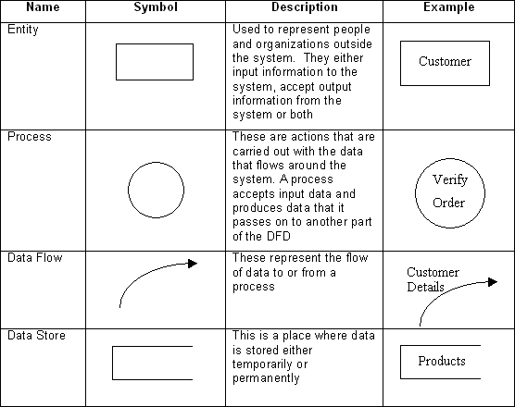

#### Fig 3.1: Data Flow Diagram Symbols

* + 1. **DFD LEVEL0**

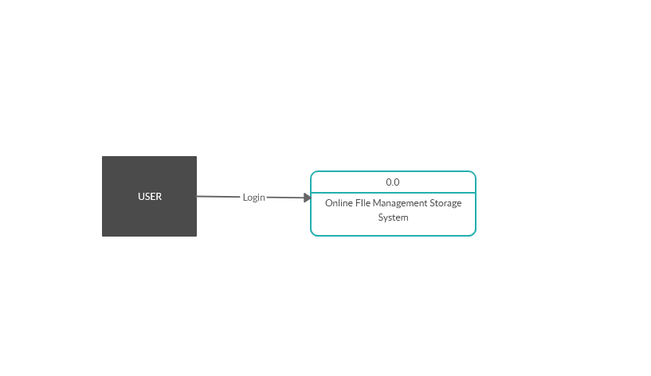

**Fig 3.2: 0 Level DFD**

* + 1. **DFD LEVEL 1**

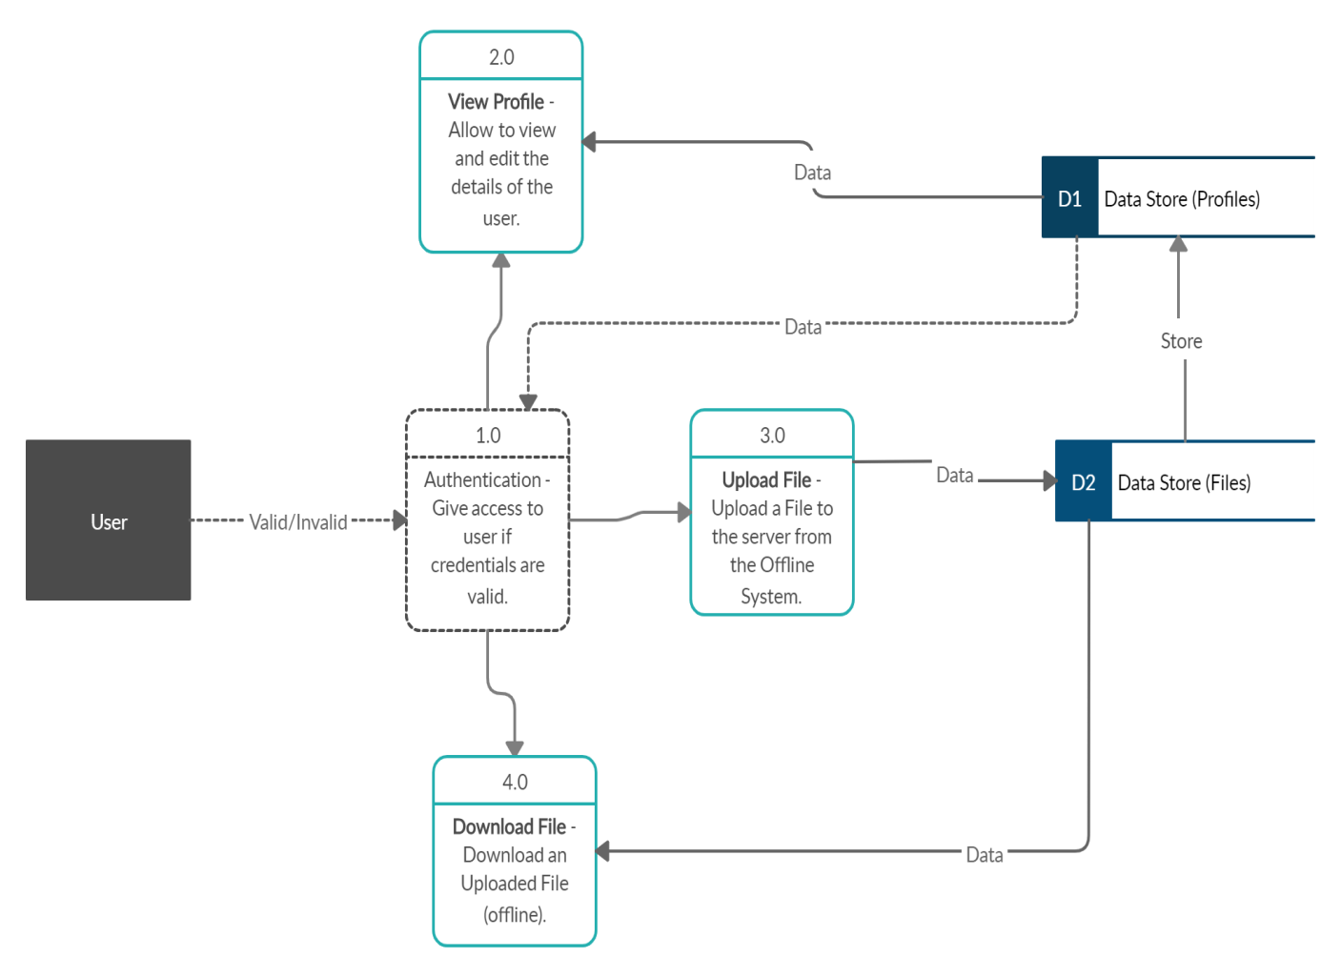

* + 1. **DFD ADMIN**

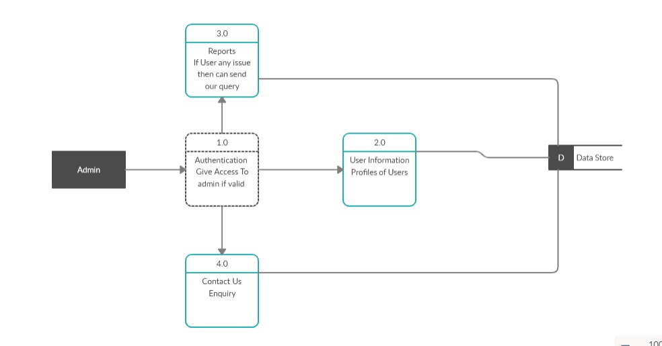

**DFD ADMIN**

## Entity Relationship Diagram(ER-Diagram)

An entity-relationship diagram (ERD) is a graphical representation of an information system that shows the relationship between people, objects, places, concepts, or events within that system.AnERDisa[datamodeling](http://searchdatamanagement.techtarget.com/definition/data-modeling)techniquethatcanhelpdefinebusiness processes and can be used as the foundation for a [relational database](http://searchsqlserver.techtarget.com/definition/relational-database).

While useful for organizing [data](http://searchdatamanagement.techtarget.com/definition/data) that can be represented by a relational structure, an entity-relationship diagram can't sufficiently represent semi-structured or [unstructured](http://searchbusinessanalytics.techtarget.com/definition/unstructured-data) [data,](http://searchbusinessanalytics.techtarget.com/definition/unstructured-data) and an ERD is unlikely to be helpful on its own in integrating data into a preexisting information system.

Three main components of an ERD are the [entities](http://whatis.techtarget.com/definition/entity), which are objects or concepts that can have data stored about them, the relationship between those entities, and the [cardinality,](http://whatis.techtarget.com/definition/cardinality) which defines that relationship in terms of numbers.

#### Components of the ER Model

The three main components of the ER Model are **entities**, **attributes** and

#### relationships.

* In ERM terms, an entity is a "thing" within the organization that we want to keep information about, such as a customer, employee, or course. In other words, an entity in an ERM refers to a table, and rows within the table are referred to as entity occurrences. Entities are represented by rectangles containing the name of the entity. Entity names must be singular and in capital letters.
* Eachentityhasattributeswhicharethepropertiesofeachentity.Attributes will be implemented as columns in the tables. Each attribute has a domain that specifies these to possible value san attribute can have. For instance, the range of value for a telephone extension may be specified as a set of integer numbers between 4000 and 4999. An attribute domain is not displayed in ER diagrams but is recorded in the data dictionary.
* Attributes can be of various types. A composite attribute can be subdivided into smaller parts. For example, an attribute Name can be subdivided into First Name and Last Name. Attributes that cannot be subdivided are called simple attributes. First Name and Last Name are now simple attributes. Most attributes have only a single value and as such are called single-valued attributes. For example, a Teacher can have only one Last Name or a Subject can have only one Subject Code. Multivalued attributes can have more than one value. For example, a student could have more than one certificate, or a Department may have several extensions.
* A key attribute is an attribute that has a unique value for each entity occurrence. In other words, a key attribute is used to identify each row uniquely. For example, a Subject Code will uniquely identify each subject as notwosubjectscanhavethesameSubjectCode.Keyattributesarerepresented by underlining its name.
* A relationship is an association between entities or entity occurrences

#### 3.2.1 ER Diagram of CLODY STORAGE :

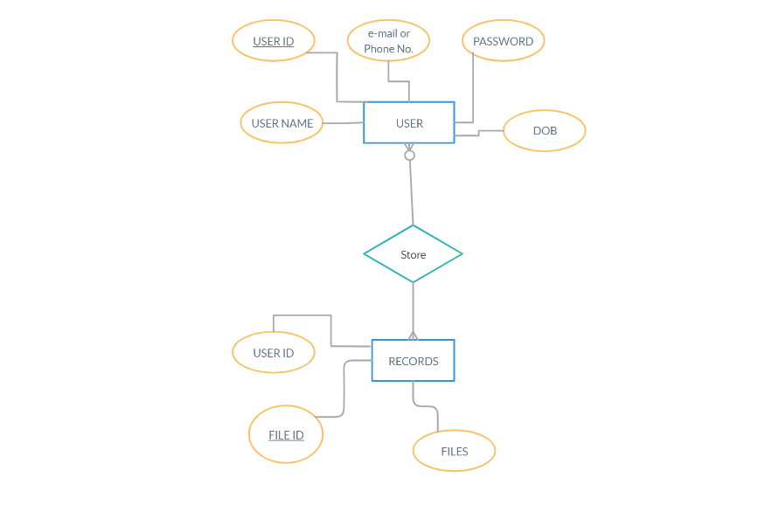

**Fig 3.7: Entity Relationship Diagram**

**3.3 Database Design**

Good database design is crucial for a high-performance application, just as an Aerodynamic body is important to a race car. If the car doesn’t have smooth lines, it will produce drag and go slower. Without optimized relationships, your database won’t perform as efficiently as possible. Thinking about relationships and database efficiency is part of normalization.

Beyondtheissueofperformanceistheissueofmaintenance—your database should be easy to maintain. This includes storing only a limited amount(if any)of repetitive data. If you have a lot of repetitive data and one instance of that data changes (such as a name change), that change has to be made for all occurrences of the data. To eliminate duplication and enhance your ability to maintain the data, you might create a table of possible values and use a key to refer to the value. That way, if the value changes names, the change occurs only once in the master table. Therefore it remains the same throughout other ables.

|  |  |  |  |
| --- | --- | --- | --- |
| **Attribute** | **Type** | **Description** | **Constraints** |
| Username | Varchar(30) | Username of Admin | Primary Key |
| Password | Varchar(30) | Password of Admin | Not Null |

**Table 3.2: Admin login**

|  |  |  |  |
| --- | --- | --- | --- |
| **Attribute** | **Type** | **Description** | **Constraints** |
| ID | Int(11) | ID of user | Primary Key |
| FName | varchar(50) | First Name of the user | Not Null |
| lname | varchar(50) | Last name of the user | Not Null |
| dob | Date | Dob of user | Not Null |
| phone | Bigint(15) | Contact of user | Not Null |
| username | varchar(100) | Mail of user | Not Null |
| password | varchar(50) | password of user | Not Null |

**Table 3.3: user**

|  |  |  |  |
| --- | --- | --- | --- |
| **Attribute** | **Type** | **Description** | **Constraints** |
| Id | Int(11) | Id of user | Primary Key |
| userName | varchar(50) | Name of user | Not Null |
| title | varchar(50) | Title of file | Not Null |
| caption | Varchar(100) | Caption of file | Not Null |
| filename | Varchar(255) | Name of file | Not Null |
| date | date | Date of file | Not Null |

**Table 3.4: user files**

16

|  |  |  |  |
| --- | --- | --- | --- |
| **Attribute** | **Type** | **Description** | **Constraints** |
| Id | Int(10) | id of user | Primary Key |
| Name | varchar(20) | Name of user | Not Null |
| phone | Begin(15) | Phone of user | Not null |
| Email | Varchar(40) | Mail of user | Not null |
| comment | Varchar(100) | Comments of user | Not null |

**Table 3.5: contact**

**IMPLEMENTATION &USER INTERFACE**

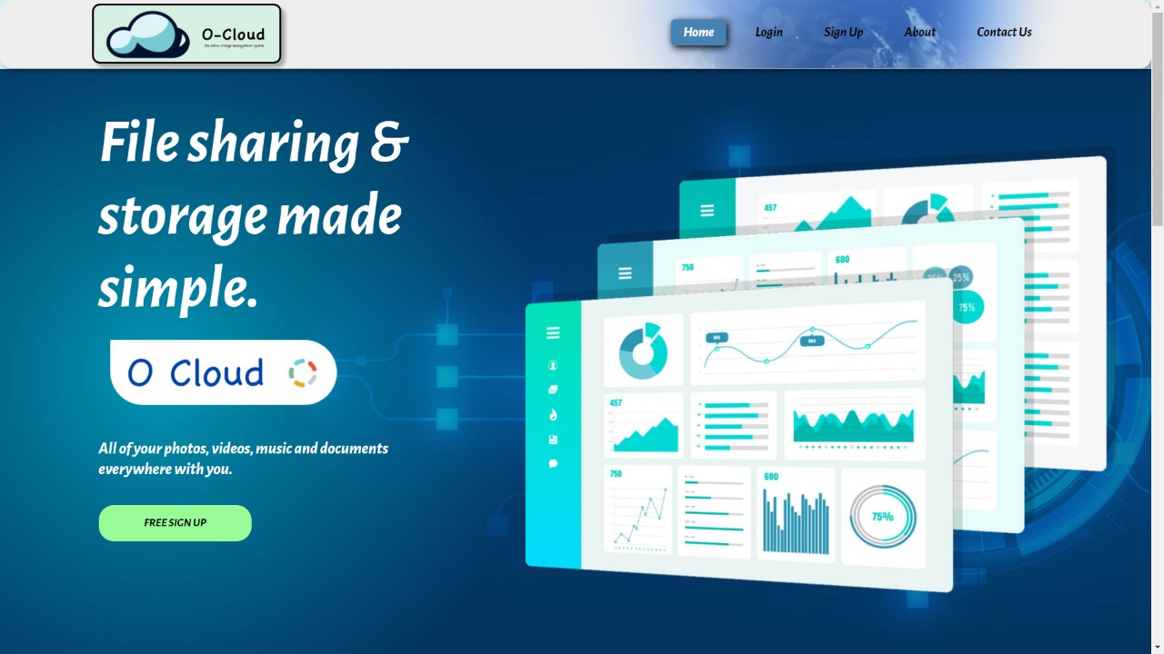

**Fig 4.1: Home**

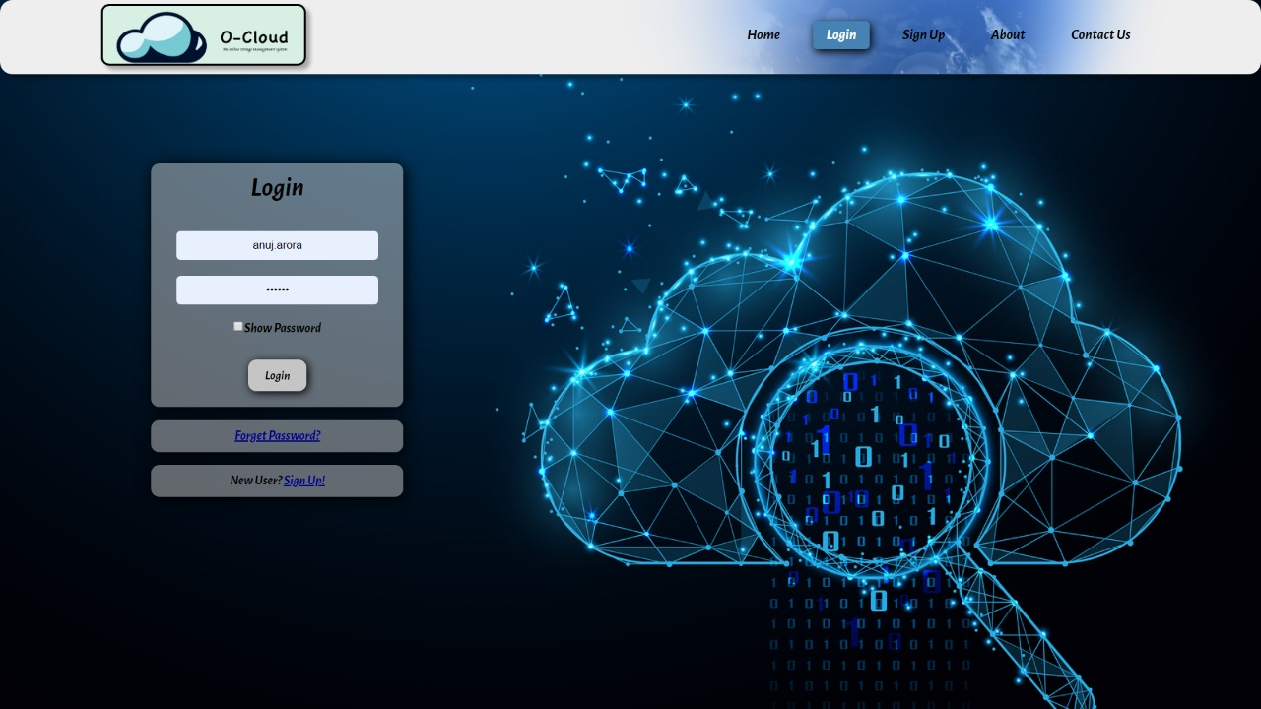

**Fig 4.2: login**

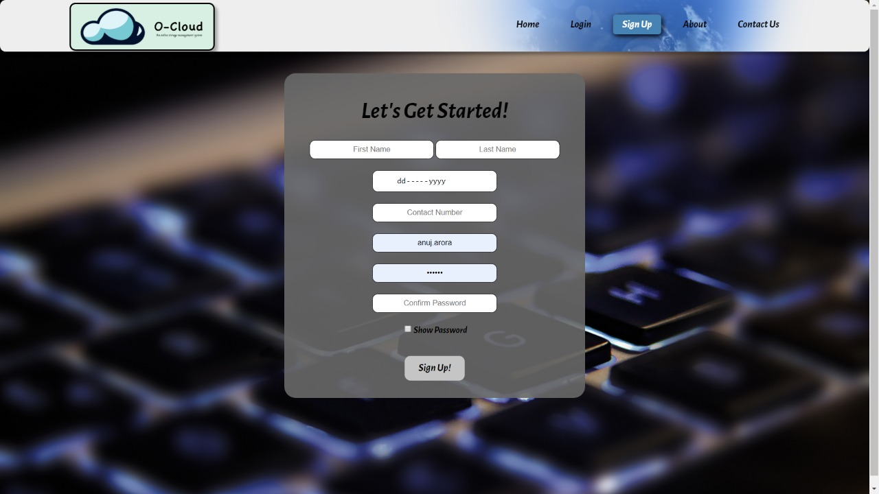

#### Fig 4.3: sign up

#### 

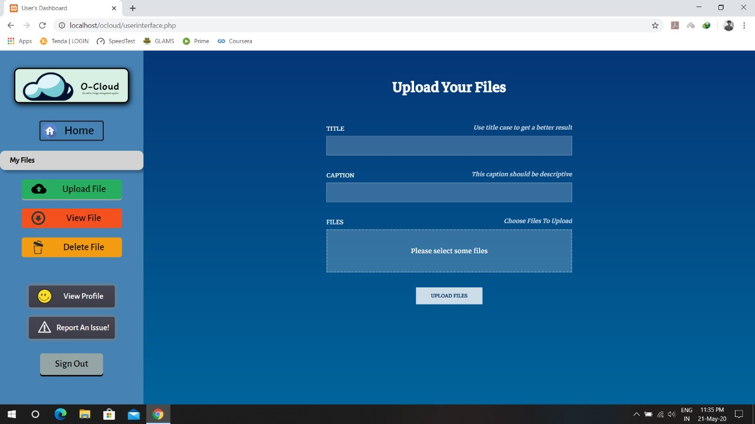

**Fig 4.4: upload files**

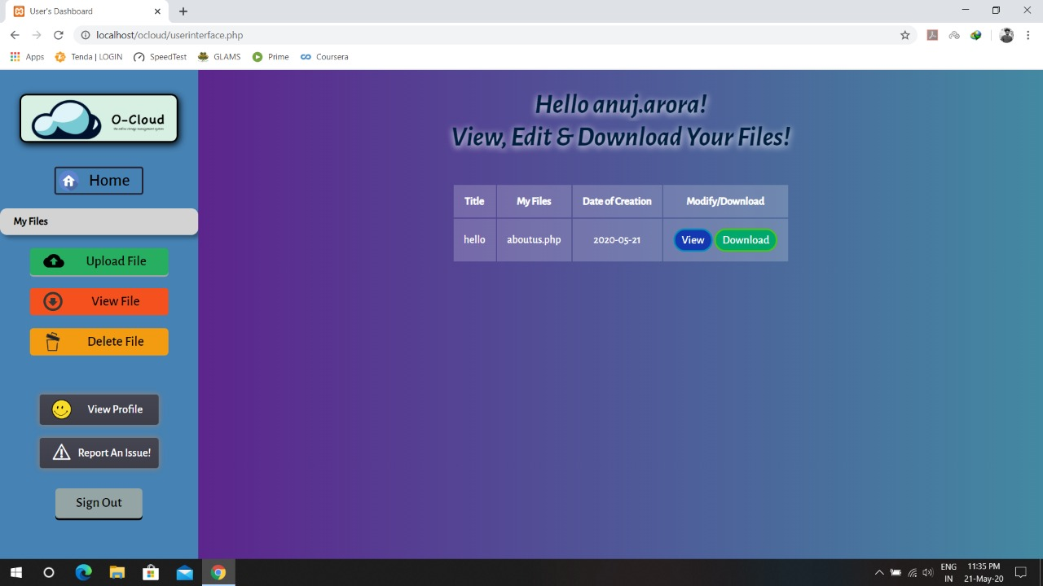

**Fig 4.5: view files**

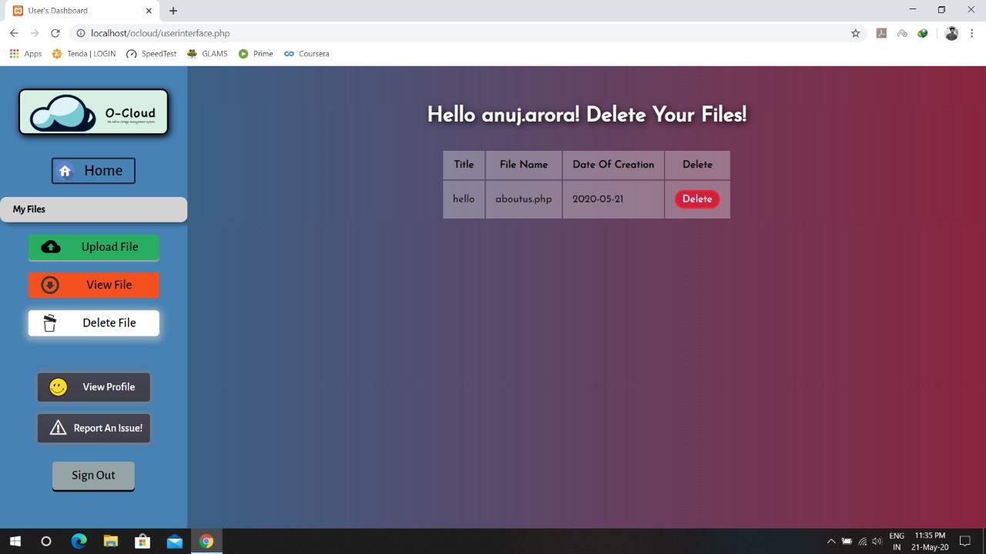

**Fig 4.6: delete files**

**Chapter 4**

**Implementation & User Interface**

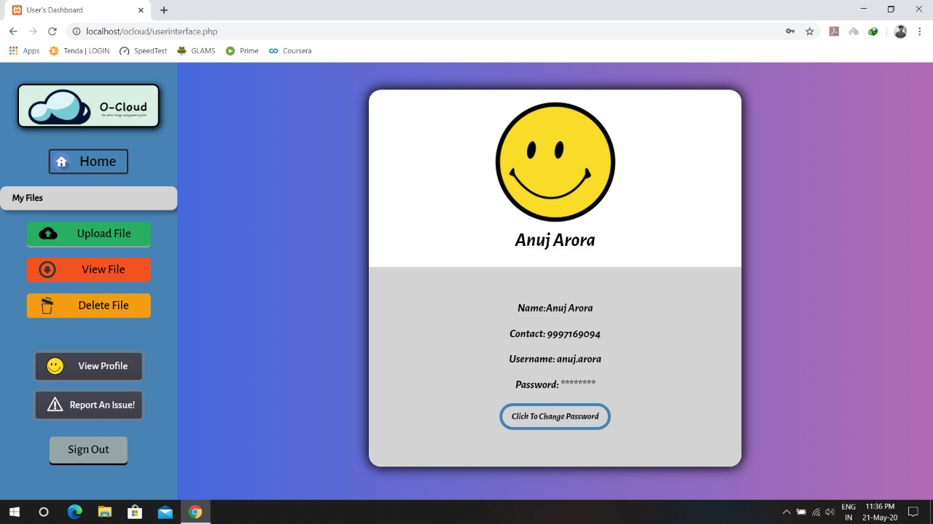

**Fig 4.7: view profile**

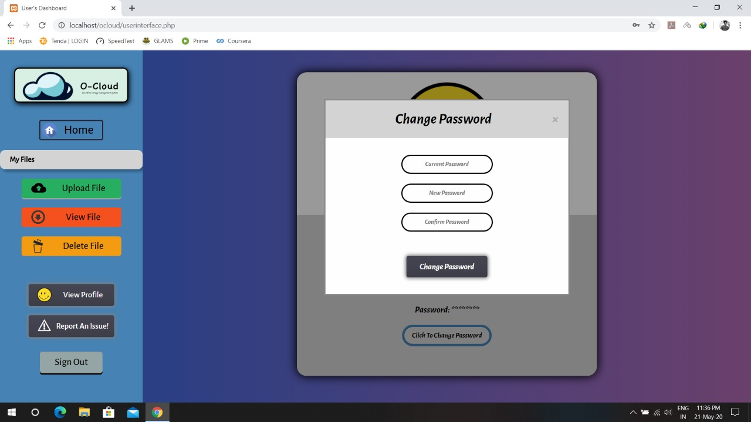

**Fig 4.8: Change password**

**SOFTWARE TESTING**

21

## Testing

* + - Software testing is the process of executing a program with the intension of finding errors in the code. It is a process of evolution of a system or its parts by manual or automatic means to verify that it is satisfying specified or requirements or not.
    - Generally, no system is perfect due to communication problems between user and developer, time constraints, or conceptual mistakes by the developer.
    - The purpose of the system, testing is to check and find out these errors or faults as early as possible so losses due to it can be saved.
    - Testing is a fundamental process of software success.
    - Testing is not a distinct phase in the system development life cycle but should be applied throughout all phases i.e. design development and maintenance phase.
    - Testing is used to show incorrectness and considered to succeed when an error is detected.

## Objectives of Software Testing

* + - **Software Quality Improvement:** The computer and the software are mainly used for complex and critical applications and a bug or fault in software causes severe losses. So a great consideration is required for checking for the quality of software.

#### Verification and validation:

* + - * Verification means to test that we are building the product in the right way .i.e. are we using the correct procedure for the development of software so that it can meet the user requirements.
      * Validation means checking whether we are building the right product or not.

22

**Chapter 5**

**Software Testing**

* + - **Software Reliability Estimation:**

The objective is to discover the residual designing errors before delivery to the customer. The failure data during process are taken down in order to estimate the softwarereliability

## Principles of Software Testing

* + - All tests should be traceable to end-user requirements.
    - Tests should be planned long before testing begins
    - Testing should begin on a small scale and progress towards testing in large
    - To be most effective testing should be conducted by an independent third party

The primary objective for test case design is to derive a set of tests that has the highest livelihood for uncovering defects in software. To accomplish this objective two different categories of test case design techniques are used. They are

* + - White box testing.
    - Black box testing.

#### White-box testing:

White box testing focuses on the program control structure. Test cases are derived to ensure that all statements in the program have been executed at least once during testing and that all logical conditions have been executed.

#### Block-box testing:

Black box testing is designed to validate functional requirements without regard to the internal workings of a program. Black box testing mainly focuses on the information domain of the software, deriving test cases by partitioning input and output in a manner that provides thorough test coverage. Incorrect and missing functions, interface errors, errors in data structures, error in functional logic are the errors falling in this category.

23

**Chapter 5**

**SoftwareTesting**

## Testing fundamentals

Testing is a process of executing a program with the intent of finding the error. A good test case is one that has a high probability of finding an undiscovered error. If testing is conducted successfully it uncovers the errors in the software. Testing cannot show the absence of defects, it can only show that software defects present.

## Testing Information flow:

Information flow for testing flows the pattern. Two class of input provided to test the process. The software configuration includes a software requirements specification, a design specification, and a source code.

Test configuration includes test plan and test cases and test tools. Tests are conducted and all the results are evaluated. That is the test result sare compared with expected results. When erroneous data are uncovered, an error is implied, and debugging commences.

24

**CONCLUSION**

This was the first considerably large and important project undertaken by me during my BCA course. It was an experience that changed the way I perceived project development. The coding could not be started before the whole system was completely finalized. Even then there were so many changes required and the coding needed to be changed. I attribute this to inadequate information gathering from the user. Though there were many meetings with the user and most of the requirements were gathered, a few misinterpretations of the requirements still crept in. It made me realize how important the systems analysis phase is. The project is a classic example, that learning of concepts needs to be supplemented with the application of that knowledge.

On the whole, it was a wonderful experience developing **CLOUDY STORAGE** and I would have considered my education incomplete without undertaking such a project which allowed me to apply all that I have learned and tried to develop a project that can be useful for people to save their data easily and efficiently. It is developed using PHP so that it can be accessed very easily and at any time. The system will be capable of storing any type of data with no errors and the system will be available and operational all the time. The system is developed with an aim of usability so that it is an easy to use system that requires the least amount of user input possible. For using this system general computer knowledge is enough. An easy well-structured module will show the correct path to reach the destination. Users will be authenticated to ensure that no unauthorized users gain access to private information.

25