**PROJECT TOPIC: CLOUD STORAGE MANAGEMENT SYSTEM**

**Group No.: 02**

**Project Members:**

1. Anuj Arora (14 / 184200036) **2.** Yogesh Kumar (13 /184200035)

**3.** Adarsh Pandey (03 / 184200049) **4.** Abhishek Gupta (01 /1842000.)

**5.** Aryan Varshney (16 / 184200165) **6.**  Shivam Sharma ()

**Project Supervisor:** Ms. Kriti Bansal, Assistant Professor.

**About the Project:**

* This Project is about an Online Storage Management System which helps a user to save their data on clouds (i.e. Online).
* It is used for storing the essential data securely om clouds.
* It provides a user to have a drive-less storage system in his/her pocket which the user can access any time being at any place in this world.
* It provides data security so that it couldn’t be stolen. Offline data can be stolen more easily than online data
* A user can store whatever he/she wants irrespective of the type of the data.
* The data can be shared among an organization or a group of people without having the trouble of offline drives concern.
* This project has two modules:
* Admin Module: Has access to all the profiles, can only view the data(don’t have access to write or download the data.)
* User Module: Can upload/download the data of their choice.

**Motivation:** Scope of your project. Why it should be count as a major project (i.e. final year project)? How it will be useful to the society or what is innovative in this project. (**4-5 lines**)

The scope of this project is, nowadays in the era of advancement, people don’t use to carry offline storage devices with them as it is tough to carry the drives along with other essential stuff. Also, the offline storage devices require high maintenance, may stop working after a period of time, can get damaged. So, this project will help those people to carry their essential data along with them in their mobile phones and laptops which can be accessed from any place in this world.

**Project Planning:** How will you proceed to complete the project? A rough Gantt Chart that shows phase and approximate time to complete those phases, including the time to learn the language (if that’s the case) in which you will make the project.

Typical example of Gantt chart is shown below. Create your similar sort of graph depending upon your project activities. Project duration must start from the month of *January* *2020* and Project completion must be shown in the month of *April 2020*.

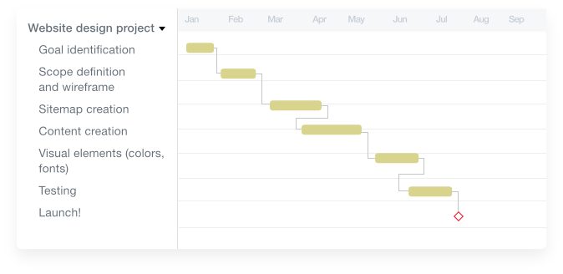

**Tools required:**

* Operating System: Any Operating System.
* Front End: HTML, JavaScript, CSS.
* Back End: PHP, MYSQL.
* Processor: Intel Celeron (Minimum Version)
* RAM: 512MB
* Hard Disk Drive: 20GB (Window Installation + Server Installation)

**Signature of Project Supervisor: _____________________**