Application Distribue:

**Devoir 2**

1. Created a Dynamic Web Project

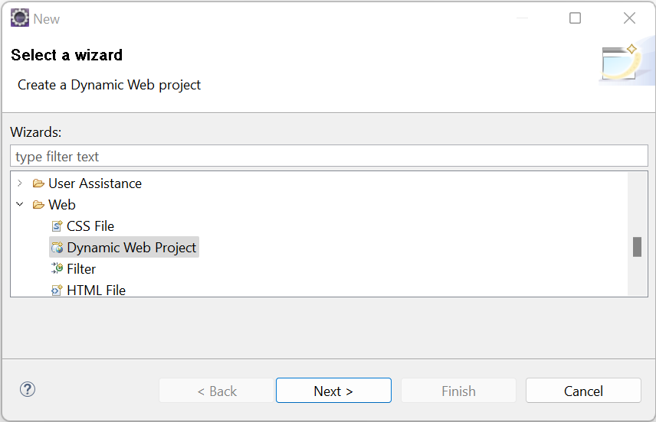

1. Made sure it was connected to the right directory.

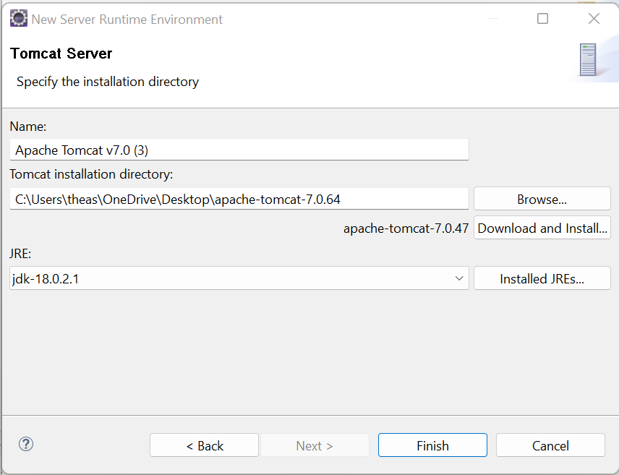

1. Created a servlet.

1. Made sure the method was service.

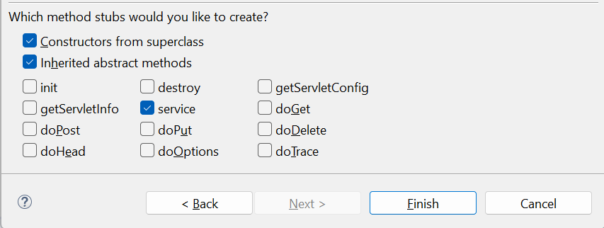

1. The servlet codes. Graphical user interface, text, application

   Description automatically generated
2. The compilation.

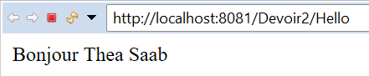

1. And from the google chrome browser.

1. The HTML file. 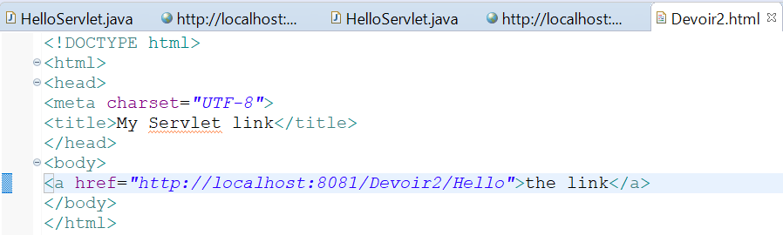
2. The compilation.

