MD. MEHADI HASAN
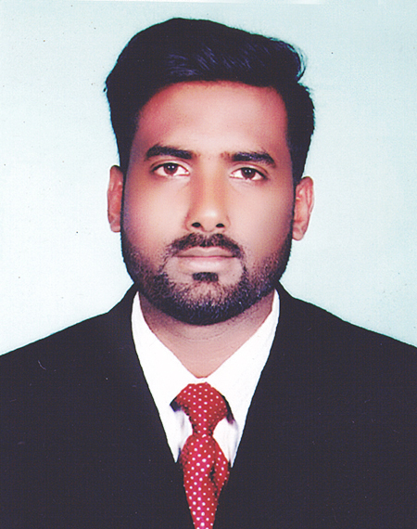
23/2/C Shah ali bag, Mirpur-1, Dhaka-1216
Cell No.+8801879600617
E-mail- mehadihasanaiub@gmail.com

Career Objective:

Being an enthusiastic new comer in the area of Electrical Engineering, I am aspiring to be a dynamic engineer. As a young aspirant, I want to pursue my goal with absolute dedication, sincerity, honesty and perseverance.

Educational Background:

►Examination : Bachelor of Science. (B. Sc.)
Major Field of study : Electrical & Electronics Engineering
Institution : American International University-Bangladesh (AIUB)
Result : 3.05 out of 4.00
Pas. Year : 2018

►Examination : Higher Secondary Certificate (H.S.C)
Major Field of study : Science
Institution : Alauddin Ahmed Degree College
Result : 4.20 out of 5.00
Pas. Year : 2012

►Examination : Secondary School Certificate (S.S.C)
Major Field of study : Science
Institution : United Secondary School
Result : 4.63 out of 5.00
Pas. Year : 2010

Computer Knowledge:

- Internet Skills:
- Having good knowledge about Internet Browsing
- E-mail Handling

- Skills on Application Software:
- MS Office 98 / 2000 / XP (MS Word, MS Excel, MS Power Point)
- Working with Word Processing Software with an average typing speed of English respectively.
- MATH Lab , Proteus, Multisim .

Language Proficiency:

- First/Native language (Bengali): Excellent in reading, writing, Speaking and Understanding

- Second language (English): Excellent in reading, writing, Speaking and Understanding

Personal Information:

- Full Name : MD. MEHADI HASAN
- Father's Name : Md. Jahid Hossain
- Mother's Name : Mst. Shekha Khatun
- Date of Birth : 25 Nov.1994
Present Address : 23/2/C Shah ali bag, Mirpur-1, Dhaka-1216
- Permanent Address : C/O-Md. Jahid Hossain
Village: Banshgram, P.O: Durbachara
P.S: Kumarkhali, District: Kushtia.
- Sex : Male
- Religion : Islam
- Nationality : Bangladeshi
- Marital status : Unmarried
- Blood group : A+ (Positive)

Personal Remarks:

I hereby certify that all above information is true and correct to the best of my knowledge.
- Honest and hard working.
- Creative and able to develop ideas.
- Interests, Traveling, Reading Religious Books, Develop creative ideas and outfits
- Able to adapt to new environment.
- Like to take the challenge.
- To express as responsible and independent

Reference:

Faiz Ahmad
General Manager
Akij Ceramics Limited
Cell: 01713221920

Sincerely Yours
Date: MD. MEHADI HASAN

