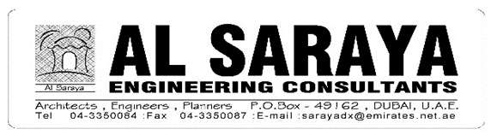 |  | 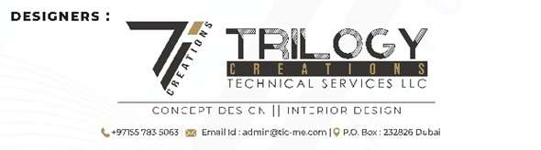 | 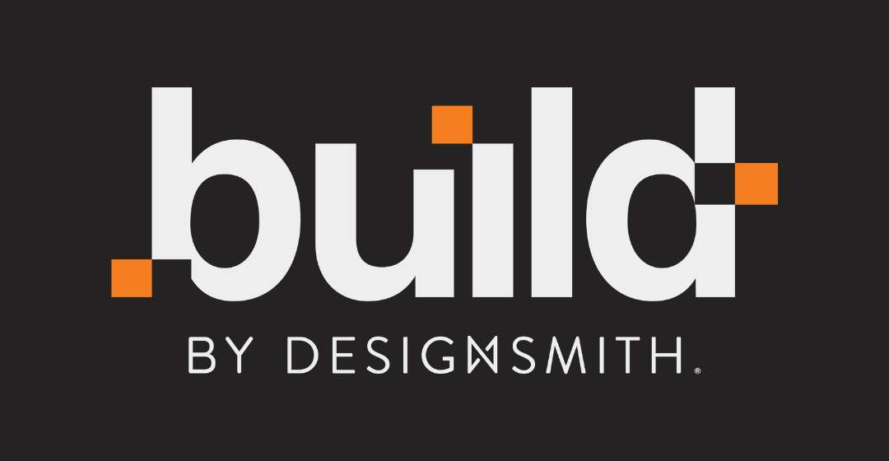
PROJECT NO: | 1010619 | PROJECT NAME: | Trilogy B+G+7+R Hotel Project
REQUEST FOR INFORMATION
R.F.I NO : | DS-STR-ASEC-RFI-CIVIL-003 | DATE | 04/11/2026
CONTRACTOR : | Build by Designsmith
Consultant : | Al Saraya Engineering Consultants
DRAWING NO. : | S-101, S-102, S-106, S-110, S-302 to S-308 | TITLE: | Door for cargo lift
SPECIFICATION : |  | TITLE: | Beams for all core/lift walls
EST. COST IMPACT : |  | EST. TIME IMPACT :
PREPARED BY : | Sunil Kumar | REQUESTED RESPONSE BY :
DESCRIPTION OF REQUEST :
Subject : Core/lift wall beams (B47–B50), cargo lift entrance and casting of lift walls
1. As per the structure drawings, we have noticed that the beams B47–B50 of all core/lift walls are wider than the core wall thickness, which will affect the lift car size and the headroom of the staircase in the mid-landing area, impacting (Affecting drawings S-110, S-301 to S-308).
2. As per the drawings S-101, S-102 and S-106, the cargo lift entrance is not matching. Full detailed information is required for execution.
3. We request you to finalise/approve to proceed with casting of the lift walls without lift shop drawings.
Attached: highlighted drawings S-101, S-102, S-106, S-110 and S-302 to S-308.
DATE : 04/11/2026
ENGINEER'S RESPONSE :

BY : ____________________________________ DATE : ______________________
CLIENT's Comments (If Applicable):

By : ____________________________________ DATE : ______________________
RECEIVED
CONTRACTOR : ______________________________________ DATE : ______________________

