ILLIANA NEWS

JANUARY 2017

MEETING:

Since the Christmas in the Village and the Holiday Season is over (along with the Club House “closed up” for the winter and unpredictable weather), there WILL NOT be a meeting of the Illiana Antique Power Assoc. in January. Plans for a February meeting will be discussed with an alternative location. We’d like to THANK Ted and Carol Stout for hosting our November meeting at their lovely home in West Point Indiana and Dan McCain from Canal Park- Delphi Indiana for his fund raising/ grants presentation.

A LETTER FROM OUR PRESIDENT:

HELLO and HAPPY NEW YEAR to EVERYONE,

Where did 2016 go? Once again, too fast! Thankfully we survived all the T-V ads, the Presidential campaign is over and we can get on with our lives. 2016 was a good year for Illiana. We had a wonderful show in July once again. The Quonset building was built thanks to many volunteers. A new well was dug. The new septic system was installed in preparation for the new assembly hall. A “once in our lifetime” celebration of the Indiana Bicentennial in conjunction with our History Day and ending with the carrying of the Torch coming through our show grounds. WOW! None of these things could have taken place without all of your efforts.

We also celebrated Christmas in the Village with a large attendance both nights. So glad it wasn’t the following weekend with the bitter cold and ice.

For those members that are not aware: At our November meeting, Ed and Pat Grubb put forth a proposal to raise funds for our new assembly hall. They generously agreed to donate $15,000 to the building fund “IF” the club will match their donation with $15,000. I have already had a pledge of $3,000 toward this project. Give this some thought and anything you pledge or give will be confidential unless your permission is given otherwise.

(Letter continued)

Looking ahead to 2017, I want to put the sawmill frame on concrete pillars along with a new roof overhead. We have a substantial amount of new tin roofing on hand. In doing this project, I want to be able to connect our Cat Engine to the mill as the power source.

In November and December the Illiana Board of Directors met with our Insurance Agent concerning safety on our grounds…which is our first priority. After much thought, deliberation and discussion, your Board of Directors made this unanimous decision. This will also be printed on our flyers and will have it printed on our mailings that I send to our exhibitors.

NOTICE:

Due to safety concerns, the use of golf carts, gators and UTV’s on Illiana show grounds will be limited to handicapped, directors and officers only. Drivers of tractors, vehicles and lawnmowers on Illiana show grounds and in the parade must have a valid driver’s license. No ATV’s on grounds. Thank you for your cooperation regarding this matter.

Tom Swanson – President

In closing, thank you for all your generous help, donations of time and money to make Illiana what it is. Thanks to all who worked in the cold for Christmas in the Village!

Tom Swanson

PARTY!

The Christmas Party at Donnie and Christy Bodine’s was a huge success! There was plenty of delicious food and fun for “young and old”…..watching the trains “run the rails” around the train layout. On display was their finished cattle car and a combination passenger/baggage car that Terry is currently building. Doc Fontaine’s steam engine was also on display. Kaaren Parsell put together a lovely poster of pictures taken at this year’s Christmas in the Village and Tom Bastin surprised them with an antique Christmas picture he purchased and thought they would enjoy. Thanks Kaaren and Tom! Finny Filchak entertained everyone singing “Back Home Again in Indiana and On the Banks of the Wabash” and explained a brief history of the two songs. Special guest was George Kester – Kester’s Old Time Collectables , Grant Park, Illinois. He produces cast iron models and his Minneapolis Engine and Water Wagon were modeled after Donnie’s engine and wagon. Pictures of his models are included in the newsletter.

(E –mailers as an attachment). Price sheets are available.

Thanks to all who attended!

PINE CREEK & WESTERN R.R. NEWS:

Well…..Christmas in the Village was a great success as participants and visitors alike discovered where the cookies were…..the lack of glittering moon light glistening off the new fallen snow that never showed up…..didn’t slow down the railroad operating on Friday and Saturday. Friday John Young and Chuck Morgan brought their locomotive and riding cars and John operated the train through the cold and dark night hauling passengers both Friday and Saturday. Word through the grapevine said that by the following Tuesday, John had thawed out and was back to normal. Saturday the Fox’s from Mahomet Illinois brought their railroad equipment and enjoyed operating the railroad also. There were minor complaints heard from some of the operators of steam equipment that there wasn’t any coal found in their hanging stockings Christmas morning…..so plans are in the works on being “bad” in 2017!

Here is a picture of Gene Miller on his famous steam locomotive that was known throughout the Midwest. Gene and Jim Fain railroaded at many power shows hauling Jim’s portable track to run their trains on. Gene was one of the original members of the Pine Creek & Western Railroad development. This message is brought to you by the letters P C & W R R .

Charlie Lupinek…..darn it’s cold!!!!! (Just counting the days to Spring and warm weather!)

NOTE: A meeting of the PC&W Railroaders is scheduled for January 22, 2017 at Donnie Bodine’s shed.

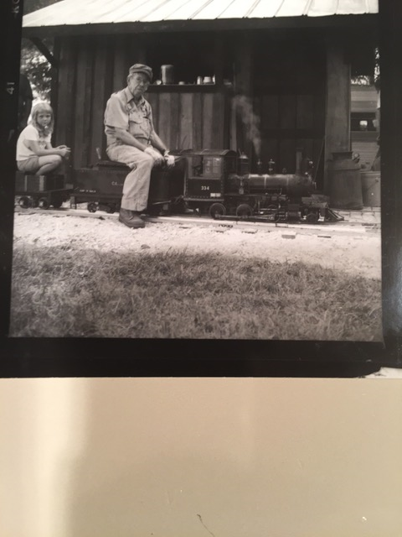

TRACTOR TRIVIA:

1. True or False: In the early 1800’s, nine out of ten people were employed on farms?
2. What early tractor manufacturer marketed “Old Reliable”?

FROM THE ENGINE SHED:

Hello from the Engine Shed! It has been cold, wet and soggy. Just plain “miserable”! Oh well, the shop is warm. I got parts ordered for the 6 HP IHC M gas engine. The head is welded, valve seated and I am looking forward to going to Florida Fly Wheelers and Zolpho Spring Shows. Hope there is plenty of sunshine! A belated “Merry Christmas and a Happy New Year” to all my engine friends.

Submitted by: John Byroad

It was reported at the November meeting that “Summers’ Campground” will be re-opening this summer. Since our camping facilities are limited, we can refer the over-flow in their direction if necessary.

ILLIANA QUILTERS NEWS:

The Quilters didn’t have a regular meeting in December, but did gather in the home of Joan Fry for a great catered meal, grab bag exchange and much jocularity! Many ideas were discussed for the coming year, some ladies were unable to attend but the rest of the Quilters tried to have fun anyway!! Shame – Shame!! Just kidding! Next meeting will be January 23, 2017!! Hope we’re all in good health and able to attend. ??

Submitted by: Marsha Watkins

SAD NEWS:

There have been several deaths among our members and friends. The Gas Engine Group lost Phillip Foetisch (Lowell, In.) on November 29, 2016. Phillip attended our July Show each year. Railroader Darwin Enders Jr.’s (South Bend, In.) Dad passed away on November 30, 2016 and former member Mahlon White (Alvin, Il.) passed away December 7, 2016. Our sympathy goes to all their families.

ROCKY FORGE BLACKSMITH NEWS:

We will have a meeting of the Rocky Forge Blacksmiths at Ted’s heated shop on Saturday, January 14th. Coffee and munchies will be available at 8:30 A.M. so come early so we have time to socialize and catch up each other’s doings. The weather may influence attendance, but do your best to be here with safety in mind. Be sure to bring quality iron in the hat items. Ted has several neat things to put in the drawing. Carol is preparing roasted chickens and scallop potatoes for lunch so bring whatever you can to go with that meal. Salad or vegetables anyone? We can share a coal forge and a gas forge inside so think of an item or items you may want to do. I doubt it will warm enough to work outside, although we do have some pretty hardy smiths in our midst. Searcy, where are you?

There are many more toys in my shop if you so desire, sheet metal tools and the best teacher around (Gene H.), welding equipment, knife handle work, repousse’, fold forming and many more potential projects. I have lots of videos on blacksmithing you can relax, learn and enjoy. There is now a theater popcorn popper in the shop so you can pretend to be at the theater without spending a dime. Also, I have laid out over 100 pairs of tongs and many hammers for you to pick through for sale. See you all on Saturday…….Ted

Submitted by: Ted Stout

TRIVIA ANSWERS:

1. True
2. Hart Parr’s 30/60 was “Old Reliable”.

THANK YOU!!!!!

Special THANKS to Amanda Hobbs who has donated her time, supplies and equipment each year during our Christmas in the Village. Amanda takes “Pictures with Santa”! Everyone has a souvenir picture to take home for free!

THANKS AMANDA!!!!! And, thanks to all who donated the dozens of cookies and other fun items to make this event a success!