KHOJ-BEEN
( A Search Engine for books)
Developed For:-placement_challenge09(www.pagalguy.com)
Developed By:-Atul pandey(atulpandey88@rediffmail.com)

Installation:

- Copy the contents of Script folder in Cgi-bin directory of server.
- Copy the contents of HTML folder in default directory of server.
- Execute the ‘crawler.rb’ file. It will create three files named ‘good indian.txt.crw’, ‘warandpeace.txt.crw’ and ‘oldindiandays.txt.crw’ in default directory.
- Now program is ready to use.
- The program is tested in Apache Server (V-2.2) with ruby installed in C:\ruby on windows XP(SP2) platform.

How to Use:

- Run the program from web browser by entering the URL of the server file.
- Enter the Query String in the text field and then click on ‘SEARCH’ button to view the results.
- From results you can open the book by clicking on the Hyper Link given on the top of each result which is the name of book.
- You can also view some related results by clicking Hyper Link given at the top and bottom of result window. It contains results which are generated by breaking the query string.
- Query string entered follows the rules of Ruby Regular Expressions.

How it Works:

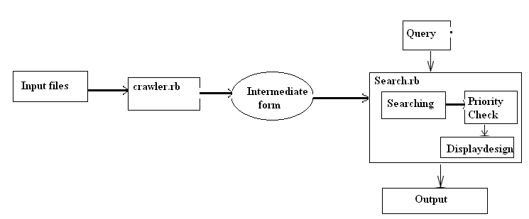

- Program contains three ruby files
a. Crawler.rb
b. Search.rb
c. Open.rb

- Crawler.rb used to convert input files in a format that can help to search file in a more efficient and relevant way.

- Search.rb used to search the books, generate the results and display the results.

- Open.rb used to open the respective book while we click on Hyper Link in the result window.

Rules Followed for searching:

- The Phrase will be searched according to the word boundaries. For eg: it will not consider ‘the’ in ‘other’ if searched for ‘the’.
- Search is case insensitive
- Search will treat all new line characters of paragraph as space to produce relevant results if part of query string occurs in next line.
- The result will be displayed in paragraph with book name at the top according to the priority of paragraph which is based on maximum no. of occurrences of query string in the paragraph. Other low priority results will be displayed on a Hyper Link ‘related results’ at the bottom of page.

Future aspects

- Dividing results in multiple pages
- Creating advance search option in which user can search book wise and can enter priorities like case sensitive/insensitive or individual word search for multiword phrase should be done or not.
- Search can be more optimized and fast.
- Creating cache in which some data of frequent searches can be stored and displayed.

