Progress report 2 of 10
LLM-Guided Neural Network Compilation for Real-time UAV Edge Inference
Atul Kumar Gupta · 25MCSS06
The language model may only name a plan
Report 1 separated flight from vision.
This note fixes who may choose the compile recipe. A language model, asked to make a network fast, will invent passes that do not exist and quote speeds it never measured.
The model may only name a plan from a fixed list. A checker accepts or cuts that plan. An engine then rewrites the ONNX graph. A profiler measures time and compares outputs with the untouched graph. The model does not edit the file, and it does not fly the aircraft.
The plan is checked as JSON before any rewrite. A sentence that contains a made-up speed is stripped. The stored record always says that no frame rate was claimed.

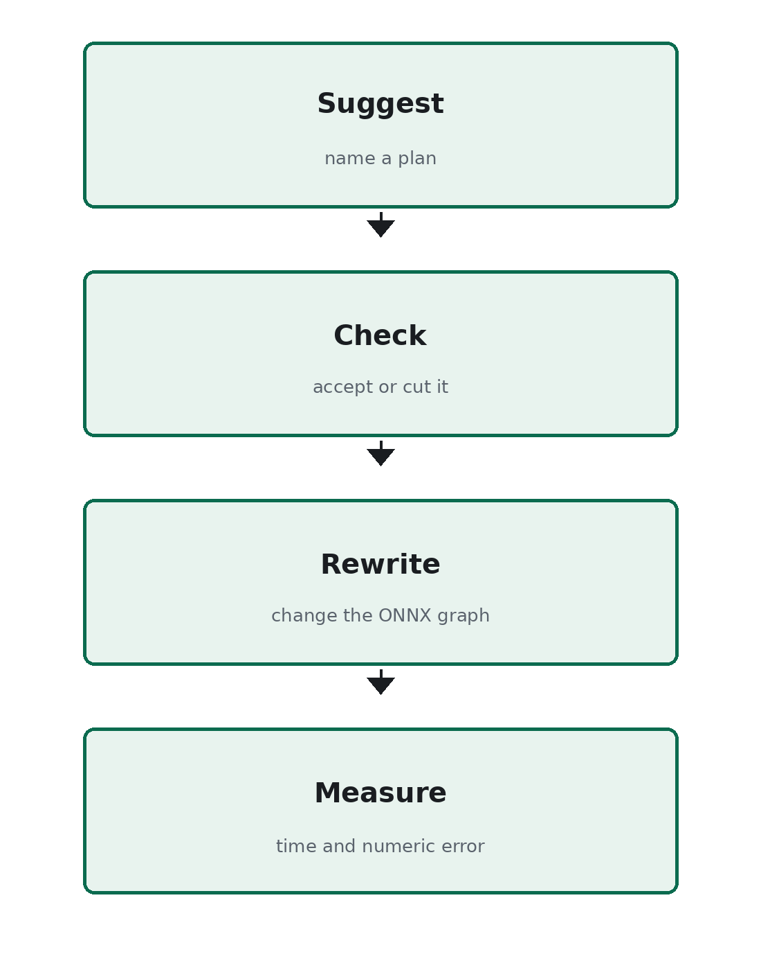
Figure 1. The model suggests. The rest of the system checks, rewrites, and measures.
The model is a planner, not the compiler. The next note shows that the rewrite changes a real graph.

